Prepared specifically for the FERTBIO 2012 Conference, Maceio, Brazil
September 20, 4:00 pm
Sensor Based Management of Nitrogen for Cereal Crop Production
William Raun, Brian Arnall, Randy Taylor, Ivan Ortiz-Monasterio*, John Solie, and Marvin Stone
Oklahoma State University
044 N. Ag Hall
Department of Plant and Soil Sciences
Department of Biosystems and Agricultural Engineering
Stillwater, OK 74078
*CIMMYT
Apdo. Postal 6-641
Mexico DF 06600
Prologue, written by B. Raun
In early 1992, Dr. Marvin Stone and Dr. John Solie stopped by my office and asked me a few questions. At the time, I did not know either one of them, and had just recently returned to the United States having spent 6 years with CIMMYT in Central America and Mexico. Nonetheless I was a bit uneasy considering the candor of their questions. As an agronomist they wanted to know if I were going to use one parameter that could be estimated indirectly using x-technology, what would I want? My response was that if they could predict plant biomass, I could do a lot with that. Both sat puzzled for a short while and then responded that yes they could indeed produce an indirect estimate of biomass using red and near infrared reflectance. Thus began a relationship that has now spanned 3 different decades, and has produced more than 160 refereed journal publications, 9 patents, and graduate degrees for over 80 students that are now scattered all over the world. The Greenseeker sensors and “Greenseeker system” as it is more commonly known today reflects a sustained and collaborative effort from faculty, students, and industry coming from an array of diverse backgrounds. The root of the success we have achieved has been the joint commitment of our Agronomy and Engineering team members.
Review
Need for estimates of plant biomass
Biomass at early stages of growth can easily account for up to half the total amount of x-nutrient that will be removed. Girma et al. (2010) noted that more than 61% of the total N accumulated in wheat at physiological maturity could be accounted for by Feekes growth stage 5 (leaf sheath strongly erect, Large, 1954). For corn, over 45% of the total N accumulated could be found by the 8 leaf growth stage (V8). What this clearly delineates is that cereal grains accumulate a very large percentage of the total nutrient needs, early in their life cycle. As a result, growth rate, health, and potential deficiencies are recognizable at early stages of growth. With an accurate estimate of wet and/or dry biomass, precise nutrient removal can be estimated based on known concentrations of each element and that are known to be crop specific. The International Plant Nutrition Institute (IPNI) recently reported values for N, P, and K in more than 30 different crops (http://www.ipni.net/nutrientremoval). And while there are errors that accompany these individual estimates, they are reasonably accurate.
Scale for precision agriculture
Embedded within precision agriculture is the question of scale. Scale in the sense of identifying the optimum resolution where precision agriculture should operate. Is it by-plant or is it every hectare? This question was asked early on by our entire team. We simply wanted to know the resolution in agricultural fields where real biological differences could be detected, whether it was the soil or the plant growing in that soil. Work by Solie et al. (1999) showed that in order to describe the variability encountered in a 21 x 2 m area, soil and plant measurements needed to be made at the meter or submeter level. Also, this was consistent for total N, extractable P and K, organic C and pH. Work by Raun et al. (1998) also noted that significant differences in surface soil test analyses were found when samples were less than 1 m apart for both mobile and immobile nutrients.
On the plant side, Martin et al. (2005) found that over all sites in all countries and states, plant-to-plant variation in corn grain yield averaged 2765 kg ha⁻¹ (44.1 bu ac⁻¹). This value came from 46 transects from a range of commercial corn fields in Argentina, Mexico, Iowa, Nebraska, Ohio, Virginia, and Oklahoma. Other wording for this value was that the average difference in yields from one plant to the next was 2765 kg/ha. At an average value of 1.2%N in the corn grain this translates into average differences in plant to plant N uptake of 33 kg N/ha. Today, the same rate of N is applied to all corn plants, yet we still have differences of this magnitude, and virtually all over the world where maize is produced. This same effect has been noted in winter wheat when yields were collected at sub meter resolutions (currently unpublished).
Predicting Yield
If we know that small scale variability exists, the ensuing question is whether or not grain yields can be predicted, in-season. And, all this in time to alter inputs that ultimately have an effect on yield. This is further complicated by knowledge of the scale. Can we physically adjust inputs using advanced engineering on the small scales (<1m2) identified in this work? And if inputs can be adjusted on this small of a scale using automated techniques, will it ultimately increase yields and nutrient use efficiency? Over many years, and at several locations around the world, our work has shown that mid-season NDVI measurements collected using the GreenSeeker sensor can indeed be used to accurately predict wheat and corn grain yields (Raun et al., 2001; Teal et al., 2006).
Predicting N Response
While yield levels certainly impact the demand for fertilizer N, N responsiveness by itself also impacts demand. Work from long-term field experiments in Oklahoma has shown that the demand for nitrogen changes dramatically from year to year. This is evidenced in the long-term winter wheat experiment (Exp. 502) near Lahoma, Oklahoma, where check plot yields and the high N rate yields are plotted from 1971 to 2012. The response to fertilizer N was estimated by dividing the high N rate yield by the check plot yield (referred to as the response index or RI, Figure 1).

Figure 1. Wheat grain yield from the check plot (0-N applied) and the high N rate (112 kg N/ha) from 1971 to 2012, and the associated response index estimated by dividing the yield from the high N rate by the yield of the check plot, each year.
Over this forty year period, the RI ranged from less than 1 to more than 4. That means that in 1994, a four fold increase in yield was realized when N was applied at a rate of 112 kg N/ha when compared to the check plot. This is not necessarily surprising, but what was important to find was that the demand for fertilizer N was incredibly small in 2002, 30 years after the trial was started. It is again worth noting that the check plot had received no fertilizer N since 1971 when the trial was started. How then could the check plot in 2002 produce 2500 kg/ha when the fertilized plot only produced 2900 kg/ha? The answer for this question lies in the weather that was encountered over the winter and early spring. For this year, enough N was mineralized from soil organic matter (even in an N depleted check plot) to produce near maximum yields. And this being the product of a warm wet winter, and a spring with adequate rainfall whereby N mineralization from the soil organic matter pool was adequate to produce near maximum yields. As a result the need for added N was small and the response index was also close to 1 (indicating little or no demand for added N).
Again, this was a check plot that had not received any N for 30 years (at the time). What this drives home is that the soil organic matter pool is still large, even with 30 years of no fertilization. Also, it addresses the importance of considering atmospheric N (fixation via lightning and/or other processes) that are not generally considered in N balance studies.
If near maximum yields were produced in the check plot in 2002 (no N applied for 30 years), why are we applying 112 kg N/ha every year? For Oklahoma, a common N rate for producers having yields in the 2000 to 4000 kg/ha range is 112 kg N/ha. Why? Unfortunately, what producers did last year is what they are going to do this year. Our common recommendation for preplant applications is 2 lbs N/bushel they hope to grow or, 33 kg N/1000 kg wheat. When evaluating all 41 years of data in Figure 1, the optimum N rate, based on yield level ranged from 0 to 160 kg N/ha, with an average near 60 kg N/ha.
And, yet, we continue with the application of the same rate, year after year.
Over the years, our project has thus focused on making decisions mid-season whereby the decision to apply added N could be made based on the mid-season performance of the crop, with and without fertilizer N. This focus led to research by Mullen et al.(2003), that found in-season response to fertilizer N could be predicted using in-season NDVI sensor readings collected from an adequately fertilized plot (N Rich Strip) and the farmer practice.
At this stage the chips were in place. We could predict yield levels using mid-season NDVI measurements with known dates of planting, and we could determine what level of N responsiveness might be encountered based on environmental conditions that had been encountered.
Algorithm Formulation
The final formulation/testing of algorithms became basically intuitive. The original diagram that delineates the different approaches and that has never been published is included below in Figure 2. The first algorithm approach or A is the root of what we believe to be correct. If we accept that yield potential can be predicted, then that level multiplied times the response index (RI), should give us the yield potential that can be achieved with added N. It does not generate the N rate, but does provide the basics needed for an accurate algorithm. The N rate is equally intuitive whereby estimated N removed at YPN minus the estimated N removed at YP0 divided by an expected efficiency factor should be equal to demand. All that is needed is an average percent N value for the grain under evaluation.
N Rate =(((YPN* percent grain N)-(YP0*percent grain N))/ expected efficiency.
The expected efficiency for fertilizer N applied mid-season is generally greater than that for N applied at planting. We have in general used 50%. This value is much higher than that found for preplant fertilizer N applications and that are also consistent with low NUE’s found for fertilizer N applied in the world that hover near 33% (Raun et al., 1999).
The second option (B, Figure 2) assumes that the crop is capable of recovering from early season N stress, and that maximum yields can be achieved if enough fertilizer N is applied. Many years of research have shown that this can only be achieved if near-perfect plant stands are present as is the case for a lot of the spring wheat produced in Ciudad Obregon, MX.
The third option (C, Figure 2) essentially encumbers systems in between A and B whereby the lower the CV of the plant stand (highly homogenous), even with severe N stress, the more the crop can recover from mid-season N stress. Higher plant stand CV’s (more heterogeneous stands) would suggest that plant stand variability has impacted YPN so much so that added fertilizer N may not result in complete recovery. This approach is very workable since both NDVI and CV data can be utilized using the Greenseeker sensor.
Figure 2. Delineation of the different algorithms that have been developed and tested at OSU. This includes the use of yield potential with no N added fertilizer (YP0), yield potential if added N fertilizer is applied (YPN), yield potential under ideal conditions (YPmax), predicted response index (RI), and the different approaches (A, B, C) described above.
Independence of Yield Potential and N Response
Work by Raun et al. (2011) that evaluated yield level and N responsiveness in long term wheat and corn experiments found that there were large differences in fertilizer N demand, and that fertilizer N requirements needed to be based yield potential and N responsiveness independent of one another. Ensuing work has shown that no relationship between N responsiveness and yield existed when evaluating 176 and 73 years of data from long term wheat and corn experiments, respectively (Figure 3). No relationship between yield level and RI was recorded whether or not the RI was determined using the check (0-N) or a mid-N rate. Algorithms that do not include both (yield level and RI) and that do not consider them independently when used for fertilizer N rate recommendations, will be flawed.
Figure 3. Relationship between grain yield and N responsiveness (determined by dividing the yield of the high N rate plots by the yield of a mid N rate plot) for long-term winter wheat (176 years) and long-term corn (73 years) data in Wisconsin, Nebraska, and Oklahoma.
Summary
The future of precision agriculture is evidenced in Figure 4 whereby OSU has developed the technology to sense and fertilize every single corn plant, on-the-go with prescribed N rates. The importance of this work is that it combines yield prediction, N responsiveness, and scale. All 3 are important, but must be managed independently. This is substantiated by our work showing that grain yields could be increased by treating small scale variability in winter wheat (Thomason et al., 2002) and corn (Raun et al., 2002). It should be noted that this increase would never have been achieved unless yield potential, N responsiveness, and scale were treated independent of one another when used within an algorithm to determine the final fertilizer N rate.
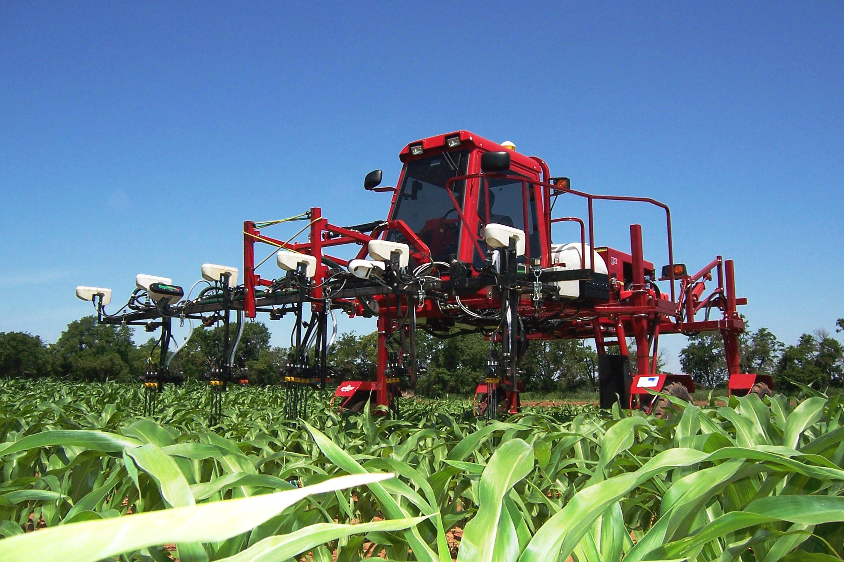
Figure 4. On-the-go sensor/fertilizer applicator developed at Oklahoma State University, capable of working on a by-plant scale.

References
Girma, Kefyalew, Starr Holtz, Brenda Tubaña, J.B. Solie and W.R. Raun. 2010. Nitrogen accumulation in shoots as a function of growth stage of corn and winter wheat J. Plant Nutr. 33:165-182.

International Plant Nutrition Institute (IPNI) http://www.ipni.net . Nutrients removed in harvested portion of crop. (site visited, July 2012).

Large, E.C. 1954. Growth stages in cereals: Illustration of the Feekes scale. Plant Pathology 3:128-129.

Martin, K.L., P.J. Hodgen, K.W. Freeman, Ricardo Melchiori, B. Arnall, R.W. Mullen, K. Girma, J.B. Solie, M.L. Stone, Octavio Caviglia, Fernando Solari, Hailin Zhang, Agustin Bianchini, D.D. Francis, J.S. Schepers, J. Hatfield, and W.R. Raun. 2005. Plant-to-Plant Variability in Corn Production. Agron. J. 97:1603-1611.

Mullen, R.W., Kyle W. Freeman, William R. Raun, G.V. Johnson, M.L. Stone, and J.B. Solie. 2003. Identifying an in-season response index and the potential to increase wheat yield with nitrogen. Agron. J. 95:347-351.

Raun, W.R., J.B. Solie, G.V Johnson, M.L. Stone, R.W. Whitney, H.L. Lees, H. Sembiring and S.B. Phillips. 1998. Micro-variability in soil test, plant nutrient, and yield parameters in bermudagrass. Soil Sci. Soc. Am. J. 62:683-690.

Raun, W.R., G.V. Johnson, M.L. Stone, J.B. Solie, E.V. Lukina, W.E. Thomason and J.S. Schepers. 2001. In-season prediction of potential grain yield in winter wheat using canopy reflectance. Agron. J. 93:131-138.

Raun, W.R., and G.V. Johnson. 1999. Improving nitrogen use efficiency for cereal production. Agron. J. 91:357-363.

Raun, W.R., J.B. Solie, G.V. Johnson, M.L. Stone, R.W. Mullen, K.W. Freeman, W.E. Thomason, and E.V. Lukina. 2002. Improving nitrogen use efficiency in cereal grain production with optical sensing and variable rate application. Agron. J. 94:815-820.

Raun, William R., John B. Solie, and Marvin L. Stone. 2011. Independence of yield potential and crop nitrogen response. Precision Agric. 12:508-518.

Solie, J.B., W.R. Raun and M.L. Stone. 1999. Submeter spatial variability of selected soil and bermudagrass production variables. Soil Sci. Soc. Am. J. 63:1724-1733.

Teal, R.K., B. Tubana, K. Girma, K. W. Freeman, D. B. Arnall, O. Walsh, and W. R. Raun. 2007. In-season prediction of corn grain yield potential using normalized difference vegetation index. Agron. J. 2006 98: 1488-1494.

Thomason, W.E., W.R. Raun, G.V. Johnson, K.W. Freeman, K.J. Wynn, and R.W. Mullen. 2002. Production system techniques to increase nitrogen use efficiency in winter wheat. J. Plant Nutr. 25:2261-2283.

