REPORT 2. HAND PLANTER ACTIVITIES IN EL SALVADOR. July 6, 2015
- Among main activities done in June and July in the experimental site, we have: 1. Protect the experiment against pests, mainly worms, using Monarca 112,5 insecticide, 2. Keep the experiment free from weeds, 3. Take rainfall data and other observations.
- Second fertilization was done according to treatments on June 12. As you may remember, due to the small size of the experimental site, Urea treatment is not in the experiment. However, we installed bigger plots close to the experiment. Urea application went well, the fertilizer was falling right on the hole, urea is not commonly applied for farmers in the country for reasons of handling and mainly price, instead they go for Ammonium Sulpahte.

But some Interesting things have aroused, in the picture below in the far left, we have corn planted 80 cm between rows, 2 plants separated 40 cm in between (Local Practice) and fertilized with the GS. And at the right side of the picture we have the 18 cm between each plant, rows separated 80 cm , and as you can see that vigor is better in this case. You may say, the comparison is not fair, because we should have used a different drum (maybe 1.7 seven grams) in the local practice in order to level amount of nutrients. However, looks like if crowding the corn plants has permitted to use more efficiently, nutrients, light and water. Same thing happens, when we compared the 18 cm treatment Ammonium Sulphate 100 N level, fertilized by hand.

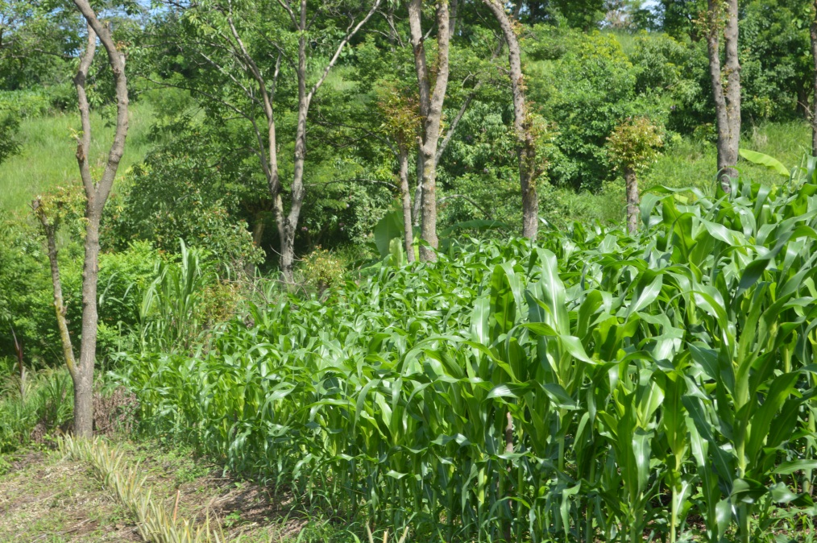

- After we use the GS with urea, I let people from CENTA to use for the same purpose, they don´t have plots they have just a couple of long rows planted with the GS. When I received the GS back I noticed it was a little difficult to disassemble. The reason was the rust caused by the urea, see pictures below. Consequently I consider that some recommendations about cleaning and maintaining have to be added in the manual. Remember that small farmers are not used with mechanical equipment.

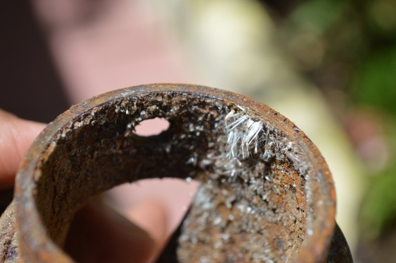

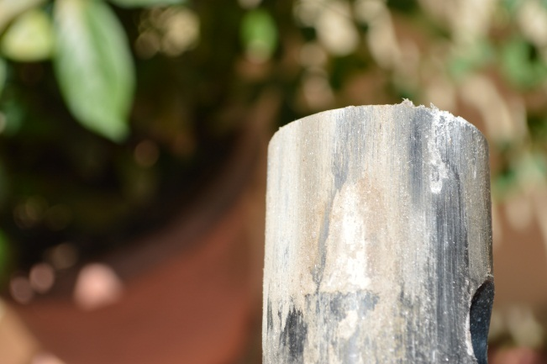

- I clean the equipment and assembled again in order to try it with beans (third advantage of GS), I made just a 50 hits stationary test, and the results are shown below. They look fine, and I think they will improve in the field it’s just a matter of refine the technique. Additionally pliers like the one in the picture are useful to change the washer and wire pin, by the way these pins are not easy to find here.

Cleaning the equipment

Results using beans, each cell include number of beans discharged per hit
3 | 2 | 2 | 1 | 1 | 1 | 2 | 2 | 1 | 2
1 | 2 | 2 | 0 | 2 | 1 | 2 | 1 | 2 | 2
1 | 1 | 1 | 3 | 1 | 1 | 1 | 2 | 1 | 3
0 | 1 | 1 | 2 | 1 | 1 | 2 | 2 | 1 | 1
1 | 2 | 1 | 1 | 1 | 2 | 1 | 2 | 1 | 1

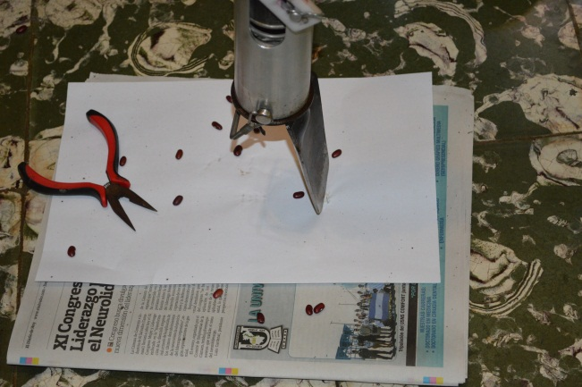

5. Buying planters or how many we need?
Things are not easy for farmers this year; many farmers have lost their crops as you can see in the newspaper report that I´m attaching. Also you can see it, in the rainfall data I´m sending. Farmers are afraid of losing crop production and lost the money invested. In the meantime, I talk to a lady in ALBA Petroleos which is the government office in charge of financing and buying corn production and she expect that next year is more likely to implement some validation with the GS. However she told me that Pioneer is the company that provides them most of the seed they buy. So, I´m planning to visit them and propose him a validation of the GS for next year in lomas de Santiago, hope they could buy at least 40 planter for the farmers to use next year, maybe they can give them some seed and Alba some fertilizer and implement a validation exercise. Would you agree with this idea? Or. Do you think Pioneer is not okay? Please let me know, what you think.

- Finally, after talking with people here. They say that using the GS is not just a matter changing a tool that has been used since colonial times. Adopting the GS implies a change of attitude and a conviction that the advantages of the GS, are worth the change. Our small field day is going to be oriented to show these advantages. Some of the farmers find a high density of plants, a disadvantage, because implies more seed, more money and more plants to take care. They also think that crowding is detrimental for the crop and like open space. However, with climatic change more light between plants can imply more water evaporation.

