Needs Assessment Report for the Greenseeder Hand Planter Project for Abuja Nigeria (Federal Capital Territory)
NOTE: The original Needs Assessment was conducted for Lira Uganda where we had former students and personnel working in that region. The proposal we submitted to Rotary International was likely close to being accepted before deficiencies in the Uganda Rotary club were identified. Reorganizing and re directing our efforts in Nigeria became necessary. Having now secured a robust Rotary Chapter in Nigeria, we have relied on the Needs Assessment from Uganda. Maize (corn) production is very similar in much of sub-Saharan Africa (Badu-Apraku et al., 2017) and thus the reason for using this information that was prepared for the original Uganda proposal submitted to Rotary International. As a small university project, we do not have the horsepower/people/resources to reproduce this study/information for Nigeria, but where our global experience suggests that the maize production issues in both countries should be the same.

Introduction
Agriculture is the mainstay of Nigeria’s economy and that employed nearly 40 percent of the population in 2018. Like many countries in Sub Saharan Africa, low crop yields are a major factor that has led to severe food insecurity. There are numerous factors that contribute to low crop yields but important to note is poor production methods and tools commonplace in developing countries, including Nigeria.
The World Bank provides data for Nigeria from 1991 to 2018, and that lists Nigerian employment in agriculture, using an indicator percent for total employment. The average value for Nigeria during that period was 44.29 percent with a minimum of 36.62 percent in 2018 and a maximum of 50.17 percent in 1992. It is important to recall that in 2017, agriculture contributed 20.85 percent to Nigeria’s GDP, and where 22.32 percent came from industry, and 55.8 percent from the services sector. (See annex. Source https://www.theglobaleconomy.com/Nigeria/Employment_in_agriculture/)
A pilot study was proposed for implementation in the North-Central part of the country (Benue, Nassarawa and the Federal Capital Territory) specifically to assess the major production challenges farmers face, with focus on using the Greenseeder hand planter developed at Oklahoma State University that has been thoroughly evaluated for efficiency and engineering tolerance (Omara et al., 2016). The tool has undergone rigorous testing and evaluation in many parts of the world including Nigeria and Uganda. Study participants have included both farmers who have experience using the Greenseeder hand planter and those who do not (that is, those using their routine farming tools).
Information collected from farmers included demographic characteristics, major crops grown with yield estimates, major planting tool used and experience in using the Greenseeder hand planter. Fifty (50) respondents in and or near Lira Uganda. This region is very similar to North Central Abuja, Nigeria where maize production is very similar. These respondents include those who had not used the Greenseeder hand planter before and farmers who would participate in the evaluation and testing process and would later be given one that they would own. Considering the sizeable investment in planters and personnel for Uganda, this could not be duplicated in Nigeria. Albeit defined regional differences, Nigeria and Uganda both struggle with low maize grain yields (both near 2 Mg ha, FAOSTAT.org) (total of 10 and 3 million tons/yr, Nigeria and Uganda, respectively). The recent study by Ten Berge et al. (2019) reported similar estimated grain yield in Nigeria and Uganda at 1.6 t/ha.
Demographic characteristics
Respondents’ sex and age are the demographic characteristics reported in this survey (Table 1). The survey targeted farming households or farmers at least 18 years old. From the 50 respondents interviewed, 29 respondents (58%) were female while 21 (42%) who were male participated in the interview. Respondents were categorized in three age groups, 20-30, 31-40, and 41-50 years. Uganda with the 10th highest population in Africa (Nigeria is 1st) unfortunately has a low life expectancy, estimated at 60 years in 2017. Average age for most farmers stands at 30 years which explains why the majority of survey respondents fall in the age group of 20-30 years (58%); 36 percent were in the age group of 31-40 while only 6 percent are in the age group of 41-50 years.
Major Crops grown
Respondents listed beans, groundnuts, maize, finger millet, sesame, sorghum, soybeans, and sunflower as major crops they grow in the region (Figure 1). From the list, maize stood out as the major crop cultivated by the majority (86%) of households in the region. This was followed by sesame at 48% while groundnuts were the least with only 12% of respondents. This is consistent with scholarly reports indicating maize as the food security crop in Nigeria identical to that in Uganda.
Maize grain yield
The average maize grain yield reported by respondents is indicated in Figure 1. It is clearly evidenced that the average grain yield for farmers interviewed in Uganda was less than 2 Mg ha⁻¹. This figure is similar to what has been reported in the literature, that developing world maize grain producers generally have average grain yields near 2 Mg ha⁻¹. This same statistic is present in Central America where maize grain yields average 2 Mg ha⁻¹) (https://doi.org/10.1201/9780429042171). Compared to developed countries, this is low and thus explains why farmers are often disillusioned with highly variable yields from year to year for their number one food security crop. Therefore, there is an urgent need to understand, from the farmers’ perspective, the reason why they experience these low yield levels
Planting tools used
From the 50 respondents randomly sampled, results showed that 33 percent were using Ox-plough, and where all the respondents interviewed were using hand hoes. Greenseeder hand planters that were delivered in Uganda continue to be used. The number of farmers using the Greenseeder hand planters remains low as the initial quantities available were initially meant for extension/research purposes and only a few lucky farmers had this tool. Since all the respondents interviewed were using local hand hoes, a follow up question on challenges of using this tool was fronted. All the farmers (100%) indicated that the traditional hand hoe is very labor intensive, 54 percent indicated exposure to chemically treated seeds when using the traditional hand hoe, and 22 percent reported calluses in their hands (Figure 2). According to respondents, the labor requirements and exposure to the chemically treated seeds seemed the main problems in using the traditional hand hoes. They indicated a need for a more labor efficient tool, and one that would house and deliver the seed they were currently handling by hand (potential contamination via seed to skin contact).
Greenseeder hand planter
Respondents using the Greenseeder hand planter were asked about the mode of acquisition. None of the respondents indicated buying the Greenseeder hand planter, 69 percent received the Greenseeder hand planter through donation while 31 percent acquired use of the planter from fellow farmers (Figure 3). Asked about the benefits of using the Greenseeder hand planter, all respondents, 100 percent, indicated that it is a labor saving tool, 55 percent noted reduced exposure to chemically treated seeds while 85 percent reported increased maize grain yield (50% of the average 2 Mg ha⁻¹) using the Greenseeder hand planter.
When respondents were asked about what they think are possible reasons that would hinder the adoption of the Greenseeder hand planter, 33 percent said the tool is not affordable at current pricing, 16 percent indicated that the tool can only be used to plant a few selected large seeded crops like, maize, beans and soybeans among others. Up to 84 percent of respondents indicated the non-availability of the planters locally as the main reason that would hinder adoption of the planters (Figure 4). When respondents were asked about their likelihood of recommending the Greenseeder hand planter to fellow farmers, 94 percent indicated they would most likely recommend this tool to a fellow farmer to use (Figure 5).

Table 1. Demographic characteristics of respondents in Northern Uganda
Demographic character | Frequency | Percent (%)
Sex
F | 29 | 58
M | 21 | 42
Age group
21-30 | 29 | 58
31-40 | 18 | 36
41-50 | 3 | 6

Figure 1. Major crops cultivated by respondents in Northern Uganda.

Figure 2. Proportion of respondents reporting problems with using traditional hand hoe

Figure 3. Proportion of respondents reporting mode of acquisition of the Greenseeder hand planter

Figure 4. Reasons that could possibly hinder adoption of the Greenseeder planter by farmers in Northern Uganda

Figure 5. Proportion of respondents reporting the likelihood of recommending the Greenseeder hand planter

Annex: Data Review for Pilot Study (similar data for Uganda and Nigeria)
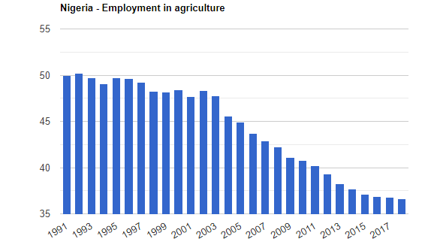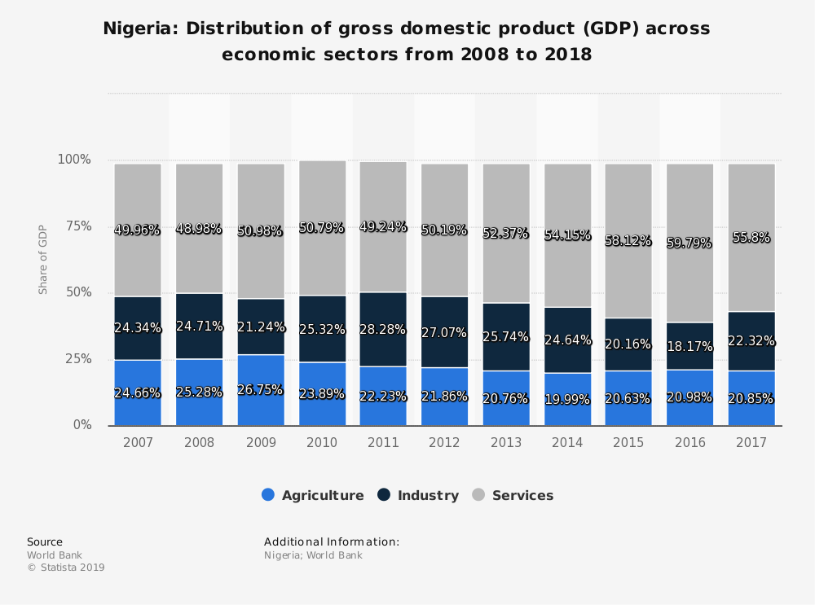

References
- Badu-Apraku B., Fakorede M.A.B. (2017) Maize in Sub-Saharan Africa: Importance and Production Constraints. In: Advances in Genetic Enhancement of Early and Extra-Early Maize for Sub-Saharan Africa. Springer, Cham. DOI https://doi.org/10.1007/978-3-319-64852-1_1.
- Omara, P., Aula, L., Raun, B., Taylor, R., Koller, A., Lam, E., Ringer, J., Mullock, J., Dhital, S. and Macnack, N., 2016. Hand planter for maize (Zea mays L.) in the developing world. Journal of Plant Nutrition, 39(9), pp.1233-1239.
- Ten Berge, H.F., Hijbeek, R., van Loon, M.P., Rurinda, J., Tesfaye, K., Zingore, S., Craufurd, P., van Heerwaarden, J., Brentrup, F., Schröder, J.J. and Boogaard, H.L., 2019. Maize crop nutrient input requirements for food security in sub-Saharan Africa. Global Food Security, 23, pp.9-21.

