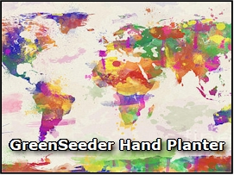
Rotary Club of Arua #64894
Rotary Int.-District 9211
Tanzania & Uganda – Zone #20
dan.tuli44@gmail.com
Senator Ed Long
Frontier Rotary, Stillwater, OK

Kevin Raun
Minden Rotary Club
#5630 Minden, NE

Title: New Age Hand Planter for the Developing World

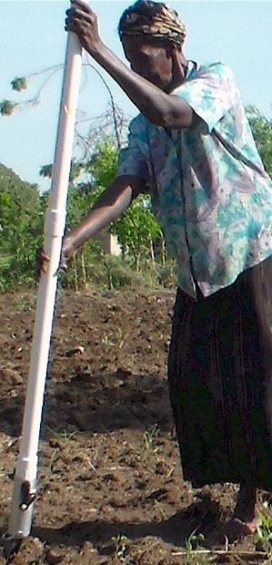
Summary
The world demands a better device for planting the 30,000,000 ha’s (80,000,000 acres) of maize in the world that are produced on highly marginal landscapes, and where everything is accomplished by hand. OSU has developed a simple mechanical hand planter that is capable of singulating corn seed with a potential worldwide impact that could approach $2 billion/year. This continuing work delivers a fully tested and viable hand planter capable of singulating cereal seed. It is further valuable as a sidedress fertilizer applicator, via the simple replacement of an internal drum. This project dates back to 1987 where work with the International Maize and Wheat Improvement Center (CIMMYT, Spanish acronym) highlighted the importance and need for improved maize planting on marginal landscapes. Soon after the delivery of the Greenseeker NDVI sensor technology in 2001, OSU engineers worked to deliver what is now known as the Greenseeder Hand Planter. All over the world, chemically treated seed is a must for basic insect control, but creates an unacceptable physical risk for women and men handling this seed by hand. Design and engineering continues to evolve as have methods of producing them affordably. At present, over 350 Greenseeder hand planters are being used all over the world. With a heightened level of demand, we aggressively seek to meet this demand and to go much further.

Woman near Lira, Uganda using the Greenseeder planter for seeding maize

http://nue.okstate.edu/Hand_Planter.htm
http://nue.okstate.edu/Hand_Planter/HP_PDF2016_us_metric.pdf

Issue
Corn grown in developing countries is typically planted by hand. Their methods vary but they generally use heavy sticks whereby 2-4 seeds are planted per hill, roughly 16 inches apart. Their method of planting is commonplace, largely dictated by terrain, circumstance, and resources. If single seeds could be placed 7-9 inches apart, much like conventional planters, production levels could increase by 25%.

What has been done?
We have developed a hand planter very similar in shape, size, and weight to planters currently used, but that can reliably singulate seeds, in various soil textures, moisture, and tillage systems. This planter has been tested with various seed sizes and when properly set up it can singulate seeds (greater than 85%) while keeping misses below 5-6 percent. From 2012 to 2016, prototype planters have been used in Mexico, Guatemala, El Salvador, Honduras, Colombia, Ecuador, Uganda, Kenya, Zambia, Mali, and Thailand. Feedback from these countries has been incorporated
into the new version currently being manufactured.

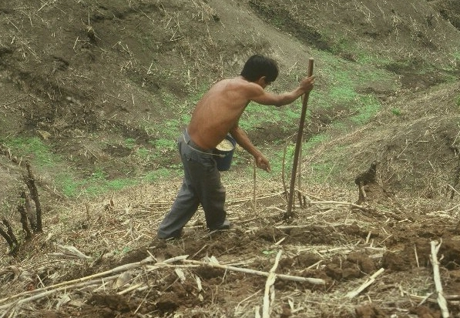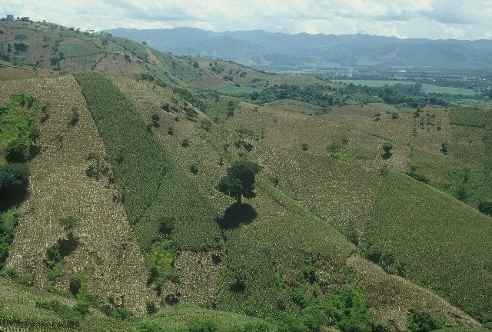
Conventional maize hand planting in Central America where the producer makes the seed depression with a metal tipped wooden stick, and with his other hand, deposits 2-3 seeds within that depression. Seed in the bucket on his hip, is treated with insecticide.
Picture below is of the same area, but a larger landscape and that shows rill erosion on these marginal landscapes.

Impact
The OSU designed planter removes chemically treated seeds from the hands of small farmers. This decreases seed-chemical-exposure and associated health risks for these farmers, especially child bearing women who do so much of this work. This planter will also result in improved plant spacing which in turn delivers decreased soil erosion and increased yields. This planter is expected to provide widespread increases in developing-world corn production, rivaling many advances made in the last 50 years. If adopted on 60 percent of the more than 80 million acres of developing world corn, the worldwide impact could approach $2 billion each year (assumes a 25% yield increase and corn grain value of 4 USD/bu). Via a simple internal-drum switch this planter can be adapted to place urea below the surface reducing NH₃ losses and accommodating mid-season applications of urea-N fertilizer. Improved nitrogen use efficiency will lead to even greater economic impact for producers adopting this technology. The planter can also be easily adapted to plant other crops such as rice, wheat, sesame, and that can also be used to apply fertilizer. Homeowners planting gardens and/or the wildlife industry planting food plots are also expected to be future markets.

Scope of Impact
International/National
Potential Source of Funding
Rotary International www.rotary.org

Participants:
Bill Raun Joshua Ringer Randy Taylor
044 N. Ag Hall Indigdev LLC 139 Ag Hall
Okla. State Univ. 601 S. Washington, PMB 234 Oklahoma Coop. Ext
Stillwater OK, 74078 Stillwater, OK 74074 Stillwater, OK 74078
Daniel Tuli Jackie Bayoa Gary Mullins
Arua, Uganda Uganda Tanzania

Craig Edwards Lawrence Aula Dr. Edgar Ascencio
Distinguished OSU Professor Lira, Uganda San Salvador, El Salvador

Jagmandeep Dhillon Fikayo Oyebiyi Eva Nambi
PhD Grad Student, India MS Grad Student, Nigeria MS Grad Student, Uganda

Bruno Figueiredo Alimamy Fornah Tyler Lynch
PhD Grad Student, Brazil PhD Grad Student, Sierra Leone Grad Student, OK

Daniel Forestieri Uzman Ali Luiz Narro/Javier Orellana
LSU, MS student, Honduras Nigeria Colombia

Pat Bell Festus Attah Peter Omara
Tanzania Ghana PhD Graduate Student

Budget/Planning
Work List
1. Local construction of 100 additional hand planters at $100/planter ($10,000)
2. Delivery, shipping for 10 packages of 10 planters (Latin America and Africa), $150/package, ($1500)
El Salvador 10 Honduras 10
Uganda 10 Nigeria 10
Colombia 10 Thailand 10
Ghana 10 Tanzania 10
DR Congo 10 Zimbabwe 10
3. On-line training by-country. Some locations will require purchasing AdobeConnect hardware/software.
4. Field testing at all sites, minimum of 2 ha’s planted for each planter delivered ($200/site = $20,000), (planting, fertilizing, harvesting, pesticide application application, + seed grain cost, fertilizer cost, insecticide/herbicide,)
5. Data collection, compiling all data/feedback. By-country interaction, written compilation for sharing that includes all participants. ($20/site = $2000)
6. Joint on-line session, all countries, with discussion focusing on salient successes and potential failures.
7. Solicitation for manufacturing hand planters in-country. Open sharing of blue-prints, manufacturing issues/engineering tolerances. Securing serious entrepreneurs, with promise for success.
8. Education component will embed one-on-one farmer training concerning the importance of homogeneity of plant stands. This will also emphasize the value of singulating seed (provided by using the Greenseeder planter), and the importance of consistent plant to plant spacing that can singlehandedly increase grain yields. Including farmers in the ‘science’ that is taking place by using this device is pivotal to successful adoption.
TOTAL Budget: $33,500
Summary of Benefits
● Remove chemically treated seeds from the hands of producers
● Decreased soil erosion from improved plant spacing
● Accommodate mid-season applications of urea-N fertilizer
● Place urea below the surface reducing NH3 losses
● Planter technology for all kinds of planted crops/seeds
● Significant increases in developing world maize production
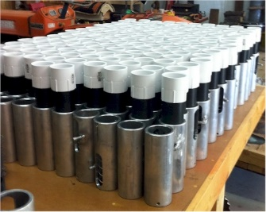
- Accommodates more vertical posture for planting
An LLC has been established (Greenseeder LLC, via Indigdev.org) and where Dr. Joshua Ringer has headed this up for OSU. Present sales and pricing will be determined, consistent with our end-goal to produce the hand planters in-country.

APPENDIX Information
Same amount of maize (corn) mechanically produced in the USA is planted, managed, and harvested by hand in the developing world. This is 29,400,000 ha (72,618,000 ac) of maize produced on marginal landscapes. Combined, Sub Saharan Africa accounts for 29,000,000 ha’s of cereals (maize, sorghum, rice, + others). Central America has 3,000,000 ha (7,400,000 ac) of hand planted maize. Planting is accomplished using heavy sticks whereby 2-3 seeds are planted per strike, roughly 35cm (14in) apart. This method of planting is common for subsistence maize farmers, largely dictated by terrain, and circumstance.
When single seeds are placed 14-17cm apart (6 to 7 in), much like conventional planters, production levels can increase 25%. Because developing world maize yields hover near 2 Mg/ha (30 bushels/ac), a 25% yield increase (+0.5 Mg/ha) on 60% of the hand planted maize area in the developing world is worth more than 3 billion USD/year.
The Greenseeder hand planter is similar in shape, size, and weight (1.4 kg or 3 lb) to planters currently used, but that can reliably singulate seed. The woman in Uganda (right) really liked the new planter but wanted improvements in the tip.
World Values (2015)
World maize ha’s, 184,000,000 (454,000,000 ac)
Developing world maize ha’s, 49,356,000 (121,909,000 ac)
Developing world maize planted by hand (60% of tot) 29,400,000 ha’s (72,618,000 ac)
25% increase on world hand planted maize (avg 2 Mg/ha *0.25 = 0.5 Mg/ha)
29,400,000*(2000kg/ha*0.25%)*$0.23/kg (or $6.00/bu)= $3,381,000,000
Fertilizer drum (included with Greenseeder Planters
provides 1.5 g urea per strike per plant
(population of 70,000 seeds/hectare)
= 50 kg N/ha.

450S drum, (cavity volume is 0.087ml), it works well when seed size is within the range of 2500 to 4000 seeds/kg, and where we do accept multiples (2-3) but that conforms with our expectation of having NO MISSES. No misses is critical if farmers are to accept this technology.

260-20 drum, (cavity volume is 0.055ml) it does work for smaller seed (more seeds per kg) (3500-4000 seeds/kg), and that will have multiples, but again no misses.
We have not evaluated seed that was more than 4000 seeds/kg. Either way, we try to include one “blank” drum so as to encourage in-country modification/innovation with the drums that can be easily modified (cavity volume / drum depression).

The distance between strikes or where seed is placed, has to be embedded within the producer computer. He/she either knows or can be easily taught what that distance is.

For 64,000 plants per/ha with a 76 cm row spacing, plant to plant spacing is 20.5cm
For 74,000 plants per/ha with a 76 cm row spacing, plant to plant spacing is 18 cm

The Human Computer for us has to be encumbered within any model that will achieve success. Publications coming from our team follow.

OSU Team Publications
http://www.tandfonline.com/doi/abs/10.1080/01904167.2015.1022186
http://nue.okstate.edu/Index_Publications/Bee125258.pdf
Evaluation of drum cavity size and planter tip on singulation and plant emergence in maize (Zea Mays L.)

Proposal email List
bill.raun@okstate.edu
joshua.ringer@okstate.edu
randy.taylor@okstate.edu
dan.tuli44@gmail.com
bayoajackline@gmail.com
gmullins@ifdc.org
craig.edwards@okstate.edu
aula@okstate.edu
noelascencio@yahoo.com
jagman.dhillon@okstate.edu
fikayo.oyebiyi@okstate.edu
enambi@okstate.edu
brunom@okstate.edu
fornah@okstate.edu
tklynch@okstate.edu
dfores6@lsue.edu
usco_ali@yahoo.com
l.narro@cgiar.org
pat.bell@okstate.edu
festussel.attah25@uga.edu
peter.omara@okstate.edu
kevin.raun@me.com
edlong54@swbell.net

