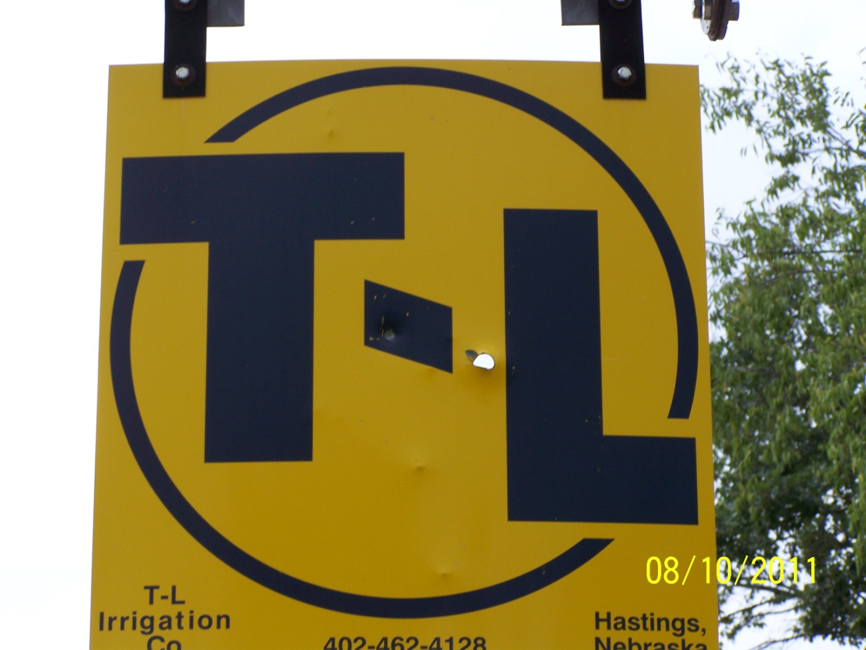
Irrigation Users Manuel
Basic Setup and Operation
Preventative Maintenance
Trouble Shooting and Previous Issues
Contacts for Parts and Repair
Known Issues
Photo Gallery

Basic Setup and Operation

Operating the TL Irrigation system:

Starting the lateral line:
- Connect all hoses to the lateral system.
    - Riser connects to flexible hose͢ 6 inch plastic hose flexible hose lateral system
- Connect chains to the plastic hose and the lateral system. This will allow the unit to pull the irrigation hose as the system advances across the field.
- Place the lazy man shutoffs at the end of the field.
- Place guide wheel in direction of travel.
- Turn lateral movement to neutral.
- Start lateral engine. This will allow water to flow into the lateral and not build up pressure on the pump engine and killing the pump engine.
  - Turn off hydraulic oil to the lateral system. This allows for smoother start up.
  - Hold glow plugs, Murphy switch, and starter until the engine starts.
  - Once the engine starts depress the switches in the following order—glow plugs, engine starter, and finally the Murphy switch. Hold the Murphy for at least 5 seconds or the engine will shut off.
  - Open hydraulic valve shut off in step a.
- In the control panel turn the run/start switch to run.

Starting the pump engine:
- Prime the pump.
  - Can use the hand pump until the pump and water pipe from the lake to the pump is full of water.
  - Back prime by using a small engine to force water into the line. Use the hose attached to the in-take screen.
    - CAUTION: When priming the pump in this manner, it is imperative the irrigation pump is started immediately when the system is full of water, if not pressure can build and flow valves can be damaged or pipe fittings will break.
- Disengage the clutch on the pump engine.
- Turn run/start switch to start.
- Start the pump engine using the same procedure used to start the lateral engine.
- Engage the clutch to begin the flow of water.
- If the pump is hand primed proceed to setting the system. If the pump is primed by using a small engine to force water into the pump: stop the small engine, close the valve on the priming hose, and then disconnect the pump. If the valve is not closed before being disconnected air will enter into the system and the prime will be lost.

Setting the system:

The following provide information for how to set up the water flow to stop automatically and how to change the speed that the lateral unit moves at.
Setting the system to automatically shut off
- With the lateral system switch engaged, turn the pump engine start/run switch to run. This switch will kill the engine with pressure build up.
  - CAUTION: If this switch is not engaged pressure will build up and damage to the irrigation system could result
- With water flowing turn the run/start switch to run on the lateral line. This switch is the deadman guage that shuts off water flow when the lateral system engine is off. This shuts off water flow allowing pressure to build which kills the pump engine.
  - If this switch is not activated, once the lateral reaches the end of the field, water will continue flowing.
- In the red control box in the pump house set the pressure guage switches. This allows a minimum and maximum pressure to be set and if the pressure is outside of this zone the engine will shut off. Normally after the first run of the season, unless sections have been turned off or different nozzles have been placed on the system, the previous settings will work.
  - If nozzles or engine speed has been changed, the pressure could be different and kill the engine if it exceeds the range of the switches.
- Turn the red control box switch to run.

Adjusting lateral travel speed:

- Engage lateral movement by engaging system in desired direction.
- Set end lateral control tower speed by adjusting to desired speed.
- Adjust tractor flow valve to match tower speed by turning valve until the correct setting is reached.
  - NOTE: This can only be done with the lateral system moving.

Nozzle tips being used, pressure, and lateral speed will all have an effect on the amount of water. To get the best results measure the amount of water that the area receives and adjust accordingly.

Preventative Maintenance

Daily Maintenance Before Operating:
Check engine oil, coolant, and fuel levels in pump engine and lateral engine.
Check hydraulic fluid level in lateral line.

Start-up for new season—yearly maintenance:
Change oil and oil filters in both pump engine and lateral engine.
Change yearly or every 200 hours, whichever is first.
Change fuel filters on diesel tanks.
Change air filters.
Check in-take screen and make sure it is not enclosed in silt.
In-take screen sits on the bottom of the lake and will settle into the bottom and can result in poor performance.
Dig and clear out the guide wheel trench. If trench is obstructed the lateral system can
travel outside of the directed path.

Year end maintenance:
Add diesel cleaner/stabilizer to both pump engine and lateral diesel tanks.
Check antifreeze concentrations.
Drain all water out of pump, using bleed valve.
Drain all water out of line from the lake to pump house.
Water will drain from the lateral through mushroom plugs and lateral fittings that
only hold water under pressure automatically.
Trouble Shooting and Previous Issues
As any mechanical system with functioning parts there can be a variety of problems experienced. With proper preventative maintenance these issues can be greatly diminished. The following list highlights problems that have occurred while operating the TL system and how to correct them.

Engine Issues: Possible Malfunctions:
Engine fails to start: Replace Battery

Check fuel levels, if empty the engine has to be primed by cranking the starter. Crank the engine for 30 seconds allow the starter to cool and repeat until engine is primed.

Engine starts but runs Check fuel filters and replace. Both fuel filters on the
faster and slower: engine and filter on the primary filter on diesel tank.

Engine shuts off due to If the engine shuts off due to the Murphy switch, check
engine temperature: coolant levels and wash the radiator with water to clean it.

Continued issues have resulted from operating under extremely hot weather and from “pulling” water too far. Possible fixes include: reducing the length that water is pulled to the engine (shortening pipe that goes into the lake), reducing the water output at the lateral line allowing the engine to pump less water, and increasing air circulation to the engine.

Pump fails to prime: Make sure that air is not entering the system by placing silicon around pipe joints.

Insure that both check valves that hold the water in the pump system are working properly. In some cases the lower back flow and upper valve have not shut allowing water to flow out.

Check the screen at the pipe entrance. Holes in the screen have resulted in priming failure because debris can enter the pump.

Pump primes but will only Insure the screen is tightly fitted on the pipe and that
pump a small amount: the bottom of the screen allows adequate room for water to flow into the pipe. The screen has been known to move up the pipe constricting the flow of water.

Mushroom plugs and Increase water pressure flowing through the system to
fittings leak water: 30 psi or greater. Use smaller tip fittings on the lateral system, turn off a section of sprinklers, and/or increase pump speed.
.

Contacts for Parts and Repairs

Hydro, Oklahoma: Wayne Kraybel (405) 542-7500
Hastings, Nebraska (800) 330-4264

Known Issues
Current issues to be addressed:
- Change diesel fuel tank filter on lateral line.
- Change engine fuel filters in lateral line and pump engine. (These need to be special ordered)
- Replace radiator mount brackets on the pump engine. (We have the wrong ones)
- Replace tin on the shed.
- Change battery behind lateral speed control box. (Special order)
- Adjust clutch setting on pump engine.

Photo Gallery
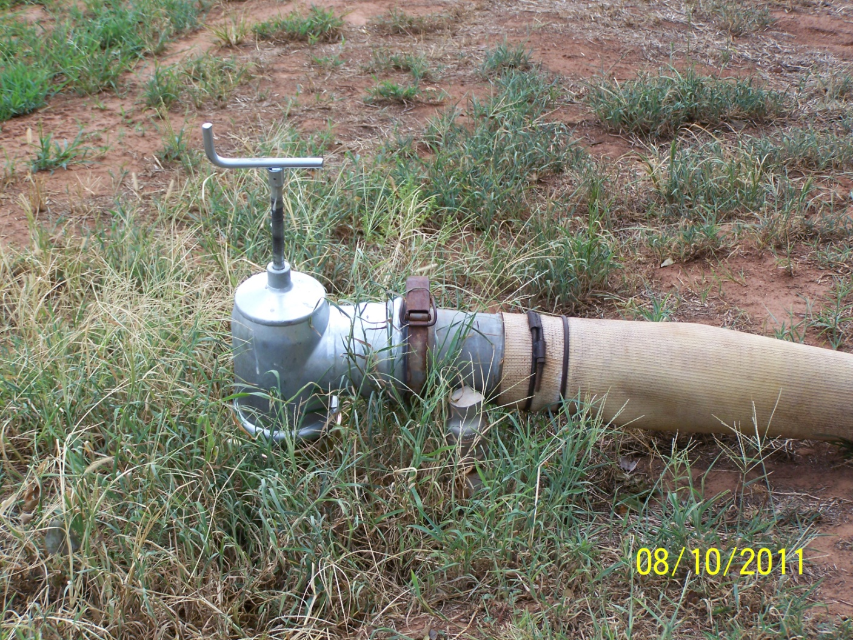
Riser connected to flex hose.
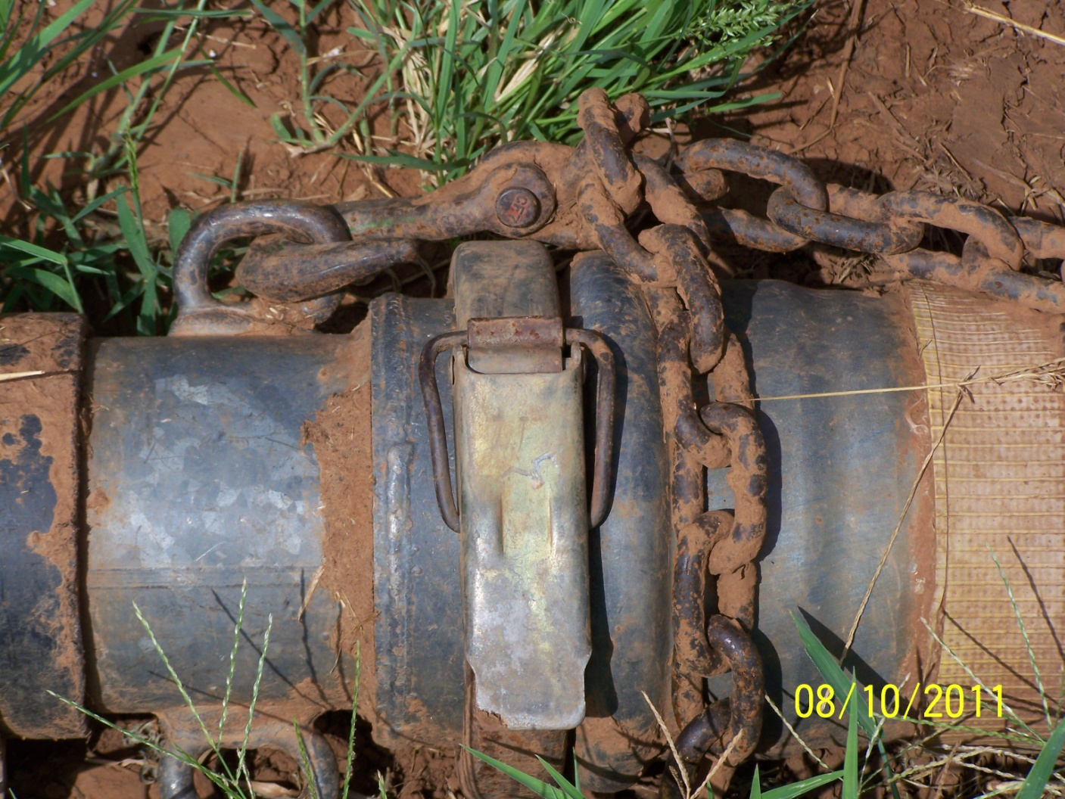
6 inch plastic hose connected to flex hose and chains to pull the hose as system moves.

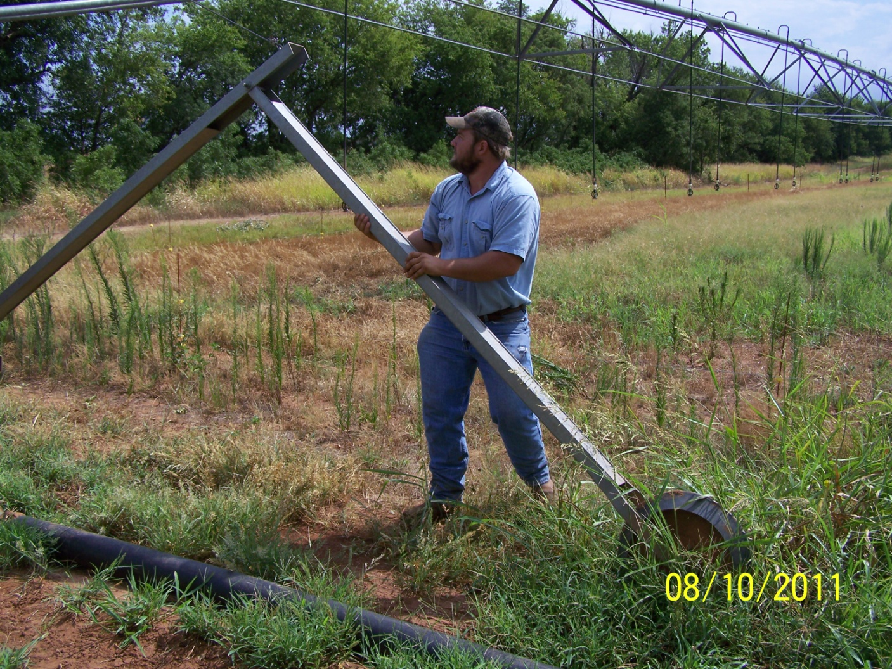
Guide wheel.
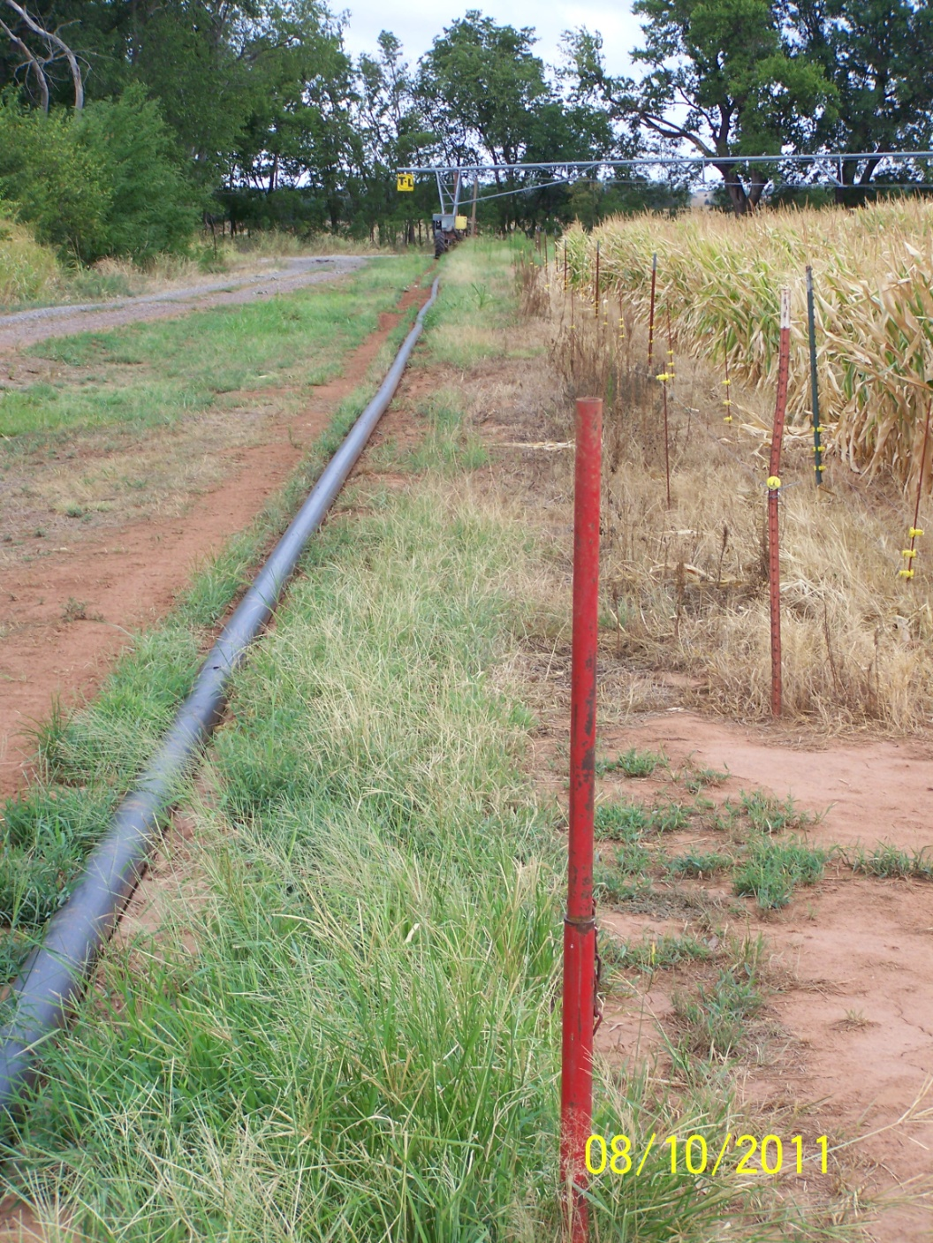
View of lateral moving away from camera.
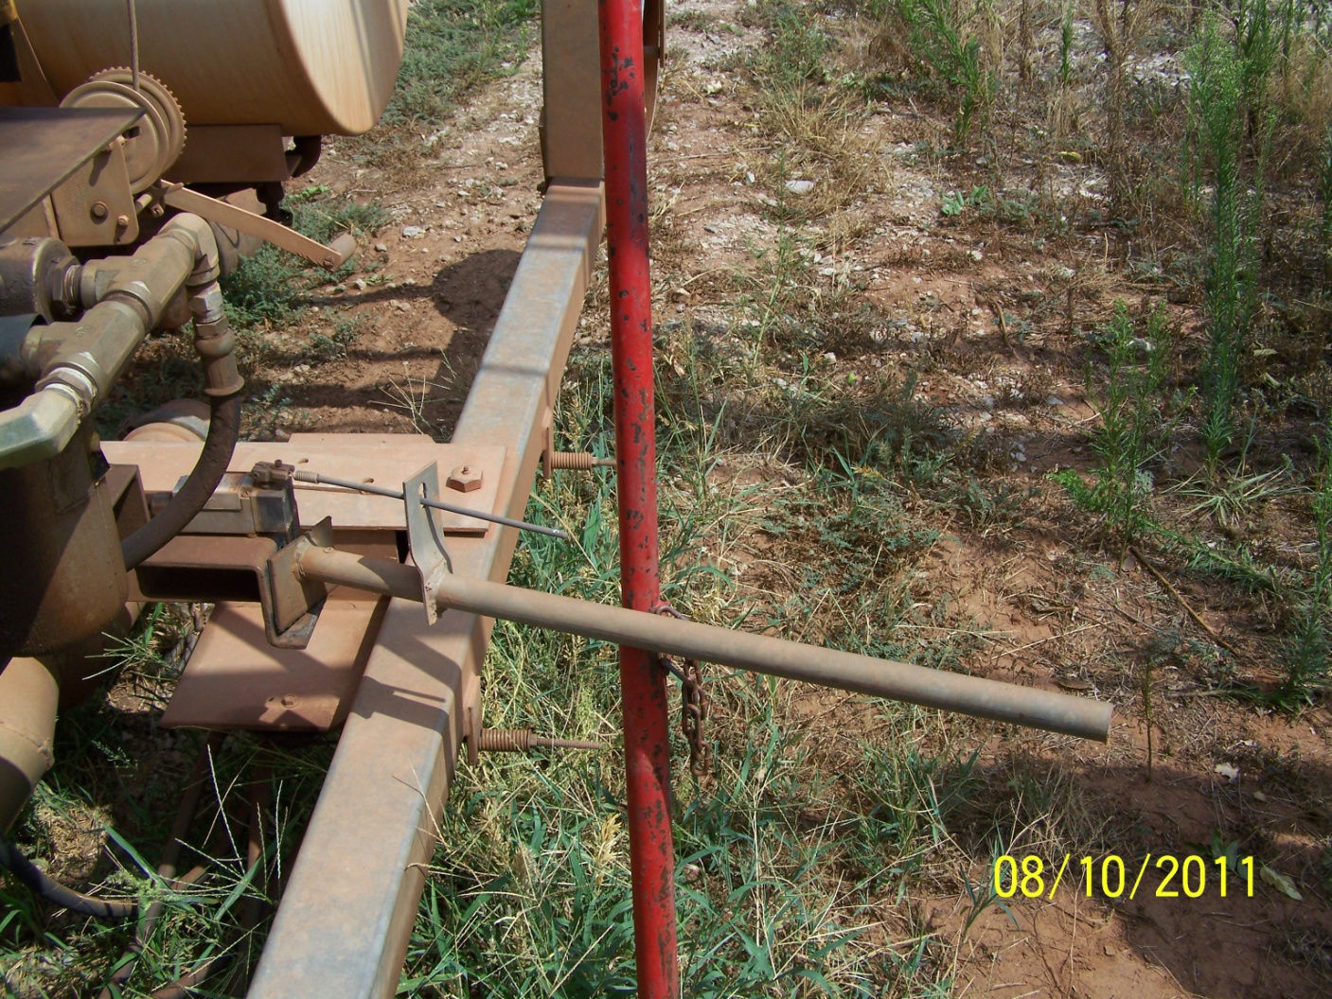
Operating view of lazy man shut off.
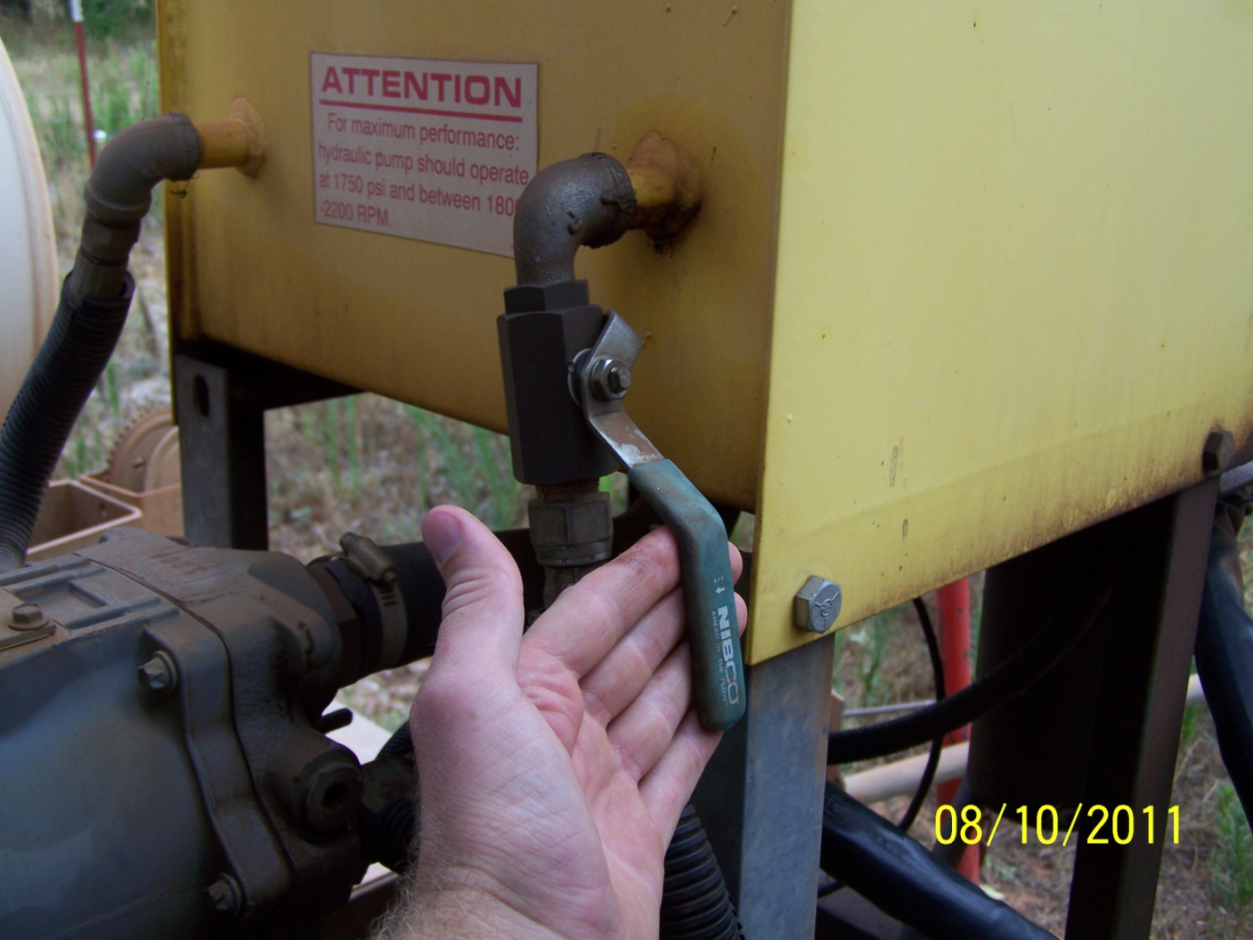
Lateral hydraulic oil valve closed.

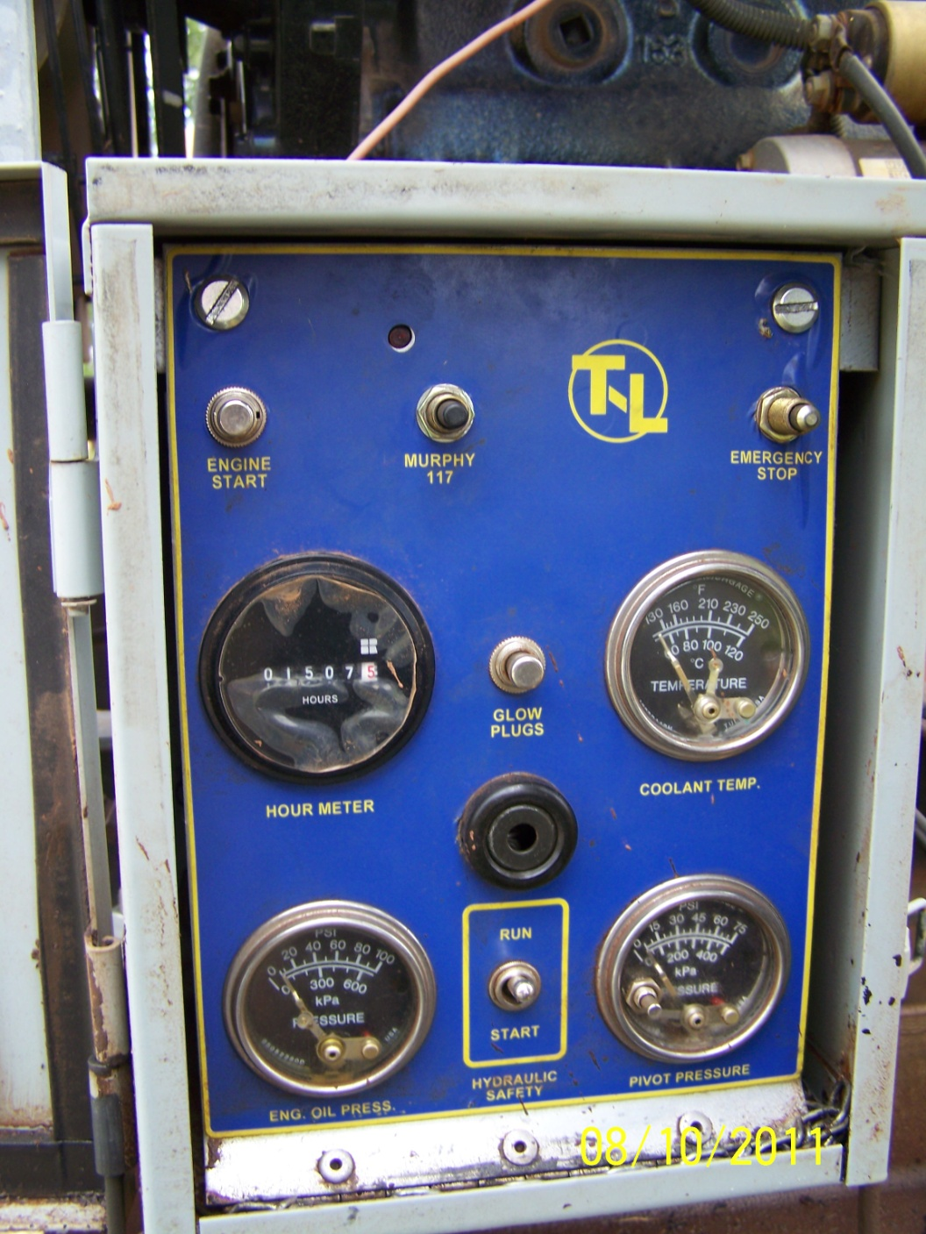
Lateral and pump engine control boxes.
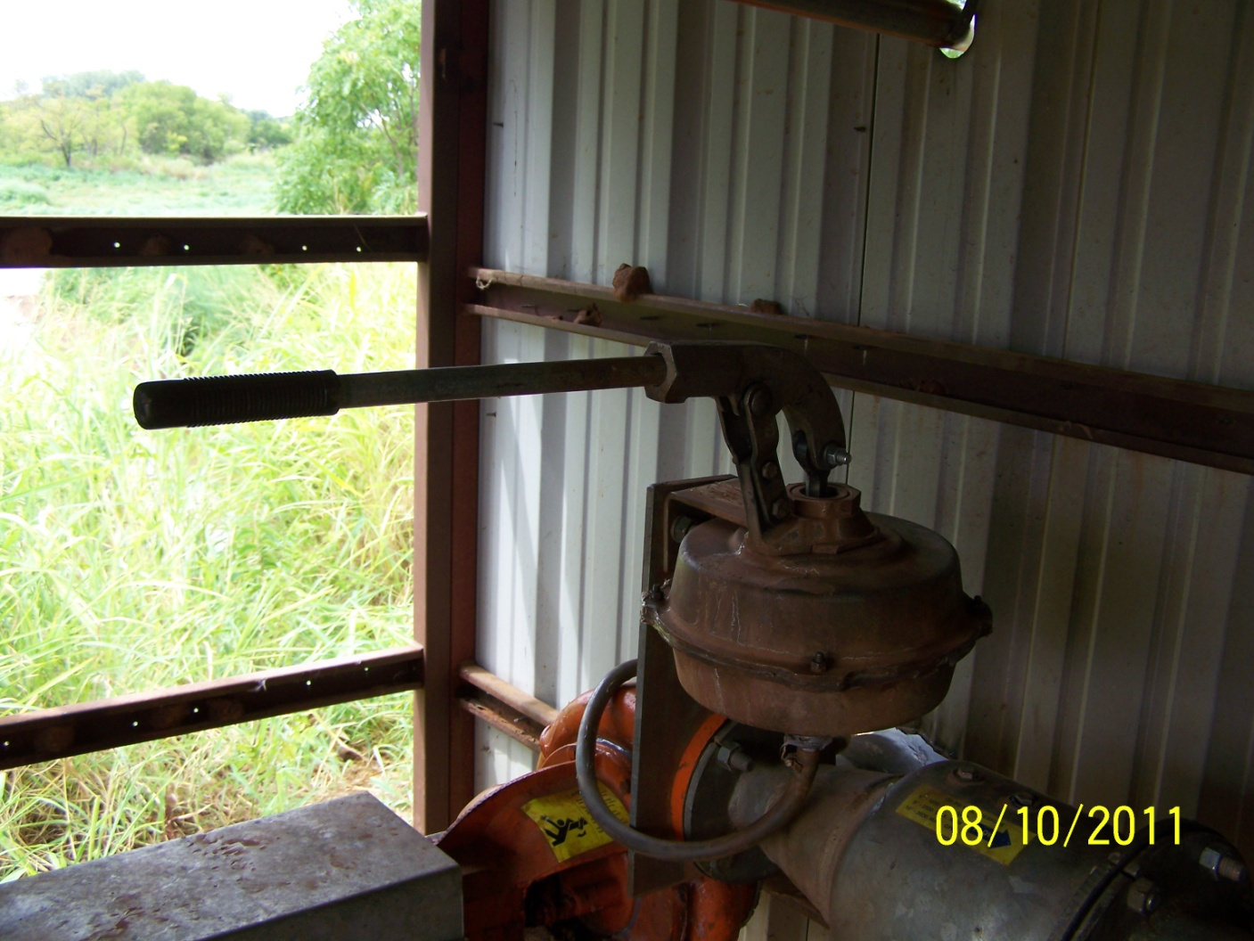
Hand pump to prime system.
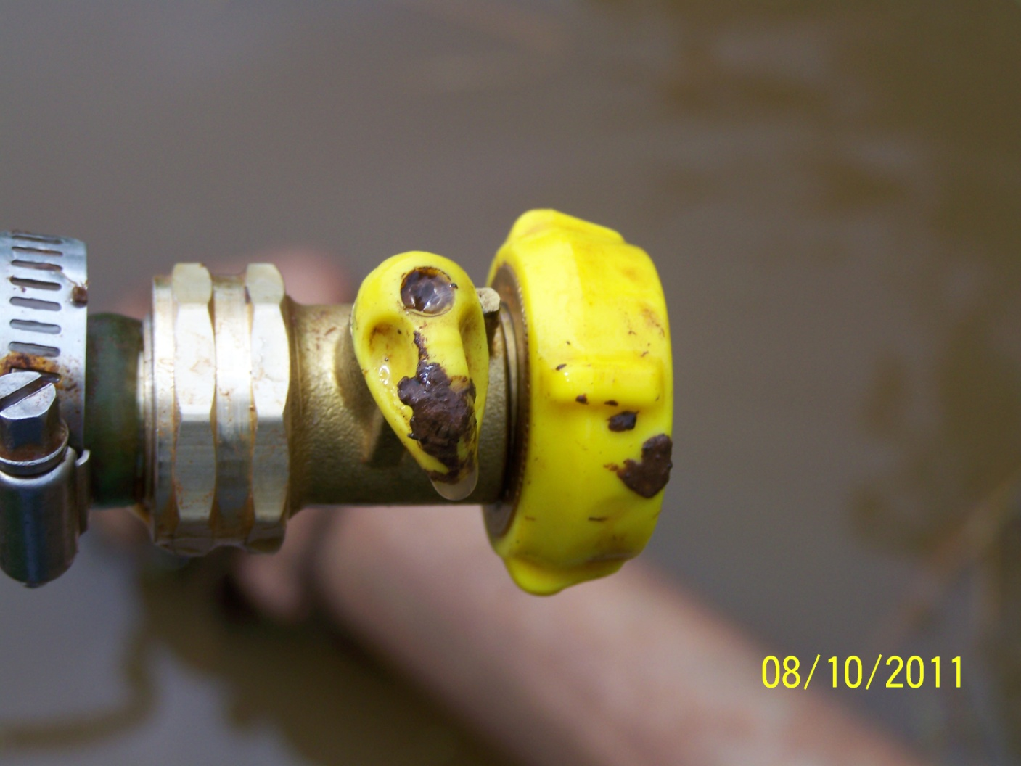
Hose and valve to back prime the irrigation system.
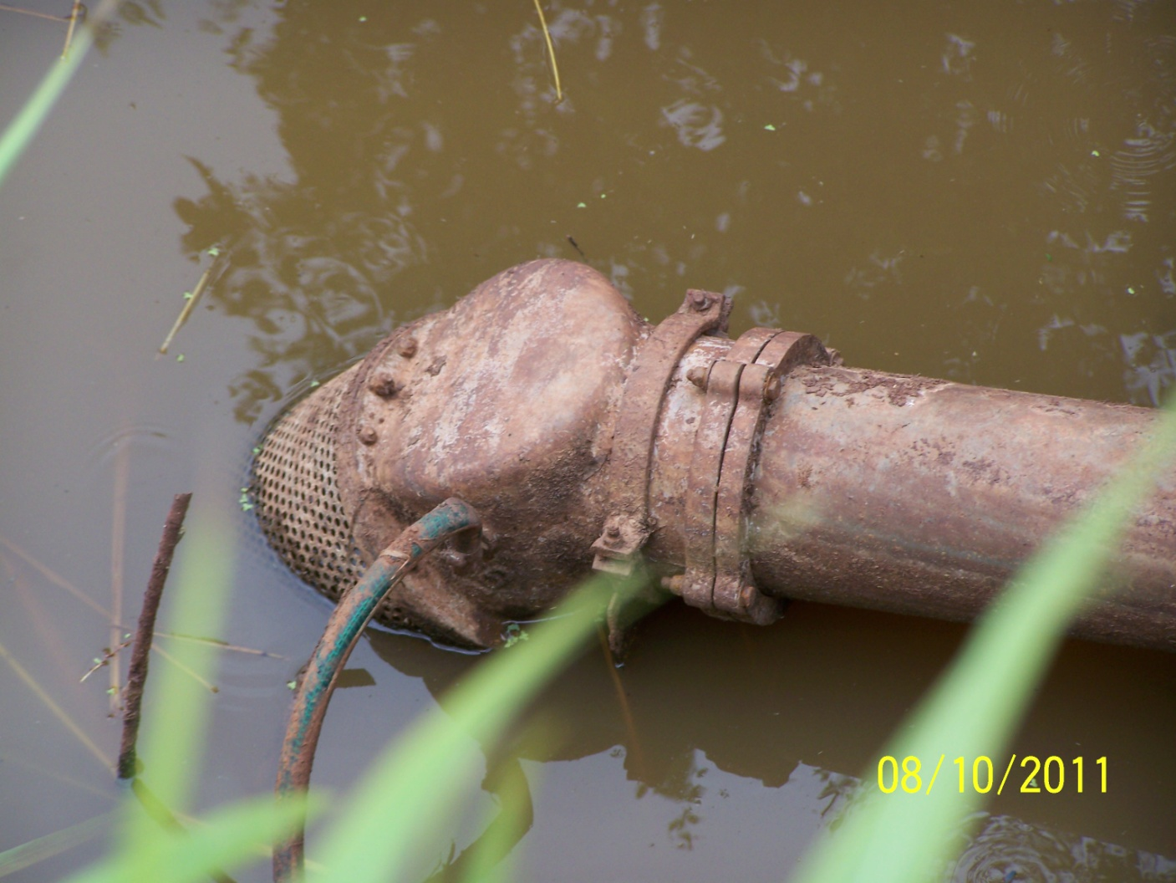
In-take screen at low water level that also shows the priming fill hose.

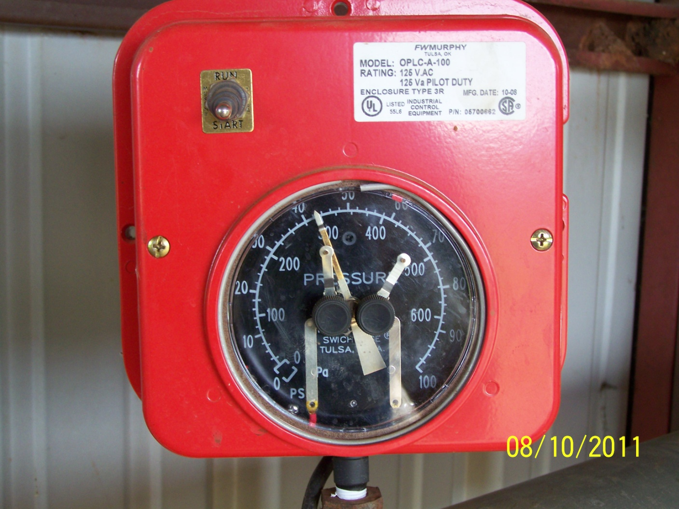
Red control box showing run/start switch and adjustments for maximum and minimum pressure.
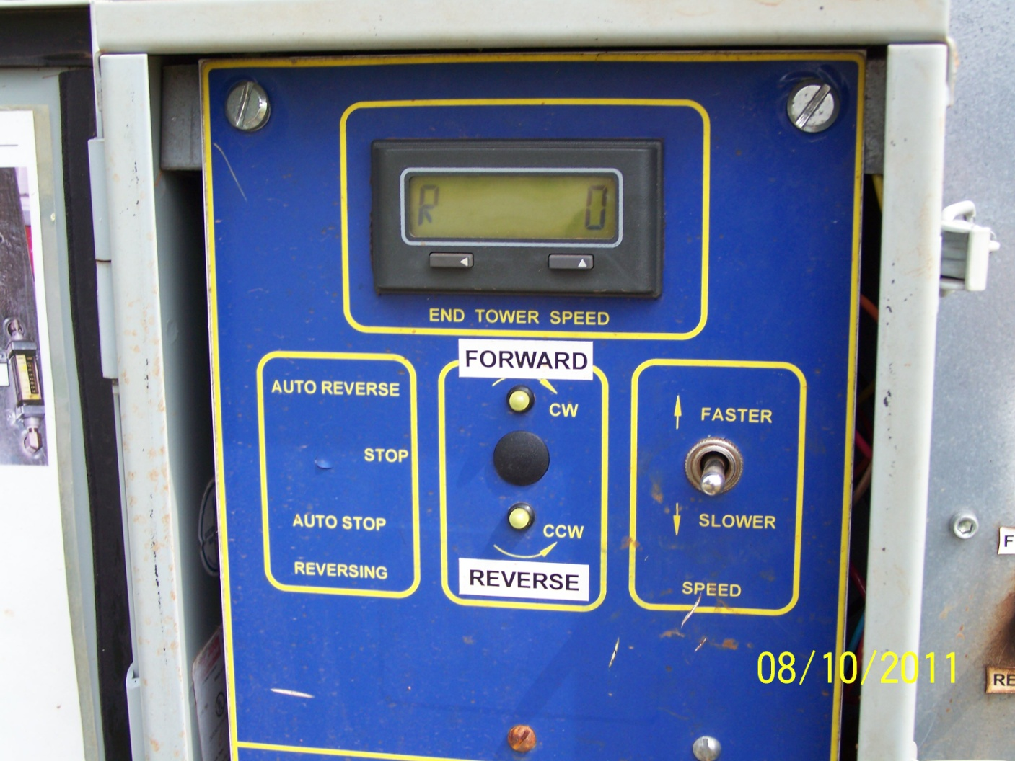
Lateral speed control box. Digital display shows end tower speed.
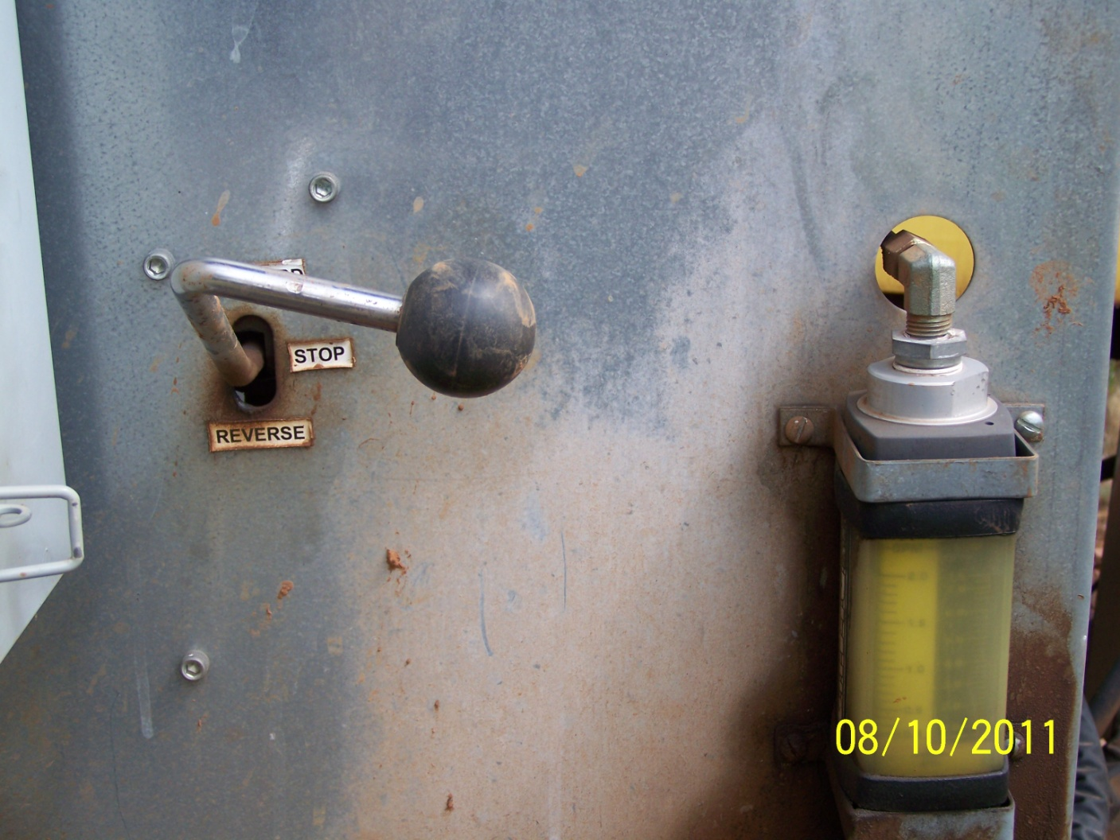
Lever to engage lateral movement and tractor flow meter guage. Used with tractor flow valve to adjust speed.
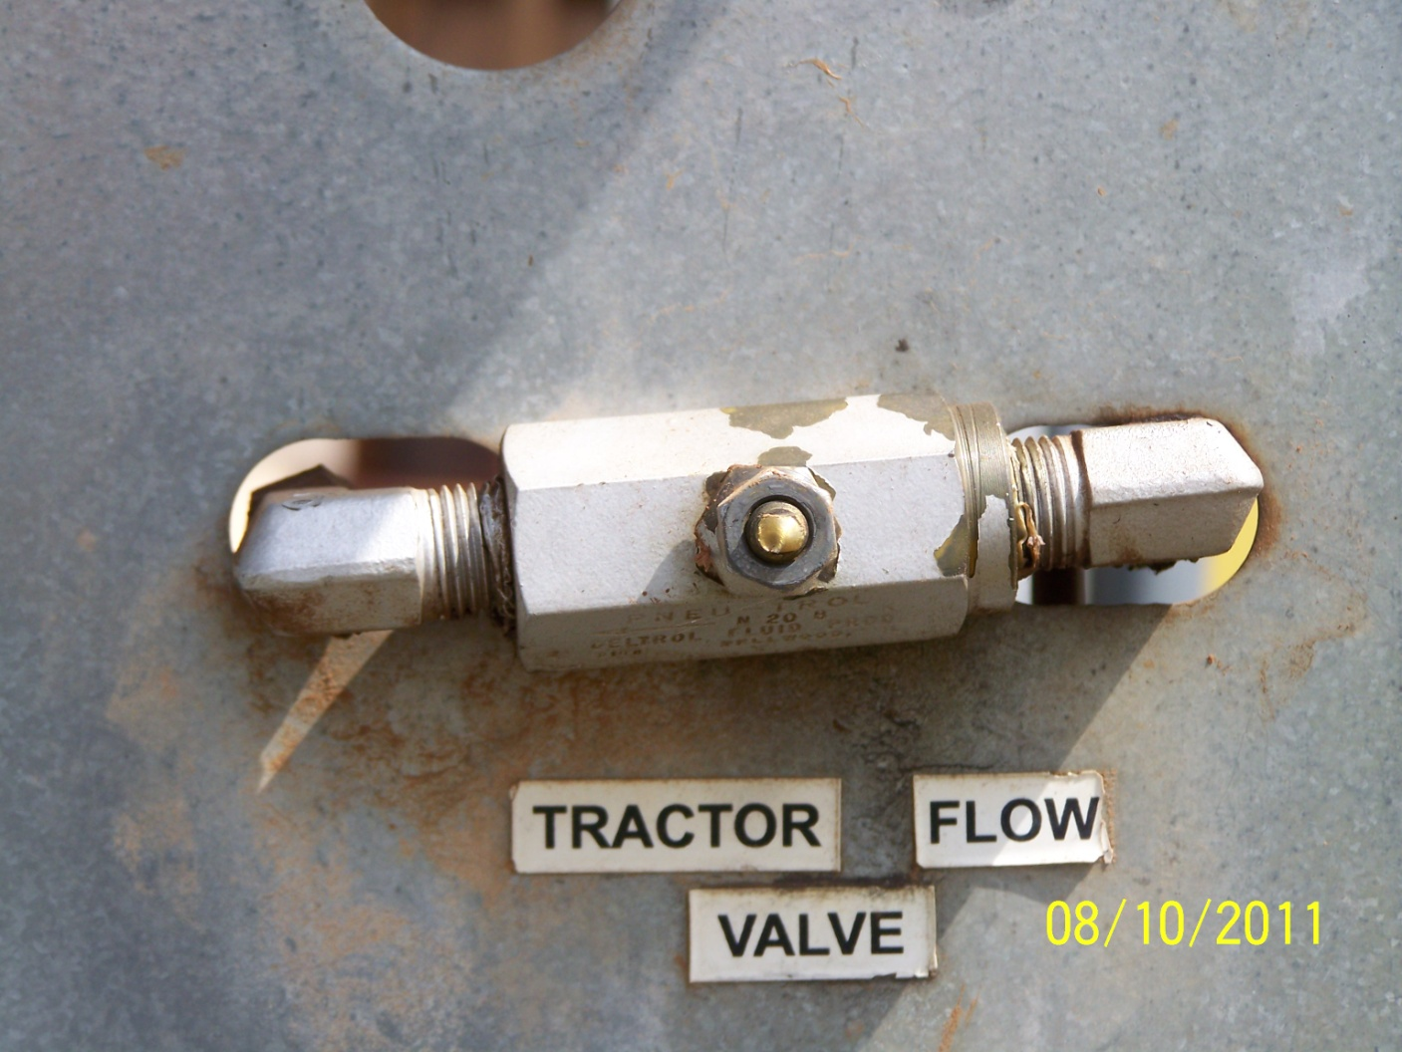
Tractor flow valve. Adjust to flow valve to speed or slow lateral system.

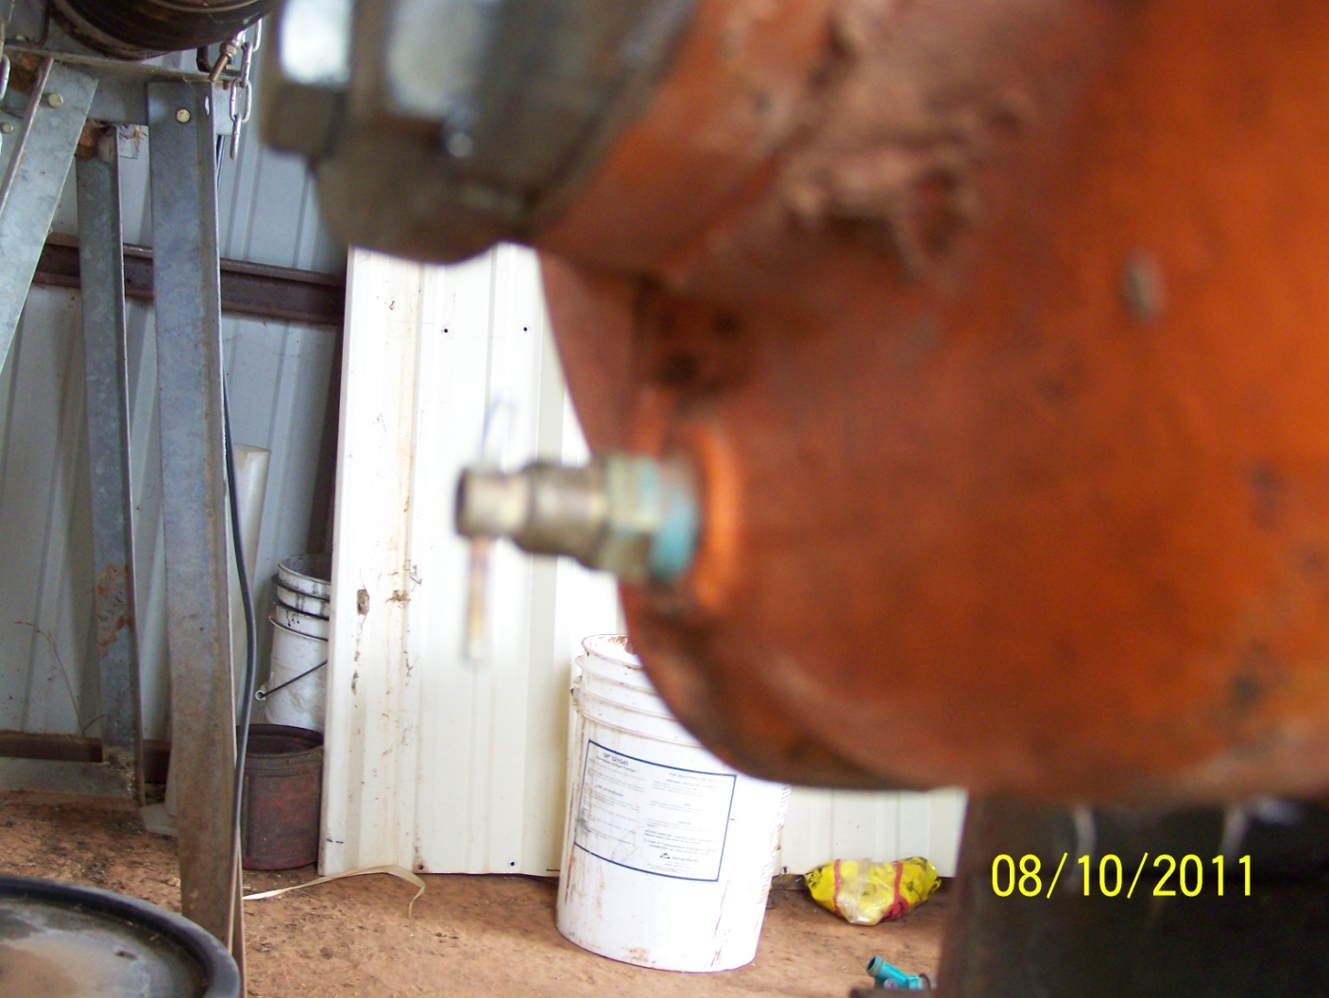
Bleed valve to drain pump for the winter.
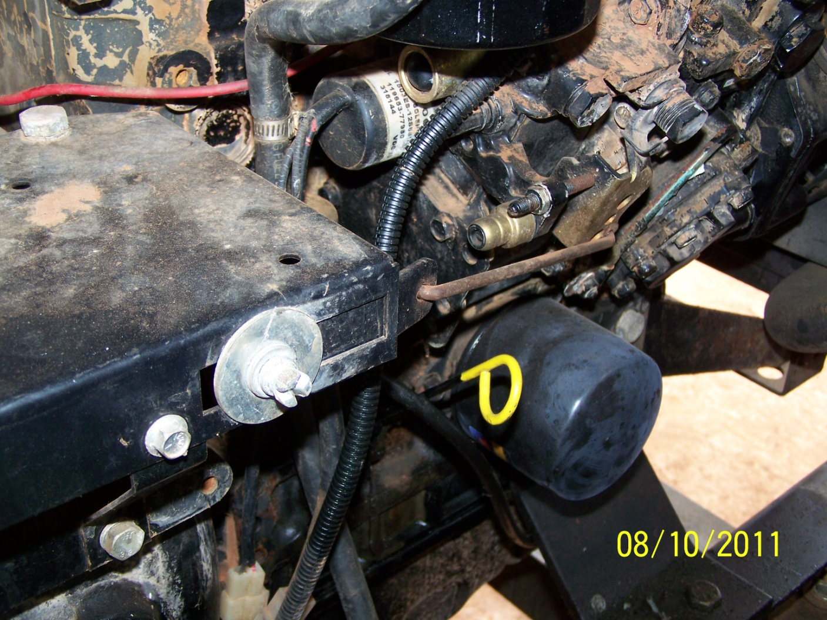
Throttle that can be adjusted.
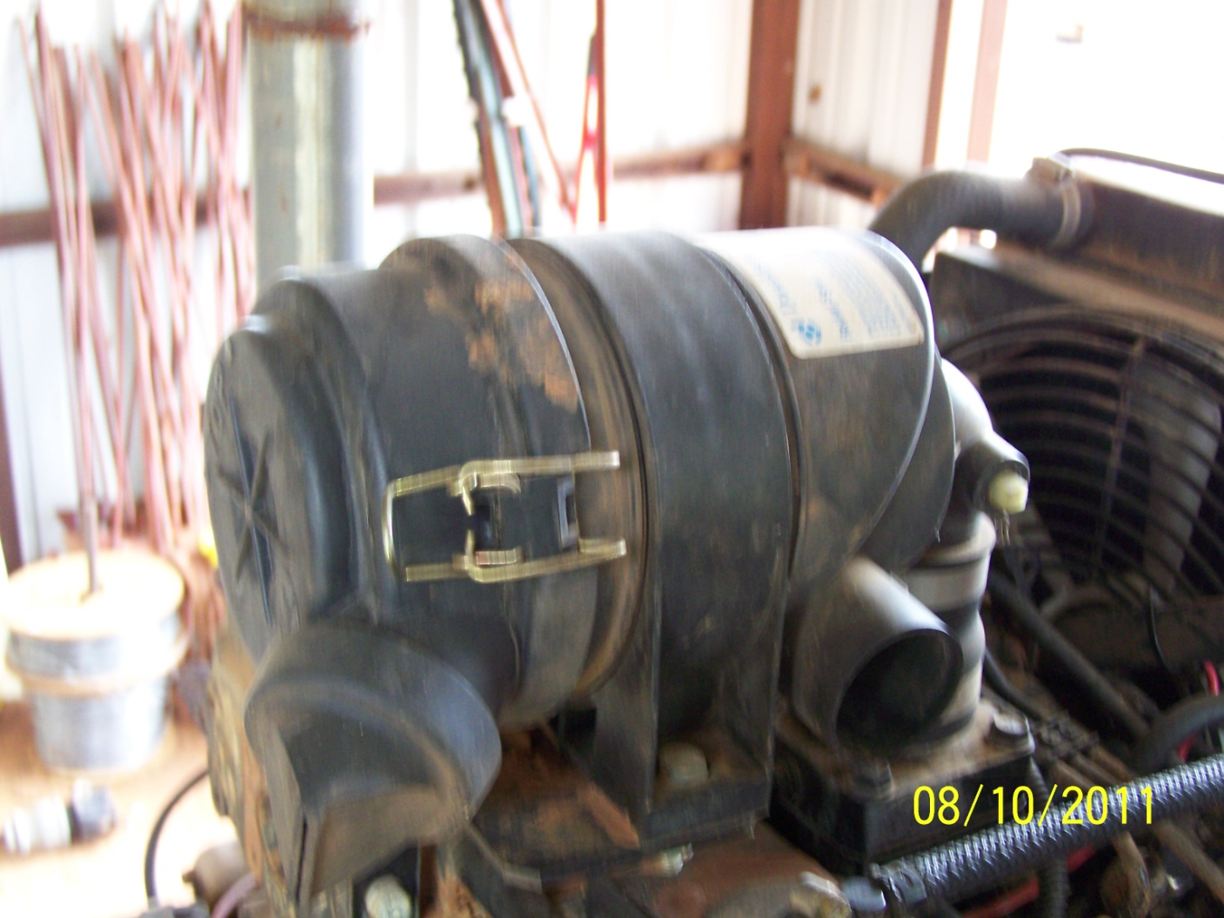
Air filter.
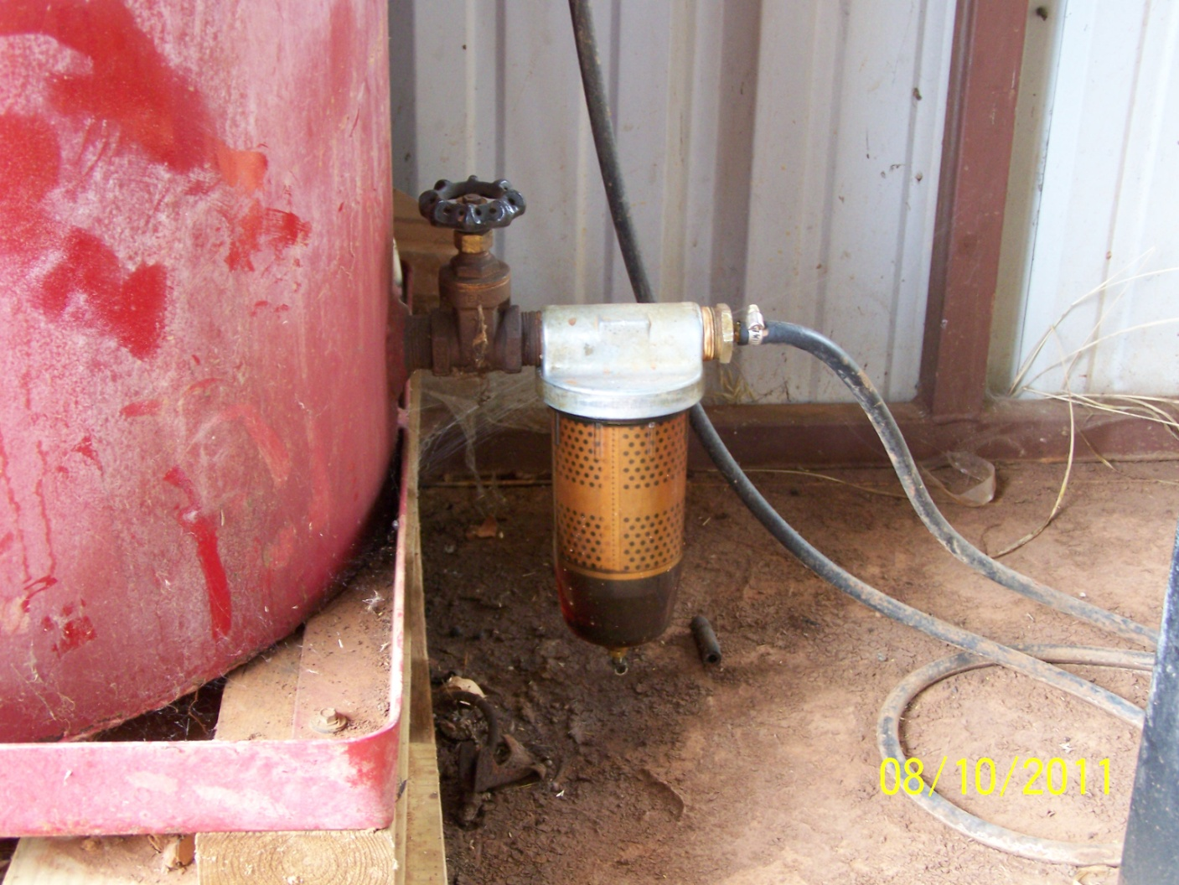
Fuel filter from pump engine diesel tank.

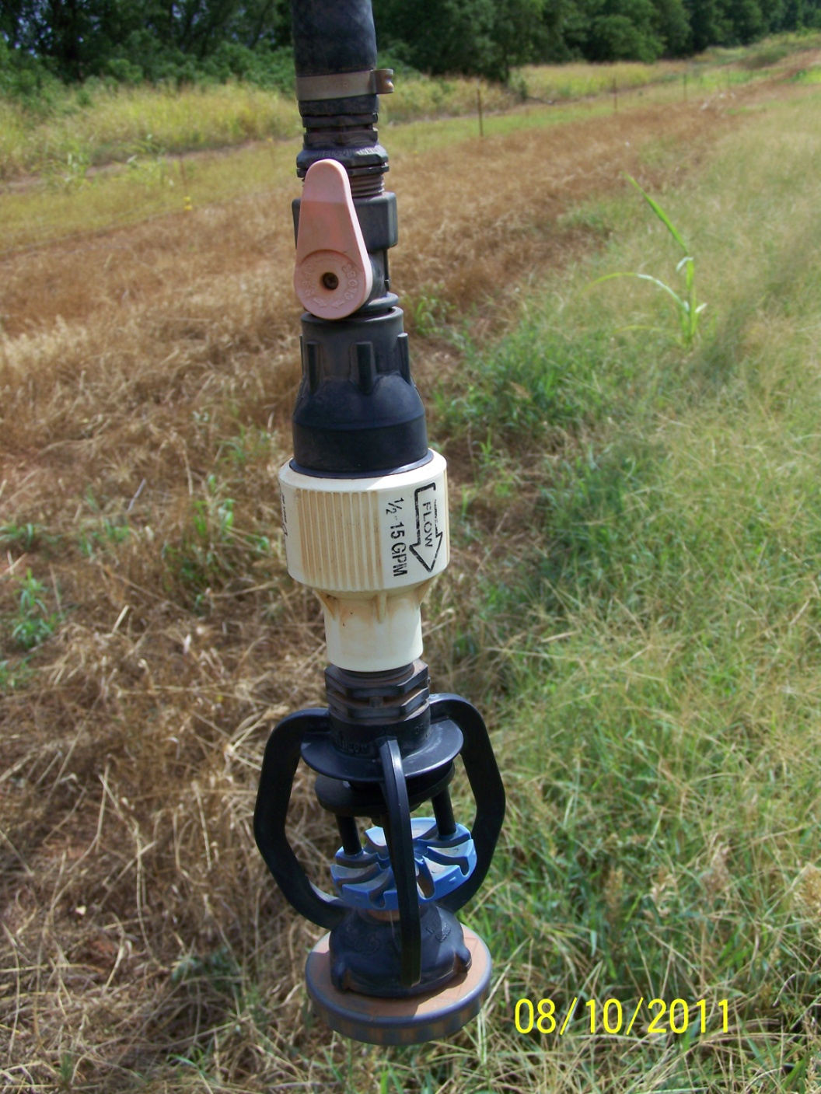
Sprinkler head.
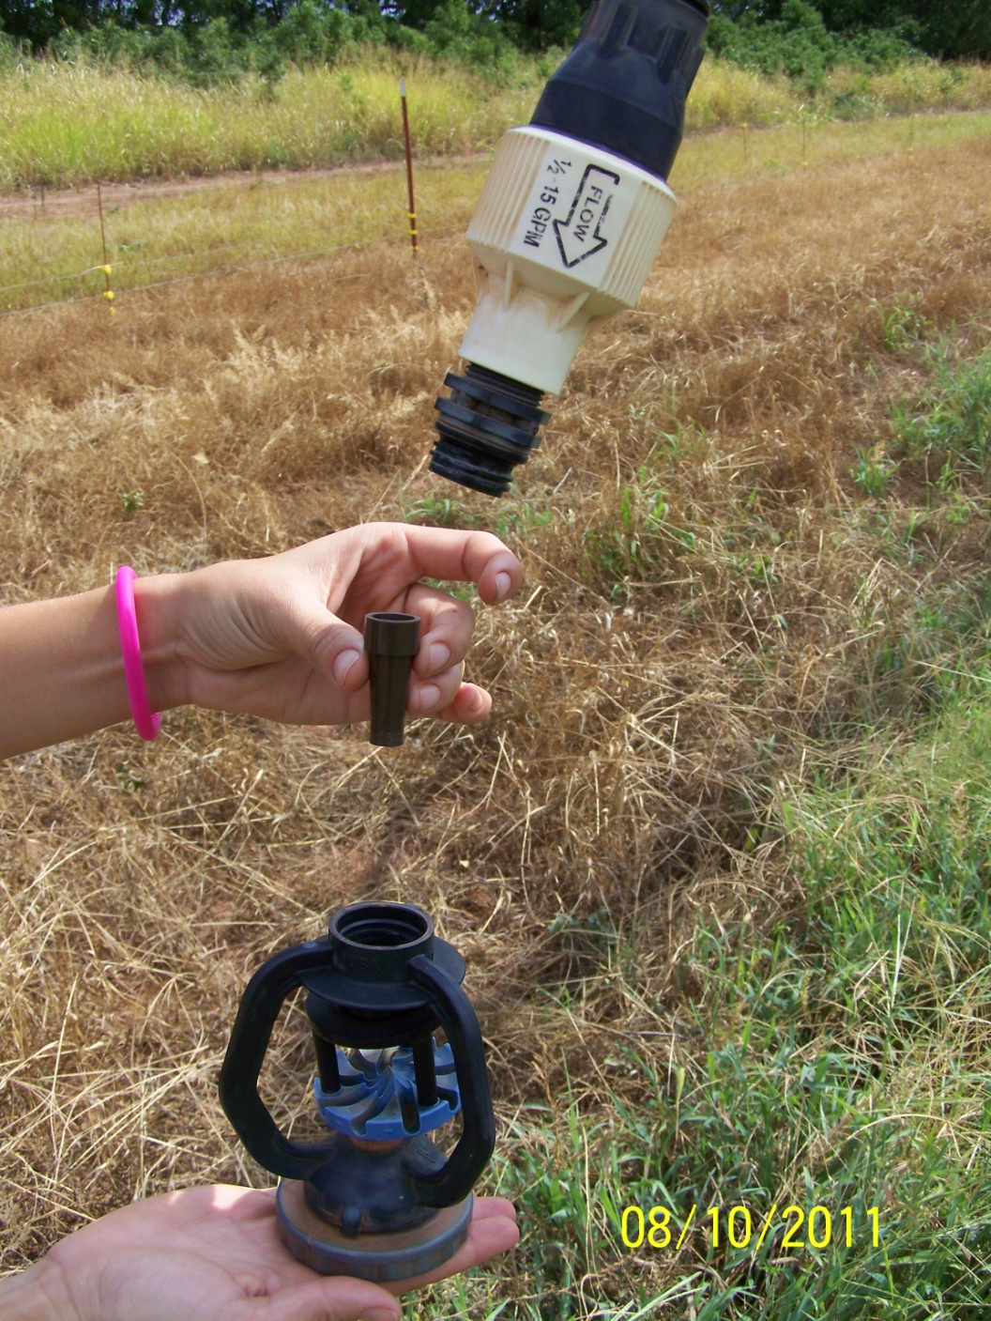
Sprinkler head with nozzle tip that can be changed.
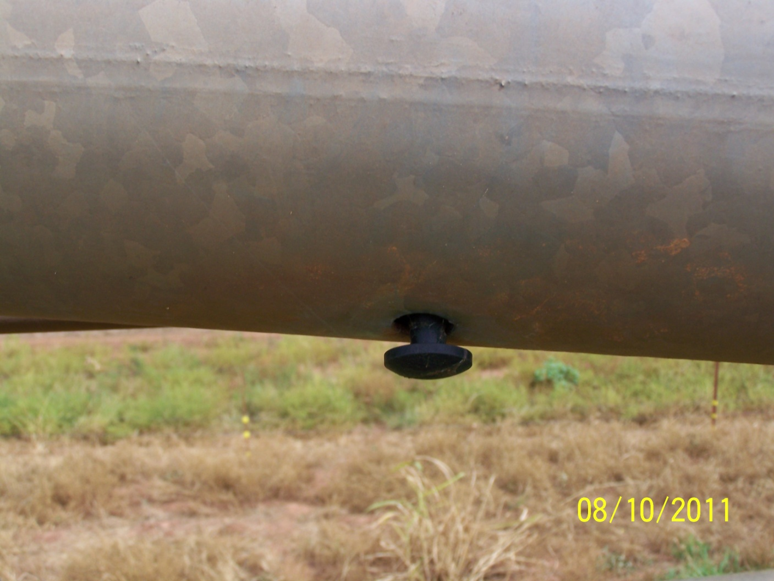
Mushroom plug that seals under pressure.

