Where, when, and how do I apply an N-Rich Strip?
For More Information:
N-Rich Strips should be applied in the middle of the field in a representative area, applied over the entire length. The strip should be easily accessible from a drive-by road so it can be conveniently inspected, and often. The strip should be applied as early as possible. The best results are obtained from strips put out at planting or soon thereafter. Broadcast fertilizer applicators work well for the initial application. You should apply enough N so that it isn’t a limiting factor. See the below table for recommended amount.

Wheat Yield N-Rich Strip
(bu/acre) (lbs/acre)
- 50
- 75
- 100
- 125
- 150
- 175

Contact:

Bill Raun, John Solie, Marvin Stone, or Hailin Zhang

(wrr@mail.pss.okstate.edu

VOICE: (405) 744-6418
FAX: (405) 744-9575



Production Technology 2006-4
Department of Plant and Soil Sciences
And Department of Biosystems and Agricultural Engineering
Oklahoma State University
368 Agriculture Hall
Stillwater, Ok 74078

Prepared by:
Jessica Sheffield

Are You Spending Too Much On Nitrogen Fertilizer?

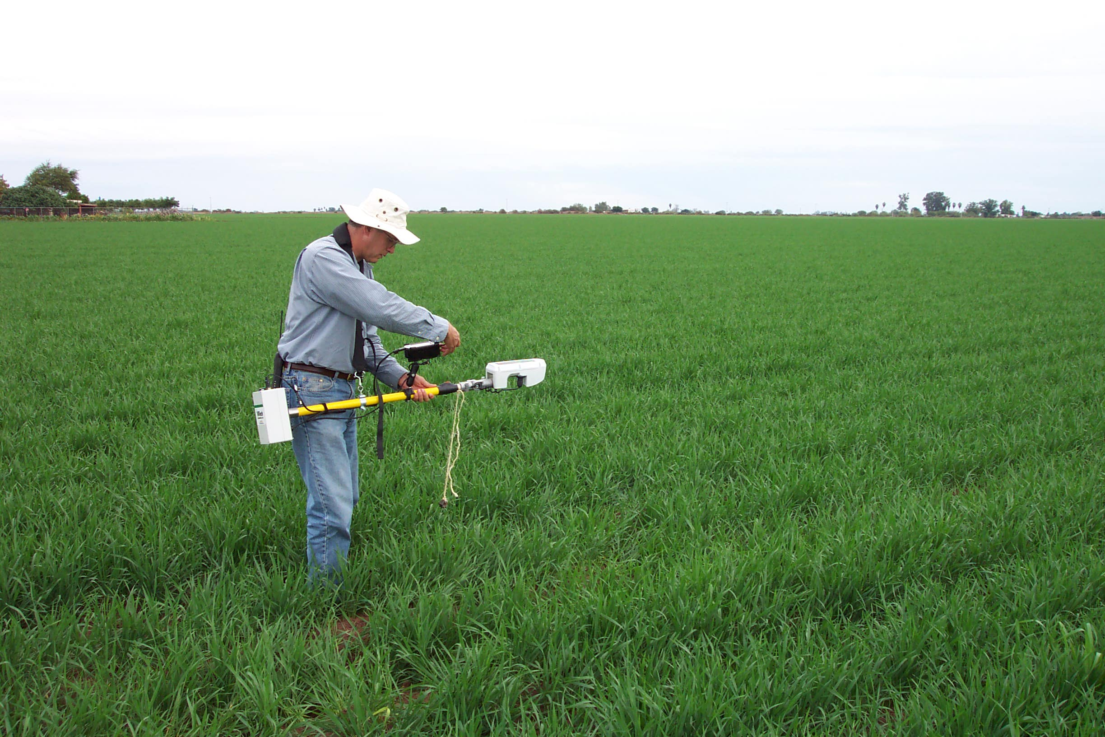

Saving producers time and money by providing an economical system to apply nitrogen fertilizer in an environmentally responsible way

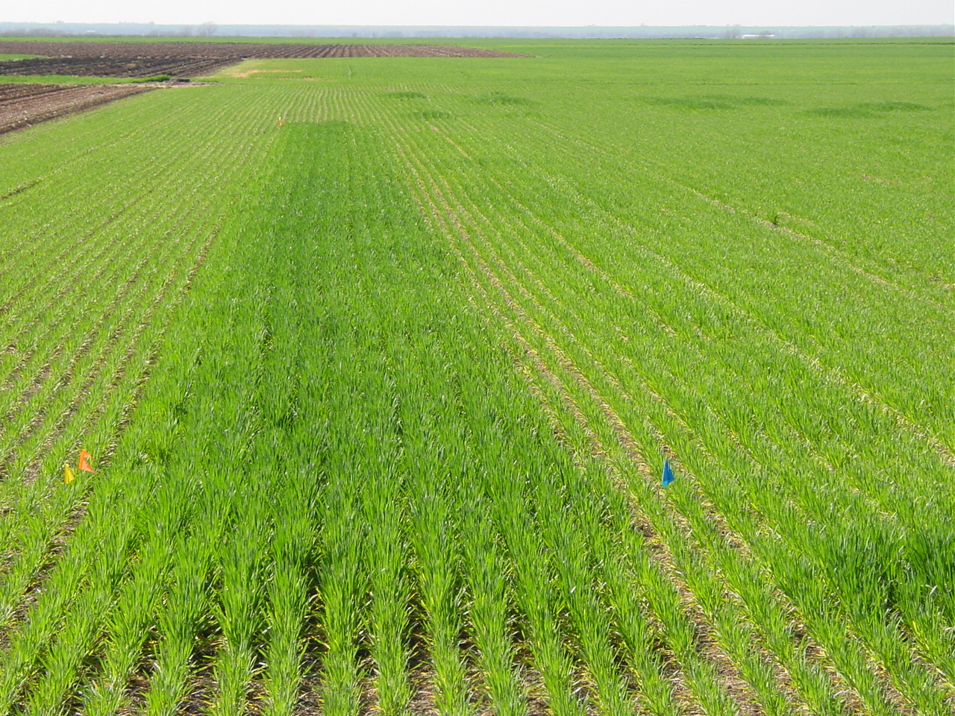

Why should I put out a Nitrogen-Rich Strip?
The nitrogen (N)-rich strip on average has made producers over $10 per acre. When you apply only the needed amount of N you save money on your fertilizer and save money on your fuel costs. As natural gas prices continue to rise, you can be sure that the cost of N will also increase. It is also better for the environment by minimizing the amount of N lost in runoff and leaching.
How do I determine the N rate to topdress?
Using the GreenSeeker Hand-Held Sensor obtained from your County Extension Educator you can collect readings after wheat has broken dormancy (February to early March). After you have collected the readings you or your County Extension Educator will enter the readings into the Sensor Based Nitrogen Rate Calculator found at www.nue.okstate.edu. Entering the information is easy and takes less than 5 minutes, and that determines the exact amount needed.
Can I use the N-Rich technique on other crops?
Irrigated and dryland Corn, Sorghum, and Bermudagrass are currently available along with Spring and Winter Wheat. More information is available at www.nue.okstate.edu.
How does the N-Rich Strip fit in with my current management?

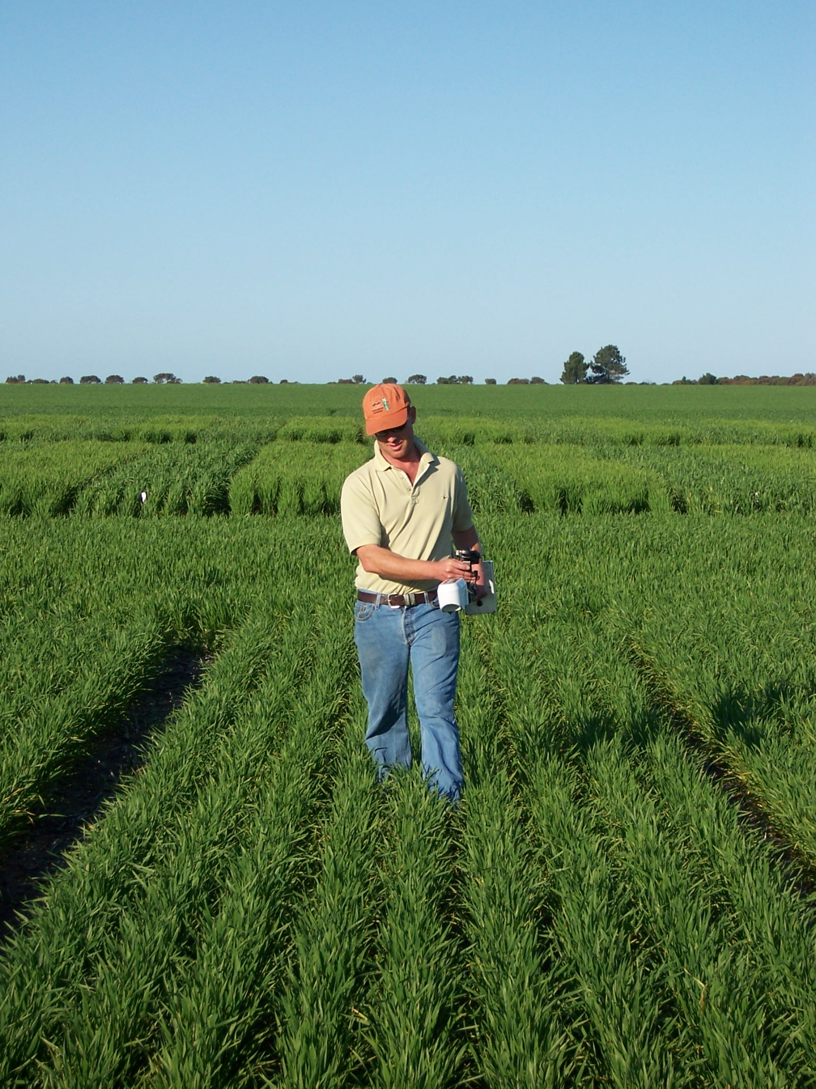
N-Rich strips replace the use of yield goals for making mid-season nitrogen fertilizer recommendations.
- Yearly soil tests are still valuable
- Takes the guess work out of applying mid-season N
- Unused N from the previous crop is not reliably predicted without N-rich strips
- Unused N from current crop has a limited impact on the next crop’s needs
- Saves time, fuel, and money by applying the correct amount

