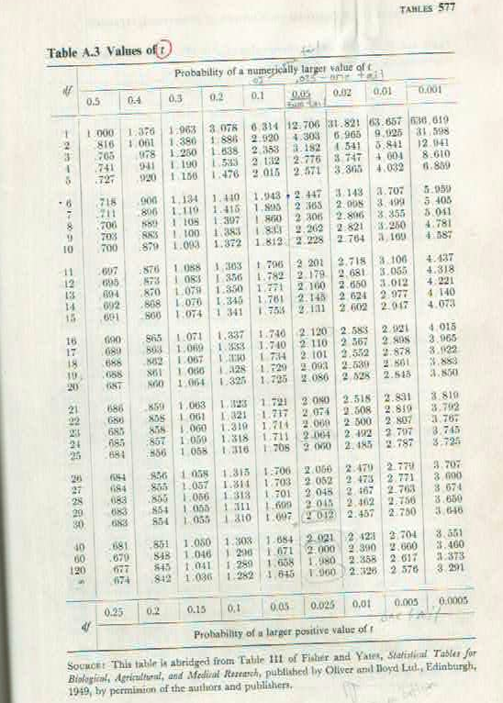
Standard Error of the Difference between 2 Equally Replicated Means (SED)
SED = square root (2*MSE/n)
LSD = t,dfe,alpha * SED
LSD, 20 dfe, alpha 0.05 = 2.08 * SED

