Using Virtual SAS (On Campus) on a Windows 7 Computer
- Search for Remote Desktop on your “Start Menu” search box.
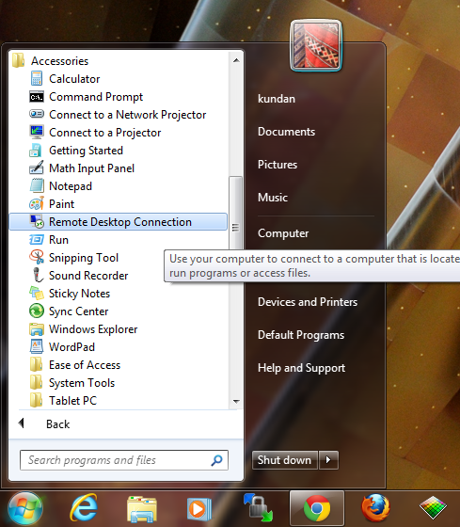
- Click on Remote Desktop Connection
- Type virtualsas.okstate.edu in Computer
- Provide your credentials in User name (e.g. pistol.pete@okstate.edu)
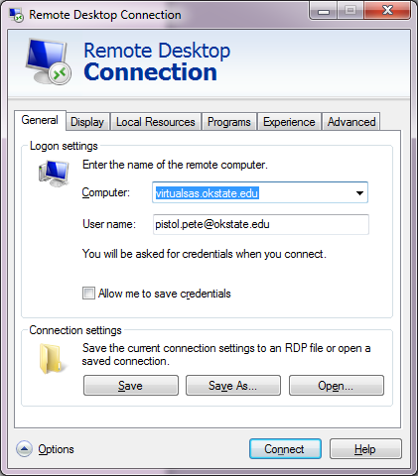

- Click “Yes” if you are prompted with this message box.
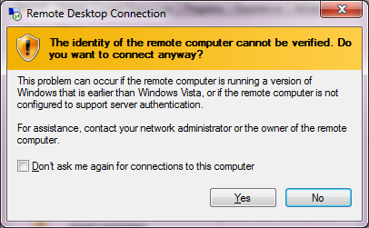
- Provide your log in credentials (i.e. your okey user name and password)

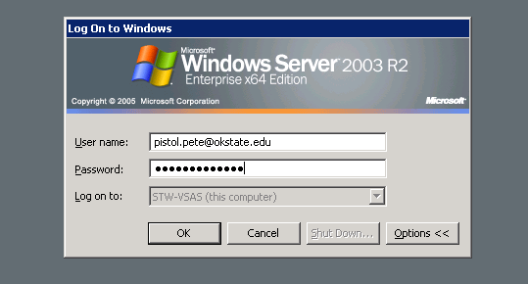
- Now you are logged in into the remote SAS server.

Using Virtual SAS (Off Campus) on a Windows 7 Computer
- In your internet browser go to vpn.okstate.edu
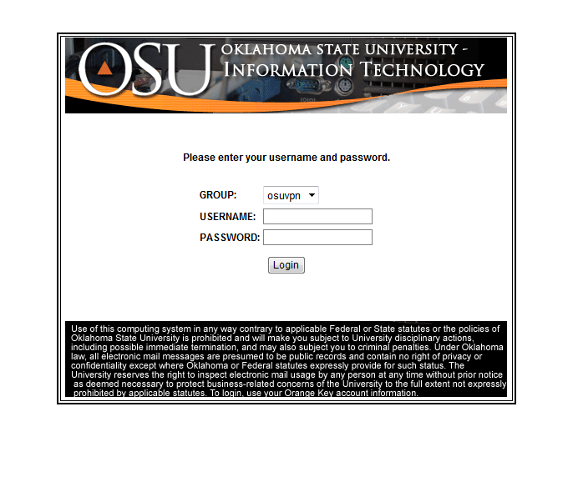
- Provide your log in credentials
- Install the CISCO AnyConnect Secure Mobility Client

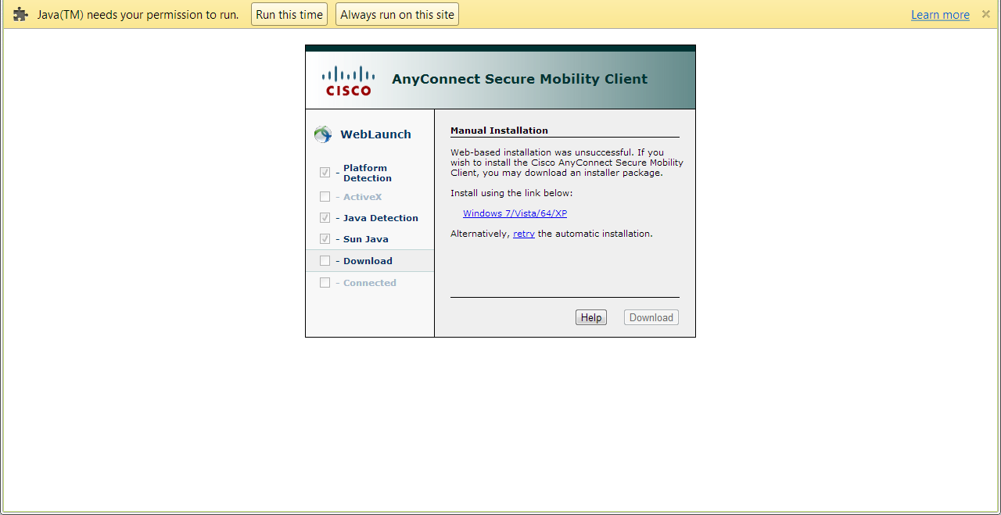

- Click “Yes”
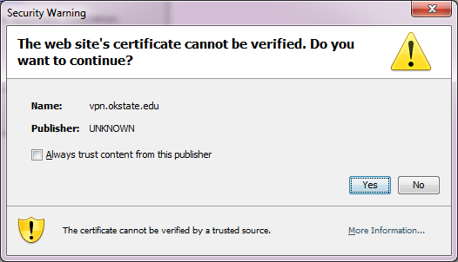
- Click “Run”

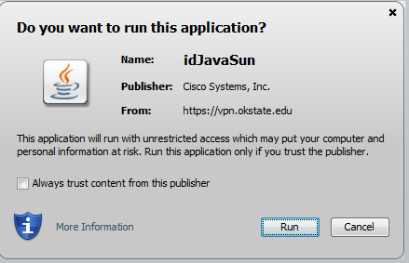
- You will see CISCO VPN client in your system tray. Click the VPN client and enter “osuvpn.okstate.edu” and click connect.

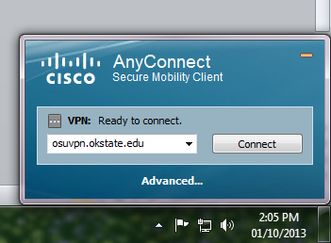

- Provide your log in credentials
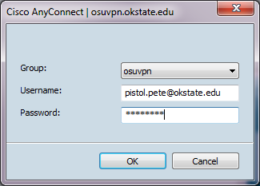
- Once the VPN is connected, follow the procedure to use the Virtual SAS from on-campus.

