Authors: William R. Raun*¹ and John B. Solie²
Title: Independence of Yield Potential and Nitrogen Responsiveness

Department of Plant and Soil Sciences
Department of Biosystems and Agricultural Engineering
044 N. Ag Hall
Oklahoma State University
Stillwater, OK 74078
* corresponding author
email: bill.raun@okstate.edu
Abstract
Confusion exists on what is the appropriate theory to apply for making nitrogen (N) fertilizer rate recommendations, sufficiency of nitrogen to produce maximum yield, or calculating nitrogen application rate as a function of estimated yield potential and N responsiveness. The sufficiency approach applies a fixed rate of N at a computed sufficiency level, regardless of yield potential. Mid-season optical sensor estimates of yield potential and crop response to additional N provides a physiological basis to estimate N removal and N application rate. This study investigated the relationship of grain yield and N responsiveness in long-term wheat and corn experiments. No relationship between N responsiveness and grain yield was found. Also, no relationship between yield and year was found at two of three sites. Finally, no relationship between N responsiveness and year was found at any site. Because yield and N responsiveness were consistently found to be independent of one another, and since both influence the demand for fertilizer N, both measures should be combined to calculate realistic in-season N rates.
Introduction
With the advent of advanced sensor based methods for improving fertilizer N use efficiency, algorithms have been developed that fail to account for accepted fundamental concepts and theories on nutrient management. Current use of indirect measurements to estimate biological parameters, e.g. biomass estimated NDVI from an optical sensor, requires that we use caution before applying this methodology to estimate fertilizer N rates. The same fundamental theories, such as Bray’s mobility concept (Bray 1954), that restricted the use of sufficiency theory to immobile nutrients like phosphorus still apply to current new sensing methods.
Yield potential (YP0) is defined as the potential grain yield achievable with no additional N fertilization (Raun et al., 2002). Yield potential is known to change from one year to the next because temporal variability, i.e., change in rainfall, temperature, relative humidity, etc. can vary radically from year to year (Girma et al., 2007). As a result, yield potential is specific to the season for which it is being evaluated.
New sensing technologies are being developed to directly or indirectly measure plant properties. Among those is measurement of reflected or transmitted light at specific wave lengths. Girma et al. (2006) showed that mid-season normalized difference vegetative index (NDVI) calculated from optical sensor measurements and plant height were good predictors of final winter wheat grain yield. Earlier work by Lukina et al. (2001) showed that early-season NDVI alone was a good predictor of final winter wheat grain yield over several locations and years.
Johnson and Raun (2003) first discussed the use of the harvest response index (RI_{Harvest}) to predict additional N requirements. RI_{Harvest} was calculated by dividing the maximum yield of fertilized plots by the yield of unfertilized plots. This was then used to estimate the response of the crop to additional N for a given year. Mullen et al., (2003) showed that the RI (yield in the high N plot, divided by the check or farmer practice) could be predicted using mid-season optical sensor based NDVI measurements collected from the same plots (NDVI in the high N plot divided by the check or farmer practice). This ratio was termed R_{INDVI} Similar to the year to year changes in yield, RI_{NDVI} was found to be unpredictably variable (Johnson and Raun, 2003).
Bray (1954) noted that Liebig’s law of the minimum could be interpreted as meaning that the crop consumed all the deficient nutrient in the soil, making yield directly proportional to the amount of the deficient nutrient present, and the crop content of the nutrient. Later work by Bray noted that nitrogen must follow Liebig’s law of the limiting nutrient, since a given level of nitrate nitrogen can be more than adequate for the first stages of growth, yet can become highly deficient in later stages of growth, thus limiting yield to a certain value (Bray, 1963). He further stated that not all nutrient forms can follow a percentage sufficiency concept like that used for phosphorus. Moreover, the relatively mobile forms like N should follow the law of the limiting nutrient, not sufficiency.
A number of agronomists and engineers are attempting to use direct and indirect measurements of crop parameters from newly developed sensors to predict crop supplemental nitrogen requirements. Frequently, proposed algorithms to calculate N rates are empirical and do not account for temporal variability in crop growth and yield. Specifically, these algorithms do not account for the effects of temporal variability in available N, temporal variability in the crops environment, particularly available moisture, and the consequent temporal variability in crop yield. The objectives of this study were to determine if grain yield was related to N responsiveness, and if there was any relationship between N responsiveness, grain yield and time.
Materials and Methods
The response index (RI) was computed by year from three long-term experiments, two in Oklahoma and one in Nebraska, whereby the yield of the high N treatment was divided by the yield of the low N treatment. The three long-term experiments were Experiment 222, Experiment 502 (both winter wheat in Oklahoma) and Mead (long-term corn trial in Nebraska). Experiments 222 and 502 were established in 1969 and 1970, respectively, under conventional tillage. Experiment 222 is located at the Agronomy Research Station in Stillwater, OK at an altitude of 272 masl on a well drained, very deep and very slowly permeable Kirkland silt loam (fine, mixed, thermic Udertic Paleustoll). Experiment 502 is located at the North Central Research Station in Lahoma, OK at an altitude of 396 masl) on a well drained, deep and moderately permeable Grant silt loam (fine-silty, mixed, thermic Udic Argiustoll) soil. The one corn experiment was established in 1969 and that was continued until 1983 on a Sharpsburg silty clay loam (fine, montmorillonitic, mesic Typic Argiudoll) at the Nebraska Agricultural Experiment Station Field Laboratory near Mead, NE at an altitude of 342 masl. Fertilizer was applied at rates of 0, 90, 180, and 270 kg N ha⁻¹ to 9.1 by 20 m plots. Plot details, planting, and management associated with this trial are reported in Olson et al. (1986). The average annual precipitation at Stillwater and Lahoma is 80 cm, and 72 cm at Mead, NE. The experimental design was a randomized complete block with four replications in all experiments. There were 12 and 13 treatments that comprised application of different rates of N, P, and K fertilizers included in Exp. 222 and 502, respectively. Nitrogen, P, and K were applied as ammonium nitrate (34% N), triple super phosphate (20% P), and potassium chloride (53% K), respectively, in both experiments. Plots are permanent from year to year and received fixed rates of N, P, and K every year. The treatments used to determine the response index and yield potential (high preplant N rate) were 90-29-37 and 0-29-37 (N-P-K) at Experiment 222, and 112-20-56 and 0-20-56 (NPK) at Experiment 502. Individual plots at Stillwater were 6.1 m wide and 18.3 long, and at Lahoma were 4.9 m wide and 18.3 m long. Experimental plots were conventionally tilled every year in the summer approximately to a 15-cm depth using a disk plow. Plots were then harrowed before fertilization using a spike tooth harrow every year. Winter wheat was planted for 38 (Stillwater) and 37 (Lahoma) continuous years in 25.4-cm wide rows at seeding rates of 67 kg ha⁻¹. In some years, the seeding rate was increased to 110 kg ha⁻¹ in anticipation of poor germination and emergence due to unfavorable soil moisture conditions at seeding. Since 1992, winter wheat has been planted in 19-cm rows at Stillwater. At the Oklahoma locations, varieties were changed with time due to increased genetic yield potential and the need for rust resistance (Table 1). In both experiments, preplant fertilizer was broadcast and incorporated in late August to mid-September. Winter wheat was planted in late September to early October every year, corn planted in April-May. Grain yield data was collected in each plot and year using a self propelled combine at all sites.
From the long-term data base from all trials, RI_{Harvest} was computed by dividing the high N treatment yield by the check plot yield with no fertilizer N. Maximum yields, however, did not always correspond with the high N treatment, but rather came unpredictably from the range of N treatments evaluated. All linear regression analysis employing yield used maximum yields for each year irrespective of what N treatment they came from. The latter condition ensured that plots of maximum yields versus RI’s avoided potential autocorrelation, due to how RI was computed. In addition, maximum grain yield and RI_{Harvest} were plotted against year or time.
Results
At two of the three sites, there was no relationship between the response index and grain yield (Table 1). At Experiment 502, the slope component was significant but the linear model explained only 17% of the observed variation (Figure 1). Slope of Experiment 222 (wheat) was slightly positive and Mead, NE (corn) was slightly negative, but at neither location was the slope of the linear model significant. (Figures 2 and 3, respectively). Overall this data shows that grain yield level over these sites and years is not related to N responsiveness. This finding is important because it shows that the crop’s N responsiveness is independent or very marginally dependent on grain yield.
Grain yield was plotted against crop year to determine if long term yield trends affected grain yield at all three sites (Figures 4,5, and 6). No relationship was found between yield and crop year at Experiment 222 and Mead, NE sites. However, yield increased significantly with crop year at Experiment 502. This was likely due to the changes in varieties with higher yield potential in later years (Table 2). However, the linear model for yield and year only explained 26% of the variability. Grain yields ranged from 440 to 3561 kg/ha at Experiment 222 over 38 years, from 1420 to 5930 kg/ha at Experiment 502 over 40 years, and from 5393 to 8279 kg/ha at Mead, NE over 14 years. Nitrogen removal using an average 2.39% N in wheat grain and 1.19% N in corn grain ranged from 10 to 85 kg/ha, 34 to 142 kg/ha, and 64 to 99 kg/ha at Experiments 222, Experiment 502, and Mead, NE, respectively. This broad range over years clearly shows why N demand must also be different over years, and ultimately tied to the environment in question.
Crop year as a function of RI_{Harvest} was significant for Experiment 502, marginally significant for Experiment 222, and not significant at Mead (Fig. 7, 8, and 9, respectively and Table 1). Identical to observations made for yield with time, the response index or the N responsiveness varied with time and was unpredictable. The trend was small with an increase of The linear model explained only 19% of the variability for Experiment 222. At best, response index was only marginally related to crop year. One year with a low RI_{Harvest} could have been followed by another year with a low RI_{Harvest}, which is somewhat counter intuitive since conventional wisdom would have us believe that if no N response was encountered one year and we applied fertilizer, the next year should be N responsive.
Combined, no or only a marginal relationship between grain yield and the response index with time says that yield level and N responsiveness are dependent upon the year in which they were evaluated. Equally important was that no visible trend was apparent over years or from one year to the next that could be used to predict yield potential and/or N responsiveness.
Discussion
So, why is it important to show that yield and N responsiveness are independent of one another? If they are indeed independent of one another, then if they are to be estimated, they must be determined individually. Any practice that combines the two without considering their independence can create large errors in N application rates. An example where yield and N responsiveness was not partitioned was the use of a sufficiency concept for recommending fertilizer N (Varvel et al., 2007). This procedure used normalized chlorophyll meter readings and relative or normalized yields. If yield and N responsiveness are independent of one another, and both vary significantly year to year, using a sufficiency index (SI, or normalized chlorophyll meter readings to obtain N responsiveness) disregards the variability in N responsiveness and yield level, both bound by the environment (year), Figures 7, 8, and 9. Why? Because the final N rate recommended is fixed to a percent sufficiency, and not tied to the yield potential achievable that year. The potential yield achievable is fundamental to calculate total N demand for cereal crops.
How can relative yields be used when yield levels are known to vary significantly from one year to the next and N responsiveness also varies widely from year to year, both of which influence N rate? The answer is that you cannot use relative yields or relative chlorophyll meter readings precisely because both vary from year to year and are unpredictable at planting. Use of relative or normalized values is a last resort when deterministic, in-season models using independent variables were unsuccessful. Dividing by a maximum yield value (by year) at the end of the season, and by all metrics after the fact, holds little value for computing or determining in-season N rates. All long-term trials document that this years’ yield is unlikely to be related to last years’ maximum yield or last years’ relative yield (Figures 4, 5, and 6).
When observing how wide the range in N removal was over time in both trials, what farmer would apply the same N rate each year with this knowledge in hand? If the upper boundary on achievable yield potential changes by year, and the demand for fertilizer N changes by year, the obvious solution for improving fertilizer N rate recommendations is to be able to predict yield potential (Raun et al., 2001; Raun et al., 2002; Raun et al., 2005) and N responsiveness or the response index (Mullen et al., 2003) independently. Once these have been predicted independent of one another, the ensuing step is to combine them into a meaningful algorithm that will result in mid-season estimation of the added fertilizer N needed to achieve maximum yields. As delineated in Raun et al. (2005), the yield achievable with added fertilizer N is the product of estimated yield potential (YP0) and the response index (RI) and that is termed YPN. The final fertilizer N rate is determined by subtracting N uptake at YP0 from N uptake at YPN, divided by an expected use efficiency. Nitrogen uptake is estimated using an average percent N in the grain for the crop in question. For winter wheat this is approximately 2.39% and 1.19% for corn.
The range in N demand (N uptake in the high N plot minus N uptake in the low N plot divided by an efficiency factor of 0.5, assuming that N would be applied as a conventional inorganic fertilizer) was from 0 to 156 kg N/ha, with an average of 56 kg N/ha at Experiment 502, 0 to 110 kg N/ha with an average of 35 kg N/ha at Experiment 222, and 26 to 172 kg N/ha with an average of 81 kg N/ha at Mead, NE. These values encumbered 37, 38, and 15 years, respectfully. Thus, with knowledge of such wide differences in N demand, would farmers apply the same N rate each year? These results and that from other long-term trials demonstrate the wide differences in N demand, and the need to fertilize based on independent assessments of yield potential and N responsiveness. Fertilizing each year using a fixed rate, or based on a sufficiency value that does not compensate for predicted yield levels is therefore considered problematic.
Because of the wide differences in N demand, these results address a separate issue, and that is whether or not N Rich strips are needed each year. Without the N Rich Strip, it would be impossible to assess N demand that clearly fluctuated over years (Figures 7, 8, and 9). It would further not be possible to estimate the RI, since the non-N-limiting plot is critical to determining N responsiveness. Recent claims that suggest N Rich Strips are not needed and that these can be estimated virtually are cause for concern. If the nutrient in question were not documented, and optimum growth not tied to repeatable conditions, erroneous interpretation of the final effect (N, P, K, S, etc., demand) could easily happen. Liebig’s law of the limiting nutrient is still in place today and will be the case well into the future. Determining the demand for fertilizer N without an N Rich Strip is not recommended. Furthermore, the process of determining which element is needed can only occur with paired comparisons of the field rate of an element and an immediately adjacent non-limiting rate.
This study showed that N responsiveness (response index) and grain yield were not related in three long term experiments. No relationship between yield and year was found at two of three sites, and no relationship between N responsiveness and year was found at any site. The independence of N responsiveness and yield shows why N rates cannot be based on one or the other, but must combine both to arrive at realistic in-season N rates.

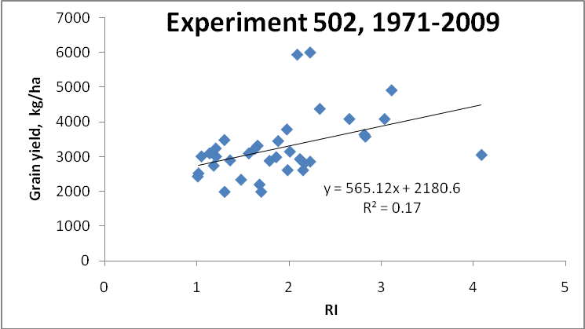
Figure 1. Relationship between the response index (RI), and maximum winter wheat grain yield at Experiment 502 near Lahoma, OK, 1970 to 2008.
Figure 2. Relationship between the response index (RI), and maximum winter wheat grain yield at Experiment 222, Stillwater, OK, 1969 to 2008.

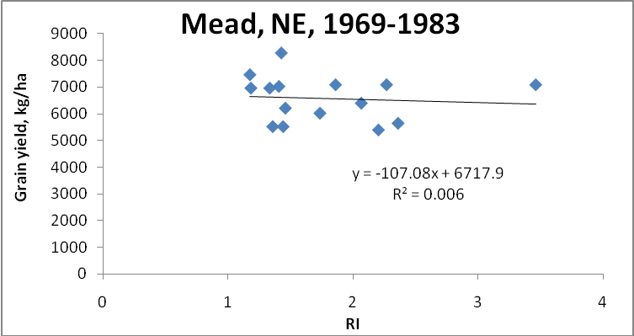
Figure 3. Relationship between the response index (RI), and maximum corn grain yield at Mead, NE, 1969 to 1983.

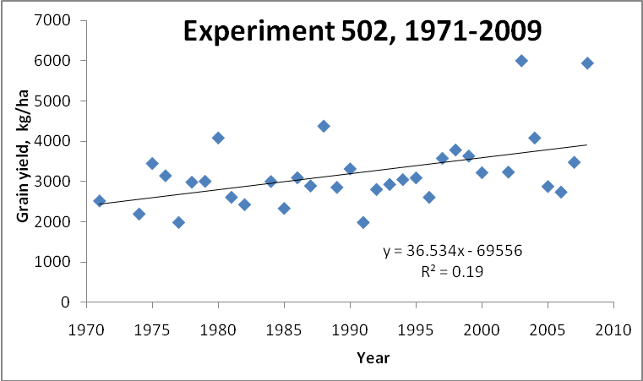
Figure 4. Relationship between maximum grain yield and time (year) for the long-term winter wheat Experiment 502, near Lahoma, OK, 1970-2008.
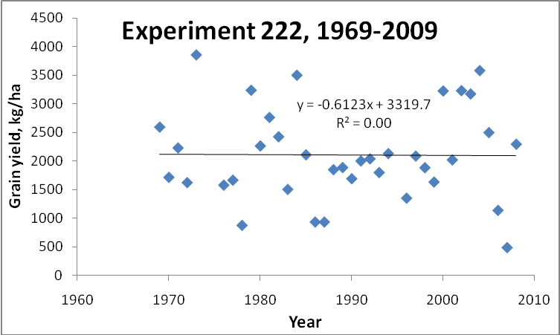
Figure 5. Relationship between maximum grain yield and time (year) for the long-term winter wheat Experiment 222, Stillwater, OK, 1969-2008.
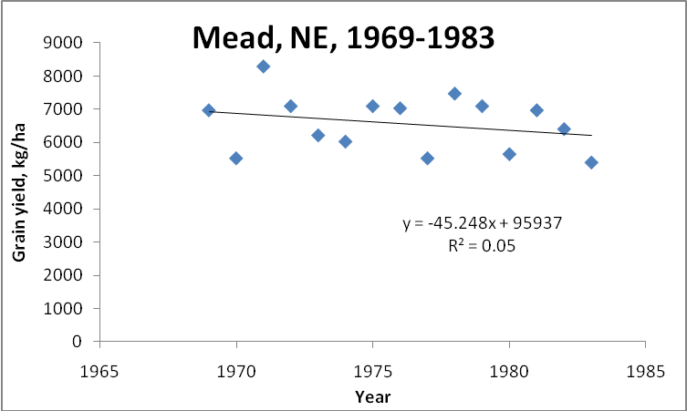
Figure 6. Relationship between maximum grain yield and time (year) for the long-term corn experiment at Mead, NE, 1969-1983.

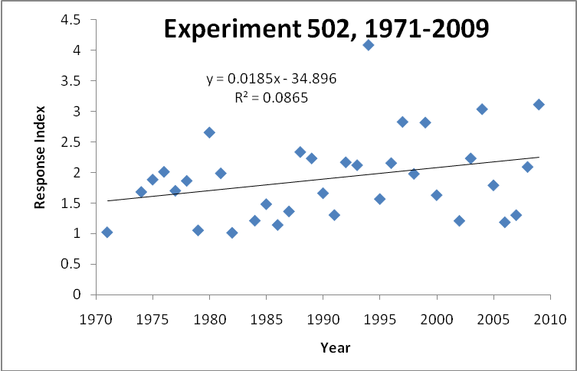
Figure 7. Relationship between the response index and time (year) for the long-term wheat Experiment 502, near Lahoma, OK, 1970-2008.

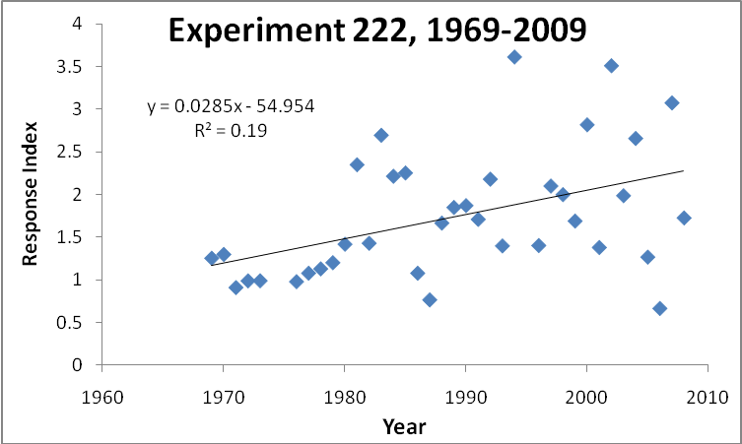
Figure 8. Relationship between the response index and time (year) for the long-term winter wheat Experiment 222, Stillwater, OK, 1969-2008.

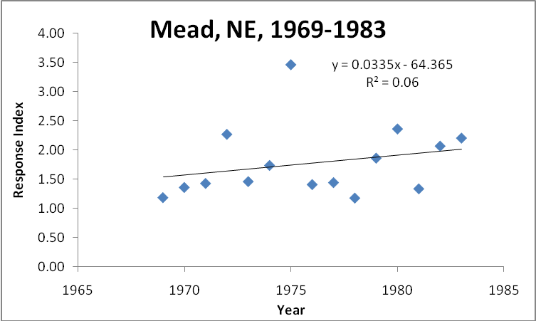
Figure 9. Relationship between the response index and time (year) for the long-term corn experiment at Mead, NE, 1969-1983.

Table 1. Model R², slope components, and slope significance for the relationships between RI_{Harvest} and grain yield, year and grain yield, and year and RI_{Harvest}, for Experiment 502, Experiment 222, and Mead, NE.
Experiment | Variables |  | Slope | Slope Significance | Model R²
 | Independent | Dependent |  | PR>|t|
Experiment 502 | RI_{Harvest} | Grain Yield | 565 | 0.011 | 0.17
Experiment 222 | RI_{Harvest} | Grain Yield | 289 | 0.108 | 0.07
Mead, NE | RI_{Harvest} | Grain Yield | -107 | 0.730 | 0.01
Experiment 502 | Year | Grain Yield | 43 | 0.001 | 0.26
Experiment 222 | Year | Grain Yield | -0.61 | 0.958 | 0.00
Mead, NE | Year | Grain Yield | -45 | 0.335 | 0.07
Experiment 502 | Year | RI_{Harvest} | 0.018 | 0.086 | 0.08
Experiment 222 | Year | RI_{Harvest} | 0.028 | 0.007 | 0.19
Mead, NE | Year | RI_{Harvest} | 0.033 | 0.380 | 0.06

Table 2. Winter wheat varieties planted in Experiment 222, and 502, 1969-present.
____________________________________
Experiment 502 Experiment 222
Year Variety Variety

1969 - Scout 66
1970 - Scout 66
1971 Scout 66 Scout 66
1972 Scout 66 Scout 66
1973 Scout 66 Scout 66
1974 Scoun 66 Scout 66
1975 Triumph 64 Triumph 64
1976 Triumph 64 Triumph 64
1977 Osage Triumph 64
1978 Osage Osage
1979 TAM 101 Osage
1980 TAM 101 Osage
1981 TAM 101 TAM 101
1982 TAM 101 TAM 101
1983 TAM 101 TAM 101
1984 TAM 101 TAM 101
1985 TAM 101 TAM 101
1986 TAM 101 TAM 101
1987 TAM 101 TAM 101
1988 TAM 101 TAM 101
1989 TAM 101 TAM 101
1990 TAM 101 TAM 101
1991 TAM 101 TAM 101
1992 TAM 101 TAM 101
1993 Karl Karl
1994 Karl Karl
1995 Tonkawa Tonkawa
1996 Tonkawa Tonkawa
1997 Tonkawa Tonkawa
1998 Tonkawa Tonkawa
1999 Tonkawa Tonkawa
2000 Custer Custer
2001 Custer Custer
2002 Custer Custer
2003 Custer Custer
2004 Custer Custer
2005 Overley P2174
2006 Overley Endurance
2007 Overley Endurance
2008 Overley OK Field
________________________________________

References
Bray, R.H. 1954. A nutrient mobility concept of soil-plant relationships. Soil Sci. 78:9-22.

Bray, R.H. 1962. Confirmation of the nutrient mobility concept of soil-plant relationships. Soil Sci. 86:124-130.

Girma, Kefyalew, K.L. Martin, R.H. Anderson, D.B. Arnall, K.D. Brixey, M.A. Casillas, B. Chung, B.C. Dobey, S.K. Kamenidou, S.K. Kariuki, E.E. Katsalirou, J.C. Morris, J.Q. Moss, C.T. Rohla, B.J. Sudbury, B.S. Tubana, and W.R. Raun. 2006. Mid-Season Prediction of Wheat Grain Yield Potential Using Plant, Soil, and Sensor Measurements. J. Plant Nutr. 29:873-897.

Girma, Kefyalew, Kyle W. Freeman, Roger Teal, Daryl B. Arnall, Brenda Tubana, Starr Holtz, and William R. Raun. 2007. Analysis of yield variability in winter wheat due to temporal variability, and nitrogen and phosphorus fertilization. Arch. Agron. Soil Sci. 53:435-442.

Girma, Kefyalew, Starr L. Holtz, Daryl B. Arnall, Lisa M. Fultz, Travis L. Hanks, Kyle D. Lawles, Clinton J. Mack, Kevin W. Owen, Stewart D. Reed, Jesus Santillano, Olga Walsh, Michael J. White, and W.R. Raun 2007. Weather, fertilizer, previous year grain yield and fertilizer response level affect ensuing year grain yield and fertilizer response of winter wheat. Agron. J. 99:1607-1614.
Johnson, G.V., and W.R. Raun. 2003. Nitrogen response index as a guide to fertilizer management. J. Plant Nutr. 26:249-262.

Lukina, E.V., K.W. Freeman, K.J. Wynn, W.E. Thomason, R.W. Mullen, A.R. Klatt, G.V. Johnson, R.L. Elliott, M.L. Stone, J.B. Solie, and W.R. Raun. 2001. Nitrogen fertilization optimization algorithm based on in-season estimates of yield and plant nitrogen uptake. J. Plant Nutr. 24:885-898.

Mullen, R.W., Kyle W. Freeman, William R. Raun, G.V. Johnson, M.L. Stone, and J.B. Solie. 2003. Identifying an in-season response index and the potential to increase wheat yield with nitrogen. Agron. J. 95:347-351.

Olson, R. A., W. R. Raun, Yang Shou Chun and J. Skopp. 1986. Nitrogen management and interseeding effects on irrigated corn and sorghum and on soil strength. Agron. J. 78:856-862.

Raun, W.R., J.B. Solie, G.V. Johnson, M.L. Stone, R.W. Mullen, K.W. Freeman, W.E. Thomason, and E.V. Lukina. 2002. Improving nitrogen use efficiency in cereal grain production with optical sensing and variable rate application. Agron. J. 94:815-820.

Raun, W.R., G.V. Johnson, M.L. Stone, J.B. Solie, E.V. Lukina, W.E. Thomason and J.S. Schepers. 2001. In-season prediction of potential grain yield in winter wheat using canopy reflectance. Agron. J. 93:131-138.

Raun, W.R., J.B. Solie, M.L. Stone, K.L. Martin, K.W. Freeman, R.W. Mullen, H. Zhang J.S. Schepers, and G.V. Johnson. 2005. Optical sensor based algorithm for crop nitrogen fertilization. Commun. Soil Sci. Plant Anal. 36:2759-2781.

Varvel, G.E., W.W. Wilhelm, J.F Shanahan, and J.S. Schepers. 2007. An algorithm for corn nitrogen recommendations using a chlorophyll meter based sufficiency index. Agron. J. 99:701-706.

