THE GREEN SEEDER
Smallholder farmers in Ghana traditionally plant grains (cereals and legumes) with the cutlass (Fig.1), hoe (Fig.2) or dibbling stick (Fig.3).

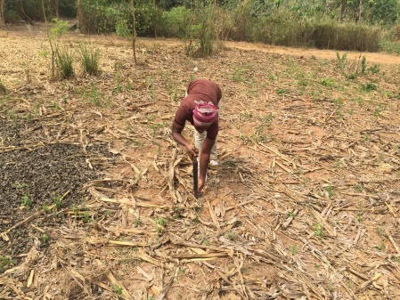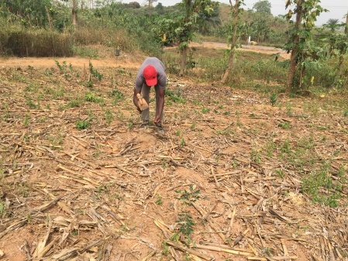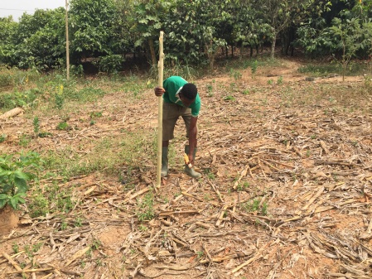
Fig.1 planting with cutlass Fig.2 planting with the hoe Fig.3 planting with the stick

Planting with any of these tools requires that the farmer bends down to place the seed in the hole created and then closes it. This action is very strenuous on the waist plus of course the fact that a farmer can easily get the fingers pinched by plant debris or stumps when dropping the seed in the hole on the stubble covered no-till plot.

It has therefore become very necessary to explore ways of planting directly through the mulch in the no-till system without any fear of hurting the fingers and also reducing the pressure on the waist whilst ensuring optimum plant stand. For this reason, farmers visiting the Howard G. Buffett Foundation Centre for No-Till Agriculture at Amanchia in the Ashanti region of Ghana have been exposed to the Jab Planter (Fig.4) and the OSU Green Seeder (Figs. 5 & 6).

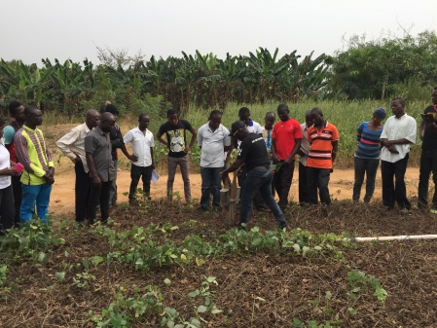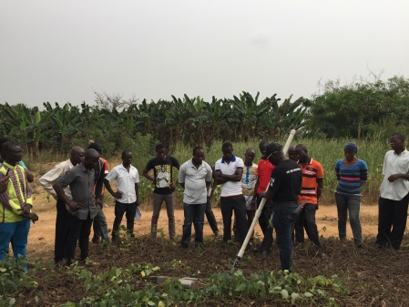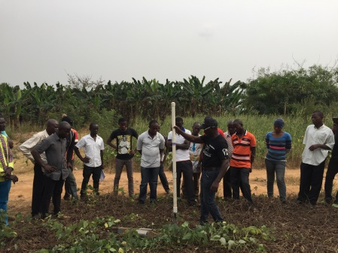
Fig.4 Jab Planter Fig.5 Green Seeder into the soil Fig.6 releasing the seed

Both the Jab Planter (Fig. 7) and the Green Seeder (Fig. 8) gave equal and acceptable plant stand of 40,300 and 40,258 plants/ha respectively) resulting in grain yield of maize of 3.56 t/ha for the jab planter and 3.50 t/ha for the Green Seeder.

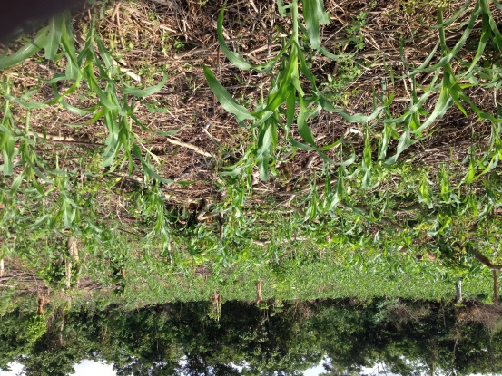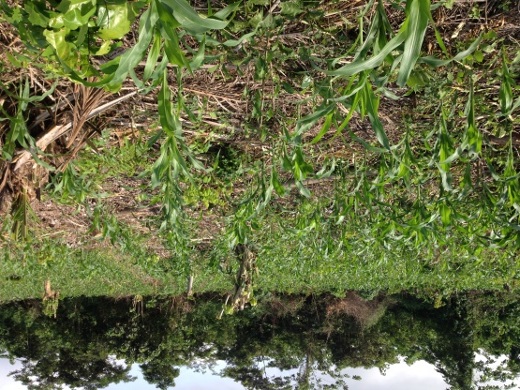
Fig. 7 Jab planter field Fig. 8 green seeder field

The ease of usage has however been the matter of concern for farmers as noted in the following paragraphs.

The Jab Planter
Farmers realized that they could load both the seed and fertilizer into the two-port jab planter and plant and apply inorganic fertilizer at the same time with just a single jab. There have been mixed opinions about this because some farmers, especially the elderly women find the jab planter loaded with seed and fertilizer too heavy to manage in the first 20 minutes of planting when all two pots are filled. With the Jab Planter, a farmer could easily change the seeding rate to drop one, two or three seeds/jab or even switch between larger and smaller seeds just by pulling or pushing a knob at the base of the seed port.

Farmers were also concerned about the technical skills needed to operate the Jab Planter effectively. One needed to build the rhythmic skills of opening and closing whilst jabbing otherwise the planter gets easily clogged with dirt and the seed/fertilizer will not drop. This can lead to poor plant stand. The soil moisture level also becomes a matter of concern especially in the silty and clayey loamy soils. It was noted to be difficult planting with the jab planter a day after a good rainfall on those two soils as the soils at that time become a bit sticky and present difficulties in opening to release the seed. The lack of adjustment of the height of the jab planter also posed a bit of a problem for the very tall and very short farmers.

The Green Seeder
For some farmers especially the youth, the inability of the Green Seeder to plant and apply fertilizer at the same as compared to the jab planter was of a concern. It was also not easy for farmers to change the seeding rate once a particular metering device had been installed.

Generally farmers realized that it was easier to plant with the Green Seeder as it was not so much different from using the traditional dibbling stick in punching holes. The possibility of dropping the seeds without bending down which has always been a strain on the farmers’ waist was noted to be a very big advantage. The use of the Green Seeder also eliminated the chances of farmers hurting their fingers. Other observations by farmers were that the soil moisture condition required for planting was not as critical as the jab planter and that the window of operation in terms of being able to plant any time after rainfall was wider. The long pole of the Green Seeder made it feasible for use by farmers of different heights.

Generally, farmers preferred the use of the Green Seeder to the Jab Planter but farmers would love to see improvements in the ability to change the seeding rate or switch between planting smaller and larger seeds easily as it is the case with the jab planter.

