Automated Calibration Stamp Technology for Improved In-Season Nitrogen Fertilization

W.R. Raun¹*, J.B. Solie², M.L. Stone²,
D.L. Zavodny², K.L. Martin¹, and K.W. Freeman¹

¹Department of Plant and Soil Sciences, ²Department of Biosystems and Agricultural Engineering, Oklahoma State University, Stillwater, OK 74078. Contribution from the Oklahoma Agricultural Experiment Station. Received ______________ *Corresponding author, wrr@mail.pss.okstate.edu.

Automated Calibration Stamp Technology for Improved In-Season Nitrogen Fertilization

Abbreviations: PSNT, pre-sidedress nitrate test; NDVI, normalized difference vegetative index; NUE, Nitrogen Use Efficiency; UAN, urea ammonium nitrate; PLC, programmable logic controller.

Abstract
Mid-season fertilizer N is currently recommended using a wide range of differing soil-test, plant-test, and soil-N mineralization procedures. The objective of this paper is to present an applied approach for determining mid-season fertilizer N rates. A conventional 2003 Honda FourTrax Foreman ES 4-wheeler (433-cc, 127-cm wheel base, 116-cm wide) with a 3-m wide spray boom and a 1-m spacing between nozzles was modified to deliver a range of fixed N rates as urea ammonium nitrate (28 %N) within a 9-m² grid. Within each grid, 9 separate 1-m² areas exist, whereby each of the four corners receive no fertilizer N. Rates of 22, 45, 67, 90, and 112 kg N ha⁻¹ occupy the other 5, 1m² areas within the 9m² grid (termed as an N rate calibration stamp). Traveling at 8-km h⁻¹ (5-mph), consecutive 9m² grids can be applied continuously. Calibration stamps should be applied preplant or soon thereafter and superimposed on top of the farmer practice. By mid-season, differences between the 1m² N rate areas can be visualized and a field-specific topdress N rate prescribed by choosing the lowest N rate where no visual differences were observed between it and the highest rate. Calibration stamps applied preplant or soon after planting can assist in providing visual interpretation of N mineralization + atmospheric N deposition from planting to the time mid-season N is applied, and improved determination of topdress N rates.

Introduction
Procedures for determining the fertilizer N rate that must be applied mid-season to optimize grain yields have not been perfected. Work by Voss (1998) suggested that the greatest improvement in fertilizer recommendations in many states was the development of the nitrate soil test. The pre-sidedress nitrate test (PSNT) was an extension of preplant nitrate tests (PPNT) whereby an in-season soil nitrate analysis was used to refine topdress rates (Bundy and Andraski, 1995). Much research has been directed to predicting N mineralized from soil organic matter, which could lead to improved N fertilizer recommendations (Cabrera and Kissel, 1988). Most recently, Mulvaney et al. (2001) found that the concentration of amino sugar N was highly correlated with check-plot yields and fertilizer N response. Of these procedures, only the PSNT test partially accounts for temporal variability caused by the environment that occurs during the growing season and between growing seasons. This variability strongly influences N supplied by soil organic matter. This source of N is affected by rainfall and other environmental factors which ultimately control the demand for in-season fertilizer N.
In many states, 33 kg N ha⁻¹ is recommended for every 1 Mg of anticipated wheat yield (2 lb N ac⁻¹ for every bushel of expected wheat grain yield) that the farmer hopes to produce (Johnson et al., 2000). This strategy explicitly places the risk of predicting the environment (good or bad year) on the farmer, especially when the decision is made to apply all N prior to planting. Schmitt et al. (1998) reported similar recommendations of 20 kg N ha⁻¹ for every 1 Mg of corn grain yield (1.2 lb N ac⁻¹ per bushel) minus soil test NO₃-N and/or any credits from previous leguminous crops in the rotation.
Some research has employed measurements of NO₃-N in plant tissue to identify N sufficiency or deficiency at early growth stages in winter wheat (Vaughan et al., 1990). Unfortunately, the applicability of this methodology is limited, since critical tissue NO₃-N levels change as a function of temporal variability (Raun and Westerman, 1991).
Research in Nebraska showed that chlorophyll meter readings and end-of-season stalk NO₃-N concentrations (threshold of 2000 mg kg⁻¹) could be used to separate fields into areas with potentially different levels of residual soil N (Varvel et al., 1997a). Wood et al. (1992) reported that tissue N concentration at V10 and mid-silk were good predictors of corn grain yield, noting that field chlorophyll measurements using a SPAD-502 chlorophyll meter (Minolta Camera Co., Ltd., Japan) were highly correlated with tissue N concentration. Varvel et al. (1997b) employed chlorophyll meter readings to calculate a sufficiency index (as-needed treatment/well-fertilized treatment) whereby in-season N fertilizer applications were made when index values were below 95%. If sufficiency index values were below 90% at the V8 growth stage in corn, maximum yields could not be achieved with in-season N fertilizer applications.
Indirect methods of evaluating crop health using sensors have included the use of chlorophyll meters (Blackmer and Schepers, 1995;Varvel et al., 1997b) and various remote sensing procedures including satellite imagery and ground-based sensors in red, green and near infrared bands (Schepers and Francis, 1998). Using sensor data from the red and near infrared portions of the spectrum, the normalized difference vegetation index (NDVI) divided by the number of days from planting to sensing was used to predict mid-season winter wheat yield potential (Raun et al., 2002). They used this early-season information to determine ultimate topdress N rates and reported increases in nitrogen use efficiency (NUE) of >15% when variable N rates were applied to each 1m² compared to traditional practices, which applied N at uniform rates. A key component of this work was optically sensing each 1-m² area and fertilizing each 1-m² recognizing that differences existed in yield potential at this spatial scale and that subsequent fertilizer additions needed to take place at the same resolution. Potential response to additional fertilizer was determined with paired optically sensed measurement of an N Rich (sufficient nitrogen but not excess) strip and the adjacent area with the field rate of preplant applied N. The existence of variability at this resolution was shown in previous research where extensive soil sampling and geostatistical analyses demonstrated that differences in N availability existed at a 1-m² scale and that each square meter needed to be treated independently (Raun et al., 1998; Solie et al., 1999). This technology has been applied to field applicators and to single handheld optical sensors for determining N rate on-the-go and whole field topdress application. The sensor technology is being marketed as the GreenSeekerTM system by NTech Industries, Ukiah, CA.
Leaf color has been shown to be highly effective for mid-season N management and to avoid over application of N in rice and wheat (Singh et al., 2002), bermudagrass (Goatly et al., 1994), and corn (Scharf and Lory, 2002). Although systems have been developed to determine midseason N fertilizer topdress recommendations, the need exists for a simple system that cereal grain producers can use to quickly estimate required N topdress rates. The objective of this work is to describe a simple apparatus and procedure that can be readily used by farmers to determine mid-season N rates based on visual observation, without optical sensors or other instrumentation.

Materials and Methods
The approach taken by Oklahoma State University to visually determine N topdress rates for cereal grains is based on the realization that visually inspecting a group of plots with varying levels of preplant N will show which N rates achieve maximum forage production. The lowest preplant rate that results in near maximum forage production is a good estimate of the amount of additional N needed to achieve optimum grain yield. The producer need only inspect these plots prior to applying N fertilizer topdress to determine the optimum application rate. The only equipment needed is a device to quickly apply N fertilizer pre or post planting at several rates in an array of small plots. To do this, a sprayer was designed and fabricated to automatically apply urea ammonium nitrate (UAN), 28-0-0 (N-P-K) fertilizer in an array and was mounted on an all-terrain vehicle.
The array consisted of 9 elements or small plots. Plot size could be varied from 1 by 1 m to 1 by 2 m. The array dimension varied from 3 by 3 meters to 3 by 6 meters, depending on the element size. The array consisted of four 0-N checks and five topdress rates (Fig. 1). The four corner elements served as the checks. In wheat, rates of 22, 45, 67, 90, and 112 kg N ha⁻¹ were applied to the other elements. This nine-element array is called the calibration stamp.
Urea ammonium nitrate fertilizer was metered through 80 deg, even flat-fan nozzles. The nozzles were positioned 0.61 m above the ground and nozzles were sized for an applicator speed of 8 km h⁻¹ with an operating pressure of 207 kPa. Rates applied on the calibration stamp can be adjusted upward or downward using selected nozzle tips as deemed necessary for selected crops. Blue dye (Shield, BlueSpray indicator, Wichita Falls, TX 76303) was added at a rate of 30 ml L⁻¹ to assist in seeing the different rates applied and visual structure of the calibration stamps.
A pumpless, pressurized spray system was developed to service a 3-m boom equipped with three nozzle/electro-solenoid valve sets. Nozzle set spacing was 1 m. Texas Industrial Remcor solenoid valves with integrated standard agricultural nozzle bodies were attached directly to a 1.9-cm (0.75-inches) schedule 40 stainless steel pipe, which served as a wet boom The left nozzle set consisted of a single valve with a Spraying Systems 8003 E-SS nozzle (left and center nozzle sets visible in Figure 4). The center valve set consisted of two valves containing Spraying Systems 8006 E-SS nozzles and one valve with an 8015 E-SS nozzle. The right set consisted of one Spraying Systems 8003 E-SS nozzle and one 8006 E-SS nozzle and two valves. When the system was triggered, the two center set valves with 8006 nozzles were actuated to apply 90 kg N ha⁻¹. In the second step of the application process, the 8003 nozzle in the left valve set was actuated to apply N at 22 kg ha⁻¹, the 8015 nozzle in the center valve set was actuated to apply 112 kg N ha⁻¹ and the 8003 and 8006 nozzles in the right valve set were actuated to apply 67 kg N ha⁻¹. In the third step, one valve in the center set with an 8006 nozzle was actuated to apply the 45 kg N ha⁻¹ treatment to produce the pattern illustrated in Figure 1.
A 19-L auxiliary air tank served as the source of pressure for the sprayer. An air pressure regulator was fitted between the tank and the liquid fertilizer reservoir. A 11.3-L Spartanburg (Spartanburg, SC 29303) stainless steel container was used as a liquid fertilizer reservoir. This pressure supplied liquid from the bottom and simply pressurizing the container provides a pressurized supply of liquid fertilizer. The reservoir was attached to the supply tube with a flexible chemical resistant tube (Apache Belting & Hose, Cedar Rapids, IA). This configuration allowed the air pressure reservoir to be charged to a high pressure and to deliver air pressure to the liquid fertilizer tank at a constant pressure. All fertilizer handling components of the system were compatible with urea ammonium nitrate (28%N) solution.
A 12V programmable logic controller (PLC) was used to control the sprayer. The PLC can use either the built-in speed pickup provided with the 4-wheeler or a proximity sensor that can be added to detect wheel lug bolts during wheel rotation. In both cases, pulses from the sensor were input to the PLC and used to drive three counters in the PLC. The counters were each set to provide output after the desired amount of wheel rotation. Outputs from the PLC were used to directly drive the solenoid valves that actuated the nozzles. A momentary switch was provided as an input to the PLC to trigger the timing sequence. When engaged, the aforementioned spray sequence was initiated to produce the pattern shown in Figure 1. The resulting system is illustrated on the applicator in Figure 2. The system applied a single calibration stamp (rate array) when the trigger was momentarily depressed. When the trigger was depressed continuously, the applicator applied consecutive, adjacently located stamps.
A conventional 2003 Honda FourTrax Foreman ES ATV (433-cc, 127-cm wheel base, 116-cm wide) with an automatic clutch, electrical shifting and independent double-wishbone suspension was purchased locally for $5,200 USD to serve as the spray vehicle. Any 4-wheel drive all terrain vehicle equipped with a proximity switch to measure vehicle velocity or which can be equipped with a proximity sensor can be used to transport the calibration stamp applicator. This requirement can be met by most brands of 4-wheel ATV’s. Including the 4-wheeler, and all materials and equipment described, the total cost of the calibration stamp applicator was less than $6000 USD.

Discussion
The automated calibration stamps described in this paper should be applied preplant or soon after planting and be superimposed on top of the farmer practice. Figure 3 shows the stamps (UAN applied with blue dye) applied soon after wheat planting, and the visual response at Feekes growth stage 6 (first node visible, Large 1954) when mid-season fertilizer N topdress rates can be applied. A close up of the nozzles, and dyed UAN delivery is illustrated in Figure 4. A detailed engineering schematic of the calibration stamp applicator including all components excluding the 4-wheeler is illustrated in Figure 5. At Feekes growth stage 6, wheat biomass differences between the 1-m² areas are evident (Figure 3) and can be used to determine field-specific topdress N rates. Optimum N topdress determination is accomplished by finding the lowest N rate where no visual differences can be observed between it and the next highest rate. For example, if the 22 kg N ha⁻¹ treatment looked significantly better than the check (0-N applied), but no difference could be discerned between the 22 and 45 kg N ha⁻¹ plots, the topdress N rate would be somewhere between 22 and 45 kg N ha⁻¹. Similarly, if the 90 kg N ha⁻¹ treatment looked significantly better than the 0, 22, 45, and 66 kg N ha⁻¹ plots, but no differences could be visualized between the 90 and 112 kg N ha⁻¹ plots, the topdress rate should be targeted somewhere between 90 and 112 kg N ha⁻¹. This approach of basing in-season fertilizer N rate by observing the lowest preplant rate where no differences were observed between it and the non-N-limiting rate (working backwards from the 112 kg N ha⁻¹ rate) is consistent with work by Boman et al. (1995) reporting that early-season N stress in winter wheat can be compensated for by in-season fertilizer N. Boman et al. (1995) also noted that if grain production is the only goal, N fertilization can be delayed until much later in the season without significantly affecting grain yields.
By using the calibration stamps, in-season fertilizer N rates can be tailored for specific fields based on the growing conditions encountered from planting to stamp interpretation or topdress date. These calibration stamps need to be placed in farmer fields every year, consistent with research by Johnson and Raun (2003) showing that the response to applied N in the same field can be entirely different from one year to the next and independent of whether or not previous year yields were high or low. They studied grain yield response to applied N in a long-term replicated experiment where the same rates were applied to the same plots each year for over 30 years. The response to applied N changed drastically from one year to the next, with the check plot yield (no N applied over this 30+ year period) showing no consistent trend to decline. This in turn noted the importance of tailoring fertilizer N needs to the current year growing environment.
Mullen et al. (2003) showed that mid-season NDVI values collected using an optical sensor could be used to predict the variable responsiveness reported by Johnson and Raun (2003). They applied preplant N in strips in several fields at rates where N would not become limiting during the entire winter wheat cycle (N Rich strip). They then divided the NDVI of the N Rich strip by the NDVI of a strip representative of the rest of the field (farmer practice) and identified the ratio as the response index (RI), which when >1.1 indicated that the probability of a crop response to N fertilizer was good and additional N should be applied. Similar to the spatial and temporal variability reported by Johnson and Raun (2003), Mullen et al. (2003) found RI to vary among fields in a given year and within a single field from year to year. The importance of the Mullen et al. (2003) work was that the mid-season estimate of RI was indicative of the increase in grain yield that could be obtained via fertilization; however, RI by itself does nothing in terms of determining an optimum in-season N rate. Building on the work of Boman et al. (1995) who demonstrated that early-season N stress could be corrected using mid-season applied N (even in check plots receiving no N at planting), the mid-season response index estimated using NDVI sensor readings (Mullen et al., 2003), opened the door to determining when and when not to apply mid-season fertilizer N. These two concepts (early-season N stress can be corrected from mid-season applied N and end-of year grain yield response to applied fertilizer N can be predicted from mid-season sensor readings) provide the fundamental basis for using the calibration stamp, which is essentially a mid-season visual assessment of whether or not fertilizer N should be applied, and if so, how much.
Considering the temporal and spatial variability in production fields that has been documented, the calibration stamp provides a simple method of estimating how much N was supplied by the environment (either via mineralization, rainfall, or atmospheric deposition) and to determine the mid-season N rate. Although the calibration stamp approach of determining mid-season N rates does not rely on the prediction of yield potential as reported by Raun et al. (2002), it is consistent with the aforementioned methods since it refines N rates based on the growing conditions encountered up until the time of calibration stamp interpretation. Also, this method capitalizes on known uses of leaf color for mid-season N management in cereal crops (Singh et al., 2002; Scharf and Lory, 2002). Determining differences among N rates within the calibration stamp works much the same as the response index reported by Mullen et al. (2003), but identifies the specific N rate (within the calibration stamp) to optimize crop yield, at a specific location. In areas where response to other nutrients is temporally dependent (e.g., sulfur), calibration stamps may be equally useful in identifying mid-season application rates.
Using preplant or early-season applied calibration stamps, topdress N rates can be determined that account for N mineralization and atmospheric N deposition from planting to the time mid-season N is applied.

References
Blackmer, T.M., and J.S. Schepers. 1995. Use of a chlorophyll meter to monitor nitrogen status and schedule fertigation for corn. J. Prod. Agric. 8:56-60.
Boman, R.K., R.L. Westerman, W.R. Raun, and M.E. Jojola. 1995. Time of nitrogen application: effects of winter wheat and residual soil nitrate. Soil Sci. Soc. Am. J. 59:1364-1369.

Bundy, L.G., and T.W. Andraski. 1995. Soil yield potential effects on performance of soil nitrate tests. J. Prod. Agric. 8:561-568.

Cabrera, M.L., and D.E. Kissel. 1988. Evaluation of a method to predict nitrogen mineralized from soil organic matter under field conditions. Soil Sci. Soc. Am. J. 52:1027-1031.

Goatley, J.M. Jr., V. Maddox, D.J. Lang, and K.K. Crouse. 1994. Tifgreen bermudagrass response to late-season application of nitrogen and potassium. Agron. J. 86:7-10.

Johnson, G.V., and W.R. Raun. 2003. Nitrogen response index as a guide to fertilizer management. J. Plant Nutr. 26:249-262.

Johnson, G.V., W.R. Raun, H. Zhang, and J.A. Hattey. 2000. Soil fertility handbook. Okla. Agric. Exp. Sta. Stillwater, OK.

Large, E.C. 1954. Growth stages in cereals. Illustration of the Feekes Scale. Plant Pathol. 3:128-129.

Mullen, R.W., Kyle W. Freeman, William R. Raun, G.V. Johnson, M.L. Stone, and J.B. Solie. 2003. Identifying an in-season response index and the potential to increase wheat yield with nitrogen. Agron. J. 95:347-351.

Mulvaney, R.L., S.A. Khan, R.G. Hoeft, and H.M. Brown. 2001. A soil organic nitrogen fraction that reduces the need for nitrogen fertilization. Soil Sci. Soc. Am. J. 65:1164-1172.

Raun, W.R., and R.L. Westerman. 1991. Nitrate-N and phosphate-P concentration in winter wheat at varying growth stages. J. Plant Nutr. 14:267-281.

Raun, W.R., J.B. Solie, G.V Johnson, M.L. Stone, R.W. Whitney, H.L. Lees, H. Sembiring and S.B. Phillips. 1998. Micro-variability in soil test, plant nutrient, and yield parameters in bermudagrass. Soil Sci. Soc. Am. J. 62:683-690.

Raun, W.R., J.B. Solie, G.V. Johnson, M.L. Stone, R.W. Mullen, K.W. Freeman, W.E. Thomason, and E.V. Lukina. 2002. Improving nitrogen use efficiency in cereal grain production with optical sensing and variable rate application. Agron. J. 94:815-820.

Scharf, P.C., and J.A. Lory. 2002. Calibrating corn color from aerial photographs to predict sidedress nitrogen need. Agron. J. 94:397-404.

Schepers, J.S., and D.D. Francis. 1998. Precision agriculture -- what’s in our future. Commun. Soil Sci. Plant Anal. 29:1463-1469.

Schmitt, M.A., G.W. Randall, and G.W. Rehm. 1998. A soil nitrogen test option for N recommendations with corn. Univ. of Minnesota Ext. Serv. FO-06514-GO.

Singh, B., V. Balasubramanian, J. Singh, C.S. Khind, Y. Singh, J.K. Ladha, and K.F. Bronson. 2002. Chlorophyll meter and leaf color chart-based nitrogen management for rice and wheat in northwestern India. Agron. J. 94:821-829.

Solie, J.B., W.R. Raun and M.L. Stone. 1999. Submeter spatial variability of selected soil and bermudagrass production variables. Soil Sci. Soc. Am. J. 63:1724-1733.

Varvel, G.E., J.S., Schepers, and D.D. Francis. 1997a. Chlorophyll meter and stalk nitrate techniques as complementary indices for residual nitrogen. J. Prod. Agric. 10:147-151.

Varvel, Gary E., James S. Schepers, and Dennis D. Francis. 1997b. Ability for in-season correction of nitrogen deficiency in corn using chlorophyll meters. Soil Sci. Soc. Am. J. 61:1233-1239.

Vaughan, B., K.A. Barbarick, D.G. Westfall, and P.L. Chapman. 1990. Tissue nitrogen levels for dryland hard red winter wheat. Agron. J. 82:561-565.

Voss, R. 1998. Fertility recommendations: past and present. Commun. Soil Sci. Plant Anal. 29:1429-1440.

Wood, C.W., D.W. Reeves, R.R. Duffield, and K.L. Edmisten. 1992. Field chlorophyll measurements for evaluation of corn nitrogen status. J. Plant Nutr. 15:487-500.
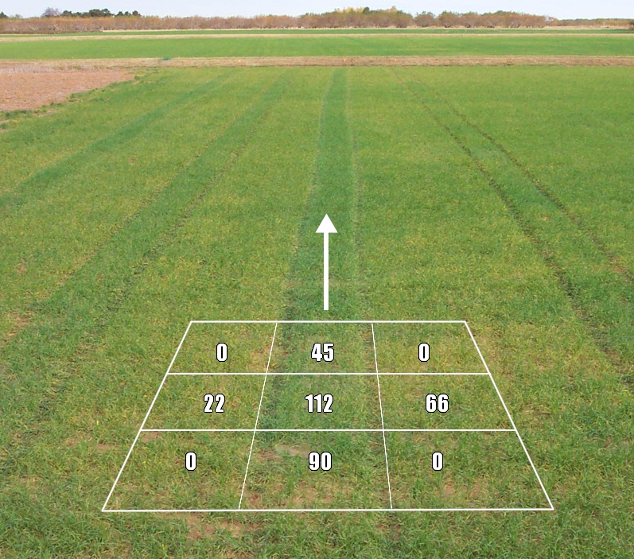
Figure 1. Continuous calibration stamps (9 m²) at Perkins, OK, in winter wheat at Feekes growth stage 4, and superimposed schematic of actual N rates in kg N ha⁻¹ using urea ammonium nitrate applied as a foliar spray.

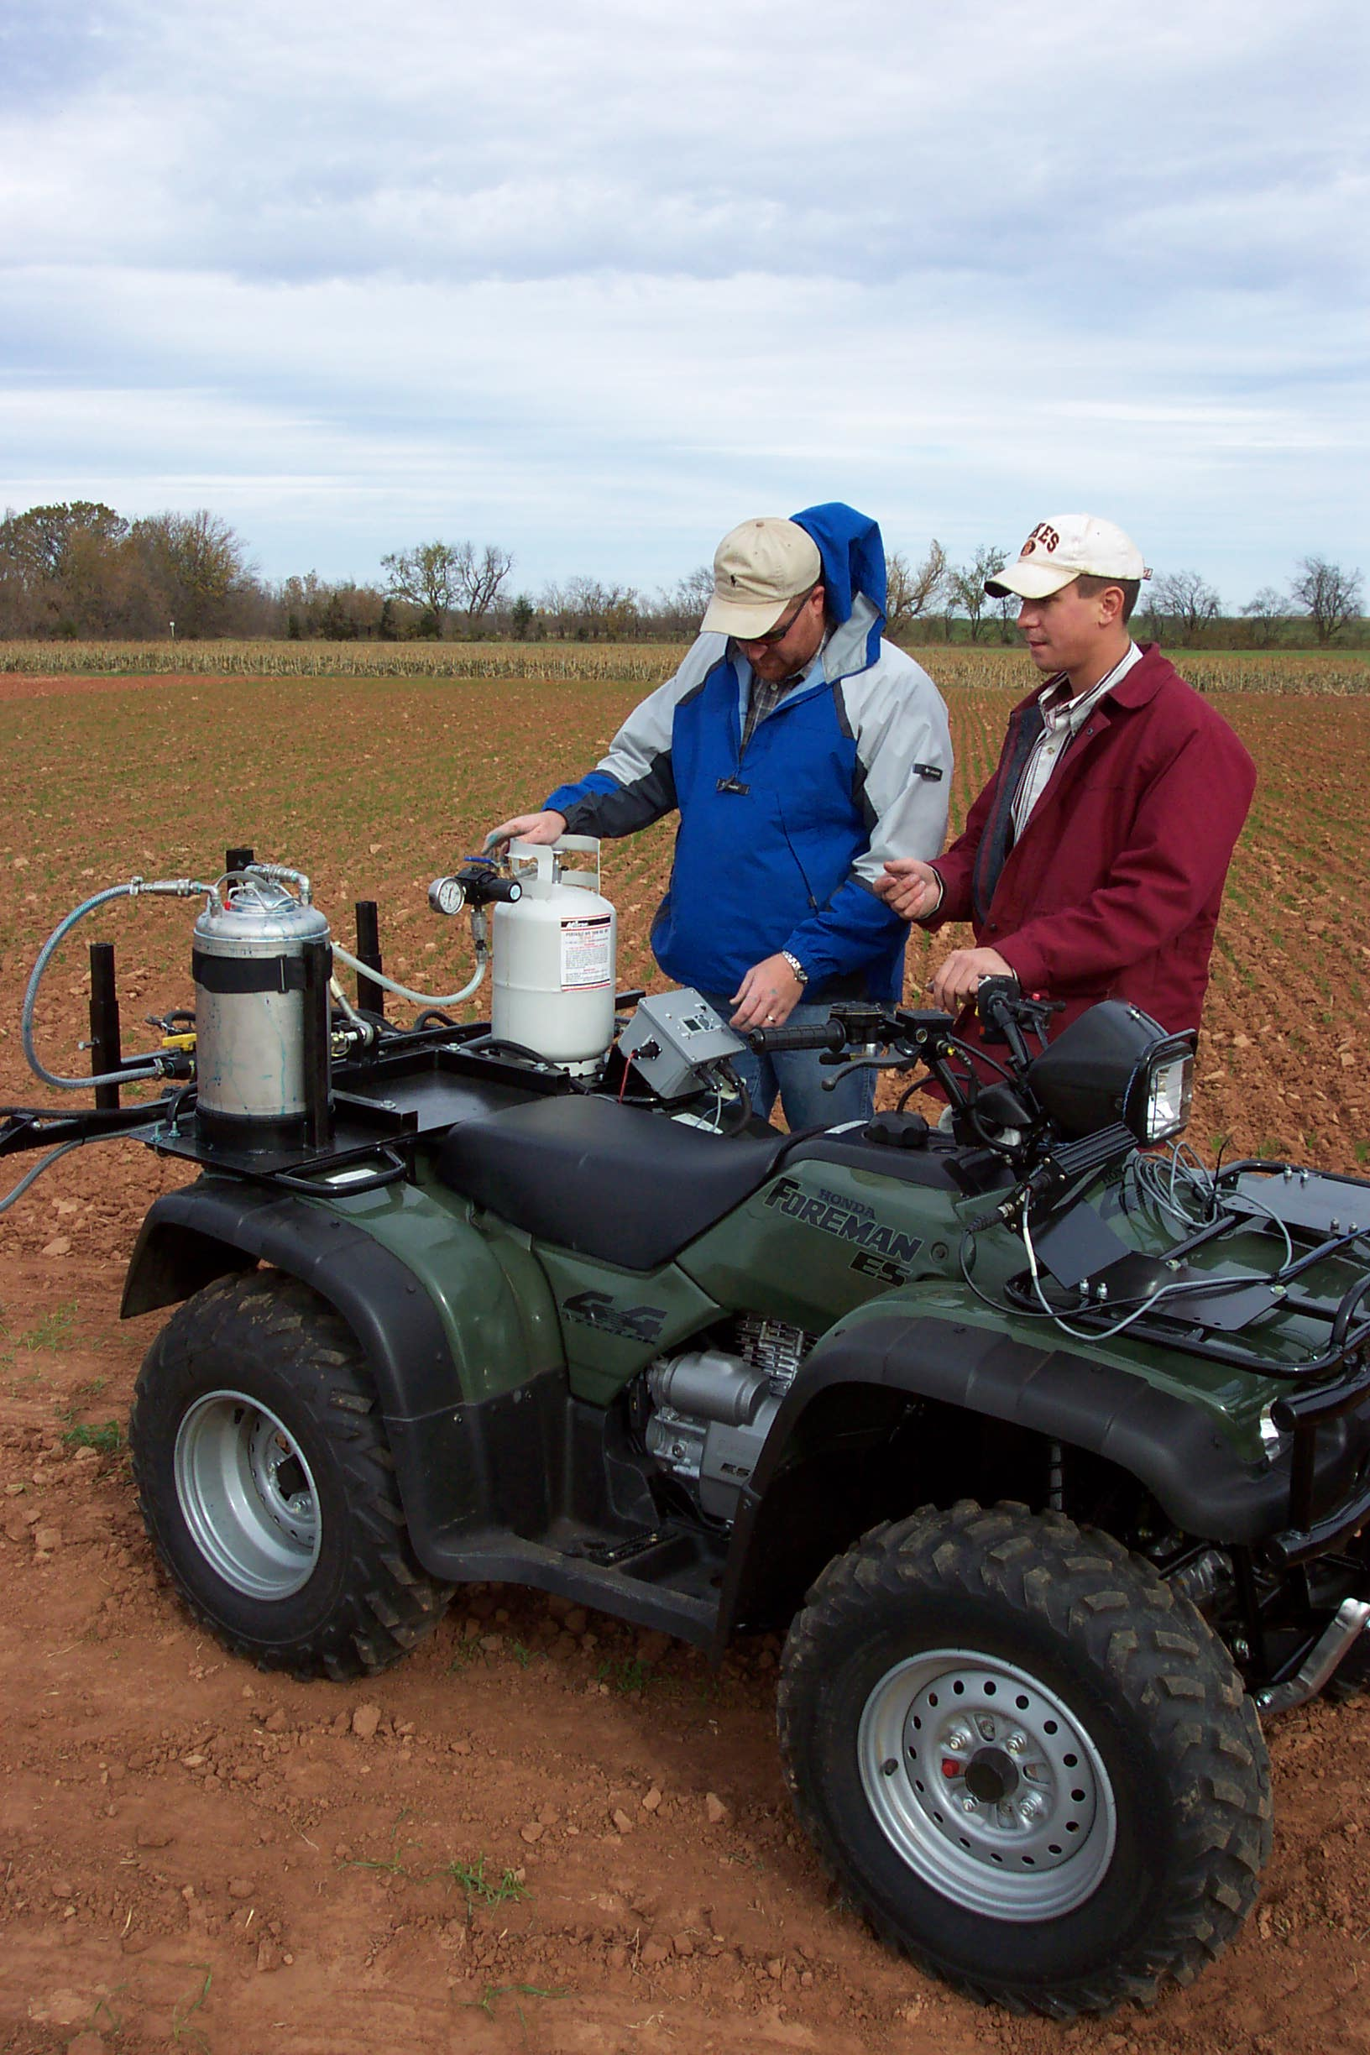
Figure 2. Automated controller, 8 liter pressured delivery tank and on-board pressurized air tank.

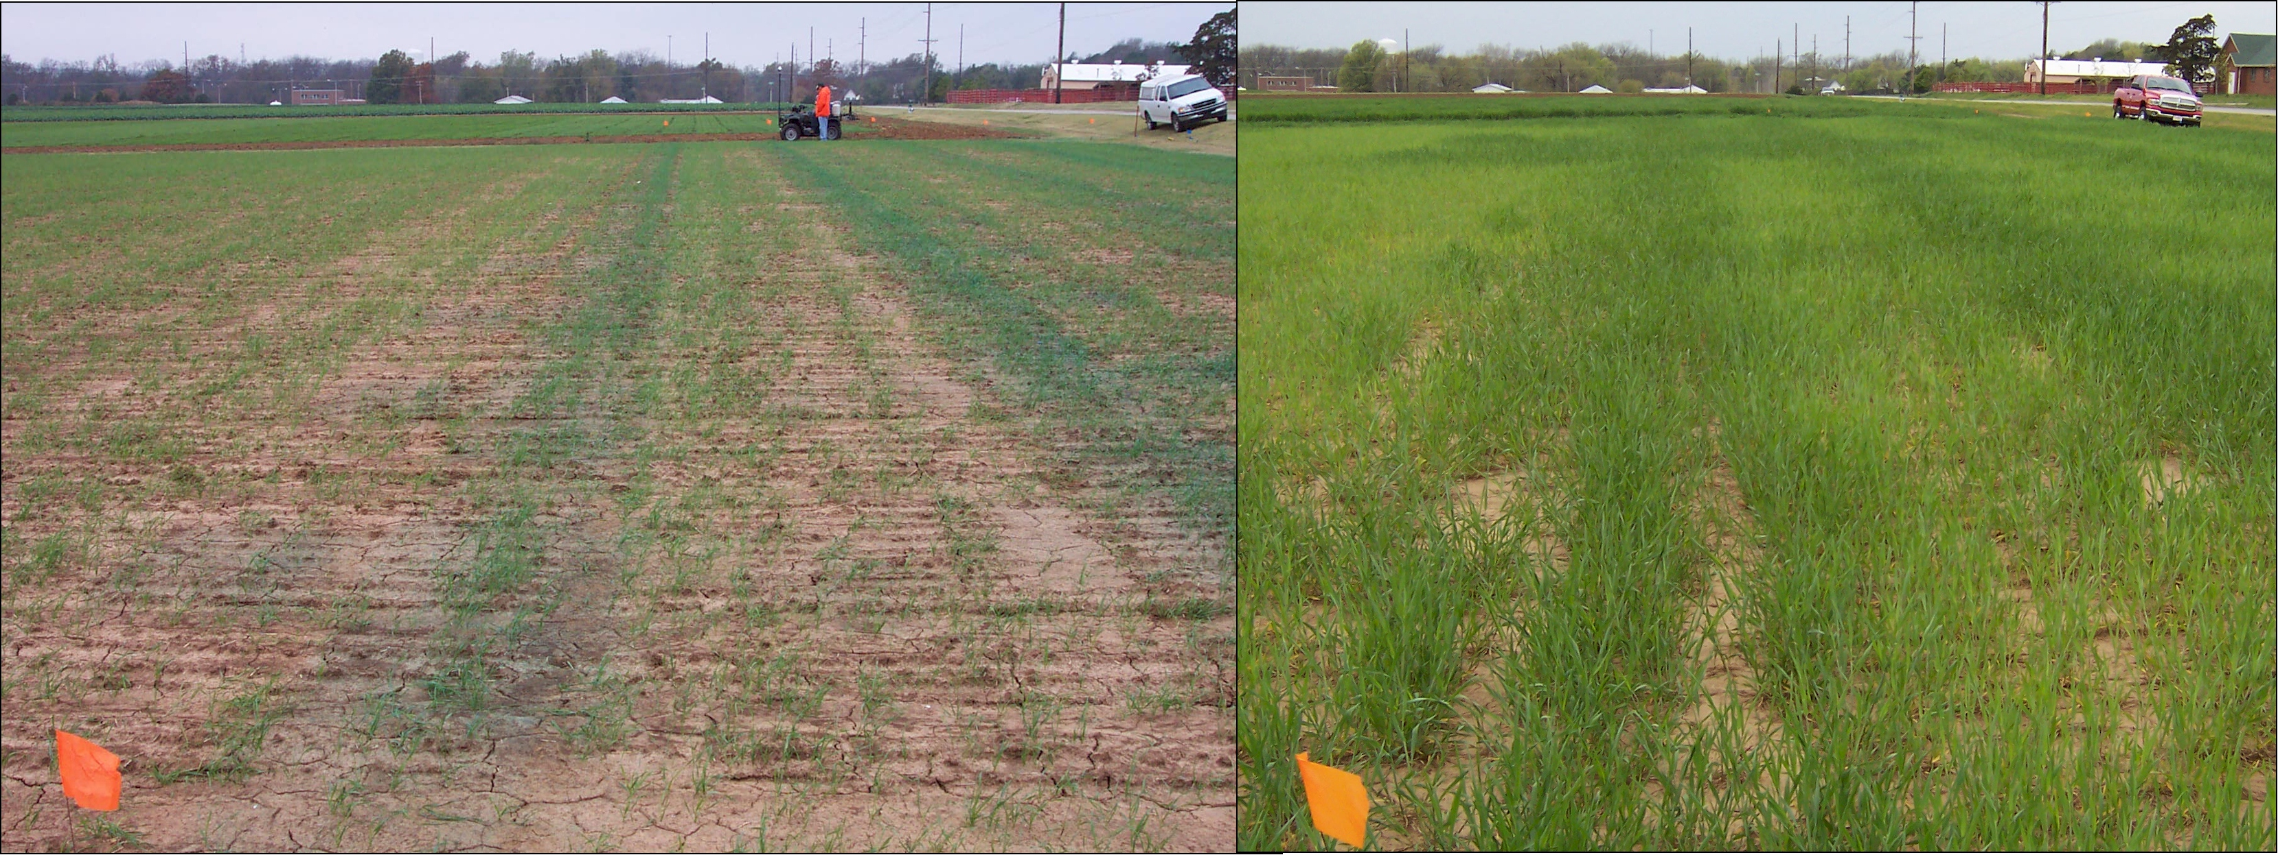 Figure 3. Calibration stamps applied soon after planting (left) and visual stamp differences mid-season (right) that are used to prescribe accurate mid-season N fertilizer rates.
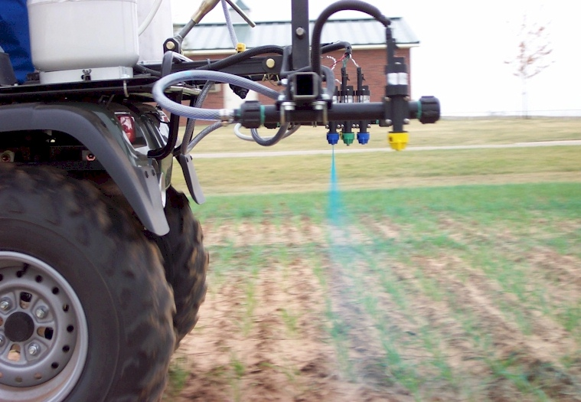
Figure 4. Side view of the calibration stamp showing the outside nozzle (yellow) and center 3 nozzles, and delivery of dyed urea ammonium nitrate via fan nozzles.
Figure 5. Schematic diagram of the calibration stamp applicator retrofitted for assembly on a conventional 4-wheeler including the air tank, fertilizer tank, electronics, and applicator boom.

