Soil-Plant Buffering of Inorganic Nitrogen in
Continuous Winter Wheat

W.R. Raun* and G.V. Johnson

Dep. of Agronomy, Oklahoma State University, Stillwater, OK 74078; Contribution from the Okla. Agric. Exp. Stn. *Corresponding author.

ACKNOWLEDGMENTS
The authors thank Dr. R.L. Westerman for initiating many of the ideas behind this work, Dr. Antonio Mallarino (Iowa State University) for his assistance with SAS programming and S.L. Taylor, R.K. Boman, M.E. Jojola, J. Chen, and S.E. Taylor for their assistance in compiling field and laboratory data.

Soil-Plant Buffering of Inorganic Nitrogen in
Continuous Winter Wheat

ABSTRACT
The soil-plant system can limit soil profile inorganic N accumulation when N fertilizers are applied at rates greater than needed for maximum yield. Nitrogen rates which maximized grain yield and that increased soil profile inorganic N accumulation under continuous dryland winter wheat (Triticum aestivum L.) were evaluated in four long-term experiments. Soil cores (0-210cm) were taken in 1988 and again in 1993 from N rate treatments where wheat has been grown for more than 23 years. Soil cores were split in 15-30 cm increments and analyzed for NH₄-N, NO₃-N, total N and organic C. Critical N fertilization rates were determined from linear-plateau models of wheat grain yield on annual N applied. Plateau-linear models were established for soil profile inorganic N accumulation (sum of NH₄-N + NO₃-N, converted to kg ha⁻¹) on annual N applied. Maximum yields were observed at N rates less than that required to increase soil profile inorganic N accumulation. Annual N fertilization rates which increased inorganic N accumulation, exceeded that required for maximum yields by more than 23.3 kg N ha⁻¹ in all experiments. Increased plant N volatilization, and grain N uptake have been found when N rates exceed yield maximums. High N rates can also increase straw yield and straw N, subsequently increasing surface soil organic C, N and the potential for denitrification when wheat straw residues are incorporated. Soil-plant buffering (considering the processes discussed) implies that the system buffers (resist) against soil accumulation of inorganic N, even when N rates exceed that required for maximum grain yield.

Introduction
Environmentally safe N rates for dryland winter wheat grain production systems require an evaluation of inorganic soil profile N accumulation. Early use of soil testing as a means of refining fertilizer N rates is discussed by Allison and Sterling, 1949, and has since evolved into various reliable procedures (Dahnke and Johnson, 1990). More recent work has addressed economic optimum rates of N fertilization using various methods (Nelson et al., 1985, Barreto and Westerman, 1987). It is important to note that refined N fertilizer rate recommendations have also resulted from improved methods of placement (Sharpe et al., 1988), timing of application (Olson et al., 1979), source (Touchton and Hargrove, 1982), and tillage system (Mengel et al., 1982), all of which have received considerable attention in continuous winter wheat and corn production systems. Recent work by Cerrato and Blackmer (1990), has focused increased attention on economic and environmental effects of over-fertilization.
Early work by Herron et al. (1971) identified the need to test soils for NH₄-N and NO₃-N to a depth of 90 cm to better evaluate fertilizer requirements for irrigated corn. Work by Westerman et al. (1994) employed the use of two quadratic equations (grain yield on N rate and soil profile NO₃-N accumulation on N rate) to determine the point where yields were maximized and soil profile NO₃-N accumulation was minimized. Their maximum difference method predicted N rates which optimized grain yield while minimizing the potential for inorganic soil N accumulation. Similar work by Jackson and Sims (1977) used a comprehensive N fertilizer management model for dryland winter wheat that considered soil properties and climatic factors, however, environmentally safe recommendations were not addressed.
Substantial research has been devoted to estimating nitrogen fertilizer recovery in continuous cropping systems. Nitrogen fertilizer recovery experiments have attributed unaccounted-for fertilizer N to plant N loss as NH₃ (Hooker et al., 1980; Daigger et al., 1976; O’Deen, 1989; Francis et al., 1993), denitrification (Olson et al., 1979; Olson and Swallow, 1984), surface volatilization of NH₃ when urea-N fertilizers have been used (Christensen and Meints, 1982), and NO₃-N leaching (Jokela and Randall, 1989; Olson and Swallow, 1984).
Present N recommendations in continuous grain production systems do not simultaneously consider N rates required for maximum grain yield while also minimizing N accumulation within the soil profile. The objective of this work was to establish these fertilizer N rates using linear-plateau and plateau-linear models. The difference between these N rates (N needed for maximum yield and N needed to increase soil profile inorganic N accumulation) is an estimate of the soil-plant buffering capacity for inorganic N when N rates exceed that needed for maximum yield.

MATERIALS AND METHODS
Four continuing long-term winter wheat (Triticum aestivum L.) fertility experiments (Table 1) were comprehensively soil sampled in July of 1993. This followed an initial sampling in 1988-1990 (Westerman et al., 1994) to further evaluate soil profile accumulation of NH₄-N and NO₃-N. Results from these two sampling periods were evaluated independently. The experiments employ a randomized complete block design and are identified as 222, 406, 502 and 505. Experiments 502 and 505 are separate studies conducted at the same location on a Grant silt loam (fine-silty, mixed, thermic Udic Argiustoll). Experiment 222 was on a Kirkland silt loam (fine, mixed, thermic Udertic Paleustoll), and 406 on a Tillman clay loam (fine, mixed, thermic Typic Paleustoll). Plots were (width x length) 6.1 x 18.3, 5.7 x 18.3, 4.9 x 18.3 and 4.9 x 12.2 m at experiments 222, 406, 502 and 505, respectively. Additional site information is provided in Table 1.
Winter wheat (Triticum aestivum L.) was planted in 25-cm rows at seeding rates of 67 kg ha⁻¹ and grown under conventional tillage (disk incorporation of wheat straw residues following harvest and prior to planting) in all years, at all locations. Ammonium nitrate (34-0-0), triple superphosphate (0-20-0), and potassium chloride (0-0-50) were broadcast and incorporated prior to planting. Annual fertilizer treatments for each experiment are defined in Table 2.
In 1993, three soil cores from each plot, 4.5 cm in diameter were taken to a depth of 210 cm and split in increments of 0-15, 15-30, 30-45, 45-60, 60-90, 90-120, 120-150, 150-180, and 180-210 cm. Samples were air-dried at ambient temperature and ground to pass a 20-mesh screen. Samples were extracted using 2M KCl (Bremner, 1965) and analyzed for NH₄-N and NO₃-N using an automated flow injection analysis system (Lachat, 1989, 1990). Total N and organic C were determined using a Carlo-Erba NA 1500 dry combustion analyzer (Schepers et al., 1989). For experiment 406, soil organic C was determined via digestion with an acidified dichromate (K₂Cr₂O₇-H₂SO₄) solution (Yeomans and Bremner, 1988) due to the presence of free CaCO₃ in surface horizons. Inorganic N (NH₄-N + NO₃-N) accumulation was determined on the mean of the three cores after concentration was converted to kg ha⁻¹ based on measured bulk density, to a depth of 210 cm. Previously collected soil cores (1 per plot, 0-240 cm) taken in 1988 or 1990 (Westerman et al., 1994) from the same treatments in each of the experiments had been stored at 10°C (over this 3-5 year time period). These samples were reanalyzed for NH₄-N and NO₃-N using the same procedures described here to assure analytical consistency. Only the 0-210 cm profile increments were included from the 1988-1990 sampling in order to be consistent with the 1993 sampling depth. Separate surface soil (0-30 cm) analyses from a composite sample (20 cores per plot) collected in the summer of 1993 from the same treatments in all experiments is reported in Table 2.
The center 3.0 m, over the entire length of each plot was harvested for grain yield each year using a conventional combine, and wheat straw was uniformly redistributed in all plots each year. Depending on the location, harvest areas ranged between 37.2 and 55.7 m². Average grain yields were calculated from the time of initiation of each experiment up to the 1988 or 1990 and 1993 sampling dates when deep soil cores were taken from each long-term experiment.
Yield response to applied N was evaluated using a two-segment linear-plateau model (Anderson and Nelson, 1975). Similarly, soil profile inorganic N accumulation at the two sampling dates was evaluated using a two-segment plateau-linear model. Linear-plateau and plateau-linear programs were adapted using the NLIN procedure (SAS, 1988). Equations for the linear-plateau models were y = b₀ + b₁ [min(X,A)] such that b₀ is the intercept, b₁ is the slope of the line up to where X (N rate) = A (point where the combined residuals were at a minimum) (Mahler and McDole, 1987). In each case, model significance was obtained using all replications. Best estimates for b₀, b₁ and the point of intersection (joint for linear and plateau portions, defined here as the critical N rate) were obtained from the model which minimized combined residuals. Combinations of possible values of b₀, b₁ and the point of intersection were evaluated (holding the other two constant), that ultimately resulted in the highest coefficient of determination (Mahler and McDole, 1987). Similarly, plateau-linear models minimized combined residuals by first establishing the plateau (no effect of N rate). Significant differences in the critical N rate for maximum grain yield that compared the two years included in this work were determined using a t-test that assumes unequal variances (Cochran and Cox, 1957) from independent linear-plateau models. Differences in critical N rates from plateau-linear models for soil profile inorganic N accumulation were determined using this same procedure. Soil-plant buffering capacities were estimated by subtracting the jointing point from plateau-linear models of inorganic N accumulation on N rate from that determined from linear-plateau models of grain yield on N rate (Tables 3 and 4). Lower and upper 90% confidence intervals about the critical N rate (joint) were calculated for both linear-plateau and plateau-linear models, and results from the two time periods compared (all years up to 1988 for experiments 222, 406 and 502 and all years to 1990 for experiment 505 compared to all years to 1993, Tables 3 and 4).
The response of average annual grain N uptake (grain yield multiplied times total N in the grain) to applied N was evaluated at each location for all years up to 1993 using a quadratic regression model. Linear-plateau models of average grain N uptake on N applied were also evaluated but failed to explain equivalent variation found in quadratic models.

RESULTS
A wide range in annual precipitation (by location) and average precipitation (across locations) was present in these long-term continuous winter wheat experiments. Extended periods occurred where soils were both saturated and extremely dry at each location in different years. A trend for increased soil organic carbon (0-30 cm) at the higher N rates was found in all experiments (Table 2).
Linear-plateau models of grain yield on N rate were all highly significant (PR<0.001) for both time periods (Tables 3 and 4 and Figures 1 and 2). Nitrogen rates which maximized grain yields (joint from linear-plateau models) were not significantly different between the two time periods (weighted t-test, PR = 0.98, 0.92, 0.79 and 0.79 for experiments 222, 406, 502 and 505, respectively). Predicted N rates which maximized grain yields differed by less than 3.5 kg N ha⁻¹ when comparing the same experiments over time (Figures 1 and 2 and Tables 3 and 4).
The sum of NH₄-N and NO₃-N was used to establish inorganic profile N accumulation even though significant differences in profile N were largely due to NO₃-N alone in all trials and both years sampled. Including both NH₄-N and NO₃-N was expected to reflect actual differences in soil profile inorganic N when comparing results across locations. Plateau-linear models of inorganic N accumulation on N rate were significant (PR < 0.001) in all experiments and both time periods excluding experiment 502 in 1988 (Figures 1 and 2 and Tables 3 and 4). For each experiment and time period, annual N application rates which significantly increased soil profile inorganic N were all greater than the N rate needed for maximum grain yields. Predicted N rates which resulted in a significant increase in soil profile inorganic N were not significantly different for the two sampling periods, excluding experiment 502 (weighted t-test, PR = 0.78, 0.93, 0.002 and 0.50 for experiments 222, 406, 502 and 505, respectively, Figures 1 and 2 and Tables 3 and 4). The poor correlation of soil profile inorganic N accumulation on N rate in experiment 502 in 1988 was limited by the range of N rates, which failed to produce a highly significant cause-effect relationship (Figure 1 and Table 3). Following five additional years of fertilizing and cropping (1993), small but significant increases in soil profile inorganic N at the high N rate were observed (Figure 2 and Table 4).
Soil profile inorganic N accumulation increased at only one observed N rate above the joint estimate in 3 of 8 plateau-linear models (experiment 222, Figures 1 and 2, and experiment 502, Figure 1). In these cases, the joint (critical N rate) would be >= 90 and < 135 kg N ha⁻¹ (experiment 222) and >=90 and < 112 kg N ha⁻¹ (experiment 502) since the joint could fall anywhere within these ranges without affecting residuals. However, the confidence limits about the joint estimate envelop this problem (significant increase in soil profile inorganic N accumulation only observed at the highest N rate) in terms of where to expect soil profile inorganic N accumulation to become significant.
Regression analyses of soil profile inorganic N accumulation on N rate, at N rates less than the jointing point is reported in Table 5. This analyses was performed to verify the presence of a plateau (no cause effect relationship) prior to the estimated joint. For all experiments and sampling periods the slope was not significantly different from zero, excluding experiment 406 in 1988 where a slightly negative slope was found (Table 5).

Discussion
Differences Between 1988-90 and 1993 Sampling
Critical N rates for maximum grain yield did not differ between the first (1988 or 1990) or second (1993) time periods for any of the long-term field experiments (Tables 3 and 4). Furthermore, critical N rates for inorganic soil profile N accumulation were also not different for the same contrasting time periods. An exception was experiment 502 where a significant increase in soil profile inorganic N could not be established in 1988 thus restricting this comparison.
Soil profile inorganic N (kg ha⁻¹) was similar when comparing the same locations for the two independent sampling dates (Figures 1 and 2). Given the large amount of inorganic N found (>500 kg ha⁻¹ in high N treatments in all experiments and years), and considering that rainfall was above average during the time period separating sampling dates, it was interesting to find no significant differences in soil profile inorganic N over this time period (AOV over time not reported). These results indicate that if leaching of N occurred, it was no different in the check (0-N) or fertilized plots (up to rates where accumulation was significant) since the N rate where accumulation became significant was the same for both time periods (sampling dates).
Once maximum grain yields had been achieved at a given N rate, one might expect that excess fertilizer N would immediately result in increased inorganic soil profile N accumulation. However, this was not observed at any of the four locations or years sampled. The estimated N rate (joint) where soil profile inorganic N accumulation increased, was considerably higher than the optimum N rate for maximum grain yields at all locations and for both time periods. In addition, the upper confidence limit for the estimated N rate required to achieve maximum grain yields was less than the lower confidence limit for the estimated N rate needed to increase soil profile inorganic N accumulation for both time periods excluding experiment 406 in 1988 (Tables 3 and 4). The N rates required to significantly increase soil profile inorganic N, exceeded that required for maximum yields by > 23.3 kg N ha⁻¹ (all experiments and both time periods, Tables 3 and 4). Given the significance of each model, these results show a resistance to change in inorganic soil profile N accumulation (buffering) when fertilizer N was applied at rates greater than that needed for maximum yield.

N Buffering Mechanisms
Mechanisms that would limit soil profile N accumulation when N rates exceeded that required for maximum yield were considered to explain the presence of soil-plant buffering of inorganic N. Results from several wheat experiments have shown that increased N rates resulted in increased grain protein without a subsequent increase in grain yield (Wuest and Cassman, 1992, Rasmussen and Rohde, 1991, Fowler and Brydon, 1989). Similar results were found in these experiments (Figure 3). Average grain N uptake beyond the N rate required for maximum yield but less than the N rate required to increase soil profile inorganic N, was 9.4, 5.3, 3.2 and 14.9 kg N ha⁻¹ yr⁻¹ (experiments 222, 406, 502 and 505, respectively). Based on the 1993 joint estimates for maximum yield and increased soil profile inorganic N accumulation, this increased grain N uptake represented, 19, 19, 14 and 27% of the soil-plant buffer at the same respective locations (Table 4 and Figure 3). Furthermore, increased grain N uptake was observed at all locations when N rates exceeded that required to increase soil profile inorganic N accumulation (Figure 3). Although this was found to level off soon after N rates exceeded that required to increase soil profile inorganic N accumulation, it enhances the importance of increased grain N uptake as a buffering mechanism against accumulation.
Increased plant NH₃ loss (and other volatile N forms) at high N rates have been observed in wheat (Parton et al., 1988, Harper et al., 1987) while similar results have also been found in corn (Francis et al., 1993). In experiments conducted by Harper et al. (1987), it was estimated that 21% of the applied N fertilizer was lost from the wheat plant and soil as volatilized NH₃ in an experiment that also reported no NO₃-N leaching. Work by Olson et al. (1979) noted that denitrification losses assisted in explaining unaccounted-for N which may have been greater at the higher N rates evaluated. Burford and Bremner (1975) found that denitrification losses increased under anaerobic conditions with increasing soil organic carbon from surface (0-15 cm) soils with a wide range in pH, texture, and organic carbon. Their work supports the action of denitrification as a buffering mechanism (during wet periods of the year) which could decrease the amount of NO₃-N leaching when N rates exceeded that required for maximum yields. The necessary substrate for denitrification, soil organic C, tended to be higher with increasing applied N in all four long-term experiments reported here (Table 2). Although soils were only saturated for limited periods of time in our dryland trials, work by Burford and Bremner (1975) aids in explaining added N loss (at high N rates) other than via NO₃-N leaching. Similar work by Havlin et al. (1990) found that high rates of applied N can result in increased soil organic C and N. This is attributed to increased biomass production at the higher N rates over a long period of time. Increased wheat straw N uptake and straw dry matter yields at high N rates (Rasmussen and Rohde, 1988) can account for increased soil organic C and total N when N fertilization rates exceeded requirements for maximum grain yield.

Soil-Plant Buffering of Inorganic N
Although not specifically investigated in this work, each of the previously mentioned mechanisms aid in understanding why immediate increases in soil profile inorganic N were not observed when N rates exceeded that required for maximum yields. Furthermore, each of these mechanisms aid in understanding why plateau-linear models would be appropriate to evaluate soil profile inorganic N accumulation as a function of N applied. Two distinct relationships between soil profile inorganic N and N rate are implied; no cause and effect up to a critical N rate (plateau, slope=0) and a significant cause and effect (linear, slope significantly different from zero) beyond the critical N rate. Excess N fertilizer can continue to be assimilated by the plant resulting in increased grain protein, straw N removal and plant N loss, each of which could act as compensating factors or buffering mechanisms. Work by Harper et al. (1987) found no evidence to suggest large amounts of N translocated from vegetative plant parts to the roots and subsequent N loss by the roots to the soil. Even if this were a significant pathway for plant N loss, soil profile inorganic N accumulation from these long-term trials would reflect these possible differences.
This work supports the hypothesis that applied inorganic N and/or inorganic N coming from organic pools are subject to various fates that can diminish the likelihood of NO₃-N leaching. Work by Westerman et al. (1994) reported soil profile NO₃-N accumulation within specific profile increments (e.g., experiment 505, 180-210 cm) at levels exceeding the annual amount of N applied when extremely high rates were used. For this to occur, leaching below the depth sampled could not have been a major pathway for N loss. Excluding freely drained deep sandy soils, inorganic N accumulation reported here was expected to reveal if and where excessive N rates contributed to the potential for NO₃-N leaching in dryland wheat production systems.
An illustration of the buffer concept is shown in Figures 1 and 2 whereby an inorganic N buffer zone is calculated based on the differences between the N rate where significant soil profile inorganic N accumulation took place and the N rate where maximum yields were achieved. Use of the maximum difference method proposed by Westerman et al. (1994) did not identify this inorganic N buffer zone since two quadratic equations (grain yield on N rate and soil profile NO₃-N accumulation on N rate) were employed that resulted in one specific N rate when simultaneously solving for X. While their approach optimizes the difference between yield and inorganic soil N accumulation, it is limited to identifying a single rate for both dependent variables. Alternatively, the combined use of linear-plateau and plateau-linear models are useful in identifying factor(s) which control response following an observed maximum with one variable (Y₁), but prior to an increase in another variable (Y₂) when both are regressed on X.
Grain yield maximums were obtained at markedly different N rates at all locations, which was expected to be a function of the native N supplying power of each soil, percent organic matter, rainfall, and a combination of other biological factors. Although limited by the number of sites reported, the soil-plant buffer tended to be positively correlated with surface soil (0-30 cm) organic carbon. It is possible that the soil-plant buffer could be greater in soils with high soil organic matter, however, this is expected to be dependent upon the cropping system employed, climatic conditions which influence plant and soil gaseous N loss, variety, and the possible combination of several other factors. It is important to note that these relationships could not have been studied in short-term experiments where changes in soil organic carbon levels would not have been expressed in three to five year studies, and when N rates were only slightly above the requirement for maximum yield.
Differences in the size of the soil-plant buffer at the locations studied here could not be attributed to differences in plant type since the same varieties were employed. However, in all instances, the N rate required for inorganic N accumulation to become significant was greater than that required for maximum yield and that the confidence intervals about each estimate (maximum yield and inorganic N accumulation) did not overlap (exception was experiment 406, 1988). While the soil-plant buffer zone has been emphasized, we recognize that buffering exists over the entire range of fertilizer N rates used in these studies. Long-term N rate experiments with other continuous cropping systems should reveal similar results when the same common, fundamental chemical and biological processes are active. Where inorganic soil profile N accumulation directly reflects the potential for NO₃-N leaching, this evaluation method should be useful in establishing ‘safe’ N rates in crop production systems. Future work will focus on identifying the specific variables which characterize differences in soil-plant buffering.

REFERENCES

Allison, F.E., and L.D. Sterling. 1949. Nitrate formation from soil organic matter in relation to total nitrogen and cropping practices. Soil Sci. 67:239-252.

Anderson, R.L., and L.A. Nelson. 1975. A family of models involving intersecting straight lines and concomitant experimental designs useful in evaluating response to fertilizer nutrients. Biometrics 31:303-318.

Barreto, H.J., and R.L. Westerman. 1987. YIELDFIT: A computer program for determining economic fertilization rates. J. Agron. Educ. 16:11-14.

Bremner, J.M. 1965. Inorganic forms of nitrogen. In C.A. Black et al. (ed.) Methods of soil analysis, Part 2. Agronomy 9:1179-1237. Am. Soc. of Agron., Inc., Madison WI.

Burford, J.R., and J.M. Bremner. 1975. Relationships between the denitrification capacities of soils and total, water-soluble and readily decomposable soil organic matter. Soil Biol. Biochem. 7:389-394.

Cerrato, M.E., and A.M. Blackmer. 1990. Comparison of models for describing corn yield response to nitrogen fertilizer. Agron. J. 82:138-143.

Christensen, N.W., and V.W. Meints. 1982. Evaluating N fertilizer sources and timing for winter wheat. Agron. J. 74:840-844.

Cochran, William G., and Gertrude M. Cox. 1957. Experimental designs. 2nd ed. John Wiley & Sons. New York, New York.

Dahnke, W.C. and Gordon V. Johnson. 1990. Testing soils for available nitrogen. In R.L. Westerman (ed.) Soil testing and plant analysis. 3rd ed. SSSA, Madison, WI.

Daigger, L.A., D.H. Sander and G.A. Peterson. 1976. Nitrogen content of winter wheat during growth and maturation. Agron. J. 68:815-818.

Fowler, D.B., and J. Brydon. 1989. No-till winter wheat production on the Canadian praries: timing of nitrogen fertilization. Agron. J. 81:817-825.

Francis, D.D., J.S. Schepers and M.F. Vigil. 1993. Post-anthesis nitrogen loss from corn. Agron. J. 85:659-663.

Harper, L.A., R.R. Sharpe, G.W. Langdale and J.E. Giddens. 1987. Nitrogen cycling in a wheat crop: soil, plant and aerial nitrogen transport. Agron. J. 79:965-973.

Havlin, J.L., D.E. Kissel, L.D. Maddux, M.M. Claassen and J.H. Long. 1990. Crop rotation and tillage effects on soil organic carbon and nitrogen. Soil Sci. Soc. Am. J. 54:448-452.

Herron, G.M., A.F. Dreier, A.D. Flowerday, W.L. Colville and R.A. Olson. 1971. Residual mineral N accumulation in soil and its utilization by irrigated corn (Zea mays L.). Agron. J. 63:322-327.

Hooker, M.L., D.H. Sander, G.A. Peterson and L.A. Daigger. 1980. Gaseous N losses from winter wheat. Agron. J. 72:789-792.

Jackson, Grant D., and James R. Sims. 1977. Comprehensive nitrogen fertilizer management model for winter wheat. Agron. J. 69:373-376.

Jokela, W.E., and G.W. Randall. 1989. Corn yield and residual soil nitrate as affected by time and rate of nitrogen application. Agron. J. 81:720-726.

Lachat Instruments. 1989. Quickchem method 12-107-04-1-B. Lachat Instr., Milwaukee, WI.

Lachat Instruments. 1990. Quickchem method 12-107-06-1-B. Lachat Instr., Milwaukee, WI.

Mahler, R.L., and R.E. McDole. 1987. Effect of soil pH on crop yield in northern Idaho. Agron. J. 79:751-755.

Mengel, D.B., D.W. Nelson and D.M. Huber. 1982. Placement of nitrogen fertilizers for no-till and conventional till corn. Agron. J. 74:515-518.

Nelson, L.A., R.D. Voss, and J.T. Pesek. 1985. Agronomic and statistical evaluation of fertilizer response. p. 53-90. In O.P. Engelstad (ed.) Fertilizer technology and use, 3rd ed. ASA, Madison, WI.

O’Deen, W.A. 1989. Wheat volatilized ammonia and resulting nitrogen isotopic fractionation. Agron. J. 81:980-985.

Olson, R.V., L.S. Murphy, H.C. Moser and C.W. Swallow. 1979. Fate of tagged fertilizer nitrogen applied to winter wheat. Soil Sci. Soc. Am. J. 43:973-975.

Olson, R.V., and C.W. Swallow. 1984. Fate of labeled nitrogen fertilizer applied to winter wheat for five years. Soil Sci. Soc. Am. J. 48:583-586.

Parton, W.J., J.A. Morgan, J.M. Altenhofen and L.A. Harper. 1988. Ammonia volatilization from spring wheat plants. Agron. J. 80:419-425.

Rasmussen, P.E., and C.R. Rohde. 1988. Stubble burning effects on winter wheat yield and nitrogen utilization under semiarid conditions. Agron. J. 80:940-942.

Rasmussen, P.E., and C.R. Rohde. 1991. Tillage, soil depth, and precipitation effects on wheat response to nitrogen. Soil Sci. Soc. Am. J. 55:121-124.

SAS Institute Inc. 1988. SAS/STAT Procedures, Release 6.03 Edition. Cary, NC.

Schepers, J.S., D.D. Francis, and M.T. Thompson, 1989. Simultaneous determination of total C, total N, and ¹⁵N on soil and plant material. Commun. In Soil Sci. Plant Anal. 20:949-959

Sharpe, R.R., L.A. Harper, J.E. Giddens and G.W. Langdale. 1988. Nitrogen use efficiency and nitrogen budget for conservation tilled wheat. Soil Sci. Soc. Am. J. 52:1394-1398.

Touchton, J.T., and W.L. Hargrove. 1982. Nitrogen sources and methods of application for no-tillage corn production. Agron. J. 74:823-826.

Westerman, Robert L., Randal K. Boman, William R. Raun and Gordon V. Johnson. 1994. Ammonium and nitrate nitrogen in soil profiles of long-term winter wheat fertilization experiments. Agron J. 86:94-99.

Wuest, S.B., and K.G. Cassman. 1992. Fertilizer-nitrogen use efficiency of irrigated wheat: I. uptake efficiency of preplant versus late-season application. Agron. J. 84:682-688.

Yeomans, J.C., and J.M. Bremner. 1988. A rapid and precise method for routine determination of organic carbon in soil. Commun. In Soil Sci. Plant Anal. 19:1467-1476.
FIGURES

Figure 1. Linear-plateau models of grain yield on annual N applied and plateau-linear models of inorganic N accumulation on annual N applied and the estimated soil-plant buffer for inorganic N (gray) from experiments 222, 406, 502 (1988) and 505 (1990).
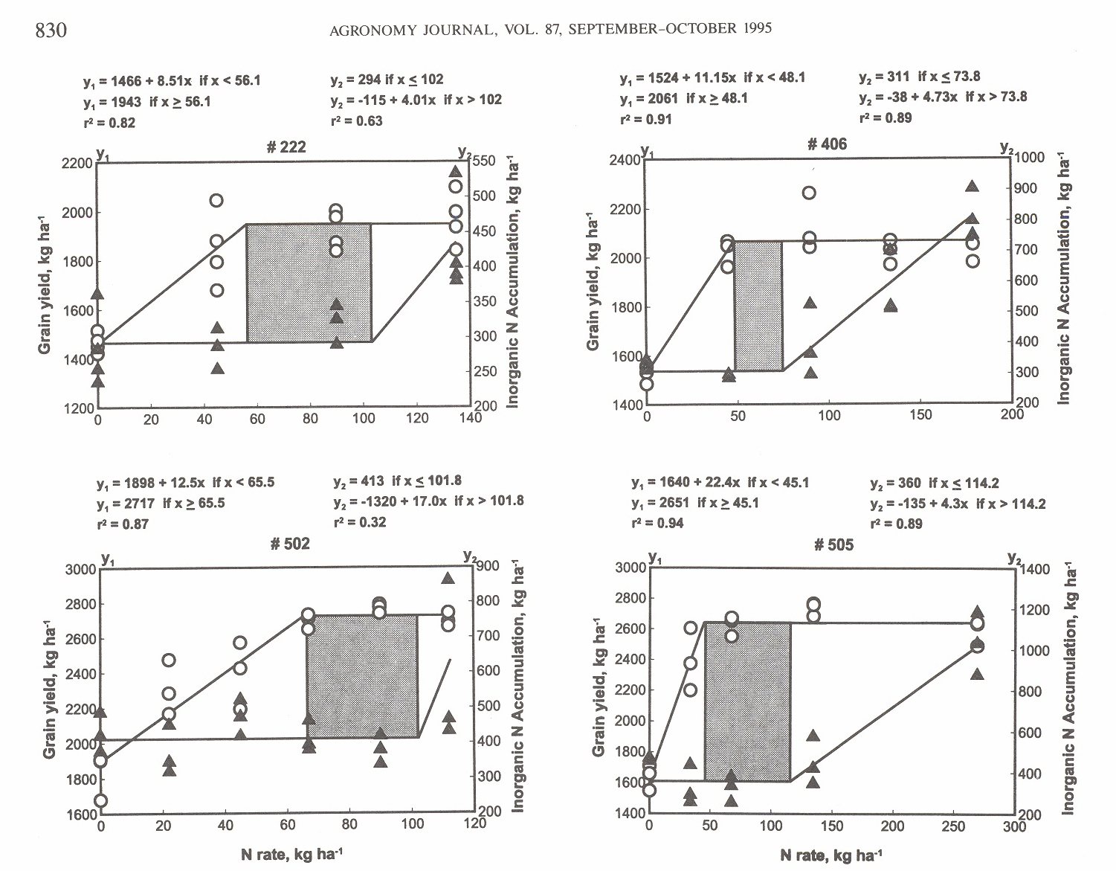

Figure 2. Linear-plateau models of grain yield on annual N applied and plateau-linear models of inorganic N accumulation on annual N applied and the estimated soil-plant buffer for inorganic N (gray) from experiments 222, 406, 502 and 505 (1993).
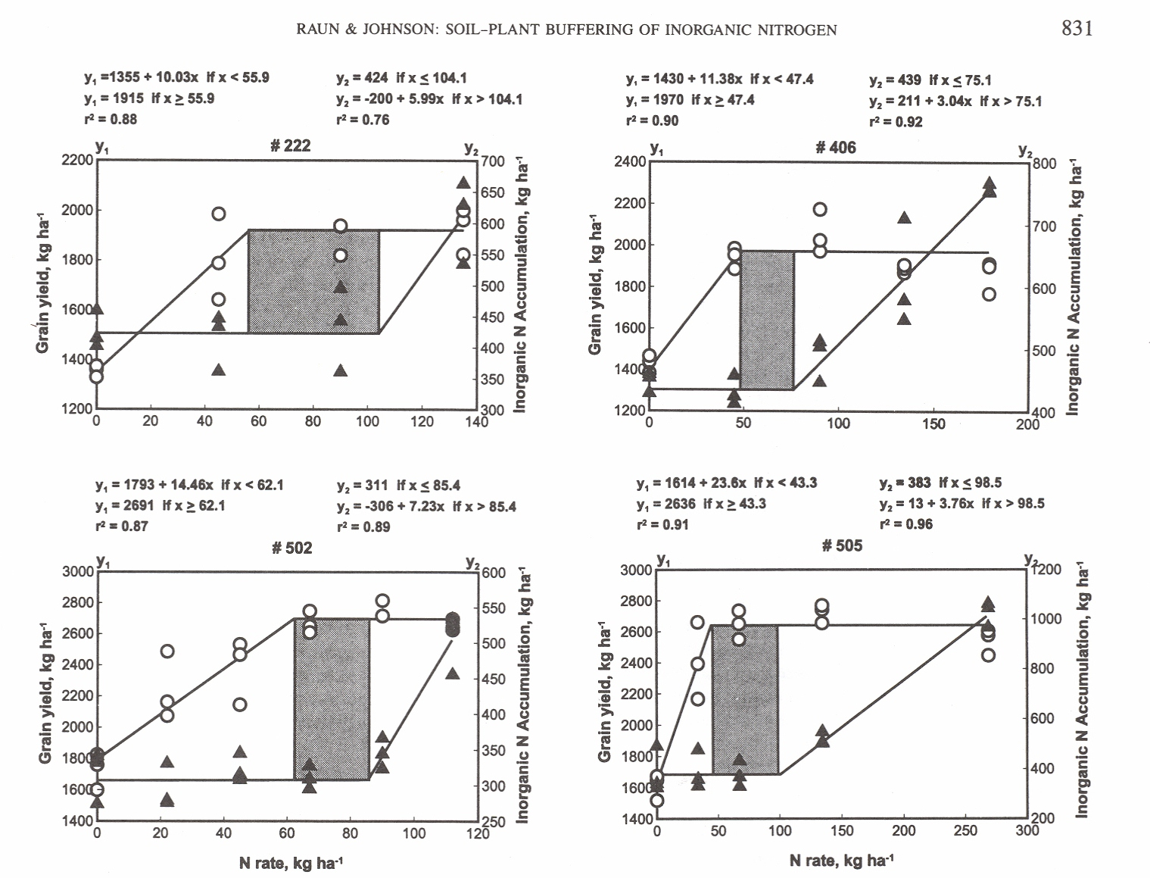
Figure 3. Quadratic regression models of grain N uptake on annual N applied, superimposed critical levels for maximum grain yield and soil profile inorganic N accumulation (difference between the two vertical lines represents the estimated soil-plant buffer in Figure 2) and percent of the soil-plant buffer explained by increased N uptake, experiments 222, 406, 502 and 505 (all years up to 1993).

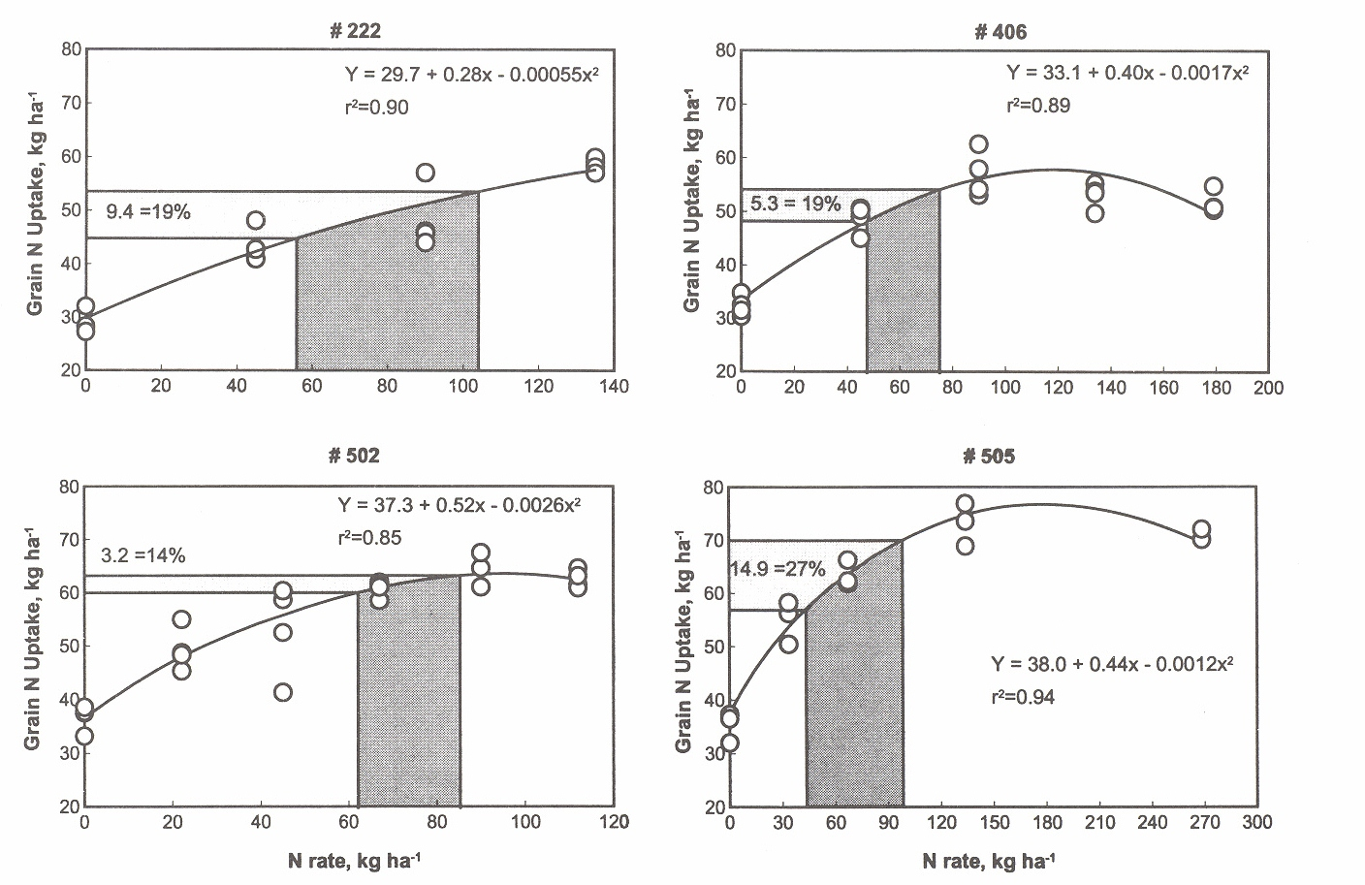
Table 1. Long-term experiment included in the analysis, year established, soil core sampling date, crop years prior to sampling, annual average rainfall and range in annual rainfall.
_____________________________________________________________________________________
Experiment Year Number of Dates Crop Years Annual avg.
Established Replications Sampled Prior to Rainfall╫ Range
Sampling
_____________________________________________________________________________________
-------- mm --------
222 1969 4 Sept. 1988 19 894 606-1403
July 1993 24 922 606-1493
1057╪ 738-1493╪
406 1965 4 Sept. 1988 23 640 295-1141
July 1993 28 670 295-1141
806╪ 698-1053╪
502 1970 4 Sept. 1988 18 772 503-1314
July 1993 23 771 503-1314
765╪ 556-1017╪
505 1970 3 July 1990 20 768 503-1314
July 1993 23 771 503-1314
780╪ 555-1017╪
______________________________________________________________________________________
╫ - obtained from the years each study was conducted up until soil profile sampling and analyses was performed.
╪ - average rainfall and range for the last 5 years (experiments 222, 406 and 502) and last 3 years (experiment 505).
Table 2. Treatments and surface soil test characteristics (0-30 cm) in 1993 for experiments 222, 406, 502 and 505.
_____________________________________________________________________________________
Experiment Fertilizer Applied Soil Test Level
N P K pH P K Organic C╪ Total N╪
_____________________________________________________________________________________
------------ kg ha⁻¹ ------------ mg kg⁻¹ mg kg⁻¹ g kg⁻¹ g kg⁻¹
222 0 29 38 5.76 81 43 6.15 0.79
45 29 38 5.49 62 45 6.16 0.75
90 29 38 5.47 66 32 6.14 0.75
134 29 38 5.38 56 32 6.48 0.84
SED 0.12 16 6 0.31 0.05
406 0 0 0 7.15 15 60 7.57 0.68
45 20 38 7.11 51 66 6.95 0.69
90 20 38 7.07 45 72 8.11 0.71
134 20 38 6.63 44 69 8.31 0.71
179 20 38 6.60 45 68 8.30 0.75
SED 0.18 3 4 0.42 0.05
502 0 20 56 5.67 92 69 5.34 0.70
22 20 56 5.66 93 65 5.68 0.74
45 20 56 5.42 91 66 5.88 0.72
67 20 56 5.41 113 69 5.94 0.80
90 20 56 5.25 122 70 5.98 0.78
112 20 56 5.07 94 69 5.76 0.79
SED 0.13 18 5 0.44 0.02
505 0 29 56 5.35 156 56 6.38 0.71
34 29 56 5.23 150 58 6.46 0.70
67 29 56 5.00 142 61 6.41 0.70
134 29 56 4.85 126 56 7.91 0.77
269 29 56 4.62 140 59 7.18 0.76
SED 0.21 9 3 0.89 0.04
_____________________________________________________________________________________
pH, 1:1 soil:water; K and P, Mehlich III; Organic C (carbon) and Total N, dry combustion.
╪ average of 0-15 and 15-30 cm profiles.
SED - standard error of the difference between two equally replicated means.
Table 3. Confidence limits about joint estimates (critical levels) for linear-plateau models of grain yield on N rate and plateau-linear models of soil profile inorganic N accumulation on N rate, and the estimated soil-plant buffer for inorganic N when N rates exceed that required for maximum yield from long-term experiments sampled in the summer of 1988 (222, 406 and 502) and the summer of 1990 (505).
_____________________________________________________________________________________
Experiment Dependent 90% Confidence Interval Soil-Plant
Variable Lower Upper Joint r² Buffer
_____________________________________________________________________________________
------------------- kg N ha⁻¹ ---------------------- kg N ha⁻¹
222 Grain Yield 40.8 71.4 56.1 0.82** 45.9
Profile N 91.7 112.4 102.0 0.63**
406 Grain Yield 39.2 56.9 48.1 0.91** 25.7
Profile N 52.4 95.2 73.8 0.89**
502 Grain Yield 45.2 85.7 65.5 0.88** 36.3
Profile N 95.8 107.8 101.8 0.32*
505 Grain Yield 35.4 54.8 45.1 0.94** 69.1
Profile N 80.2 148.2 114.2 0.89**
_____________________________________________________________________________________
* Buffer estimate could not be established since inorganic profile N did not increase with increasing N applied.
** ,* - model significant at the 0.001 and 0.05 probability levels, respectively.

Table 4. Confidence limits about joint estimates (critical levels) for linear-plateau models of grain yield on N rate and plateau-linear models of soil profile inorganic N accumulation on N rate, and the estimated soil-plant buffer for inorganic N when N rates exceed that required for maximum yield from long-term wheat experiments sampled in the summer of 1993.

_____________________________________________________________________________________
Experiment Dependent 90% Confidence Interval Soil-Plant
Variable Lower Upper Joint r² Buffer
_____________________________________________________________________________________
-------------------- kg N ha⁻¹ ---------------------- kg N ha⁻¹
222 Grain Yield 40.7 71.1 55.9 0.88** 48.2
Profile N 95.8 112.5 104.1 0.76**
406 Grain Yield 37.8 57.0 47.4 0.90** 27.7
Profile N 57.1 93.1 75.1 0.92**
502 Grain Yield 46.9 77.2 62.1 0.87** 23.3
Profile N 80.2 90.5 85.4 0.89**
505 Grain Yield 34.7 51.9 43.3 0.91** 55.2
Profile N 75.9 121.0 98.5 0.96**
_____________________________________________________________________________________
** - model significant at the 0.001 probability level.
Table 5. Test for the significance of slope components (different from zero) for the regression of soil profile inorganic N accumulation on N rate, when N rates were less than the joint determined from plateau-linear models, for both sampling periods and all experiments.

Experiment Year slope (b1) PR > |t|
_____________________________________________________________________________
222 1988 0.37 0.27
1993 0.08 0.84
406 1988 -0.73 0.03*
1993 -0.36 0.38
502 1988 0.63 0.35
1993 0.06 0.85
505 1988 -1.96 0.10
1993 -0.17 0.87
_____________________________________________________________________________
PR > |t| - probability of a greater absolute value of t.
* - significant at the 0.05 probability level.

