Soil Fertility Research Report 2000

Oklahoma Agricultural Experiment Station
Oklahoma Cooperative Extension Service
Division of Agricultural Sciences and Natural Resources
Oklahoma State University

Editors

E.V. Lukina, K.W. Freeman, R.W. Mullen, K.J. Wynn,
W.E. Thomason, Roger Teal, Jagadeesh Mosali,
Tao Feng, D.E. Needham, C.N. Washmon, J.B. Solie, M.L. Stone, N.T. Basta, J.A. Hattey,
H. Zhang, S. Deng, J.M. Shaver, R.L. Westerman, G.V. Johnson and W.R. Raun

Department of Plant and Soil ScienceS
Department of biosystems and agricultural engineering

Foreword
On November 1, 1989, the state adopted a program whereby an assessment of thirty cents ($0.30) per ton of fertilizer sold in the state would be directed for the sole purpose of conducting soil fertility research involving efficient fertilizer use on agronomic crops and forages and groundwater protection from plant food nutrients. A Research Advisory Committee was formed to oversee and guide research programs as mandated by the legislation. The committee is composed of representatives from the Oklahoma Fertilizer and Chemical Association, fertilizer dealer representatives from the northeast, southeast, northwest and southwest quadrants of the state, representative from a fertilizer manufacturer, representatives from the Farm Bureau and Farmers Union and the Director of the Oklahoma Department of Agriculture with Ex-Officio members consisting of the Head of the Department of Plant and Soil Sciences, Oklahoma State University, the Director of the Oklahoma Conservation Commission and the President of the Oklahoma Fertilizer and Chemical Association. Each year, the Research Advisory Committee meets to review preproposals for research. Without the support provided by The Fertilizer Advisory Board (Senate Bill 314), the extent of work reported here would not have been possible.
Over the years many agricultural industries, agencies and commodity groups have provided support and service for ongoing research projects that promote the wise and efficient use of fertilizers that minimize environmental risks. Significant contributors include the following:

The Fertilizer Advisory Board, SB 314
Samuel Roberts Noble Foundation
Oklahoma Fertilizer and Chemical Association
Oklahoma Plant Food Educational Society
Farmland Industries
Phillips Chemical Company
Agrico
Allied Chemical
The Potash/Phosphate Institute
The Foundation for Agronomic Research
The Fluid Fertilizer Foundation
Tennessee Valley Authority
State Department of Agriculture
Oklahoma Wheat Research Foundation
Oklahoma Wheat Commission
Oklahoma Center for the Advancement of Science and Technology

Many of these groups still provide financial assistance and service today. Investigators whose work is cited in this report greatly appreciate the cooperation of many County Extension Agents, Area Extension Agronomists, farmers and ranchers, fertilizer dealers, grain dealers, seed suppliers, fertilizer equipment manufacturers, agricultural chemical manufacturers, and the representatives of the various firms who contributed time, effort, land, machinery, materials and laboratory analyses. Without their support, much of the work reported here would have greatly diminished.
This report provides a summary of some of the latest results in soil fertility research and as such does not constitute publication of the finalized form of the various investigations. No part of this report may be duplicated or reproduced without the written consent of the individual researchers involved.
Both English and metric units are used in the articles which comprise this document. A simple conversion table has been included (Appendix Table 1) in order to avoid any confusion that might arise.

Robert L. Westerman
Professor and Head
Department of Plant and Soil Sciences
Oklahoma State University

Graduate Students in Soil Fertility (1992-present)
1. Attefat, Mehdi Iraq M.S 1992
2. Ascencio, Edgar Noel. El Salvador M.S. 1992
3. Sembiring, Hasil. Indonesia M.S. 1993
4. Jojola, Michael E. USA M.S. 1994
5. Ascencio, Edgar Noel. El Salvador Ph.D. 1995
6. Kanampiu, Fred Kenya Ph.D. 1995
7. Gavi-Reyes, Francisco Mexico Ph.D. 1995
8. Ball, Jeff B. USA M.S. 1995
9. Phillips, Steven B. USA M.S. 1995
10. Taylor, Shannon L. USA M.S. 1996 **
11. Chen, Jing China M.S. 1997
12. Keahey, Dale, Alan. USA M.S. 1997
13. Lees, Heather, L. USA M.S. 1997 **
14. Sembiring, Hasil Indonesia Ph.D. 1997 ***
15. Thomason, Wade USA M.S. 1998
16. Lukina, Erna V. Uzbekistan M.S. 1998
17. LaRuffa, Joanne M. USA M.S. 1999 **
18. Phillips, Steven B. USA Ph.D. 1999 ***
19. Dennis, Jeremy USA M.S. 1999
20. DeLeon, Micah Argentina M.S. 1999
21. Cossey, Doug USA M.S. 1999
22. Woolfolk, Curt USA M.S. 1999
23. Lukina, Erna, V. Uzbekistan Ph.D. 2002 ‡
24. Mullen, R.W. USA M.S. 2000 ‡
25. Wang, Jing China M.S. did not finish
26. Thomason, Wade USA Ph.D. 2002 ‡ ***
27. Ladd, Jay USA M.S. did not finish
28. Wynn, Kathy USA M.S. 2001 ‡
29. Freeman, Kyle USA M.S. 2002 ‡
30. Prajakta, Ghatpande India M.S. did not finish
31. Feng, Tao China M.S. 2002 ‡
32. Teal, Roger USA M.S. 2002 ‡
33. Mosali, Jagadeesh India Ph.D. 2002 ‡
34. Moges, Shambel Ethiopia M.S. 2003 ‡

** Outstanding M.S. student, Department of Plant and Soil Sciences
*** Outstanding Ph.D. student, Department of Plant and Soil Sciences
‡ Current graduate student

Contributing Plant and Soil Sciences Faculty and Staff
N.T. Basta USA Soil Chemistry
J.A. Hattey USA Soil Science Teaching and Research
Hailin Zhang China Director Soil, Water and Forage Anal. Lab
Jonathan M. Shaver USA Plant Science Teaching
R.B. Westerman USA Row Crops Weed Specialist
J.H. Stiegler USA Soil Management
J.L. Caddel USA Alfalfa Breeding
E.G. Krenzer USA Small Grains Specialist
D.S. Murray USA Row Crops Weed Control
J.F. Stritzke USA Forage Weed Control
C.M. Taliaferro USA Bermudagrass and Switchgrass Breeding
B. Woods USA Extension Area Agronomist
M.P. Anderson USA Plant Biochemistry
J.C. Banks USA Cotton Specialist
R.L. Westerman USA Department Head
G.V. Johnson USA Soil Fertility Extension and Research
W.R. Raun USA Soil Fertility Research

Contributing Biosystems and Agricultural Engineering Faculty
J.B. Solie USA Machine Design and Analysis
M.L. Stone USA Sensor Design and Controls
Paul Weckler USA Electronics/Sensors

Contributing Staff from The Noble Foundation
J.L. Rogers USA Soil Fertility
W. Altom USA Soil Fertility/Crop Management
J.B. Ball USA Soil Fertility

Undergraduate Support Personnel

Aaron Witt Hooker, OK
Tyson Tillman Hollis, OK
Michael Clay Kelly Mustang, OK
Jason Lawles Hydro, OK
Chad Miller El Dorado, OK
Paul James Hodgen Roachadale, IN
Angela Dawn Lewis Stillwater, OK
Erica Jane Justesen Pawhuska, OK
Bambi Sidwell Goltry, OK
Gricelda Esquilin Nicaragua

TABLE OF CONTENTS
THE WEB 9
Future of Sharing Research Results 9
NITROGEN USE EFFICIENCY 11
Evaluating Nitrogen Use Efficiency for Cereal Production 11
In-Season Prediction of Potential Grain Yield in Winter Wheat Using Canopy Reflectance 21
Winter Wheat Fertilizer Nitrogen Use Efficiency in Grain and Forage Production Systems 35
Production System Techniques to Increase Nitrogen Use Efficiency in Winter Wheat 44
Improving Fertilizer Nitrogen Use Efficiency Using Alternative Legume Interseeding in Continuous Corn 55
Estimating Grain Response Index with an In-season NDVI Response Index 60
Improving Nitrogen Use Efficiency for Cereal Production 75
Relationship Between Ammonium and Nitrate in Wheat Plant Tissue and Estimated Nitrogen Loss 87
PRECISION AGRICULTURE 100
Optimum Field Element Size for Maximum Yields in Winter Wheat Using Variable Nitrogen Rates 100
Late-Season Prediction of Wheat Grain Yield and Grain Protein 111
Detection of Nitrogen Deficiencies in Cotton Using Spectral Irradiance and Cotton Response to Topdress Applications 125
In-season Sensor Based Measurements from Long-Term Experiments to Refine Estimates of INSEY 133
Nitrogen Fertilization Optimization Algorithm Based on In-Season Estimates of Yield and Plant Nitrogen Uptake 141
Use of INSEY for Topdress Nitrogen Applications in Winter Wheat 151
Estimating Vegetation Coverage in Wheat Using Digital Images 160
Effect of Row Spacing, Growth Stage, and Nitrogen Rate on Spectral Irradiance in Winter Wheat 169
FERTILIZER AND THE ENVIRONMENT 188
Detection of Phosphorus Runoff from Long-term Continuous Wheat Fertility Trials 188
PRODUCTION AGRICULTURE 191
Nitrogen Loss from Urea Fertilizer Applications in Hot, Dry Soils 191
Winter Wheat Yield Response to Deep Knifed Nitrogen Applications 196
Alfalfa Yield Response To Method and Rate Of Applied Phosphorus 204
Switchgrass Response to Harvest Frequency, and Time and Rate of Applied Nitrogen 214
Forage Yield and Crude Protein of Interseeded Legume-Bermudagrass Mixtures as Affected by Phosphorus Fertilizer 224
Soybean Grain Yield and Protein Responses to Rate, Source, and Timing of Application of Fertilizer N 232
Alfalfa Yield Response to Nitrogen Applied After Each Cutting 236
Effects of Ethephon and KH₂PO₄ on Winter Wheat Nitrogen Use Efficiency 251
Effect of Nitrogen Source and Method of Application on NUE in Winter Wheat 255
Relationship Between Mean Yield, Coefficient of Variation, Mean Square Error and Plot Size in Wheat Field Experiments 261
CARBON SEQUESTRATION 269
Estimated Land Area Increase of Agricultural Ecosystems to Sequester Excess Atmospheric Carbon Dioxide 269
Estimated Increase in Atmospheric CO₂ due to Worldwide Decreases in Soil Organic Matter 277
LONG TERM EXPERIMENTS 283
The Magruder Plots: Environmental Production History 1892-2000 283
Experiment 222: Long-Term Winter Wheat Fertility With Continuous Application of N, P and K 286
Experiment 301: Long-Term Application of Sewage Sludge and Ammonium Nitrate on Wheat Grain Yield and Forage Quality 289
Experiment 406: Wheat Grain Yield Response to Nitrogen, Phosphorus and Potassium Fertilization 292
Experiment 407: Response of Dryland Winter Wheat to Nitrogen, Phosphorus and Potassium Fertilization 296
Experiment 439: Effect of Long-Term Applications of N, P, and K on Cotton Lint Yields 301
Experiment 501: Response of Grain Sorghum to Nitrogen, Phosphorus and Potassium Fertilization 307
Experiment 502: Effect of Annually Applied N, P and K on Long-Term Wheat Grain Yields 310
Experiment 505: Nitrogen Source and Rate Effects on Long-Term Continuous Winter Wheat Grain Yield 313
Experiment 801: Effects of Nitrogen, Phosphorus, and Potassium on Yield of Winter Wheat 317
Experiment 802: Wheat Grain Yield Response in Acid Soils to Phosphorus Applications 320
Experiment 803: Wheat Grain Yield Response in Acid Soils to Potassium Applications 323
Experiment 804: Wheat Grain Yield Response in Acid Soils to Lime Applications 326
CHLORIDE and LIME 329
Soil Chloride, Nitrate and Sulfate in Oklahoma Soils 329
Effect of Chloride Fertilizers and Lime on Wheat Grain Yield and Take-All Disease 332

THE WEB

Future of Sharing Research Results

G.V.Johnson, J.B. Solie, M.L. Stone, R.W. Mullen,
W.E. Thomason, and W.R. Raun

Abstract
Since early 1997, we began working on methods to rapidly disseminate research results. The world wide web (WWW) or internet has provided us with an incredible opportunity concerning sharing research information. Our first site placed on the Division of Agriculture and Natural Resources (DASNR) server was the Nitrogen Use Efficiency Web Page (NUE-W) (www.dasnr.okstate.edu/nitrogen_use). Since first being placed on the Web (May 6, 1998), this site has received 7400 hits or an average of 8.5/day (Table 1). This site includes 448 total pages and has 305 additional hyperlinks. An equally important characteristic is the number of sites that have included NUE-W as a referenced hyperlinked site. Comprehensive information on fertilizer sources, methods of application, nitrogen cycling and methods to improve NUE are included on this site and will be expanded. The Precision Agriculture (www.dasnr.okstate.edu/precision_ag) web page has received a total of 2300 hits, averaging 3.0 per day. This site is referenced in various other Precision Ag web sites, and has continued to grow, largely due to the demand for relevant material in this area. The Fertilizer Checkoff web site (www.dasnr.okstate.edu/fertilizer_checkoff) was developed to communicate specific results associated with research funding to our Advisory Board. Two additional sites, SOIL 5813 (http://soil5813.okstate.edu) and SOIL 4213 (http://soil4213.okstate.edu) are web pages used specifically for teaching. SOIL 5813 is an advanced class on ‘Soil-Plant Nutrient Cycling and Environmental Quality’ for M.S. and Ph.D. students, while SOIL 4213 is an extension of our Precision Ag efforts, and that is offered to Junior and Seniors in the Division of Agriculture. A total of 2652 hyperlinks are included in the SOIL 5813 class web site, clearly indicating the extensive nature of a class-web-site, and also showing that substantial information is available on the web that is relevant in teaching. The last site ‘NPK’ (www.dasnr.okstate.edu/NPK) was developed primarily as an extension tool, but also serves as a link for SOIL 4234 ‘Soil Nutrient Management.’ In addition, the SOIL FERTILITY HANDBOOK is listed in digital format on this site. These web sites developed primarily by soil fertility personnel are a small subsample of what is available in the Division. They clearly show how quickly research results can be communicated in Oklahoma with the added benefit of world-wide dissemination. Past investment in printing brochures, books, pamphlets, etc., could now be invested in web-based educational materials.

Table 1. Web sites developed by the soil fertility research program, date established, focus, hits and pages included in each site.

Web Site | Web Address | Focus | Start Date | Hits | Avg. Hits/day | Total # of Pages | Total # of Hyperlinks
Nitrogen Use Efficiency | www.dasnr.okstate.edu/nitrogen_use | Increased nitrogen use efficiency for winter wheat and corn | May 6, 1998 | 7400 | 8.5 | 448 | 305
Precision Agriculture | www.dasnr.okstate.edu/precision_ag | Development of sensor-based technologies for precise management of each 1m² area | July 22, 1998 | 2300 | 3 | 144 | 174
Fertilizer Checkoff | www.dasnr.okstate.edu/fertilizer_checkoff | Management and reporting of fertilizer checkoff funds | Nov 13, 1998 | 837 | 1 | 53 | 106
Soil 5813 | http://soil5813.okstate.edu | Class lectures, notes, handouts, exams, etc., for the graduate level class, ‘Soil-Plant Nutrient Cycling and Environmental Quality’ | Jan 11, 2000 | 705 | 3 | 129 | 2652
Soil 4213 | http://soil4213.okstate.edu | Class lectures, notes, handouts, exams, etc., for the undergraduate, and graduate level class, ‘Topics in Precision Agriculture’ | May 4, 2000 | 115 | 2 | 9* | 15*
Soil 4234 | www.dasnr.okstate.edu/NPK | Extension of the Soil Fertility Handbook, class lectures, notes, handouts, exams, etc., for ‘Soil Nutrient Management.’ | March 17, 1999 | 1161 | 2 | 53 | 56

*many of the links from the class site are embedded within the precision agriculture site (www.dasnr.okstate.edu/precision_ag)
NITROGEN USE EFFICIENCY

Evaluating Nitrogen Use Efficiency for Cereal Production

G.V. Johnson and W.R. Raun

Efficiency is a term used by science and engineering to express the degree to which inputs to a system contribute to desired outputs. Everyday lives have many examples where efficiencies play an important role. Kilometers driven per liter of fuel consumed is an expression of fuel efficiency for automobiles. Our own daily activity compared to caloric food intake is an indication of how efficiently we use food. In addition to maintaining our bodies, some food is used as we work. Excess may be passed on as waste, and some may be stored as fat. When food is abundant, there is little concern for the amount that is passed through the body or that which may be stored as fat. Efficiency on an individual basis may not seem important. However, the efficiency of a population is the product of its individuals, and on a macro scale efficiency becomes very important. This simple description for food efficiency in the animal kingdom also serves as a general model for nitrogen (N) use efficiency (NUE) in cereal production.
Fertilizer-N undergoes a tortuous path before it accumulates in the grain of maize or sorghum. Once applied to the soil, there are many pathways that can prevent it from accumulating in the grain. Each alternative pathway contributes to decreased NUE. Fertilizer-N must navigate through several soil processes that may either prevent or promote its seasonal uptake by plant roots. Unused N may be stored for use in a subsequent season or lost permanently from the soil-plant system. Nitrogen absorbed during plant development may accumulate in the grain only to the extent of available storage capacity (determined after flowering). Excess plant-N may be permanently lost by ammonia (NH₃) gas volatilization from plant leaves (Francis et al., 1993).
NUE is usually calculated as the ratio of fertilizer-N in the grain to fertilizer-N applied, expressed as a percentage. NUE for maize and sorghum is highest when fertilizer-N inputs exactly match grain accumulation removed in harvest, and management can eliminate potential losses from the system on a recurring basis.

NUE Definition. Nitrogen use efficiency in crop production may be defined simply as the ratio of N harvested to N applied for a production field or unit. Dividing N harvested by N applied and multiplying by 100 results in expressing NUE as a percentage:

(Harvested-N/Fertilizer-N) 100 = % NUE [1]

In any single growing season fertilizer-N may either be supplemented or partially consumed by soil biological activity to an unknown degree. Because of this, NUE computations account for harvested-N from an unfertilized area. Thus, in field plot research the calculation of NUE is usually expressed as

((Harvested-N₁-Harvested N₀)/Fertilizer-N₁) 100 = % NUE [2]

Where N₁ and N₀ refer to fertilized and unfertilized conditions, respectively.

NUE Interpretations. It may be argued that biological release of plant available-N is enhanced in the unfertilized plot as a result of continual plant removal of, ammonium-N (NH₄-N).

Soil Organic-N == mineralization ===➔ NH₄-N [3]

In such a case, calculated NUE would be erroneously low because there is no opportunity for the reverse process, immobilization, to occur. However, research has also shown an increase in mineralization of organic-N when fertilizer-N is applied, referred to as a “priming effect” (Westerman and Kurtz, 1973). Using the heavy isotope ¹⁵N as a fertilizer tracer has not resolved the issue of seasonal soil biology influences as NUE’s calculated by either approach are similar.

Small Plot Research. Reported NUE values for different crops using small plot research are typically in the range of 20 to 80 %. Given the uncertainties of soil biological influences for a given site and season, the most reliable estimates of NUE are from long-term plot studies and from large geographic regions. Long-term averages from plot studies tend to remove season-to-season fluctuations between mineralization and immobilization of N. An example for winter wheat response to N fertilizer and associated NUE values averaged for a 20-year period from Oklahoma, USA, is shown in Figure 1. NUE was calculated using equation [2]. This figure shows the typical relationship where as yields increase by addition of fertilizer-N, NUE decreases. Similarly, this relationship for maize and sorghum was the same in long-term studies from Nebraska, USA (Figure 2).

World NUE. Calculation of NUE for large geographic regions on an annual basis will include a wide range of conditions for which the average net mineralization or immobilization in a given year would more likely represent general trends in soil organic-N changes over time. A common feature of most, if not all, cultivated soils is the general loss of soil organic matter, associated with mineralization of organic-N, over time. This is especially true for the first 100 years of cultivation. The extent of this organic-N loss is directly related to how long the soil has been under cultivation, cultivation intensity, and harvested yield level. Consequently, when NUE for geographical regions is considered, it is important to identify a ‘soil input’, similar to N uptake for untreated plots in small plot trials, in addition to the fertilizer-N input. A second, non-fertilizer input to consider is atmospheric deposition or rainfall. Accounting for these inputs leads to the general equation

100 [(Harvested-N) –(N from soil and rainfall)]/(Fertilizer-N) = % NUE [4 ]

In review of world fertilizer use and production estimates, an NUE value of 33 % has been estimated for world cereal grain production (Raun and Johnson, 1999). This estimate (Table 1) includes an assumption that 50 % of the harvested N is derived from rainfall and soil mineralization (Keeney, 1982). This value is in agreement with the averages from long-term plot research of maize and sorghum from Nebraska (22.7 %) and wheat from Oklahoma (40.0 %). The economic importance of improving NUE on a global scale is provided from the calculation that raising NUE by 1 % would have a value of $234,658,462 in N fertilizer savings if yields were maintained.

Cause of low NUE’s.

N losses. Soil-plant systems are inefficient because some N is lost during the growing season. Soil losses are associated with leaching of nitrate-N (NO₃⁻-N); gaseous loss as nitric oxide (NO), nitrous oxide (N₂O) and diatomic nitrogen (N₂), all products of denitrification; and ammonia (NH₃) volatilization of ammonium (NH⁺₄) at alkaline pH. Additionally there is loss of NH₃ from cereal plant leaves following anthesis when the plant has accumulated more tissue-N than can be assimilated into grain. Each of these losses, commonly depicted in what is known as the ‘nitrogen cycle’ (Figure 3.), decrease the efficiency with which indigenous and fertilizer N are used by the crop.
It is important to recognize that each of the above losses is a product of either a biological or chemical reaction. Common to these reactions is the fact that as the concentration (or amount) of one or more of the reactants increases, it drives the reaction to create more product. Consequently, losses occur in direct relation with the excess of N in the soil-plant system. The amount of excess N present depends upon how closely N inputs can be managed to exactly match crop requirements during the growing season. Common fertilization practices usually involve only one or two inputs. When these are made, the result is a high concentration of NH₄ and/or NO₃-N in the soil. Since plants can only assimilate small amounts each day, there is a high risk for loss and immobilization of unassimilated fertilizer-N over time. This system response is like dumping a large volume of water into a reservoir connected to several pipes that can accept water, when only one or two of the pipes will transport the water to a desired location. If a few of the undesired pipes leak or slowly transport the water away from the desired location, then the more pressure (volume of water in the reservoir) the more water will be lost and transport efficiency to the desired location will decrease.

Economics. Although NUE values for cereal production are quite low, there is little concern among crop producers because the relative value of the yield continues to be high, compared to the low cost of applying N required for large and often maximum yields. For maximum wheat yields using the US data with N priced at $0.44/kg and wheat at $0.098/kg, the value/ha of yield increase to N fertilizer cost was approximately $103 to $43 for a 2.4:1 return on investment. However, when the response curve is examined for maximum profit, it is found to exist at an N rate 21.4 % below the rate for maximum yield. At maximum profit the yield response is valued at $98 and the N fertilizer cost at $33 for a 3.0 to 1 return on investment. In the latter case, there is only a yield reduction of about 50 kg grain/ha but an increase in marginal profit of $5/ha.
Similarly, with maize valued at $0.085/kg the data from Nebraska would provide returns of 2.8 to 1 at an N rate for maximum yield (8857 kg/ha) and 3.3 to 1 at an N rate for maximum marginal profit. At maximum marginal profit the N rate would be 39 kg/ha less than for maximum yield, the yield would be 100 kg/ha less, and the return would be $8/ha greater. However, if the N rate is 39 kg more than that required for maximum yield the yield is almost unchanged while the marginal profit is decreased by $26/ha. As a result, it is clear from this work that there is a greater economic loss from a slightly excessive N rate than a deficient rate (Figure 4).
Economic outcomes vary from year to year depending on the relative cost of N and value of the harvested crop. However, when crops respond to N there is almost always a good return on investment even when the N rate that results in maximizing yield is not the most economical. Since producers do not have the benefit of yield response curves for their fields, they tend to apply more N than necessary even for maximum yield. Excess N leads to low NUE values. The skill and management abilities of farmers is judged by their peers based on what they see, such as crop yield levels, and not profit margin realized.

Improving NUE.

Avoid Excess Fertilizer-N. Highest NUEs will be obtained when crops are produced without excess N during the growing season. While it may be near impossible to provide daily inputs to exactly match daily crop needs adjusting input of seasonal needs is probable. This is commonly done by estimating a realistic yield goal, calculating the N removed by the crop, adjusting for NUE, subtracting any available soil-N measured by soil test and applying the difference as fertilizer. Two assumptions in this approach that contribute to poor NUE are:
That the yield goal (or potential yield) is reliable, and
That contribution from non-fertilizer-N is minimal and constant.

Inspection of the Nebraska data for irrigated maize and sorghum shows that although maximum yields varied some over the 15 years, yields without fertilizer-N (control) varied more. Maize control plots averaged 5610 kg/ha with a coefficient of variation (CV) of 34.3 % while the maximum yielding plots averaged 9050 kg/ha and had a CV of only 15.7 %. Sorghum control plots averaged 6060 kg/ha and had a CV of 31.7 % while the maximum yielding plots averaged 8290 kg/ha and had a CV of only 16.3 %. For both the maize and sorghum there is almost twice as much error associated with assuming a constant yield from the control (availability of non-fertilizer-N) as from estimating the potential yield from the average fertilized grain yield. The CV’s from fertilized plots that were but half that found in check plots suggests that N fertilization assisted in decreasing year-to-year variability. In addition these decreased CV’s indicate that N was indeed limiting since the addition of this commodity lessened the impact of environment on observed yields (compared to the check).
In order to avoid excess N fertilization it is imperative that the yield without fertilizer-N and the potential yield with optimum N input be known or estimated for each year. If this can be achieved, then N fertilization can be low in years when the soil is capable of supplying N for a high yield relative to the potential yield and N fertilization can be high when the soil-N supply is poor relative to needs of a high potential yield. If these adjustments could be made then NUE would be improved by inputting fertilizer-N according to the degree to which a yield response is possible. Evidence for this is illustrated in Figure 5, where NUE is shown in relation to the crop response index and the response index is calculated as

Response Index = Maximum fertilized yield / Unfertilized yield [5]

This Response Index identifies the extent to which N-response is possible in a given year and is seen to vary from little N response (1.1 Response Index) to 3.5 times the control yield. Although average NUE was highest for the 90 kg N/ha rate, annual NUE for this rate was not correlated well (R² = 0.37) with the Response Index because this low rate was not as much in excess at small Response Indexes. The best NUE for each rate was obtained at the highest Response Index because each rate is in excess least in this growing environment. The best relationship (R² = .80) between NUE and Response Index over the 15-year period is found for the 180 kg N/ha rate which, on average (Figure 2), was the lowest rate to provide near maximum yield. While nearly as excessive as the 270 kg N/ha rate at low Response Index, it is less excessive at high Response Indexes. The 270 kg N/ha rate tends to be in excess, and thus results in low NUE, across all Response Indexes.
The high correlations between NUE and Response Index is partly because each variable has the control yield in its calculation. However, the maximum yield or fertilized yield is also in each calculated variable. A plot of the control yield and the maximum yield from N-fertilized plots against Response Index shows the control yield to vary considerably more than grain yield at the 180 kg N/ha rate or the maximum yield from N fertilization, relative to Response Index (Figure 6). It is important to note that control yield decreases with increasing Response Index. This indicates that years when there is poor response to N are a result more of higher yields in the check plots than lower yields where fertilizers were applied. Similarly, years when there is a large response to N are a result more from low yields in the check plots than unusually high yields of fertilized plots. Similar relationships were found for irrigated sorghum and dryland winter wheat.

In-Season Yield Estimates. Response to fertilizer-N, as measured for irrigated corn and sorghum by the response index, varied greatly over the 15-year period for which data was collected (Figure 7.). There was a trend for increasing response with time for maize, but no change in response with time for sorghum. Since there is great variability in response to fertilizer-N from year to year, there is also great variation in NUE from year to year (Figure 8) if the fertilizer-N rate is held constant, which is the common practice.
There are several management practices that could be implemented to improve NUE on a field-by-field, regional, or global basis (Raun and Johnson, 1999). However, for each of these or combination thereof, the greatest opportunity for increased NUE will be from improved reliability in estimating the final yield of fertilized crops and the extent to which that yield may be supported from indigenous soil N. Current research (Raun, et al., 2000, unpublished) using optical sensors to evaluate potential yield of 1 m² areas within a field at early growth stages will allow for in-season adjustment of fertilizer N based on projected yield potential. In addition, this work will likely lead to increased NUE and grain yields.

References
Francis, D.D., J.S. Schepers, and M.F. Vigil. 1993. Post-anthesis nitrogen loss from corn. Agron. J. 85:659-663.

Keeney, Dennis R. 1982. Nitrogen management for maximum efficiency and minimum pollution. In Frank J. Stevenson (ed.) Nitrogen in agricultural soils. Agron. Monogr. 22. ASA, CSSA and SSSA, Madison, WI.

Tkachuk, R. 1977. Calculation of the nitrogen-to-protein conversion factor. In Hulse, J.H., K.O. Rachie and L.W. Billingsley (ed.) Nutritional standards and methods of evaluation for food legume breeders. International Development Research Centre: Ottawa, p. 78-82.

Westerman, R.L., and L.T. Kurtz. 1973. Priming effect of ¹⁵N-labeled fertilizers on soil nitrogen in field experiments. Soil Sci. Soc. Amer. Proc. 37:725-727.

Table 1. World consumption of N fertilizers for cereal production, N removal in cereal grain, and estimated nitrogen use efficiency.
Computation/commodity | Total N,  g kg⁻¹ | Production, N Removed, t
World consumption of fertilizer-N, 1996 |  | 82,906,340
Cereal consumption of fertilizer-N (60% of total applied)
0.60 * 82,906,340 = 49,743,804 t in cereals |  | 49,743,804
World cereal production, 1996
Wheat |  | 586,960,900
Corn |  | 590,417,900
Rice |  | 569,683,000
Barley |  | 156,148,100
Sorghum |  | 70,667,040
Millet |  | 28,857,320
Oats |  | 30,881,440
Rye |  | 23,022,100
Total cereal production |  | 2,056,637,800
World cereal grain N removal (production * %N), 1996
Wheat | 21.3 | 12,502,267
Corn | 12.6 | 7,439,266
Rice | 12.3 | 7,007,101
Barley | 20.2 | 3,154,192
Sorghum | 19.2 | 1,356,807
Millet | 20.1 | 580,032
Oats | 19.3 | 596,012
Rye | 22.1 | 508,788
Total N removed in cereals |  | 33,144,465
N removed in cereals coming from the soil and that deposited in rainfall (50% of total) |  | 16,572,232
Estimated NUE = ((total N removed in cereals - N coming from the soil)/total N applied)*100 |  | 33%
N fertilizer savings per year for each 1% increase in NUE (same yield) |  | 489,892 t
Value of fertilizer savings using $479/t of actual N |  | $234,658,462
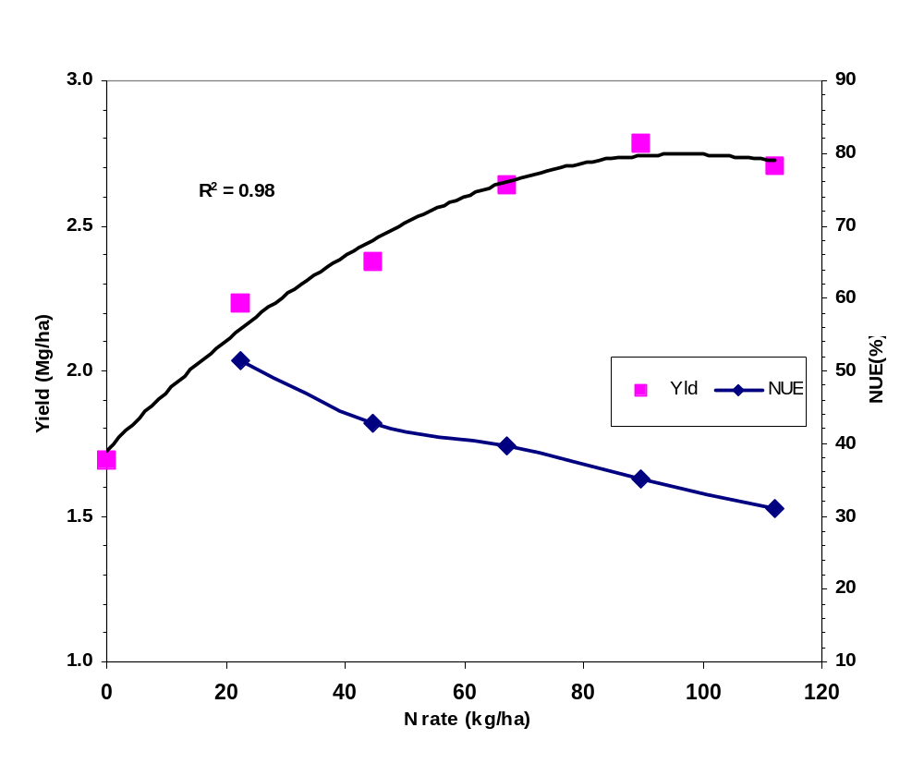
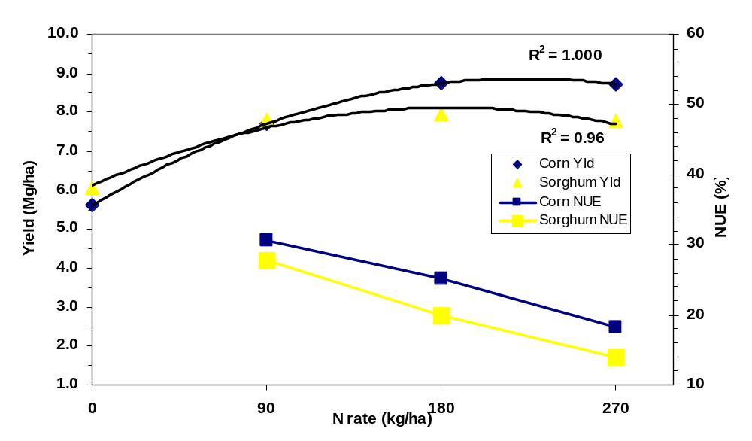
Figure 1. Effect of ammonium nitrate-N on wheat yield and NUE (1979-1998, 502-Lahoma, OK).

Figure 2. Effect of UAN-N on irrigated maize and sorghum yield and NUE (Nebraska, 1969-83).
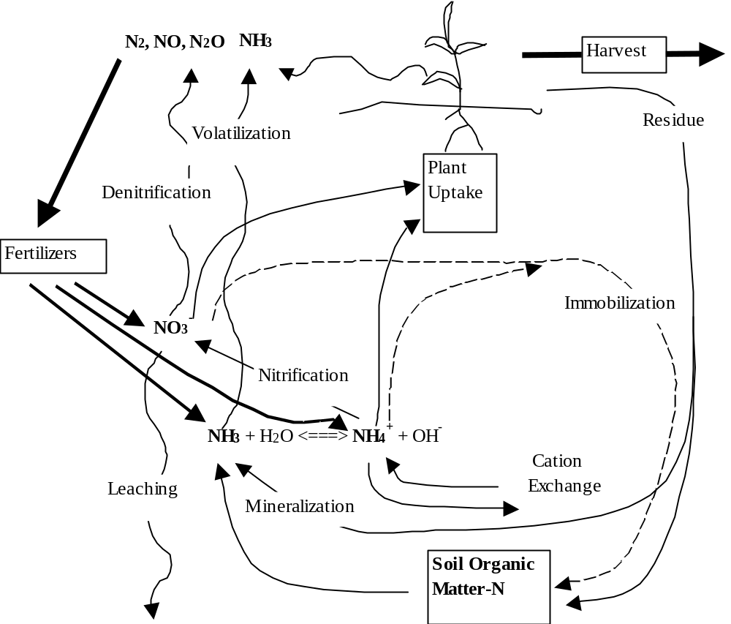

Figure 3. Natural conservation of N through cyclic transformations.
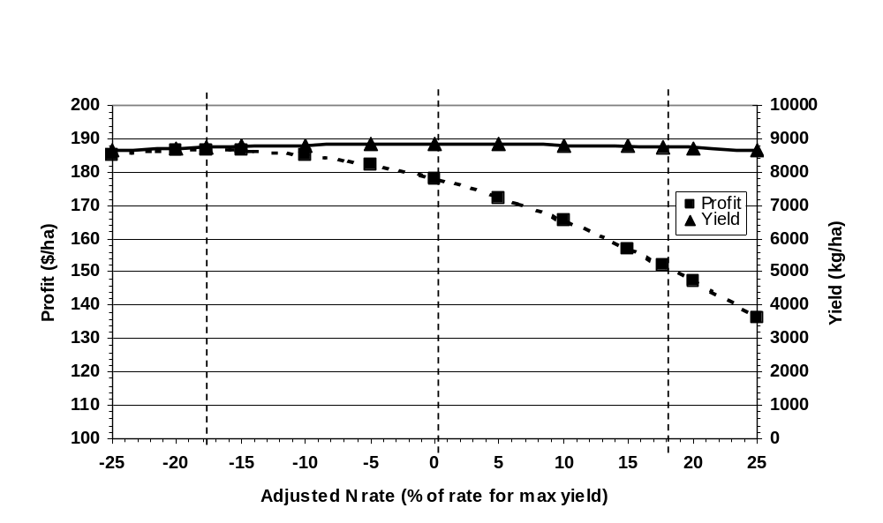

Figure 4. Effect of UAN-N at planting on irrigated maize yield and marginal profit (Nebraska).

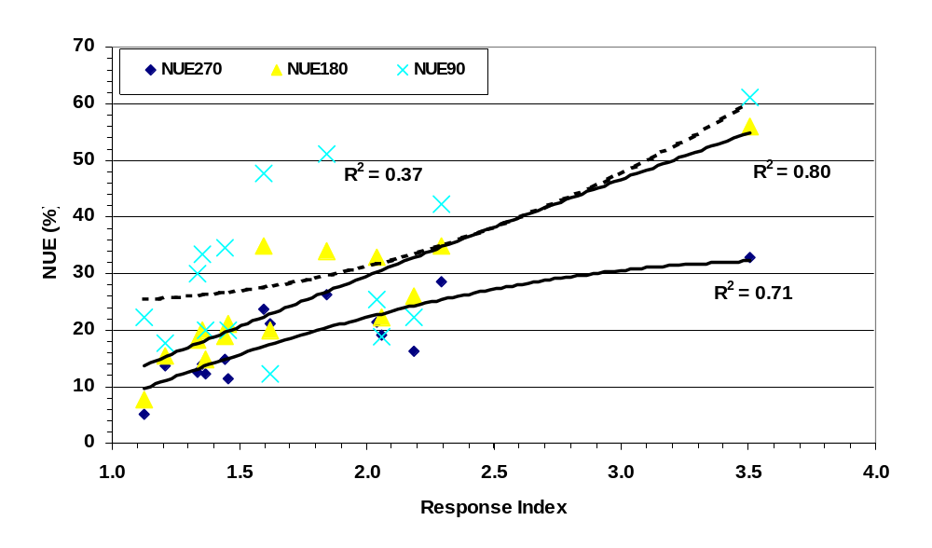
Figure 5. Influence of response index on NUE of irrigated maize at different UAN fertilizer-N rates.
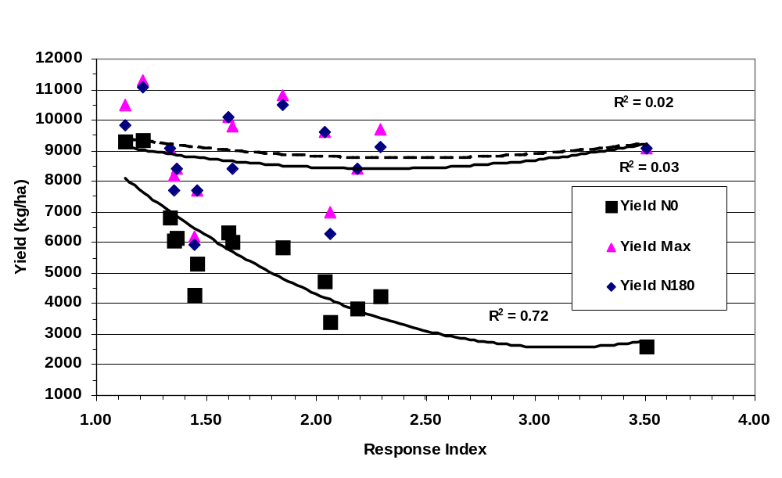

Figure 6. Yield of irrigated maize with and without N as influenced by response index.

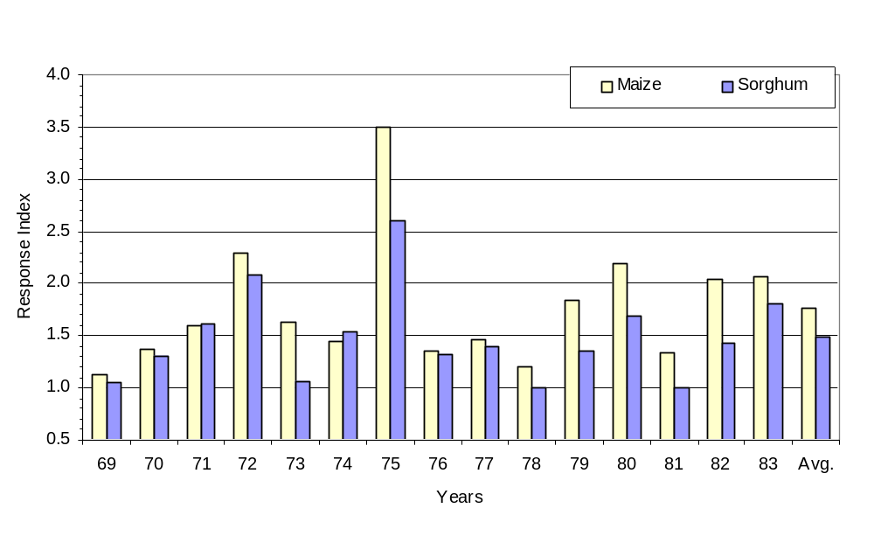
Figure 7. Response potential of irrigated maize and sorghum to UAN-N at planting over time.

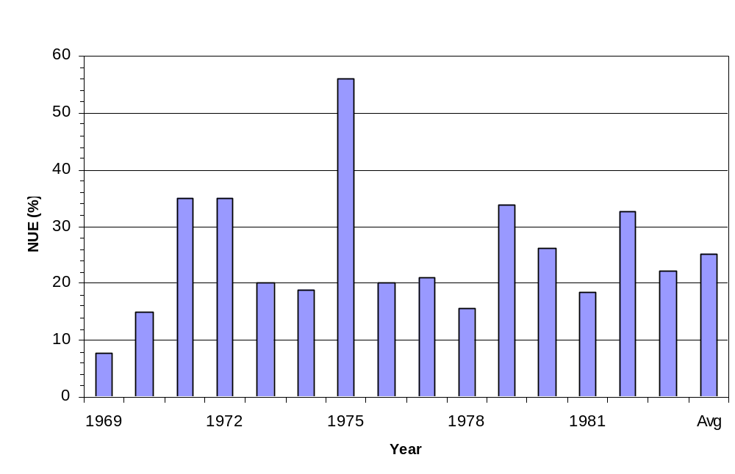
Figure 8. Annual NUE of 180 kg N/ha as UAN at planting for irrigated maize over 15 years.

In-Season Prediction of Potential Grain Yield in
Winter Wheat Using Canopy Reflectance

W.R. Raun, J.B. Solie, G.V. Johnson, M.L. Stone,
E.V. Lukina, W.E. Thomason and J.S. Schepers

Abstract
Nitrogen fertilization rates in cereal production systems are generally determined by subtracting soil test N from a specified grain yield goal-based N requirement, where yield goal represents the best achievable grain yield in the last four to five years. If grain yield could be predicted in-season, topdress N rates could be adjusted based on projected N removal. Our study was conducted to determine if winter wheat (Triticum aestivum L.) potential grain yield could be predicted using in-season spectral measurements collected between January and March. The normalized difference vegetation index (NDVI) was determined from reflectance measurements under daytime lighting in the red and near infrared regions of the spectra. In-season estimated yield (EY) was computed using the sum of two post-dormancy NDVI measurements (January and March), divided by the cumulative growing degree days from the first to second reading. A significant relationship between grain yield and EY was observed (R² = 0.50, PR>F 0.0001) when combining all nine locations across a two-year period. Our estimates of potential grain yield (made in early March) differed from measured grain yield (mid July) at three sites where yield-altering factors (e.g., late summer rains delayed harvest and increased grain yield loss due to lodging and shattering) were encountered after the final sensing. Evaluating data from six of the nine locations across a two-year period, EY values explained 83 % of the variability in measured grain yield. Use of EY may assist in refining in-season application of fertilizer N based on predicted potential grain yield.

INTRODUCTION
Historically, grain yield goals have been the most reliable method available for estimating pre-plant fertilizer N rates. Recent advancements in weather forecasting and crop modeling have enabled the development of technologies for predicting potential grain yields thus allowing for in-season nutrient adjustment to reflect early crop development and growing conditions.
Yield Goals
Crop grain yield may be expressed simply as a function of all conditions of the growing environment, or growth factors, and any preconceived yield goal or limit set by management. In dryland agriculture, it is usually advantageous to set the grain yield goal above that of average yields in order to fully take advantage of above-average growing conditions (Johnson, 1991). Yield goal was defined by Dahnke et al. (1988) as the yield per acre you hope to grow. They further noted that what you hope to grow and what you end up with are two different things. Yield goals can vary all the way from past average yield to potential yield (Dahnke et al., 1988). They defined potential grain yield as the highest possible yield obtainable with ideal management, soil, and weather. In our work, what they define as potential grain yield would be maximum grain yield, since 'potential' yield is associated with specific soil and weather conditions that can change annually. For most farmers, North Dakota State University recommends that the grain yield goal is the highest yield attained in the last four to five years and that it is usually 30 to 33% higher than the average yield (personal communication, R. J. Goos, 1998).
Rehm and Schmitt (1989) noted that with favorable soil moisture at planting it would be smart to aim for a 10 to 20% increase over the recent average when selecting a grain yield goal. They also indicated that if soil moisture is limiting, use of history and past maximums (used to generate averages) may not be the best method for setting a grain yield goal for the upcoming crop. Use of farm and/or county averages was not suggested for progressive farmers concerned with high farm profitability (Rehm and Schmitt, 1989).
Black and Bauer (1988) reported that the grain yield goal should be based on how much water is available to the winter wheat crop from stored soil water to a depth of 1.5 m in the spring plus the anticipated amount of growing season precipitation. Combining grain yield goal, soil test NO₃-N and a simple estimate of nitrogen use efficiency can be used to estimate N fertilization requirements. Several states recommend that farmers apply 33 kg N ha⁻¹ for every 1 Mg of wheat (2 lb N ac⁻¹ for every bushel of wheat) they hope to produce, minus the amount of NO₃-N in the surface (0-15 cm) soil profile (Johnson et al., 1997). Therefore, when grain yield goals are applied, it explicitly places the risk of predicting the environment (good or bad year) on the producer. University extension (e.g., soil testing), fertilizer dealers and private consulting organizations have historically used grain yield goals, due to the lack of a better alternative.

In-Season Soil Testing
Initial work by Magdoff et al. (1984) evaluated the use of an in-season NO₃-N soil test for corn by sampling soils to 30 cm when plants are 15-30 cm tall. This test, which was later referred to as the pre-sidedress nitrate test (PSNT), was useful for predicting N needs in the Northeastern portions of the USA. The benefits of PSNT over yield goals to recommend N for corn (Zea mays L.) was shown by Durieux et al. (1995), where less N was applied with no reduction in grain yield. Sims et al. (1995) indicated that the leaf chlorophyll meter could be an alternative to the PSNT for refining in-season fertilizer N requirements in maize. Spellman et al. (1996) showed that the critical PSNT ranged between 13 and 15 mg N kg⁻¹ for the 0-30 cm soil sampling depth, for irrigated corn grown in a semi-arid environment in Colorado, well below the 21 mg N kg⁻¹ suggested for humid regions of the USA. Bundy and Andraski (1995) indicated that separating nitrate test data according to the potential yield of soils (medium and high based on depth of root zone, water holding capacity and length of growing season) may improve the utility of the preplant nitrate test (PPNT) and PSNT for making N recommendations for corn when soil test values are in the N responsive region.
Fox et al. (1993) evaluated PSNT, near-infrared spectrophotometer reflectance from soil samples taken at planting, and an at-planting soil nitrate test for use in predicting grain yield and soil N-supplying capability. These methods did not predict relative grain yield or the potential to supply N. However, they noted that near-infrared preplant soil testing did predict whether or not humid-region corn fields would respond to N fertilizer.

Use of Indirect Measures for Grain Yield Prediction
Estimating crop yields is an important application of remote sensing (Lillesand and Kiefer, 1994; Moran et al., 1997). The normalized difference vegetation index (NDVI), calculated with measurements of reflected light from the red and near-infrared bands, has long been used as an indirect measure of crop yield, including that of wheat (Colwell et al., 1977; Tucker et al., 1980; Pinter et al., 1981). Aase and Siddoway (1981) confirmed the relationship of NDVI to wheat grain yield but noted that the relationship deteriorated rapidly as wheat ripened. Soil background, view and solar angles, atmospheric conditions, and crop canopy architecture are also important factors affecting NDVI (Huete, 1987; Jackson and Huete, 1991). Pinter et al. (1981) reported that summing NDVI values from late-season (Feekes 10.5, flowering to grain fill) spectral measurements was useful in predicting wheat grain yield. Bartholome (1988) reported that accumulated NDVI was a more stable predictor of millet and sorghum grain yields than a single spectral measurement. Rasmussen (1992) calculated a sampling-interval weighted average NDVI by integrating multi-temporal spectral measurements with time, which improved millet grain yield estimates from a single spectral measurement. Smith et al. (1995) reported that sensing twice and combining NDVI using a linear model improved correlation with wheat grain yield compared to sensing once. Rasmussen (1998) failed to improve the correlation of NDVI to grain yield by integrating the product of multi-temporal NDVI measurements and photosynthetically active radiation (PAR).

Definitions of Measured Grain Yield, Potential, and Maximum Grain Yields
Measured grain yield is that actually harvested in a given year at a given site (independent of scale). Potential grain yield is that predicted for a given year and site, based on the assumption that the level of growth factors responsible for early development of the crop will be maintained (limitations that existed at early stages of growth will continue to similarly influence development to maturity, e.g., N deficiency). Maximum grain yield is that achievable when all manageable growth factors (nutrients, insects, disease, weeds, etc) are non-limiting and the environment is ideal. Depending on the environment, potential grain yield would always be ≤ maximum grain yield.

Prediction of Biomass and Percent Coverage
Recent work has shown that NDVI measurements in winter wheat between Feekes physiological growth stages 4 and 5 can provide reliable prediction of both N uptake and biomass (Stone et al., 1996; Solie et al., 1996). The percentage of soil covered by wheat was highly correlated with NDVI at Feekes physiological growth stages 4 and 5, and both NDVI and coverage were correlated with vegetative biomass (Lukina et al., 1999). In these trials, plant coverage was generally > 50% at Feekes 4 and 60% at Feekes 5. Similar work by Reeves et al. (1993) used direct in-season measurements of total N uptake in winter wheat at Feekes growth stage 5 to predict grain yield.
Much of the work associated with making fertilizer recommendations has not considered the potential for using in-season prediction of potential grain yield. Therefore, the objective of this work evaluated the use of early-season red and near infrared spectral reflectance field measurements of wheat tissue combined with growing degree days to predict potential grain yield.

Materials and Methods
During the winter months of 1998 and 1999, spectral reflectance readings were taken from nine winter wheat experiments. Each experiment was either an on-going long-term experiment (numbers assigned as 222, 301, 502 and 801), or a short-term (1-3 years) field experiment that included the evaluation of preplant N rates. Each of these locations, is further defined in Table 1. The soils at each of these locations follow; Perkins, Teller sandy loam (fine-loamy, mixed, thermic Udic Argiustolls); Tipton, Tipton silt loam (fine-loamy, mixed, thermic Pachic Argiustolls); Stillwater, Kirkland silt loam (fine, mixed, thermic Udertic Paleustolls); Stillwater-Efaw, Norge silt loam (fine-silty, mixed, thermic Udic Paleustolls); Lahoma, Grant silt loam (fine-silty, mixed, thermic Udic Argiustolls); and Haskell, Taloka silt loam (fine, mixed, thermic Mollic Albaqualfs). The row spacing by N rate (S*N) and Efaw anhydrous ammonia (AA) experiments were each one-year trials. The N rate by P rate (N*P) experiment at Perkins was initiated in 1996. Experiments 222, 301 and 502 were initiated in 1969, 1993 and 1971, respectively, and all three evaluated annual rates of applied N at constant levels of P and K (Table 1). Winter wheat was planted at a 78 kg ha⁻¹ seeding rate using a 0.19 m row spacing, excluding the S*N experiment at Perkins (spacing ranged from 0.15 to 0.30 m).
Spectral reflectance was measured using an instrument that included two upward directed photodiode sensors that received light through cosine corrected Teflon™ windows fitted with red (671±6nm) and near-infrared (NIR)(780±6nm) interference filters. The instrument also included two down-looking photodiode sensors that received light through collination and interference filters identical to the up-looking sensors. The instrument used a built in 16 bit A/D converter that converted the signals from all four photodiode sensors simultaneously. The collination was configured to constrain the view of the down-looking sensors to a 0.84 m² oblong area at the plant surface. Stability of the sensor was maintained across time through calibration using a barium sulfate coated aluminum plate. The reflectance of the barium sulfate coated plate was assumed to be 1.0 for both spectral bands investigated.
All experiments included in this study are described in Table 1. Varietal differences were not targeted in this work because the findings of Sembiring et al. (2000) showed limited differences in post-dormancy NDVI readings for common wheat varieties grown in this region. Reflectance readings from all experiments were collected at two post-dormancy dates. The two dates (Time-1 and Time-2, respectively) where readings were collected generally corresponded to Feekes growth stage 4 (leaf sheaths beginning to lengthen) and 5 (pseudo-stem, formed by sheaths of leaves strongly erect) (Large, 1954). Due to differences in planting times and growing conditions, spectral reflectance readings were collected between January and March (Table 1). All reflectance readings from wheat were taken from a 4.0 m² area between 10 a.m. and 4 p.m under natural lighting.
Reflectance values (the ratio of incident and reflected values) were used in the NDVI calculation to minimize the error associated with cloud cover, shadows and sun angle. The modified equation used was; NDVI = [(NIR_{ref}/NIR_{inc})-(Red_{ref}/Red_{inc})] / [(NIR_{ref}/NIR_{inc})+(Red_{ref}/Red_{inc})], where NIR_{ref} and Red_{ref} = magnitude of reflected light, and NIR_{inc} and Red_{inc} = magnitude of the incident light.
In both years, grain yield was determined using a self propelled combine from the same 4.0 m² area where spectral reflectance data were collected. We assumed that growth from planting in October to the mid winter months of January and February would provide an excellent indicator of wheat health in each 4.0 m² area and thus the early-season growth-limiting conditions for small areas. The sum of NDVI at Time-1 and NDVI at Time-2, divided by growing degree days between the two dates (GDD = [(Tmin + Tmax)/2 - 4.4°C] (Tmin and Tmax recorded from daily data) was computed and evaluated as an index for in-season prediction of potential grain yield (in-season estimated yield, or EY). Minimum and maximum air temperatures, and rainfall data were collected within 1.7 km of the actual experiment at all locations.
The EY index was one of many indices evaluated that included mathematical combinations of the following; NDVI at Time-1 and Time-2, GDD and total days from Time-1 to Time-2, GDD and total days from planting to Time-1, and GDD and total days from planting to Time-2. The EY value was expected to reflect a point on the potential growth curve for that season, thus providing an estimate of potential grain yield based on local growing conditions between planting and the dates of sensing. This index was found to include all sites, and had a high combined r² when compared to the many other indices tested.
Measured grain yield was considered to be the best available measure of potential grain yield, especially where limited stress occurred after sensor readings in late February and early March. The use of GDD in the computation of EY allowed us to integrate early season growing conditions and growth rate. This approach is consistent with work by Rickman et al. (1996) showing the relationship between above ground dry mass and cumulative growing degree days (Fig. 1). Dividing the sum of NDVI at Time-1 and Time-2 by GDD results in a unit of predicted biomass (using NDVI) per growing degree day. Linear, quadratic, logarithmic and exponential models were evaluated that included all locations and data subsets using various indices to predict measured grain yield. In addition, confidence limits were established for point estimates about regression lines for those models that best fit the data.

Results
It is important to note that grain yield-limiting factors associated with post Feekes 5 environments can cause measured grain yields to differ from predicted potential grain yields. Therefore, it was critical to identify those sites where obvious yield-limiting or yield-enhancing factors were present following the final sensor measurement. In this regard, we recognized that it would be extremely difficult to identify an index that would reliably predict measured grain yield across nine locations where planting date, harvest date, sensor dates, rain, and growing degree days differed.
Although many indices were evaluated that included NDVI at Times 1 and 2 (e.g., GDD from planting to Time 1 and 2, d from Time 1 and Time 2 and days from planting), the EY index proved to account for more of the variability in measured grain yield, especially when sites where post-sensing grain yield limiting factors were considered. It was not until GDD was used as a divisor (combined with mid-winter sensor data) that we found models that included the majority of the nine sites studied. Therefore, regression analysis reported in this paper focuses on results from EY that included GDD in its calculation.
EY versus Grain Yield (all nine locations)
The relationship between measured grain yield and EY for all nine locations is illustrated in Fig. 2. Although definite differences were noted between the nine experiments included in this work, quadratic and exponential models for the entire data set resulted in coefficients of determination (r²) > 0.50 and were highly significant (PR>F 0.0001).
Three sites exhibited responses that were markedly different from the rest of the experiments: Experiment 502 in 1999; N*P Perkins in 1999; and Efaw AA in 1999. When compared to the remaining six locations, Experiment 502 in 1999 and N*P Perkins in 1999 had lower than expected grain yields and high EY values (Fig. 2). Combined, data for these two sites alone still showed a good relationship between EY and grain yield (r² = 0.78). Plant stands were excellent following planting at all sites, a result of timely but not excessive rain, and growing conditions were near ideal prior to sensing. However, at Experiment 502, 1999, excessive rain delayed grain harvest to 30 June, 1999 (3 to 4 weeks later than normal), and, consequently reduced grain yields because of lodging and shattering. Had grain harvest taken place on time, we believe that grain yields would have been much higher and likely to have been similar to the S*N Tipton data in 1998 (Fig. 2).
Grain yields were much lower than predicted by EY for the N*P Perkins, 1999 experiment. Although EY values reflected a much higher potential grain yield, yields were characteristically lower at this site. Forage growth was excellent early in the season as was plant development up to flowering. However, without timely rain, the sandy loam soil at this site dries out quickly and the lower moisture storage becomes more yield-limiting than the silt loam and clay loam soils at other sites. As a result, measured grain yields were lower than what would have been predicted using EY, even though plant stands and growth up to late February were indicative of a higher yielding crop.
Measured grain yields at the Efaw AA, 1999 experiment were higher than what would have been expected using EY. This experiment was located on an alluvial portion of the landscape and received added moisture via runoff from adjoining slopes. Forage growth was abnormally low at this site due to the late (9 November) planting date (Table 1). As a result, potential grain yields estimated using EY were low, since wheat plants were small when sensed in February and March. However, forage growth improved significantly later in the season. Late season wheat growth benefited from the added moisture received via runoff, and a soil profile that provided ample water during grain fill. We believe these factors caused potential grain yields to be underestimated using EY.

EY versus Grain Yield (six locations)
When data for the three sites where grain yield was strongly influenced by abnormal post-sensing conditions (N*P Perkins, 1999; Efaw AA, 1999; and Experiment 502, 1999) were removed, the relationship between measured grain yield and EY improved (Fig. 3). Including data obtained from these six locations across a two year period, EY values explained 83 % of the variability in grain yield (PR>F 0.0001). Two of the six experiments included in this data set were 450 km apart, and rain from planting to harvest ranged from 645 mm (S*N Tipton, 1998) to 1016 mm (Experiment 801, 1999). Considering the range of factors that affect final grain yield, and the influence of environment from Time-2 to maturity, we considered it important to find an index that closely predicted potential grain yield.
In our work, all data were combined in an attempt to derive a single standard curve to predict potential grain yield for the purpose of variably applying nitrogen fertilizer. This is noteworthy considering the wide range in NDVI values found at all locations at Feekes growth stages 4 and 5 (Table 2). The only adjustment to the sum of NDVI values from Feekes growth stage 4 to 5 was the division of this sum by GDD between the two measurements. This divisor was expected to partially account for growing conditions when combining sites and years. Considering the many non-controllable environmental factors that can influence final grain yield (after spectral data was acquired), we were willing to tolerate some error if it would enable using a single curve to estimate potential grain yield across a range of conditions. This is important if algorithms are to be developed that minimize the need to recalibrate the sensor/fertilizer controller for changing conditions within a field or between fields. Predicted mean grain yield of the six experiments used to develop the standard curve in Fig. 3 fell within ±14% of the average measured grain yields (Table 3). Linear regression of predicted mean grain yield on measured mean grain yield for the subset of 6 locations discussed previously, and all 9 locations had r² of 0.98 (PR>F, 0.01) and 0.33 (PR>F, 0.10), respectively. For these same models, slopes were not significantly different from 1, and intercepts were not different from 0. We believe these errors are tolerable in estimating potential grain yield if the benefits of variable applying topdress N fertilizer can still be obtained. Experience may identify sites where the sensor consistently over or underestimates potential grain yield, and the calibration can be reliably adjusted.

Discussion
It is important to note that the sum and not the difference in NDVI from Time-1 to Time-2 was used since the sum would reflect the average, while the difference (NDVI at Time-2 minus NDVI at Time-1) would theoretically take into account growth rate. Although we were interested in growth from Time-1 to Time-2, the difference in NDVI from Time-1 to Time-2 was inconsistent since some measurements resulted in negative values. This was a biological possibility in winter wheat; especially considering what can happen in terms of weather from January to February and its effect on wheat foliage. This is in addition to other factors affecting optical measurements enumerated by Huete (1987) and Jackson and Huete (1991). The sum of NDVI at Time-1 and Time-2 was used because the initial prediction of biomass (Time-1) integrated growing conditions and plant health (stand density, vigor and N uptake) from planting until the first winter spectral reading. Also, adding the two NDVI readings (estimates of biomass) assisted in removing some of the variability in radiometric data collected from the same 1 m² area at different times, and that would be influenced by changing soil moisture (reduced NIR and increased red reflectance). Pinter et al. (1981) reported that summing NDVI values assisted in predicting grain yield, however, their work employed spectral readings that were first collected at flowering (Feekes 10.5) and proceeded to senescence. Our approach was to collect sufficient information prior to Feekes 5 (60-90 days before flowering) that could be used to predict potential grain yields, and in time to apply fertilizer N without damaging the crop.
Data collected in the 1998 and 1999 growing seasons were unique since adequate moisture was present at planting, and continued throughout each growing season. Only limited moisture stress was present, and all sites received timely rain near flowering. For this reason, measured grain yield and potential grain yield were expected to be similar for 1998 and 1999, and this we believe contributed strongly to our finding a high correlation of EY with measured grain yield at six locations. We would not expect EY to be highly correlated with measured grain yield in all growing seasons, since so many things can happen to the wheat crop from post-dormancy to maturity (frost, disease, drought, etc.). However, our interest was in developing a yield parameter that was seasonal-sensitive, intrinsic, and that would reflect the potential grain yield likely to be realized in that season than traditional yield goal estimates. If growth was poor from planting to Time-2, it is unlikely that a high potential grain yield would be realized. Similarly, if growth was excellent from planting to post-dormancy, but declined from the first to second reading (Time-1 to Time-2, drought, frost damage, etc.), potential grain yield would be expected to be lower.
The 10 to 40 d period immediately following dormancy is critical in terms of the resulting grain yield. Obtaining two sensor readings during this period provides a measure of crop development and growing conditions. Unlike growth models that rely on various inputs to predict plant growth, optical sensing uses the plant as the indicator. The first reading establishes a base measurement of crop condition and the second reading assesses post dormancy change across a short, measured time period. Combined, these two readings and the adjustment for GDD should provide a reasonable indication of potential grain yield. Typically, early-season growing condition information is accessed by the first reading in late February. The period from planting (mid October) to the end of dormancy (late February) represents more than half the growing season and provides potential grain yield information. Once potential yield is determined, topdress N rates could be adjusted based on projected grain N removal. Sensing beyond Feekes physiological stage 5 (Time-2) is not practical for winter wheat grown in the United States since significant stand damage is encountered when topdress equipment is used for N applications following this time.
When spatially precise estimates of potential grain yield are made, these estimates will be determined at the finest resolutions (1 m²) where differences in soil test parameters are found (Solie et al., 1996; Solie et al., 1999). At coarser resolutions (>30 m), the variation in potential grain yield will be masked by averaging and benefits that may have been realized in treating the variability can be lost. Thus, one of the reasons why we found such good correlation between EY and measured grain yield (or potential grain yield) was because we were operating at a resolution of 4 m². In this regard, topdress N rates based on in-season prediction of potential grain yield must take place at the same resolution where spatial variability is encountered.

Conclusions
We propose the use of two post dormancy spectral reflectance readings (NDVI collected at or near Feekes growth stage 4 and again at Feekes growth stage 5) to assess the initial status of plant growth from planting to the end of dormancy, and post dormancy growth across a short time period (January to March). Adding these two NDVI readings, and dividing by the growing degree days between readings provides an indication of what potential grain yield should be for a wide range of growing conditions, planting times and sensing dates. For the two years evaluated, measured grain yield and estimated potential grain yield or EY were expected to be similar, since the dryland growing conditions were near-ideal throughout the season. Including data obtained from six locations for a two-year period, EY values explained 83 % of the variability in grain yield and thus an early-season indication of potential grain yield (measured grain yield used as the indicator variable) across a range of growing environments.

Acknowledgements
The authors wish to thank J.M. LaRuffa, S.B. Phillips, J.L. Dennis, D.A. Cossey, M.J. DeLeon, C.W. Woolfolk, R.W. Mullen, B.M. Howell, and Jing Wang for their assistance with field and lab work.

References
Aase, J.K., and F.H. Siddoway. 1981. Assessing winter wheat dry matter production via spectral reflectance measurements useful in providing an estimate of residue production for erosion control and as a potential source for feed and energy. Remote Sensing of Environ. 11:267-277.

Bartholome, E. 1988. Radiometric measurements and crop yield forecasting: some observations over millet and sorghum experimental plots in Mali. Int. J. Remote Sensing. 9:1539-1552.

Black, A.L., and A. Bauer. 1988. Setting winter wheat yield goals. In J.L. Havlin (ed.) Central Great Plains Profitable Wheat Management Workshop Proc. Wichita, KS. Aug. 17-20, 1988. Potash & Phosphate Institute, Atlanta, GA.

Bundy, L.G., and T.W. Andraski. 1995. Soil potential yield effects on performance of soil nitrate tests. J. Prod. Agric. 8:561-568.

Colwell, J.E., D.P. Rice, and R.F. Nalepka. 1977. Wheat yield forecasts using Landsat data. Proc. 11th International Symposium on Remote Sensing of Environment. Ann Arbor MI p. 1245-1254.

Dahnke, W.C., L.J. Swenson, R.J. Goos, and A.G. Leholm. 1988. Choosing a crop yield goal. North Dakota State Ext. Serv. SF-822. Fargo, North Dakota.

Durieux, R.P., H.J. Brown, E.J. Stewart, J.Q. Zhao, W.E. Jokela and F.R. Magdoff. 1995. Implications of nitrogen management strategies for nitrate leaching potential: roles of nitrogen source and fertilizer recommendation system. Agron. J. 87:884-887.

Fox, R.H., J.S. Shenk, W.P. Piekielek, M.O. Westerhaus, J.D. Toth, and K.E. Macneal. 1993. Comparison of near-infrared spectroscopy and other soil nitrogen availability quick tests for corn. Agron. J. 85:1049-1053.

Huete, A.R. 1987. Soil-dependent spectral response in a developing plant canopy. Agron. J. 79:61-68.

Jackson, R.D., and A.R. Huete. 1991. Interpreting vegetation indices. Prev. Vet. Med. 11:185-200.

Johnson, G.V. 1991. General model for predicting crop response to fertilizer. Agron. J. 83:367-373.

Johnson, G.V., W.R. Raun, H. Zhang, and J.A. Hattey. 1997. Soil fertility handbook. Okla. Agric. Exp. Sta. Stillwater, OK.

Large, E.C. 1954. Growth stages in cereals. Illustration of the Feekes Scale. Plant Pathol. 3:128-129.

Lillesand, T. M., and R. W. Kiefer. 1994. Remote Sensing and Image Interpretation, 3rd Ed. New York: John Wiley & Sons, Inc.

Lukina, E.V., M.L. Stone, and W.R. Raun. 1999. Estimating vegetation coverage in wheat using digital images. J. Plant Nutr. 22:341-350.

Magdoff, F.R., D. Ross, and J. Amadon. 1984. A soil test for nitrogen availability to corn. Soil Sci. Soc. Am. J. 48:1301-1304.

Moran, M.S., Y. Inoue, and E.M. Barnes. 1997. Opportunities and limitations for image-based remote sensing in precision crop management. Remote Sens. Environ. 61:319-346.

Pinter, P.J., Jr., R.D., R.D. Jackson, S.B. Idso, and R.J. Reginato. 1981. Multidate spectral reflectance as predictors of yield in water stressed wheat and barley. Int. J. Remote Sensing. 2(1):43-48.

Rasmussen, M.S. 1992. Assessment of millet yields and production in northern Burkina Faso using integrated NDVI from AVHRR. Int. J. Remote Sensing. 13(18):3431-3442.

Rasmussen, M.S. 1998. Developing simple operational consistent NDVI-vegetation models by applying environmental and climatic information. Part II: crop yield assessment. Int. J. Remote Sensing. 19(1):119-139.

Reeves, D.W., P.L. Mask, C.W. Wood, and D.P. Delaney. 1993. Determination of wheat nitrogen status with a hand-held chlorophyll meter: influence of management practices. J. Plant Nutr. 16:781-796.

Rehm, George, and Michael Schmitt. 1989. Setting realistic crop yield goals. Minnesota Ext. Serv. AG-FS-3873, Univ. of Minnesota, 55108.

Rickman, R.W., Sue E. Waldman, and Betty Klepper. 1996. MODWht3: A development-driven wheat growth simulation. Agron J. 88:176-185.

Sembiring, H., H.L. Lees, W.R. Raun, G.V. Johnson, J.B. Solie, M.L. Stone, M.J. DeLeon, E.V. Lukina, D.A. Cossey, J.M. LaRuffa, C.W. Woolfolk, S.B. Phillips, and W.E. Thomason, . 2000. Effect of growth stage and variety on spectral radiance in winter wheat. J. Plant Nutr. 23:141-149.

Sims, J.T., B.L. Vasilas, K.L. Gartley, B. Milliken, and V. Green. 1995. Evaluation of soil and plant nitrogen tests for maize on manured soils of the Atlantic Coastal Plain. Agron. J. 87:213-222.

Smith, R.C.G., J. Adams, D.J. Stephens, and P.T. Hick. 1995. Forecasting wheat yield in mediterranean-type environment from NOAA Satellite. Aust. J. Agric. Res. 46:113-25.

Solie, J.B., W.R. Raun, R.W. Whitney, M.L. Stone and J.D. Ringer. 1996. Optical sensor based field element size and sensing strategy for nitrogen application. Trans. ASAE 39(6):1983-1992.

Solie, J.B., W.R. Raun, and M.L. Stone. 1999. Submeter spatial variability of selected soil and bermudagrass production variables. Soil Sci. Soc. Amer. J. 63:1724-1733.

Spellman, D.E., A. Rongni, D.G. Westfall, R.M. Waskom, and P.N. Soltanpour. 1996. Pre-sidedress nitrate soil testing to mange nitrogen fertility in irrigated corn in a semi-arid environment. Commun. Soil Sci. Plant Anal. 27:561-574.

Stone, M.L., J.B. Solie, W.R. Raun, R.W. Whitney, S.L. Taylor, and J.D. Ringer. 1996. Use of spectral radiance for correcting in-season fertilizer nitrogen deficiencies in winter wheat. Trans. ASAE 39(5):1623-1631.

Tucker, C.J., J.H. Elgin, Jr., J.E. McMurtrey III. 1980. Relationship of spectral data to grain yield variation. Photogrammetric Engineering and Remote Sensing. 46(5):657-666.

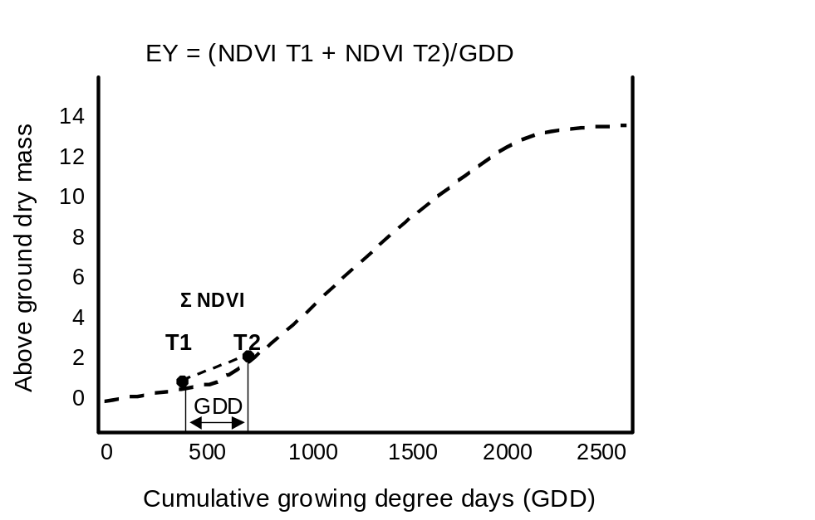

Figure 1. Schematic relationship (Rickman et al., 1996) between above ground dry mass (estimated using NDVI) obtained at two stages of growth (T1 and T2), and cumulative growing degree days (GDD), and the calculation of in-season estimated yield (EY).

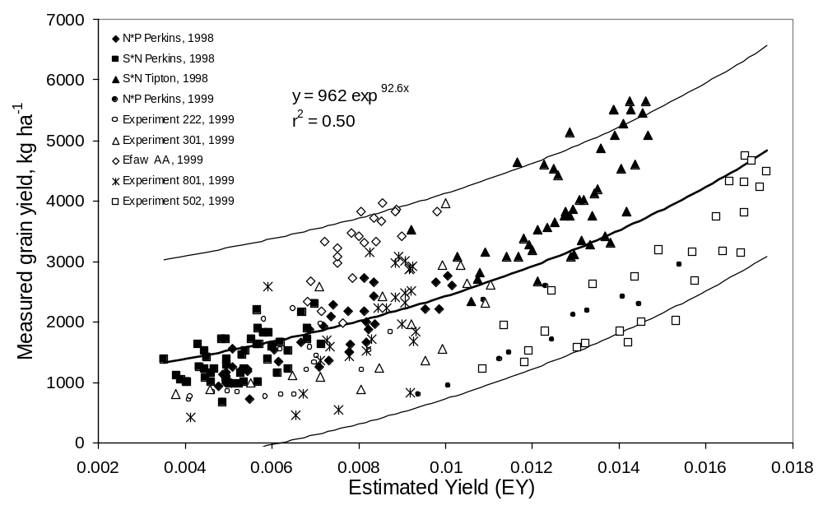

Figure 2. Relationship between in-season estimated grain yield (EY) computed from two post-dormancy NDVI readings, divided by the cumulative growing degree days (from Time-1 to Time-2), and measured grain yield in nine winter wheat experiments, 1998 and 1999 (confidence limits for point estimates about the exponential model).

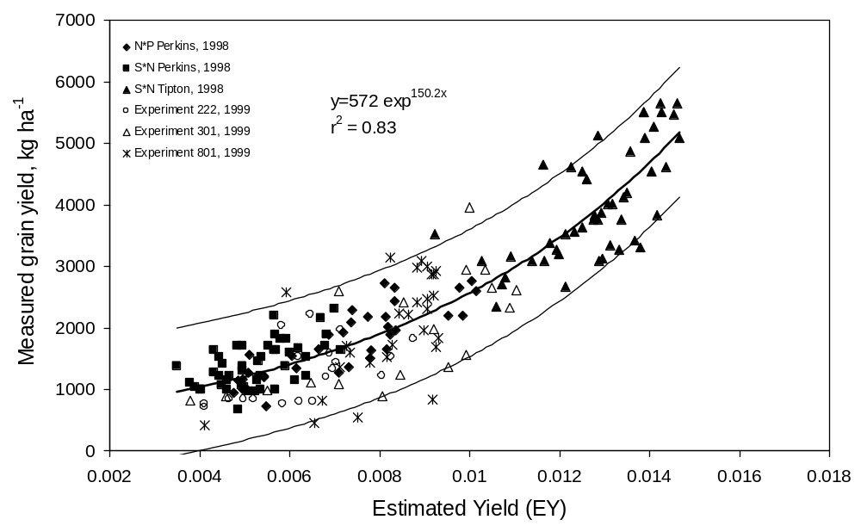

Figure 3. Relationship between in-season estimated grain yield (EY) computed from two post-dormancy NDVI readings, divided by the cumulative growing degree days (from Time-1 to Time-2), and measured grain yield in six of nine winter wheat experiments, 1998 and 1999 (confidence limits for point estimates about the exponential model).
Table 1. Experiments where sensor and winter wheat grain yield data were collected, location, number of plots, growth stage, and sampling date.
______________________________________________________________________________________________________
Experiment Location Year No. Dates Days GDD‡ Planting Harvest Variety -----------Rainfall---------
of plots Sensed T1 to T1 to date date planting planting T2
sensed (T1 & T2) T2† T2† to to T2 to
maturity mat.
------------ mm -----------_____

S*N§ Perkins, OK 1998 48 24/2/98 42 187 21/10/97 15/6/98 Tonkawa 638 396 242
6/4/98
S*N§ Tipton, OK 1998 48 27/1/98 31 120 7/10/97 3/6/98 Tonkawa 415 277 138
26/2/98
N*P¶ Perkins, OK 1998 36 24/2/98 38 154 21/10/97 15/6/98 Tonkawa 638 396 242
2/4/98
N*P¶ Perkins, OK 1999 12 12/2/99 21 99 12/10/98 9/6/99 Tonkawa 655 244 411
4/3/99
Experiment 222 Stillwater, OK 1999 20 18/1/99 38 153 13/10/98 15/6/99 Tonkawa 759 305 454
24/2/99
Experiment 301 Stillwater, OK 1999 18 19/2/99 34 142 15/10/98 15/6/99 Tonkawa 759 309 450
24/3/99
Efaw AA Stillwater-Efaw, OK 1999 21 19/2/99 34 142 9/11/98 15/6/99 Tonkawa 596 146 450
24/3/99
Experiment 502 Lahoma, OK 1999 28 10/2/99 24 96 9/10/98 30/6/99 Tonkawa 882 337 545
5/3/99
Experiment 801 Haskell, OK 1999 28 16/2/99 36 189 16/10/98 6/7/99 2163 1016 600 416
23/3/99
____________________________________________________________________________________________________________________
†T1 to T2, (d/m/yr) Time-1 (Feekes growth stage 4) to Time-2 (Feekes growth stage 5)
‡GDD, growing degree days calculated as the daily sum of (Tmin + Tmax)/2 - 4.4°C.
§S*N, row spacing by N rate experiment
¶N*P, N rate by P rate experiment
Table 2. Minimum, maximum, and mean values for NDVI collected at Feekes growth stages 4 and 5 and EY, from nine experiments.
_______________________________________________________________________________
Exp. Location Year NDVI Feekes 4 NDVI Feekes 5 EY†
min max mean min max mean min max mean

S*N§ Perkins, OK 1998 0.33 0.64 0.47 0.32 0.76 0.52 0.0035 0.0071 0.0053
S*N§ Tipton, OK 1998 0.50 0.85 0.74 0.60 0.91 0.80 0.0092 0.0146 0.0128
N*P¶ Perkins, OK 1998 0.26 0.76 0.47 0.39 0.86 0.63 0.0047 0.0101 0.0071
N*P¶ Perkins, OK 1999 0.55 0.77 0.66 0.37 0.76 0.56 0.0094 0.0154 0.0123
Exp. 222 Stillwater, OK 1999 0.14 0.60 0.39 0.12 0.74 0.54 0.0041 0.0087 0.0063
Exp. 301 Stillwater, OK 1999 0.31 0.74 0.55 0.23 0.84 0.64 0.0038 0.0110 0.0084
Efaw AA Stillwater-Efaw, OK 1999 0.33 0.62 0.41 0.59 0.80 0.72 0.0068 0.0098 0.0080
Exp. 502 Lahoma, OK 1999 0.40 0.79 0.66 0.41 0.88 0.73 0.0085 0.0174 0.0145
Exp. 801 Haskell, OK 1999 0.42 0.89 0.77 0.35 0.89 0.78 0.0041 0.0093 0.0082
_________________________________________________________________________________________
† EY (in-season estimated yield = (NDVI Feekes 4 + NDVI Feekes 5)/growing degree days from Feekes 4 to Feekes 5)
Exp-experiment,
§S*N, row spacing by N rate experiment
¶N*P, N rate by P rate experiment
Table 3. Predicted, measured and percent of measured mean winter wheat grain yield from nine experiments.
_____________________________________________________________________________________
Experiment Location Year Measured Predicted Percent
mean grain mean grain of measured
yield yield† mean grain yield
------- kg ha⁻¹ ------
S*N§ Perkins, OK 1998 1409 1212 86.0
S*N§ Tipton, OK 1998 3999 3911 97.8
N*P¶ Perkins, OK 1998 1752 1654 94.4
N*P¶ Perkins, OK 1999 1932 3622 187.4
Experiment 222 Stillwater, OK 1999 1274 1438 112.8
Experiment 301 Stillwater, OK 1999 1909 2042 106.9
Efaw AA Stillwater-Efaw, OK 1999 3247 1846 56.8
Experiment 502 Lahoma, OK 1999 2822 5426 192.3
Experiment 801 Haskell, OK 1999 1985 1916 96.5
__________________________________________________________________________
† predicted mean grain yield using exponential model of yield on EY reported in Figure 3
§S*N, row spacing by N rate experiment
¶N*P, N rate by P rate experiment

Winter Wheat Fertilizer Nitrogen Use Efficiency in Grain and
Forage Production Systems

W.E. Thomason, W.R. Raun and G.V. Johnson

ABSTRACT
Nitrogen use efficiency (NUE) is known to be less than fifty percent in winter wheat grain production systems. This study was conducted to determine potential differences in NUE when winter wheat (Triticum aestivum L.) is grown strictly for forage or grain. The effects of different nitrogen rates on plant N concentrations at different growth stages and on grain yield were investigated in two existing long-term winter wheat experiments near Stillwater (experiment 222) and Lahoma (experiment 502), Oklahoma. At both locations in all years, total N uptake was greater when wheat forage was harvested twice (Feekes 6 and flowering) compared to total N uptake when wheat was grown only for grain. Percent N content immediately following flowering was much lower compared to percent N in the forage harvested prior to flowering, indicating relatively large losses of N after flowering. Averaged over locations and years, at the 90 kg N ha ^{–1} rate, wheat produced for forage had much higher NUE (82%) compared with grain production systems (30%). While gaseous N loss was not measured in this trial, the higher NUE values found in the forage production systems were attributed to harvesting prior to anthesis and the time when plant N losses are known to be greater.

INTRODUCTION
Nitrogen use efficiency is important when discussing fertilizer applications and plant growth. Two principal components of NUE are efficiency of uptake and efficiency of N utilization to produce grain or forage (Moll et al., 1982). Nitrogen use efficiency is influenced by nitrification rate of the soil, form of N applied, growth stage of the plant, and weather. Farmers desire to apply N at the ideal time and using the fertilization method that will optimize efficiency. Environmentally, it is important to know how much fertilizer is used by the plant and how much is lost. Scientifically, it is important to understand the processes and storage methods for N and other nutrients.
Nitrogen content varies with the growth stage of the plant (Wuest and Cassman, 1992). Gaseous plant N loss has been found to be significant from flowering to physiological maturity (Harper et al. 1987). Recent work has found that the total N content in the grain and straw is not equal to total N content of plants at flowering (Harper et al. 1987). Fertilizer N use efficiency, as reflected in grain yield of winter wheat, has also been shown to change with time and rate of application (Ellen and Spiertz, 1980). Nitrogen use efficiency varies with different genotypes of winter wheat, a result of gaseous plant N loss from flowering to physiological maturity that was estimated to range between 4 and 28 kg N ha⁻¹ (Kanampiu et al., 1997). Work with winter wheat has shown that high N concentrations in plants at flowering are associated with increased plant N loss (Parton et al., 1988). Many authors have noted that grain yield and N content of cereal grain crops increase significantly with applied N (Simonis, 1987; Raun and Johnson, 1995). However, the higher N rates generally result in decreased NUE values. Harper et al. (1987) found that much of the loss of fertilizer N is due to gaseous loss from plants at senescence. At flowering, N is translocated to the grain causing gaseous N losses to increase and efficiency to decrease (Harper et al., 1987). O’Deen (1989) detected volatile ammonia emissions from winter wheat and attributed the source of ammonia to the decomposition of protein during translocation from the leaf to the seed. Similar work by Bruno et al. (1987) indicated that NUE decreases at grain fill in cereals, mostly due to gaseous N loss. Whitehead (1995) found that N concentration in the plant tends to decrease as plants age, mostly due to the increase in cell wall material and decrease in cytoplasm.
In the south central United States, producers often use winter wheat as a forage crop for cattle and also for grain production. The period of winter growth and the relatively high N content of winter wheat make it a good forage crop for ruminant grazing. However, it should be noted that the NUE in livestock production is generally much lower (usually less the 20%) due to inefficiency of conversion and harvest (Van der Ploeg et al., 1997). Whitehead (1995) suggested that forage production systems are more efficient users of N than grain production systems because harvest before maturity prevents loss of volatile ammonia. Many research sources are available discussing NUE in either forage or grain production systems, but there is little information comparing forage-only versus grain-only production systems for the same crop. The objective of this experiment was to determine potential differences in NUE when winter wheat is grown strictly for either forage or grain.

MATERIALS AND METHODS
Experimental sites were selected as sub-plots in two existing long-term winter wheat experiments near Stillwater (experiment 222) and Lahoma (experiment 502), Oklahoma, where N rates have been applied annually since 1969 and 1970, respectively. Both experiments employed randomized complete block experimental designs with four replications. Plots were 6.1 x 18.3 and 4.9 x 18.3 m at 222 and 502, respectively. At both sites, N has been applied preplant and incorporated utilizing a conventional tillage system. Nitrogen rates were 0, 45, 90, and 134 kg N ha⁻¹ yr⁻¹ at Stillwater and 0, 45, 67, 90, and 112 kg N ha⁻¹ yr⁻¹ at Lahoma. Ammonium nitrate (34-0-0) was applied broadcast and incorporated preplant at both sites. Phosphorus and potassium as triple superphosphate (0-46-0) and potassium chloride (0-0-62) were applied with the N each year at rates of 29 and 20 kg P ha⁻¹ and 38 and 56 kg K ha⁻¹ at Stillwater and Lahoma, respectively. Initial soil test data taken from the check plots is shown in Table 1. In all years, forage sub-plots (1.44-2.08 m²) were hand harvested at Feekes growth stages 6 and again from the same area at Feekes 10 (Large, 1954). Grain was harvested from sub-plots, adjacent to forage sub-plots, with a combine from an area of 3.66 m². Forage and grain samples were dried and ground to pass a 140 mesh sieve (100 μm) and analyzed for total N content using a Carlo-Erba NA 1500 automated dry combustion analyzer (Schepers et al., 1989). Total N uptake in the forage was determined by multiplying N content and dry matter yield for both harvests taken from the same area. Grain N uptake was determined by multiplying dry matter grain yield and grain total N. Nitrogen use efficiency was determined as N uptake in N treated plots minus N uptake from the check (0-kg N applied) divided by the applied N rate. Fertilizer applications, planting and harvest dates are reported in Table 2.

RESULTS AND DISCUSSION
Analyses of variance and associated means for total forage yield and N uptake, grain yield, and grain N uptake are reported in Tables 3-10 for Stillwater and Lahoma for 1996-99. A significant grain yield and grain N uptake response to N fertilization was found for the grain production system at both sites. Similarly, forage and forage N uptake responded to applied N at both sites (Tables 3-10). It was interesting to note that dry matter production levels were nearly double for forage-only when compared to the grain production system at both sites. Although less pronounced, forage N uptake or removal was nearly double in the forage-only system when compared to grain-only at both locations (Tables 3-10).
As a result of increased dry matter production and N removal, NUE’s were much greater for the forage-only systems at both sites when compared to grain-only systems (Tables 3-10). As per the work of Francis (1993), gaseous plant N losses are known to be greatest between flowering and maturity. The two forage harvests (March, Feekes 6 and May, Feekes 10) were both prior to flowering. Regrowth, including secondary tillers, following the March harvest did produce plants with heads by May, however, flowering did not occur prior to the last forage harvest. Only limited growth was observed in the forage-only plots following the May harvest. By harvesting the plant for forage before grain fill, potential losses were avoided, thus increasing NUE.
Averaged over locations and years, NUE values for forage production systems (76%) were substantially higher than those for grain only production systems (34%). At both locations, grain-only production systems had estimated NUE's less than 62 percent in all years excluding the low N rate. With forage-only production systems, NUE's were much greater, exceeding 80% at Lahoma. The forage system was shown to be a more efficient user of N than the grain-only system with a 41% increase at Lahoma and a 49% increase at the Stillwater site. Although NUE’s were expected to decrease with increasing N rates for grain production, this effect was not consistent, excluding the high N rates where depressed NUE’s were found. Figures 1 and 2 represent 4-year average NUE values at Stillwater and Lahoma, respectively. Four-year average NUE values were included because the purpose of this study was to evaluate the long-term differences between forage and grain production systems. In 1997, forage yields were well above normal, exceeding 10 Mg ha⁻¹ at both sites at the highest N rates. Forage production conditions were ideal with a mild wet winter and cool spring. Increased production at the high N rates was a result of depressed yields in both 1995 and 1996 due to poor growing conditions, leaving significant residual N in an environment where nitrate leaching is not expected (Raun and Johnson, 1995). When environmental conditions favored higher yields than the current fertilizer application could support, N was possibly mineralized from the soil organic pool and made available to growing plants. While the 1998 crop year was also conducive to superior forage production, we did not see yields as high as those achieved in 1997, because the reserve of soil-N (NO₃ or mineralizable N) was depleted in 1997. At Stillwater in 1999, NUE values for forage and grain were higher than all years other than 1997. Good soil moisture levels and mild fall temperatures allowed the crop to proceed at high levels of growth. Forage yields at Lahoma were again much higher than those at Stillwater, nearly reaching 10 Mg ha ^{–1}, and forage NUE’s were consistently higher at this site. Grain NUE’s and yields were among the lowest of the four years, largely due to heavy rains that delayed harvest by several weeks causing heads to shatter, thus reducing harvested grain yield.

CONCLUSIONS
Averaged over locations and years, NUE values for forage production systems (76%) were substantially higher than those for grain only production systems (34%). At 90 kg N ha^{–1}, a commonly applied preplant rate in this region, wheat produced for forage had much higher NUE’s (83%) when compared with grain production systems (30%). This is largely due to continuous pre-anthesis harvesting, prior to the onset of gaseous plant N loss. This work indicates that NUE’s can be increased using a forage production system, but that these systems will be heavily dependent upon an inefficient animal component. The human requirement for grain will necessitate future improvements in NUE that consider holistic management strategies.

REFERENCES
Bruno, M., R. Sylvie, and J.Machet. 1987. A comprehensive approach to the fertilizer part of plant nitrogen uptake. In D.S. Jenkinson and K.A. Smith (ed). Nitrogen Efficiency in Agricultural Soils. pp. 85-94. Elsevier Science.

Ellen, J., and J.H.J. Spiertz. 1980. Effects of rate and timing of nitrogen dressings on grain yield formation of winter wheat. Fert. Res. 1:177-190.

Francis, D.D., J.S. Schepers, and M.F. Vigil. 1993. Post-anthesis nitrogen loss from corn. Agron. J. 85:659-663.

Harper, L.A., R.R. Sharpe, G.W. Langdale, and J.E. Evans. 1987. Nitrogen cycling in a wheat crop: soil, plant, and aerial nitrogen transport. Agron. J. 79:965-973.

Large, E.C. 1954. Growth stages in cereals. Plant Pathol. 3:128-129.

Kanampiu, F.K., W.R. Raun, and G.V. Johnson. 1997. Effect of nitrogen rate on plant nitrogen loss in winter wheat varieties. J. Plant Nutr. 20:389-404.

Moll, R.H., E.J. Kamprath, and W.A. Jackson. 1982. Analysis and interpretation of factors which contribute to efficiency of nitrogen utilization. Agron. J. 74:562-564.

O’Deen, W.A. 1989. Wheat volatilized ammonia and resulting nitrogen isotopic fractionation. Agron J. 81:980-985.

Parton, W.J., J.A. Morgan, J.M Altenhofen, and L.A. Harper. 1988. Ammonia volatilization from spring wheat plants. Agron J. 80:419-425.

Raun, W.R., and G.V. Johnson. 1995. Soil-plant buffering of inorganic nitrogen in continuous winter wheat. Agron. J. 87:827-834.

Schepers, J.S., D.D. Francis, and M.T. Thompson. 1989. Simultaneous determination of total C total N and ¹⁵N on soil and plant material. Commun. Soil Sci. Plant Anal. 20:949-959.

Simonis, A.D. 1987. Studies on nitrogen use efficiency in cereals. In D.S. Jenkinson and K.A. Smith (ed.) Nitrogen Efficiency in Agricultural Soils. pp.110-124. Elsevier Science.

Van der Ploeg, R.R., H. Ringe, Galina Machulla, and D Hermsmeyer. 1997. Postwar nitrogen use efficiency in West German agriculture and groundwater quality. J. Environ. Qual. 26:1203-1212.

Whitehead, D.F. 1995. Grasses uptake of nitrogen and effects on morphology and physiology. pp.16. In Grassland Nitrogen. CAB Intl. Publishers, Wallingford UK.

Wuest, S.B., and K.G. Cassman. 1992. Fertilizer-nitrogen use efficiency of irrigated wheat: I. uptake efficiency of preplant versus late-season application. Agron. J. 84:682-688.

TABLE 1. Surface soil (0-15cm) chemical characteristics and classification at
Stillwater (experiment 222) and Lahoma, (experiment 502) OK in check plots, 1995.

Location pHª NH₄-N NO₃-N P^{b} K^{b} Total N^{c} Organic C^{c}
__
--------------mg kg⁻¹--------------- -------g kg⁻¹-----
Stillwater 5.7 4.6 2.3 33 159 0.9 10.6
Classification: Kirkland silt loam (fine-mixed, thermic Udertic Paleustoll)
Lahoma 5.6 5.6 4.0 77 467 0.9 11.0
Classification: Grant silt loam (fine-silty, mixed, thermic Udic Argiustoll)
ªpH: 1:1 soil:water
^{b}P and K: Mehlich III
^{c}Organic C and Total N: dry combustion

TABLE 2. Planting and harvest dates for Stillwater (experiment 222)
and Lahoma (experiment 502) OK, 1996-1999.
______________________________________________________________________
-------------------year-------------------
Procedure 1996 1997 1998 1999

Stillwater 222

Fertilization Oct 9 Sept 5 Oct 2 Sept 3
Planting Oct 10 Oct 3 Oct 3 Oct 13
Forage harvest 1 Mar 1 Jan 6 Feb 18 Mar 3
Forage harvest 2 May 7 May 13 May 12 Apr 30
Grain harvest June 11 June 19 June 10 June 15

Lahoma 502

Fertilization Aug 31 Sept 4 Sept 10 Sept 12
Planting Oct 10 Oct 3 Oct 17 Oct 9
Forage harvest 1 Mar 5 Jan 3 Mar 25 Feb 25
Forage harvest 2 May 6 May 6 May 11 May 11
Grain harvest June 21 June 13 June 12 June 30
______________________________________________________________________
TABLE 3. Analysis of variance and means for total dry matter forage yield (sum of harvests in March and May) grain yield, N uptake, and nitrogen use efficiency (NUE) Stillwater, OK, 1996
__________________________________________________________________________
------------------Forage----------------- ------------------Grain-----------------
Yield N uptake NUE† Yield N uptake NUE†
Mg ha⁻¹ kg ha⁻¹ Mg ha⁻¹ kg ha⁻¹
Source of variation -------------------------------mean squares----------------------------
Replication 0.690 164 192 0.037 38 3
N rate 1.956* 1995* 332 0.329* 628* 403
Residual error 0.612 396 192 0.059 108 109
SED 0.553 14.0 9.7 0.171 7.3 6.9

N rate, kg ha⁻¹ Mg ha⁻¹ kg ha⁻¹ % Mg ha⁻¹ kg ha⁻¹ %
0 2.719 49.6 - 1.007 29.0 -
44 2.841 59.0 21 1.274 35.6 15
90 3.553 83.1 37 1.382 48.5 22
134 4.228 98.6 36 1.701 56.8 21
__________________________________________________________________________
* Significant at the 0.05 probability level
**Significant at the 0.01 probability level
†df for NUE, N rate = 2
SED- Standard error of the difference between two equally replicated means

TABLE 4. Analysis of variance and means for total dry matter forage yield (sum of harvests in March and May) grain yield, N uptake, and nitrogen use efficiency (NUE) Stillwater, OK, 1997
______________________________________________________________
------------------Forage----------------- ------------------Grain-----------------
Yield N uptake NUE† Yield N uptake NUE† Mg ha⁻¹ kg ha⁻¹ Mg ha⁻¹ kg ha-1
Source of variation ---------------------------------mean squares-----------------------------------
Replication 1.10 336 1113 .0364 235 3
N rate 19.1* 3667** 4016 1.011* 725* 403
Residual error 0.79 793 1046 0.126 79 109
SED 1.21 20.0 22.9 0.251 6.3 6.9

N rate, kg ha-1 Mg ha⁻¹ kg ha⁻¹ % Mg ha⁻¹ kg ha⁻¹ %
0 3.334 49.9 - 0.872 20 -
44 5.077 76.1 58 0.859 21 17
90 7.460 103.8 60 1.069 29 19
134 9.668 143.1 69 1.920 50 21
______________________________________________________________
* Significant at the 0.05 probability level
**Significant at the 0.01 probability level
†df for NUE, N rate = 2
SED- Standard error of the difference between two equally replicated means

TABLE 5. Analysis of variance and means for total dry matter forage yield (sum of harvests in March and May) grain yield, N uptake, and nitrogen use efficiency (NUE) Stillwater, OK, 1998
______________________________________________________________
------------------Forage----------------- ------------------Grain------------------
Yield N uptake NUE† Yield N uptake NUE†
Mg ha⁻¹ kg ha⁻¹ Mg ha⁻¹ kg ha⁻¹
Source of variation -----------------------------mean squares----------------------------------
Replication 1920.4** 377** 744 1.876 103 163*
N rate 6265.5** 2766** 1709 1012** 324** 319**
Residual error 187.23 41.20 261 109 32.42 40.75
SED 0.306 4.54 11.42 0.233 4.03 4.51

N rate, kg ha-1 Mg ha⁻¹ kg ha⁻¹ % Mg ha⁻¹ kg ha⁻¹ %
0 1.886 23.2 - 1.153 22 -
44 2.768 41.2 40 1.434 31 20
90 3.276 51.0 31 1.808 38 18
134 4.868 80.8 47 2.316 43 15
____________________________________________________________________________
* Significant at the 0.05 probability level
** Significant at the 0.01 probability level
SED- Standard error of the difference between two equally replicated means

TABLE 6. Analysis of variance and means for total dry matter forage yield (sum of harvests in March and May) grain yield, N uptake, and nitrogen use efficiency (NUE) Stillwater, OK, 1999
_______________________________________________________________
------------------Forage----------------- ------------------Grain------------------
Yield N uptake NUE† Yield N uptake NUE†
Mg ha⁻¹ kg ha⁻¹ Mg ha⁻¹ kg ha⁻¹
Source of variation -------------------------------mean squares------------------------------------
Replication 735.16 354.8 425 144.88 181.09 2607.94
N rate 2288.79* 2720.4** 1988** 2196.43* 2024.04** 1037.88
Residual error 514.61 164.4 255 377.71 263.60 710.94
SED 0.253 4.53 5.65 0.217 5.74 9.43

N rate, kg ha-1 Mg ha⁻¹ kg ha⁻¹ % Mg ha⁻¹ kg ha⁻¹ %
0 2.792 44.6 - 1.315 37 -
44 3.217 57.4 29 1.529 46 22
90 4.537 91.2 52 2.124 60 27
134 3.799 98.7 40 2.970 88 38
______________________________________________________________
* Significant at the 0.05 probability level
** Significant at the 0.01 probability level
SED- Standard error of the difference between two equally replicated means

TABLE 7. Analysis of variance and means for total dry matter forage yield (sum of harvests in March and May) grain yield, N uptake, and nitrogen use efficiency (NUE) Lahoma, OK, 1996
_______________________________________________________________
------------------Forage----------------- ------------------Grain---------------------
Yield N uptake NUE† Yield N uptake NUE†
Mg ha⁻¹ kg ha⁻¹ Mg ha⁻¹ kg ha⁻¹
Source of variation ------------------------------mean squares---------------------------------------
Replication 1.300 1394 2.580 324 660* 1341*
N rate 3.197* 4844* 5.708 1510** 1140** 2850**
Residual error 0.520 568 4.033 184 156 387
SED 0.509 16.8 1.16 0.247 7.2 11.4

N rate, kg ha⁻¹ Mg ha⁻¹ kg ha⁻¹ % Mg ha⁻¹ kg ha⁻¹ %
0 2.89 58.0 _ 1.48 33 -
45 3.49 87.3 65 2.22 58 55
67 4.29 113.3 80 2.17 54 32
90 5.24 149.9 102 2.87 74 46
112 4.91 133.9 68 3.17 80 42
____________________________________________________________________________
* Significant at the 0.05 probability level
**Significant at the 0.01 probability level
†df for NUE, N rate = 4
SED- Standard error of the difference between two equally replicated means

TABLE 8. Analysis of variance and means for total dry matter forage yield (sum of harvests in March and May) grain yield, N uptake, and nitrogen use efficiency (NUE) Lahoma, OK, 1997
______________________________________________________________
------------------Forage----------------- ------------------Grain------------------
Yield N uptake NUE† Yield N uptake NUE†
Mg ha⁻¹ kg ha⁻¹ Mg ha⁻¹ kg ha⁻¹
Source of variation ---------------------------------mean squares------------------------------------
Replication 17412** 2541** 6744* 663 426 879
N rate 32914** 17434** 19830** 4265** 2361* 3049
Residual error 2012 344 1675 462 201 811
SED 0.82 10.7 23.6 0.39 8.2 16.5

N rate, kg ha⁻¹ Mg ha⁻¹ kg ha⁻¹ % Mg ha⁻¹ kg ha⁻¹ %
0 3.94 69 - 1.47 35 -
45 8.37 123 121 2.30 55 45
67 9.17 146 114 3.05 73 56
90 10.99 206 153 3.58 81 51
112 12.20 143 162 4.32 104 62
____________________________________________________________________________
* Significant at the 0.05 probability level
**Significant at the 0.01 probability level
SED- Standard error of the difference between two equally replicated means

TABLE 9. Analysis of variance and means for total dry matter forage yield (sum of harvests in March and May) grain yield, N uptake, and nitrogen use efficiency (NUE) Lahoma, OK, 1998
_________________________________________________________________
------------------Forage----------------- ------------------Grain------------------
Yield N uptake NUE† Yield N uptake NUE†
Mg ha⁻¹ kg ha⁻¹ Mg ha⁻¹ kg ha⁻¹
Source of variation ----------------------------------------mean squares-----------------------------------------
Replication 858.3 1308 6155 250.8** 506.2 1979
N rate 5536.2** 5171** 4064 3415.4** 2640** 4183
Residual error 567.1 461 3134 44.0 314.8 1086
SED 0.435 12.4 32.3 0.121 10.24 19.02

N rate, kg ha⁻¹ Mg ha⁻¹ kg ha⁻¹ % Mg ha⁻¹ kg ha⁻¹ %
0 4.06 86 - 2.112 49.4 -
45 4.86 112 57 3.719 88.7 78
67 5.79 139 79 3.665 87.2 56
90 6.65 160 82 3.426 83.1 37
112 6.89 180 83 4.542 117.1 60
_________________________________________________________________________________
* Significant at the 0.05 probability level
** Significant at the 0.01 probability level
† df for NUE, N rate = 4
SED- Standard error of the difference between two equally replicated means

TABLE 10. Analysis of variance and means for total dry matter forage yield (sum of harvests in March and May) grain yield, N uptake, and nitrogen use efficiency (NUE) Lahoma, OK, 1999
_____________________________________________________________
------------------Forage----------------- ------------------Grain------------------
Yield N uptake NUE† Yield N uptake NUE†
Mg ha⁻¹ kg ha⁻¹ Mg ha⁻¹ kg ha⁻¹
Source of variation -------------------------------mean squares------------------------------------
Replication 43060.9* 26570.7* 45169 312.2* 90.5 662
N rate 10126.4 9095.7 86306 3316.8** 2568.2** 1717**
Residual error 7134.0 7802.9 42767 76.8 109.8 258
SED 0.629 20.8 48.7 0.065 2.50 3.79

N rate, kg ha⁻¹ Mg ha⁻¹ kg ha⁻¹ % Mg ha⁻¹ kg ha⁻¹ %
0 5.24 80 - 1.29 36.2 -
45 8.41 155 166 2.08 52.6 27
67 7.25 137 83 2.49 63.1 14
90 8.95 207 141 3.19 82.7 17
112 9.81 204 111 3.63 103.1 15
__________________________________________________________________________
* Significant at the 0.05 probability level
** Significant at the 0.01 probability level
†df for NUE, N rate = 4
SED- Standard error of the difference between two equally replicated means

Production System Techniques to Increase Nitrogen Use Efficiency in Winter Wheat

W.E. Thomason, G.V. Johnson, J.B. Solie, M.L. Stone, K.W. Freeman, K.J. Wynn, R. Teal, and W.R. Raun

ABSTRACT
Most current research on winter wheat (Triticum aestivum, L.) focuses on increasing yields of either grain or plant biomass. Increased production costs and environmental awareness will promote the development of methods to increase the efficiency of applied nutrients. Nitrogen is often the most limiting nutrient to increased production and represents one of the highest input costs of cereal grain production. This study was conducted to evaluate the effects of several short-term practices on nitrogen use efficiency (NUE) in winter wheat. The variables evaluated included variety, nitrogen source, nitrogen timing, nitrogen rate, production system (forage only vs. grain only and a combination of the two), resolution of nitrogen application, and application of late season growth-inhibiting chemicals. The effects of these variables were investigated at three experimental sites in Stillwater, Oklahoma on a Norge loam (fine-silty, mixed, active, thermic Udic Paleustolls) in Tipton, OK on a Tillman-Hollister sandy loam (fine, mixed, superactive, thermic Typic Paleustolls), and in Haskell, OK on a Taloka silt loam (fine-mixed, thermic Mollic Albaqualf). Initial results indicate increases in NUE due to forage-only production systems, late season N applications, choosing more N efficient varieties, and applying N to each 1m² based on sensor measurements. These results indicate that many approaches can be taken to increase NUE in wheat production systems. Producers and researchers must work to develop the best combination of these variables for maximum NUE.

INTRODUCTION
Nitrogen use efficiency is defined as the efficiency of grain production per unit of N available from the soil and calculated as grain weight divided by N supplied by the soil (Gw/Ns) (Moll et al., 1982). Uptake efficiency from the soil is critical to the overall NUE of the system, therefore techniques that enhance uptake or provide N directly to the plant need to be evaluated. Conversion of N to plant material and grain are both critical when considering increased NUE. A plant more efficient at converting N from the tissue to grain N will likely have increased NUE.
Variety selection can have a large effect on NUE. It has been noted that different NUE’s among different corn varieties are largely due to differing utilization of N already accumulated in the plant (Moll et al., 1982). Eghball and Maranville, (1991) found that NUE usually parallels water use efficiency in corn thus the two traits can be selected simultaneously. Wheat varieties with high harvest index values are known to have higher NUE’s (Kanampiu et al., 1997). It has been reported that wheat varieties that accumulate large amounts of N early in the growing season do not necessarily have high nitrogen use efficiency (Cox et al., 1985). Plants must convert this accumulated N to grain nitrogen and must assimilate N after anthesis to produce high NUE’s. Since most variety selection is done under high N fertility conditions, efficiency of N use is often considered second in importance to total yield. This approach will have to change in response to the worldwide need for more nutrient efficient crops.
In the south-central United States, producers often use winter wheat as a forage crop for cattle as well as for grain production. Research indicates that forage production systems are more efficient users of N than grain production systems with forage system NUE’s over 70% and grain-only NUE’s less than 40% (Thomason et al., 2000). Working in corn, O’Leary and Rehm (1990) reported that NUE values were greater for silage than those for grain. Much of the loss of applied N fertilizer efficiency is due to the loss of N to the atmosphere at senescence (Morgan and Parton, 1989). At flowering, N is translocated to the grain and movement at this stage of development causes gaseous N losses to increase and efficiency to decrease (Harper et al., 1987).
Some researchers have noted that application of N as NH₄ will produce plants with higher total N uptake and therefore higher NUE. As stated earlier, late-season N uptake and assimilation are critical for increasing NUE. Nitrogen in the NH₄ form is not mobile in the soil and may therefore be available for late season uptake by the plant. Plants with preferential uptake of NH₄ during grain fill may provide increases in NUE over plants without this preference (Tsai et al.,1992). Ammonium-N supplied to high yielding corn genotypes increased yield over plants supplied with NO₃ at the critical ear development time (Pan et al., 1984). Plant assimilation of NO₃ requires the equivalent of 20 ATP mol⁻¹ NO₃, but NH₄ assimilation requires only 5 ATP mol⁻¹ of NH₄ (Salsac et al.,1987). It is evident that this energy savings could be beneficial to the plant late in the season.
Fertilizer use efficiency as reflected in grain yield of winter wheat has been shown to change with time and rate of application (Ellen and Spiertz, 1980). Studies by Harper et al. (1987) noted decreased N concentrations in winter wheat with time during the growing season. Olson and Swallow (1984) noted in-season N application resulted in increased efficiency in four of five years when compared to pre-plant incorporated nitrogen in winter wheat. Nitrogen supplied late-season has been shown to increase grain protein and NUE over pre-plant applied nitrogen (Wuest and Cassman, 1992a). In another study by Wuest and Cassman (1992b) recovery of pre-plant N was found to be less than 55%, while recovery of N applied at anthesis was noted at 55-80%.
Precision agriculture practices can increase NUE by providing precise in-season application of N fertilizer. To capitalize on any potential N fertilizer savings and increased NUE, management decisions need to be made at the appropriate field element size (Raun et al., 1998; Solie et al., 1996). Field element size is defined as that area or resolution which provides the most precise measure of the available nutrient where the level of that nutrient changes with distance (Solie et al., 1996). Random variability in soil test and plant biomass has been documented at resolutions less than or equal to one square meter (Raun et al., 1998; Solie et al., 1996). When N management decisions are based on this information, the variability in the crop present at that resolution can be detected using sensors (normalized difference vegetative index or NDVI) (Solie et al., 1996; Stone et al., 1996). These differences can then be addressed by supplying N at prescribed rates, thus increasing NUE (Stone et al.,1996).
Application of chemicals to wheat late in the season has shown increases in NUE and N mobilization within the plant. Ethephon ([2-chloroethyl] phosphonic acid) (C₂H₆ClO₃P) applied at either Feekes growth stage 6 or 9 has shown increased N remobilization from vegetative plant parts and increased dry matter levels at harvest (Van Sanford et al., 1989). Foliar applications of KH₂PO₄ at rates of 10 kg ha⁻¹ have been shown to increase grain yields in regions where late season drought and temperature stress occurs (Benbella and Paulson, 1998). The objectives of this trial were to evaluate the effects of variety, nitrogen source, nitrogen timing, nitrogen rate, production system (forage only vs. grain only and a combination of the two), resolution of nitrogen application, and application of late season growth inhibiting chemicals on NUE in winter wheat.

Materials and Methods
Three experimental sites were initiated in Stillwater, OK on a Norge loam (fine-silty, mixed, active, thermic Udic Paleustolls) in Tipton, OK on a Tillman-Hollister sandy loam (fine, mixed, superactive, thermic Typic Paleustolls), and in Haskell, OK on a Taloka silt loam (fine-mixed, thermic Mollic Albaqualf). The variables evaluated were variety, nitrogen source, nitrogen timing, nitrogen rate, production system (forage only vs. grain only and a combination of the two), resolution of nitrogen application, and application of late season growth inhibiting chemicals. Two wheat varieties, 2174 and Jagger, were planted in plots with pre-plant N rates of 0, 34, 56, or 112 kg ha⁻¹ in the 1999-00 crop year. Variety 2180 was planted instead of 2174 in 1998. Two treatments received fixed-rate topdress N applications of 78 kg ha⁻¹ and one treatment received 45 kg N ha⁻¹, with eleven others receiving a prescribed topdress N rate based on NDVI readings and in-season prediction of potential yield (INSEY) values (Raun et al., 2000). The plots receiving N based on NDVI values were sensed and treated on a 1m2 resolution, while plots receiving fixed rates of N were fertilized on a whole plot basis (13.9m²). Variable rates were applied at a range of 0-78 kg N ha⁻¹. Ten treatments, some with variable and some with fixed topdress rates received an additional 22 kg N ha⁻¹ at flowering. Two treatments, one for each variety, were grown for forage-only with forage removed at Feekes growth stage 5 and again at flowering (Large, 1954). Two treatments, again one for each variety, were managed for both forage and grain with only one forage harvest at Feekes growth stage 5. Growth inhibiting chemicals were applied to two treatments late in the season to attempt to increase nitrogen use efficiency (Table 2).
Forage samples from forage-only, and forage/grain plots were harvested from 1m² areas in the center of the plots at Feekes 5 and the entire plot was mowed to a height of 15 cm. In the forage-only plots, forage was again harvested from 1m² in the center of the plot at flowering. In the grain/forage plots, forage was harvested from a 1m² area in the center of the plot at Feekes 5 and the plot was then mowed but allowed to re-grow and produce grain. Forage harvests were taken by hand at both growth stages. From all grain and grain/forage plots, grain was harvested from an area of 3.05 x 2 m using a self-propelled combine harvester. Forage and grain samples were dried and ground to pass a 140 mesh sieve (100 um) and analyzed for total N content using a Carlo-Erba NA 1500 automated dry combustion analyzer (Schepers et al., 1989). Statistical evaluation and analysis of variance was performed using SAS (SAS Inst., 1989)

Results
A significant interaction effect was found to exist between variety and N rate so only simple effects involving variety will be discussed. Results will also be presented by individual year and location.
At the Stillwater site in 1999, we found no significant response to applied N. The block planted to 2180 experienced germination problems and could not be harvested. The Jagger plots were harvested and some high yields (3.2 Mg ha⁻¹) were noted at treatment level 9 (a 3-way split application with 34 kg ha⁻¹ applied pre-plant, topdress N applied based on INSEY and 22 kg N ha⁻¹ applied at flowering). The N uptake values for this plot were also indicative of good production conditions (Table 3). Forage dry matter yields and N uptake values for forage-only plots were much greater than those for forage+grain (FG) system plots (Table 4). The lack of harvest data for the 2180 plots eliminated the possibility of comparison of the two varieties for grain yield on those plots. When FG plots were compared to the grain-only plots at the same fertility and management levels, yields of grain-only plots were found to be significantly higher.
The Haskell site also experienced poor germination of the 2180 plots and so those plots were not harvested. Due to some dry conditions in the mid-spring and a very wet harvest, grain yields were highest in the 0 N check. Losses from lodging of high biomass producing plots were significant as well as shattering losses from the heads. The greatest N uptake value for the experiment was from a 112 kg ha⁻¹ pre-plant application (Table 3). Forage yields were greatest for the forage-only (two-cut) system (Table 4). We were unable to compare the two varieties for yield at the FG treatment, but did note higher grain yields for the grain-only system when compared to the complementary FG plots.
The 1999 data from the Tipton experiment did include the 2180 plots so the entire experiment was harvested. Yields for the pre-plant only N application were lower than the 3-way split application system (3.8 vs. 3.0 Mg ha⁻¹) for the 2180 plots. The same treatments applied to the Jagger plots had no effect on grain yield. No significant difference of NUE was noted for either pre-plant or split applications on either variety (Table 3). The highest NUE for this site was for the 112 kg N ha⁻¹ application to the Jagger plots (71%). This response could be due to near ideal conditions for fall growth in 1998. The plants would have taken up a large amount of N earlier in the season and so the plots with sufficient N applied early would have an advantage. Less than ideal environmental conditions occurred in the spring of 1999 at this location with warm and dry conditions favoring volatilization of topdress and flowering applications. A late season hail storm also damaged yields at this site. Yields for the forage-only Jagger plots were significantly higher compared to 2174 (Table 4). Again, total dry matter yields for the forage-only (two harvest) plots were higher than the yields from the combination plots. There was no difference in yield between varieties within the FG plots. Values for N uptake from these plots followed the same trend as yields (Table 4).
In the 2000 crop year, the winter wheat variety 2174 was substituted for 2180 at all locations. At Stillwater, the highest yields were obtained when 78 kg N ha⁻¹ was applied topdress with a flowering application of 22 kg ha⁻¹ (Table 3). This treatment also gave the highest NUE for the experiment at 168%. This value was obtainable because of ideal topdress application conditions and very high yields used to calculate NUE for these plots. NUE’s for the 3-way split application using INSEY adjusted topdress rates were both greater than 47%. There was no difference in forage yield for the forage only plots between varieties in 2000. The forage-only system had higher dry matter yields than the single cutting from the FG plots (Table 4). Total N uptake values for these plots were also higher than those for FG plots. Grain yields from the grain-only versus the FG plots were not significantly different (Table 3).
At Haskell in 2000, the highest yielding treatment was 2174 with 34 kg ha⁻¹ N applied pre-plant, topdress N applied based on INSEY and another 22 kg ha⁻¹ N applied at flowering (trt. 8) (Table 3). This site year also gave us the first response to late-season senescence delaying chemicals. The KH₂PO₄ treatments showed greater yields than those receiving ethephon (2.2 vs. 1.2 Mg ha⁻¹). These results coincide with those from a similar study at the same location testing these two chemicals. In that trial we also found decreased yield and NUE due to ethephon application, however, no visible damage was seen due to ethephon (data not shown). Grain N uptake was the highest for the 2174 plot receiving the 3-way split application of fertilizer. This plot also had the highest NUE. The fixed topdress plots also had high NUE at this location. Also, the three-way split application produced one of the better NUE’s even for the lower yielding Jagger plots.
Grain yield for the grain-only plots were greater than yields from FG plots. Forage yields from forage-only plots with two harvests were significantly higher when compared to FG plots. There was no difference of variety using either system. At Tipton, the Jagger plots receiving a 3-way split application (optimum) gave the highest yields and NUE values (Table 3). The 2174 plots receiving 0 pre-plant N and 78 kg ha⁻¹ topdress out yielded the variably applied (INSEY) N rates at this site (2895 vs. 2196 kg ha⁻¹). At the 40 kg ha⁻¹ fixed topdress rate, yields were not different than those from the INSEY plots. This seems to indicate that the INSEY rates at this year and location were not high enough to maximize yields. NUE was highest for the pre-plant only applications. It seems that at the Tipton site, pre-plant fertilization is necessary to produce high N use efficiency. Forage-only plots had higher dry matter yields than those from the forage+grain system. Values for N uptake were also higher for forage-only plots. Grain yields were higher for grain-only plots when compared to forage+grain treatments.

Conclusions
Overall, the highest grain yields were achieved with 34 kg N ha⁻¹ pre-plant, winter topdress applications based on INSEY, and 22kg N ha⁻¹ applied at flowering. No differences were noted between varieties. Maximum NUE values were obtained with different treatment combinations in different years. The two treatments above were always among the best as well as Jagger with a 112 kg N ha⁻¹ pre-plant application. The fact that this treatment appears is mainly due to the results from the Tipton site. While residual nitrate from soils tests were not that much lower than the other locations, the effects of pre-plant N seems to be much greater at Tipton. As expected, forage yields for the two-cut forage-only system were greater than those from the combination grain and forage plots. In addition, grain yields for the grain-only plots were higher than yields for the forage+grain plots. This treatment did, however, show promise when forage and grain yields were combined. This large value for yield led to a large value for NUE, often over 100% (Table 5). The advantage of this system is to use the forage biomass for grazing without significantly damaging final grain yields. While this plot was not often the highest yielder, when combined with forage output, biomass production was very high per unit of applied N thus maximizing NUE.

References
Benbella, M. and G.M. Paulson. 1998. Efficacy of treatments for delaying senescence of wheat leaves: II. Senescence and grain yield under field conditions. Agron J. 90:332-338.

Cox, M.C., C,O. Qualset and D. W.Rains. 1985. Genetic variation for nitrogen assimilation and translocation in wheat. II. Nitrogen assimilation in relation to grain yield and protein. Crop Sci. 25:435-440.
.
Eghball, B. and J.W. Maranville. 1991. Interactive effects of water and nitrogen stresses on nitrogen utilization efficiency, leaf water status and yield of corn genotypes. Commun. Soil Sci. Plant Anal. 22:1367-1382.

Ellen, J., and J.H.J. Spiertz. 1980. Effects of rate and timing of nitrogen dressings on grain yield formation of winter wheat. Fert. Res. 1:177-190.

Harper, L.A., R.R. Sharpe, G.W. Langdale, and J.E. Giddens. 1987. Nitrogen cycling in a wheat crop: soil, plant, and aerial nitrogen transport. Agron. J. 79:965-973.

Kanampiu, F.K., W.R. Raun and G.V. Johnson. 1997. Effect of nitrogen rate on plant nitrogen loss in winter wheat varieties. J. Plant Nutr. 20:389-404.

Moll, R.H., E.J. Kamprath and W.A. Jackson. 1982. Analysis and interpretation of factors which contribute to efficiency to nitrogen utilization. Agron. J. 74:562-564.

Morgan, J.A and W.J. Parton. 1989. Characteristics of ammonia volatilization from spring wheat. Crop Sci. 29:726-731.

O'Leary, M.J., and G.W. Rehm. 1990. Nitrogen and sulfur effects on the yield and quality of corn grown for grain and silage. J. Prod. Agric. 3:135-140.

Olson, R.V., and C.W. Swallow. 1984. Fate of labeled nitrogen fertilizer applied to winter wheat for five years. Soil Sci. Soc. Am. J. 48:583-586.

Pan, W.L., E.J. Kamprath, R.H. Moll and W.A. Jackson. 1984. Prolificacy in corn: its effects on nitrate and ammonium uptake and utilization. Soil Sci. Soc. Am. J. 48:1101-1106.

Raun, W.R., J.B. Solie, G.V Johnson, M.L. Stone, R.W. Whitney, H.L. Lees, H. Sembiring and S.B. Phillips.1998. Micro-variability in soil test, plant nutrient and yield parameters in bermudagrass. Soil Sci. Soc. Am. J. 62:683-690.

Raun, W.R., J.B. Solie, G.V Johnson, M.L. Stone, E.V. Lukina, W.E. Thomason, and J.S. Schepers. 2000. In-season prediction of potential yield in winter wheat using canopy reflectance. Agron J. (In press)

Salsac, L., S. Chaillou, J.F. Morot-Gaudry, C. Lesaint, and E. Jolivoe. 1987. Nitrate and ammonium nutrition in plants. Plant Physiol. Biochem. 25:805-812.

SAS Institute. 1989. SAS/STAT user’s guide. Version 6. 4th ed. Vol. 2. SAS Inst., Cary. NC.

Schepers, J.S., D.D. Francis, and M.T. Thompson. 1989. Simultaneous determination of total C total N and 15N on soil and plant material. Commun. in Soil Sci. Plant Anal. 20(9&10), 949-959.

Solie, J.B., W.R. Raun, R.W. Whitney, M.L. Stone and J.D. Ringer. 1996. Optical sensor based field element size and sensing strategy for nitrogen application. Trans. ASAE 39(6):1983-1992.

Stone, M.L., J.B. Solie, W.R. Raun, R.W. Whitney, S.L. Taylor, and J.D. Ringer. 1996. Use of spectral radiance for correcting in-season fertilizer nitrogen deficiencies in winter wheat. Trans. ASAE 39:1623-1631.

Thomason, W.E., W.R. Raun, and G.V. Johnson. 2000. Winter wheat nitrogen use efficiency in grain and forage production systems. J. Plant Nutr. (In press)

Tsai, C.Y., I. Dweikat, D.M. Huber and H.L. Warren. 1992. Interrelationship of nitrogen nutrition with maize (Zea mays) grain yield, nitrogen use efficiency and grain quality. J. Sci. Food Agric. 58:1-8.

Van Sanford, D.A., J.H. Grove, L.J. Grabau, and C.T. MacKown. 1989. Ethephon and nitrogen use in winter wheat. Agron J. 81:951-954.

Wuest, S.B., and K.G. Cassman. 1992a. Fertilizer-nitrogen use efficiency of irrigated wheat: I. Uptake efficiency of preplant versus late-season application. Agron. J. 84:682-688.

Wuest, S.B., and K.G. Cassman. 1992b. Fertilizer-nitrogen use efficiency of irrigated wheat: ii. Partitioning efficiency of preplant versus late-season application. Agron. J. 84:689-694

Table 1. Initial soil chemical characteristics and classification (0-15 cm) at Stillwater Tipton, and Haskell OK.

Location pHª NH₄-N NO₃-N P^{b} K^{b} Total N^{c} Organic C^{c}

---------------------mg kg⁻¹----------------------- -------mg g⁻¹--------
Stillwater 6.2 2.2 5.6 28 472 .09 1.06

Classification: Norge loam (fine-silty, mixed, thermic Udic Argiustoll)

Tipton 7.4 23.6 5.6 85 1006

Classification: Tillman-Hollister sandy loam (fine, mixed, superactive, thermic Typic Paleustoll)

Haskell 4.8 43.1 32.1 45 240

Classification: Taloka silt loam (fine-mixed, thermic Mollic Albaqualf)
ªpH: 1:1 soil:water
^{b}P and K: Mehlich III
^{c}Organic C and total N: dry combustion
Table 2. Treatment structure including variety, production system, pre-plant N rate, topdress N rate, topdress resolution, and N applied at flowering, 1998-2001.
treatment | variety | Production  system | PP N rate | TD N rate | TD  resolution | N at flowering | chemical
1 | 2174 | grain | 0 | 0 | - | 0
2 | 2174 | grain | 112 | 0 | - | 0
3 | Jagger | grain | 0 | 0 | - | 0
4 | Jagger | grain | 112 | 0 | - | 0
5 | 2174 | grain | 0 | insey | 1m | 22
6 | Jagger | grain | 0 | insey | 1m | 22
7 | 2174 | grain | 0 | 78 | - | 22
8 | 2174 | grain | 34 | insey | 1m | 22
9 | Jagger | grain | 34 | insey | 1m | 22
10 | 2174 | grain | 34 | 45 | - | 22
11 | 2174 | grain | 0 | insey | 1m | 0
12 | 2174 | grain | 0 | 78 | - | 0
13 | 2174 | grain | 0 | insey | 1m | 22 | ethephon
14 | Jagger | grain | 0 | insey | 1m | 22 | KH₂PO₄
15 | 2174 | forage | 56 | insey | 1m | 0
16 | Jagger | forage | 56 | insey | 1m | 0
17 | 2174 | forage & grain | 56 | insey | 1m | 22
18 | Jagger | forage & grain | 56 | insey | 1m | 22

All N rates applied as actual N in Kg ha⁻¹
Topdress resolution is square meters
Ethephon applied at Feekes 9 at .42 kg ai ha⁻¹
KH₂PO₄ applied at anthesis at 10 kg material ha⁻¹ in water carrier (2 L)
Variety 2180 was planted in crop year 1998-99
Table 3. Treatment, grain yield, grain N uptake, topdress N rate, pre-plant N rate, flowering N rate, total N rate, NUE, variety, production system, and chemical applications .
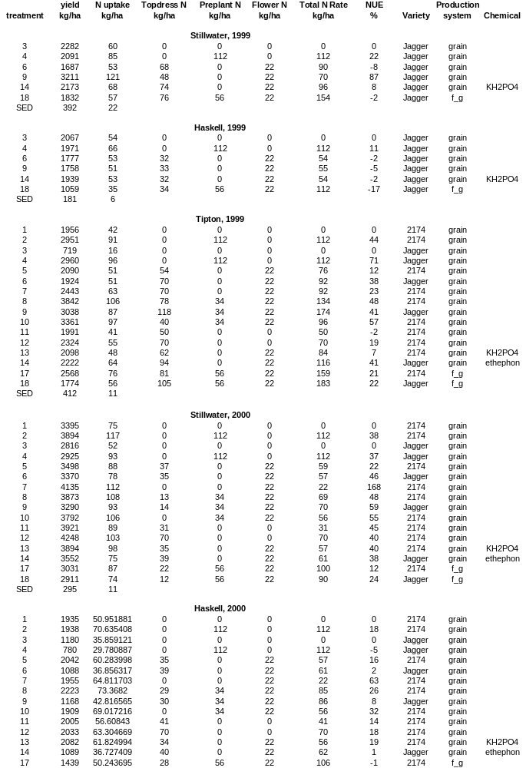
Table 4. Total forage yield, N uptake and efficiency for forage-only treatments

 | Total forage yield | Total N uptake | kg forage yld
Treatment | kg ha⁻¹ | kg ha⁻¹ | kg N applied | variety
 |  | Stillwater, 1999
16 | 7785 | 249 | 74 | jagger
18 | 951 | 22 | 7 | jagger
 |  | Haskell, 1999
15 | 4277 | 130 | 44 | 2174
16 | 5640 | 189 | 71 | jagger
17 | 103 | 4 | 1 | 2174
18 | 412 | 12 | 5 | jagger
 |  | Tipton, 1999
15 | 7121 | 183 | 56 | 2174
16 | 9950 | 262 | 61 | jagger
17 | 482 | 21 | 4 | 2174
18 | 1530 | 57 | 10 | jagger
 |  | Stillwater, 2000
15 | 7565 | 197 | 95 | 2174
16 | 5854 | 153 | 87 | jagger
17 | 1770 | 75 | 18 | 2174
18 | 1303 | 46 | 19 | jagger
 |  | Haskell, 2000
15 | 2516 | 86 | 30 | 2174
16 | 2392 | 74 | 27 | jagger
17 | 561 | 20 | 7 | 2174
18 | 584 | 23 | 7 | jagger
 |  | Tipton, 2000
15 | 3982 | 147 | 63 | 2174
16 | 4476 | 170 | 75 | jagger
17 | 1589 | 71 | 24 | 2174
18 | 1544 | 64 | 26 | jagger

Table 5. Total forage yield, total grain yield and total biomass yield, N uptake and efficiency for forage and grain treatments
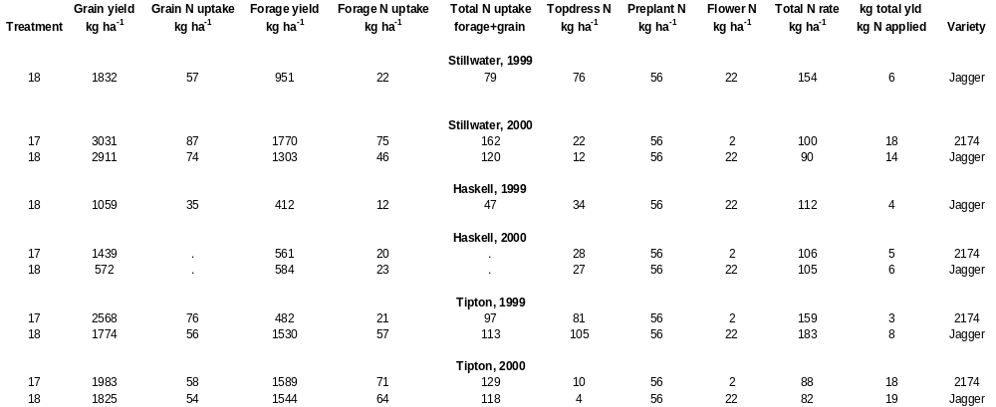

Improving Fertilizer Nitrogen Use Efficiency Using Alternative Legume Interseeding in Continuous Corn

W.E. Thomason, D.A. Keahey, D.A. Cossey, K.J. Wynn,
C.W. Woolfolk, R.W. Mullen, G.V. Johnson, and W.R. Raun

ABSTRACT
Many alternative management systems have been evaluated for corn (Zea mays L.), soybeans (Glycine max L.), and wheat (Triticum aestivum L.) production, however, most have involved rotations from one year to the next. Legume interseeding systems which employ canopy reduction techniques in corn have not been thoroughly evaluated. One study was initiated in 1994 at the Panhandle Research Station near Goodwell, OK, on a Richfield clay loam soil, to evaluate five legume species: yellow sweet clover (Melilotus officinalis L.), subterranean clover (Trifolium subterraneum L.), alfalfa (Medicago sativa L.), arrowleaf clover (T. vesiculosum L.) and crimson clover (T. incarnatum L.) interseeded into established corn. In addition, the effect of removing the corn canopy above the ear (canopy reduction) at physiological maturity was evaluated. Canopy reduction increased light interception beneath the corn thus enhancing legume growth in late summer, early fall, and early spring the following year prior to planting. Legumes incorporated prior to planting were expected to lower the amount of inorganic nitrogen fertilizer needed for corn production. Crimson clover appeared to be more shade tolerant than the other species, and intereseeding this species resulted in the highest corn grain yields when no N was applied. In the last two years, interseeding crimson clover at physiological maturity, followed by canopy reduction resulted in a 21 bu/ac increase in yield compared to conventionally grown corn with no N applied.

Introduction
Canopy reduction has been used in third world countries as a means of increasing light interception for a relay crop. Canopy reduction is imposed when the corn reaches physiological maturity when nutrient and water uptake has ceased). Over the past 20 years, various researchers have evaluated intercropped legumes for increased N supply in corn (Zea mays L.) production. As sources of inorganic nitrogen fertilizer become less dependable and prices increase, organic forms, particularly legumes, are being considered as alternative sources for non-legume crops. Searle et al. (1981) stated that corn grain yield was not affected by legume intercrop, indicating neither competitive depression nor nitrogen transfer from the legume. Nair et al. (1979) showed that intercropping corn with soybeans increased yield 19.5% when compared to monoculture corn. Scott et al. (1987) noted yields following medium red clover (T. pratense L.) were equivalent to the addition of 17 kg ha⁻¹ fertilizer-N.
Even though intercropping usually includes a legume, applied nitrogen may still confer some benefits to the system as the cereal component depends heavily on nitrogen for maximum yield (Ofori and Stern, 1986). Chowdhury and Rosario, (1993) found that intercropping corn with mungbeans (Vigna radiata L.) increased yields 71% when the N application rate was increased from 0 to 90 kg/ha. Ebelhar et al. (1984) reported with no fertilizer N applied, there was an increase in corn grain yield from 2.5 to 6.2 Mg ha⁻¹ with hairy vetch (Vicia villosa L.) treatment compared with corn residue. Corn yields increased 62% with applied N (0 versus 120 kg N ha⁻¹).
Canopy reduction is defined as the removal of the corn canopy just above the ear at physiological maturity, where the cut portion is allowed to drop to the soil surface. Some of the basis of canopy reduction come from regions where a relay crop like common beans is produced following corn. In order to increase light interception beneath the corn canopy for the bean plant, the tops of the corn can be removed once physiological maturity is reached. This in turn does not sacrifice the corn yield while increasing the chances of producing a bean crop that would not have been possible if planting took place following corn harvest.
The objective of this work was to evaluate the effect of interseeded legume species and nitrogen rates combined with canopy reduction on corn grain yield and grain protein.

Materials and Methods
One experiment was established in the spring of 1994 at the Oklahoma Panhandle Research and Extension Center near Goodwell, OK on a Richfield clay loam (fine, montmorillonitic, mesic Aridic Argiustoll). Initial soil test characteristics and soil classification are reported in Table 1. A randomized complete block experimental design with three replications was used. Plot size consisted of four rows (30 inch) x 25 ft. All treatments received 90 lb N/ac of urea (45-0-0) in the fall of 1995. In 1996 and for the remaining years of this experiment, treatments 1-5, 7 and 12 received no N to assess legume N fixation compared to identical treatments with 45 lb N/ac. Each year, corn was planted at a seeding rate of 30,000 seeds ac between late April and early May.
Canopy reduction was imposed by removing the tops of the corn plants just above the ear using a machete. This allowed sunlight to reach the legume seedbed. In August, when the corn had reached physiological maturity, five legume species were interseeded by hand at the following seeding rates: yellow sweet clover (Melilotis officinalis L.) 40 lb/ac, subterranean clover (Trifolium subterraneum L.) 40 lb/ac, alfalfa (Medicago sativa L.) 30 lb/ac, arrowleaf clover (T. vesiculosum L.) 20 lb/ac and crimson clover (T. incarnatum L.) 40 lb/ac. Physiological maturity was determined by periodic monitoring grain black layer formation. Following interseeding and canopy reduction, 5 cm of irrigation water was applied for legume establishment and to prevent reduction in growth caused by moisture stress. The legume seeds were inoculated prior to planting with a mixture of Rhizobium meliloti and R. trifolii bacteria. Harvest area consisted of two rows (30 inches) x 25 ft. Harvesting and shelling were performed by hand. Plot weights were recorded and sub-sampled for moisture and chemical analysis. Subsamples were dried in a forced-air oven at 150°F and ground to pass a 140 mesh screen. Total nitrogen concentration was determined on all grain samples using dry combustion (Schepers et al. 1989). Protein N in corn grain can be determined by multiplying %N by 6.25.
Interseeded legumes remained in the field until the following spring when they were incorporated prior to corn planting using a shallow (4 inches) disk. Legumes were only used for ground cover and potential nitrogen fixation and as such were not harvested for seed or forage.

Results and Discussion
By imposing the alternative management practice of canopy reduction, we visually observed an increase in light interception beneath the corn canopy, thus enhancing legume growth in late summer, early fall before corn harvest, and early spring the following year prior to planting. Crimson clover had superior spring growth compared to the other species evaluated as visual biomass production was greater when incorporated in early April prior to planting. No grain yield response to applied N was observed in 1996, or 1997, but by 1998, yields increased 21 bushels as a result of applying N (12 vs 13, Table 2). The lack of fertilizer N response at this site restricted the early evaluation of legume N contribution and species comparison.
There was no significant difference between grain yields when tops were cut at physiological maturity compared to the normal practice (5 vs 7, crimson clover with and without canopy reduction, with no N applied) in 1996, 1997 or 1998. However, by 1999, interseeding crimson clover and using canopy reduction resulted in increased yields when compared to that observed where no canopy reduction was employed. It was important to find no differences between canopy reduction and conventional management early on, because it demonstrated the applicability of interseeding in late summer.
In the last two years, interseeding crimson clover at physiological maturity, followed by canopy reduction resulted in a 21 bu/ac increase in yield when compared to conventionally grown corn with no N applied (5 versus 12). This N fertilizer savings of approximately 24 lb N/ac would have an economic value of $4.80. Legume interseeding and canopy reduction costs would likely be greater than $4.80, thus restricting what can be promoted at this point in time.
Although not evaluated in this study, mechanized canopy reduction could decrease the time required for grain to lose moisture since more sunlight would directly come in contact with the corn ears when the tops were removed. When grain moisture is high it can delay harvest and/or significantly increase drying costs. Legume seeding rates, alternative species, method of interseeding and interseeding date will all need to be thoroughly evaluated prior to the mechanization and implementation of this practice.
Since nitrate leaching and soil erosion are becoming major concerns in production agriculture today, this experiment may lead to practices that can decrease both, via lowering the amount of inorganic fertilizer N needed for corn production and reducing the amount of bare soil susceptible to wind and water erosion.

References
Chowdhury, M.K. and E.L. Rosario. 1994. Comparison of nitrogen, phosphorus and potassium utilization efficiency in maize/mungbean intercropping. J. of Agric. Sci., Cambridge. 122:193-199.

Ebelhar, S.A., W.W. Frye and R.L. Blevins. 1984. Nitrogen from legume cover crops for no-tillage corn. Agron. J. 76:51-55.

Nair, K.P., U.K. Patel, R.P. Singh and M.K. Kaushik. 1979. Evaluation of legume intercropping in conservation of fertilizer nitrogen in maize culture. J. Agric. Sci. Camb. 93:189-194.

Ofori, Francis and W.R. Stern. 1986. Maize/cowpea intercrop system: effect of nitrogen fertilizer on productivity and efficiency. Field Crops Research 14:247-261.

Schepers, J.S., D.D. Francis and M.T. Thompson. 1989. Simultaneous determination of total C, total N and 15N on soil and plant material. Commun. Soil Sci. Plant Anal. 20:949-959.

Scott, T.W., J. Mt. Pleasant, R.F. Burt and D.J. Otis. 1987. Contributions of ground cover, dry matter, and nitrogen from intercrops and cover crops in a corn polyculture system. Agron. J. 79:792-798.

Searle, P.G.E., Yuthapong Comudom, D.C. Shedden and R.A. Nance. 1981. Effect of maize + legume intercropping systems and fertilizer nitrogen on crop yields and residual nitrogen. Field Crops Res. 4:133-145

Table 1. Initial surface (0-15 cm) soil test characteristics and soil classification at Goodwell, OK.

 | Location | pH | Total N | Org. C | NH₄-N | NO₃-N | P | K
---------- g kg⁻¹ --------- -------mg kg⁻¹ ------- -------mg kg⁻¹------
 | Goodwell | 7.7 | 1.4 | 11.7 | 65 | 25 | 29 | 580

Classification: Richfield clay loam (fine, montmorillonitic, mesic Aridic Argiustoll)
pH - 1:1 soil:water, Total N and Organic C - dry combustion, NH₄-N and NO₃-N - 2M KCl extraction,
P and K - Mehlich III extraction.

Table 2. Treatment structure including legume species interseeded, management of corn canopy and N rate, and corn grain yield means (bu/ac), 1996-1999.
Trt. | Legume | Management | N rate, lb/ac | 1996 | 1997 | 1998 | 1999 | Average
 |  |  |  | ------- | -------- | bu/ac | --------- | ----------
1 | Yellow Sweet Clover | Tops cut at PM | 0 | 155 | 109 | 116 | 142 | 131
2 | Subterranean Clover | Tops cut at PM | 0 | 160 | 101 | 99 | 116 | 119
3 | Alfalfa | Tops cut at PM | 0 | 154 | 109 | 103 | 97 | 116
4 | Arrowleaf Clover | Tops cut at PM | 0 | 158 | 110 | 111 | 103 | 121
5 | Crimson Clover | Tops cut at PM | 0 | 142 | 95 | 111 | 162 | 128
6 | Subterranean Clover | Tops cut at PM | 45 | 148 | 94 | 118 | 124 | 121
7 | Crimson Clover | Normal | 0 | 143 | 105 | 119 | 142 | 127
8 | Yellow Sweet Clover | Tops cut at PM | 45 | 136 | 91 | 108 | 137 | 118
9 | Alfalfa | Tops cut at PM | 45 | 151 | 96 | 113 | 150 | 128
10 | Arrowleaf Clover | Tops cut at PM | 45 | 151 | 98 | 122 | 157 | 132
11 | Crimson Clover | Tops cut at PM | 45 | 163 | 92 | 117 | 148 | 130
12 | No Legume | Normal | 0 | 145 | 111 | 101 | 129 | 122
13 | No Legume | Normal | 90 | 162 | 107 | 132 | 141 | 136

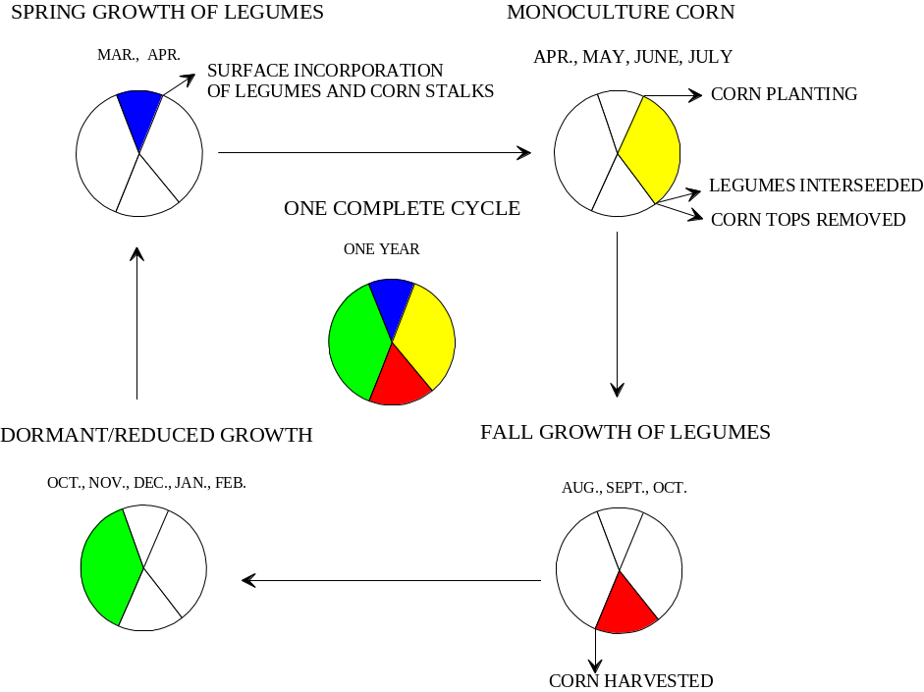

Figure 1. Time schedule for canopy reduction and legume interseeding.

Estimating Grain Response Index with an In-season NDVI Response Index

W.E. Thomason, G.V. Johnson, M.L. Stone, J.B. Solie, and W.R. Raun

Abstract
Application methods that avoid applying large amounts of N at any one time can increase NUE. If the soil/plant system is viewed as a system capable of loss, the more N available for loss at any given time can be greater if N is applied once, and in large amounts. Providing more timely inputs of N throughout the season, while potentially costly, could greatly increase NUE. Using a modified daytime lighting reflectance sensor, early-season plant N uptake between Feekes physiological growth stages 4 (leaf sheaths lengthen) through 6 (first node of stem visible) has been found to be highly correlated with NDVI. Further analyses showed that dividing the NDVI sensor measurements between Feekes growth stages 4 and 6, by the days from planting to sensing date was highly correlated with final grain yield. This in-season estimate of yield (INSEY) was subsequently used to compute the potential N that could be removed in the grain. Based on predicted plant N uptake at early stages of growth and projected grain N uptake based on yield potential, topdress fertilizer N rates can be adjusted based on the difference (Grain N uptake minus early season plant N uptake). The likelihood of obtaining a response to applied N or Response Index (RI) is determined by dividing the maximum grain yield (where N was applied) by the yield obtained where no N was applied. When the RI is greater than 1.5, increased NUE from topdress applied N is more likely. If the RI could be determined in-season, and prior to the time fertilizers are applied, the decision of whether or not to apply and how much could be markedly refined. Sensor measurements of NDVI or forage N uptake between plots receiving N and those not receiving N can be used in the same way to obtain an In-Season Response Index (ISRI). Initial results from this work indicate that the final grain yield RI could be accurately predicted using ISRI (R² = 0.86) over 16 winter wheat experiments conducted throughout Oklahoma.

Introduction

Avoiding excess application of N fertilizers to crops is one way to increase NUE. Application methods that avoid applying large amounts of N at any one time can also increase NUE. If the soil/plant system is viewed as a system capable of loss, the more N available for loss at any given time is greater if N is applied only 1 time per season. Providing more timely inputs of N throughout the season, while potentially costly, could greatly increase NUE.
Alternative methods of determining fertilizer N rates using estimates of early-season plant N uptake and potential yield determined from in-season spectral measurements collected between January and April have been developed at Oklahoma State University. Reflectance measurements under daytime lighting in the red and near infrared regions of the spectra are used to compute the normalized difference vegetation index (NDVI). Using a modified daytime lighting reflectance sensor, early-season plant N uptake between Feekes physiological growth stages 4 (leaf sheaths lengthen) through 6 (first node of stem visible) is highly correlated with NDVI. Further analyses showed that dividing the NDVI sensor measurements between Feekes growth stages 4 and 6, by the days from planting to sensing date was highly correlated with final grain yield. This in-season estimate of yield (INSEY) was subsequently used to compute the potential N that could be removed in the grain.
Based on predicted plant N uptake at early stages of growth and projected grain N uptake based on yield potential, topdress fertilizer N rates can be adjusted based on the difference (Grain N uptake minus early season plant N uptake). The likelihood of obtaining a response to applied N or Response Index (RI) is determined by dividing the maximum grain yield (where N was applied) by the yield obtained where no N was applied. When the RI is greater than 1.5, increased NUE from topdress applied N is more likely. If the RI could be determined in-season, and prior to the time fertilizers are applied, the decision of whether or not to apply and how much could be markedly refined. Sensor measurements of NDVI or forage N uptake between plots receiving N and those not receiving N can be used in the same way to obtain an In-Season Response Index (ISRI). Either way, it is our belief that maximizing yields with limited inputs will require increased accuracy in predicting the potential yield. Basing fertilizer rates on potential yield will allow accurate determination of fertilizer rates, that in turn reflect the ability of the soil to supply water and nutrients to the crop growing in individual 1m² areas. If the amount of mineralized N from the soil could be estimated, then fertilizer rates could be adjusted accordingly.

Results
Initial results indicate that the final grain yield RI can be accurately predicted using ISRI (R2 = 0.86), Figure 1. This is encouraging since the data base includes 16 different experiments conducted at various sites throughout Oklahoma.

Figure 1. Correlation of the grain response index (RI) with the in-season vegetative response index (ISRI) collected at Feekes growth stages 4-6, for 16 winter wheat experiments in Oklahoma

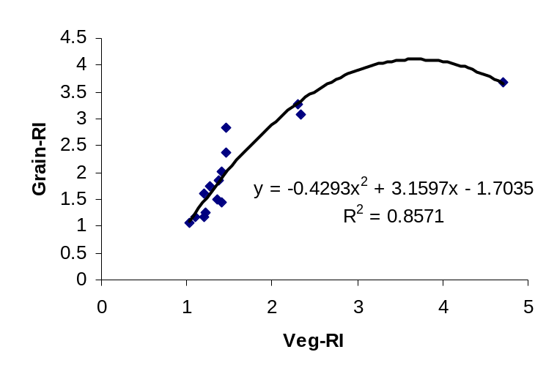
Influence of Late-Season Foliar Nitrogen Applications
on Grain Protein in Winter Wheat
C.W. Woolfolk, W.R. Raun, W.E. Thomason, G.V. Johnson, and E. Krenzer

ABSTRACT
Increasing grain protein in new higher yielding cereal grains is often difficult. Hard red winter wheat (Triticum aestivum L.) studies were conducted at two locations in Oklahoma in 1997-98 and 1998-99 to evaluate the effects of late-season foliar N applications on grain yield, total grain N (grain protein in percent = total grain N in g kg⁻¹/10 * 5.7), straw yield, and total straw nitrogen. Simulated aerial applications of N were made at two different times, relative to wheat stage of growth (pre and post flowering), using urea-ammonium nitrate (UAN) at rates of 0, 11, 22, 33, and 44 kg N ha⁻¹. Ammonium sulfate [AS-(NH₄)₂SO₄] was also applied at a single rate of 22 kg N ha⁻¹ both pre and post flowering, but did not produce differing results from that of UAN. Limited foliar burn was observed, however, there was a tendency for increased foliar burn with AS compared to UAN. In both years and at both sites, a significant linear increase in total grain N was observed for post flowering application times using UAN. In three out of the four site-years, a significant linear increase was observed for preflowering application times using UAN. No consistent increases or decreases were observed for grain yield, straw yield, or straw N from foliar N applications. Late-season foliar nitrogen applications prior to or immediately following flowering may significantly enhance total grain N and thus protein contents in winter wheat.

INTRODUCTION
Grain protein is the most important factor in determining milling and baking quality of wheat. Market adjustments for wheat have been established worldwide based on protein content, with premiums commonly paid for increases above baseline levels. In hard red winter wheat, grain protein contents less than 11.5-12 % often do not attract protein premiums and may indicate N deficiencies (Strong,1982). The desired protein of wheat is dependent upon the type and/or use of the wheat. High protein content is desirable in hard red winter wheat varieties. Bread flour, certain foods (i.e., macaroni and egg noodles), and animal feeds require a high protein content (12-16 %), while low protein content (8-11 %) is preferred in many soft red winter wheat’s (Hunter and Stanford, 1973). Nitrogen (N) is the essential component of amino acids, thus proteins, within a plant. Early investigations concluded that climate was the influencing factor for grain protein, but as soil N became more limiting, it became apparent that grain protein levels in the High Plains region of the U.S. were being limited by N deficiencies (Daigger et al., 1976). Many have studied content of N in the wheat plant to better understand the nutrition of wheat. A better understanding of N content and distribution within the wheat plant would enable researchers to increase the effectiveness of N fertilization. As native soil fertility levels continue to decline and environmental concerns heighten, the need for efficient use of inorganic fertilizers, especially nitrogen, continues to increase. While most nitrogen fertilizers are highly effective and have been extensively studied, increasing nitrogen use efficiency (NUE) has not been a priority in agricultural research until recently. A better scientific understanding involving the efficient use of nitrogen fertilizers is essential for sustained economic crop production, environmental stewardship, and increased grain quality in wheat.
Although constantly surrounded by nitrogen in the atmosphere, humans cannot synthesize this element from the air to produce crucial proteins and other biological molecules essential for life. While only a minimal amount of nitrogen can be absorbed and transformed into protein by growing plants and animals, human nutrition relies on these transformations to supply key proteins for life. The movement of nitrogen from the atmosphere to crops is a difficult task, and thus the need for efficient utilization of nitrogen fertilizers by plants for protein becomes imperative. (Smil 1997)
Nitrogen is taken up by the roots of plants as ammonium and nitrate. In wheat and maize, up to 80 % of the nitrate entering the plant passes unaltered through the roots. There is a constant flow and recycling of nitrogen around the plant. Nitrogen taken up and assimilated by the roots passes in the xylem to the shoot, where it may be temporarily stored as protein. This may be degraded to provide amino acids which are re-exported in the phloem to support growth of other parts of the plant. In plants such as wheat, nitrogen is exported from the leaves mainly as glutamine. Much of the nitrogen found in seeds is taken up from the soil before flowering, and may have been cycled several times and into several different organs before reaching the seeds. It is estimated that up to 40 % of seed nitrogen is derived from leaves, and the remaining nitrogen is assimilated during seed fill. The redistribution of nitrogen in cereals during the growing season may be great. Up to 90 % of the nitrogen found in the mature plant may be taken up from the soil by the time the plant is half-grown with 85 % of the nitrogen in wheat leaves being transported to the developing grain. The photosynthetic tissues closest to the spikelet, including the glumes and flag leaves, normally provide much of the nitrogen. (Chesworth, 1998)
Nitrogen use efficiency was defined by Moll et al. (1982) as the amount of grain production per unit of N available in the soil. An important component of this definition includes the efficiency with which N is absorbed and utilized to produce grain. Other components of this definition included: (a) efficiency of the plant to assimilate applied N; (b) efficiency of the soil to supply and retain applied N for plant assimilation; and (c) composite system efficiency. Many considerations must be taken into account when evaluating NUE. Some of these considerations include: soil moisture, soil type, variety of wheat, N source, N application timing, N application method, tillage, N rate, and type of production system. Climatic conditions following N applications are also extremely important factors. The realization that modern cultivated crops often recover less than half of the nitrogen added as fertilizer has only recently been explored. The use of lower fertilizer rates and less demanding hybrid crops in the past have not fully exposed the unacceptable recovery rates of nitrogen by plants such as wheat.
Nitrogen is extremely susceptible to loss when considering that average recovery rates fall in the range of 20-50% for grain production systems in winter wheat. Strong (1982) noted that the introduction of high yielding semi-dwarf wheat varieties had added to the quantity of low protein wheat produced and stated that little or no change in fertilizer strategy had accompanied the shorter, higher yielding wheat cultivars. Cassman et al. (1992) emphasized the complexities of N fertilizer management involved in optimizing both yield and protein in wheat due to the economics of protein premiums.
Wheat producers in the Great Plains typically use two options for applying N fertilizer: (i) all N fall-applied prior to planting or (ii) a small amount of N fall-applied, followed by a late winter or early spring topdressing (Kelley, 1995). Cooper (1974) demonstrated that dryland wheat receiving N at planting or before ear emergence may respond to increases in grain yield, but may have little or no effect on grain protein content. Preplant N applications are designed to eliminate potential nutrient deficiencies. Although preplant fertilizer applications decrease the potential for nutrient deficiencies in early stages of growth, residual soil nitrate-N may pose a risk to the environment. Many researchers have found that preplant applications may lead to losses or immobilization prior to plant uptake, thus greatly affecting NUE (Welch et al., 1966; Olson and Swallow, 1984; Lutcher and Mahler, 1988; Fowler and Brydon, 1989; Wuest and Cassman, 1992a). The common practice of using soil test analysis for adjusting fertilizer N prior to planting does not allow for late-season deficiency symptoms to be corrected. Mascagni and Sabbe (1991) and Boman et al.(1995) found that split applications are extremely important to maximize crop utilization of applied fertilizer N throughout the growing season. Late-season applied nitrogen provides increased management flexibility by allowing farmers to adjust N rates according to crop growth. Late-season N applications may also reduce potential N losses from leaching or denitrification over the winter. Plant availability of N late in the season when soil moisture content is low and root uptake is slowed is particularly necessary for increasing grain protein contents and many times yield (Ellen and Spiertz, 1980).
Management goals of the producer and type of production system are important factors in discussing plant N losses and composite NUE. Wuest and Cassman (1992b) and Moll et al. (1982) reported decreased NUE with increasing N applied for grain production systems of various crops, whereas in forage production systems NUE does not decrease with increasing N applied. Altom et al. (1996) found that forage production systems may have lower plant gaseous N loss (improved NUE) because the plant is never allowed to approach flowering. Gaseous plant N losses in winter wheat have been found to be greatest between anthesis and maturity, and increase with increasing N content in the tops of plants (Hooker et al., 1980; Parton et al., 1988; Wetselaar 1980). Applications of N near flowering have been found to increase post flowering N uptake, grain protein content, and grain protein concentration (Bänziger et al., 1994; Bulman and Smith, 1993).
Yield increases from foliar applications are greatly varied among studies. An early review of this type of research was presented by Finney et al. (1957). They found that nitrogen applied preplant will normally give a response equal to that of nitrogen applied up to tillering. Nitrogen applied after tillering, and up to heading will normally give progressively smaller yield increases. They also found that nitrogen applied after heading usually did not result in yield increases in most years unless N deficiency was severe. Finney proposed that the greatest grain protein increases occurred when foliar nitrogen applications were applied at anthesis (flowering), and that responses declined rapidly before or after that time.
Modern high yielding wheat varieties require large amounts of available N. The amount of N present in the plant at flowering and potentially utilizable for remobilization to the grain may not meet this requirement. Spiertz (1983) found that with a regular nitrogen supply, wheat will usually attain 65-80% of its grain nitrogen from the vegetative parts, with the remainder originating from root uptake after flowering. Bhatia and Rabson (1976) found that cereals with a typical protein concentration would require an additional 6-11% nitrogen for a 1 percent increase in grain protein, depending on the crop variety and the initial protein concentration within the plant. Wuest and Cassman (1992) found that while the availability of soil N and water may often constrain post flowering N uptake, applications of N near flowering were found to increase post flowering N uptake, grain protein content and grain protein concentrations. Dhugga and Waines (1989) postulated that the N uptake capacity of grain is a determining factor for post flowering N uptake. Austin et al. (1977) found a negative correlation between dry weight loss from the straw and N uptake during grain fill.
In a five year study, Olson and Swallow (1984) found that 27-33% of the applied N fertilizer was removed by the grain over the time of the experiment. Harper et al. (1987) reported that 21% of the applied N fertilizer was lost as volatile NH₃, 11.4% was lost from both the soil and plants soon after fertilization, and 9.8% was lost from the leaves of wheat between anthesis and physiological maturity. Francis et al. (1993) summarized that the failure to include direct plant N losses when calculating a N budget led to an overestimation of N loss from the soil by denitrification, leaching and ammonia volatilization. Kanampiu et al. (1997) proposed estimating potential plant N loss by subtracting the N (grain + straw) removed at harvest from the N uptake at flowering (pt. of max. N accumulation). More N is assimilated at earlier stages of growth, therefore, uptake efficiency should be estimated at the stage of maximum N accumulation and not at maturity when less N can be accounted for.
Increasing grain protein content by applying higher rates of fertilizer is relatively inefficient (NUE decreases with increasing N level), especially under dry soil conditions (Gauer et al., 1992). In-season N applied with point injection or topdressing can maintain or increase NUE compared with preplant N in wheat (Sowers et al., 1994).
As discussed by Raun and Johnson (1999), late season foliar N is critical when considering increased NUE, thus differences in total grain and straw N. Sulfur is an important constituent in many amino acids within the plant. Fertilizer applications containing sulfur may lead to increased grain quality due to beneficial N:S ratios within the plant. Gooding and Davies (1992) speculated that improvements in breadmaking quality might be achieved if sulfur nutrition was improved to maintain this ratio in the grain. Sulfur is an important constituent of wheat flour gluten, and if sulfur supply to wheat plants is inadequate, breadmaking quality of the flour is reduced (Griffiths and Kettlewell, 1990).
In this study, late-season foliar applications of nitrogen were applied without dilution in order to simulate aerial applications. Other studies involving foliar applications have involved N source dilution and have shown visual signs of “scorching,” “burning,” or “tipping” even at relatively low rates and similar sources. Severe burn has also been associated with early morning applications when dew is still on the crop. Gooding and Davies (1992) found increases in leaf burn with AN (ammonium nitrate) and AS (ammonium sulfate) when compared to urea. They further noted three important reasons for foliar applications: (a) foliar application could decrease leaching and/or denitrification; (b) make uptake less dependent on soil conditions; and (c) foliar N applications may suppress disease pressures. Nitrogen uptake prior to or immediately following flowering (the physiological stage of a grass in which anthesis occurs) must be more extensively researched in order to better understand nitrogen use efficiency in winter wheat.
The objective of this experiment was to determine the effects of late-season applications of varying rates of two N fertilizer sources (urea-ammonium nitrate vs. ammonium sulfate) at two times of application (pre vs. post flowering) on grain yield, total grain N, straw yield, and total straw N.

MATERIALS AND METHODS
In October 1997, two studies were initiated at Perkins, Oklahoma on a Teller sandy loam (fine-mixed, thermic, Udic Argiustolls) and Stillwater, Oklahoma on a Easpur silt loam. Studies were repeated at both locations in 1998-99. A randomized complete block experimental design was employed at both locations with 3 and 4 replications for the 1997-98 and 1998-99 crop years, respectively. At both sites, plot size was 3.05 x 2.44 m. Results of soil test data from samples collected prior to treatment application are reported in Table 1. Nitrogen and phosphorus fertilizers were applied and incorporated prior to planting under a conventional tillage system (repeated disk incorporation of wheat straw residues following harvest until planting) at both locations. Nitrogen was broadcast applied preplant as ammonium nitrate (N-P-K, 34-0-0) at a rate of 67.2 kg N ha⁻¹ the first year and 44.8 kg N ha⁻¹ the second year. These rates were based on soil test N and high to moderate yield goals in respective years. Phosphorus, as triple super phosphate (0-46-0), was applied with the nitrogen in 1997 at both locations at a rate of 44.8 kg P ha⁻¹ to ensure adequate phosphorus availability over the two year study period. Hard red winter wheat (‘Tonkawa’) was planted at both sites on October 20, 1997, and October 15, 1998, respectively. Dates of field procedures and environmental conditions for both locations are shown in Tables 2 and 3. At both locations and for both years, wheat was planted in 19 cm rows at a seeding rate of 78.5 kg ha⁻¹ .
Relative to the physiological maturity of the wheat plant, foliar applications of nitrogen were applied at preflowering (Feekes 10.5) and post flowering (Feekes 10.5.4) stages of growth (Large, 1954). The treatment structure employed at both sites is reported in Table 4. Foliar N application dates for each experiment were determined by collecting 20 random wheat heads from each experimental area and examining them under a 10x hand lens to assess maturity. Two N sources commonly available in the central Great Plains were evaluated in the study. Liquid UAN (28% N) was foliar applied with no dilution at rates of 0, 11.2, 22.4, 33.6, and 44.8 kg N ha⁻¹. These rates corresponded to volumes of 24, 47, 70, and 93 ml applied to each 7.43 m² plot. For the AS solution, 700 g of material (21% N) was dissolved in 1,000 ml of water, resulting in a total volume of 1300 ml (ammonium sulfate crystals occupy less volume when dissolved in water). The AS solution was 8.7% N by weight and 11.4% N by volume, therefore, this solution required a higher volume (114 ml) than UAN to achieve the single rate of 22.4 kg N ha⁻¹. Both nitrogen sources were applied using 175 ml mechanically-pressurized spray bottles (Marianna® Research Labs-#413) in order to simulate an aerial application. Because of the small plot size and application method, spray patterns were simulated on paper prior to each application timing. Sufficient leaf surface, good plant density, and small spray volumes allowed for interception of UAN and AS spray with minimal, if any, runoff of the foliage. Treated plots were visually monitored for variation in leaf burn following the applications. At maturity, wheat was harvested using a Massey Ferguson 8XP combine from a 2.0 x 3.05 m area in each plot. Straw samples were also collected from the harvested area in each plot. Both grain and straw samples were dried and ground to pass a 140 mesh sieve (100um). The samples were analyzed for total N content utilizing a Carlo-Erba NA 1500 Series II dry combustion analyzer (Schepers et al., 1989). Grain N uptake and straw N uptake were calculated by multiplying yield by total N concentration within the respective plant part. Wheat grain protein can be determined by the following: total grain N in g kg⁻¹/10 * 5.7 (Martin del Molino, 1991). Treatment effects on grain yield, grain N uptake, grain total N (protein), straw yield, and straw N uptake were evaluated using the PROC GLM procedure (SAS, 1988).

RESULTS AND DISCUSSION
Analysis of variance and associated means for grain yield, grain N uptake, grain N, straw yield, and straw N uptake are reported in Tables 5-8 for Perkins (1998 and 1999) and Stillwater (1998 and 1999), respectively. Single degree of freedom contrasts are also included in each AOV table.
Limited foliar burn was observed at either site in both years. There was, however, a tendency for increased foliar burn with AS compared to UAN applications. Foliar burn from AS at a rate of 22 kg N ha⁻¹ was similar to that for UAN applications at 44 kg N ha⁻¹. Increased awn burn was observed with increasing rates of UAN, but even at 44 kg N ha⁻¹ there was little visual effect on spikelet or leaf color. Differences between UAN and AS at the 22 kg N ha⁻¹ rate applied either pre or post flowering were not consistent for any of the dependent variable analyzed.
Grain yield
With one exception, grain yield increases due to foliar applications of nitrogen were not observed. This exception was found at Stillwater in 1999 where UAN applied preflowering showed a significant quadratic response, and N applied as UAN post flowering showed a significant linear response (Table 8). Maximum grain yields were generally observed when N, as UAN, was applied post flowering at rates between 22 and 33 kg N ha⁻¹, although differences were small. No significant yield differences were noted with AS treatments, although this treatment applied post flowering resulted in the maximum yield at Perkins in 1998 (Table 5).
Grain N uptake
Similar to grain yield data, only limited differences in grain N uptake were observed in either year at both sites. In one out of the four site-years (Stillwater 1999), a significant quadratic trend was observed with preflowering UAN treatments. At this site, grain N uptake decreased at lower N rates and then increased up to 107 kg N ha⁻¹ when 44 kg N ha⁻¹ was applied preflowering, closely following changes in grain yield (Table 6). However, for all site-years, limited differences were observed among treatments in grain N uptake.
Total N in the grain (protein)
For both years at Stillwater, total grain N was highest with a post flowering UAN application of 44 kg N ha⁻¹. The highest grain N values at Perkins were observed for preflowering AS applications at 22 kg N ha⁻¹ and preflowering UAN applications at 33 kg N ha⁻¹ for harvest years 1998 and 1999, respectively. Post flowering UAN treatments resulted in a linear increase in total N (grain protein) for both years at both locations. Maximum grain N was achieved at rates between 33 and 44 kg N ha⁻¹ applied post flowering as UAN at Stillwater in both years. In three out of the four site-years, preflowering applications of UAN significantly increased grain N (Stillwater 1998 as the exception, Tables 5-8). At Perkins, maximum grain N was observed with AS applied preflowering at 22 kg N ha⁻¹ in 1998 and a 33 kg N ha⁻¹ preflowering UAN application in 1999. Considering preplant soil test levels (Table 1) and the amount of N applied prior to planting (45-67 kg N ha⁻¹, Tables 2-3) at both sites and both years, it was important to find significant increases in total grain N under moderate to high fertility levels.
Straw yield
Straw yield responses to pre and post flowering N applications were variable at both sites. Straw yield means were highest for post flowering treatments at 11 and 22 kg N ha⁻¹ rates for Perkins 1998 and 1999, respectively. At Stillwater straw yields were highest for the check in 1998. In general, differences in straw yield were small regardless of rate or time of application.
Straw N uptake
Differences due to treatment in straw N uptake were generally small excluding Stillwater in 1998. At Stillwater in 1998 (Table 7) straw N uptake ranged from 35 to 73 kg N ha⁻¹, far greater than that observed in other site-years. In 1999 at Stillwater, straw N uptake was greatest when foliar N was applied preflowering as UAN at rates between 22 and 44 kg N ha⁻¹. Similar to grain yield and grain N uptake data, only limited differences in straw N uptake were observed over the two-year period at both sites.
Straw total N
Total straw N results were highly variable. At Perkins, significant linear trends were observed with post UAN applications and pre UAN applications in 1998 and 1999, respectively. In 1998, preflowering AS treatments resulted in higher total straw N than preflowering UAN applications at Perkins (Table 5), however, at Stillwater preflowering applications of UAN increased total straw N over UAN applied post flowering (Table 7). Total straw N at Perkins showed a significant linear trend with post flowering UAN applications in 1998, while the following year showed a significant linear response to preflowering UAN treatments.

CONCLUSIONS
Increased total grain N (grain protein in percent = total grain N in g kg⁻¹/10 * 5.7) was observed in three out of the four site-years when N was applied preflowering at the 33.6 kg N ha⁻¹ rate. From the increased total grain N values, these preflowering applications resulted in an average total grain N increase of 2.8 g kg⁻¹ (1.6 % protein). Increased total grain N was observed at both sites for both years with post flowering applications at the 33.6 kg N ha⁻¹ rate. Post flowering applied N as UAN resulted in an average total grain N increase of 2.7 g kg⁻¹ (1.5 % protein). In general, grain yield, straw yield, and straw N were not affected by foliar N applications. Apparently, ammonia volatilization losses from UAN were not significant. Late-season foliar N applications prior to or immediately following flowering may significantly enhance total N even under moderate to high fertility conditions. No consistent differences were observed between N sources, AS and UAN, for any of the variables analyzed. Increased total grain N
resulting from pre or post flowering applied N may result in higher nutritional value, protein premiums, and thus economic gains.

Table 1. Initial surface (0-15cm) soil test characteristics and soil classification at Perkins and Stillwater, OK, 1997.
________________________________________________________________________________________

Location pHª NH₄-N NO₃-N P^{b} K^{b} Total N^{c} Organic C^{c}
________________________________________________________________________________________
-----------------mg kg⁻¹--------------- -------g kg⁻¹-------
Perkins 5.8 18.87 4.9 12 140 0.63 4.03

Classification: Teller sandy loam (fine-mixed, thermic Udic Argiustolls)

Stillwater 5.5 3.47 14.7 31 222 0.94 10.51
________________________________________________________________________________________
Classification: Kirkland silt loam (fine-mixed, thermic, Udertic Paleustolls)
ªpH: 1:1 soil:water
^{b}P and K: Mehlich III extraction
^{c}Total N and Organic C: dry combustion

Table 2. Dates of field procedures and environmental conditions for Perkins and Stillwater, OK, 1997-1998.

September 15, 1997 67.2 kg N ha⁻¹ blanket of AN (34-0-0)
44.8 kg P ha⁻¹ blanket of TSP (0-46-0)
applied and incorporated
October 20, 1997 ‘Tonkawa’ planted at 78.5 kg ha⁻¹
April 30,1998 Preflowering treatments applied
Air temp at application 68⁰ F
Average daily temp 57.4
Dewpoint 47.4
Humidity 72
Wind 5 mph W
Soil temp 56⁰ F
Rainfall 0.00

May 8,1998 Post flowering treatments applied
Air temp at application-------- 75⁰ F
Average daily temp------------ 65.2
Dewpoint------------------------ 51.7
Humidity------------------------ 64
Wind----------------------------- 8 mph E
Soil temp------------------------ 66.8⁰ F
Rainfall-------------------------- 0.00

June 10, 1998 Grain and straw harvest, Stillwater
June 15,1998 Grain and straw harvest, Perkins

Table 3. Dates of field procedures and environmental conditions for Perkins and Stillwater, OK, 1998-1999.

September 16, 1998 44.8 kg N ha⁻¹ blanket of AN (34-0-0)
October 15, 1998 ‘Tonkawa’ planted at 78.5 kg ha⁻¹
April 28,1999 Preflowering treatments applied
Air temp at application 65⁰ F
Average daily temp 59⁰ F
Dewpoint 53.5
Humidity 83
Wind 5 mph W
Soil temp 63⁰ F
Rainfall 0.00

May 8,1999 Post flowering treatments applied
Air temp at application-------- 62⁰ F
Average daily temp------------ 70⁰ F
Dewpoint------------------------ 55
Humidity------------------------ 63
Wind----------------------------- 8 mph E
Soil temp------------------------ 65⁰ F
Rainfall-------------------------- 0.00

June 9, 1999 Grain and straw harvest, Perkins
June 10,1999 Grain and straw harvest, Stillwater

Table 4. Treatment structure employed: N source, N rate, and time of application, Perkins and Stillwater, OK, 1997-98 and 1998-99.

Treatment | N source | N rate | Time of Application
 |  | (kg N ha⁻¹)
1 | ---- | 0 | Check
2 | UAN | 11.2 | Preflowering
3 | UAN | 22.4 | Preflowering
4 | UAN | 33.6 | Preflowering
5 | UAN | 44.8 | Preflowering
6 | AS | 22.4 | Preflowering
7 | UAN | 11.2 | Post flowering
8 | UAN | 22.4 | Post flowering
9 | UAN | 33.6 | Post flowering
10 | UAN | 44.8 | Post flowering
11 | AS | 22.4 | Post flowering
Preflowering: foliar N applied just prior to flowering (late April-Feekes 10.5)
Post flowering: foliar N applied immediately following flowering (early May-Feekes 10.5.4)

Table 5. Analysis of variance, treatment means, and single degree of freedom contrasts for grain yield, grain N uptake, total grain N, straw yield, straw N uptake, and total straw N, Perkins, OK, 1998.
 |  |  |  | --------------------Grain-------------------- |  |  |  | ---------------------Straw-----------------------
 |  |  |  | Yield |  | N uptake | Total N | Yield | N uptake | Total N
 |  |  |  | kg ha⁻¹ |  | kg ha⁻¹ | g kg⁻¹ | kg ha⁻¹ | kg ha⁻¹ | g kg⁻¹
Source of variation |  |  |  | ---------------------------------------Mean squares-----------------------------------
Rep |  |  |  | 352357 |  | 174.9 | 3.35 | 1141874 | 24.8 | 1.82
Trt |  |  |  | 77111 |  | 49.1 | 8.16** | 592963 | 44.7* | 3.52*
Contrast
 | UAN lin pre |  |  | 32295 |  | 65.0 | 35.65** | 623216 | 48.3 | 2.83
 | UAN quad pre |  |  | 61 |  | 46.5 | 8.48* | 289772 | 13.3 | 0.10
 | UAN lin post |  |  | 127002 |  | 11.1 | 31.46** | 64333 | 53.9 | 7.08*
 | UAN quad post |  |  | 479 |  | 6.8 | 2.11 | 917947 | 27.8 | 0.04
 | AS pre vs. UAN pre |  |  | 75184 |  | 3.1 | 7.26* | 418976 | 181.1** | 12.63**
 | AS post vs. UAN post |  |  | 230739 |  | 14.8 | 18.13** | 426633 | 65.4* | 1.89
 | UAN pre vs. UAN post |  |  | 61629 |  | 124.2 | 5.22 | 2263374* | 84.7* | 0.01
 | AS pre vs. AS post |  |  | 230739 |  | 14.8 | 18.13** | 26634 | 65.4* | 1.89
 | AS pre vs. check |  |  | 34133 |  | 127.1 | 56.03** | 705675 | 212.1** | 17.66**
 | AS post vs. check |  |  | 87380 |  | 228.8 | 10.42** | 34921 | 41.9 | 7.99*
Residual error |  |  |  | 136586 |  | 114.6 | 1.25 | 399890 | 13.8 | 1.44
SED |  |  |  | 302 |  | 8.7 | 0.91 | 516 | 3.0 | 0.98
CV |  |  |  | 17 |  | 17.9 | 4.13 | 29 | 27.2 | 18.70
Treatment
Source |  | Timing | Rate, kg ha⁻¹ |  | -----------------------------------Treatment means--------------------------------
nt |  | nt | 0 | 2269 |  | 53 | 23.54 | 1795 | 10 | 5.31
UAN |  | Pre | 11.2 | 2338 |  | 62 | 26.84 | 1413 | 9 | 5.71
UAN |  | Pre | 22.4 | 2342 |  | 64 | 27.46 | 1953 | 10 | 5.83
UAN |  | Pre | 33.6 | 2040 |  | 58 | 28.23 | 1777 | 11 | 6.65
UAN |  | Pre | 44.8 | 2254 |  | 63 | 28.30 | 2334 | 15 | 6.37
AS |  | Pre | 22.4 | 2118 |  | 63 | 29.66 | 2481 | 21 | 8.74
UAN |  | Post | 11.2 | 2350 |  | 59 | 25.30 | 2939 | 14 | 4.92
UAN |  | Post | 22.4 | 2012 |  | 55 | 27.18 | 2139 | 13 | 5.95
UAN |  | Post | 33.6 | 2176 |  | 58 | 26.60 | 2718 | 19 | 6.87
UAN |  | Post | 44.8 | 2030 |  | 57 | 28.01 | 2137 | 14 | 6.76
AS |  | Post | 22.4 | 2510 |  | 66 | 26.18 | 1948 | 15 | 7.61
*,** - Significant at the 0.05 and 0.01 probability levels, respectively
SED-Standard error of the difference between two equally replicated means
Pre----Foliar N applied just prior to flowering (late April-Feekes 10.5)
Post----Foliar N applied immediately following flowering (early May-Feekes 10.5.4)

Table 6. Analysis of variance, treatment means, and single degree of freedom contrasts for grain yield, grain N uptake, total grain N, straw yield, straw N uptake, and total straw N, Perkins, OK, 1999.
 |  |  |  | --------------------Grain----------------------- |  |  |  |  |  | ------------Straw-----------
 |  |  |  | Yield |  |  | N uptake | Total N |  | Yield | N uptake | Total N
 |  |  |  | kg ha⁻¹ |  |  | kg ha⁻¹ | g kg⁻¹ |  | kg ha⁻¹ | kg ha⁻¹ | g kg⁻¹
Source of variation |  |  |  | -----------------------------------------Mean squares---------------------------------
Rep |  |  |  | 302802 |  |  | 306.8 | 3.30 |  | 1441828 | 115.8* | 0.43
Trt |  |  |  | 169398 |  |  | 293.6 | 11.96* |  | 253804 | 18.6 | 0.97
Contrast
 | UAN lin pre |  |  | 75107 |  |  | 507.3 | 43.58** |  | 244798 | 57.8 | 3.61*
 | UAN quad pre |  |  | 107558 |  |  | 288.9 | 6.40 |  | 20718 | 2.7 | 0.01
 | UAN lin post |  |  | 85058 |  |  | 700.4 | 66.27** |  | 78286 | 15.2 | 0.86
 | UAN quad post |  |  | 150457 |  |  | 269.2 | 2.90 |  | 133838 | 0.4 | 1.05
 | AS pre vs. UAN pre |  |  | 2525 |  |  | 78.7 | 8.13 |  | 45541 | 7.3 | 0.01
 | AS post vs. UAN post |  |  | 133216 |  |  | 37.8 | 6.13 |  | 8758 | 0.2 | 0.01
 | UAN pre vs. UAN post |  |  | 57814 |  |  | 37.0 | 0.94 |  | 27618 | 11.9 | 1.14
 | AS pre vs. AS post |  |  | 133216 |  |  | 37.8 | 6.13 |  | 8758 | 0.2 | 0.01
 | AS pre vs. check |  |  | 161231 |  |  | 231.6 | 0.96 |  | 153897 | 14.3 | 0.24
 | AS post vs. check |  |  | 1336 |  |  | 82.2 | 11.95 |  | 89229 | 17.9 | 0.25
Residual error |  |  |  | 289745 |  |  | 464.4 | 5.02 |  | 535830 | 37.0 | 0.77
SED |  |  |  | 381 |  |  | 15.2 | 1.58 |  | 518 | 4.3 | 0.62
CV |  |  |  | 29 |  |  | 34.9 | 7.87 |  | 34 | 36.9 | 11.38
Treatment
Source |  | Timing | Rate, kg ha⁻¹ |  |  | --------------------------------------Treatment means------------------------------------------
nt |  | nt | 0 |  | 1657 |  | 50 | 25.87 |  | 1948 | 14 | 7.48
UAN |  | Pre | 11.2 |  | 1955 |  | 62 | 27.00 |  | 1939 | 13 | 6.96
UAN |  | Pre | 22.4 |  | 1977 |  | 67 | 28.58 |  | 2376 | 19 | 7.85
UAN |  | Pre | 33.6 |  | 1861 |  | 66 | 30.74 |  | 2045 | 17 | 8.67
UAN |  | Pre | 44.8 |  | 1921 |  | 65 | 29.22 |  | 2286 | 18 | 8.13
AS |  | Pre | 22.4 |  | 1941 |  | 61 | 26.56 |  | 2225 | 17 | 7.83
UAN |  | Post | 11.2 |  | 1591 |  | 49 | 26.73 |  | 1796 | 14 | 7.34
UAN |  | Post | 22.4 |  | 2292 |  | 79 | 29.26 |  | 2636 | 19 | 7.05
UAN |  | Post | 33.6 |  | 1616 |  | 57 | 30.50 |  | 1823 | 14 | 7.68
UAN |  | Post | 44.8 |  | 1875 |  | 67 | 30.42 |  | 2156 | 17 | 8.04
AS |  | Post | 22.4 |  | 1683 |  | 56 | 28.31 |  | 2159 | 17 | 7.84
*,** - Significant at the 0.05 and 0.01 probability levels, respectively
SED-Standard error of the difference between two equally replicated means
Pre----Foliar N applied just prior to flowering (late April-Feekes 10.5)
Post----Foliar N applied immediately following flowering (early May-Feekes 10.5.4)

Table 7. Analysis of variance, treatment means, and single degree of freedom contrasts for grain yield, grain N uptake, total grain N, straw yield, straw N uptake, and total straw N, Stillwater, OK, 1998.
 |  |  |  | ------------------Grain---------------------- |  |  |  | ----------------Straw---------------
 |  |  |  | Yield | N uptake | Total N |  | Yield | N uptake | Total N
 |  |  |  | kg ha⁻¹ | kg ha⁻¹ | g kg⁻¹ |  | kg ha⁻¹ | kg ha⁻¹ | g kg⁻¹
Source of variation |  |  |  | --------------------------------------Mean squares-------------------------------------------
Rep |  |  |  | 319596* | 81.1 | 8.56* |  | 2684727* | 390.3* | 3.61
Trt |  |  |  | 128308 | 176.4 | 1.89 |  | 1429040* | 272.2* | 1.95
Contrast
 | UAN lin pre |  |  | 7257 | 44.6 | 0.87 |  | 1330669 | 43.4 | 0.11
 | UAN quad pre |  |  | 208833 | 199.2 | 0.06 |  | 8704134* | 1109.5** | 3.23
 | UAN lin post |  |  | 37040 | 322.4 | 9.69* |  | 700995 | 16.9 | 3.19
 | UAN quad post |  |  | 1.37 | 0.3 | 0.01 |  | 321 | 44.8 | 0.83
 | AS pre vs. UAN pre |  |  | 46260 | 84.6 | 0.49 |  | 4175328* | 578.0* | 2.20
 | AS post vs. UAN post |  |  | 1700 | 2.6 | 0.01 |  | 35658 | 4.8 | 0.01
 | UAN pre vs. UAN post |  |  | 62749 | 160.0 | 2.02 |  | 5006196** | 1085.5** | 6.42*
 | AS pre vs. AS post |  |  | 1700 | 2.6 | 0.01 |  | 35658 | 4.8 | 0.01
 | AS pre vs. check |  |  | 72527 | 40.7 | 0.04 |  | 714571 | 43.4 | 0.01
 | AS post vs. check |  |  | 52019 | 22.9 | 0.09 |  | 1069481 | 77.1 | 0.01
Residual error |  |  |  | 72885 | 76.9 | 2.08 |  | 555566 | 101.6 | 1.45
SED |  |  |  | 220 | 7.2 | 1.18 |  | 609 | 2.6 | 0.90
CV |  |  |  | 7 | 7.9 | 5.10 |  | 12 | 20.1 | 14.71
Treatment
Source |  | Timing | ---------------------------------------Treatment means--------------------------------------------
nt |  | nt | 0 | 4052 | 112 | 27.66 |  | 6989 | 56 | 8.06
UAN |  | Pre | 11.2 | 3877 | 110 | 28.53 |  | 5746 | 46 | 7.90
UAN |  | Pre | 22.4 | 3656 | 99 | 27.25 |  | 4631 | 31 | 6.88
UAN |  | Pre | 33.6 | 4032 | 115 | 28.65 |  | 5108 | 40 | 7.61
UAN |  | Pre | 44.8 | 4053 | 115 | 28.45 |  | 6255 | 53 | 8.51
AS |  | Pre | 22.4 | 3832 | 107 | 27.82 |  | 6299 | 51 | 8.09
UAN |  | Post | 11.2 | 3831 | 104 | 27.34 |  | 6078 | 45 | 7.40
UAN |  | Post | 22.4 | 3824 | 112 | 29.25 |  | 6872 | 67 | 9.75
UAN |  | Post | 33.6 | 4457 | 129 | 28.88 |  | 6362 | 57 | 8.99
UAN |  | Post | 44.8 | 3915 | 116 | 29.73 |  | 6083 | 54 | 8.90
AS |  | Post | 22.4 | 3866 | 108 | 27.90 |  | 6145 | 49 | 8.04
*,** - Significant at the 0.05 and 0.01 probability levels, respectively
SED-Standard error of the difference between two equally replicated means
Pre----Foliar N applied just prior to flowering (late April-Feekes 10.5)
Post----Foliar N applied immediately following flowering (early May-Feekes 10.5.4)

Table 8. Analysis of variance, treatment means, and single degree of freedom contrasts for grain yield, grain N uptake, total grain N, straw yield, straw N uptake, and total straw N, Stillwater, OK, 1999.
 |  |  |  | ------------------Grain---------------------- |  |  |  |  | -------------------Straw---------------------
 |  |  |  | Yield |  | N uptake | Total N |  | Yield | N uptake | Total N
 |  |  |  | kg ha⁻¹ |  | kg ha⁻¹ | g kg⁻¹ |  | kg ha⁻¹ | kg ha⁻¹ | g kg⁻¹
Source of variation |  |  |  | ----------------------------------------------------Mean squares-------------------------------------------------
Rep |  |  |  | 1478076** |  | 2930** | 22.46** |  | 1045627* | 238.3 | 7.24**
Trt |  |  |  | 235916* |  | 402** | 5.16** |  | 156415 | 20.2 | 0.54
Contrast
 | UAN lin pre |  |  | 81778 |  | 391.6 | 10.89* |  | 11721 | 20.8 | 1.53
 | UAN quad pre |  |  | 432779* |  | 739.9* | 1.42 |  | 170914 | 61.7 | 1.95
 | UAN lin post |  |  | 404481* |  | 174.3 | 13.74** |  | 71531 | 7.5 | 0.02
 | UAN quad post |  |  | 53358 |  | 40.6 | 0.96 |  | 3485 | 2.7 | 0.19
 | AS pre vs. UAN pre |  |  | 2275 |  | 106.6 | 8.74* |  | 152820 | 9.8 | 0.01
 | AS post vs. UAN post |  |  | 18 |  | 24.8 | 1.48 |  | 98821 | 31.3 | 0.47
 | UAN pre vs. UAN post |  |  | 158927 |  | 115.4 | 2.27 |  | 140956 | 11.7 | 0.08
 | AS pre vs. AS post |  |  | 18 |  | 24.8 | 1.48 |  | 98821 | 31.3 | 0.47
 | AS pre vs. check |  |  | 353221 |  | 708.7* | 2.85 |  | 26039 | 2.8 | 0.02
 | AS post vs. check |  |  | 358239 |  | 468.4 | 0.22 |  | 23407 | 15.3 | 0.28
Residual error |  |  |  | 90799 |  | 135.9 | 1.62 |  | 258159 | 28.9 | 0.64
SED |  |  |  | 213 |  | 8.2 | 0.90 |  | 359 | 3.8 | 0.57
CV |  |  |  | 12 |  | 12.6 | 4.05 |  | 16 | 23.3 | 11.02
Treatment
Source |  | Timing | -----------------------------------------------------Treatment means--------------------------------------------
nt |  | nt | 0 |  | 2775 | 100 | 31.04 |  | 3287 | 24 | 7.16
UAN |  | Pre | 11.2 |  | 2453 | 85 | 29.90 |  | 3131 | 22 | 7.01
UAN |  | Pre | 22.4 |  | 2388 | 88 | 31.94 |  | 2896 | 21 | 7.04
UAN |  | Pre | 33.6 |  | 2772 | 102 | 31.64 |  | 3376 | 24 | 6.95
UAN |  | Pre | 44.8 |  | 2841 | 107 | 32.78 |  | 3250 | 27 | 8.17
AS |  | Pre | 22.4 |  | 2355 | 81 | 29.85 |  | 3173 | 23 | 7.05
UAN |  | Post | 11.2 |  | 2518 | 91 | 31.20 |  | 2821 | 21 | 7.23
UAN |  | Post | 22.4 |  | 2421 | 88 | 31.13 |  | 3215 | 23 | 7.12
UAN |  | Post | 33.6 |  | 2842 | 108 | 32.97 |  | 3203 | 24 | 7.49
UAN |  | Post | 44.8 |  | 2110 | 81 | 33.09 |  | 2885 | 20 | 6.92
AS |  | Post | 22.4 |  | 2352 | 85 | 30.71 |  | 3395 | 27 | 7.54
*,** - Significant at the 0.05 and 0.01 probability levels, respectively
SED-Standard error of the difference between two equally replicated means
Pre----Foliar N applied just prior to flowering (late April-Feekes 10.5)
Post----Foliar N applied immediately following flowering (early May-Feekes 10.5.4)

Improving Nitrogen Use Efficiency for Cereal Production

W.R. Raun and G.V. Johnson

Abstract
Worldwide, nitrogen use efficiency (NUE) for cereal production (wheat, Triticum aestivum L., corn, Zea mays L., rice, Oryza sativa L., barley, Hordeum vulgare L. sorghum, Sorghum bicolor, L. , millet, Pennisetum glaucum L., oats, Avena sativa L. and rye, Secale cereale L.) is approximately 33%. The unaccounted 67% represents a $15.9 billion annual loss of N fertilizer (assuming fertilizer-soil equilibrium). Loss of fertilizer N results from gaseous plant emission, soil denitrification, surface runoff, volatilization, and leaching. Increased cereal NUE is unlikely unless a systems approach is implemented that uses varieties with high harvest index, incorporated NH₄-N fertilizer, application of prescribed rates consistent with in-field variability using sensor-based systems within production fields, low N rates applied at flowering, and forage production systems. Furthermore, increased cereal NUE must accompany increased yields needed to feed a growing world population that has yet to benefit from the promise of N-fixing cereal crops. The Consultative Group on International Agricultural Research (CGIAR) linked with advanced research programs at universities and research institutes is uniquely positioned to refine fertilizer N use in the world via the extension of improved NUE hybrids/varieties and management practices in both the developed and developing world.

Introduction
In 1996, a total of 82,906,340 metric tons of fertilizer-N were applied in the world, of which 11,184,400 were applied in the United States (FAO, 1996). Cereal production accounted for approximately 49,743,804 metric tons of N fertilizer world-wide (60% of total, Table 1)(FAO, 1995). Of that, only 16,572,232 metric tons were estimated to have been removed in the grain (Dale, 1997; Tkachuk, 1977; Keeney, 1982, Table 1). The world cereal grain NUE would therefore be estimated at 33% (NUE = ((total cereal N removed)-(N coming from the soil+N deposited in rainfall))/(fertilizer N applied to cereals)), far less than the 50% generally reported (Hardy and Havelka, 1975). Similar results in NUE for West German agriculture would have been found, had they considered N derived from the soil (Keeney, 1982; van der Ploeg et al., 1997). Using the same references and assumptions in Table 1, developed and developing nation cereal NUE's are 42 and 29%, respectively. Based on present fertilizer use, a 1% increase in the efficiency of N use for cereal production world wide would lead to a $234,658,462 savings in cost of N fertilizer (Table 1). An increase in NUE of 20% would result in a savings in excess of $4.7 billion per year.

Why are NUE's so low?
Not until recently have scientists documented that cereal plants release N from plant tissue, predominantly as NH₃ following anthesis (Harper et al., 1987; Francis et al., 1993). Plant N losses have accounted for 52 to 73 % of the unaccounted N using ¹⁵N in corn research ( Francis et al., 1993), and between 21% (Harper et al., 1987) and 41% (Daigger et al., 1976) in winter wheat. Gaseous plant N loss in excess of 45 kg N ha⁻¹ yr⁻¹ has also been documented in soybean (Stutte et al., 1979).
Reported gaseous N losses due to denitrification from applied fertilizer N include 9.5% in winter wheat (Aulakh et al., 1982), 10% in lowland rice (DeDatta et al., 1991), and 10 (conventional tillage) to 22% (no-till) in corn (Hilton et al., 1994). Incorporation of straw and/or application of straw on the surface of zero till plots can double denitrification losses (Aulakh et al., 1984).
Fertilizer N losses in surface runoff range between 1% (Blevins et al., 1996) and 13% (Chichester and Richardson, 1992) of the total N applied, and are generally lower under no-tillage. When urea fertilizers are applied to the surface without incorporation, losses of fertilizer N as ammonia can exceed 40% (Fowler, 1989, Hargrove et al., 1977), and generally greater with increasing temperature, soil pH, and surface residue.
When fertilizer N is applied at rates in excess of that needed for maximum yield in cereal crops, nitrate leaching can be significant (Olson and Swallow, 1984; Raun and Johnson, 1995). In cooler temperate climates, nitrate losses through tile drainage have approached 26 kg N ha⁻¹ yr⁻¹ under conventional tillage corn when only 115 kg N ha⁻¹ was applied (Drury et al., 1996). However, it should be noted that because past N balance work has failed to account for plant N losses, leaching losses attributed to unaccounted N have likely been overestimated (Francis et al., 1993; Kanampiu, 1997).
Many ¹⁵N recovery experiments have reported loss of fertilizer N in cereal production from 20 to 50%. These losses have been attributed to the combined effects of denitrification, volatilization and/or leaching (Francis et al., 1993; Olson and Swallow, 1984; Karlen et al., 1996; Wienhold et al., 1995; Sanchez and Blackmer, 1988) when each was not measured separately.
Using today's management practices, low nitrogen use efficiencies in the world are compounded by both complacency and economics. Depending on the source of fertilizer, N costs approximately $0.49 kg⁻¹. Applying an added 40 kg N ha⁻¹ at planting when average cereal N rates are greater than 100 kg N ha⁻¹ will cost less than $20 ha⁻¹. This affordability combined with the convenience of not having to apply N again during the growing season is attractive to farmers. In this regard excess N is applied as insurance, and because farmers are often overly optimistic concerning expected yields and yield goals (Schepers et al., 1991). Because of this, the affordability of N in the developed world has led to its misuse and over application. In the developing world, the same does not always hold true as access to fertilizer is limited (Hubbell, 1995), especially for subsistence farmers in remote areas whose immediate goal is economic survival, not preservation of the environment (Campbell et al., 1995).

How can NUE's be increased?
Production practices that have resulted in increased NUE when compared to conventional or standard practices are those that will counter conditions, or environments, known to contribute to N loss from soil-plant systems.

Rotations
In irrigated or high-rainfall production regions, soybean-corn rotations have high NUE and can reduce the amount of residual N available for leaching when compared to continuous corn (Wen-Yuan et al., 1996). Also, precipitation use efficiency is greater for corn grown in rotation when compared to continuous corn (Varvel, 1994). Unfortunately, rotations are not easily adopted by farmers who have become accustomed to monoculture production systems since a new crop often requires purchase of additional equipment and learning to integrate new cultural practices. In irrigated agriculture, the use of high N rates as a substitute for more N use efficient rotation systems (corn-soybean) must be weighed against the increased potential for NO₃-N loss (Anderson et al., 1997).
Nitrogen use efficiency for wheat following legumes is greater than that for wheat following fallow or continuous wheat (Badaruddin and Meyer, 1994). Wheat-corn-fallow production systems are now promoted instead of popular wheat-fallow where only 420 mm precipitation is received per year (Kolberg et al., 1996). The more intensive systems (growing more crops in a given period of time), require greater fertilizer N inputs but are higher in total yield and economically advantageous (Kolberg et al., 1996). More intensive dryland cropping systems lead to increased water use efficiency and better maintain soil quality (Halvorson and Reule, 1994). Alternative dryland systems proposed include spring barley (Hordeum vulgare L.) corn (Zea mays L.) and winter wheat (Triticum aestivum L.) grown in rotation with adequate N fertilization instead of continuous winter wheat-fallow (Halvorson and Reule, 1994).

Forage Production Systems
Forage-only production systems have lower plant gaseous N loss and improved NUE because the plant is never allowed to approach flowering where N losses have been found to be greater (Altom et al., 1996). Averaged over 3 years and 2 locations, forage-only NUE's for winter wheat were 77% compared to 31% for grain-only when 90 kg N ha⁻¹ yr⁻¹ was applied preplant (Thomason, 1998). Total N removed in the forage-only production system was nearly double that found in grain, averaging 104 and 59 kg N ha⁻¹, respectively (Thomason, 1998). Similarly, calculated NUE's for forage (silage) production in corn exceeded 70% and were greater than that reported for grain (O'Leary and Rehm, 1990). However, it should be noted that substitution of forage for grain will ultimately place greater dependency on animal protein and decrease the supply of starch for human diets.

Improved NUE hybrid/variety
The early study of NUE was facilitated by identifying individual components that explained both uptake and utilization efficiency (Moll et al., 1982). Differences among corn hybrids for NUE are largely due to variation in the utilization of accumulated N before anthesis, especially under low N supply (Moll et al., 1982). Eghball and Maranville (1991) noted that NUE generally parallels water use efficiency (WUE) in corn.
Wheat varieties with a high harvest index (grain produced divided by the total dry biomass) and low forage yield have low plant N loss and increased NUE (Kanampiu et al., 1997). Higher NUE has also been observed in rice varieties with high harvest index (Bufogle et al., 1997). Other work by Karrou and Maranville (1993) suggests that wheat varieties that produce more seedling dry matter with greater N accumulation are not necessarily the ones that use N more efficiently. Furthermore, N assimilation after anthesis is needed to achieve high wheat yields (Cox et al., 1985) and high NUE.
Genetic selection is often conducted with high fertilizer N input in order to eliminate N as a variable, however this can mask efficiency differences among genotypes to accumulate and utilize N to produce grain (Kamprath et al., 1982). This is consistent with Earl and Ausubel (1983), noting that high yielding varieties of corn, wheat, and rice released during the Green Revolution were selected to respond to high N inputs. Consequently, continued efforts are needed where plant selection is accomplished under low N, often not considered to be a priority by plant breeders and uncharacteristic of agricultural experiment stations.

Conservation tillage
Conservation tillage systems have not been found to increase productivity of high-yielding corn genotypes; yet they have not resulted in yield reductions compared to conventional tillage (Al-Darby and Lowery, 1986). The use of conservation tillage is based more on erosion control, the environment and operation costs, not yield potential (Al Darby and Lowery, 1986), where potential advantages in NUE would be seen.
Under a no-tillage production system, grain yield was improved 32% when 60 kg N ha⁻¹ was banded 8 to 10 cm below the seed row, and 15% when banded between the rows compared to surface broadcast urea (Rao and Dao, 1996). Adaptation of subsurface placement of N fertilizer for no-till winter wheat has the potential to significantly improve N availability to plants and thereby improve NUE and reduce environmental and economic risks (Rao and Dao, 1996).

NH₄-N Source
Because ammonium-N is less subject to leaching or denitrification losses, N maintained as ammonium in the soil should be available for late-season uptake (Tsai et al., 1992). Increased N uptake during grain-fill, for N-responsive hybrids, indicates a potential advantage of ammonium nutrition for grain production (Tsai et al., 1992).
Wheat N uptake was increased 35% when supplying 25% of the N as NH₄⁺ compared to all N as NO₃⁻ (Wang and Below, 1992). High-yielding corn genotypes were unable to absorb NO₃⁻ during ear development, thus limiting yields otherwise increased by supplies of NH₄⁺ (Pan et al., 1984). Assimilation of NO₃⁻ requires the energy equivalent of 20 ATP mol ⁻¹ NO₃⁻, whereas NH₄⁺ assimilation requires only 5 ATP mol⁻¹ NH₄⁺ (Salsac et al., 1987). This energy savings may lead to greater dry weight production for plants supplied solely with NH₄⁺ (Huffman, 1989). However, this has not been consistently observed, nor is it easy to carry out given N-cycle dynamics.

In-season and foliar applied N
Increasing protein content by applying higher rates of fertilizer is relatively inefficient, as NUE decreases with increasing N level, especially under dry soil conditions (Gauer et al., 1992). In-season applied N resulted in more efficient fertilizer use in four of five years when compared to N incorporated prior to planting winter wheat (Olson and Swallow, 1984). Pre-plant N must be carefully managed to optimize grain yield, but adding excess N at that time reduces NUE, whereas the late-season supplied N can be adjusted to increase grain protein and NUE (Wuest and Cassman, 1992a). In-season N, with point injection or topdressing can maintain or increase NUE compared with pre-plant N in wheat (Sowers et al., 1994).
Nitrogen fertilization should take place early in the season to maximize winter wheat forage production (Boman et al., 1995a). However, if grain production is the only goal, N fertilization can be delayed until much later in the season without significantly affecting wheat grain yields. Injection of anhydrous ammonia into established winter wheat has produced significant stand damage, however, it has proven to be equally effective when compared with broadcast urea-ammonium nitrate in grain production (Boman et al., 1995b). In general, placement of fertilizer N below the surface soil layer can decrease immobilization and increase plant uptake of N (Sharpe et al., 1988).
As early as 1957, foliar application of urea solutions at rates from 11 to 56 kg N ha⁻¹ at flowering were shown to increase wheat grain protein by as much as 4.4% (Finney et al., 1957). Recovery of N applied at planting ranged from 30 to 55% while that applied at anthesis ranged from 55 to 80% (Wuest and Cassman, 1992b). Foliar applied urea (6-10 days after awn emergence at a rate of 50 kg N ha⁻¹ applied in three sprayings to minimize leaf damage) to barley (Hordeum vulgare L.) increased grain protein more effectively than broadcast NH₄NO₃ (Bulman and Smith, 1993).

Irrigation
Work in corn has shown that maximum fertilizer use efficiency was obtained with the low N rates, applied in-season, and with light, frequent irrigation (Russelle et al., 1981). Randall et al. (1997) reported that split N applications do not always result in increased NUE for corn production in cooler, wetter climates. Freney (1997) indicated that supplying fertilizer in the irrigation water, applying fertilizer to the plant rather than the soil and use of slow-release fertilizers were useful for controlling losses of fertilizer N. This work also suggested that urease and nitrification inhibitors have the capacity to prevent loss of N and increase yield of crops. Wienhold et al. (1995) reported that supplemental irrigation appears to be a viable technology for growing corn in the northern Great Plains if care is taken to ensure that irrigation inputs are optimized to prevent nutrient leaching from the root zone. On sandy soils, N fertilizer placement and timing, and effective irrigation management are important considerations in promoting efficient N use that will also maintain groundwater quality (Oberle and Keeney, 1990). In this work, the principles of production related to increased NUE are considered to be similar under dryland and irrigated conditions since NUE decreases in relation to the amount of excess fertilizer N applied in both systems.

Precision agriculture and application resolution
Conventional application of N to cultivated fields is made at a single rate based upon perceived average needs of the field, usually areas more than 10 ha. Natural and acquired variability in production capacity or potential within a field cause the average rate to be excessive in some parts and inadequate in others. Alternatively, precision agriculture practices include the timely and precise application of N fertilizer to meet plant needs as they vary across the landscape.
In order to capitalize on any potential N fertilizer savings and increased NUE, management decisions need to be made at the appropriate field element size (Solie et al., 1996). Field element size is defined as that area or resolution which provides the most precise measure of the available nutrient where the level of that nutrient changes with distance (Solie et al., 1996). Random, field variability in soil test and plant biomass has been documented at resolutions less than or equal to one square meter (Solie et al., 1996). When N management decisions are made on areas of one square meter, the variability present at that resolution can be detected using sensors (normalized difference vegetative index or NDVI), treated accordingly with foliar N (Solie et al., 1996; Stone et al., 1996), thus increasing NUE (Stone et al., 1996).
It is important to note that soil testing (NO₃-N), irrespective of within field variability is a first approximation to refine field N rates. A combination of soil testing, fertilizer N experiences of the producer, and projected N requirement (expected yield or yield goal) are the best management tools available for farmers to determine fertilizer N rates (Westfall et al., 1996).

Discussion
The best hope for reducing growth in N use is in finding more efficient ways to fertilize crops (Smil, 1997). After five years of annually applied N (56 – 112 kg N ha⁻¹) in winter wheat produced under conventional tillage, only 27 to 33% of the fertilizer N had been recovered in the grain (Olson and Swallow, 1984). Results like these are common, consistent with worldwide NUE and cause for initiating a collaborative global effort to increase NUE.
Organic farming methods that include legume cultivation and crop rotation are highly efficient, however, if all farmers adopted these methods, they could not feed today's population (Smil, 1997). Also, the promise of N-fixing cereal crops by the turn of the century (Hardy, 1988), specifically corn and wheat have not materialized, compelling the present need for increased adoption of high NUE practices using commercial fertilizers. Alternative N application strategies, specifically split applications (e.g., part pre-plant, part in-season) of N that are known to increase NUE, have not been widely adopted, largely because of the ease and affordability of applying more N than needed at or before planting. Agriculture's focus in developed countries has been on maximizing yields per unit area, and not until recently have we considered the environmental consequences of over application of nutrients (Schlegel et al., 1996). Improving NUE will decrease the risk of NO₃-N contamination of inland surface and groundwater supplies (Stone et al., 1996), as well as hypoxia in specific oceanic zones believed to be caused by excess nitrogen fertilizer (Malakoff, 1998).
It should be noted that there are some benefits associated with practices that have low NUE's. Increasing the N rate will increase crop production, especially in the developing world (Hardy and Havelka, 1975), where lower rates are applied, however, this will decrease NUE if not combined with recommended management practices. Also, when N fertilizer is applied at rates greater than that required for maximum yield, plant biomass and long-term soil organic C increases (Raun et al., 1998), but NUE decreases. Increasing soil organic C when high N rates are used could assist in removing atmospheric CO₂ widely believed to be responsible for global warming (Smit et al., 1988), but likely to increase N losses via denitrification (Aulakh et al., 1984).
Similar to what took place in the auto industry when confronted with demands to increase fuel efficiency, approaches to increase NUE should integrate many known components of grain crop production into one system. Foliar-applied N at 10 to 25 kg N ha⁻¹ is highly efficient, but it alone will not meet N demands for maximum yields. Slow-release NH₄-N sources, forage production, improved NUE hybrids and varieties, and in-season applied N combined with an application resolution consistent with in-field variability is expected to lead to NUE's in excess of 85%. Unfortunately, there is no published research today where scientists have designed a package of practices specifically for high NUE. Some combinations of practices which optimize NUE may presently be unaffordable, nonetheless, agronomic sciences need to accumulate the knowledge of systems that will achieve an NUE for grain crop production in excess of 85%. What may make sense for increased NUE may adversely impact our ability to maintain production and satisfy human needs.
The overall impact of adopting increased NUE production practices in cereal production, suggests that the environment would be less at risk. However, economic risk should increase substantially since short-term adoption would likely come with a cost. The humanitarian risk or hunger incidence should decrease as these practices as a whole should increase production, reflecting the value of better stewardship.
Research and extension of production practices that would lead to a world wide increase in NUE should be implemented by a reorganized and formal association of the CGIAR centers with universities and research institutes that have advanced plant and soil science research programs. Although the principal focus of the CGIAR centers has been on developing improved varieties, they are uniquely equipped to extend management and fertilization practices, along with new seed, that are easily adopted by farmers. In addition, the CGIAR network of regional programs, directly interfaced with the national programs of virtually every developing nation in the world provide needed access and credibility for both short and long-term adoption of new production practices. Advanced research programs at universities and research institutes can provide the basic and strategic research underpinning to backstop NUE. A 1% increase in NUE for cereal production world wide would cover 3/4 of the entire annual budget for the CGIAR that encompasses 16 international centers ($304 million, 1996 budget (Consultative Group on International Agricultural Research, 1996)).
So who would pay for such an effort? The international community should expand support to the CGIAR to enable the CGIAR centers to engage in and coordinate a worldwide effort on NUE. Likewise, developed countries should provide funding for research to increase NUE. The benefit-cost ratio to the U.S. government for contributions to the International Maize and Wheat Improvement Center (CIMMYT) in Mexico and the International Rice Research Institute (IRRI) in the Philippines were estimated at 190 to 1 and 17 to 1, respectively, (Pardey et al., 1996). Both of these CGIAR centers focus on improved higher yielding genetic materials and have outreach programs in place to extend both new varieties and production practices to wheat, maize, and rice growing regions throughout the world. With this kind of success and benefit to the U.S. economy from U.S. government support of CGIAR research centers, their involvement seems obvious. Excess nitrogen flowing down the Mississippi each year is estimated to be worth $750,000,000 (Malakoff, 1998). At an average value of $490 per ton of actual N, the $750,000,000 would comprise over 13.6% of the total value of N fertilizer ($5,480,356,000) applied in 1996 in the entire United States. In light of this excessive waste, adoption of known practices which will improve NUE should be encouraged, and increased NUE should be a first priority.

Table 1. World consumption of N fertilizers for cereal production, N removal in cereal grain, and estimated nitrogen use efficiency.
Computation/commodity | Total N,  g kg⁻¹ | Production, N Removed, t | Reference
World consumption of fertilizer-N, 1996 |  | 82,906,340 | 1
Cereal consumption of fertilizer-N (60% of total applied) |  |  | 2
0.60 * 82,906,340 = 49,743,804 t in cereals |  | 49,743,804
World cereal production, 1996
Wheat |  | 586,960,900 | 1
Corn |  | 590,417,900 | 1
Rice |  | 569,683,000 | 1
Barley |  | 156,148,100 | 1
Sorghum |  | 70,667,040 | 1
Millet |  | 28,857,320 | 1
Oats |  | 30,881,440 | 1
Rye |  | 23,022,100 | 1
Total cereal production |  | 2,056,637,800
World cereal grain N removal (production * %N), 1996
Wheat | 21.3 | 12,502,267 | 3-1, 4
Corn | 12.6 | 7,439,266 | 3-2, 4
Rice | 12.3 | 7,007,101 | 3-3, 4
Barley | 20.2 | 3,154,192 | 3-4, 4
Sorghum | 19.2 | 1,356,807 | 3-5, 4
Millet | 20.1 | 580,032 | 3-6, 4
Oats | 19.3 | 596,012 | 3-7, 4
Rye | 22.1 | 508,788 | 3-8, 4
Total N removed in cereals |  | 33,144,465
N removed in cereals coming from the soil and that deposited in rainfall (50% of total) |  | 16,572,232 | 5
Estimated NUE = ((total N removed in cereals - N coming from the soil)/total N applied)*100 |  | 33%
N fertilizer savings per year for each 1% increase in NUE (same yield) |  | 489,892 t
Value of fertilizer savings using $479/t of actual N |  | $234,658,462
1 - FAO, 1996
2 - FAO, 1995
3 - Dale, 1997
3-1, average of hard and soft wheat grain; 3-2, corn yellow grain; 3-3, rice grain, rough; 3-4, barley grain; 3-5 sorghum, milo, grain; 3-6, millet, grain, 3-7, oats grain, 3-8, rye grain;
4 - Tkachuk, 1977, to determine %N, crude protein was divided by 5.7, for wheat, barley, sorghum, millet, oats and rye, 6.25 for corn and 5.95 for rice (%N * 10 = g kg⁻¹)
5 - Keeney, 1982

References
Al-Darby A.M., and B. Lowery. 1986. Evaluation of corn growth and productivity with three conservation tillage systems. Agron. J. 78:901-907.

Altom, W., J.L. Rogers, W.R. Raun, G.V. Johnson, and S.L. Taylor. 1996. Long-term rye-wheat-ryegrass forage yields as affected by rate and date of N application. J. of Prod. Agric. 9:510-516.

Anderson, Irvin C., Dwayne R. Buxton, Douglas L. Karlen, and Cynthia Cambardella. 1997. Cropping system effects on nitrogen removal, soil nitrogen, aggregate stability, and subsequent corn grain yield. Agron. J. 89:881-886.

Aulakh, M.S., D.A. Rennie, and E.A. Paul. 1982. Gaseous nitrogen losses from cropped and summer fallowed soils. Can. J. Soil Sci. 62:187-195.

Aulakh, D.A. Rennie, and E.A. Paul. 1984. The influence of plant residues on denitrification rates in conventional and zero tilled soils. Soil Sci. Soc. Am. J. 48:790-794.

Badaruddin, M., and D.W. Meyer. 1994. Grain legume effects on soil nitrogen, grain yield, and nitrogen nutrition of wheat. Crop Sci. 34:1304-1309.

Blevins, D.W., D.H. Wilkison, B.P. Kelly, and S.R. Silva. 1996. Movement of nitrate fertilizer to glacial till and runoff from a claypan soil. J. Environ. Qual. 25:584-593.

Boman, R.K., R.L. Westerman, W.R. Raun, and M.E. Jojola. 1995a. Time of nitrogen application: effects on winter wheat and residual soil nitrate. Soil Sci. Soc. Am. J. 59:1364-1369.

Boman, R.K., R.L. Westerman, W.R. Raun, and M.E. Jojola. 1995b. Spring-applied nitrogen fertilizer influence on winter wheat and residual soil nitrate. J. Prod. Agric. 8:584-589.

Bufogle, A. Jr., P.K. Bollich, J.L. Kovar, R.E. Macchiavelli, and C.W. Lindau. 1997. Rice variety differences in dry matter and nitrogen accumulation as related to plant stature and maturity group. J. Plant Nutr. 20:1203-1224.

Bulman, Patrick, and Donald L. Smith. 1993. Grain protein response of spring barley to high rates and post-anthesis application of fertilizer nitrogen. Agron. J. 85:1109-1113.

Campbell, C.A., R.J. K. Myers, and D. Curtin. 1995. Managing nitrogen for sustainable crop production. Fert. Res. 42:277-296.

Chichester, F.W., and C.W. Richardson. 1992. Sediment and nutrient loss from clay soils as affected by tillage. J. Env. Qual. 21:587-590.

Consultative Group on International Agricultural Research. 1996. www.cgiar.org

Cox, Michael C., Calvin O. Qualset, and D. William Rains. 1985. Genetic variation for nitrogen assimilation and translocation in wheat. II. Nitrogen assimilation in relation to grain yield and protein. Crop Sci. 25:435-440.

Daigger, L.A., D.H. Sander, and G.A. Peterson. 1976. Nitrogen content of winter wheat during growth and maturation. Agron. J. 68:815-818.

Dale, Nick. 1997. Ingredient analysis table:1997 edition. Feedstuffs. 69(30):24-31.

DeDatta, S.K., R.J. Buresh, M.I. Samsom, W.N. Obcemea, and J.G. Real. 1991. Direct measurement of ammonia and denitrification fluxes from urea applied to rice. Soil Sci. Soc. Am. J. 55:543-548.

Drury, C.F., C.S. Tan, J.D. Gaynor, T.O. Oloya, and T.W. Welacky. 1996. Influence of controlled drainage-subirrigation on surface and tile drainage nitrate loss. J. Environ. Qual. 25:317-324.

Earl, C.D., and F.M. Ausubel. 1983. The genetic engineering of nitrogen fixation. Nutrition Reviews 41:1-6.

Eghball, Bahman, and J.W. Maranville. 1991. Interactive effects of water and nitrogen stresses on nitrogen utilization efficiency, leaf water status and yield of corn genotypes. Commun. Soil Sci. Plant Anal. 22:1367-1382.

FAO. 1995. World agriculture: towards 2010 an FAO study. Nikos Alexandratos (ed.). Food and Agriculture Organization of the United Nations and John Wily & Sons, West Sussex, England. p. 190.

FAO. 1996. FAOSTAT. www.fao.org.

Finney, K.F., J.W. Meyer, F.W. Smith, and H.C. Fryer. 1957. Effect of foliar spraying of pawnee wheat with urea solutions on yield, protein content, and protein quality. Agron. J. 49:341-347.

Fowler, D.B., and J. Brydon. 1989. No-till winter wheat production on the Canadian prairies: placement of urea and ammonium nitrate fertilizers. Agron. J. 81:518-524.

Francis, D.D., J.S. Schepers, and M.F. Vigil. 1993. Post-anthesis nitrogen loss from corn. Agron. J. 85:659-663.

Freney, J.R. 1997. Strategies to reduce gaseous emissions of nitrogen from irrigated agriculture. Nutrient Cycling in Agroecosystems 48:155-160.

Gauer, L.E., C.A. Grant, D.T. Gehl, and L.D. Bailey. 1992. Effects of nitrogen fertilization on grain protein content, nitrogen uptake, and nitrogen use efficiency of six spring wheat (Triticum aestivum L.) cultivars, in relation to estimated moisture supply. Can. J. Plant Sci. 72:235-241.

Halvorson, Ardell D., and Curtis A. Reule. 1994. Nitrogen fertilizer requirements in an annual dryland cropping system. Agron. J. 86:315-318.

Hardy, R.W.F. 1988. Biotechnology for agriculture and food in the future. Amer. Chem. Soc. Symposium Series. 362:312-319.

Hardy, R.W.F., and U.D. Havelka. 1975. Nitrogen fixation research: a key to world food? Science:188:633-643.

Hargrove, W.L., D.E. Kissel, and L.B. Fenn. 1977. Field measurements of ammonia volatilization from surface applications of ammonium salts to a calcareous soil. Agron. J. 69:473-476

Harper, L.A., R.R. Sharpe, G.W. Langdale, and J.E. Giddens. 1987. Nitrogen cycling in a wheat crop: soil, plant, and aerial nitrogen transport. Agron. J. 79:965-973.

Hilton, B.R., P.E. Fixen, and H.J. Woodward. 1994. Effects of tillage, nitrogen placement, and wheel compaction on denitrification rates in the corn cycle of a corn-oats rotation. J. Plant Nutr. 17:1341-1357.

Hubbell, D.H. 1995. Extension of symbiotic biological nitrogen fixation technology in developing countries. Fert. Res. 42:231-239.

Huffman, J.R. 1989. Effects of enhanced ammonium nitrogen availability for corn. J. Agron. Educ. 18:93-97.

Kamprath, E.J., R.H. Moll, and N. Rodriguez. 1982. Effects of nitrogen fertilization and recurrent selection on performance of hybrid populations of corn. Agron. J. 74:955-958.

Kanampiu, Fred K., William R. Raun and Gordon V. Johnson. 1997. Effect of nitrogen rate on plant nitrogen loss in winter wheat varieties. J. Plant Nutr. 20:389-404.

Karlen, D.L., P.G. Hunt, and T.A. Matheny. 1996. Fertilizer 15nitrogen recovery by corn, wheat, and cotton grown with and without pre-plant tillage on Norfolk loamy sand. Crop Sci. 36:975-981.

Karrou, M., and J.W. Maranville. 1993. Seedling vigor and nitrogen use efficiency of Moroccan wheat as influenced by level of soil nitrogen. Commun. Soil Sci. Plant Anal. 24:1153-1163.

Keeney, Dennis R. 1982. Nitrogen management for maximum efficiency and minimum pollution. In Frank J. Stevenson (ed.) Nitrogen in agricultural soils. Agron. Monogr. 22. ASA, CSSA and SSSA, Madison, WI.

Kolberg, R.L., N.R. Kitchen, D.G. Westfall, and G.A. Peterson. 1996. Cropping intensity and nitrogen management impact of dryland no-till rotations in the semi-arid western great plains. J. Prod. Agric. 9:517-522.

Malakoff, David. 1998. Death by suffocation in the gulf of Mexico. Science 281:190-192.

Moll, R.H., E.J. Kamprath, and W.A. Jackson. 1982. Analysis and interpretation of factors which contribute to efficiency to nitrogen utilization. Agron. J. 74:562-564.

Oberle, S.L., and D.R. Keeney. 1990. Factors influencing corn fertilizer N requirements in the Northern U.S. corn belt. J. Prod. Agric. 3:527-534.

O'Leary, M.J., and G.W. Rehm. 1990. Nitrogen and sulfur effects on the yield and quality of corn grown for grain and silage. J. Prod. Agric. 3:135-140.

Olson, R.V., and C.W. Swallow. 1984. Fate of labeled nitrogen fertilizer applied to winter wheat for five years. Soil Sci. Soc. Am. J. 48:583-586.

Pan, W.L., E.J. Kamprath, R.H. Moll, and W.A. Jackson. 1984. Prolificacy in corn: its effects on nitrate and ammonium uptake and utilization. Soil Sci. Soc. Am. J. 48:1101-1106.

Pardey, Philip G., Julian M. Alston, Jason E. Christian, and Shenggen Fan. 1996. Hidden harvest: U.S. benefits from international research aid. International Food Policy Research Institute, Washington DC.

Randall, G.W., T.K. Iragavarapu, and B.R. Bock. 1997. Nitrogen application methods and timing for corn after soybean in a ridge-tillage system. J. Prod. Agric. 10:300-307.

Rao, Srinivas C., and Thanh H. Dao. 1996. Nitrogen placement and tillage effects on dry matter and nitrogen accumulation and redistribution in winter wheat. Agron. J. 88:365-371.

Raun, W.R., and G.V. Johnson. 1995. Soil-plant buffering of inorganic nitrogen in continuous winter wheat. Agron. J. 87:827-834.

Raun, W.R., G.V. Johnson, S.B. Phillips, and R.L. Westerman. 1998. Effect of long-term N fertilization on soil organic C and total N in continuous wheat under conventional tillage in Oklahoma. Soil & Tillage Research 47:323-330.

Russelle, M.P., E.J. Deibert, R.D. Hauck, M. Stevanovic, and R.A. Olson. 1981. Effects of water and nitrogen management on yield and 15N-depleted fertilizer use efficiency of irrigated corn. Soil Sci. Soc. Am. J. 45:553-558.

Salsac, L., S. Chaillou, J.F. Morot-Gaudry, C. Lesaint, and E. Jolivoe. 1987. Nitrate and ammonium nutrition in plants. Plant Physiol. Biochem. 25:805-812.

Sanchez, C.A., and A.M. Blackmer. 1988. Recovery of anhydrous ammonia-derived nitrogen-15 during three years of corn production in Iowa. Agron. J. 80:102-108.

Schepers, J.S., M.G. Moravek, E.E. Alberts, and K.D. Frank. 1991. Maize production impacts on groundwater quality. J. Env. Qual. 20:12-16.

Schlegel, A.J., K.C. Dhuyvetter, and J.L. Havlin. 1996. Economic and environmental impacts of long-term nitrogen and phosphorus fertilization. J. Prod. Agric. 9:114-118.

Sharpe, R.R., L.A. Harper, J.E. Giddens, and G.W. Langdale. 1988. Nitrogen use efficiency and nitrogen budget for conservation tilled wheat. Soil Sci. Soc. Am. J. 52:1394-1398.

Smil, Vaclav. 1997. Global population and the nitrogen cycle. Scientific Amer. 277(1):76-81.

Smit, B., L. Ludlow, and M. Brklacich. 1988. Implications of a global climatic warming for agriculture: a review and appraisal. J. Env. Qual. 17:519-527.

Solie, J.B., W.R. Raun, R.W. Whitney, M.L. Stone, and J.D. Ringer. 1996. Optical sensor based field element size and sensing strategy for nitrogen application. Trans. ASAE 39(6):1983-1992.

Sowers, K.E., W.L. Pan, B.C. Miller, and J.L. Smith. 1994. Nitrogen use efficiency of split nitrogen applications in soft white winter wheat. Agron. J. 86:942-948.

Stone, M.L., J.B. Solie, W.R. Raun, R.W. Whitney, S.L. Taylor, and J.D. Ringer. 1996. Use of spectral radiance for correcting in-season fertilizer nitrogen deficiencies in winter wheat. Trans. ASAE 39:1623-1631.

Stutte, C.A., R.T. Weiland, and A.R. Blem. 1979. Gaseous nitrogen loss from soybean foliage. Agron. J. 71:95-97.

Tkachuk, R. 1977. Calculation of the nitrogen-to-protein conversion factor. In Hulse, J.H., K.O. Rachie and L.W. Billingsley (ed.) Nutritional standards and methods of evaluation for food legume breeders. International Development Research Centre: Ottawa, p. 78-82.

Thomason, W.E., 1998. Winter wheat nitrogen use efficiency in grain and forage production systems. M.S. thesis. Oklahoma State Univ. Stillwater, OK. 74078.

Tsai, C.Y., I. Dweikat, D.M. Huber, and H.L. Warren. 1992. Interrelationship of nitrogen nutrition with maize (Zea mays) grain yield, nitrogen use efficiency and grain quality. J. Sci. Food Agric. 58:1-8.

van der Ploeg, R.R., H.Ringe, Galina Machulla, and D. Hermsmeyer. 1997. Postwar nitrogen use efficiency in West German agriculture and groundwater quality. J. Environ. Qual. 26:1203-1212.

Varvel, G.E. 1994. Monoculture and rotation system effects on precipitation use efficiency in corn. Agron. J. 86:204-208.

Wang, Xingting and Fred E. Below. 1992. Root growth, nitrogen uptake, and tillering of wheat induced by mixed-nitrogen source. Crop Sci. 32:997-1002.

Wen-Yuan Huang, D. Shank, and T.I. Hewitt. 1996. On-farm costs of reducing residual nitrogen on cropland vulnerable to nitrate leaching. Rev. Agric. Econ. 18:325-339.

Westfall, D.G., J.L. Havlin, G.W. Hergert, and W.R. Raun. 1996. Nitrogen management in dryland cropping systems. J. Prod. Agric. 9:192-199.

Wienhold, Brian J., Todd P. Trooien, and George A. Reichman. 1995. Yield and nitrogen use efficiency of irrigated corn in the northern great plains. Agron. J. 87:842-846.

Wuest, S.B., and K.G. Cassman. 1992a. Fertilizer-nitrogen use efficiency of irrigated wheat: ii. partitioning efficiency of preplant versus late-season application. Agron. J. 84:689-694.

Wuest, S.B., and K.G. Cassman. 1992b. Fertilizer-nitrogen use efficiency of irrigated wheat: i. Uptake efficiency of preplant versus late-season application. Agron. J. 84:682-688.

Relationship Between Ammonium and Nitrate in Wheat Plant Tissue and Estimated Nitrogen Loss

D.A. Cossey, W.E. Thomason, G.V. Johnson, and W.R. Raun

Abstract
Nitrogen (N) is one of the most important elements in the nutrition of higher plants. N fertilizer is one of the most costly inputs in the production of winter wheat in the Great Plains. It ranks second only to precipitation as the most frequent yield limiting factor, and even when N is not the yield limiting factor, wheat is less than 50% efficient at utilizing applied N fertilizer. If N supplied to the crop is not utilized efficiently, it may then be lost from the cropping system to the surrounding environment. Because of the costs associated with N fertilizer and the potential degradation of the environment from inefficient use of N by the soil-plant system, it is imperative to understand the loss mechanisms that cause this inefficiency. The primary objective of this study was to evaluate the relationship between NH₄-N and NO₃-N contents in wheat tissue and estimated plant nitrogen loss. A secondary objective was to evaluate the use of early-season NH₄-N and NO₃-N contents in wheat tissue to predict late-season nitrogen accumulation in the forage and grain. Two experimental sites for this study were selected as subplots located within existing plots in two long-term winter wheat experiments at Stillwater (experiment 222) and Lahoma (experiment 502), Oklahoma. Wheat forage samples were collected at Feekes growth stage 5 (leaf sheath strongly erected) Feekes growth stage 10.5.2 (flowering complete to top of ear). Once the samples were dried and ground, total N, NH₄-N and NO₃-N analysis were performed. The relationship between total N, NH₄-N and NO₃-N at both growth stages and estimated plant nitrogen loss (plant N uptake at flowering minus total N uptake in the grain plus straw) were evaluated. No linear relationship was found to exist between forage NH₄-N and NO₃-N with estimated plant N loss at either growth stage at either location in either year. Due to cool and moist climatic conditions during late spring in both years, limited N losses were observed from anthesis to maturity using the method described above. However, NO₃-N tissue contents at Feekes growth stage 5did predict the N accumulation in the 10.5.2 forage and in the grain at experiment 502 in both years. The same relationship did not exist in either year at experiment 222. Biomass sensor readings at Feekes 5 of RED, NIR, RED/NIR, and NDVI showed a significant relationship with Feekes 5 NO₃-N at experiment 502 in 1999. The same relationship was not seen at experiment 222 in 1999. However, at experiment 222 in 1999, Feekes 5 readings did show a relationship with forage total N at Feekes 5. These relationships may have an impact on precision farming techniques used to maximize yield, such as mid-season topdress N applications.

Introduction
It is important to understand losses of nitrogen that occur in soil-plant systems, and how these losses may effect nitrogen use efficiency. Denitrification, volatilization from the soil surface and leaching are potential sinks of N. Denitrification is the conversion of nitrate nitrogen (NO₃-N) to gaseous forms such as N₂O, NO and N₂. This process occurs in anaerobic conditions, usually at pH < 6. 0. In many fertilizer recovery studies, denitrification is often cited as the most significant loss of N. Nitrogen losses due to denitrification of applied fertilizer have been reported as ranging from 9.5% (Aulakh et al., 1982) to 22% (Hilton et al.). Another potential loss is ammonia (NH₃) volatilization from the soil surface. Fertilizer N (especially urea) added to a soil with a pH greater than 7.0 may result in ammonia volatilization and further loss of fertilizer N. Losses of 55-65% of applied urea have been reported (Al Kanani, 1990, Volk, 1966). This can be significant under certain environmental conditions such as low moisture, high wind velocity and high pH. Nitrogen leaching is the process whereby NO₃-N is translocated by percolation of water through the soil profile. This loss could lead to groundwater contamination. One study reported that 113 kg ha⁻¹ of nitrate nitrogen leached below the root zone when two consecutive bean crops were grown (Robbins and Carter, 1980.) Losses such as these account for much of the inefficiency with which wheat uses applied N. Another potential loss is volatile plant loss of gaseous forms of N. Tissue analysis has been used to determine nutrient deficiencies in-season and to apply subsequent additions of N fertilizer. It may be possible to use tissue tests at certain stages of growth to estimate the amount of N being volatilized from the crop canopy.
The relationship between ammonium and nitrate in wheat tissue has not been evaluated as a tool to predict estimated gaseous nitrogen loss in winter wheat. Understanding gaseous N loss may be a key to increasing the efficient use of N fertilizers applied to cropping systems. Harper et al. (1987), in a N cycling study, concluded that approximately 11% of N was lost in a 20-day period following fertilization from both soil and plant. The plant loss was attributed to the overloading of plant N as NH₄⁺. They considered additional losses of N (9.8%) from the plants between anthesis and maturity. This loss was due almost entirely to plant senescence and inefficient redistribution of N within the plant. Eleven percent of the potential N available for redistribution from the stems and leaves was lost as volatile NH₃. The high N (and therefore, increased NH₄⁺) content of the plants lends itself to NH₃ volatilization from the plant to the atmosphere. Francis et al. (1993) in a corn (Zea mays L.) study found that N losses from aboveground biomass in a hybrid variety ranged from 45 to 81 kg N ha⁻¹. Also, they reported that 52 to 73% of the unaccounted for fertilizer in ¹⁵N balance studies could be attributed to plant N loss. They also stated that in the past, studies have listed denitrification as the major gaseous loss of N from the systems. The estimations of denitrification and leaching might have been less if N loss from the plant would have been considered. Papakosta and Gagianas (1991) stated that N loss from anthesis to maturity depends on the plant N content at anthesis. When N content was high at anthesis (>200 kg ha⁻¹), N losses were inevitable even when yields were high. When N content was lower (150 kg ha⁻¹) at anthesis, N losses were not observed. Between these N contents, N loss was highly correlated with yield, where high yields prevented N loss and low yields caused a net loss of N. Daigger et al. (1976) studying N content in wheat noted that the percent N in plant tissue did not change during a 23-day period preceding maturity. He found, though, that the period between anthesis and maturity netted a total loss of 30% of the applied N, and losses of N increased with increasing N applied. The N loss accounted for 26, 28 and 41% of the anthesis N when 0, 67, and 133 kg of N/ha were applied, respectively. In the above-cited studies the major components of gaseous N loss seem to be the amount of N supplied to the plant and, therefore, the plant content of N at later stages of growth. Because of this, it is important to understand the processes controlling N uptake and assimilation within the growing wheat plants and redistribution of supplied N, especially at later stages of growth.
Nitrate (NO₃⁻) and ammonium (NH₄⁺) are the two inorganic forms of N that are taken up by plants. Nitrate is taken up by the roots of the plant, moved through the xylem, and stored in the vacuoles of plant cells. Nitrate must then be reduced to NH₃ to be incorporated into organic molecules by the plant. Two enzymes catalyze this reduction, nitrate reductase (NR) and nitrite reductase (NiR). The reduction occurs in two steps; conversion of nitrate to nitrite via nitrogen reductase, and conversion of nitrite to ammonia via nitrite reductase. Reduction of NO₃⁻ may take place in the roots or shoots of growing plants. Up to 80% of the NO₃⁻ taken up by wheat may pass through the roots without being reduced (Agricultural Biochemistry, 1998). Ammonia is very toxic to most cells and it seems to uncouple the electron transport from ATP production in the mitochondria and chloroplasts. It must be converted into organic compounds as quickly as possible. This conversion of ammonia to glutamine (the most common form of transported N in non-leguminous plants) is accomplished by the action of two enzymes, glutamine synthetase and glutamate synthase. Glutamine can then be used in the biosynthesis of amino acids. As the wheat approaches maturity, the N contained in the roots, shoots and leaves are redistributed to the grain. In the case of cereals, up to 90% of the of the total N in the plant at maturity will be taken up during the first half of its growth cycle and 85% of the N in leaves will be translocated to the grain (Agricultural Biochemistry, 1998). Grain production is greatly affected by NH₄⁺ and NO₃⁻ nutrition. Silberbush and Lips (1991) found that the number of tillers per plant was correlated with dry matter yield. The number of tillers also increased with nitrogen concentration and with NH₄⁺/NO₃⁻ ratio fed to plants. Mean grain weight was negatively correlated with NH₄⁺/NO₃⁻ ratio fed to plants. The number of grains per plant also decreased with increasing NH₄⁺/NO₃⁻ ratio fed to plants. They concluded that plants receiving high NH₄⁺ concentrations are stimulated to invest most of their carbohydrate reserves on new tiller formation. Nitrate-fed plants, on the other hand, invest the bulk of the carbohydrates in grain production. In a study by Martin del Molino (1991), he found that grain protein increased linearly with grain yield and aboveground plant dry weight at anthesis. Grain yield also increased linearly with leaf N content at anthesis. The study showed, however, that grain protein was more closely related to the aboveground dry weight at anthesis multiplied by the level of N in the two upper most leaves, than either of the components taken separately. Leaf N concentration at anthesis had less of an effect on grain protein and more effect on the production of biomass. Raun and Westerman (1991) found that crown and leaf NO₃⁻ was correlated with yield when sampled at Feekes growth stages 4 and 5. A linear relationship was established between leaf NO₃⁻ content and N rate at Feekes 5. Samples taken at Feekes 7 and 10 did not correlate well with yield. Gregory et al. (1981), in a nutrient study found that even when there was limited uptake of N after anthesis, the grain continued to grow and substantial amounts of N was translocated from the leaves and stems. He stated that 23 to 26% of the final amount of N contained in the grain was taken up after anthesis. This was in contrast to the previous year, when uptake of N after anthesis represented 42 to 52% of the total N in the grain. The higher percentages of post anthesis uptake were attributed to higher moisture content in the soil. He concluded that amounts of N and moisture in the soil played a major role in the amount of N translocated from other parts of the plants.

Materials and Methods
Two experimental sites were selected as subplots located within existing plots in two long-term winter wheat experiments at Stillwater (222) and Lahoma (502), Oklahoma. Nitrogen rates have been applied annually since 1969 and 1970 in experiments 222 and 502, respectively. Both experiments employ randomized complete block designs with four replications. Plots were 6.1x18.3 m and 4.9x18.3 m at experiments 222 and 502, respectively. At both sites N was applied preplant incorporated utilizing conventional tillage. N rates were 0, 45, 90, and 134 kg ha⁻¹ yr⁻¹ at Stillwater and 0, 45, 67, 90, and 112 kg ha⁻¹ yr⁻¹ at Lahoma. Each year, ammonium nitrate (34-0-0) has been applied broadcast and preplant incorporated at both sites. Phosphorus and potassium as triple superphosphate (0-46-0) and potassium chloride (0-0-62) were applied with nitrogen each year at rates of 29 and 20 kg P ha⁻¹ and 38 and 56 kg K ha⁻¹ at experiment 222 and 502 . Initial soil test data taken from the check plots is shown in Table 1. Each year forage was hand-harvested from plots at Feekes growth stage five (leaf sheath strongly erected) and again at Feekes growth stage 10.5.2 (flowering complete to top of ear) (Large, 1954). Grain was harvested from the center of each plot measuring 6.1x18.3m and 4.9x18.3m at experiment 222 and experiment 502, respectively, with a Massey Ferguson self-propelled combine. Forage and grain samples were dried and ground to pass a 140 mesh (106 um) sieve and lab analysis was completed for both the 1997-98 and 1998-99 crop years. Forage samples were extracted with 0.01 M calcium sulfate and the concentration of NH₄-N and NO₃-N in the extracts was analyzed using flow injection analysis (Lachat, 1989). Each year, forage, straw, and grain samples were analyzed for total N content via dry combustion analysis using a Carlo Erba NA 1500 analyzer (Schepers, 1989). Total N uptake in the forage, grain and straw was calculated as the %N contained in each times the dry matter yield. Plant N loss was calculated as the difference in the total N uptake in the Feekes 10.5.2 forage and the total N uptake in the grain plus straw. Statistical analysis was performed using SAS software (SAS Institute, 1985).

Results and Discussion
Analysis of variance and associated treatment means for grain and straw yield are reported in tables 2-5 for experiment 222 and experiment 502 for 1997-98 and 1998-99. Grain yield showed a significant response to increasing N rate at both sites in both years. Similarly, straw yield increased significantly with applied N at each location and each year, excluding experiment 222 in 1999.
With few exceptions, no measurement of tissue N (NH₄-N, NO₃-N and total N) was well correlated with estimated plant N loss. Since estimated plant N is calculated as the total N uptake in the tissue at flowering minus the total N uptake at maturity (grain + straw), it is likely that the wheat continued to take up N after flowering, since limited N loss was observed at either site in either year. The increased uptake of N after anthesis could be a direct result of highly favorable environmental conditions in both years during grain fill. In both years, moisture levels were adequate and temperatures were cool during the period between Feekes 10.5 and maturity. Because of these conditions, wheat continued to take up N and redistribute it to the grain, thus limiting N loss observed by others (Kanampiu et al. (1997), Harper et al. (1991), and Daigger et al. (1976)).
The relationship between NO₃-N content at Feekes 5 and total N at Feekes 5 at both locations and both years is reported in Figures 1 and 2. These two parameters were well correlated as could be expected, since the measurements are at the same stage of growth and the two N contents are interrelated.
Figures 3 and 4 illustrate the relationship between NO₃-N content at Feekes 5 and the total N content of forage at Feekes 10.5. Forage NO₃-N at Feekes 5 was a good predictor of total N in the wheat forage at Feekes 10.5, the exception being experiment 222 in 1998. This observation, combined with the ability to predict grain yield and total grain nitrogen, may have further use for precision agriculture, since topdress N is applied at Feekes 5. Early work by Raun and Westerman (1991) showed that grain yield could be reliably predicted using NO₃-N and PO₄-P in the leaves at Feekes 5. However, they noted that this was highly dependent upon environment. Considering new technologies designed to sense plant health at early stages of growth using sensor-based methods, this information could be interlaced within precision agriculture strategies for mid-season nutrient adjustment.
The relationship between NO₃-N content at Feekes 5 and final grain N content was also significantly correlated at experiment 502 in both years, but not at experiment 222 in either year. Graphs for both locations and years are shown in Figures 5 and 6. It was interesting to note that total grain N could be predicted using a forage NO₃-N reading approximately 2-3 months before the grain was harvested at experiment 502. Similarly, this information may have further use for precision agriculture, since topdress N is applied at Feekes 5, and because NO3-N contents could possibly be sensed.
The relationship between total N at Feekes 5 and grain yield at both locations and both years is reported in Figures 7 and 8. Total N content of the forage at Feekes 5 was significantly correlated with grain yield. This was the most consistent predictor of grain yield above all other measurements of N (NH₄-N and/or NO₃-N) versus grain yield at either location or in either year.
Figure 9 illustrates the relationship between sensor readings (RED, NIR, RED/ NIR, and NDVI) at Feekes 5 and NO₃-N in the forage at Feekes 5 at experiment 502 in 1999. There was no significant relationship found between the measurements. However, as Figure 10 illustrates, there was a significant relationship between sensor readings (RED, NIR, RED/ NIR, and NDVI) at Feekes 5 and total N in the forage at Feekes 5 at experiment 502 in 1999. This relationship is important because if total N could be used to estimate yield, and sensor readings could be used to estimate total N, then sensor readings could be used to estimate yield without taking samples out of the field.
Figure 11 illustrates the relationship between sensor readings (RED, NIR, RED/ NIR, and NDVI) at Feekes 5 and NO₃-N in the forage at Feekes 5 at experiment 222 in 1999. There was a significant relationship found between the measurements. This could be important in estimating late-season N accumulation and allow management decisions to made on whether or not to apply topdress fertilizer. However, as Figure 12 illustrates, there was no significant relationship between sensor readings (RED, NIR, RED/ NIR, and NDVI) at Feekes 5 and total N in the forage at Feekes 5 at experiment 502 in 1999.

Conclusions
Concentrations of NH₄-N and NO₃-N, and total N contents in the wheat tissue at Feekes 5 and Feekes 10.5.2 were not good predictors of estimated N loss. Many factors could have caused poor estimates of N loss. Ideal climatic conditions during the period from anthesis to maturity may have minimized N losses. These conditions may have promoted further N uptake from anthesis, thus increasing the error associated with estimated plant N loss.
The use of early season N measurements may prove to be effective estimates of late-season N accumulation in wheat. NO₃-N contents at Feekes 5 were significantly correlated with total N contents of the forage at Feekes 5, however the relationship was not as good as expected. NO₃-N content at Feekes 5 was significantly correlated with total N content at Feekes 10.5.2. At Lahoma 502, Feekes 5 NO₃-N contents were significantly correlated with grain N in both years. This relationship was not observed at Stillwater 222 in either year. Total N in the forage at Feekes 5 was significantly correlated with grain yield at both sites in both years.
Sensor readings taken at Feekes 5 may be useful in assessing the relationships described above. Non-invasive measures of nutrient status may allow estimations of yield potential, thus improving management decisions regarding topdress N applications.
In conclusion, early-season N measurements may prove useful in the estimation of late season N accumulation in winter wheat. It may also be used to better understand yield potential. Coupled with the precision farming techniques used to predict yield potential, these early season estimates of late-season N accumulation may help refine the techniques used to maximize yield, such as topdress fertilizer application.

References
Al-Kanani, T., A. F. Mackenzie, and J. Blenkhorn. 1990. The influence of formula modifications on ammonia losses from surfaced-applied urea-ammonium nitrate solutions. Fertilizer Research. 22:49-59.

Aulakh, M. S., D. A. Rennie, and E. A. Paul. 1982. Gaseous nitrogen losses from cropped and summer fallowed soils. Can. J. Soil Sci. 62:187-195.

Chesworth, J. M., T. Stuchbury, and J. R. Scaife. 1998. Agricultural biochemistry. 1st ed. Chapman & Hall, London, UK.

Daigger, L. A., D. H. Sander, and G. A. Peterson. 1976. Nitrogen content of winter wheat during growth and maturation. Agron. J. 68:815-818.

Francis, D. D., J.S. Schepers, and M. F. Vigil. 1993. Post-anthesis nitrogen loss from corn. Agron. J. 85:659-663.

Gregory, P. J., B. Marshall and P. V. Biscoe. 1981. Nutrient relations in winter wheat. (3) Nitrogen uptake, photosynthesis of flag leaves and translocation of nitrogen to grain. Agric. Sci. 96:539-547

Harper, L. A. , R. R. Sharpe, G.W. Langdale, and J. E. Giddens. 1987. Nitrogen cycling in a wheat crop: soil, plant, and aerial nitrogen transport. Agron. J. 79:965-973.

Hilton, B. R., P. E. Fixen, and H. J. Woodward. 1994. Effects of tillage, nitrogen placement, and wheel compaction on denitrification rates in the corn cycle of a corn-oats rotation. J. Plant Nutr. 17:1341-1357.

Kanampiu, F. K., W. R. Raun, G. V. Johnson. 1997. Effect of nitrogen rate on plant nitrogen loss in winter wheat varieties. J. Plant Nutr. 20:389-404.

Large, E. C. 1954. Growth stages in cereals. Plant Pathol. 3:128-129.

Lachat Instruments. 1989 and 1990. Quickchem Methods12-107-06-1-B and 12-107-04-1-A. Lachat Instr., Milwaukee, WI.

Martin del Molino, I. M. 1991. Relationship between wheat grain protein yield and grain yield, plant growth , and nutrition at anthesis. Plant Physiol. 14:1297-1306.

Papakosta, Despo K and A. A. Gagianas. 1991. Nitrogen accumulation, remobilization, and losses for mediterranean wheat during grain filling. Agron J. 83:864-870.

Raun, W. R. and R. L. Westerman. 1991. Nitrate-N and phosphate-P concentrations in winter wheat at varying growth stages. J. Plant Nutr. 14:267-281.

Robbins, C. W. and D.L. Carter. 1980. Nitrate-nitrogen leached below the root zone during and following alfalfa. J. Environ. Qual. 9:447-450.

Schepers, J. S, D. D. Francis, and M. T. Thompson. 1989. Simultaneous determination of total C, total N, and ¹⁵N on soil and plant material. Commun. in Soil Sci. Plant Anal. 20:949-959.

Stutte, C. A., R. T. Weildand, and A. R. Blem. 1979. Gaseous nitrogen loss from soybean foliage. Agron. J. 71:95-97.

Volk, G. M. 1966. Efficiency of fertilizer urea as affected by method of application, soil moisture, and lime. Agron. J. 58:249-252.

Table 1. Surface soil (0-15 cm) chemical characteristics and classification at Stillwater, (experiment 222) and Lahoma, (experiment 502) OK, 1998.
Location | pHª | NH₄-N | NO₃-N | P^{b} | K^{b} | Total N^{c} | Organic C^{c}
-------------------------------mg kg⁻¹-------------------------------- ------------g kg⁻¹------------
Stillwater | 5.7 | 4.64 | 2.3 | 33 | 159 | 0.9 | 10.6
Classification: Kirkland silt loam (fine-mixed, thermic Udertic Paleustolls)
-------------------------------mg kg⁻¹-------------------------------- ------------g kg⁻¹-------------
Lahoma | 5.6 | 5.60 | 4.0 | 77 | 467 | 0.9 | 11.0
Classification: Grant silt loam (fine-silty, thermic Udic Argiustolls)
ªpH: 1:1 soil:water
^{b}P and K: Mehlich III
^{c}Organic C and Total N: dry combustion

Table 2.Analysis of variance and treatment means for grain and straw yield, Lahoma, OK, 1998.
 |  |  | Grain yield, kg ha⁻¹ | Straw yield, kg ha⁻¹
Source of variation |  | df | ---------------mean squares, kg ha⁻¹---------------
Replication |  | 3 | 2381017 | 648246
N rate |  | 4 | 12190808 | 202730
Residual error |  | 12 | 7060506 | 530556
SED |  |  | 542 | 515
CV |  |  | 22 | 47
N Rate, kg ha⁻¹ |  | ------------------------ kg ha⁻¹-----------------------
0 |  |  | 2111 | 539
45 |  |  | 3585 | 1546
67 |  |  | 3665 | 1197
90 |  |  | 3426 | 215
112 |  |  | 4541 | 2264
SED-standard error of the difference between two equally replicated means.
CV-coefficient of variation, %

Table 3.Analysis of variance and treatment means for grain and straw yield, Lahoma, OK, 1999.
 |  |  |  | Grain yield, kg ha⁻¹ | Straw yield, kg ha⁻¹
Source of variation |  |  | df | ----------------mean squares, kg ha⁻¹------------
Replication |  |  | 3 | 837542 | 1291289
N rate |  |  | 4 | 9079732 | 2142045
Residual error |  |  | 12 | 1192464 | 572796
SED |  |  |  | 772 | 544
CV |  |  |  | 28 | 47
N Rate, kg ha⁻¹ |  |  | ----------------------- kg ha⁻¹------------------------
0 |  |  |  | 2181 | 776
45 |  |  |  | 2381 | 1320
67 |  |  |  | 4496 | 1526
90 |  |  |  | 5240 | 1646
112 |  |  |  | 5191 | 2774
SED-standard error of the difference between two equally replicated means.
CV-coefficient of variation, %

Table 4.Analysis of variance and treatment means for grain and straw yield, Stillwater, OK, 1998.
 |  |  | Grain yield, kg ha⁻¹ | Straw yield, kg ha⁻¹
Source of variation |  | df | -----------------mean squares, kg ha⁻¹--------------
Replication |  | 3 | 186953 | 305468
N rate |  | 3 | 20234 | 2757312
Residual error |  | 9 | 80974 | 269533
SED |  |  | 201 | 367
CV |  |  | 20 | 29
N Rate, kg ha⁻¹ |  | ------------------------ kg ha⁻¹-------------------------
0 |  |  | 983 | 587
45 |  |  | 1461 | 2029
90 |  |  | 1594 | 2261
134 |  |  | 1726 | 2375
SED-standard error of the difference between two equally replicated means.
CV-coefficient of variation, %

Table 5.Analysis of variance and treatment means for grain and straw yield, Stillwater, OK, 1999.
 |  |  | Grain yield, kg ha⁻¹ | Straw yield, kg ha⁻¹
Source of variation |  | df | -------------------mean squares, kg ha⁻¹--------------
Replication |  | 3 | 144881 | 374323
N rate |  | 3 | 2196434 | 131411
Residual error |  | 9 | 377707 | 138575
SED |  |  | 435 | 263
CV |  |  | 31 | 69
N Rate, kg ha⁻¹ |  | -------------------------- kg ha⁻¹-------------------------
0 |  |  | 1315 | 273
45 |  |  | 1529 | 606
90 |  |  | 2124 | 608
134 |  |  | 2970 | 675
SED-standard error of the difference between two equally replicated means.
CV-coefficient of variation, %
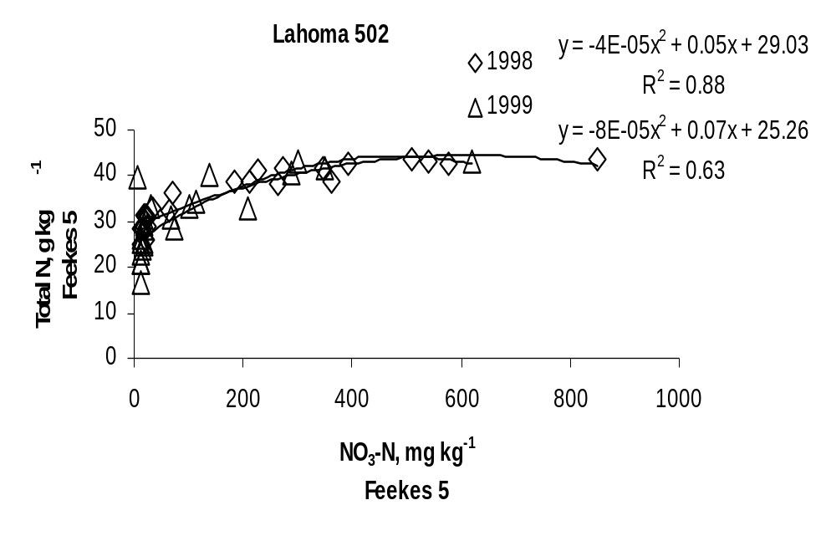

Figure 1. Relationship between NO₃-N at Feekes 5 and total N at Feekes 5 at Lahoma, 1998 and 1999.

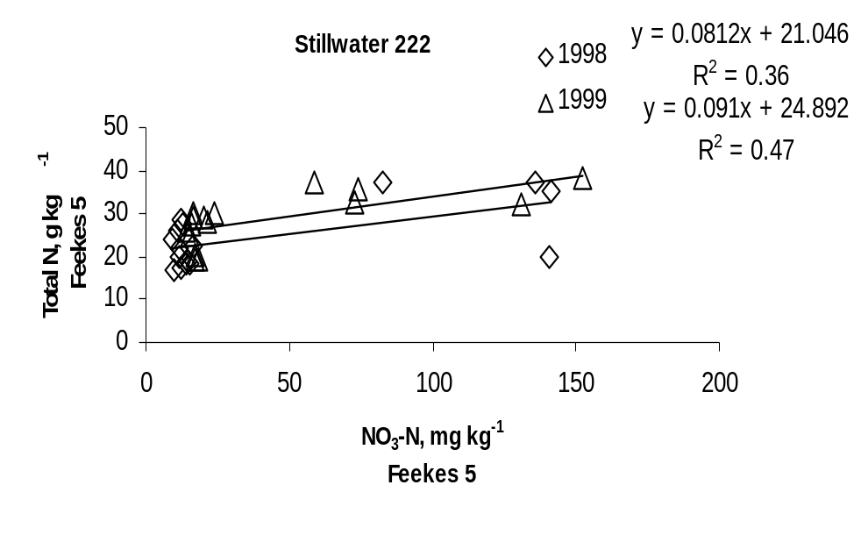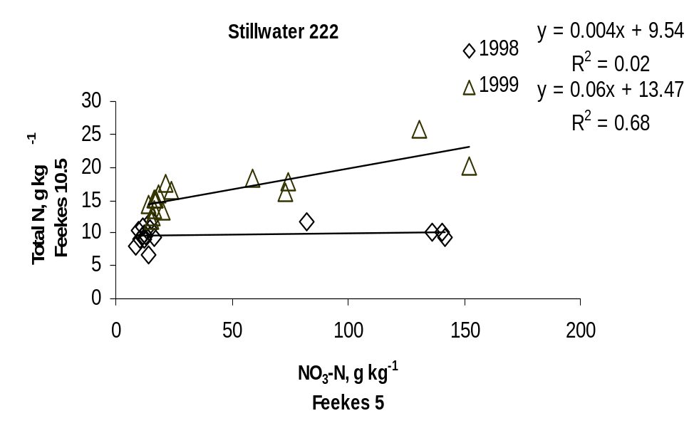Figure 2. Relationship between NO₃-N at Feekes 5 and total N content at Feekes 5 at Stillwater, 1998 and 1999.
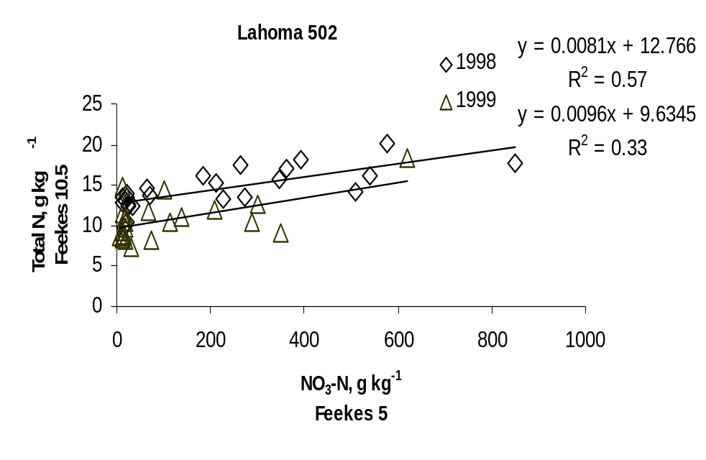

Figure 3. Relationship between NO₃-N at Feekes 5 and total N at Feekes 10.5 at Lahoma, 1998 and 1999.

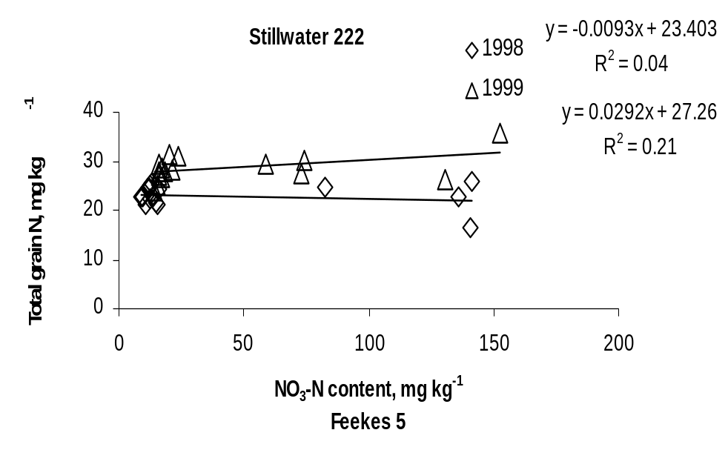
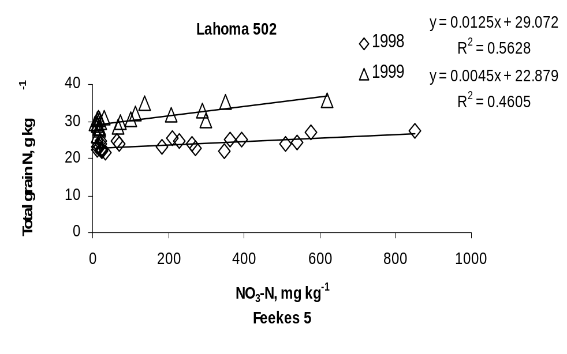Figure 4. Relationship between NO₃-N at Feekes 5 and total N at Feekes 10.5 at Stillwater, 1998 and 1999.

Figure 5. Relationship between NO₃-N at Feekes 5 and total grain N at Lahoma, 1998 and 1999.

Figure 6. Relationship between NO₃-N at Feekes 5 and total grain N at Stillwater, 1998 and 1999.

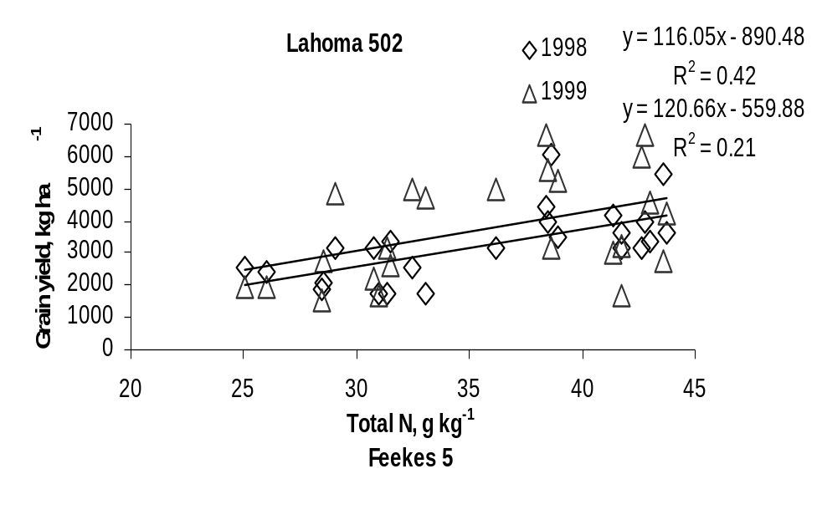
Figure 7. Relationship between total N at Feekes 5 and grain yield at Lahoma, 1998 and 1999.

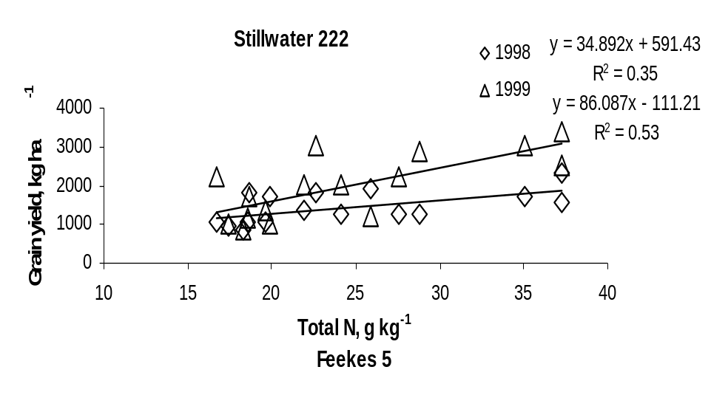

Figure 8. Relationship between total N at Feekes 5 and grain yield at Stillwater, 1998 and 1999.

PRECISION AGRICULTURE

Optimum Field Element Size for Maximum Yields in Winter Wheat Using Variable Nitrogen Rates

J.M. LaRuffa, W.R. Raun, S.B. Phillips, J.B. Solie,
M.L. Stone, and G.V. Johnson

ABSTRACT
The resolution at which variability in soil test and yield parameters exists is fundamental to the efficient use of real-time sensor-based variable rate technology. This study was conducted to determine the optimum field element size for maximum yields in winter wheat (Triticum aestivum L.) using variable nitrogen rates based on sensor readings. The effect of applying N at four different resolutions (0.84, 3.34, 13.38 and 53.51m²) on grain yield, N uptake and efficiency of use was investigated at Haskell, Hennessey, Perkins, and Tipton, Oklahoma. At Feekes growth stage 5 an optical sensor developed at Oklahoma State University measured red (670± 6 nm) and near-infrared (NIR, 780±6 nm) reflectance in each subplot. A normalized-difference-vegetative-index (NDVI) was calculated from the sensor measurements. Nitrogen was applied based on a NDVI – N rate calibration. Nitrogen rate, yield, N uptake, and efficiency of use responses to treatment resolution and applied N fertilizer differed in the three years of this experiment. In the first year, no significant influence of resolution on N rate, yield, N uptake, or efficiency of use was observed, likely a result of a late freeze that drastically reduced yields. In the second year of the experiment, there was a trend for a lower N rate and a higher efficiency of use for the 0.84 m² resolution. In the third year of this study, there was a trend for a higher yield and a higher efficiency of use for the 53.51 m² resolution at both sites. In general, the finer resolutions tended to have increased efficiency of use in high yielding environments (>2300 kg ha⁻¹), and decreased yields in low yielding environments. This study indicates that application of prescribed fertilizer rates based on spatial variability at resolutions finer than 53.51m² could lead to increased yields, decreased grower costs, and decreased environmental impact of excess fertilizers.

INTRODUCTION
Soil testing is the most widely used method to detect nutrient availability. However, a composite sample estimates the mean soil test nutrient level which does not address the variability encountered in that field (Raun et al., 1998). Optical sensor-based variable rate technology (s-VRT) has the ability to detect submeter-variability of nutrients on-the-go and simultaneously apply prescribed fertilizer rates based on those needs, thus realizing the potential to increase yields, decrease grower costs, and decrease the environmental impact of excess fertilizers. In order to effectively utilize s-VRT, Sawyer (1994) suggested that within-field variation must be accurately identified and reliably interpreted. Therefore, there is a need to establish the optimum field element size, which is fundamental to s-VRT in order to detect micro-variability of nutrients, such as nitrogen. Solie et al. (1996) defined the optimum field element size as that area which provides the most precise measure of the available nutrient where the level of that nutrient changes with distance. They proposed 0.8 to 1.4 m as the range for the field element size. The field element size should identify the smallest resolution where cause and effect relationships can be measured, where misapplication could pose a risk to the environment, where net economic return can be achieved, and where differences in yield potential may exist (Raun et al., 1998). Sensing need and applying fertilizer based on the optimum field element size should provide the most precise measurement of actual crop need and its application to the crop (Solie et al., 1996).
Sawyer (1994) recently pointed out that on-the-go sensing was still futuristic; however, new developments by Stone et al. (1996) have demonstrated that optical sensor based variable rate application systems are capable of detecting nutrient variability, and research is being conducted to more fully develop s-VRT. The initial optical sensor based system at Oklahoma State University measured spectral irradiance or light energy per unit area of the target crop. Irradiance is sensitive to sunlight, illumination angle, crop direction, and cloud cover. The current sensor based system measures reflectance. Spectral irradiance measurements are obtained using an integrated sensor with photodiode-based sensors and interference filters for red (671± 6 nm) and near infrared (NIR, 780 ± 6 nm) (Stone et al., 1996b). Up-oriented and down-oriented sensors measure solar spectral irradiance (incident radiation) and plant surface irradiance (reflected radiation), respectively. Reflectance values are calculated as a ratio of the incident and reflected radiation. Measurements taken at these wavelengths can be used to calculate a normalized-difference-vegetative-index (NDVI), which has been demonstrated to be highly correlated with plant N uptake (Stone et al., 1996a), and a reliable predictor of topdress N needs (Roth et al., 1989). The objective of this study was to determine the optimum field element size for maximum yields in winter wheat using variable nitrogen rates based on sensor readings and the calculated NDVI values.

MATERIALS AND METHODS
Two studies were initiated in January 1997 at Tipton and Hennessey, Oklahoma. The study was continued in 1998 at Tipton and Perkins, Oklahoma and in 1999 at Tipton and Haskell, Oklahoma. Soil types and initial soil test results are reported in Table 1. Most sites were N deficient, but had no P or K deficiencies. Winter wheat (Triticum aestivum L.) ‘Tonkawa’ had been previously established at all sites at 78 kg ha⁻¹ seeding rate. Wheat was planted in early October using 0.19 m row spacing. No preplant N was applied to any site in any year. At each location, a completely randomized design was employed. Four levels of resolution (field element size) were evaluated in a randomized complete block design with three replications. Resolutions tested were 0.91 by 0.91m, 1.83 by 1.83 m, 3.66 by 3.66m and 7.32 by 7.32m or 0.83, 3.34, 13.38, 53.31 m², respectively. Plot size for all treatments was 7.32 by 7.32m with main plots subdivided by the appropriate number of subplots for each resolution (Figure 1). In addition, planting , sensing, fertilization, and harvest dates at each site are reported in Table 2.
At Feekes growth stage 5 (Large, 1954) an optical sensor developed at Oklahoma State University measured red (671± 6 nm) and near-infrared (NIR, 780±6 nm) wavelengths in each subplot. The sensor was mounted on the front of a John Deere model 318 lawn and garden tractor with a field-of-view of 0.91 m x 0.15 m. Approximately 10 readings were taken per 0.84 m² area. In 1996-97, a normalized-difference-vegetative-index (NDVI) was calculated from the sensor measurements obtained for red and NIR uncalibrated voltage readings, according to the following equation, NDVI = (NIR-red)/(NIR+red).
In 1997-98, NDVI was calculated from calibrated voltage readings that accounted for incoming light. The sensor used in these tests measured both incident and reflected radiation. Field-of-view was the same as that in the 1996-97 experiments. Reflectance values (the ratio of incident and reflected values) were used in the NDVI calculation to minimize the error associated with cloud cover, shadows and sun angle. The modified equation used in 1997-98 was; NDVI = [(NIR_{ref}/NIR_{inc})-(Red_{ref}/Red_{inc})]/[(NIR_{ref}/NIR_{inc})+(Red_{ref}/Red_{inc})] where NIR_{ref} and Red_{ref} = magnitude of reflected light, and NIR_{inc} and Red_{inc} = magnitude of the incident light.
In 1996-97, variable N rates were determined for the subplots based on a linear NDVI - N rate scale. Subplots with the lowest NDVI values received the highest fertilizer N rate (112 kg ha⁻¹) and the highest NDVI values received the lowest fertilizer N rate (0 kg ha⁻¹). Linear regression models were calculated in Excel (Table 3). An identical linear NDVI – N rate scale was utilized at Perkins in 1997-98. However, a ramped NDVI – N rate scale was utilized at Tipton in 1997-98 to account for variation in percent coverage or stand density. The linear NDVI - N rate scale was based on previous work reported by Stone et al. (1996a).
In 1998-99, nitrogen fertilization rates were based on the in-season estimated yield or INSEY index (Raun et al., 1999). Based on previous work, INSEY was computed using the sum of NDVI at Feekes 4 and NDVI at Feekes 5, divided by the growing degree days from Feekes 4 to Feekes 5. Nitrogen fertilizer rates were then determined using the following equation:
N rate =[(Predicted grain yield *%N in the grain)–(Predicted forage N uptake at Feekes 5)]/0.70

where predicted grain yield was estimated from INSEY, %N in the grain was obtained from average values associated with winter wheat at different yield levels, and predicted forage N uptake at Feekes 5 was based on the relationship with NDVI (Raun et al., 2000).
Each year the amount of N fertilizer for each subplot was determined and the appropriate amount of ammonium nitrate was broadcast applied by hand. Each location was harvested with a Massey Ferguson 8XP self-propelled combine in June and early July (Table 2). The entire subplot area was harvested and grain weights and percent moisture were automatically recorded. Pre-harvest calibration of the combine scales indicated that weights had precision of ± 15.44 g. Grain samples were collected and weighed on lab scales when yields were low (<50 g). Grain was ground to pass a 106 um (140 mesh) screen and total nitrogen content in grain was analyzed using a Carlo Erba NA 1500 dry combustion analyzer (Schepers et al., 1989). The efficiency of use index was calculated as grain yield/N rate (Moll et al., 1982). Nitrogen uptake was determined by multiplying percent N in the grain by grain yield. Statistical analysis was performed using SAS (SAS Institute, 1988).

RESULTS
Response to treatment resolution and applied N fertilizer differed over the three years and four locations. Results from each location and year are discussed separately due to the contrasting response.
Hennessey, 1996-97
There was no significant influence of resolution on N rate, yield, N uptake, or efficiency of use (Table 4). The NDVI values for this location ranged from 0.70 to 0.81 (mean of 0.78 ± 0.01) and were normally distributed. In general, NDVI values in excess of 0.70 indicate that plant coverage of the soil was equal to or greater than 70% (Lukina et al., 1999). At the early stages of growth evaluated here, this also indicated that plant health was excellent for the entire experimental area and that plot to plot variability was likely small. Also, the CV (coefficient of variation) for NDVI was very low (1%), indicating that limited variability existed at this site. A large portion of the experiment had high NDVI values (high N uptake) and was likely non-responsive. Because of this, low N rates were applied to areas where no response was expected and high N rates were applied where only limited increases were realistic.

Tipton, 1996-97
NDVI values at this location ranged from 0.18 to 0.48 (mean of 0.34 ± 0.05) and were normally distributed. More variability in NDVI was found at this site than the Hennessey site. Grain yields were drastically lower at Tipton compared to Hennessey due to freeze damage on April 11, 12 and 13. There was no significant influence of resolution on N rate, yield, N uptake or efficiency of use (Table 5). However, it should be noted that the poor stands (evidenced in the low NDVI’s) were the result of moisture limiting conditions that lowered yield potential. Therefore, the chances of observing a response to added fertilizer at any of the treatment resolutions were poor.

Perkins, 1997-98
NDVI values at this location ranged from 0.28 to 0.63 (mean of 0.42 ± 0.05) and were normally distributed. The linear NDVI – N rate scale used was expected to encompass the entire range of N needs (maximum N need at NDVI = 0.28 and limited N need at NDVI = 0.63). There was no significant influence of resolution on N rate, yield, N uptake or efficiency of use (Table 6). However, there was a trend for a lower N rate and a higher efficiency of use for the 0.84 m² resolution. Although nitrogen uptake was somewhat lower for the finest resolution (0.84 m²), it was important to find that the standard deviation was lower at this resolution when compared to coarser resolutions (means of 51.53 ± 1.88, 52.30 ± 5.81, 54.21 ± 4.67, and 60.27 ± 6.63 for the 0.84, 3.34, 13.38, 53.51 m² resolutions, respectively). This suggests that topdress N fertilization based on predicted forage N uptake (every 0.84 m²) at early stages of growth could result in homogeneity of grain yield. Furthermore, it was important to note that the CVs separated by treatment for yield and efficiency of use were lowest for the 0.84 m² resolution (Table 7), suggesting that small-scale management assisted in decreasing treatment heterogeneity.

Tipton, 1997-98
NDVI values at this location ranged from 0.28 to 0.79 (mean of 0.56 ± 0.08) with a bimodal distribution. Grain yields increased for the coarser resolutions at this site (Table 8). There was no significant influence of resolution on N rate, efficiency of use or N uptake. However, there was a trend for a higher efficiency of use at the 0.84 m² resolution, supported in part by a significant quadratic relationship between efficiency of use and resolution. The CVs separated by treatment for yield and efficiency of use were lowest for the 13.38 m² resolution (Table 9). This suggests that micro-variability was better managed at a resolution less than 53.51 m² but not necessarily at the 0.84 m² resolution that we expected. This supports management of resolutions of 13.38m², much finer than anything presently promoted in commercial agriculture.

Haskell, 1998-99
INSEY values at this location ranged from 0.0043 to 0.0069 (mean of 0.0057 + 0.0005). There was no significant influence of resolution on N rate, grain yield, N uptake, or efficiency of use (Table 10). However, there was a trend for a higher N rate, yield, N uptake, and efficiency of use at the 53.51 m² resolution. A significant linear relationship was found between yield and resolution and N uptake and resolution. However, it should be noted that this observation took place at low yield levels (<1750 kg ha⁻¹).

Tipton, 1998-99
INSEY values at this location ranged from 0.0027 to 0.0059 (mean of 0.0038 + 0.0005). Similar to results at Haskell, 1998-99, a trend for increased N uptake and grain yield at the coarser resolutions was observed, but at low yield levels.

Discussion
The lack of differences due to management resolution noted in this study may have been due to several factors that were not initially considered. Using the John Deere 318 lawn and garden tractor to sense each 0.84m² area in all 24 subplots for the 0.84m² resolution increased soil compaction, reduced forage growth, and decreased yields when compared to the coarser resolutions that required few passes over main plots. The range of INSEY values for the 1998-99 cropping season was unusually narrow when observing other data reported for wheat (Raun et al., 2000). This in turn limited the likelihood of observing yield differences as a result of treating within plot variability. The strategies used to adjust fertilizer N based on sensor readings differed for all three years of the study. Changes in the N fertilization strategy were made based on increased understanding of problems encountered in other ongoing projects. Lastly, the lack of notable statistical treatment differences could have been due to the low grain yields found at all sites in all years. Nitrogen availability although normally limiting, likely was only a minor factor affecting grain yield under these conditions. Some of the main factors limiting grain yields for the locations and years evaluated included poor stands, late harvest, lodging, and compaction.

CONCLUSIONS
The effect of applying N at four different resolutions (0.84, 3.34, 13.38 and 53.51m²) on wheat grain yield, N uptake and efficiency of use was investigated from 1996 to 1999. Sensor readings were collected at Feekes growth stage 5 and subsequently used to determine topdress N rates based on predicted forage N uptake. In general, the finer resolutions tended to have increased efficiency of use in high yielding environments (>2300 kg ha⁻¹), and decreased efficiency of use in low yielding environments. Although not consistent over the years included in this work, application of prescribed fertilizer rates based on spatial variability at resolutions finer than 53.51m² could lead to increased yields, decreased grower costs, and decreased environmental impact of excess fertilizers.

REFERENCES
Large, E.C. 1954. Growth stages in cereals. Plant Pathol. 3:128-129.

Lukina, E.V., M.L. Stone and W.R. Raun. 1999. Estimating vegetation coverage in wheat using digital images. J. Plant Nutr. 22(2):341-350.

Moll, R.H., E.J., Kamprath, and W.A. Jackson. 1982. Analysis and interpretation of factors which contribute to efficiency of nitrogen utilization. Agron J. 74:562-564.

Raun, W.R., J.B. Solie, G.V. Johnson, M.L. Stone, R.W. Whitney, H.L. Lees, H. Sembiring, and S.B. Phillips. 1998. Micro-variability in soil test, plant nutrient and yield parameters. Soil Sci. Soc. Am. J. 62:683-690.

Raun, W.R., G.V. Johnson, M.L. Stone, J.B. Solie, W.E. Thomason and E.V. Lukina. 1999. In-season prediction of yield potential in winter wheat. Better Crops 83(2): 24-25.

Raun, W.R., J.B. Solie, M.L. Stone, G.V. Johnson, E.V. Lukina, W.E. Thomason and J.S. Schepers. 2000. In-season prediction of wheat yield potential using canopy reflectance. (Agron. J.)

Roth, G.W., R.H. Fox, and H.G. Marshall. 1989. Plant tissue tests for predicting nitrogen fertilizer requirements of winter wheat. Agron. J. 81:502-507.

SAS Institute Inc. 1988. SAS/STAT User’s Guide. 6.03 ed. SAS Institute Inc., Cary, NC.

Sawyer, J.E. 1994. Concepts of variable rate technology with considerations for fertilizer application. J. Prod. Agric. 7:195-201.

Schepers, J.S., D.D. Francis, and M.T. Thompson. 1989. Simultaneous determination of total C, total N, and 15N on soil and plant material. Commun. in Soil Sci. Plant Anal. 20(9&10):949-959.

Solie, J.B., W.R. Raun, R.W. Whitney, M.L. Stone, J.D. Ringer. 1996. Optical sensor based field element size and sensing strategy for nitrogen application. Trans. ASAE 39(6):1983-1992.

Stone, M.L., J.B. Solie, R.W. Whitney, W.R. Raun, and H.L. Lees. 1996a. Sensors for detection of nitrogen in winter wheat. SAE Technical paper series. SAE Paper No. 961757. SAE, Warrendale PA.

Stone, M.L., J.B. Solie, W.R. Raun, R.W. Whitney, S.L. Taylor, and J.D. Ringer. 1996b. Use of spectral radiance for correcting in-season fertilizer nitrogen deficiencies in winter wheat. Trans. ASAE 39(5):1623-1631.

TABLE 1. Initial surface (0-15 cm) soil test characteristics prior to treatment application, and soil classification at Haskell, Hennessey, Perkins, and Tipton, Oklahoma.

Location | pH | P | K | NH₄-N | NO₃-N | Total N | Organic C
 |  | ------------------mg kg⁻¹----------------- |  |  |  | ----------g kg⁻¹----------
Haskell | 4.8 | 34 | 240 | 19 | 14 | 0.56 | 6.84
Classification | Taloka silt loam (fine, mixed, thermic Mollic Albaqualfs)
Hennessey | 6.5 | 144 | 457 | 5 | 14 | 1.09 | 12.37
Classification | Shellabarger sandy loam (fine-loamy, mixed, thermic Udic Argiustolls)
Perkins | 6.7 | 51 | 143 | 5 | 4 | 0.60 | 5.33
Classification | Teller sandy loam (fine, mixed, thermic Udic Argiustolls)
Tipton, 1996 | 7.3 | 44 | 523 | 4 | 9 | 0.69 | 7.53
Tipton, 1997 | 7.5 | 40 | 359 | 11 | 10 | 0.69 | 7.53
Classification | Tillman-Hollister clay loam (fine, mixed, thermic Pachic Argiustolls)
pH – 1:1 soil:deionized water; P and K – Mehlich-3 extraction; NH₄-N and NO₃-N – 2 M KCL extract, organic C and total N – dry combustion

TABLE 2. Planting , sensing, fertilization, and harvest dates, 1996-1999.
_____________________________________________________________________

Location Planting Date Sensing Date Fertilization Date Harvest Date
Hennessey 10/02/96 02/11/97 02/13/97 07/25/97
Tipton 10/07/97 02/04/97 02/06/97 07/12/97
Perkins 10/21/97 02/24/98 03/04/98 06/16/98
Tipton 10/16/97 01/27/98 02/12/98 06/07/98
Haskell 10/26/98 02/24/99 03/23/99 07/06/99
Tipton 10/08/98 02/09/99 03/02/99 06/07/99
_____________________________________________________________________

TABLE 3. Linear regression models developed for a linear NDVI – N rate scale.

Location | Minimum NDVI | Maximum NDVI | Equation*
Hennessey | 0.70 | 0.81 | y = -916.20x + 740.07
Tipton, 1996-97 | 0.18 | 0.48 | y = -325.59x + 157.34
Perkins | 0.28 | 0.63 | y = -290.88x + 182.88
* x = NDVI; y = N rate
TABLE 4. Analysis of variance for NDVI, nitrogen rate, grain yield, nitrogen uptake, and efficiency of use in wheat at Hennessey, OK, 1996-97.

Source of variation | df | NDVI | Nitrogen rate  kg ha⁻¹ | Grain yield  kg ha⁻¹ | Nitrogen uptake  kg ha⁻¹ | Efficiency of use
 |  | ----------------------------Mean Squares----------------------------
Replication | 2 | ns | ns | * | ns | ns
Resolution | 3 | ns | ns | ns | ns | ns
Error | 6 | 0.0001 | 68.33 | 188670 | 145.59 | 788.79
Resolution, m² |  | ---------------------------------Means----------------------------------
0.84 |  | 0.78 | 32.36 | 2039 | 55.84 | 64.17
3.34 |  | 0.77 | 39.06 | 1842 | 64.06 | 47.92
13.38 |  | 0.79 | 21.32 | 1948 | 77.60 | 95.50
53.51 |  | 0.78 | 29.74 | 2574 | 58.74 | 99.45
SED |  | 0.01 | 6.75 | 355 | 9.85 | 22.93
CV, % |  | 1 | 27 | 21 | 19 | 37
* Significant at the 0.05 probability level; df = degrees of freedom; ns = not significant; SED = standard error of the difference between two equally replicated treatment means; CV = coefficient of variation

TABLE 5. Analysis of variance for NDVI, nitrogen rate, grain yield, nitrogen uptake, and efficiency of use in wheat at Tipton, OK, 1996-97.

Source of variation | df | NDVI | Nitrogen rate  kg ha⁻¹ | Grain yield  kg ha⁻¹ | Nitrogen uptake  kg ha⁻¹ | Efficiency of use
 |  | ----------------------------Mean Squares----------------------------
Replication | 2 | ns | ns | ns | ns | ns
Resolution | 3 | ns | ns | ns | ns | ns
Error | 6 | 0.0031 | 395.11 | 52414 | 26.90 | 21.59
Resolution, m² |  | --------------------------------Means---------------------------------
0.84 |  | 0.33 | 54.44 | 582 | 17.74 | 10.93
3.34 |  | 0.30 | 66.44 | 656 | 13.67 | 9.48
13.38 |  | 0.38 | 37.45 | 572 | 16.07 | 19.23
53.51 |  | 0.34 | 53.48 | 645 | 19.91 | 12.52
SED |  | 0.05 | 16.23 | 187 | 4.23 | 14.39
CV, % |  | 16 | 38 | 37 | 31 | 36
* Significant at the 0.05 probability level; df = degrees of freedom; ns = not significant; SED = standard error of the difference between two equally replicated treatment means; CV = coefficient of variation
TABLE 6. Analysis of variance for NDVI, nitrogen rate, grain yield, nitrogen uptake, and efficiency of use in wheat at Perkins, OK, 1997-98.

Source of variation | df | NDVI | Nitrogen rate  kg ha⁻¹ | Grain yield  kg ha⁻¹ | Nitrogen uptake  kg ha⁻¹ | Efficiency of use
 |  | ----------------------------Mean Squares----------------------------
Replication | 2 | * | ns | * | ns | *
Resolution | 3 | ns | ns | ns | ns | ns
Error | 6 | 0.0009 | 292.84 | 24114 | 15.51 | 79.46
Resolution, m² |  | -------------------------------Means----------------------------------
0.84 |  | 0.45 | 56.95 | 2323 | 51.53 | 44.25
3.34 |  | 0.40 | 74.17 | 2329 | 52.30 | 33.47
13.38 |  | 0.42 | 69.28 | 2473 | 54.21 | 38.77
53.51 |  | 0.42 | 73.93 | 2555 | 60.27 | 37.58
SED |  | 0.02 | 13.97 | 127 | 3.22 | 7.28
CV, % |  | 7 | 25 | 6 | 7 | 23
* Significant at the 0.05 probability level; df = degrees of freedom; ns = not significant; SED = standard error of the difference between two equally replicated treatment means; CV = coefficient of variation
TABLE 7. Coefficients of variation, by treatment, for grain yield and efficiency of use in wheat at Perkins, OK, 1997-98.

Resolution, m² | Grain Yield | Efficiency of Use
 | -------Coefficient of Variation, %-------
0.84 | 7 | 35
3.34 | 16 | 37
13.38 | 9 | 36
53.51 | 10 | 37
TABLE 8. Analysis of variance for NDVI, nitrogen rate, grain yield, nitrogen uptake, and efficiency of use in wheat at Tipton, OK, 1997-98.

Source of variation | df | NDVI | Nitrogen rate  kg ha⁻¹ | Grain yield  kg ha⁻¹ | Nitrogen uptake  kg ha⁻¹ | Efficiency of use
 |  | ----------------------------Mean Squares----------------------------
Replication | 2 | ns | * | ns | ns | ns
Resolution | 3 | ns | ns | * | ns | ns
Error | 6 | 0.00535 | 175.01 | 76678 | 105.90 | 66.05
Resolution, m² |  | -------------------------------Means----------------------------------
0.84 |  | 0.57 | 53.78 | 2809 | 49.19 | 56.07
3.34 |  | 0.55 | 70.47 | 3196 | 57.26 | 46.96
13.38 |  | 0.55 | 75.60 | 3354 | 62.60 | 45.34
53.51 |  | 0.56 | 73.93 | 3706 | 74.21 | 54.45
SED |  | 0.06 | 10.80 | 226 | 8.40 | 6.64
CV, % |  | 13 | 19 | 8 | 17 | 16
* Significant at the 0.05 probability level; df = degrees of freedom; ns = not significant; SED = standard error of the difference between two equally replicated treatment means; CV = coefficient of variation
TABLE 9. Coefficients of variation, by treatment, for grain yield and efficiency of use in wheat at Tipton, OK, 1997-98.

Resolution, m² | Coefficient of Variation (CV), %
 | Grain Yield | Efficiency of Use
0.84 | 15 | 27
3.34 | 14 | 16
13.38 | 5 | 15
53.51 | 8 | 36

TABLE 10. Analysis of variance for INSEY, nitrogen rate, grain yield, nitrogen uptake, and efficiency of use in wheat at Haskell, OK, 1998-99.

Source of variation | df | INSEY | Nitrogen rate  kg ha⁻¹ | Grain yield  kg ha⁻¹ | Nitrogen uptake  kg ha⁻¹ | Efficiency of use
 |  | ----------------------------Mean Squares----------------------------
Replication | 2 | ns | ns | * | * | *
Resolution | 3 | ns | ns | ns | ns | ns
Error | 6 | 2.12E-7 | 5.72 | 43858 | 34.15 | 40.27
Resolution, m² |  | -------------------------------Means----------------------------------
0.84 |  | 0.0055 | 29.63 | 1269 | 33.44 | 42.16
3.34 |  | 0.0054 | 30.78 | 1397 | 37.38 | 45.49
13.38 |  | 0.0058 | 31.70 | 1292 | 35.10 | 40.97
53.51 |  | 0.0060 | 33.41 | 1721 | 47.97 | 51.60
SED |  | 0.0004 | 1.95 | 171 | 4.84 | 5.18
CV, % |  | 8 | 8 | 15 | 15 | 14
* Significant at the 0.05 probability level; df = degrees of freedom; ns = not significant; SED = standard error of the difference between two equally replicated treatment means; CV = coefficient of variation

TABLE 11. Analysis of variance for INSEY, nitrogen rate, grain yield, nitrogen uptake, and efficiency of use in wheat at Tipton, OK, 1998-99.

Source of variation | df | INSEY | Nitrogen rate  kg ha⁻¹ | Grain yield  kg ha⁻¹ | Nitrogen uptake  kg ha⁻¹ | Efficiency of use
 |  | ----------------------------Mean Squares----------------------------
Replication | 2 | * | * | ns | * | ns
Resolution | 3 | ns | ns | ns | * | ns
Error | 6 | 3.05E-8 | 1.18 | 5060 | 0.84 | 2.51
Resolution, m² |  | -------------------------------Means----------------------------------
0.84 |  | 0.0038 | 49.19 | 932 | 18.26 | 18.92
3.34 |  | 0.0037 | 48.28 | 950 | 18.90 | 19.63
13.38 |  | 0.0037 | 48.82 | 1002 | 20.86 | 20.55
53.51 |  | 0.0036 | 48.91 | 1043 | 21.36 | 21.33
SED |  | 0.0001 | 0.89 | 58 | 0.75 | 1.29
CV, % |  | 5 | 2 | 7 | 5 | 8
* Significant at the 0.05 probability level; df = degrees of freedom; ns = not significant; SED = standard error of the difference between two equally replicated treatment means; CV = coefficient of variation
FIGURE 1. Diagram of the physical layout of the experiments showing treatments (1-4) and resolution within treatment.
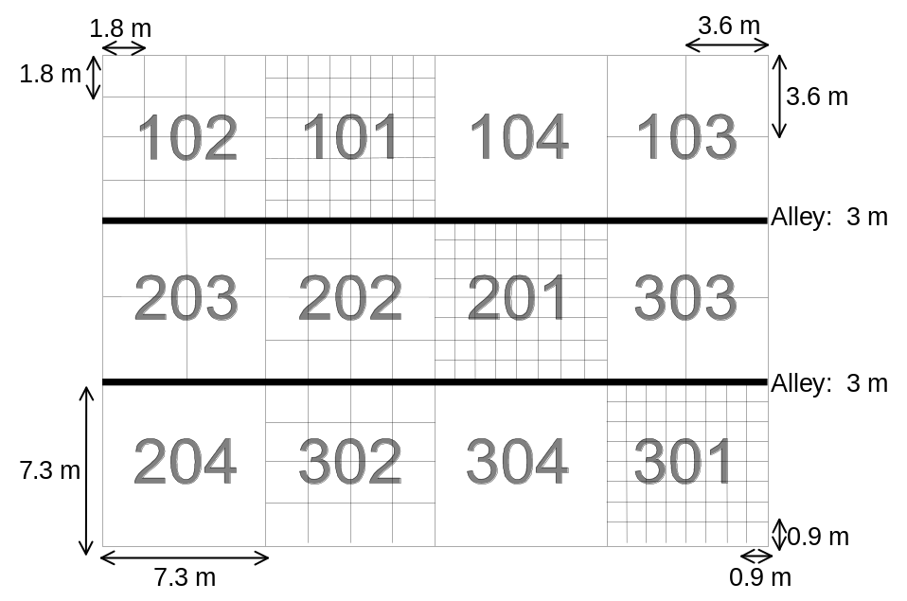

Late-Season Prediction of Wheat Grain Yield and Grain Protein

K.W. Freeman, R.W. Mullen, K.J. Wynn, W.E. Thomason, E.V. Lukina, J.B. Solie, M.L. Stone, G.V. Johnson, and W.R. Raun

ABSTRACT
Sensor-based variable rate technology (s-VRT) is making instrumental advancements in winter wheat (Triticum aestivum L.) production throughout the world. Some of this work has been directed at estimating nitrogen uptake of winter wheat during early vegetative growth and correlating it to final grain yield. This study focuses on predicting the final yield and/or grain protein of winter wheat at late growth stages using sensors. Pre-harvest prediction of wheat will assist producers in generating yield maps and allow for reliable means of product marketing. This study was conducted at seven locations where existing long-term field experiments were already in place. Sub-plots, 2m by 2m, were placed within main plots with differing N rates. Sub-plot spectral readings were taken at Feekes growth stages 9, 10.5, 11.2, and 11.4. The normalized difference vegetative index (NDVI), red reflectance (Red_{ref}), and NIR reflectance (NIR_{ref}) were calculated for each sub-plot. Preliminary results showed that NDVI and NIR_{ref} were positively correlated with grain yield at growth stages 9 and 10.5, and negatively correlated at growth stage 11.4. Red_{ref} values increased over time with the higher yielding plots showing larger increases in Red_{ref}. The methods defined here will assist us in refining in-season estimates of grain yield and that will subsequently be used to adjust for fertilizer need in each 1m² area. Furthermore, late-season prediction of wheat grain yield may assist other industries that assess crop loss.

INTRODUCTION
The use of sensors in agriculture production has become a necessity for continued agricultural growth. Lukina et al. (2001) describes precision agriculture technology (PAT) advancements as decreasing inputs while maintaining yield or supplying the same inputs but achieve higher yields through more efficient crops. Araus (1996) reported that methods based on red/near infrared ratios can be used to estimate leaf area index (LAI), green biomass, crop yield, and canopy photosynthetic capacity. In fact, green leaves are strong absorbers in the red, but highly reflected in the near infrared. Mahey et al. (1991) found a highly correlated linear trend between NDVI and wheat grain yield, establishing the potential to predict grain yield of wheat with remote sensed data. They also noted that the strongest correlation occurred between 75 and 104 days after planting. Also, NDVI has been found to be highly correlated with yield and biomass in barley (Hordeum vulgare L.) (Penuelas et al., 1997). According to work using satellite imagery by Quarmby et al. (1993), yield estimates during the early part of the growing season change rapidly. However, 50 to 100 days prior to harvest, yield estimates stabilize. These results are encouraging since accurate yield estimates can be made two months prior to harvest.
As noted by Filella et al., (1995), remote sensing could provide inexpensive, large-area estimates of N status in wheat. They further reported that the use of reflectance at 430, 550, 680 nm, and red edge wavelengths offers potential for assessing N status of wheat. Work by Kleman and Fagerland, (1987) studied different ratios of red, NIR, and infrared (IR) and concluded that IR/red was related to the biomass and grain yield of spring barley (Hordeum distichum L.). Stone et al. (1996) demonstrated that N uptake and NDVI are highly correlated. Raun et al. (2001) showed that the sum of two NDVI readings taken at Feekes growth stages 4 and 5 (Large, 1954) divided by the growing degree days (GDD) between these readings was a reliable predictor of final grain yield at six of nine sites. However, this work required two post dormancy readings. Ensuing work by Lukina et al. (2001) showed a stronger correlation with yield when NDVI readings taken at Feekes growth stage 5 (Large, 1954) were divided by the total number of days from planting to the reading date.

Field Resolution and Mapping
As precision farming becomes adapted and accepted, delineating the proper field element size becomes more important. Solie et al. (1996) defines field element size as the area that provides the most precise measure of the available nutrient and where the level of that nutrient changes with distance. This work went on to say that the fundamental field element size averages 1.5m. A microvariability study by Raun et al. (1998) found significant differences in surface soil test analyses when samples were <1m apart for both mobile and immobile nutrients. Solie et al. (1999) stated that in order to describe the variability encountered in field experiments soil, plant, and indirect measurements should be made at the meter or submeter level.
Willis et al. (1999) defined yield maps as tools used by producers to look for general patterns and trends, such as unusually high or low yielding areas. They go on to state that many errors are associated with yield monitor data that could be corrected for by integrating remotely sensed data for correction to the yield maps. Blackmore and Marshall (1996) describe these errors as: 1) the time lag of crop from intake to yield sensor, 2) yield sensor calibration, 3) GPS accuracy, 4) uncertain crop width entering the header, 5) surging grain, and 6) grain losses.

Predicting Grain Protein
Stone et al. (1996) demonstrated a high correlation between the plant nitrogen spectral index (PNSI), the reciprocal of NDVI, and the total N uptake of wheat forage. This work showed that sensors were reliable indicators of the plant N status. According to Wuest and Cassman, (1992) early season N environment has a large influence on N partitioning at maturity. The ability to determine the N status of wheat and relate it to N accumulation in the grain opens the possibility to indirectly predict wheat grain protein using remotely sensed data.

MATERIALS AND METHODS
This study is being conducted at seven locations within existing field experiments. Locations included long-term N and P fertility studies at Stillwater (Kirkland silt loam; fine, mixed, thermic Udertic Paleustoll), Lahoma (Grant silt loam; fine-silty, mixed, thermic Udic Argiustoll), Perkins (Teller sandy loam; Udic Argiustoll), and Haskell (Taloka silt loam; fine, mixed, thermic Mollic Albaqualf). Additional locations included anhydrous ammonia (AA) experiments at Hennessey (Shellabarger sandy loam; fine-loamy, mixed, thermic Udic Argiustoll) and Stillwater (Easpur loam; fine-loamy, mixed, superactive, thermic Fluventic Haplustoll), and a sewage sludge loading experiment near Stillwater (Norge loam; fine mixed, thermic Udertic Paleustoll). Sub-plots, 2m by 2m, were placed in main plots with differing N rates. Spectral reflectance readings were taken using a photodiode-based sensor with interference filters for red at 671±6 and near infrared (NIR) at 780±6 nm wavelengths, developed by Stone et al. (1996). The normalized difference vegetative index (NDVI) was calculated in accordance to the equation NDVI=(NIR_{ref}-red_{ref})/(NIR_{ref}+red_{ref}). Red reflectance (Red_{ref}) is calculated by dividing red reflected by red incident, and NIR reflectance (NIR_{ref}) is calculated by dividing NIR reflected by NIR incident light. Sub-plot spectral readings were taken at Feekes growth stages 9 (ligule of last leaf visible), 10.5 (flowering), 11.2 (mealy ripe, contents of kernel soft but dry), and 11.4 (ripe for harvest, straw dead) (Large, 1954).
Each location was harvested using a self-propelled Massey Ferguson 8XP combine. The entire 2m² area was harvested and grain weight and moisture were recorded at that time. Grain samples were then ground to pass a 120-mesh screen (125 um) and analyzed for total nitrogen using a Carlo Erba NA-1500 dry combustion analyzer (Schepers et al., 1989). Statistical analysis was performed using SAS (SAS Institute, 1988).

RESULTS
Initial results indicate that NDVI and NIR_{ref} are positively correlated with grain yield at Feekes growth stages 9 and 10.5, and negatively correlated at growth stage 11.4. Red_{ref} increased over time with the higher yielding plots showing larger increases in Red_{ref}. The INSEY values also provide strong relationship with yield at growth stages 9 and 10.5. The in season response index (ISRI = NDVI from fertilized plot divided by NDVI from 0-N check plot) was highly correlated with the response index (RI) determined at harvest (highest grain yield divided by the yield obtained in the 0-N check).
Finding an in-season index that could reliably predict whether or not there would be a response to applied fertilizer N is incredibly important. For many years, researchers have struggled to develop indices that assessed N mineralization potential. The basic thought process was that if N mineralization potential could be determined, more accurate methods of refining N fertilizer recommendations could be developed. This is not to say that soil test NH₄ and/or NO₃ in surface horizons is not a reliable tool of assessing N need, but rather that the soil test level determined at one point in time is static and provides no prediction of what might be mineralized and/or immobilized from that point on.
Imagine for a moment that we could predict if and when crops will respond to added fertilizer. Many years, farmers apply topdress fertilizer and achieve little if any response in yield and/or grain protein. Why? Some years, we have adequate rainfall, mild winters, and ideal conditions throughout the growing season for continuous N mineralization. As a result, the demand for fertilizer N is diminished via the soil-organic matter pool supply. The opposite is generally true in years that were dry up to planting, mid-winter conditions were cool and dry, all of which limited mineralized N from soil-organic-N pools. In these years, the probability of obtaining a response to applied topdress N is likely high. So why do we need a sensor to tell us that? This is a good question that is explained by two words ‘spatial variability.’ The spatial variability is so great in fields that when one moves 1 m left or 1 m right (from any given spot), large differences in moisture holding capacity, soil test P, organic C, NO₃-N, and NH₄-N are known to exist. Simply think about terraces in the majority of all wheat fields in Oklahoma and you can visualize differences in water holding capacity over very short distances whether it is a wet year or a dry year. The sensor allows us to first accurately predict what the yield potential is in each 1m² area, and secondly, the RI allows us to be able to assess the probability of obtaining a response to applied N based on ‘actual differences’ in fertilized and non fertilized plots at the time of sensing. Combined, we should be able to obtain a prescribed rate of N based both on need and the likelihood of achieving a response.
When locations were partitioned based on high RI (>1.5) and low RI (<1.5), an interesting relationship was revealed. Grain yield was strongly correlated with NDVI and can accurately be predicted at Feekes growth stages 9 and 10.5 when the RI was more than 1.5 (Figures10 and 12). However, when those locations with low RI (<1.5) were removed, correlation between NDVI and yield was poor. This is important when determining topdress fertilization rates and the risks that are involved. If the RI is high then it might be profitable to apply more N and the risk associated with this added cost will be low. If RI is low the crop will not respond well to N and the additional cost may not be warranted.

CONCLUSION
Grain yield was highly correlated with NDVI, NIR_{ref}, and Red_{ref} values and can be accurately predicted using indirect spectral measurements collected prior to mechanical harvest. The in season response index (ISRI = NDVI from fertilized plot divided by NDVI from 0-N check plot) was highly correlated with the response index (RI) determined at harvest (highest grain yield divided by the yield obtained in the 0-N check). Using these two results we can first accurately predict what the yield potential is in each 1m² area, and secondly, the RI allows us to be able to assess the probability of obtaining a response to applied N based on ‘actual differences’ in fertilized and non fertilized plots at the time of sensing. Combined, this information will be used to determine a prescribed rate of N based both on need and the likelihood of achieving a response.

REFERENCES
Araus, J.L. 1996. Integrated physiological criteria associated with yield potential. p. In M.P. Reynolds, S. Rajaram, and A. McNab (eds) Increasing Yield Potential in Wheat: Breaking the Barriers. Mexico, D.F.: CIMMYT.

Blackmore, B.S. and C.J. Marshall. 1996. Yield mapping; Errors and algorithms. p. In Proc. of the 3rd Int. Conf. on Precision Agriculture, Minneapolis, MN. 23-26 June, 1996

Filella, I., L. Serrano, J. Serra, and J. Penuelas. 1995. Evaluating wheat nitrogen status with canopy reflectance indices and discriminant analysis. Crop Sci. 35:1400-1405.

Kleman, J. and E. Fagerlund. 1987, Influence of different nitrogen and irrigation treatments of the spectral reflectance of barley. Remote Sens. Environ. 21:1-14.

Large, E.C. 1954 Growth stages in cereals. Plant Pathol. 3:128-129.

Lukina, E.V., K.W. Freeman, K.J. Wynn, W.E. Thomason, R.W. Mullen, G.V. Johnson, R.L. Elliot, M.L. Stone, J.B. Solie, W.R. Raun. 2000. Nitrogen fertilizer optimization algorithm based on in-season estimates of yield and forage nitrogen uptake. J. Plant Nutr. (in press).

Mahey, R.K., R. Singh, S.S. Sidhu, and R.S. Narang. 1991. The Use of Remote Sensing to Assess the Effects of Water Stress on Wheat. Expl. Agric. 27:423-429.

Penuelas, Josep, I. Isla, I. Filella, and J.L. Araus. 1997. Visible and Near-Infrared Reflectance Assessment of Salinity Effects on Barley. Crop Sci. 37:198-202.

Quarmby, N.A., M. Milnes, T.L. Hindle and N. Silleos. 1993. The use of multi-temporal NDVI measurements from AVHRR data for crop yield estimation and prediction. Int. J. Remote Sensing. 14(2):199-210.

Raun, W.R., J.B. Solie, G.V. Johnson, M.L. Stone, R.W. Whitney, H.L. Lees, H. Sembiring and S.B. Phillips. 1997. Micro-variability in soil test, plant nutrient and yield parameters in bermudagrass. Soil Sci. Amer. J. 62(2):683-690.

Raun, W.R., G.V. Johnson, M.L. Stone, W.E. Thomason and E.V. Lukina. 1999. In-season prediction of yield potential in winter wheat. Better Crops. 83:24-25.

Raun, W.R., J.B. Solie, G.V. Johnson, M.L. Stone, E.V. Lukina, W.E. Thomason, and J.S. Schepers. 2000. In season prediction of potential grain yield in winter wheat using canopy reflectance. Agron. J. (in press).

Schepers. J.S., D.D. Francis, and M.T. Thompson. 1989. Simultaneous determination of total C, total N and 15N on soil and plant material. Commun. Soil Sci. Plant Anal. 20:949-959.

Solie, J.B., W.R. Raun, R.W. Whitney, M.L. Stone, J.D. Ringer. 1996. Optical sensor based field element size and sensing strategy for nitrogen application. Trans. ASAE 39(6):1983-1992.

Solie, J.B., W.R. Raun and M.L. Stone. 1999. Submeter spatial variability of selected soil and plant variables. Soil Sci. Soc. Amer. J. 63:1724-1733.

Stone, M.L., J.B. Solie, R.W. Whitney, W.R. Raun, and H.L. Lees. 1996. Sensors for the detection of nitrogen in winter wheat. SAE Technical paper series. SAE Paper No. 961757. SAE, Warrendale PA.

Stone, M.L., J.B. Solie, W.R. Raun, R.W. Whitney, S.L. Taylor, and J.D. Ringer. 1996. Use of spectral radiance for correcting in-season fertilizer nitrogen deficiencies in winter wheat. Trans. ASAE. 39(5):1623-1631.

Willis, P.R., P.G. Carter and C.J. Johanannsen. 1999. Assessing yield parameters by remote sensing techniques. p. 1465-1473. In Proc. of the 4th Int. Conf. on Precision Agriculture. St. Paul. MN. 19-22 July 1998.

Wuest, S.B. and K.G. Cassman. 1992. Fertilizer-nitrogen use efficiency of irrigated wheat II: Partitioning efficiency of preplant versus late-season application. Agron. J. 84:689-694.

Table 1. Treatment means for NDVI by location for each sensing.

Location | NDVI  Feekes 9 | NDVI  Feekes 10.5 | NDVI  Feekes 11.2 | NDVI  Feekes 11.4 | Veg. R.I  Feekes 9. | Veg. R.I  Feekes 10.5.
Stillwater AA | 0.87 ± 0.06 | 0.76 ± 0.1 | 0.23 ± 0.1 | -0.04 ± 0.02 | 1.11 | 1.13
Stillwater SS | 0.64 ± 0.27 | 0.56 ± 0.03 | 0.14 ± 0.1 | 0.05 ± 0.11 | 3.69 | 4.38
Haskell 801 | 0.79 ± 0.1 | 0.73 ± 0.1 | 0.44 ± 0.1 | N/A | 1.23 | 1.17
Stillwater 222 | 0.69 ± 0.24 | 0.62 ± 0.22 | 0.16 ± 0.07 | 0.16 ± 0.10 | 2.75 | 2.51
Hennessey AA | 0.92 ± 0.01 | 0.85 ± 0.01 | 0.31 ± 0.05 | -0.05 ± 0.01 | 1.02 | 1.01
Lahoma 502 | 0.72 ± 0.18 | 0.66 ± 0.2 | 0.30 ± 0.07 | 0.09 ± 0.06 | 1.95 | 2.16
Perkins N & P | 0.84 ± 0.07 | 0.71 ± 0.07 | 0.18 ± 0.12 | 0.01 ± 0.05

Table 2. Treatment means for INSEY by location for Feekes 9 and 10.5 sensing and Grain yield means and response index.

Location | INSEY  Feekes 9 | INSEY  Feekes 10.5 | INSEY R.I.  Feekes 9 | INSEY R.I.  Feekes 10.5 | Grain Yield  kg ha⁻¹ | Grain R.I.
Stillwater AA | 0.0049 ± 0.0003 | 0.0038 ± 0.0005 | 1.11 | 1.13 | 2416 ± 739 | 1.17
Stillwater SS | 0.0036 ± 0.0015 | 0.0028 ± 0.0013 | 3.69 | 4.38 | 2475 ± 1169 | 3.68
Haskell 801 | 0.0050 ± 0.0006 | 0.0036 ± 0.0005 | 1.23 | 1.17 | 2586 ± 790 | 1.18
Stillwater 222 | 0.0039 ± 0.0013 | 0.0031 ± 0.0011 | 2.75 | 2.52 | 2013 ± 913 | 3.08
Hennessey AA | 0.0053 ± 0.0001 | 0.0042 ± 0.0001 | 1.02 | 1.01 | 3819 ± 575 | 1.05
Lahoma 502 | 0.0043 ± 0.0011 | 0.0034 ± 0.0010 | 1.95 | 2.16 | 2846 ± 836 | 1.86
Perkins N & P | 0.0047 ± 0.0004 | 0.0036 ± 0.0003 |  |  | 4551 ± 681

TABLE 3. Initial surface (0-15 cm) soil chemical characteristics and classification at Haskell, Hennessey, Lahoma, Perkins, Stillwater, and Tipton, OK.

Location pH NH₄-N NO₃-N P K Total N Organic C

------------------------- mg kg⁻¹ --------------------------- ----------- g kg⁻¹ --------
Stillwater AA 6.0 2.5 11.3 19.9 197 0.94 10.4
Classification: Easpur loam (fine-loamy, mixed,superactive, thermic Fluventic Haplustoll)

Stillwater SS 5.8 6.9 5.0 30.2 16.8 1.06 11.9
Classification: Norge loam (fine mixed, thermic Udertic Paleustoll)

Haskell 801 5.3 7.4 3.4 8.5 163 0.7 7.4
Classification: Taloka silt loam (fine, mixed, thermic Mollic Albaqualf)

Hennessey AA 5.6 19.3 14.5 95.6 558 1.05 11.9
Classification: Shellabarger sandy loam (fine-loamy, mixed, thermic Udic Argiustoll)

Lahoma 502 5.5 5.3 13.9 39.9 416 0.8 7.4
Classification: Grant silt loam (fine-silty, mixed, thermic Udic Argiustoll)

Perkins N&P 5.4 2.6 9.1 16.5 132 0.79 7.0
Classification: Teller sandy loam (fine-loamy, mixed, thermic Udic Argiustoll)

Stillwater 222 5.9 12.0 8.6 4.9 192 0.96 7.9
Classification: Kirkland silt loam (fine, mixed, thermic Udertic Paleustoll)
_____
pH – 1:1 soil:water, K and P – Mehlich III, Organic C and Total N – dry combustion.
TABLE 4. Treatment structure at Haskell, Hennessey, Lahoma, Perkins and Stillwater, OK.

 | Stillwater AA | Stillwater SS | Haskell 801 | Hennessey AA | Lahoma 502 | Perkins N & P | Stillwater 222
 | -------------------------------------------------------------------------N-P₂O₅-K₂O (kg ha⁻¹)------------------------------------------------------------------------
Treatments | 0-0-0 | 0-0-0 | 0-0-0 | 0-0-0 | 0-0-0 | 0-0-0 | 0-0-0
 | 56-0-0 | 45-0-0 | 0-134-134 | 56-0-0 | 0-45-67 | 56-67-0 | 0-67-45
 | 90-0-0 | 90-0-0 | 112-134-134 | 90-0-0 | 22.4-45-67 | 112-67-0 | 45-67-45
 | 123-0-0 | 179-0-0 | 112-0-134 | 123-0-0 | 45-45-67 | 168-67-0 | 90-67-45
 | (Two | 269-0-0 | 112-45-134 | (Two | 67-45-67
 | application | 538-0-0 | 112-90-134 | application | 90-45-67
 | methods) |  |  | methods)

TABLE 5. Planting, sensor readings, and harvest dates at Haskell, Hennessey, Lahoma, Perkins and Stillwater, OK for 1999-2000.

 | Stillwater AA | Stillwater SS | Haskell 801 | Hennessey AA | Lahoma 502 | Perkins N & P | Stillwater 222
Planting date: | 10/07/99 | 10/07/99 | 10/08/99 | 10/07/99 | 10/12/99 | 10/08/99 | 10/07/99
Sensing date 1: | 04/04/00 | 04/04/00 | 03/14/00 | 03/28/00 | 03/28/00 | 04/04/00 | 03/30/00
Sensing date 2: | 04/24/00 | 04/24/00 | 04/25/00 | 04/27/00 | 04/27/00 | 04/24/00 | 04/24/00
Sensing date 3: | 05/22/00 | 05/22/00 | 05/16/00 | 05/22/00 | 05/22/00 | 05/22/00 | 05/22/00
Sensing date 4: | 07/07/00 | 06/15/00 | - | 06/07/00 | 06/13/00 | 05/30/00 | 07/06/00
Grain harvest date: | 07/07/00 | 06/15/00 | 06/02/00 | 06/07/00 | 06/13/00 | 05/30/00 | 07/06/00

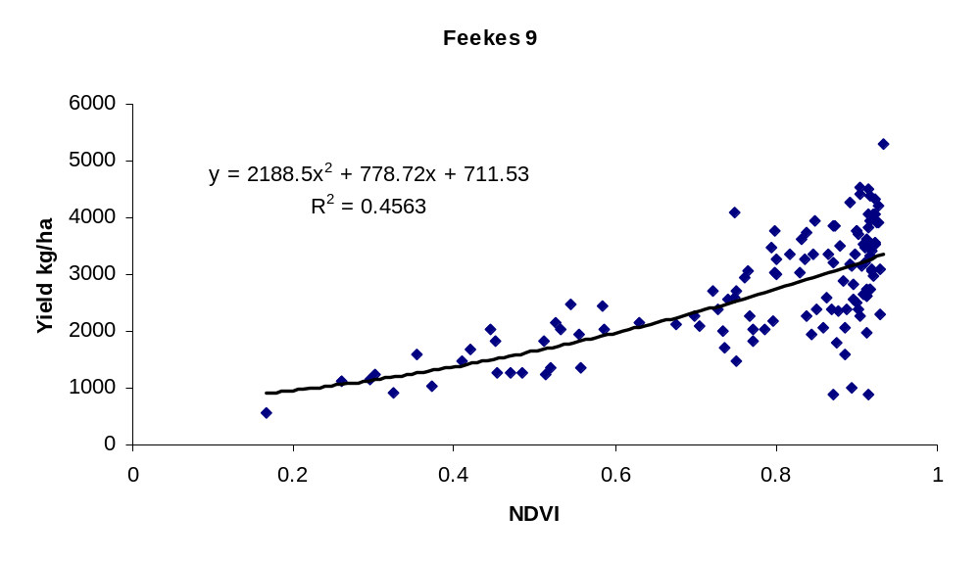
FIGURE 1. Correlation of NDVI and wheat grain yield at Feekes 9, 7 locations in Oklahoma, 2000.

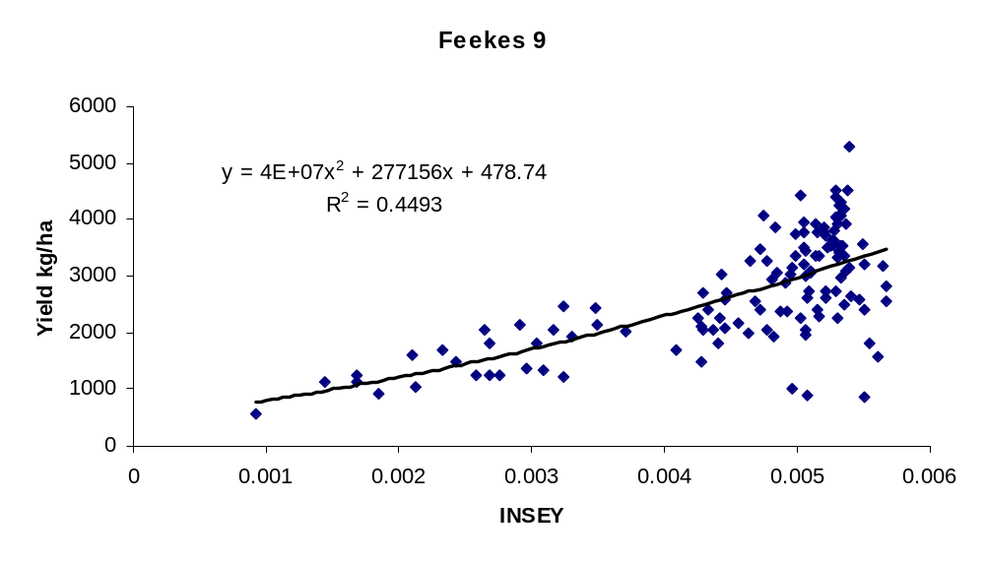
FIGURE 2. Correlation of INSEY and wheat grain yield at Feekes 10.5, 7 locations in Oklahoma 2000.

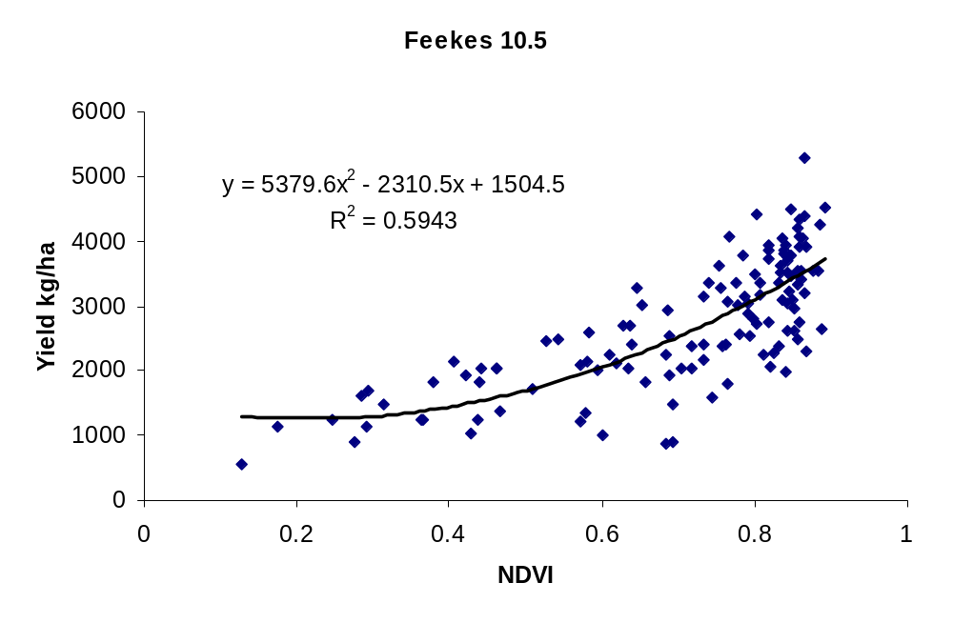

FIGURE 3. Correlation of NDVI and wheat grain yield at Feekes 10.5, 7 locations in Oklahoma, 2000.
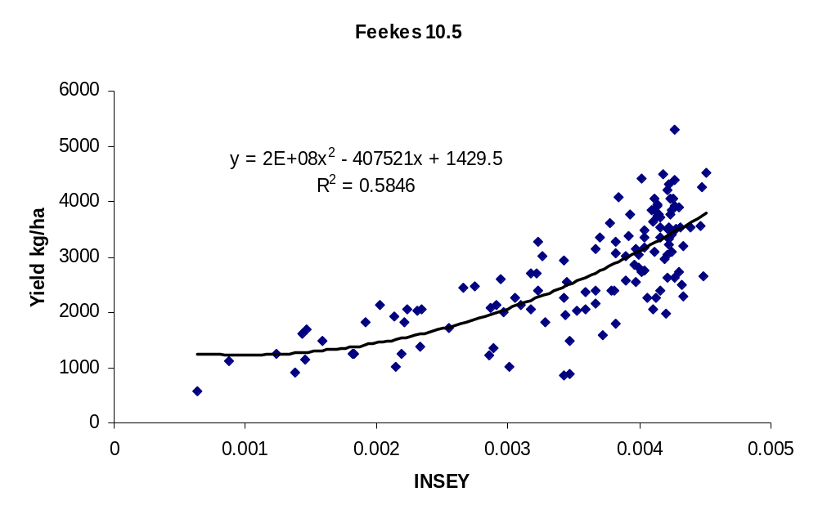
FIGURE 4. Correlation of INSEY and wheat grain yield at Feekes 10.5, 7 locations in Oklahoma, 2000.
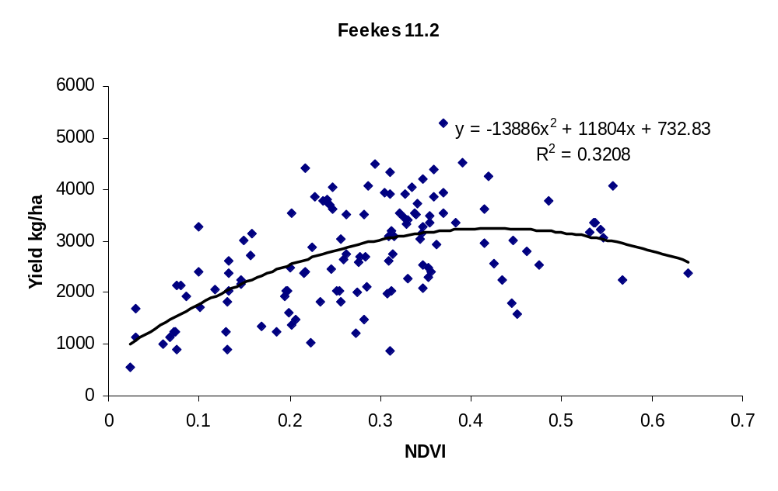

FIGURE 5. Correlation of NDVI and wheat grain yield at Feekes 11.2, 7 locations in Oklahoma, 2000.

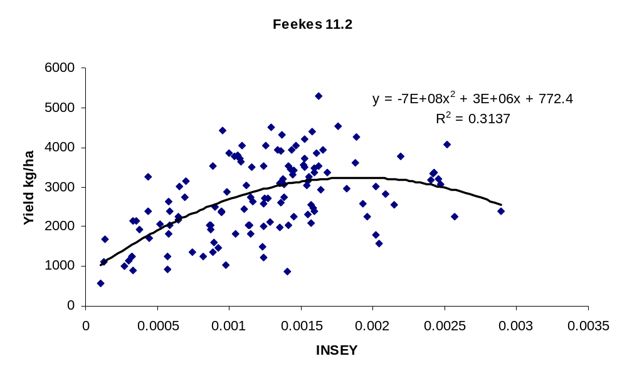
FIGURE 6. Correlation of INSEY and wheat grain yield at Feekes 11.2, 7 locations in Oklahoma, 2000.

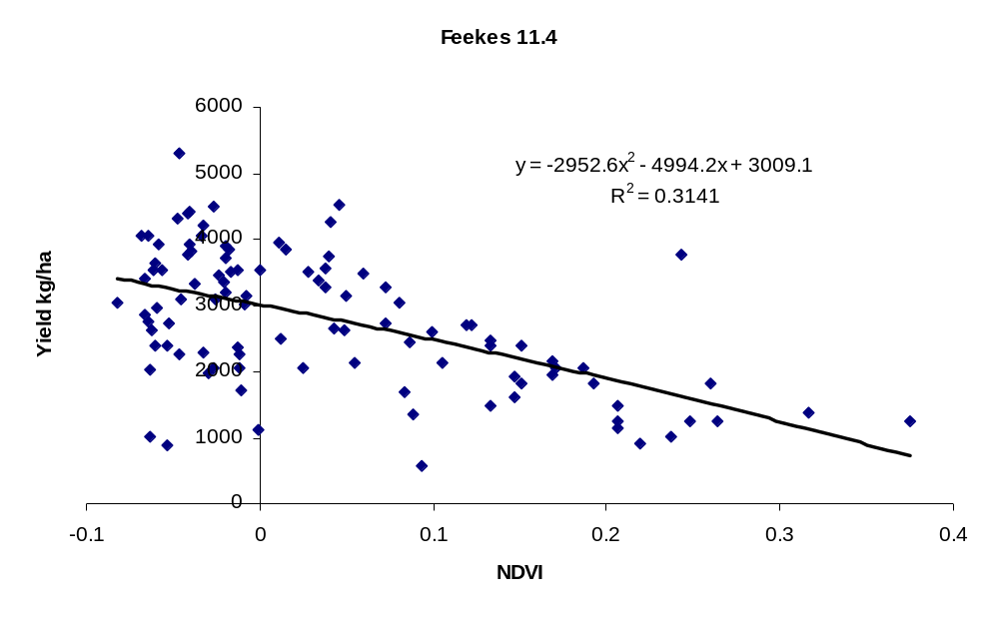
FIGURE 7. Correlation of NDVI and wheat grain yield at Feekes 11.4, 7 locations in Oklahoma, 2000.

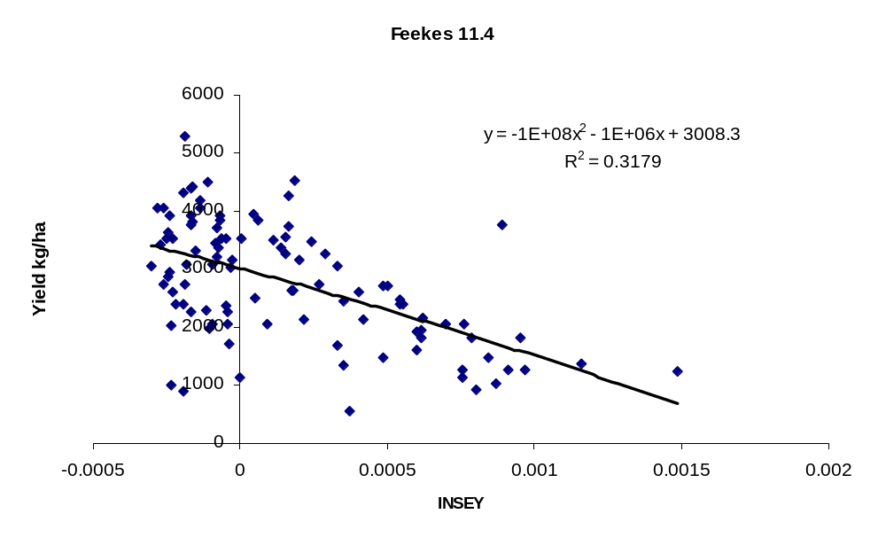
FIGURE 8. Correlation of NDVI and wheat grain yield at Feekes 11.4, 7 locations in Oklahoma, 2000.
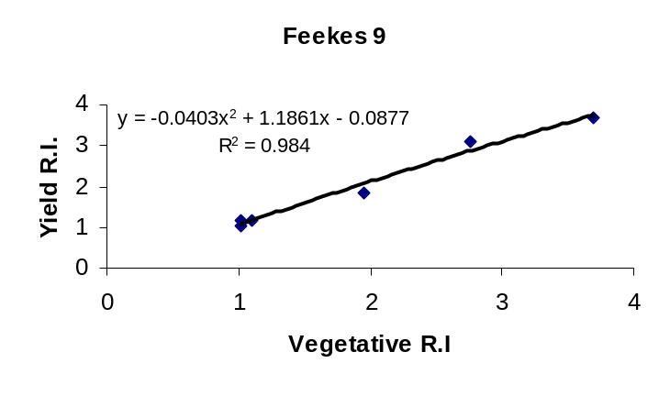
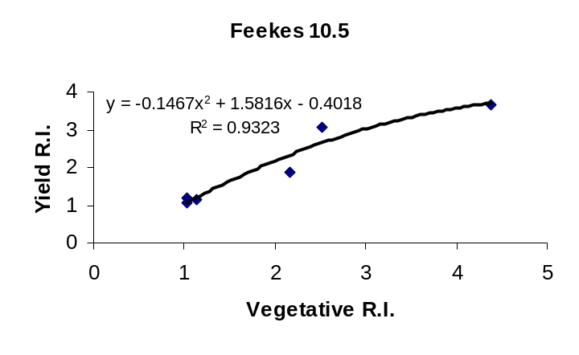
FIGURE 9. Relationship between the response index (RI) determined at harvest and the RI determined using NDVI at Feekes growth stages 9 and 10.5, 7 locations in Oklahoma, 2000.

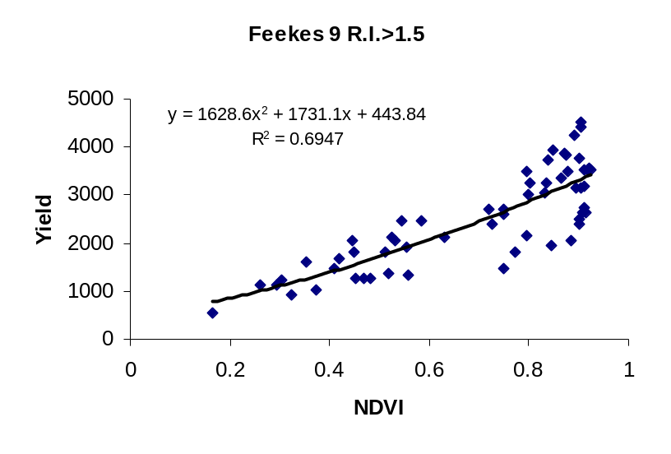
FIGURE 10. Relationship between NDVI at Feekes 9 and Yield at 3 locations with a R.I. greater than 1.5 in Oklahoma, 2000.

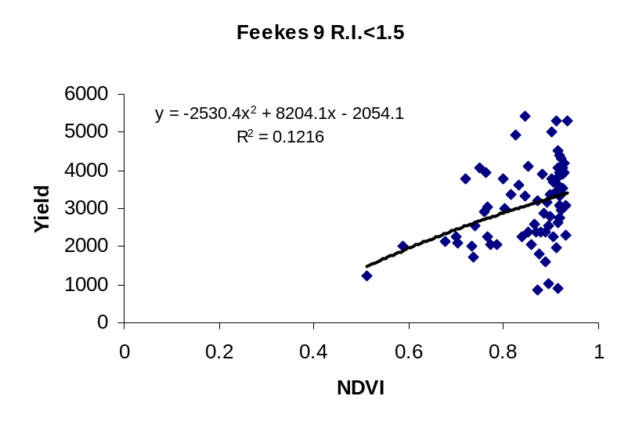
FIGURE 11. Relationship between NDVI at Feekes 9 and Yield at 4 locations with a R.I. less than 1.5 in Oklahoma, 2000.

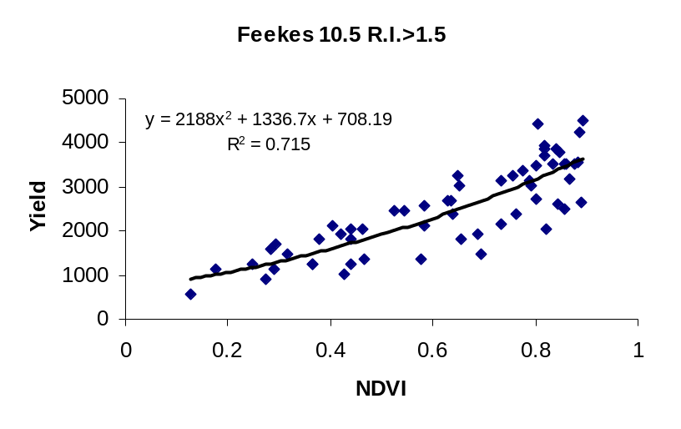
FIGURE 12. Relationship between NDVI at Feekes 10.5 and Yield at 3 locations with a R.I. greater than 1.5 in Oklahoma, 2000.
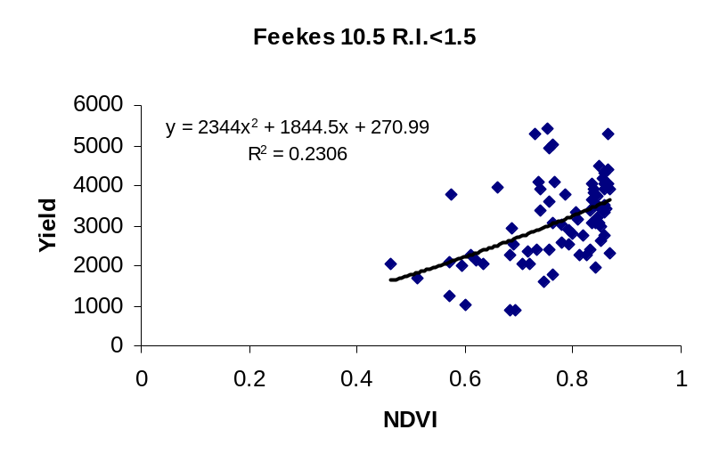
FIGURE 13. Relationship between NDVI at Feekes 10.5 and Yield at 4 locations with a R.I. less than 1.5 in Oklahoma, 2000.

Detection of Nitrogen Deficiencies in Cotton Using Spectral Irradiance and Cotton Response to Topdress Applications

W.E. Thomason, K.J. Wynn, K.W. Freeman, and W.R. Raun

Abstract
Upland cotton (Gossypium hirsutum L.) requires adequate, but not excessive N to produce optimum yields and still reach maturity at a reasonable date. This optimum rate of N is strongly dependent on yield potential and environmental conditions. The ideal situation is to keep N from limiting plant growth while avoiding excessive N applications. In-season N applications are popular because they allow the producer to adjust fertilizer inputs based on how the crop is maturing. This study was conducted to evaluate spectral radiance in cotton canopies and discern which wavelengths detect N deficiencies, and to evaluate the effect of foliar applied N on cotton lint yield based on spectral radiance measurements. The effects of differing N rates and timing were evaluated using a spectrometer. The normalized difference vegetative index (NDVI) from spectral radiance measurements collected mid bloom was highly correlated with preplant N rate and cotton petiole N concentration. Reliable prediction of the N status in cotton using NDVI was also indicated by the variable N rate treated plots as N rates were reduced compared to fixed rates with no decrease in yield.

Introduction
Upland cotton (Gossypium hirsutum L.) requires adequate, but not excessive N to produce optimum yields. Optimum rates of N are strongly dependent on environmental yield potentials. Plentiful N can lead to larger plants with the potential to produce more cotton. Excessive N stimulates excessive plant growth to the detriment of yield and earliness (Boquet et al., 1994). The ideal situation is to keep N from limiting plant growth while avoiding excessive N applications. Many producers apply most of the required N before planting and then make additional N applications when environmental conditions favor high yields. Modern, high-yielding varieties grow and fruit faster than older varieties and therefore, require larger amounts of nutrients in a shorter time. These characteristics make in-season nutrient application even more critical. In some cases, even when soil tests indicate sufficient plant nutrients, deficiency symptoms appear. This suggests that plant uptake mechanisms may not immediately meet plant requirements. Attempts have been made to correct in-season deficiencies with foliar fertilizer applications in hopes that the fertilizer would be more readily available to the plant.
One common method of supplementing N is with foliar applied liquid UAN. Foliar application of N has been shown to increase cotton yields when N was deficient (Miley and Bonner, 1985). The problem with foliar application is determining the point in the growth pattern of the plant that will provide maximum response.
Modern testing procedures often use the plant itself as an indicator of nutrient need (Gardner and Tucker, 1967). One school of thought follows the idea that the petiole from the most recently mature leaf is the best indicator of plant N status (Gardner and Tucker, 1967). This plant part is often used as the benchmark for the rest of the plant. Petiole N content has been used for many years to determine N status in the plant (Baker et al., 1972). These results have varied between regions and years, often owing to the difficulty of determining the most recently mature leaf of the plant and variable environmental conditions. Total N values for leaves are more stable, but are less sensitive to N status of the plant (Cope, 1984). Leaf characteristics such as age and surface wax are some of the factors that affect plant response to foliar-applied N (Bondada et al., 1994).
Soil analysis for N content is a common method for determining N application rates. The amount of N detected in soils has been correlated with the amount of N taken up by the plant. The major drawback to this method is that soil sampling and analysis involve money and time, time the producer does not have when attempting to correct in-season deficiencies. The ideal time for N application during the growing season has a narrow window (Ebelhar and Welch, 1996). The perennial growth habit of the cotton plant forces producers to wait until the plant has produced enough leaves for later determination of plant N status. Producers must also apply nitrogen during blooming or earlier to avoid excess vegetative growth.
Spectral properties of the leaf canopy can provide alternative measures for detecting nutrient status (Raun et al., 1996). This technology offers the ability to detect N deficiencies and apply fertilizer at the same time, eliminating the need for more time consuming, in-season testing methods and reduces the number of trips made across the field. Fields are not totally uniform and plants vary in N uptake due to environmental factors. Some seeds may germinate sooner than others depending on the quality of the seed and the temperature of the soil. Soil temperature also changes within specific areas of the field.
The most important thing to remember about in-season testing is that the deficiency must be detected before severe deficiency stress occurs. If the problem is detected early enough, minimal loss of yield will result. Thus, in-season testing offers the ability to tailor N applications with crop status at the time of sensing, while also having a plant indicator (biomass) as an index of yield potential. Combined with planting density, time of planting and environmental data, indirect in-season measurements could assist in refining N fertilization strategies.
Sensor based applications rely on in-season application of a liquid or granular N source. Foliar N applications have been reported to provide yield increases when N is limiting (Miley and Bonner, 1985). Foliar applications make the applied N available to the plant for use in the critical early square to early boll growth stages. Foliar applications have also been observed to increase root development of seedling cotton (Chiles,1989). The effectiveness of this treatment is contingent on growth stage and leaf morphology of the plant. While there are many different views on the feasibility of foliar N applications, most of the research indicates that foliar applications are productive if N is deficient. When combined with sensor-based deficiency detection, this method should improve yield and increase producer profits. The objectives of this study were: 1) to evaluate spectral irradiance from cotton leaf canopies and discern which wavelengths detect N deficiency; and 2) evaluate the effect of foliar applied N on cotton lint yield based on spectral irradiance measurements.

Materials and Methods
One experimental site was chosen at Altus, Oklahoma (Tables 1 and 2). A randomized complete block experimental design with three replications was employed. Plot size was 4.06 x 18.3 m. Pre-plant nitrogen rates were 0, 22, 45, 67, and 90, kg ha⁻¹. Ammonium nitrate (34-0-0) was the N source used for all pre-plant treatments. Phosphorus as triple superphosphate (0-46-0) and potassium as potassium chloride (0-0-62) were applied at rates of 80 kg P ha⁻¹ and 80 kg K ha⁻¹ to the area. Paymaster HS-26 seed was planted on May 14, 1997 at a rate of 19.3 kg ha⁻¹. Dates for irrigations and pesticide applications are listed in Table 1. Soil classification and characteristics are listed in Table 2. Spectral data was collected within each plot using a PSD-1000 portable dual spectrometer manufactured by Ocean Optics Inc., from two overlapping bandwidths, 300-850 nm and 650-1100 nm. The PSD-1000 is connected to a portable computer through a PCMCIA slot using a PCM-DAS16D/12 A/D converter manufactured by Computer Boards, Inc. The fiber optic spectrometer has spectral resolution as low as 1nm, however, all spectral readings were partitioned into 10 nm bandwidths (75 spectral bands per reading). Six spectral readings (350-1100 nm) were taken from three 1m2 areas within each plot at bloom and 10 days post-bloom and averaged for each 10 nm bandwidth. In addition to the 75 spectral bands collected from each reading, the spectral indices normalized difference vegetative index (NDVI) microwave polarization difference index (MPDI, Becker and Choudhury, 1988), water band index (WBI, Penuelas et al., 1993), and normalized total pigment to chlorophyll a ratio index (NPCI, Penuelas et al., 1993), were calculated for all spectral radiance readings. The 75, 10 nm bandwidths for each growth stage where data was recorded and indices computed were evaluated for simple correlation with petiole NO₃-N, total N, and N use efficiency components adapted from Moll et al. (1982). Specific wavelengths where no correlation was found were evaluated as divisors, for their potential use within indices whereby illumination deviations can be removed from spectral indices. These indices were again analyzed in the AOV model for their use in detecting main effects and main effect interactions. Spectral radiance readings were taken from each plot at bloom and ten days post-bloom. At these same time periods, petiole samples were taken from the first mature leaf from sixteen plants in the center two rows. Petiole samples were dried and ground to pass a 140 mesh sieve (100μm) and analyzed for total N using a Carlo-Erba NA 1500 dry combustion analyzer (Schepers et al., 1989) and for NO₃-N using cadmium reduction (Lachat, 1985). In-season applications of 0 and 45 kg ha⁻¹ as a fixed rate, and a variable rate of N were applied as UAN (28% N) at mid bloom. Variable rates were determined by analyzing petioles for total N content and comparing it with the sensor readings but on a much finer grid (1 x 2 m). The index NDVI was used as the basis for topdress N applications. The values for this index were correlated with the N concentrations determined from the tissue samples to determine plant N status and fertilizer need. The plot with the lowest NDVI values received the highest rate of N (45 kg ha⁻¹) and the plots with the highest values received no added N.

Results
Spectrometer readings showed peaks at 527 and 770 nm for the cotton crop (Figure 1). No one index was consistently shown to have the highest correlation with petiole N content. The index NDVI (I780nm-I671nm/ I780nm+I671nm, where I represents the spectrometer reading) paralleled preplant N rate over time and was therefore used as a measure of crop N status (Figures 2,3, and 4). The NDVI readings were correlated with actual plant N measures and the N status of the plant was evaluated by the use of spectral irradiance (Figures 3 and 4). With this correlation established, we then used the NDVI readings to determine the N status of the plant on site, and liquid UAN applied as needed based on these spectral readings using the equation, N rate applied = -0.0089(NDVI) + 0.3565. NDVI indices gave a good prediction of the amount of N the plant would require for the remainder of the growing season based on final lint yields (Figure 3). Cotton lint yields increased with increasing N applied either preplant or in-season, with lower yields seen in plots with in-season only treatments (Table 3). The observed effects of increased yield with N rate were linear (Table 3). Yields at the three highest variable rates were greater than those for the in-season fixed applications with less fertilizer applied, up to 30 kg at the highest rate. We also found a general trend toward increasing yields with increasing N rates for the variable rate treated plots and average lint yields for the same pre-plant N rates were higher for the variable applied treatments. In-season variable treatments allowed us to use a lower pre-plant rate and then adjust the amount of N based on NDVI. The 67 kg ha⁻¹ pre-plant rate produced 918 kg, with the in-season addition of 26 kg ha⁻¹ of N (based on NDVI values) yields of that treatment were brought up to the maximum yield which was also achieved with the 90 kg ha-1 pre-plant rate(Table 3). This information would allow producers to begin the growing season with less N and adjust applications according to crop status. Production per unit of N values (kg lint kg N applied⁻¹) are shown in Table 3. Highest efficiencies were obtained with the lowest rates of applied N. Variable treated plots showed increased efficiencies when compared to the in-season fixed applications. These results show yields for the variable plot were similar to or greater than the in-season fixed treatments with less total fertilizer applied. This indicates that variable applied N based on NDVI readings could result in less total input cost for the producer. This work will be continued for the 1998 crop year.

REFERENCES
Baker, J.M., R.M. Reed, and B.B. Tucker. 1972. The relationship between applied nitrogen and the concentration of nitrate-N in cotton petioles. Soil Science and Plant Analysis. 3(4), 345-350.

Becker, Francois and Bhaskar J. Choudury. 1988. Relative sensitivity of normalized vegetation index and microwave polarization difference index (MPDI) for vegetation and desertification monitoring. Remote Sens. Environ. 24:297-311.

Bondada, B.R., D.M. Oosterhuis, and R.J. Norman. 1994. Leaf characteristics and foliar nitrogen absorption in cotton. Arkansas Farm J. 43 (6):212-216

Boquet, D.J., E.B. Moser, and G.A. Breitenbeck. 1994. Boll weight and within-plant yield distribution in field-grown cotton given different levels of nitrogen. Agron. J. 86:20-26.

Chiles, J.W. 1989. The benefits of a starter fertilizer high in phosphate that can be sprayed on the leaves of seedling cotton. Proc. Beltwide Cotton Prod. Res. Conf., Natl. Cotton Counc. of Am., Memphis, TN. p. 478-482.

Cope, J.T. 1984. Relationships among rates of N, P, K, and soil test values, leaf analysis, and yield of cotton at six locations. Commun. Soil Sci. Plant Anal. 15(3):253-276.

Eblehar, M.W., and R.A. Welch. 1996. Cotton response to multiple split applications of nitrogen. Proc. Beltwide Cotton Prod. Res. Conf., Natl. Cotton Counc. of Am., Memphis, TN. p. 1345-1347.

Gardner, B.R., and T.C. Tucker. 1967. Nitrogen effects on cotton: I. Vegetative and fruiting characteristics. Soil Sci. Soc. Am. Proc. 31:780-785.

Jones, J.B., Jr., and V.W. Case. 1990. Sampling, handling, and analyzing plant tissue samples. p. 389-427. In R.L. Westerman (ed) Soil testing and plant analysis. 3rd ed. ASA, Madison, WI.

Lachat instruments. 1989. Quickchem method 12-107-04-1-B. Lachat Instr., Milwaukee, WI.

Miley, W.N., and C.M. Bonner. 1985. Modern cotton plant nutrition in Arkansas. Cotton comments (1-85). Arkansas Coop. Ext. Serv., Little Rock.

Penuelas, Josep, John A. Gamon, Kevin L. Griffin and Christopher B. Field. 1993. Assessing community type, plant biomass, pigment composition, and photosynthetic efficiency of aquatic vegetation from spectral reflectance. Remote Sens. Environ. 46:110-118.

Raun, W.R., G.V. Johnson, J.B. Solie, M.L. Stone, R.W. Whitney, H.L. Lees, and S.L. Taylor. 1996. Potential replacement for traditional soil test calibration: sensor based plant analysis. In S.M. Combs (ed.) Enhancing soil testing and recommendations to meet the future. p. 27-32. ASA, annual meetings, Indianapolis, IN.

Schepers, J.S., D.D. Francis, and M.T. Thompson. 1989. Simultaneous determination of total C total N and ¹⁵N on soil and plant material. Commun. Soil Sci. Plant Anal.,20(9&10), 949-959.

Table 1. Dates and information regarding Altus Variable Rate Cotton Expt., 1997
________________________________________________________________________
Irrigations:
July 14
July 28

Herbicide applications:
March 26 Treflan 4EC(PPI) at 2.0 pts. product/ac
May 14 Caparol 4L (Pre) at 3.2 pts. product/ac
July 3 Staple (Post) at 1.2 oz product/ac

Fungicide application:
May 14 Start 15 G Brand Fungicide (In furrow) at 2.0 lb. product/ac

Insecticide applications:
May 14 Temik 15 G (In furrow) at 0.5 lb. Ai/ac
June 21 Vydate C-LV (Post) at 4.25 oz. product/ac
June 28 Vydate C-LV (Post) at 4.25 oz. product/ac
July 4 Vydate C-LV (Post) at 4.25 oz. product/ac
August 9 Vydate C-LV + Larvin 3.2 at 4.40 + 5.12 oz. product/ac
August 15 Vydate C-LV + Larvin 3.2 at 4.40 + 5.12 oz. product/ac
August 23 Karate + Furadan 4F at 0.03lb. Ai/ac + 8.0 oz. product/ac
August 30 Vydate C-LV at 4.37 oz. product/ac
September 10 Malathion ULV at 10.0 oz. product/ac
September 18 Malathion ULV at 10.0 oz. product/ac
September 26 Malathion ULV at 10.0 oz. product/ac

Harvest aid applications:
September 30 Prep + Folex 6 EC at 1.3 pts. product/ac + 1.0 pt. product/ac

Harvest date:
October 31, 1997
________________________________________________________________________

Table 2. Initial surface soil (0-15cm) chemical characteristics and classification at Altus, OK.

Location pHª NH₄-N NO₃-N Total N^{c} Organic C^{c}

--------mg kg⁻¹------- ------g kg⁻¹------
Altus 8.1 5.11 4.37 0.75 8.5

Classification: Tillman-Hollister clay loam (fine-mixed, thermic Typic Paleustoll)
_____________________________________________________________________________
ªpH: 1:1 soil:water
^{c}Organic C and Total N: dry combustion

Table 3. Nitrogen rates, mean yields and analysis of variance for cotton lint yields for three N application times, Altus, 1997
______________________________________________________________________________________
Pre-plant fixed In-season fixed In-season variable
_____________________________________________________________________________
N rate, kg ha⁻¹ Yield PN N rate, kg ha⁻¹ Yield PN N rate, kg ha⁻¹ Yield PN

0 645 - 45 570 13 31 505 16
22 820 37 67 860 13 53 719 14
45 899 20 90 908 10 76 958 13
67 918 14 112 967 9 93 1168 13
90 1143 13 135 1053 8 105 1176 11

Source of variation df Mean Squares

Replication 2 32467.66
N Rate 14 130232.47*
Error 28 45593.92

Contrasts
Pre-plant linear 1 360053.60*
In season linear 1 345325.74*
Variable linear 1 963429.38*
Pre-plant quadratic 1 351.60
In season quadratic 1 33894.83
Variable quadratic 1 41313.66

SED = 45.52
_____________________________________________________________________________
*Significant at the 0.05 probability level
SED- Standard error of the difference between two equally replicated means
PN- Production of lint per unit of applied N = (yield, kg ha⁻¹/total N rate applied, kg ha⁻¹)

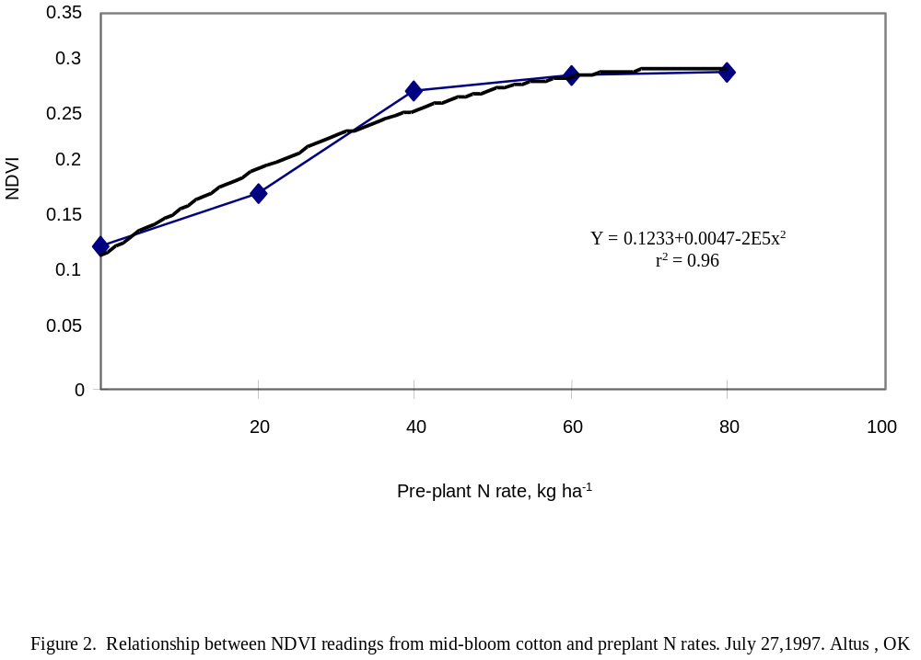
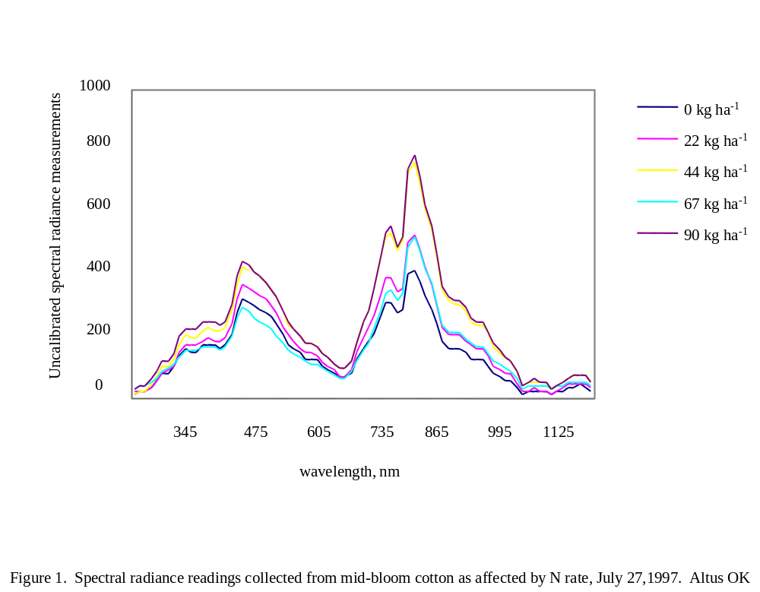
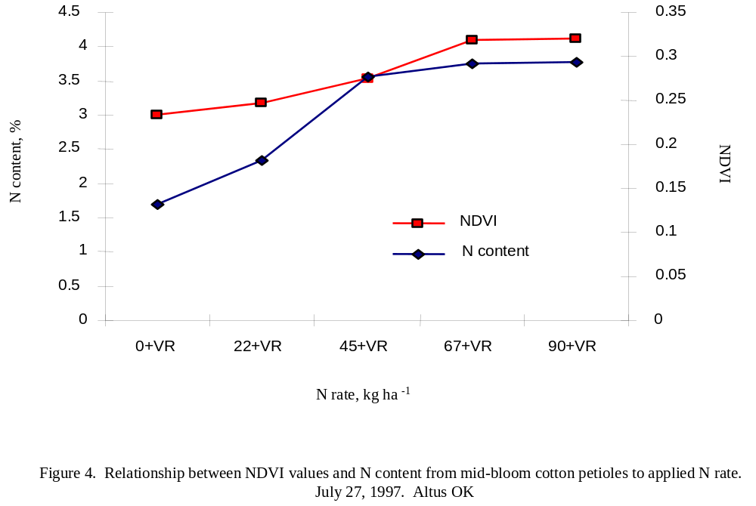
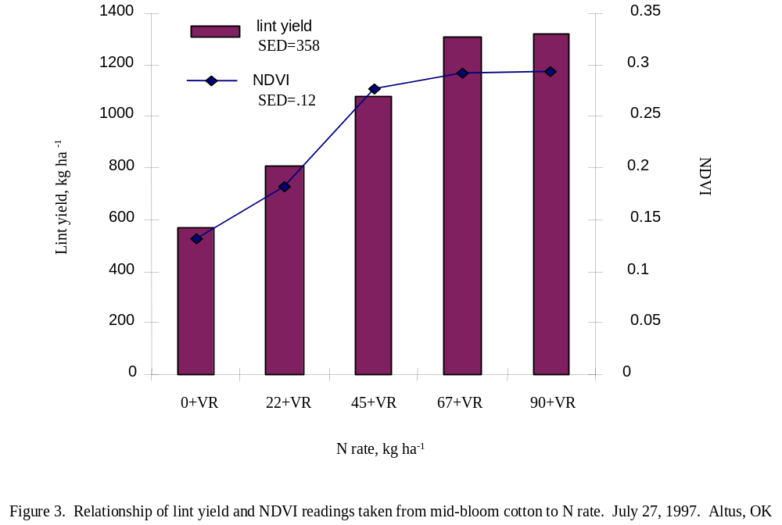

In-season Sensor Based Measurements from Long-Term Experiments to Refine Estimates of INSEY

E.V. Lukina, G.V. Johnson, J.B. Solie,
M.L. Stone, W.E. Thomason, and W.R. Raun.

ABSTRACT
Increased fertilizer use efficiency is a very important issue in modern agricultural crop production. The presence of spatial variability in farmer fields is one factor that affects fertilizer use efficiency. One of the most effective methods to account for spatial variability is the use of sensor–based variable fertilizer rates. The objectives of this study were; 1) to investigate predictability of yield potential with using in-season estimated yield (INSEY) indices; 2) to estimate various climatological inputs such as air temperature, soil type and moisture using INSEY to predict grain yield, and; 3) to compare early, normal, and delayed sensor readings for refining yield prediction. Spectral measurements were collected from 16 winter wheat (Triticum aestivum L.) experiments scattered throughout Oklahoma over three winter seasons, 1998, 1999, and 2000. Spectral measurements were taken from areas 0.84 m² at three experimental fields at Perkins and Tipton, OK. In 1999 and 2000, spectral measurements and grain yield were collected from 4.0 m² areas. Three sets of sensor readings were taken from the winter wheat canopy in two bands, red (671 ± 6 nm) and near infrared ((NIR) 780 ± 6 nm) during the growing season. The normalized difference vegetative index (NDVI), growing degree-days (GDD) and number of days from planting to sensor reading date were used in different combinations to calculate INSEY. Preliminary results showed that grain yield can be predicted using only two variables, NDVI values collected at Feekes growth stage 5 and number of days from planting to sensing date.

INTRODUCTION
The existence of spatial variability in farmer fields is an issue demanding careful consideration for efficient use of fertilizers. One approach to increase fertilizer use efficiency is variable rate technology (VRT). Different methods of VRT include the use of satellite imaging, grid sampling, and high resolution sensing by ground-based sensors. Aerial or satellite remote-sensing can provide information on spatial variability of crop nutrient status and can be used to detect N stress for further fertilizer application at variable rates (Ferguson, 1997, Mangold, 1998,).
Carr et al. (1991) investigated economic efficiency of uniform fertilizer rates for the whole field versus variable rates in accordance with soil units that had different crop yield potential. They showed positive returns of $21.68 - $23.51/ac when optimum treatments for a specific soil were applied rather than uniform rates for the whole field. Although soil units and satellite images distinguish field elements by nutrient availability, their separation is rather poor (coarse scale), which results in low efficiency of variable versus uniform application schemes.
Grid soil sampling is commonly used for fertilizer recommendations. The most common grid size is between 1.2 and 1.6 ha (Ferguson et al., 1997), from which one composite sample is taken. Usually, this type of coarse resolution soil sampling does not take into account the high variability within the field over short distances. Ferguson et al. (1997) used two sampling densities in an experiment in Nebraska for N recommendations. Both densities were much higher than commonly used. They found that 45 % of the field had discrepancies in N recommendations derived from grids of different density. To increase accuracy of N recommendations based on grid sampling is a difficult task since it is not clear what grid size is acceptable. In this regard, high-density grid sampling is very costly and time consuming.
High resolution sensing on-the-go should be the most effective out of the four methods since it allows application of variable rates based on a field element, that could be smaller than 1 m² (Solie et al., 1996). In addition, on-the-go sensing can be used for topdress N application to correct deficiencies during the growing season. This approach will likely reduce the chances of losing nutrients applied pre-plant by immobilization, leaching, and volatilization.

OBJECTIVES
The objectives of this study were 1) to investigate predictability of yield potential with using in-season estimated yield (INSEY) indices, 2) to estimate various climatological inputs such as air temperature, soil type and moisture using INSEY to predict grain yield, and 3) to compare early, normal, and delayed sensor readings for refining yield prediction.

MATERIALS AND METHODS
Spectral measurements were collected from 16 winter wheat experiments scattered throughout Oklahoma over three winter seasons, 1998, 1999, and 2000. In 1998, spectral readings were taken from areas 0.84 m² at three experimental fields at Perkins and Tipton, OK. In 1999 and 2000, spectral measurements and grain yield were collected from 4.0 m² areas. Pre-plant soil test and chemical characteristics, as well as treatment structure for these experiments are reported in Tables 1 and 2, respectively. All experiments employed a randomized complete block experimental design. For all experiments listed in Table 2, N, P and K were applied prior to planting and disk incorporated at the rates reported. Fourteen experiments were planted at a seeding rate of 78 kg ha⁻¹ with 0.19 m row spacing, while S&N experiments at Perkins and Tipton in 1998 had various row spacings ranging from 0.15 to 0.30 m with seeding rates ranging from 49 to 99 kg ha⁻¹.
Spectral reflectance measurements from the winter wheat canopy were taken in two bands, red (671 ± 6 nm) and near infrared ((NIR) 780 ± 6 nm) bandwidths (Stone et al., 1996). The reflectance sensor employed photodiode detectors with interference filters. One pair of those filters (up-looking) received incoming light from the sun, and the other pair (down-looking) received light reflected by vegetation and/or soil surface. The instrument used a built in 16 bit A/D converter that converted the signals from all four photodiode sensors simultaneously. The ratio of readings from down-looking to up-looking photodiodes allowed the elimination of fluctuation among readings due to differences in atmospheric conditions, shadows. Three sets of sensor readings were taken during the growing season. Planting, sensing, and harvest dates are reported in Table 3. The normalized difference vegetative index (NDVI) was calculated as:

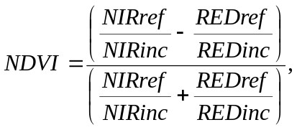(1)

where ref and inc stand for reflected light and incident light readings.
EY, EY2, EY3 and INSEY indices were also evaluated as follows;
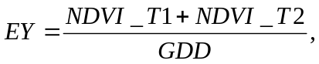
(2)

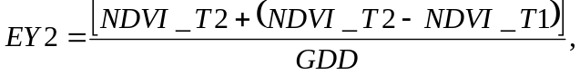
(3)
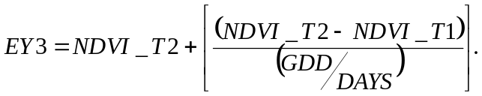

(4)

Where T1 and T2 were times of the first and second sensor readings used in the computations, respectively, and GDD was growing degree-days over that time period. GDD was calculated as follows:
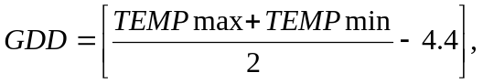
(5)

where daily maximum and minimum temperatures in centigrade were used.
Different combinations of sensor readings taken at three different times were considered in order to find the best time for taking sensor measurements for the sake of predicting yield and topdress N application. EY, EY2 and EY3 computation were based on two sets of sensor readings, while INSEY required only one reading.
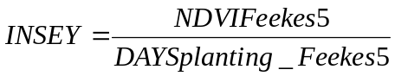
(6)

The advantage of using only one reading is that it allows for predicting grain yield without having to enter a specific field two times in a season.

EXPECTED RESULTS
It is expected that using, INSEY, EY, EY2 and EY3 to predict grain yield for each 1m² and using this predicted yield to adjust for in-season N will increase utilization of topdress N fertilizer. Comparison of these indices should demonstrate the most efficient index in terms of grain yield prediction. This should in turn reduce total fertilizer application costs. Preliminary results showed that the INSEY index gave the best estimation of grain yield using only two variables, which are include NDVI values from Feekes growth stage 5 and number of days from planting till sensing date (Figure 1). This index essentially provides rate of N accumulation from plating till sensing date, further indicating the health and development of the crop during that time period.

REFERENCES
Carr, P.M., G.R. Carlson, J.S. Jacobsen, G.A. Nielsen, and E.O. Skogley. 1991. Farming soils, not fields: a strategy for increasing fertilizer profitability. J. Prod. Agric., 4(1):57-61.

Ferguson, R.B., G.W. Hergert, J.S. Schepers. 1997. Strategies for site-specific nitrogen management.Pp. 387-395. In J.V. Stafford (ed.) Precision agriculture’97: I. Spatial variability in soil and crop.

Grant Mangold. 1998. Crop imaging. Successful Farming, 96(7):44-45.

Solie, J.B., W.R. Raun, R.W. Whitney, M.L. Stone, J.D. Ringer. 1996. Optical sensor based field element size and sensing strategy for nitrogen application. Trans. ASAE 39(6):1983-1992.

Stone, M.L., J.B. Solie, W.R. Raun, R.W. Whitney, S.L. Taylor, and J.D. Ringer. 1996. Use of spectral radiance for correcting in-season fertilizer nitrogen deficiencies in winter wheat. Trans. ASAE. 39(5):1623-1631.
TABLE 1. Initial surface (0-15 cm) soil chemical characteristics and classification at Efaw, Haskell, Hennessey, Lahoma, Perkins, Stillwater, and Tipton, OK.

Location pH NH₄-N NO₃-N P K Total N Organic C

----------------------- mg kg⁻¹ ------------------------- ----------- g kg⁻¹ --------

Efaw AA 6.0 2.5 11.3 19.9 197 0.94 10.4
Classification: Easpur loam (fine-loamy, mixed,superactive, thermic Fluventic Haplustoll)

Efaw SS 5.8 6.9 5.0 30.2 16.8 1.06 11.9
Classification: Norge loam (fine mixed, thermic Udertic Paleustoll)

Haskell 801 5.3 7.4 3.4 8.5 163 0.7 7.4
Classification: Taloka silt loam (fine, mixed, thermic Mollic Albaqualf)

Hennessey 5.6 19.3 14.5 95.6 558 1.05 11.9
Classification: Shellabarger sandy loam (fine-loamy, mixed, thermic Udic Argiustoll)

Lahoma 502 5.5 5.3 13.9 39.9 416 0.8 7.4
Classification: Grant silt loam (fine-silty, mixed, thermic Udic Argiustoll)

Perkins N&P 5.4 2.6 9.1 16.5 132 0.79 7.0
Classification: Teller sandy loam (fine-loamy, mixed, thermic Udic Argiustoll)

Perkins S&N 5.4 2.6 9.1 16.5 132 0.79 7.0
Classification: Teller sandy loam (fine-mixed, thermic Udic Argiustoll)

Stillwater 222 5.9 12.0 8.6 4.9 192 0.96 7.9
Classification: Kirkland silt loam (fine, mixed, thermic Udertic Paleustoll)

Tipton S&N 7.4 4.4 8.6 31.8 462 0.86 8.3
Classification Tipton silt loam (fine-loamy, mixed, thermic, Pachic Argiustoll)

pH – 1:1 soil:water, K and P – Mehlich III, Organic C and Total N – dry combustion.

TABLE 2. Planting, sensor readings, and harvest dates, at Efaw, Haskell, Hennessey, Lahoma, Perkins and Stillwater, OK.
__________________________________________________________________________________________________________________________
Efaw AA Efaw SS Haskell 801 Hennessey Lahoma 502 Perkins N&P Perkins S&N Stillwater 222 Tipton S&N
______
------------------------------------------------------------------------------N-P₂O₅-K₂O (kg ha⁻¹)------------------------------------------------------------------
Treatments 0-0-0 0-0-0 0-0-0 0-0-0 0-0-0 0-67-0 0-0-0 0-0-0 0-0-0
56-0-0 45-0-0 0-134-134 56-0-0 0-45-67 56-67-0 56-0-0 0-67-45 56-0-0
90-0-0 90-0-0 112-134-134 90-0-0 22.4-45-67 112-67-0 112-0-0 45-67-45 112-0-0
123-0-0 179-0-0 112-0-134 123-0-0 45-45-67 168-67-0 168-0-0 90-67-45 168-0-0
56-0-0 269-0-0 112-45-134 (Two 67-45-67 (at 4 row 134-67-45 (at 4 row
90-0-0 538-0-0 112-90-134 application 90-45-67 spacings) spacings)
123-0-0 168-134-134 methods) 112-45-67
_______________________________________________________________________________________________

TABLE 3. Planting, sensor readings, and harvest dates, at Efaw, Haskell, Hennessey, Lahoma, Perkins and Stillwater, OK.

_______________________________________________________________________________________________________________________
EfawAA EfawSS Hask801 Hennessey Lahoma502 PerkinsN&P PerkinsS&N Stil222 TiptonS&N
_______________________________________________________________________________________________________________________

1997-98

Planting date - - - - - 10/21/97 10/21/97 - 10/07/97
Sensing date at Feekes 4: - - - - - 02/24/98 02/24/98 - 01/27/98 Sensing date at Feekes 5: - - - - - 04/02/98 04/06//98 - 02/26/98
Grain harvest date: - - - - - 06/15/98 06/15/98 - 06/03/98

1998-1999

Planting date: 11/09/98 10/15/98 10/16/98 11/25/98 10/09/98 10/12/98 - 10/13/98 -
Sensing date at Feekes 4: 02/19/99 02/19/99 02/16/99 03/05/99 02/10/99 02/12/99 - 01/18/98 -
Sensing date at Feekes 5: 03/24/99 03/24/99 03/23/99 03/25/99 03/05/99 03/04/99 - 02/24/99 -
Grain harvest date: 06/15/99 06/15/99 07/06/99 06/29/99 06/30/99 06/9/99 - 06/15/99 -

1999-2000

Planting date: 10/07/99 10/07/99 10/08/99 10/07/99 10/12/99 10/08/99 - 10/07/99 -
Sensing date 1: 01/03/00 01/03/00 01/14/00 01/11/00 01/13/00 12/17/99 - 01/04/00 -
Sensing date 2: 02/10/00 02/10/00 03/14/00 02/15/00 02/15/00 02/08/00 - 02/10/00 -
Sensing date 3: 03/06/00 03/06/00 - 03/13/00 03/13/00 03/07/00 - 03/06/00 -
Grain harvest date: 07/07/00 06/02/00 06/02/00 06/07/00 06/13/00 05/30/00 - 07/06/00 -
________________________________________________________________________________________________________________________
FIGURE 1. Relationship between Observed Grain Yield and INSEY obtained from 16 experiments over 3 years of study (1998, 99, and 2000).

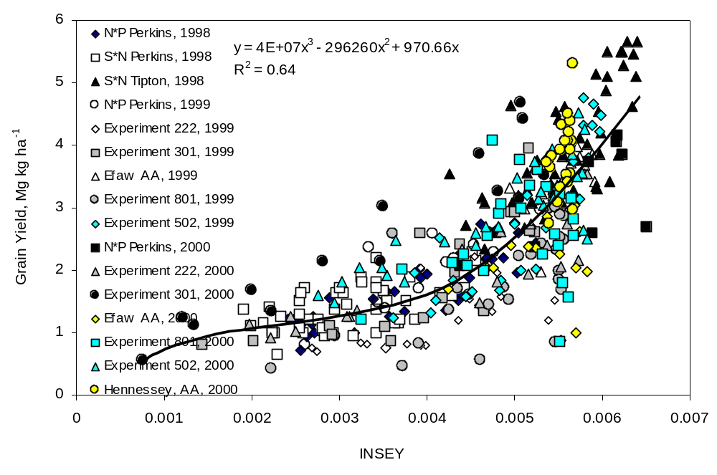

Nitrogen Fertilization Optimization Algorithm Based on In-Season Estimates of Yield and Plant Nitrogen Uptake

Lukina, E.V., K.W. Freeman, K.J. Wynn, W.E. Thomason, R.W. Mullen, A.R. Klatt, G.V. Johnson, R.L. Elliott, M.L. Stone, J.B. Solie, and W.R. Raun

Abstract
Current methods of determining nitrogen (N) fertilization rates in winter wheat (Triticum aestivum L.) are based on farmer projected yield goals and fixed N removal rates per unit of grain produced. This work reports on an alternative method of determining fertilizer N rates using estimates of early-season plant N uptake and potential yield determined from in-season spectral measurements collected between January and April. Reflectance measurements under daytime lighting in the red and near infrared regions of the spectra were used to compute the normalized difference vegetation index (NDVI). Using a modified daytime lighting reflectance sensor, early-season plant N uptake between Feekes physiological growth stages 4 (leaf sheaths lengthen) through 6 (first node of stem visible) was found to be highly correlated with NDVI. Further analyses showed that dividing the NDVI sensor measurements between Feekes growth stages 4 and 6, by the days from planting to sensing date was highly correlated with final grain yield. This in-season estimate of yield (INSEY) was subsequently used to compute the potential N that could be removed in the grain. In-season N fertilization needs were then considered to be equal to the amount of predicted grain N uptake (potential yield times grain N) minus predicted early-season plant N uptake (at the time of sensing), divided by an efficiency factor of 0.70. This method of determining in-season fertilizer need has been shown to decrease large area N rates while also increasing wheat grain yields when each 1m² area was sensed and treated independently.

INTRODUCTION
The word precision is defined as ‘the quality or state of being precise, or exactness.’ In many ways, precision agriculture is still being defined, but it certainly must include ‘being precise, or exact’ in the management of agronomic and engineering variables. The development of a precision agriculture technology (PAT) would imply that it resulted in a more precise measurement and treatment of the independent variables than had been achieved before. In this regard, the scientific community has the responsibility of making sure that each new PAT results in a measurable improvement (application, management, monitoring, and/or mapping). The measurable improvement could be decreased inputs with no sacrifice in yield, or increased yield at the same level of inputs (improved efficiency) for the specific variable being evaluated. One of the more radical hypotheses was recently posed by Solie et al. (1999) who contended that the area over which variable rate fertilizer applicators should sense and apply materials is likely to be 1.0 by 1.0 m or smaller. Taking this a step further suggests that each PAT applied to field crop production must be evaluated at a resolution less than or equal to 1.0m². This challenge has been recognized since various research programs have already noted that spatially variable N fertilizer application may reduce adverse environmental impacts and increase economic return (Fiez et al., 1995). Filella et al. (1995) noted that remote sensing could provide inexpensive, large-area estimates of N status and be used to monitor N status, since leaf chlorophyll A content is mainly determined by N availability. They further reported that the use of reflectance at 430 nm, 550 nm, 680 nm, and red edge wavelengths offers potential for assessing N status of wheat. Work with winter wheat by Raun et al. (2000) found that two post-dormancy NDVI measurements (reflectance of red and near infrared in January and March) divided by the cumulative growing degree days from the first to the second reading could be used to predict potential grain yield. They also indicated that if potential grain yield could be predicted in-season, topdress N rates could be based on predicted yield.
Sowers et al. (1994) reported that reduced N rates and split N applications between fall and spring can maintain high yields but at reduced grain protein levels. It is therefore conceivable, that if variable rate technology resulted in applied N based on projected need or potential yield (some areas receive added N, some do not), average grain protein levels may not decrease in fields where N was applied using variable rate technology.
An area where PAT’s will likely be beneficial is in the identification of sustainable production practices and management tools. Halvorson et al. (1999) recently reported that increases in soil organic carbon improved soil quality and productivity with increased N fertilization. Capitalizing on the spatial variability known to exist in agricultural fields reported by Solie et al. (1999), precision applied N could increase C sequestration (on average) when compared to flat rates.
On a global scale, Tilman (1999) reported that the doubling of agricultural food production during the past 34 years was associated with a 6.87-fold increase in N fertilization, 3.48-fold increase in P fertilization, 1.68-fold increase in the amount of irrigated cropland and a 1.1-fold increase in land in cultivation. This work further noted that the next doubling of global food production would be associated with a 3-fold increase in N and P fertilization rates, doubling of the irrigated land area, and an 18% increase in cropland. Therefore, it seems plausible that PAT’s could fill a large forecasted void regarding world food production and the need for sustainable agricultural systems.
The objectives of this work were (i) to determine the feasibility of using a single optical sensor measurement to predict early-season plant N uptake for readings obtained over locations, stages and years, (ii) to determine the best method to empirically calibrate optical sensor measurements with potential wheat grain yield when readings are made at different growth stages, geographical locations and in different years, and (iii) propose a procedure to use optically sensed estimates of early season plant N uptake and potential yield to calculate N fertilizer application rate.

Materials and Methods
During the winter months of 1998, 1999 and 2000, spectral reflectance readings were taken from 9 winter wheat experiments to refine estimates of early-season plant N uptake at or near Feekes growth stage 5 and from 16 experiments to refine estimates of potential grain yield. Each experiment was either an on-going long-term experiment (numbers assigned in the 1960’s and 1970’s as 222, 301, 502 and 801), a short-term (1-3 years) field experiment that included the evaluation of preplant N rates, or transects (50, 1x1m continuous plots). The early-season plant N uptake and potential yield experiments are further defined in Tables 1 and 2, respectively. The soils at each of these locations are; Perkins, Teller sandy loam (fine-loamy, mixed, thermic Udic Argiustolls); Tipton, Tipton silt loam (fine-loamy, mixed, thermic Pachic Argiustolls); Stillwater, Kirkland silt loam (fine, mixed, thermic Udertic Paleustolls); Efaw, Norge silt loam (fine-silty, mixed, thermic Udic Paleustolls); Lahoma, Grant silt loam (fine-silty, mixed, thermic Udic Argiustolls); and Haskell, Taloka silt loam (fine, mixed, thermic Mollic Albaqualfs). The row spacing by N rate (S*N), Efaw anhydrous ammonia (AA), and transect experiments were each one-year trials. The N rate by P rate (N*P) experiment at Perkins was initiated in 1996. Experiments 222, 301 and 502 were initiated in 1969, 1993 and 1971, respectively, and all three evaluated annual rates of applied N at constant levels of P and K (Table 1). Winter wheat was planted at a 78 kg ha⁻¹ seeding rate using a 0.19 m row spacing, excluding the S*N experiment at Perkins (spacing ranged from 0.15 to 0.30 m). Varieties used in each trial are reported in Tables 1 and 2.
Spectral reflectance was measured using an Oklahoma State University designed instrument that included two upward directed photodiode sensors, and that received incident light through cosine corrected Teflon® windows fitted with red (671±6nm) and near-infrared (NIR)(780±6nm) interference filters. The instrument also included two down-looking photodiode sensors that received light through collination and interference filters identical to the up-looking sensors. The instrument used a 16 bit A/D converter to simultaneously capture and convert the signals from the four photodiode sensors. Collination was used to constrain the view of the down-looking sensors to a 0.84 m² oblong area at the plant surface. Stability of the sensor was maintained across time by calibration with a barium sulfate coated aluminum plate. The reflectance of the barium sulfate coated plate was assumed to be 1.0 for both spectral bands investigated. Reflectance values (the ratio of incident and reflected values) were used in the NDVI calculation to minimize the error associated with cloud cover, shadows and sun angle. Reflectance based NDVI was calculated using the following equation: NDVI = [(NIR_{ref}/NIR_{inc})-(Red_{ref}/Red_{inc})] / [(NIR_{ref}/NIR_{inc})+(Red_{ref}/Red_{inc})], where NIR_{ref} and Red_{ref} = magnitude of reflected light, and NIR_{inc} and Red_{inc} = magnitude of the incident light.
Although 4 different wheat varieties are included in this work, varietal differences were not targeted, since findings of Sembiring et al. (2000) showed limited differences in post-dormancy NDVI readings for common wheat varieties grown in this region. Reflectance readings from all experiments were collected at two post-dormancy dates. The two dates (Time-1 and Time-2, respectively) where readings were collected ranged between Feekes growth stage 4 (leaf sheaths beginning to lengthen), 5 (pseudo-stem, formed by sheaths of leaves strongly erect), and 6 (first node of stem visible)(Large, 1954). For the early-season plant N uptake and grain yield potential experiments, individual wheat plot reflectance readings were taken from 1.0 m² and 4.0m² areas, respectively, between 10 a.m. and 4 p.m under natural lighting. For the early-season plant N uptake experiments (Table 1), individual 1m² plots were hand clipped (immediately following sensor readings) and weighed prior to being dried in a forced air oven at 60°C. Once dry, samples were ground to pass a 0.125mm (120-mesh) sieve and analyzed for total N using a Carlo Erba (Milan, Italy) NA-1500 dry combustion analyzer (Schepers et al., 1989). Early-season plant N uptake was determined by multiplying dry matter yield by the total N concentration determined from dry combustion.
In the grain potential yield trials, grain yield was determined using a self propelled combine from the same 4.0 m² area where spectral reflectance data were collected. We assumed that growth from planting in October to the mid winter months of January and February would provide an excellent indicator of wheat health in each 4.0 m² area and the influence of early-season growth-limiting conditions for small areas. In-season estimated yield, or INSEY, was determined by dividing NDVI sensor measurements between Feekes growth stages 4 and 6 by the days from planting to the date sensor measurements were taken. A number of possible indices relating NDVI to wheat yield were investigated. Indices were ranked by regression (R²) and the index with the highest R² for all dates was selected for estimating potential grain yield. Because NDVI at Feekes 4-6 has been shown to be an excellent predictor of early-season plant N uptake, the INSEY value reported here represents plant N uptake per day. The use of days from planting to sensing in the computation of INSEY allowed us to predict the early-season plant N uptake per day from sites where planting to sensing ranged from 123 to 167 days (Table 2).
Following initial indices of estimated yield (EY) reported by Raun et al. (2000), the INSEY index reported here was one of many indices evaluated that included mathematical combinations of NDVI at various growth stages, days from planting to sensing times, growing degree days (GDD) from planting to sensing, and days, and GDD between sensor readings (GDD = [(Tmin + Tmax)/2 - 4.4°C] (Tmin and Tmax recorded from daily data).
Measured grain yield was considered to be the best available measure of potential grain yield, especially where limited stress occurred after sensor readings in late February and early March. Linear, quadratic, logarithmic and exponential models were evaluated that included all locations and data subsets using various indices to predict grain yield.

RESULTS
The relationship between early-season plant N uptake and NDVI for the nine experiments where forage biomass, forage N and sensor readings were collected between Feekes growth stages 4 and 6, is reported in Figure 1. NDVI was an excellent predictor of early-season plant N uptake for these nine trials that covered three years, two varieties, a range of planting and sensing dates, and three physiological stages of growth. Earlier work by Sembiring et al. (2000) reported high correlation between early-season plant N uptake and NDVI between Feekes growth stages 4 and 8. However, they reported that specific by-stage early-season plant N uptake calibration would be needed when using NDVI as a predictor, since the linear regression equations differed significantly by stage. To some extent this was expected since the NDVI readings used in their work (earlier version of the sensor employed in this work) were not calibrated to account for changing light (sun angle, clouds, shadows) when recording sensor readings from one time (day, month, location) to the next. Using the reflectance based NDVI equation and the improved sensor which measured both incident and reflected radiance, early-season plant N uptake could now be reliably predicted (R²=0.75) over stage of growth (Figure 1). It is important to note that an average of 45 kg N ha⁻¹ was taken up in the forage for all nine experiments (Figure 1) and that this represents over half of the total N that would end up in the grain (average yield of 2.52 Mg ha⁻¹ would have 63 kg N ha⁻¹ removed in the grain when grain N % = 2.5, Thomason et al., 2000). Therefore, a large portion of the potential-yield-N is assimilated by early to mid-February, which is four months before harvest.
In addition to being a reliable predictor of early-season plant N uptake between Feekes growth stages 4 and 6, NDVI readings taken at these same stages were positively correlated with final grain yield (Figure 2). Although these results were encouraging, data from several locations over this three-year period clearly did not fit the general trend (Figure 2). Earlier work by Raun et al. (2000) noted that the sum of NDVI readings at Feekes 4 and Feekes 5, divided by the cumulative GDD between readings was a reliable predictor of wheat grain yield at 6 of 9 locations. Their work was considered to be somewhat cumbersome since it relied on two post-dormancy sensor readings to predict wheat grain yield. Further analyses of these same 9 trials, plus 7 more locations (total of 16) showed that NDVI divided by the total number of days from planting to sensing was better correlated (R² of 0.64 compared to R² of 0.53) with wheat grain yield. More importantly, this in-season estimate of yield (INSEY) included all sixteen sites over a three-year period, and that was clearly an improvement upon the EY equation initially reported by Raun et al. (2000).
Dividing NDVI at Feekes 5 (excellent predictor of early-season plant N uptake, Figure 1) by the days from planting to the NDVI sensing date resulted in an index that would approximate N uptake per day. This estimate of N uptake per day could be viewed as the rate at which N was accumulated from October to March. Equally important for this compiled data was knowing that the days from planting to sensing (INSEY divisor) ranged from 123 to 167 days. Even if the range in inclement mid-winter weather varied by 10 to 30 days (from one site to the next), the total number of days for potential growth would be a plausible divisor for the in-season NDVI measurement. It should be noted that almost all of the measurements were made after winter wheat had broken dormancy, thus exhibiting more rapid growth. Considering that three years of data, sixteen site-years, and differing planting and sensing dates were included in this work, the new INSEY index clearly provided a common linkage for a holistic model (Figure 3). This was also evident when plotting wheat grain yield as a function of INSEY for each of the years where data was recorded, using exponential models (Figure 4). Only limited differences were observed between models for 1998 (3 sites), 1999 (6 sites) and 2000 (7 sites).
We also found that the use of growing degree days from planting in the divisor did not provide significant improvement when predicting yield compared to the use of NDVI alone. Work by Raun et al. (2000) successfully used growing degree days from the first sensing to the second sensing, but their index (EY) was bound by needing two sensor readings. Similar to results reported here, they reported that the use of growing degree days from planting to the first or second sensor reading did not improve the prediction of wheat grain yield.

Discussion
The central component behind our nitrogen fertilization optimization algorithm (NFOA) is the ability to predict potential grain yield in-season, and early enough to apply fertilizer N based on predicted need. Equally important is the ability to identify the need for fertilizer N in such a way that added N will correct for projected need.
Because we are able to predict percent N in the grain (based on a relationship with predicted yield level), early-season plant N uptake (NDVI readings at Feekes 4 to 6) and wheat grain yield (INSEY), we propose the following procedures to determine N fertilizer application rate:

1. Predict potential grain yield (PGY) from the Grain yield-INSEY equation
PGY in (Mg ha⁻¹) = 0.74076 + 0.10210 e^{577.66INSEY}
2. Predict percent N in the grain based on predicted grain yield (Figure 5, total N determined on 688 samples where grain yield was recorded, 1980 to 1999)
Percent N in the grain = 0.0703PGY² - 0.5298PGY + 3.106
3. Calculate predicted grain N uptake (predicted percent N in the grain multiplied by predicted grain yield)
4. Calculate predicted early-season plant N uptake from NDVI
Early-season plant N uptake (kg ha⁻¹) = 14.76 + 0.7758 e^{5.468NDVI}
5. Determine in-season topdress fertilizer N requirement = (predicted grain N uptake - predicted early-season plant N uptake)/0.70

In our method, the predicted N deficit is the difference in predicted total grain N uptake minus the predicted early-season plant N uptake. Dividing the predicted N deficit (actual plant N need for added N) by 0.70 in step 5 basically says that we can achieve a maximum of 70% use efficiency for mid-winter applied N in winter wheat. In some regions, this should theoretically be much less where the potential for immobilization, denitrification, and/or volatilization are greater. Wuest and Cassman (1992) reported that recovery of applied N at planting ranged from 30 to 55% while that applied at flowering ranged from 55 to 80%. Raun and Johnson (1999) recently reported that worldwide nitrogen use efficiency for cereal production is approximately 33%. In this regard, the divisor could realistically range between 0.33 and 0.80.
This procedure is different from that used by other researchers and practitioners. The proposed procedure prescribes increased N rates in areas of the field with high yield potential as indicated by INSEY and reduced N fertilizer in areas of the field with lower yield potential. In addition, this procedure accounts for the amount of N in the wheat plant (at the time of sensing) and adjusts for need accordingly.
Field application of the process will be to compile planting date information prior to sensing, whereby NDVI readings can be collected from each 1m², divided by the number of days from planting and a prescribed fertilizer rate applied on-the-go. Nitrogen application rates will be calculated using the previously outlined procedure, whereby the fertilizer application rate needed to optimize yield at that location will be set by the predicted yield potential. If a producer chooses to lower predicted yield potential, rates could be adjusted upward or downward, based on that input.
The use of INSEY and the Nitrogen Fertilizer Optimization Algorithm could replace N fertilization rates determined using production history (yield goals), provided that the production system allows for in-season application of fertilizer N. Application of this procedure should result in increased grain yields at lower N rates when INSEY is computed and applied to each 1m². This procedure should also increase N use efficiency (decreased N applied where early-season plant N uptake was already high) when the production system allows for in-season application of fertilizer N.

References

Fiez, T.E., W.L. Pan, and B.C. Miller. 1995. Nitrogen use efficiency of winter wheat among landscape positions. Soil Sci. Soc. Amer. J. 59:1666-1671.

Filella, I., L. Serrano, J. Serra and J. Penuelas. 1995. Evaluating wheat nitrogen status with canopy reflectance indices and discriminant analysis. Crop Sci. 35:1400-1405.

Halvorson, A.D., C.A. Reule, and R.F. Follett. 1999. Nitrogen fertilization effects on soil carbon and nitrogen in a dryland cropping system. Soil Sci. Soc. Amer. J. 63:912-917.

Large, E.C. 1954. Growth stages in cereals. Illustration of the Feekes Scale. Plant Pathol. 3:128-129.

Raun, W.R., and G.V. Johnson. 1999. Improving nitrogen use efficiency for cereal production. Agron. J. 91:357-363.

Raun, W.R., J.B. Solie, G.V. Johnson, M.L. Stone, E.V. Lukina, W.E. Thomason, and J.S. Schepers. 2000. In-season prediction of potential grain yield in winter wheat using canopy reflectance. Agron. J. (in press).

Schepers, J.S., D.D. Francis, and M.T. Thompson. 1989. Simultaneous determination of total C, total N and 15N on soil and plant material. Commun. Soil Sci. Plant Anal. 20:949-959.

Sembiring, H., H.L. Lees, W.R. Raun, G.V. Johnson, J.B. Solie, M.L. Stone, M.J. DeLeon, E.V. Lukina, D.A. Cossey, J.M. LaRuffa, C.W. Woolfolk, S.B. Phillips, and W.E. Thomason, . 2000. Effect of growth stage and variety on spectral radiance in winter wheat. J. Plant Nutr. 23:141-149.

Solie, J.B., W.R. Raun and M.L. Stone. 1999. Submeter spatial variability of selected soil and bermudagrass production variables. Soil Sci. Soc. Am. J. 63:1724-1733.

Sowers, K.E., B.C. Miller and W.L. Pan. 1994. Optimizing yield and grain protein in soft white winter wheat with split nitrogen applications. Agron. J. 86:1020-1025.

Thomason, W.E., W.R. Raun and G.V. Johnson. 2000. Winter wheat fertilizer nitrogen use efficiency in grain and forage production systems. J. Plant Nutr. (in press).

Tilman, D. 1999. Global environmental impacts of agricultural expansion: the need for sustainable and efficient practices. Proc. National Academy of Sciences of the United States of America. 96(11):5995-6000.

Wuest, S.B., and K.G. Cassman. 1992. Fertilizer-nitrogen use efficiency of irrigated wheat: I. Uptake efficiency of preplant versus late-season application. Agron. J. 84:682-688.

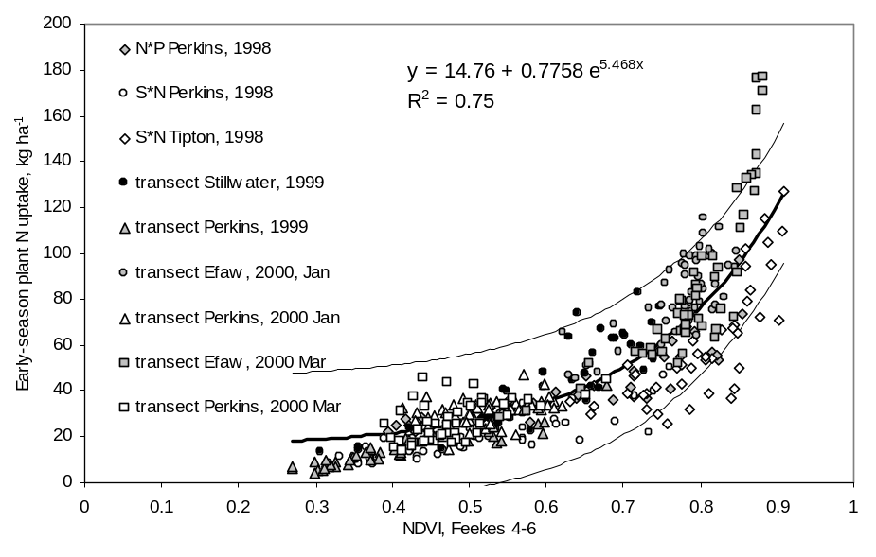

FIGURE 1. Relationship between the normalized difference vegetation index computed from red and near infrared reflectance readings from winter wheat at Feekes physiological stages 4 to 6 and measured early-season plant N uptake from nine experiments, 1998-2000.

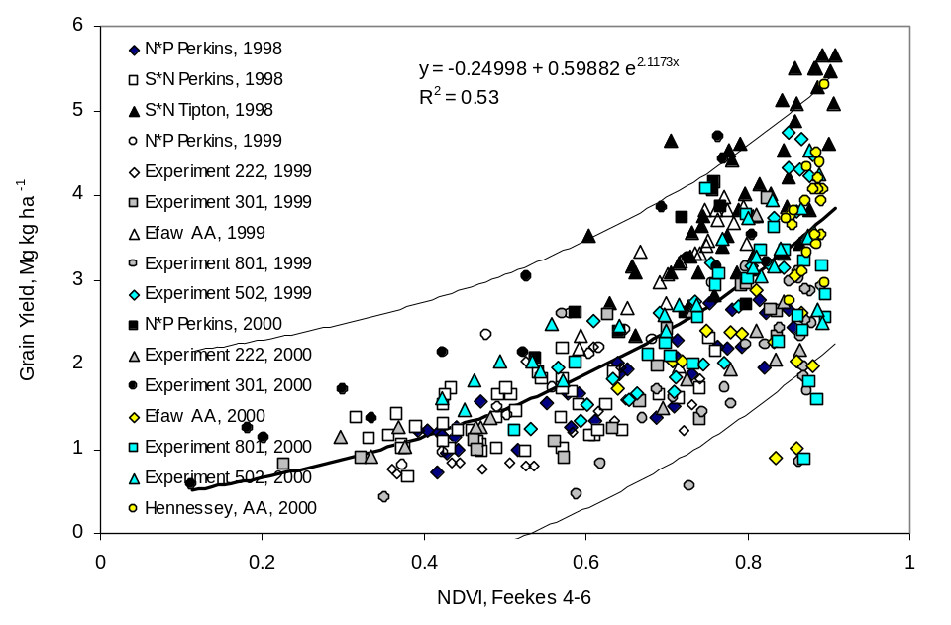

FIGURE 2. Relationship between the normalized difference vegetation index computed from red and near infrared reflectance readings from winter wheat at Feekes physiological stages 4 to 6 and measured grain yield from sixteen experiments, 1998-2000.

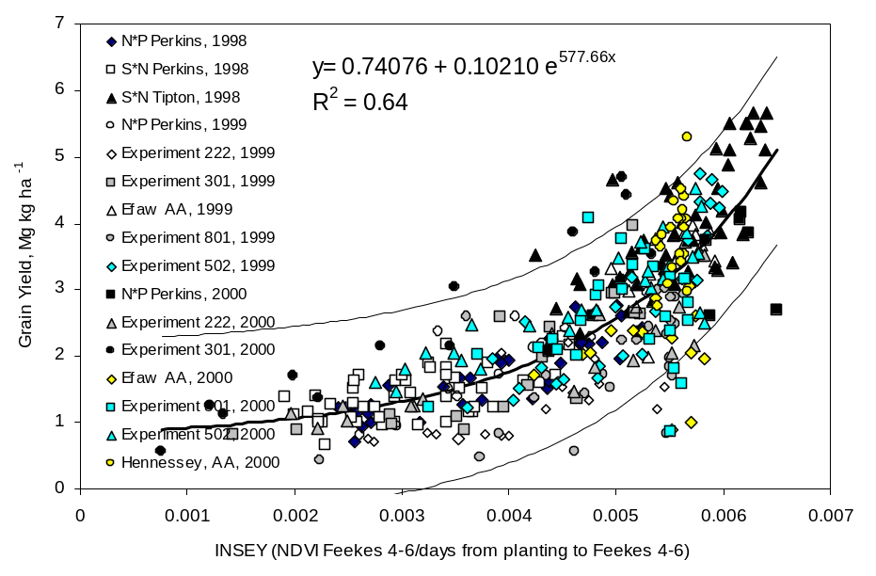

FIGURE 3. Relationship between in season estimated grain yield (INSEY) computed from NDVI readings collected between Feekes physiological growth stages 4 to 6, divided by the number of days from planting to the reading date, and measured grain yield from sixteen winter wheat experiments, 1998-2000.

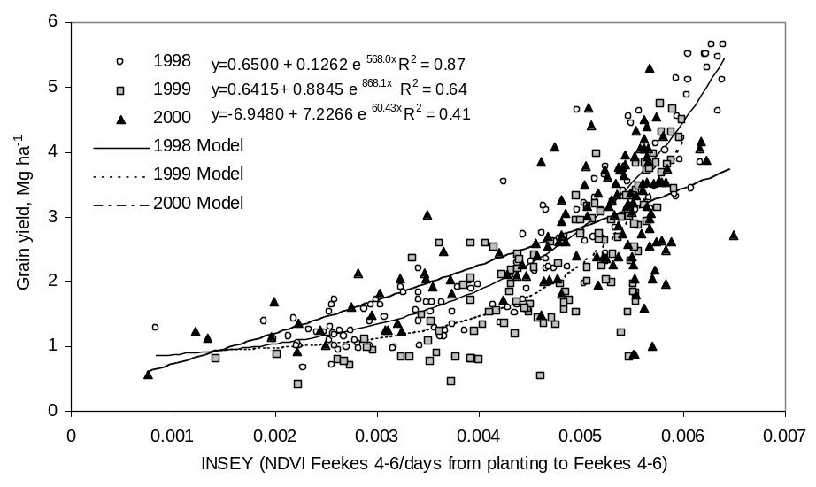

FIGURE 4. Relationship between in season estimated grain yield (INSEY) computed from NDVI readings collected between Feekes physiological growth stages 4 to 6, divided by the number of days from planting to the reading date, and measured grain yield (by year) from sixteen experiments, 1998-2000.

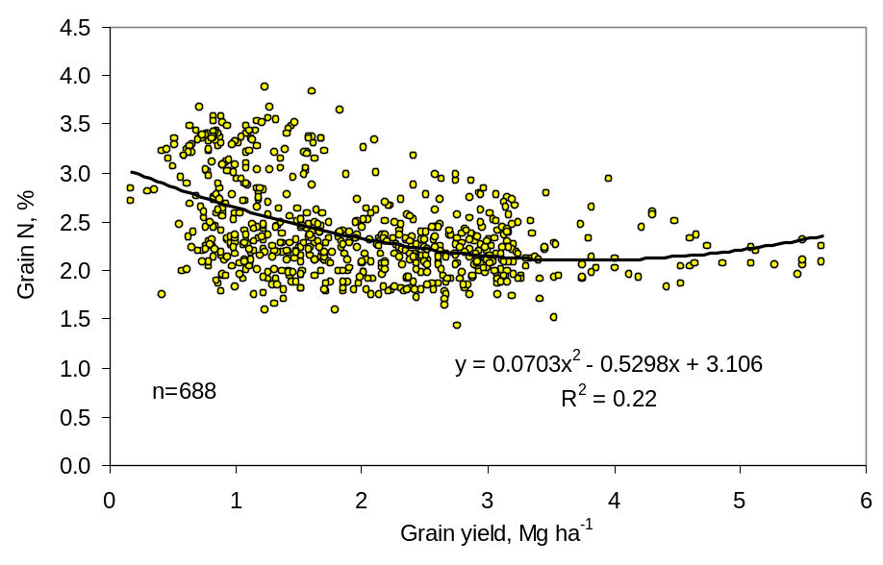

FIGURE 5. Relationship between total N in wheat grain (%) and grain yield, from multiple experiments conducted from 1980 to 2000.

Use of INSEY for Topdress Nitrogen
Applications in Winter Wheat

E.V. Lukina, G.V. Johnson, J.B. Solie, M.L. Stone,
W.E. Thomason, K.W. Freeman, K.J. Wynn, R.W. Mullen, and W.R. Raun

ABSTRACT
Efficiency of site-specific fertilizer management is largely determined by how well small-scale variability is managed and the time fertilizers are applied. In-season knowledge of yield potential might be the key to successful variable rate fertilizer applications particularly for topdress N in the spring. On-the-go sensing provides a means of applying topdress N on a fine scale. The objectives of this experiment were 1) to determine if topdress N fertilization rates can be adjusted using in-season estimates of wheat grain yield potential, 2) to compare adjusted N fertilizer rates based on the estimated-yield (EY) and/or in-season-estimated-yield (INSEY) indices with fixed N rates applied in February, and 3) to evaluate nitrogen use efficiency (NUE) associated with topdress N application using the INSEY index and fixed topdress N rates. Nine winter wheat experiments were established in the fall of 1999 to evaluate the use of EY and INSEY as a key input in deciding how much in-season fertilizer should be applied to each 1m² area. All experiments used a randomized complete block design where different rates of fixed pre-plant N, and fixed or variable topdress applications ranged from 0 to 90 kg N ha⁻¹. Each treatment was replicated 4 times. The size of each plot was 6×4 m. Spectral measurements were collected from specific plots (treatments 6, 7, and 8) where N was applied at variable rates. Spectral reflectance was measured in red (671 ± 6 nm) and near infrared ((NIR) 780 ± 6 nm) bandwidths. Reflectance readings from all experiments were collected at two post-dormancy dates. The two dates (T1 and T2, respectively) where readings were collected generally corresponded to Feekes growth stages 4 and 5. The prescribed N rate for each square meter was determined by subtracting predicted forage N uptake from predicted grain N uptake, and then dividing by an efficiency factor of 0.7. Nitrogen use efficiency was calculated using the difference method between N uptake of fertilized and unfertilized plots. We expect to show the difference in the efficiency of variable N rates based on EY and/or INSEY compared to the fixed N rates applied in spring. The difference in the efficiency of variable rates of N based on EY and/or INSEY versus fixed N rates applied in spring will also be discussed.

INTRODUCTION
Efficient use of agricultural inputs is still problematic in food production. One of the most important and commonly applied fertilizers is nitrogen (N) since it is a building block of proteins. Raun and Johnson, (1999), reported that efficiency of N utilization by cereals is about one-third of the total amount applied with fertilizers, which in turn highlights the need to develop methods for increasing N fertilizer use efficiency.
Nitrogen use efficiency is also complicated by cropland spatial variability that is known to exist at resolutions smaller than 1 m² (Solie et al., 1996). Variable fertilizer treatment of crops, where each minimal field element is treated separately can be an effective alternative to the existing uniform fertilizer application practices. Usually, fertilizer rates are defined by a specified yield goal, taking into account available soil N (Raun et al., 2000). Nitrogen fertilizer requirements depend on the potential N uptake by the crop and that is related to overall yield potential. Potential yield is the yield that can be produced on specific soil under specific weather conditions that change annually (Raun et al., 2000).
In-season knowledge of potential yield might be the key to successful variable rate fertilizer applications particularly for topdress N in the spring. Raun et al. (2000) demonstrated that the in-season estimated yield (EY) index was a good predictor of grain yield over a wide range of environmental conditions. They further noted that EY could be used to refine in-season fertilizer N based on predicted potential yield.
Site-specific fertilizer management is largely determined by how well small-scale variability is managed and the time fertilizers are applied. On-the-go sensing provides a means for applying topdress N on a fine scale. We hope that treating the existing spatial variability combined with predicting potential yield will improve efficiency of N fertilizers.
Efficient use of fertilizers applied under agricultural crops is dictated by economical and environmental concerns. Often producers apply excessive N for the sake of higher yields, which leads to environmental problems. Schepers et al. (1991) reported that in 1988 in 14% of the studied corn production area, excess N was applied by more than 100 kg N ha⁻¹ when compared to recommended rates. This amount accounted for 42% of the average excess N application rate of 48 kg ha⁻¹ by producers. Moreover, groundwater contamination with NO₃⁻-N was positively correlated with residual N in the soil surface. Wuest and Cassman (1992) confirmed that pre-plant N application at rates higher than that required for maximum yield did not result in an increase in grain N concentration. In their experiment the highest preplant fertilizer rate was 240 kg N ha⁻¹, which was twice as high as that needed and that resulted in an increase in grain N concentration. They suggested that excess N was lost by conversion to gaseous forms, immobilization or leaching. Application of recommended and not excessive amounts of N is not enough to avoid financial losses and environmental problems, and timing of application is very important in terms of efficiency of fertilizer use. Olson and Swallow (1984) demonstrated that spring application of fertilizer resulted in greater N uptake than fall application during the first 4 years of the experiment. They explained the higher efficiency of spring application by immediate uptake of applied N, breaking dormancy, and rapidly growing plants that left less chance for N loss by immobilization, often probable with fall applications. However, Olson and Swallow (1984) showed that if the spring application was made too late, utilization of N was lower than that of fall application.
Comparing pre-plant N application with treatment at anthesis, Wuest and Cassman (1992) indicated that N recovery in spring wheat production ranged from 30 to 55% and from 55 to 80%, respectively. Accordingly, grain N uptake was increased with N application at anthesis resulting in higher yields due to greater kernel weight. A 4-year experiment conducted by Boman et al. (1995) demonstrated that, spring applied N (made in February and March) resulted in the highest grain yield, grain N concentration, and grain N uptake in winter wheat.

OBJECTIVES
The objectives of this experiment were 1) to determine if topdress N fertilization rates can be adjusted using in-season estimates of wheat grain yield potential, 2) to compare adjusted N fertilizer rates based on the estimated-yield (EY) and/or in-season-estimated-yield (INSEY) indices with fixed N rates applied in February, and 3) to evaluate nitrogen use efficiency (NUE) associated with topdress N application using the INSEY index and fixed topdress N rates.

MATERIALS AND METODS
Nine winter wheat experiments were established in the fall of 1999 to evaluate the use of EY and INSEY (Raun et al., 2000) as a key input in deciding how much in-season fertilizer should be applied to each 1m² area. All experiments used a randomized complete block design. Different rates of fixed pre-plant N, fixed, and variable topdress applications ranged from 0 to 90 kg N ha⁻¹ (Table 1). Each treatment was replicated 4 times. The size of each plot was 6×4 m. Spectral measurements were collected from specific plots (treatments 6, 7, and 8) where N was applied at variable rates to each 1m². Field plot activities for each experiment where N was applied based on EY are reported in Table 2.
The relationship between EY and potential yield (Raun et al., 2000) was demonstrated using spectral reflectance. For each of the two dates sensed at each site (T1 and T2, Table 2), spectral reflectance was measured using a hand-held sensor that had two pairs of interference filters for red (671 ± 6 nm) and near infrared ((NIR) 780 ± 6 nm) bandwidths (Stone et al., 1996). Reflectance readings from all experiments were collected at two post-dormancy dates. The two dates (T1 and T2, respectively) where readings were collected generally corresponded to Feekes growth stage 4 (leaf sheaths beginning to lengthen) and Feekes 5 (pseudo-stem, formed by sheaths of leaves strongly erect) (Large, 1954). Due to differences in planting times and growing conditions, spectral reflectance readings were collected between January and March (Table 2). All reflectance readings from wheat were taken from a total surface area of 1.0 m² within the hours of 10 a.m. and 4 p.m. under natural lighting.
Reflectance values (the ratio of incident and reflected values) were used in the normalized difference vegetative index (NDVI) calculation (equation 1).
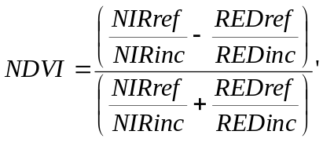
(1)

where ref and inc stand for reflected light and incident light readings.
The EY value, calculated using equation 2, was expected to reflect a point on the potential growth curve for the season, thus providing an estimate of potential yield based on local growing conditions between planting and the dates of sensing.
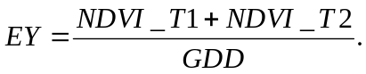
(2)

The use of GDD (equation 3) in the computation of EY allowed us to integrate early-season growing conditions and growth rate.

(3)
This approach is consistent with work showing the relationship between above ground dry weight and cumulative growing degree days (Rickman et al., 1996). Dividing the sum of NDVI at Time-1 and Time-2 by GDD results in a unit of predicted biomass (using NDVI) per growing degree day.

The INSEY index was calculated as follows (equation 4):

(4) 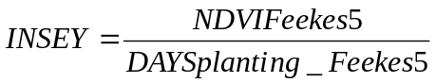,

where NDVI at Feekes growth stage 5 was divided by number of days from planting till the sensing date. Using only one set of sensor readings reduces the costs of implementing this technology without loosing accuracy of grain yield prediction.
The N rate for each square meter in treatments 6, 7, and 8 (Table 1) was calculated using the N Fertilization Optimization Algorithm (NFOA), which is the difference between predicted grain N uptake (PGNU) and predicted forage N uptake (PFNU), divided by an efficiency factor of 0.4. Nitrogen use efficiency was calculated using the difference method.
Grain yield was determined using a self-propelled combine from the same area where spectral reflectance data was collected. We assumed that growth from planting in October to the mid winter months of January and February would provide an excellent indicator of wheat health in each 1.0 m² area and thus the early-season growth-limiting conditions for small areas. Minimum and maximum temperatures and rainfall data were collected within 1.7 km of the actual experiment at all locations.

RESULTS
In general, grain yield response to applied N was limited at all nine sites. This is evidenced in the response index (RI), which is determined by dividing the highest yield of N fertilized plots by the yield of unfertilized control plots. When the RI is greater than 1.5 it is likely that the benefits of variable rate fertilizer application will be greater. When a fixed rate response to applied N is present, we believe that it is likely to obtain increased benefits from variably applied N due to increased expression of small-scale spatial variability.
At the Lahoma-S experiment, grain yields were significantly higher when N was fertilized based on INSEY (each 1m² area receiving a prescribed rate) compared to the fixed N rates (Table 3). At this site, yields were 154 kg ha⁻¹ greater using an average 57 kg N ha⁻¹ rate compared to the flat rate of 90 kg N ha⁻¹ (Tables 3 and 4). Similar results were also noted at Perry where grain yields were 2542 kg ha⁻¹ using an average N rate of 38.3 kg ha⁻¹ based on INSEY compared to 2248 kg ha⁻¹ using a flat 45 kg N ha⁻¹ fertilizer rate. This translated into a yield increase of 294 kg ha⁻¹ using 6.7 less kg N ha⁻¹. At the Lahoma-E site, 2452 kg grain ha⁻¹ was produced using an average N rate based on INSEY of 53.9 kg ha⁻¹ compared to 2284 using a fixed flat rate of 45 kg N ha⁻¹. Averaged over all sites, treatment 6 (topdress N rate based on INSEY) resulted in 2447 kg grain ha⁻¹ using an average of 46 kg N ha⁻¹ compared to 2358 kg grain ha⁻¹ using a fixed flat rate of 45 kg N ha⁻¹. A significant response to applied N was observed when looking at the average yields over all locations, however, no significant differences were noted between the INSEY treatments and the fixed N rates at comparable rates. The lack of any differences over all locations when comparing treatment 6 to the flat rates was likely due to the limited response to applied N and the low RI (Table 3, 1.22).
In addition, the equation used to predict wheat grain yield using sensor readings was that developed from 6 of 9 locations over from 1998 to 1999. Recent work by Lukina et al. (2001) has shown that the use of a different index (NDVI at Feekes 5 divided by the days from planting to sensing) is more reliable for predicting wheat grain yield. In addition, the new index is better correlated with observed grain yield over a wide range of environments. The error in predicting grain yield due to the flawed index employed may well have contributed to topdress fertilizer N rate errors (specific for each 1m²) and thus the limited treatment differences.

REFERENCES
Boman, R.K., R.L. Westerman, W.R. Raun, and M.E. Jojola. 1995. Time of nitrogen application: effects on winter wheat and residual soil nitrate. Soil Sci. Soc. Am. J. 59:1364-1369.

Large, E.C. 1954. Growth stages in cereals. Plant Pathol. 3:128-129.

Lukina, E.V., K.W. Freeman, K.J. Wynn, W.E. Thomason, R.W. Mullen, G.V. Johnson, R.L. Elliott, M.L. Stone, J.B. Solie, and W.R. Raun. 2001. Nitrogen fertilization optimization algorithm based on in-season estimates of yield and plant nitrogen uptake. J. Plant Nutr.

Olson, R.V. and c.W. Swallow. 1984. Fate of labeled nitrogen fertilizer applied to winter wheat for five year. Soil Sci. Soc. Am. J. 48:583-586.

Raun, W. R., and G. V. Johnson. 1999. Improving nitrogen use efficiency for cereal production. Agron J. 91:357-363.

Raun, W.R., G.V. Johnson, M.L. Stone, J.B. Solie, E.V. Lukina, and W.E. Thomason. 2001. In-season prediction of yield potential in winter wheat. (accepted Agron. J.).

Rickman, W.R., S.E. Waldman and B. Klepper. 1996. MODWht3: A development-driven wheat growth simulation. Agron. J. 88:176-185.

Schepers, J.S., M.G. Moravek, E.E. Alberts, and K.D. Frank. 1991. Maize production impacts on groundwater Quality. J. Environ. Qual. 20:12-16.

Solie, J.B., W.R. Raun, R.W. Whitney, M.L. Stone, J.D. Ringer. 1996. Optical sensor based field element size and sensing strategy for nitrogen application. Trans. ASAE 39(6):1983-1992.

Stone, M.L., J.B. Solie, W.R. Raun, R.W. Whitney, S.L. Taylor, and J.D. Ringer. 1996. Use of spectral radiance for correcting in-season fertilizer nitrogen deficiencies in winter wheat. Trans. ASAE. 39(5):1623-1631.

Wuest, S.B. and K.G. Cassman. 1992. Fertilizer-nitrogen use efficiency of irrigated wheat: I. Uptake efficiency of preplant versus late-season application. Agron. J. 84:682-688.
TABLE 1. Treatment structure of On Farm-INSEY-Trials.
_____________________________________________________________
No. ID Pre-plant N Topdress N Yield Potential Fertilizer
lb/ac lb/ac Index Resolution
1. Check 0 0 N -
2. TD-40 0 40 N 24m²
3. TD-80 0 80 N 24m²
4. PP-TD-40 40 40 N 24m²
5. PP-80 80 0 N 24m²
6. YP 0 YP Y 1m²
7. YP-1/2 0 YP - 1/2 Y 1m²
8. YP-PP 40 YP Y 1m²
___________________
YP - topdress N rates determined employing estimated yield potential using INSEY (in-season-estimated-yield)

TABLE 2. Field plot activities for experiments where N was applied based on in-season-estimated-yield (INSEY) at 9 locations, 1999-2000.

Plot Activity Covington Drummond Lahoma-E Lahoma-S Orlando Perkins Perry Medford

planting date 10/13/00 11/4/99 10/26/99 10-28-99 10-30-99 10/7/99 10/29/99 11/9/99
variety
seeding rate, kg ha⁻¹ 67 76 84 76 76 76 76 76
date not used 1/6/00 1/11/00 1/13/00 2/15/00 1/6/00 3/7/00 2/21/00
T1 sensor date 2/21/00 2/15/00 2/15/00 3/13/00 2/21/00 12/21/99 2/21/00 3/28/00
T2 sensor date 3/6/00 3/13/00 3/13/00 3/28/00 3/6/00 2/8/00 3/6/00 4/6/00
GDD, T1 to T2 129.4 167.8 167.8 120.9 127.0 197.8 127.5 89.1
preplant fertilization date 9/3/99 11/4/99 10/26/99 10/26/99 9/3/99 10/7/99 9/3/99 9/27/99
topdress fertilization date 3/13/00 3/21/00 3/21/00 3/31/00 3/15/00 3/14/00 3/15/00 4/6/00
harvest date 7/5/00 6/8/00 6/8/00 6/8/00 6/06/00 6/06/00 5/29/00 6/23/00

soil pH 6.1 5.3 5.4 7.6 5.1 5.9 5.1 5.7
organic C, g kg⁻¹ 9.91 8.31 7.79 7.96 9.67 7.00 7.51 9.40
total N, g kg⁻¹ 1.05 0.89 0.84 0.71 0.95 0.67 0.81 0.99
P, mg kg⁻¹ 19 32 26 8 38 8 71 7
K, mg kg⁻¹ 181 337 346 373 198 193 194 336
NH₄-N, mg kg⁻¹ 6.1 5.0 4.3 8.6 5.4 2.6 25.5 7.9
NO₃-N, mg kg⁻¹ 1.4 7.4 4.6 2.5 12.4 2.7 2.4 1.9
Preplant P fertilizer applied, kg P, ha⁻¹ 8 0 8 16 0 16 0 16

pH - 1:1 soil:water
P, K - Mehlich III
organic C, total N - dry combustion
NH₄-N and NO₃-N -2M KCl extract
TABLE 3. Wheat grain yield response to applied N at fixed rates and rates based on in-season-estimated-yield (INSEY) at 9 locations, 1999-2000.

Trt N rate Covington Drummond Lahoma-E Lahoma-S Orlando Perkins Perry Medford MEAN
kg ha⁻¹ Method kg ha⁻¹
1 0 check 1657 2369 1937 2259 2972 2198 2174 625 2023
2 45 topdress 2500 2799 2284 2818 2935 2567 2248 716 2358
3 90 topdress 2861 2655 2203 2862 2936 2810 2386 899 2451
4 90 45 preplant, 45 topdress 2564 3026 2367 2946 2937 2585 2434 908 2470
5 90 preplant 2702 2985 1913 2928 2981 2403 2028 1043 2372
6 (46†) topdress-INSEY 2422 2843 2452 3016 2859 2590 2542 854 2447
7 (23†) topdress ½ INSEY 2175 2661 1619 2496 3040 2251 2377 776 2174
8 45+(42†) 45 preplant, ( ) topdress 2718 2821 2202 2783 3007 2556 2575 825 2435

Response Index (RI) 1.73 1.28 1.26 1.33 1.02 1.28 1.18 1.67 1.22

SED 369 264 251 97 171 253 294 79
SED-standard error of the difference between two equally replicated means. RI computed by dividing the highest yield of N fertilized plots by the yield of unfertilized control plots. †-average N rate applied over all locations and years
TABLE 4. Average, minimum and maximum topdress N rates applied for three treatments employing in-season-estimated-yield (INSEY) at 9 locations, 1999-2000.

Location 6, topdress -INSEY 7, topdress, ½ INSEY 8, 45 kg N ha⁻¹ + topdress-INSEY
Average Minimum Maximum Average Minimum Maximum Average Minimum Maximum
---------------------------------------------------------------------- kg ha⁻¹ --------------------------------------------------------------------
Covington 84.1 0.0 115.6 44.5 22.7 67.9 74.2 32.4 121.6
Drummond 20.8 0.0 71.8 10.8 0.0 38.7 15.5 0.0 67.6
Lahoma-E 53.9 0.1 75.4 27.8 0 42.2 43.2 0 76.3
Lahoma-S 57.0 27.2 81.1 31.0 10.7 38.6 41.6 15.9 71.4
Orlando 24.5 6.9 42.4 13.1 0.0 22.6 27.4 10.1 40.5
Perkins 61.4 38.0 91.3 31.8 19.4 46.2 64.4 42.0 83.0
Perry 38.3 17.4 45.2 20.0 15.0 22.7 39.1 19.4 43.5
Medford 54.0 40.5 92.8 25.9 18.4 30.7 56.2 41.7 86.5
Average 46.0 23.9 41.9

Estimating Vegetation Coverage in Wheat Using Digital Images

E. V. Lukina, M. L. Stone, and W. R. Raun

ABSTRACT
No method exists to reliably predict percent vegetation coverage using indirect measures. This study was conducted to evaluate the use of digital image processing techniques applied to digital color, red-green-blue (RGB), images of crop canopies to estimate percent vegetation coverage and biomass. Two field experiments with winter wheat (Triticum aestivum L.) “Tonkawa” were planted in October, 1996 and 1997 at Perkins, OK on a Teller sandy loam (Udic Argiustoll) and at Tipton, OK on a Tipton silt loam (Pachic Argiustoll). Plot images from winter wheat canopies were taken using a Kodak DC40 Digital Camera (1995)² with an image resolution of 756 x 504 pixels. Spectral irradiance readings were taken from wheat canopies in red (671 ± 6 nm) and near infrared (780 ± 6 nm) wavelengths, and the normalized difference vegetation index (NDVI) was calculated. Percent vegetation coverage was estimated using image-processing routines in Micrografx Picture Publisher® version 7.0. The digital images were converted from 8-bit RGB tagged image file format (TIFF) files, which were produced by processing the images from the camera with Photo Enhancer®, to binary pseudo-color images. Percent of pixels corresponding to the vegetation color was then calculated and used as the percent coverage for each plot. Binary pseudo-color images provided useful estimates of percent vegetation coverage that were highly correlated with wheat canopy NDVI measurements.

INTRODUCTION
Conventional methods of fertilizer application employ soil testing to determine appropriate rates. Soil testing is a good estimator of soil nutrient availability for immobile nutrients, phosphorus (P) and potassium (K). Raun et al. (1998) highlighted that in-season nitrogen (N) deficiencies can now be detected and treated using sensor-based methods. However, past soil testing for in–season treatment has been cumbersome largely because of the time lag required between testing and final fertilizer application. In the last 20 years, newer non-destructive methods of measuring mobile and immobile nutrient availability have been developed.
The normalized difference vegetation index (NDVI) has recently proven to be a reliable estimator of N deficiency in winter wheat (Stone et al., 1996). On-the-go NDVI measurements can be used for detecting N deficiency and for making in-season topdress N applications. Stone et al. (1997) found that this method could significantly increase nitrogen fertilizer use efficiency.
Individual plants, their shadows, and soil background contribute to spectral measurements made in vegetation canopies. In early experiments with visible and infrared reflectance from wheat canopies, Stanhill et al. (1972) suggested that the difference in crop absorbtivity could be accounted for by the differences in biomass and degree of ground cover. Wanjura and Hatfield (1987) pointed out that vegetation indices were affected more by ground cover than by other variables such as fresh and dry biomass or leaf area index. They estimated ground cover by measuring canopy shadow width in different crops. Considering ground cover as an important variable, Huete et al. (1985) measured percent green canopy cover by projecting a 35 mm slide onto a dot grid and counting the dots of light and shaded surface. Later, using the same technique of ground cover estimation, Heilman and Kress (1987) concluded that soil background reflectance had the greatest influence for 50 to 75% ground cover on soils with high reflectance. Low vegetation coverage did not affect soil irradiance significantly whereas soil reflectance was insignificant at high vegetation coverage. Vegetation density and amount of soil included in the sensor view can also affect spectral measurements. In order to evaluate the impact of vegetation coverage on sensor readings Lukina et al. (1997) evaluated percent vegetation coverage at different growth stages and row spacings. Their work demonstrated a high correlation (0.8-0.97) between percent vegetation coverage and NDVI measurements.
The objective of this study was; to evaluate the use of digital image processing techniques applied to digital color, RGB, images of crop canopies to estimate percent coverage and biomass.

MATERIALS AND METHODS
Winter wheat (Triticum aestivum L.) was planted in October, 1996 and 1997 at Perkins, OK on a Teller sandy loam (fine-loamy, mixed, thermic Udic Argiustoll) and at Tipton, OK on a Tipton silt loam (fine-loamy, mixed, thermic, Pachic Argiustoll). Four N rates, 0, 56, 112, 168 kg ha⁻¹ as ammonium nitrate were broadcast and incorporated preplant. Seeding rates were 99, 80, 59 and 49 kg ha⁻¹, at row spacings of 15.2, 19.0, 25.4 and 30.5 cm, respectively. Each plot was 2.6 m x 6.1 m. Canopy irradiance measurements were taken from wheat in-situ using red (671 ± 6 nm) and near-infrared (780 ± 6 nm) wavelengths at Feekes growth stages 4 and 5 (Large, 1954). Plot images were taken using a Kodak DC40 Digital Camera (Kodak, 1995) with a resolution of 756 x 504 pixels at both locations (Tipton and Perkins), and at the same time and places as spectral irradiance measurements.
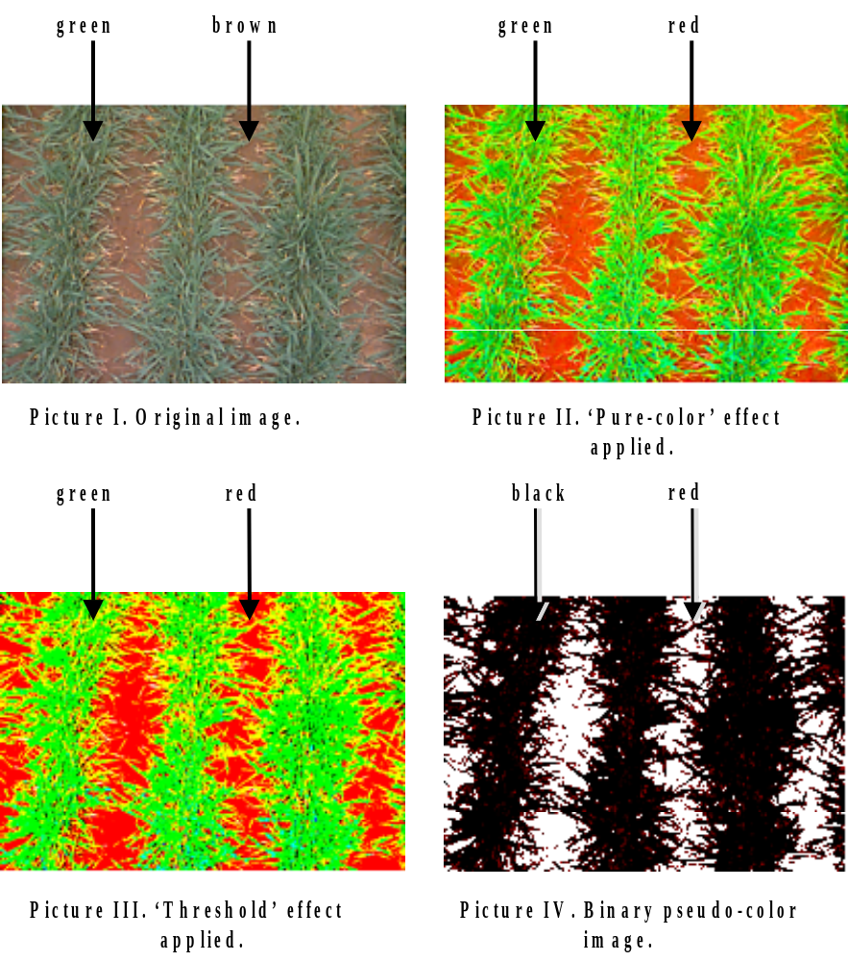
FIGURE 1. Image processing procedure, steps I - IV

Percent vegetation coverage was estimated using image-processing routines in Micrografx Picture Publisher® version 7.0 (Micrografx, 1997). The digital images were converted from 8-bit RGB TIFF files, which were produced by processing the images from the camera with Photo Enhancer® (Kodak, 1995), to binary pseudo-color images. Percent of pixels corresponding to the vegetation color was then calculated and used as the percent of coverage for each plot as illustrated in Figure 1. Table 1 summarizes the procedure used for processing the images.
It should be noted that some adjustments of contrast and color balance are required for images taken under different light and soil reflectance conditions. The color of the Udic Argiustoll soil (dark brown 10YR 4/3) at Perkins was lighter than that of the Pachic Argiustoll (very dark grayish brown 10YR 3/2) at Tipton. The Perkins images, taken at Feekes growth stage 5 in 1997, were adjusted for contrast and color balance to improve color separation. Before applying the procedure in Table 1, the contrast (Map\ColorBalance ->Joystick\Contrast) was increased (by 5%) and the balance (Map\ColorBalance ->Joystick\ Balance) of the red channel was shifted towards red (by -10%). Color saturation was then adjusted to maximum (pure): steps I, II.a - II.c in Table 1. The images were then color thresholded in red, green, and blue at a 24% level in the same way as described in steps II.d – II.f in Table 1. A ‘chroma mask’ was then generated for the combination of red and black portions of the image, and filled with red color, which corresponded to soil. The mask was then inverted and filled with a black color and processed as described in steps III.g through IV.b in Table 1.
Extremely bright images, taken on a very bright sunny day at Tipton, Feekes growth stage 4, 1998, were treated differently. Soil color at this location was darker than that of Perkins. First images were ‘smoothed’ (Image\Effects\Photographic\Smooth) by 2 units. Then all steps were executed as described in the Table 1 with the only difference in step II.b, where the ‘chroma mask’ was applied not only to red, but also to white and purple colors.

TABLE 1. Method to convert digital images of wheat in vegetative stages to percent vegetation cover.

Step | Description | Commands | Effect
I | Open the original image |  | Figure 1, picture 1
II.a | In the Image Menu chose Effects option | <Image\Effects> | Dialog box is displayed
II.b | In the Image\Effects directory choose Color Saturation option under Color Adjust submenu | <Image\Effects\  Color Adjust\  Color Saturation>
II.c | In the Color Saturation  box (on the right) set the pointer to pure (color),  then click Apply button |  | Original Image in Original box will be changed, saturated with pure colors  Figure1, picture 2
II.d | In the Image Effects directory choose  Threshold option under Color Adjust submenu | <Image\Effects\  Color Adjust\  Threshold>
II.e | In the Threshold box, set Breakpoint at 50% in all channels (RGB). Click Apply button |  | The image in the Original box will change, R,G and B values greater than 50% are converted to 100%, those less than 50% are converted to 0%
II.f | Click OK button |  | The original image will change as shown in the  Figure1, picture 3
III.a | In The Mask menu choose Chroma Mask option | <Mask\  Chroma Mask>
III.b | Select one Color Select button in the dialog box.  Point a drop stick cursor  on the red part of the  image (representing soil)  and click the left button of  the mouse.  Click OK button of the dialog box |  | Chroma mask appears on the image, soil related compartments of the image are selected
III.c | In the Mask menu choose  the Invert Mask option | <Mask\Invert Mask> | Plant related pixels in the image are selected.
III.d | In the View menu choose Color Palette,or open a Color Palette icon, and choose black color (last chosen color is the active one) | <View\Color Palette>
III.e | On the toolbar panel, click  on the Fill Tools button and choose the Fill the Selected Object with the Active Color option
III.f | Fill the mask by clicking  the left button of the mouse somewhere on the plant related part of the image |  | Plant related image pixels are colored black
III.g | From the Mask menu  choose Remove Mask  option | <Mask\  Remove Mask> | Figure 1, picture 4
IV.a | In the Map menu choose  the Histogram option | <Map\Histogram> | A histogram of each band (R, G, and B) is computed
IV.b | In the Channel box select  the Master channel (Red channel could be used also, but it appeared that Red and Blue channels are switched in ‘Micrografx.7’) |  | Soil and plant related pixels are counted. Shadow indicates the percentage of black pixels of the image, which correspond to vegetation and Midtones show the percentage of red pixels, representing soil

‘Smoothing’ can assist with separating bright spots of leaves with that of soil. However, this procedure can mis-classify some soil-related pixels as plant pixels.
It was noticed that images taken on a cloudy day were converted with better precision; largely due to the absence of glare. Thus, future images were either taken on a cloudy day or under a shadow, created by black poster boards (81x102cm). Images taken under the shadow were processed with slight differences. For images obtained at Tipton, at Feekes growth stage 5, 1998, the contrast was increased (by 5%) and the balance of the red channel was shifted towards red (by 5%). The ‘chroma mask’ was generated for red and purple colors (Table 1, step II.b) and then filled with red. The rest of the procedure was unchanged.
Images taken at Perkins, Feekes growth stages 4 and 5, 1998 were adjusted in contrast and balance (by 5 and -5 %, respectively). Colors were thresholded in red, blue, and green at the 25% level (Table 1, step II.d – II.f). The ‘chroma mask” was applied to red and purple colors (Table 1, step II.b). The difference in color adjustment and balance was determined by soil type, specifically color. To expedite the image processing procedure a macro was written for every set of images with the same soil type and brightness.

RESULTS AND DISCUSSION
Binary pseudo-color images obtained using ‘Micrografx Picture Publisher® 7’ software provided useful estimates of percent vegetation coverage that were highly correlated with NDVI. The Pearson correlation coefficient (r) between NDVI and percent vegetation coverage exceeded 0.80 for Feekes growth stages 4 and 5 at both locations (Figure 2).

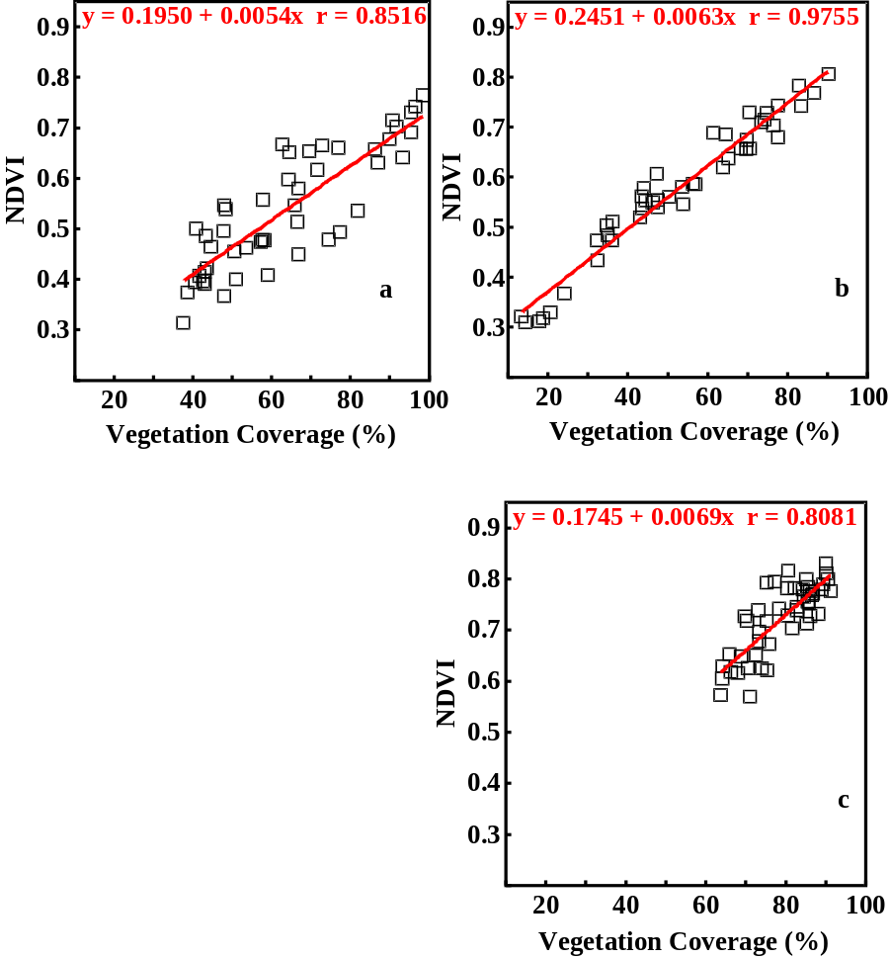
FIGURE 2. Correlation between NDVI measurements and percent vegetation coverage of winter wheat canopies at Perkins, at Feekes 4(a), Feekes 5 (b), and Tipton, at Feekes 5 (c) in 1997.
At Perkins, wheat canopies ranged between 52-68 and 40-62% vegetation coverage (averaged over N rate) at Feekes growth stages 4 and 5, respectively. At Tipton, vegetation coverage ranged between 72-89 and 69-86% at Feekes growth stages 4 and 5, respectively. A decrease in percent vegetation coverage from Feekes growth stage 4 to 5 was due to severe frost damage.

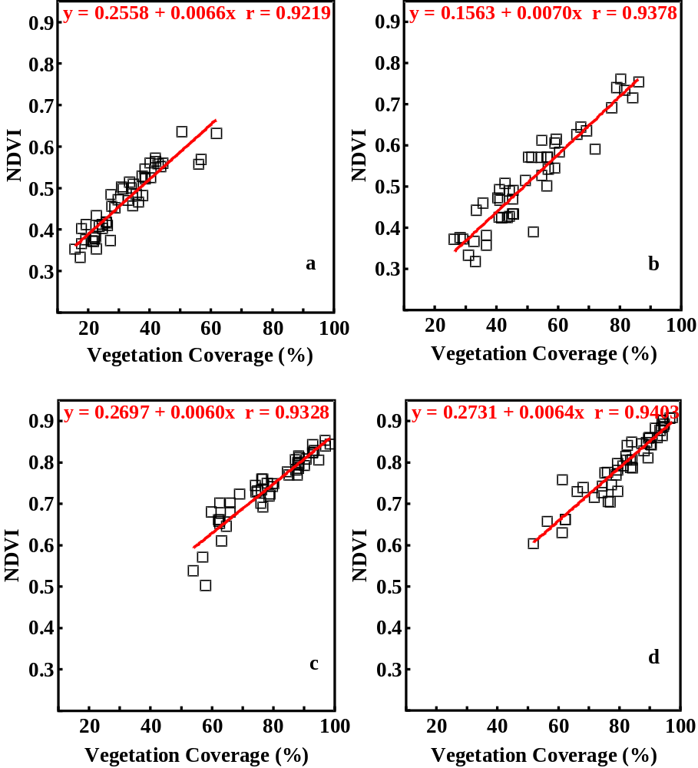
FIGURE 3. Correlation between NDVI measurements and percent vegetation coverage of winter wheat canopies at Perkins, at Feekes 4 (a), Feekes 5 (b), and Tipton, at Feekes 4 (c), and Feekes 5 (d) in 1998.

In the second year of the experiment, the range of vegetation coverage was 66-90% and 67-93% at Tipton, at Feekes growth stages 4 and 5, respectively, and 26-34% and 41-57% at Perkins, Feekes growth stage 4 and 5, respectively. The Pearson correlation coefficient between percent vegetation coverage and NDVI was higher than 0.92 at both locations and growth stages (Figure 3). The Pearson correlation coefficients between NDVI and biomass ranged from 0.35 to 0.80, and correlation coefficients between NDVI and nitrogen concentration in dry biomass ranged from 0.12 to 0.45 for data obtained in 1997. Higher r – values were observed between NDVI and total N uptake, ranging between 0.47 and 0.83. Stone et al. (1996a) reported that NDVI measurements depend on two factors, nitrogen concentration and biomass. Assuming that a change in N concentration or biomass affects NDVI, total nitrogen uptake should be a better predictor of NDVI since it takes into account variations in both (N concentration and biomass) factors. This is also consistent with results illustrated in Figure 4 where correlation was improved between NDVI and total N uptake as compared to NDVI versus N concentration and/or biomass alone. The Pearson correlation coefficients between percent vegetation coverage and biomass ranged from 0.33 to 0.81. As was expected, high r-values were observed between percent vegetation coverage and total nitrogen uptake, which ranged from 0.42 to 0.82.

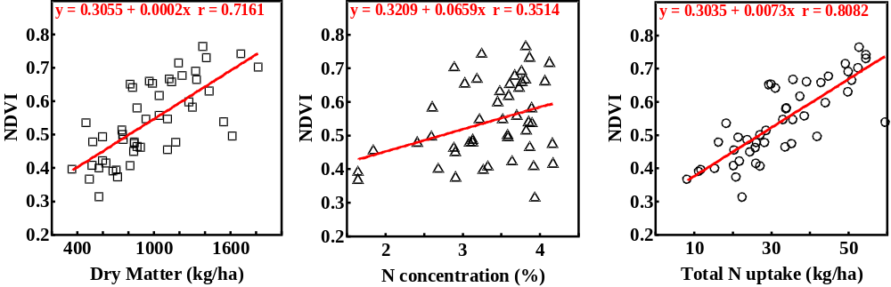
FIGURE 4. Correlation between NDVI and dry matter, N concentration, and total N uptake at Perkins, at Feekes 4, 1997

CONCLUSIONS
Digital image processing techniques provided good prediction of percent vegetation coverage. In addition, high correlation was observed between percent vegetation coverage and NDVI. The method delineated here could help determine critical percent vegetation coverage needed for precise calibration of spectral indices for topdress N application.
This method was affected by high light reflectance and thus required the use of shadowing. This was especially true on light colored soils, thus requiring location specific contrast and balance adjustment. A single procedure could not be found that would handle the range of soil color and brightness found in the images used in the study. Images from Perkins and Tipton locations had to be adjusted differently for the brightness and color due to differences in soil type. Similar methodology may be useful to separate dead vegetation from fresh plant tissue.

ACKNOWLEDGEMENTS
Appreciation is extended to Oklahoma Soil Fertility team for technical assistance of J. Dennis, S. Phillips, W. Thomason, J. LaRuffa, C. Woolfolk, H. Lees, H. Sembiring, S. Taylor, S. Norton, D. Drury, K. Wynn, C. Lively, D. Cossey, T. Johnston, J. Tallman.

REFERENCES

Heilman, J.L., and M.R. Kress. 1987. Effect of vegetation on spectral irradiance at the soil surface. Agron. J. 79:765-768.

Huete, A.R., R.D. Jackson, D.F. Post. 1985. Spectral response of a plant canopy with different soil backgrounds. Remote Sens. Environ. 17:37-53.

Kodak. 1995. Digital Camera 40. Eastman Kodak Company. New York, NY.

Large, E.C. 1954. Growth stages in cereals. Plant Pathol. 3:128-129.

Lukina, E.V., W.R. Raun, M.L. Stone, J.B. Solie, G.V. Johnson, H.L. Lees, J.M.LaRuffa, and S.B. Phillips. 1997. Effect of row spacing, N rate and growth stage on spectral radiance in winter wheat. OSU Soil Fertility Research Highlights. Oklahoma State University, Department of Plant and Soil Sciences. p. 251-258.

Micrografx. 1997. Picture Publisher® 7.0. Micrografx, Inc., Richardson, TX.

Raun, W.R., G.V. Johnson, H. Sembiring, E.V. Lukina, J.M. LaRuffa, W.E. Thomason, S.B. Phillips, J.B. Solie, M.L. Stone and R.W. Whitney. 1998. Indirect measures of plant nutrients (in press, Commun. Soil Sci. and Plant Anal.).

Stanhill, G., U. Kafkafi, M. Fuchs, and Y. Kagan. 1972. The effect of fertilizer application on solar reflectance from a wheat crop. Israel J. agric. Res. 22(2):109-118.

Stone, M.L., W.R. Raun, G.V. Johnson, J.B. Solie, R.W. Whitney, and H. Sembiring, J.M. LaRuffa, and E.V. Lukina. 1997. Sensing nitrogen deficiencies in winter wheat and bermudagrass. Better Crops. 81(4):15-16.

Stone, M.L., J.B. Solie, W.R. Raun, R.W. Whitney, S.L. Taylor, and J.D. Ringer. 1996. Use of spectral radiance for correcting in-season fertilizer nitrogen deficiencies in winter wheat. Trans. ASAE. 39(5):1623-1631.

Stone, M.L., J.B. Solie, R.W. Whitney, W.R. Raun, and H.L. Lees. 1996. Sensor for detection of nitrogen in winter wheat. SAE Paper 961757. Presented at the 1994 SAE Symposium on Off-Highway Equipment. August 1996, Indianapolis, IN. SAE, Warrendale, PA.

Wanjura, D.F. and J.L. Hatfield. 1987. Sensitivity of spectral vegetative indices to crop biomass. Transactions of the ASAE. 30(3):811-816.

Effect of Row Spacing, Growth Stage, and Nitrogen Rate on Spectral Irradiance in Winter Wheat

E.V. Lukina, W.R. Raun, M.L. Stone, J.B. Solie, G.V. Johnson, H.L. Lees, J.M. LaRuffa, and S.B. Phillips

ABSTRACT
Soil reflectance affects spectral irradiance measurements taken in winter wheat at early stages of growth when percent cover is low. The objective of this study was to determine the critical percent vegetation coverage needed for forage nitrogen (N) uptake calibration with indirect spectral irradiance measurements. Two field experiments were conducted at Tipton and Perkins, OK in October 1996. The effect of row spacing (15.2, 19.0, 25.4 and 30.5 cm) and growth stage (Feekes 4 and 5) under various N fertilizer rates (0, 56, 112, and 168 kg N per ha) on spectral irradiance measurements from wheat was evaluated. The normalized difference vegetative index (NDVI) was used to characterize wheat canopy irradiance. NDVI decreased with increasing row spacing and increased with N fertilizer rate at Feekes growth stage 4. Row spacing and N rate were independent of each other since no significant interaction was found. High correlation (0.81 – 0.98) was observed between NDVI and vegetation coverage. Percent vegetation coverage was a good predictor of the other dependent variables including forage dry matter, and total N uptake, which could indirectly be determined using NDVI. The coefficients of variation (CV’s) from NDVI values decreased with increasing vegetation coverage suggesting that less variable NDVI values (CV less than 10 percent) might be obtained from plots where vegetation coverage exceeds 50 percent.

INTRODUCTION
Improving field management techniques can increase productivity and reduce the environmental impact of modern agriculture. A problem of efficient field management is applying fertilizers where they are needed and in sufficient, but not excessive, amounts. Scientists as well as field practitioners have observed that soil nutrient levels vary within fields. Nevertheless, fertilizers are usually applied uniformly based on one composite soil sample from each field. Sawyer (1994) highlighted the concepts of variable rate technology (VRT) and indicated that the major factors which constrain VRT on a large scale are: (i) the cost of implementation (sampling, mapping, equipment, personnel); (ii) lack of expected increase in crop yield; and (iii) lack of input savings. Also, Sawyer (1994) suggested that interpretation of data and reliable recommendations should be of major concern for further study. He stated that determination of crop yield variability with on-the-go sensors was still futuristic. However, work by Stone et al. (1996) demonstrated that it would be possible to use on-the-go sensing methods to monitor soil and yield variability.
Solie et al. (1996) showed that the optimum field element size could be less than 1m², and that variable rates should be adjusted to a resolution of 1m² in order to optimize fertilizer inputs. They defined field element size as the area which provides the most precise measure of the available nutrient where the level of that nutrient changes with distance. In other words, the area, on which a single rate of nutrient fertilizer is applied, represents the field element size. Raun et al. (1998a) observed soil test variability for immobile and mobile nutrients on a submeter level (0.3 x 0.3 m). Taking into account significance of variation in nutrient content among small areas, application of variable fertilizer rates could be highly beneficial in precision farming since variable rates increase fertilizer use efficiency, and could considerably reduce fertilizer contamination of the environment (Raun et al, 1998b).
Application of reflectance measurement devices in agriculture began in the 1970s, when near infrared spectrometers were used to measure chlorophyll content in plant leaves, and moisture content in forage and plant samples. Thomas and Oerther (1972) used a Beckman Model DK-2A spectrophotometer to determine the relationship between N content and spectral data obtained from the 500 to 2500 nm region. They predicted leaf N content in sweet peppers (Capsicum annum L. var. ‘Yolo Wonder’) from reflectance measurements at 550 nm (green) and 675 nm (red) because of the direct relationship between N and chlorophyll concentration in leaf tissue.
Blackmer et al. (1994) studied light reflectance of corn leaves from plots with different N treatments within the 400-700 nm range. They found relatively strong correlation between reflectance readings near 550 nm and grain yield. Later, Blackmer et al. (1996) studied reflected radiation from irrigated corn canopies with different N treatments at the R5 (dent) physiological growth stage. They stated that absolute scale measurements were affected by many factors, such as sensor and illumination angles, solar radiation and canopy architecture. To avoid the interference of illumination factors, the data were referenced to the radiation measurements taken from the plot with highest N application (relative reflectance was set equal to 1 for this plot). Measurements at 550 and 710 nm were the most sensitive to N treatment and highly correlated with grain yield. A reflectance ratio of 550 or 710 nm to 800-900 nm also showed high correlation with relative grain yield. In the same work, Blackmer et al. (1996) used reflected radiation expressed as a ratio of red/NIR to demonstrate differences in N status of several corn hybrids. Here, reflectance was measured from plant canopies as the ratio of [(550-600)/(800-900)]. The idea to use ratios implied that there might be an advantage of compensating for other factors such as light conditions, soil background reflectance and canopy architecture.
In early experiments with visible and infrared reflectance from wheat canopies, Stanhill et al. (1972) suggested that the difference in crop absorptivity could be accounted for by differences in amount of the biomass and degree of ground cover. Therefore, application of N fertilizer could affect spectral measurements from wheat canopies by altering the optical properties of plant material due to changes in the amount of plant biomass, the percent vegetation coverage, and the posture and structure of the plants. Spectral irradiance from plant canopies is highly dependent on the optical properties of the underlying soil and which fluctuate considerably with soil type. Heilman and Kress (1986) measured the spectral irradiance of different types of soil, a highly reflecting Padina fine sandy loam, an intermediate reflectance Norwood silt loam, and a low reflectance Houston Black sandy clay. They found that the soil background reflectance at the intermediate levels, 50 to 75 percent, of soil coverage includes a significant component of the irradiance transmitted through plant canopies. This effect was not observed at coverage densities less than 40 percent, which suggested that below this level the soil irradiance could not be significantly affected by vegetation. Huete et al. (1985) indicated that soil background influences on canopy reflectance would approach a maximum level at low vegetation densities. The effect of difference in soil brightness on spectral response was greater at higher level of vegetation coverage, 60 to 75 percent, than at the lower ones, when the NIR/red ratio was used as an indicator of greenness. The normalized difference NDVI = (IR – red)/(IR + red) and transformed normalized difference (TND) equal to (NDVI + 0.5)^{1/2} were independent of soil influence when vegetation coverage was greater than 75 percent.
The main objective was; to determine the critical percentage of vegetation coverage needed for precise forage N uptake calibration with indirect spectral irradiance measurements. Secondary objectives of this study were: to estimate the soil background interference with the spectral irradiance of wheat; to determine soil background interference relationship with soil color; to evaluate how differences in vegetation cover affect soil background interference; and to evaluate the impact of each of these variables on calibration of indirect spectral measures with wheat forage N uptake.

MATERIALS AND METHODS
Two field experiments with winter wheat (Triticum aestivum L.) “Tonkawa” were planted in the beginning of October, 1996 and 1997 at Perkins, OK on a Teller sandy loam (Udic Argiustoll) and at Tipton, OK on a Tipton silt loam (Pachic Argiustoll). Initial surface (0-15 cm) soil chemical characteristics are reported in Table 1.

TABLE 1. Initial surface (0-15 cm) soil chemical characteristics and classification at Perkins and Tipton, OK.
_____________________________________________________________________________
Location pH NH₄-N NO₃-N P K Total N Organic C
______________________________________________________________________________________
---------------------------- mg kg⁻¹ --------------------------- ----------- g kg⁻¹ --------

Perkins 5.41 2.6 9.1 16.5 132 0.79 7.00
Classification: Teller sandy loam (fine-mixed, thermic Udic Argiustoll)

Tipton 7.39 4.4 8.6 31.8 462 0.86 8.30
Classification Tipton silt loam (fine-loamy, mixed, thermic, Pachic Argiustoll)
______________________________________________________________________________________
pH – 1:1 soil:water, K and P – Mehlich III, Organic C and Total N – dry combustion.

The color of the Perkins soil (dark brown 10YR 4/3) is lighter than that of Tipton (very dark grayish brown 10YR 3/2), therefore providing variable soil background interference. Soil moisture was measured gravimetrically whenever spectral readings were taken. Each plot was 2.6 m x 6.1 m. A complete factorial arrangement of N rate and row spacing treatments were randomly distributed within row spacings as main plots in three replications. Four N rates (0, 56, 112, 168, and kg N ha⁻¹) as ammonium nitrate were applied before planting. Planting and harvest dates for forage and grain are reported in Table 2.

TABLE 2. Planting and harvest dates, Perkins and Tipton, OK
_____________________________________________________________________________
Perkins Tipton
_____________________________________________________________________________

Planting Date:
First year of study 1996-97: October 4, 1996 October 8, 1996
Second year of study 1997-98: October 21, 1997 October 7, 1997

First year of the study
Forage at Feekes 4:
Harvest area: 0.91 x 0.91 m 0.91 m x row spacing
Harvest date: December 16, 1996 January 21,1997

Forage at Feekes 5:
Harvest area: 0.91 x 0.91 m 0.91 m x row spacing
Harvest date: March 4, 1997 February 4,1997

Grain:
Harvest area: 2.0 x 6.1 m 2.0 x 6.1 m
Harvest date: June 20, 1997 June 13, 1997

Second year of the study
Forage at Feekes 4:
Harvest area: 0.91 x 0.91 m 0.91 x 0.91 m
Harvest date: February 24,1998 January 27,1998

Forage at Feekes 5:
Harvest area: 0.91 x 0.91 m 0.91 x 0.91 m
Harvest date: April 6,1998 February 26,1998

Grain:
Harvest area: 2.0 x 6.1 m 2.0 x 6.1 m
Harvest date: June 15, 1998 June 3, 1998
_____________________________________________________________________________

To estimate the influence of soil background interference, treatments with the same plant density but different row spacing and seeding rates were used. The seeding rates were 98.6, 79.5, 59.4 and 49.3 kg ha⁻¹, at row spacings of 15.2, 19.0, 25.4 and 30.5 cm, respectively. Percent vegetation coverage was determined as per the method of Lukina et al. (1998) using images taken with a Kodak DC40 Digital Camera with a resolution 756 x 504 pixels. Digital images were converted from 8-bit red green blue (RGB), tagged image file format (TIFF) to binary pseudo-color images, percent of pixels corresponding to the vegetation color was estimated and used as the percent coverage for each plot. Spectral irradiance readings were taken from wheat canopies using an integrated photodiode-based sensor with interference filters for red (671 ± 6 nm) and near infrared (780 ± 6 nm) wavelengths, developed by Stone et al. (1996). Spectral irradiance readings, digital images, and forage yield were collected from 0.84 m² areas at Feekes growth stage 4 (pseudo-stem erect) and 5 (leaf sheath starts to lengthen) at both locations and years (Large, 1954). Wet and dry forage weights were measured and then ground to pass a 140 mesh screen. Total N content in forage and grain was analyzed using a Carlo-Erba NA 1500 dry combustion analyzer (Schepers et al., 1989). Sensor readings in red and near infrared bandwidths were collected from all plots of these two sites. NDVI was calculated using the formula: NDVI = (NIR - Red)/(NIR + Red). Spectral irradiance readings collected from each 0.84 m² area within each plot (average of 9 readings per plot) were further evaluated. In order to determine within plot variability, the coefficient of variation on these by-plot spectral irradiance readings was computed. The relationship between plot CV’s and vegetation coverage was then determined using linear regression. Statistical analysis was performed using SAS software (SAS Institute, 1985).

RESULTS
With few exceptions, no significant interaction between N rate and row spacing was observed for forage dry matter, vegetation coverage, NDVI, forage N content, total N uptake, grain yield, grain N content, and grain N uptake at either location, year or stage of growth, thus allowing interpretation of main effect means.
Forage dry matter yield: Forage dry matter yield increased with increasing N rate at all locations, years and stages of growth (significant N rate linear contrast) excluding Perkins, Feekes growth stage 4, in 1997-98. Forage dry matter yield increased with decreasing row spacing (Tables 3, 4, 5, 6). However, this was not always consistent. In 1996-97 at Feekes growth stage 4, row spacing had a significant influence on forage dry matter yield at both locations. Nevertheless, at Feekes growth stage 5, row spacing had little effect on dry matter yield probably because plants were able to form more tillers in the wide row spacings at the later stage of growth. Results of 1997-98 season were inconsistent with those of 1996-97 season. At Tipton and Perkins, dry matter yield decreased with increasing row spacing at both growth stages.
Vegetation coverage: Vegetation coverage increased with increasing N rate, and decreased with wider row spacings (Tables 3, 4, 5, 6). Excluding Feekes growth stage 4 at Perkins, in 1996-97, no interaction between N rate and row spacing was found for percent vegetation coverage.
Regardless of the growth stage, vegetation coverage decreased with increasing row spacing at both locations. Percent vegetation coverage increased with increasing N rate at Perkins Feekes growth stage 4, in 1997-98. Wide row spacing and low N rate resulted in lower vegetation coverage compared to that of narrow row spacing and high N rate.
TABLE 3. Treatment means for dry matter, NDVI, N content, total N uptake, percent vegetative coverage, and grain yield at Tipton, OK, Feekes growth stages 4 and 5, 1996-97 crop year.
______________________________________________________________________________________________________________
Treatment Feekes 4 Feekes 5 Grain
means Dry NDVI Cover N N uptake Dry NDVI Cover N N uptake yield N N uptake
Matter Matter
kg ha⁻¹ % g kg⁻¹ kg ha⁻¹ kg ha⁻¹ % g kg⁻¹ kg ha⁻¹ kg ha⁻¹ g kg⁻¹ kg ha⁻¹
N rate
0 1970 - 72 32.1 62 2424 0.626 69 25.5 60 822 32.2 27
56 2248 - 82 32.2 70 2951 0.723 77 28.0 82 744 33.1 25
112 2483 - 87 36.2 90 3204 0.753 84 31.0 99 879 34.1 30
168 2503 - 89 38.7 96 3105 0.786 86 31.4 95 958 33.7 32
L** L**Q** L** L** L**Q** L**Q** L**Q* L** L**Q* L* L** L**

Row spacing
15.2 2003 - 87 36.1 73 3325 0.728 81 25.4 85 936 33.5 31
19.0 2695 - 85 32.7 89 3270 0.726 81 26.4 88 760 32.7 25
25.4 2829 - 82 32.6 94 2998 0.732 78 30.7 93 787 33.4 26
30.5 1676 - 76 37.8 64 2092 0.703 75 33.4 70 920 33.5 31
NS L*Q** Q* NS Q** NS Q** Q** NS NS NS NS

SED 276 - 3 2.5 12 275 0.02 3 3.8 15 131 1.1 5
CV 15 - 5 9 19 11 3.7 5 16 21 19 4 20
______________________________________________________________________________________________________________
NS, *, ** - non-significant or significant at 0.05, and 0.01 probability levels, respectively.
L, Q – linear, and quadratic response trend, respectively
SED – standard error of the difference between two equally replicated means.
CV – coefficient of variation, %

TABLE 4. Treatment means for dry matter, NDVI, N content, total N uptake, percent vegetation coverage, and grain yield at Perkins, OK, Feekes growth Stage 4 and 5, 1996-97 crop year.
______________________________________________________________________________________________________________
Treatment Feekes 4 Feekes 5 Grain
means Dry NDVI Cover N N uptake Dry NDVI Cover N N uptake yield N N uptake
Matter Matter
kg ha⁻¹ % g kg⁻¹ kg ha⁻¹ kg ha⁻¹ % g kg⁻¹ kg ha⁻¹ kg ha⁻¹ g kg⁻¹ kg ha⁻¹

N rate
0 724 0.445 52 29.3 22 1317 0.492 40 24.8 32 996 27.9 28
56 934 0.545 66 33.4 31 1829 0.536 49 27.2 47 1043 29.7 31
112 1105 0.593 71 35.2 38 2141 0.637 62 30.6 64 1146 32.4 37
168 1106 0.574 68 36.0 39 2172 0.632 60 31.6 61 1425 33.5 48
L** L**Q* L**Q** L** L** L** L** L** L** L** L** L** L**

Row spacing
15.2 1206 0.627 81 33.8 41 1850 0.631 67 26.8 47 1173 30.3 36
19.0 922 0.571 69 33.1 31 1796 0.580 54 27.3 48 1099 30.7 34
25.4 959 0.498 57 32.5 31 2245 0.531 46 28.2 59 1222 30.8 38
30.5 781 0.460 50 35.0 28 1570 0.556 46 32.0 50 1116 31.7 36
L*Q* Q** L*Q** NS NS NS NS Q* Q* NS NS NS NS

SED 253 0.06 7.5 4.9 7.8 509 0.09 13 3.9 14 187 1.1 6
CV 32 14 14 18 29 33 19 31 16 32 20 4 19
______________________________________________________________________________________________________________
NS, *, ** - non-significant or significant at 0.05, and 0.01 probability levels, respectively.
L, Q – linear, and quadratic response trend, respectively
SED – standard error of the difference between two equally replicated means.
CV – coefficient of variation, %
TABLE 5. Treatment means for dry matter, NDVI, N content, total N uptake, percent vegetative coverage, and grain yield at Tipton, OK, Feekes growth stages 4 and 5, 1997-98 crop year.
______________________________________________________________________________________________________________
Treatment Feekes 4 Feekes 5 Grain
means Dry NDVI Cover N N uptake Dry NDVI Cover N N uptake yield N N uptake
Matter Matter
kg ha⁻¹ g kg⁻¹ kg ha⁻¹ kg ha⁻¹ % g kg⁻¹ kg ha⁻¹ kg ha⁻¹ g kg⁻¹ kg ha⁻¹
N rate
0 2717 0.652 66 22.1 59 1622 0.698 67 23.1 38 3031 18.5 56
56 3103 0.743 79 24.3 73 1947 0.782 80 23.9 46 3672 17.9 66
112 3205 0.757 79 26.2 82 2317 0.822 85 25.8 60 4013 20.0 80
168 3395 0.807 90 32.6 110 2936 0.882 93 33.5 97 5280 21.4 113
L** L** L** L** L** L** L** L** L**Q** L**Q** L**Q** L* L**Q**

Row spacing
15.2 3630 0.791 87 24.6 90 2171 0.813 84 25.9 59 4220 20.0 85
19.0 3338 0.761 82 25.6 86 2548 0.804 83 24.6 62 3579 19.9 72
25.4 2916 0.718 73 26.2 76 1972 0.803 81 26.1 51 4034 19.4 79
30.5 2536 0.689 72 28.8 74 2132 0.765 77 28.6 63 4162 18.5 78
Q** Q** Q** Q* Q* L*Q* Q* Q* Q** L* L**Q** NS NS

SED 283 0.03 5 3 11 364 0.03 5 2 12 268 2 10
CV 11 5 8 14 16 20 5 8 10 25 8 15 16
______________________________________________________________________________________________________________
NS, *, ** - non-significant significant at 0.05, and 0.01 probability levels, respectively.
L, Q – linear, and quadratic response trend, respectively
SED – standard error of the difference between two equally replicated means.
CV – coefficient of variation, %

TABLE 6. Treatment means for dry matter, NDVI, N content, total N uptake, percent vegetation coverage, and grain yield at Perkins, OK, Feekes growth stage 4 and 5, 1997-98 crop year.
______________________________________________________________________________________________________________
Treatment Feekes 4 Feekes 5 Grain
means Dry NDVI Cover N N uptake Dry NDVI Cover N N uptake yield N N uptake
Matter Matter
kg ha⁻¹ % g kg⁻¹ kg ha⁻¹ kg ha⁻¹ % g kg⁻¹ kg ha⁻¹ kg ha⁻¹ g kg⁻¹ kg ha⁻¹

N rate
0 388 0.427 26 27.5 10 709 0.442 41 22.1 15 1314 20.3 27
56 515 0.488 35 27.8 13 955 0.507 51 23.1 21 1391 21.4 29
112 477 0.486 34 30.7 14 1028 0.564 57 25.3 25 1450 22.1 32
168 443 0.476 34 32.8 14 824 0.563 57 26.8 22 1437 23.6 34
NS Q* NS L** NS NS L** L** L** NS Q** L** L**

Row spacing
15.2 556 0.504 36 28.0 15 1143 0.567 58 23.6 26 1618 21.5 35
19.0 461 0.491 33 28.3 13 910 0.539 53 23.3 21 1339 21.3 28
25.4 467 0.438 31 30.5 13 761 0.506 51 24.3 18 1332 22.3 29
30.5 339 0.444 29 31.9 10 702 0.464 44 26.0 18 1305 22.4 29
NS NS NS Q** NS Q* NS NS NS Q* NS Q* L*

SED 183 0.05 7 3.7 4 343 0.09 12 2.2 8 274 0.9 5.9
CV 49 13 28 15 41 48 21 28 11 46 24 5 23
______________________________________________________________________________________________________________
NS, *, ** - non-significant or significant at 0.05, and 0.01 probability levels, respectively.
L, Q – linear, and quadratic response trend, respectively
SED – standard error of the difference between two equally replicated means.
CV – coefficient of variation, %

At Tipton, percent vegetation coverage ranged from 51.8 to 98.5 throughout the experiment. However at Perkins, variability in percent vegetation coverage ranged from 13.3 to 98.5. Over 90 percent of all experimental plots had less than 50 percent vegetation coverage at Perkins, Feekes growth stage 4, in 1997-98.
NDVI: In general, wider row spacings resulted in lower NDVI values at Feekes growth stage 4 at all locations and years. NDVI increased and then decreased at the highest N rate (significant quadratic response at 5% level) at Perkins.
At Feekes growth stage 5, N rate and row spacing affected spectral measurements differently. NDVI increased with increasing N rates regardless of growth stage at both locations (significant linear response at 1% level). At Tipton, Feekes growth stage 5, 1996-97, NDVI had a quadratic relationship with N rate, and increased up to 112 kg ha⁻¹.
Forage N content: Forage N content tended to increase with increasing row spacing and N rate (Tables 3, 4, 5, 6). Treatment means showed that the highest N contents were found at the widest (30.5 cm) row spacing and at the highest N rate at all locations, years, and stages of growth. Forage N content was affected by row spacing and N rate at both locations, at Feekes growth stage 4. At Feekes growth stage 5, row spacing no longer affected N content at Perkins.
Total N uptake: Total N uptake in wheat forage at Feekes growth stage 4 was highest at the 168 kg ha⁻¹ N rate. The highest total N uptake tended to be at the narrowest (15.2 cm) row spacing (Table 3, 4, 5, 6). Total N uptake increased with increasing N rate at both locations, years and stages of growth. Total N uptake was significantly influenced by row spacing at Feekes growth stage 4, but this effect was less pronounced by Feekes 5 (Table 3), probably due to tillering.
Grain yield, grain N content, and total grain N uptake: In 1996-97, grain yield, grain N content and total grain N uptake increased with increasing N rate, while row spacing had no effect on those same variables at both locations. In 1997-98, Tipton, grain yield was affected by row spacing as well as N rate; however, grain N content and total grain N uptake had no response to row spacing. Grain yield increased with increasing N rate. The highest grain yields were observed at the narrowest, 15.2 cm, row spacing; however, there was no definite relationship between grain yield and row spacing. Excluding Perkins in 1997-98, where grain yield, and total grain N uptake were independent of N rate and row spacing, all yield variables were significantly affected by N rate.

DISCUSSION
Spectral readings in the red and near infrared bandwidths were affected by both biomass and bare soil surface. Irradiance from bare soil and wheat canopy plots measured using the spectrometer is illustrated in Figure 1. Bare soil had higher reflectance in the visible region of the spectra and lower in near infrared when compared with that of the green wheat canopy. Because NDVI is a combination of irradiance in red and near infrared bandwidths, this is affected by the portion of the area covered by green plants under the sensor view. Therefore, bare soil can significantly decrease NDVI. At Tipton, NDVI values for bare soil ranged from 0.114 to 0.121 at 14 percent soil moisture. At Perkins, spectral data were measured at 9 percent soil moisture, and NDVI ranged from 0.127 to 0.165.

Most of the time, greenness expresses plant N sufficiency. Although NDVI values depended on amount of green vegetation, variation in tissue N content and/or dry matter alone did not explain all the variability in spectral index. Pearson correlation coefficients for NDVI

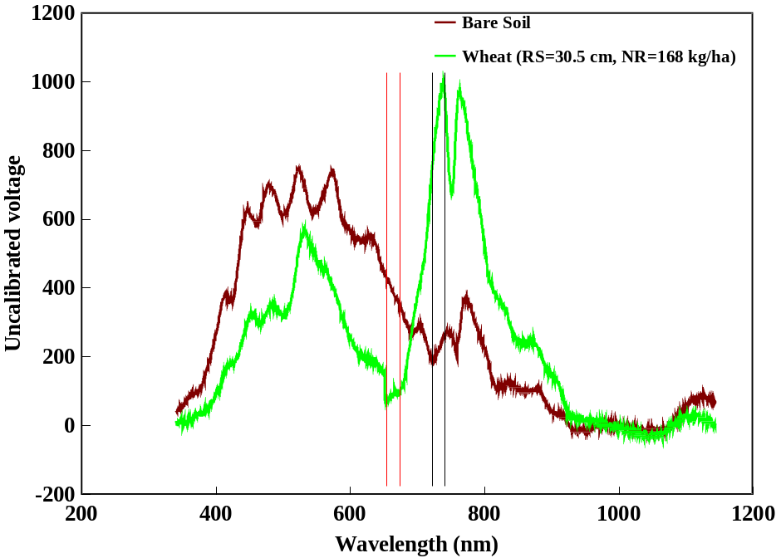
FIGURE 1. Irradiance from bare soil and the wheat canopy. Sensor readings were taken from red 671 ± 6 nm and near infrared (NIR) 780 ± 6 nm bandwidths.

and forage N content ranged from 0.04 to 0.61, and between NDVI and forage dry matter ranged from 0.33 to 0.80. Changes in either tissue N content or dry matter considerably affected spectral measurements. Vegetation density was higher at narrow row spacings and resulted in higher NDVI values compared to those of wide row spacings. On the other hand, plants from high density plots may assimilate fewer nutrients, particularly N, per plant. For instance, at Perkins, Feekes growth stage 5 in both years, fertilized plots with wide row spacing (30.5 cm) had high forage N content and low dry matter compared to plots with other narrow spacings (Tables 4 and 6). A combination of these factors possibly diminished NDVI variation due to row spacing. The complex impact of dry matter and forage N content can be taken into account by including another variable (total N uptake) in the analysis. Since total N uptake is a product of forage N content and dry matter, it should be a better predictor of NDVI. The correlation coefficients between NDVI and total N uptake were considerably higher than those of NDVI and N content or NDVI and biomass, and ranged from 0.47 to 0.83 (data not reported). Due to high infestation of annual ryegrass in the experimental field at Perkins, correlation’s between NDVI and forage N content were poor. Correlation coefficients between grain yield and NDVI showed promising results in term of predicting grain yield. They ranged from 0.32
to 0.71 (Table 7) and were considerably higher at Feekes growth stage 5 at both locations.
TABLE 7. Correlation coefficients for NDVI with forage N content, dry matter, and total N uptake at Perkins and Tipton, OK.

Growth stage, Forage Forage Forage
and year of study N content Dry Matter N uptake
_____________________________________________________________________________

Tipton, OK
Feekes growth stage 5,
crop year 1996-97 0.35 0.56 0.70

Feekes growth stage 4,
crop year 1997-98 0.45 0.58 0.76

Feekes growth stage 5,
crop year 1997-98 0.61 0.73 0.75

Perkins, OK
Feekes growth stage 4,
crop year 1996-97 0.35 0.71 0.80

Feekes growth stage 5,
crop year 1996-97 0.10 0.33 0.47

Feekes growth stage 4,
crop year 1997-98 0.13 0.35 0.52

Feekes growth stage 5,
crop year 1997-98 0.04 0.80 0.83
_____________________________________________________________________________

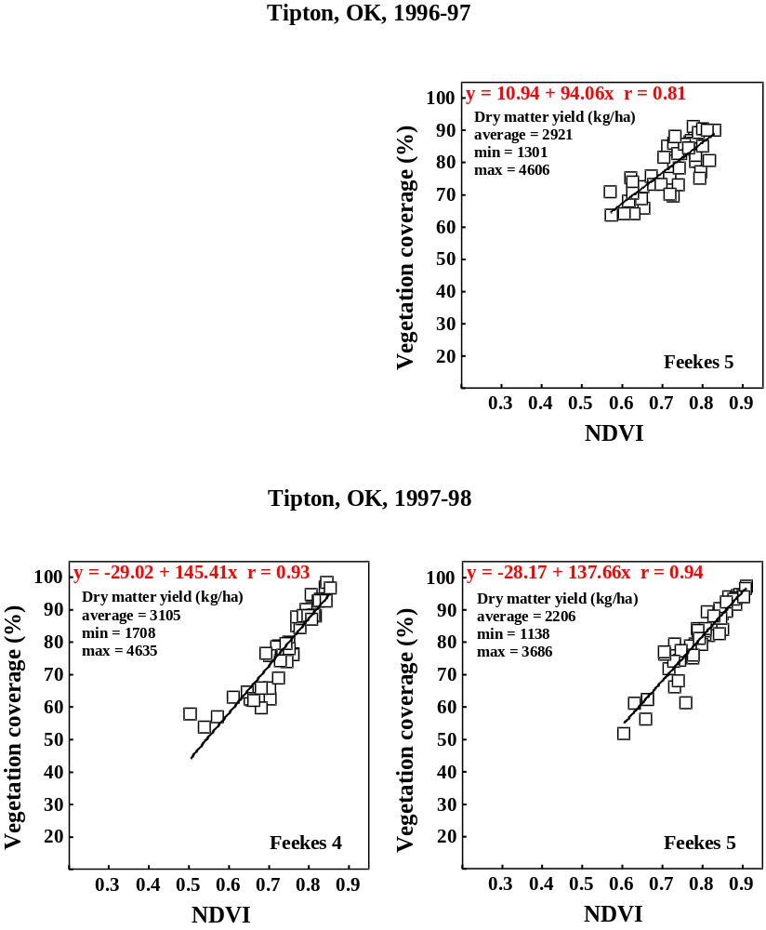
FIGURE 2. Correlation between NDVI and percent vegetation coverage of winter wheat canopies, Tipton, OK.

A highly significant linear relationship was observed between NDVI and vegetation coverage with correlation coefficients ranging from 0.80 to 0.98 (Figures 2 and 3).

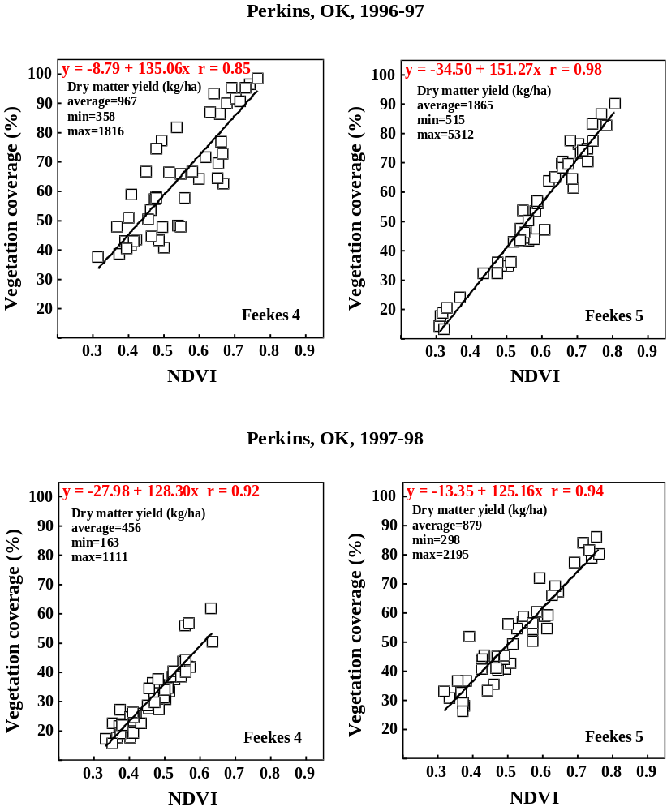
FIGURE 3. Correlation between NDVI and percent vegetation coverage of winter wheat canopies, Perkins, OK.

Changes in NDVI and vegetation coverage depending on N rate by different row spacings are illustrated in Figure 4. The patterns of these two charts were very similar, thus suggesting that NDVI was highly dependent on percent vegetation coverage. It was interesting to note that both NDVI and vegetation coverage increased with increasing N rate at the narrow row spacing for all locations years and stages of growth.
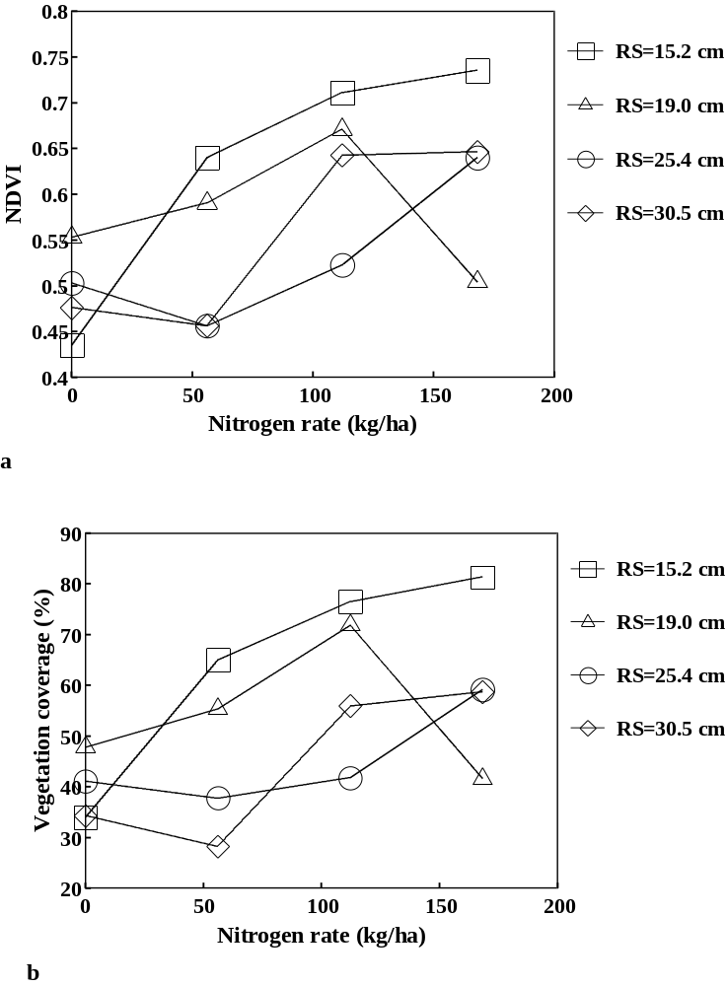
FIGURE 4. Influence of N rate and row spacing on vegetation coverage and NDVI at Perkins, Feekes growth stage 5, 1996-97.
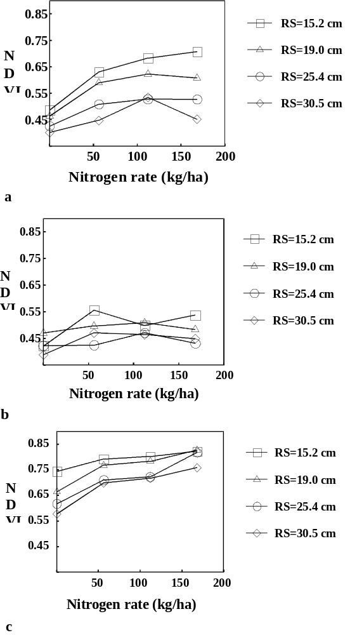
FIGURE 5. Relationship between NDVI and N rate at Perkins, Feekes growth stage 4, 1996-97 (a), Perkins, Feekes growth stage 4, 1997-98 (b), Tipton, Feekes growth stage 4, 1997-98 (c).

NDVI and vegetation coverage estimates for the narrow row spacing were apparently less affected by soil background interference.
The ability to detect differences in N rates at early growth stage was better for the narrow row spacings with higher vegetation coverage, which resulted in higher NDVI values. The highest NDVI values in plots with no N were found for narrow row spacings (Figure 5).
Regression of the CV’s from by-plot NDVI values on percent vegetation coverage is illustrated in Figure 6. As vegetation coverage increased, CV’s from NDVI values decreased. These results suggest that less variable NDVI values (CV less than 10 %) might be obtained from plots where vegetation coverage exceeded 50 percent.
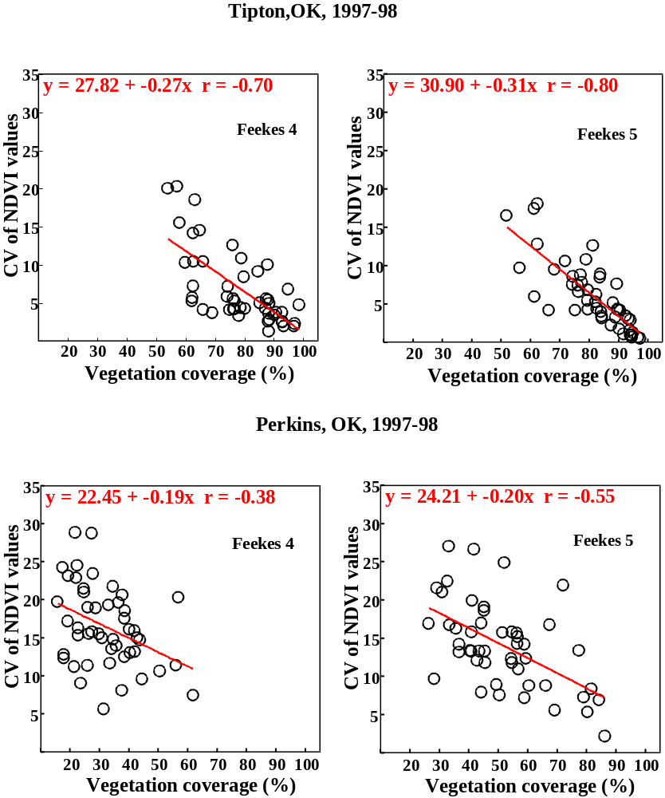

FIGURE 6. Relationship between CV's from by-plot NDVI values and percent vegetation coverage at Tipton and Perkins, OK, 1997-98.

Use of CV’s on NDVI values showed some promise in detecting critical vegetation coverage, although this method will need to be further refined.

CONCLUSION
To improve the calibration of NDVI with forage N uptake it is necessary to adjust for soil background interference. However, the critical vegetation coverage needed for precise forage N uptake calibration could not be determined from this work. This is largely because we seldom had any plots with less than 50 percent vegetation coverage, previously thought to be a breaking point in terms of calibration.
What was very exciting to show was that row spacing and N rate could be indirectly determined independent of one another since no significant interactions were detected. Row spacing did alter forage dry matter, NDVI, and N uptake; however, these were predictable based on vegetation coverage. In essence, vegetation coverage was a good predictor of the other dependant variables measured in this study (Table 8), which could indirectly be determined using NDVI regardless of row spacing.

TABLE 8. Correlation coefficients for grain yield with NDVI, percent vegetation coverage, and forage N uptake at Perkins and Tipton, OK.

Growth stage, NDVI Percent Vegetation Forage
and year of study Coverage N uptake
_____________________________________________________________________________

Tipton, OK

Feekes growth stage 4,
crop year 1997-98 0.60 0.63 0.69

Feekes growth stage 5,
crop year 1997-98 0.71 0.70 0.79

Perkins, OK

Feekes growth stage 4,
crop year 1997-98 0.32 0.35 0.14

Feekes growth stage 5,
crop year 1997-98 0.48 0.51 0.66
_____________________________________________________________________________

ACKNOWLEDGEMENTS
Appreciation is extended to members of the Soil Fertility Project including J. Dennis, W. Thomason, C. Woolfolk, H. Sembiring, S. Taylor, S. Norton, D. Drury, K. Wynn, C. Lively, D. Cossey, T. Johnston, and J. Tallman.

REFERENCES
Blackmer, T.M., J.S. Schepers, and G.E. Varvel. 1994. Light reflectance compared with other nitrogen stress measurements in corn leaves. Agron. J. 86:934-938.

Blackmer, T.M., J.S. Schepers, G.E. Varvel, and E. A. Walter-Shea. 1996. Nitrogen deficiency detection using reflected shortwave radiation from irrigated corn canopies. Agron. J. 88:1-5.

Heilman, J.L. and M.R. Kress. 1987. Effect of vegetation on spectral irradiance at the soil surface. Agron. J. 79:765-768.

Huete, A.R., R.D. Jackson, D.F. Post. 1985. Spectral response of a plant canopy with different soil backgrounds. Remote Sens. Environ. 17:37-53.

Large, E.C. 1954. Growth stages in cereals. Plant Pathol. 3:128-129.
Lukina, E.V., M.L. Stone, and W.R. Raun. 1998. Estimating vegetation coverage in wheat using digital images. (in press, J. Plant Nutr.)

Raun, W.R., J.B. Solie, G.V. Johnson, M.L. Stone, R.W. Whitney, H.L. Lees, H. Sembiring and S.B. Phillips. 1998a. Microvariability in soil test, plant nutrient, and yield parameters in bermudagrass. Soil Sci. Soc. Am. J. 62:683-690.

Raun, W.R., G.V. Johnson, H. Sembiring, E.V. Lukina, J.M. LaRuffa, W.E. Thomason, S.B. Phillips, J.B. Solie, M.L. Stone and R.W. Whitney. 1998b. Indirect measures of plant nutrients. (in press, Commun. Soil Sci. and Plant Anal.).

SAS Institute. 1988. SAS/STAT user’s guide. Version 6.03 ed. SAS Inst., Cary, NC.

Sawyer, J. E. 1994. Concepts of variable rate technology with considerations for fertilizer application. J. Prod. Agric. 7:195-201.

Schepers, J.S, D.D. Francis, and M.T. Thompson. 1989. Simultaneous determination of total C, total N, and ¹⁵N on soil and plant material. Commun. Soil Sci. Plant Anal. 20(9&10):949-959.

Solie, J.B., W.R. Raun, R.W. Whitney, M.L. Stone, , J.D. Ringer. 1996. Optical sensor based field element size and sensing strategy for nitrogen application. Trans. ASAE 39(6):1983-1992.
Stanhill, G., U. Kafkafi, M. Fuchs, and Y. Kagan. 1972. The effect of fertilizer application on solar reflectance from a wheat crop. Israel J. agric. Res. 22(2):109-118

Thomas, J.R. and G.F. Oerther. 1972. Estimating nitrogen content of sweet pepper leaves by reflectance measurements. Agron. J. 64:11-13.

FERTILIZER AND THE ENVIRONMENT

Detection of Phosphorus Runoff from Long-term Continuous Wheat Fertility Trials

W.E. Thomason, Hailin Zhang, K.W. Freeman, K.J. Wynn,
R. Teal, and W.R. Raun

Introduction
Both Nitrogen (N) and Phosphorus (P) are often associated with algal blooms and accelerated eutrophication of lakes and other surface water bodies. Phosphorus is the element most often limiting eutrophication in fresh water since algae can fix N from the atmosphere. Consequently, controlling eutrophication in surface waters may require reducing P inputs. Other avenues that may effect eutrophication are point versus non-point sources of P and the method of P movement and release. Three existing long-term winter wheat fertility experiments with yearly applied P rate fertilizer treatments will be subjected to simulated rainfall at different times during the year. Soil samples (0-15 cm) will be taken from the plots and analyzed for NH₄-N and NO₃-N as well as soil test P. Nutrients in runoff, including N and P will be measured from the entire collection volume. This information will then be used to correlate soil test P and N with runoff N and P. This study will be conducted to measure the level of P runoff from plots in long-term wheat fertility trials. The goal of this study is to determine the relationship between STP and water-soluble runoff P from agricultural fields. Findings from this study will hopefully provide a reliable risk assessment tool for fertilizer applications.

GLiterature review
ascho et al. (1998) working with corn, stated that soluble P in runoff is highest immediately after fertilizer application but bioavailable P availability increased with time up to 29 days. They also found that NO₃-N in runoff did not increase with time after application. Douglas et al. (1998) found total losses of N and P less than 5 kg ha⁻¹ in a 5-yr experiment and concluded that nutrient runoff from fields could be managed using erosion control measures. Sharpley, (1995) evaluated 10 Oklahoma soils and noted that STP (Mehlich III) and dissolved and bioavailable P were correlated and both tended to increase as soil P sorption maxima increased. Long-term applications of phosphorus from fertilizer of animal manure at rates in excess of crop removal have been shown to increase soil test P (STP) levels (Sharpley et al., 1998). At present, most available P runoff information deals with animal manure applications. Animal manures generally have a narrow N:P ratio. This means that applying manure to satisfy the N requirement of a crop will often result in over application of P. High rates of applied P-loading in excess of plant needs, have been shown to increase the amount of P in runoff (Sharpley et al., 1996; Pote et al., 1996). Nitrogen and phosphorus in runoff from plots with applied inorganic fertilizer has been found to be greater than in runoff from manure treatments (Heathwaite et.al, 1998). Good correlations were found for dissolved reactive P and STP even across sites and several P extraction methods in pasture settings (Pote et al., 1999). The relationship between STP and runoff P in cultivated fields receiving chemical fertilizer has not been thoroughly researched. This study will be conducted to measure the level of P runoff from plots in long-term wheat fertility trials where STP has been built to different levels on the same soil type. The goal of this study is to determine the relationship between STP and N, and runoff P and N from cultivated fields. Findings from this study will hopefully provide a reliable risk assessment tool for fertilizer applications.

Materials and Methods
Three experimental locations will be evaluated for soil test P levels, water extractable P levels and for NH₄-N and NO₃-N in runoff water and sediment. Experimental sites will be located at Stillwater, OK on a Norge loam, at Haskell, OK on a Taloka silt loam, and at Lahoma, OK on a Grant silt loam. Rates from 0-134 kg P ha⁻¹ have been applied to these plots annually for over 25 years at all locations and wheat has been continuously cropped on these experiments (Table 1). Treatments within each trial receiving different P rates over time have different STP levels Plots will be saturated 24 hr before initiation of the rainfall event to ensure even and timely runoff and to negate effects of previous moisture levels between plots. Rainfall on plots will be accomplished using a rain simulator similar to that developed by Miller (1987). Collection areas from each plot will be from 2.0 x 1.0 m areas in each plot. Metal borders will be installed 10cm above and below ground level to insulate runoff. A metal gutter will be placed at the lower end of the plot to divert runoff into a collection vessel. Simulated rainfall will be conducted at an intensity of 6.35 cm hr⁻¹. This intensity is equivalent to a 10 yr rainfall event in central Oklahoma. Simulated rains will be conducted twice during the year, once in late winter with vegetative cover, and once during summer with only straw residue on the surface. Runoff will be collected from the plot until a volume of 1 L is collected or 1 hour has passed since initiation of rain. The runoff will be tested for total P, TKN, dissolved P, NH₄-N, and NO₃-N. The relationship between STP and water-soluble P levels will be evaluated for each of the sites. Soil samples (0-15cm) will be taken from the plots before the rain simulation and analyzed for STP, total N, NH₄-N, and NO₃-N. Soil test values from the plot area will be compared with N in runoff from the collected sample.

Results
We expect to evaluate N and P levels from agronomic soil tests and correlate them with nutrient levels in runoff. We then plan to develop predictive runoff nutrient plans based on soil test levels and crop coverage. A reliable risk assessment tool for fertilizer applications based on soil test level will potentially be produced from this work.

Table 1. Annual nitrogen and phosphorus rates applied to long-term experiments.

Stillwater #222 | Lahoma #502 | Haskell #801
estab. 1969 | estab 1970 | estab 1977
P rate | P rate | P rate
--kg ha⁻¹-- | --kg ha⁻¹-- | --kg ha⁻¹--
0 | 0 | 0
34 | 22 | 40
68 | 45 | 80
101 | 68 | 120
 | 90

References
Douglas, C.L. Jr.; K.A. King, and J.F. Zuzel. 1998. Nitrogen and phosphorus in surface runoff and sediment from a wheat-pea rotation in northeastern Oregon. J. Env. Qual. 27, no. 1:1170-1777.

Gascho, G.J.;R.D. Wauchope, J.G. Davis, C.C. Truman, C.C. Dowler, J.E. Hook, H.R. Sumner, and A.W. Johnson. 1998. Nitrate-nitrogen, soluble and bioavailable phosphorus runoff from simulated rainfall after fertilizer application. Soil Sci. Am. J. 62:1711-1718.

Heathwaite, A.L., P. Griffiths, and R.J. Parkinson. 1998. Nitrogen and phosphorus in runoff from grassland with buffer strips following application of fertilizers and manures. Soil use mgmt. 14:142-148.

Miller, W.P. 1987. A solenoid-operated, variable intensity rainfall simulator. Soil Sci. Am. J. 51:832-834.

Pote, D.H., T.C. Daniel, A.N. Sharpley, P.A. Moore, Jr., D.R. Edwards, and D.J. Nichols. 1996. Relating extractable soil Phosphorus to phosphorus losses in runoff. Soil Sci. Am. J. 60:855-859.

Pote, D.H., T.C. Daniel; D.J. Nichols, A.N. Sharpley, P.A. Moore,Jr.; D.M. Miller, and D.R. Edwards. 1999. Relationship between phosphorus levels in three Ultisols and phosphorus concentrations in runoff. J. Env. Qual. 28, no. 1:170-175.

Sharpley, A.N. 1995. Dependence of runoff phosphorus on extractable soil phosphorus. J Env. Qual. 24:920-926.

Sharpley, A.N., T.C. Daniel, J.T. Sims, and D.H. Pote. 1996. Determining environmentally sound soil phosphorus levels. J. Water Conserv. 51:160-166.

Sharpley, A.N., J.J. Meisinger, A. Breeuwsma, T. Sims, T.C. Daniel, and J.S. Schepers. 1998. Impacts of animal manure management on ground and surface water quality. p.173-242. In J. Hatfield (ed.), Effective management of animal waste as a soil resource. Ann Arbor Press, Chelsea, MI.

PRODUCTION AGRICULTURE

Nitrogen Loss from Urea Fertilizer Applications in Hot, Dry Soils

R.W. Mullen, G.V. Johnson, K.W. Freeman,
K.J. Wynn, W.E. Thomason, and W.R. Raun

ABSTRACT
Nitrogen losses due to volatilization of surface applied urea-based fertilizers are thought to occur in sizeable quantities. Two field experiments were initiated to determine the effect of fertilizer source and incorporation of two urea-based fertilizers (urea and urea-ammonium nitrate), ammonium nitrate, and anhydrous ammonia on wheat grain yield and grain N. Experimental sites were established at Stillwater (Kirkland silt loam, fine-mixed, thermic, Udertic Paleustoll) and Tipton (Tipton loam, fine-loamy, mixed, thermic, Pachic Argiustoll) in 1998. Urea, UAN, and ammonium nitrate fertilizer sources were incorporated and surface applied, while anhydrous ammonia was injected six inches below the soil surface. In 1999 incorporated urea-based fertilizers resulted in 17% higher yields when compared to non-incorporated at the Stillwater location while having no effect at Tipton. Incorporation of urea-based fertilizers in 2000 did not effect yield or grain N compared to unincorporated treatments. The anhydrous ammonia source resulted in the highest percent grain N, at both locations in both years.

UINTRODUCTION
rea is the most widely used solid N fertilizer source in Oklahoma with over 121, 000 tons applied in 1998 (Oklahoma Ag Statistics). Volatilization losses from surface applications of urea-based N fertilizers is thought to occur in sizeable quantities under certain conditions (Ernst and Massey, 1960). Numerous research studies to date support this concept (Fenn and Hossner, 1985 and Palma et al., 1998).
Urea fertilizers must be hydrolyzed to ammonium by the enzyme urease before urea-N becomes plant available (Ernst and Massey, 1960, Meyer et al., 1961, and Terman, 1979). Increases in urease activity therefore can result in increased ammonia volatilization. The activity of urease in soil is highly dependent upon three factors - soil moisture, temperature, and pH. McInnes et al. (1986) showed that ammonia volatilization was minimal when urea was applied to dry soil, however, following wetting (not enough to result in incorporation) urea hydrolysis and ultimately ammonia volatilization increased. Volk (1966) found that 80% of prilled urea had not been hydrolyzed 14 d after surface application to an air-dry soil, but exposed surface urea continuously moist from a high water table hydrolyzed completely within 7 d with 65% of N applied lost as ammonia gas. Hydrolysis rates are maximized when soil moisture is optimum for plant growth (Havlin et al., 1999).
Urease activity is also positively correlated with soil temperature. Clay et al. (1990) showed that urea loss was highest when soil temperature was at its maximum. Similarly, Fisher and Parks (1958) reported that urea hydrolysis was 50% complete at 10ºC but 85% complete at 20ºC after 2 wk. Broadbent et al. (1958) found that urea hydrolysis took 7 d at 7ºC and only 3 d at 24ºC. Urease activity can range in temperatures from as low as 2ºC to as high as 37ºC (Havlin et al., 1999).
Mechanical incorporation of urea is a typical method used by producers to counteract the loss of N via volatilization. Palma et al. (1998) found that for conventional tillage, 8.6% and 5.4% of urea-N was lost when urea was surface applied and incorporated, respectively. Incorporation increases the amount of soil surface area which can absorb released NH₃ (Havlin et al., 1999). If urease activity is slowed due to cool or dry conditions, rain or irrigation water may move urea deeper into the soil before hydrolysis occurs, reducing volatilization losses suggesting that mechanical incorporation is not necessary (Terman, 1979). Keller and Mengel (1986) reported that losses via volatilization from granular urea and urea-ammonium nitrate (UAN) were effectively halted after a 25-mm rain shower. Significant precipitation (> 0.25 cm) 3 to 6 d after surface application can efficiently reduce N losses due to volatilization (Havlin et al., 1999). This study was initiated to determine decreases in winter wheat yield which could be attributed directly to losses of N due to ammonia volatilization on hot, dry Oklahoma soils.

MATERIALS AND METHODS
Two experimental locations were established in the fall 1998 at Oklahoma State University Efaw Research Station near Stillwater, Oklahoma (Kirkland silt loam, fine, mixed, thermic Udertic Paleustoll) and at the Southwest Research Station near Tipton, Oklahoma (Tipton silt loam, fine-loamy, mixed, thermic, Udertic Paleustoll). The experimental design was a randomized complete block with three replications. Plot size was 3.0 x 6.1 m.
Urea, urea-ammonium nitrate (UAN, 28-0-0), ammonium nitrate (AN, 34-0-0), and anhydrous ammonia (AA, 82-0-0) N sources were evaluated at 112 kg N ha⁻¹ for yield and grain N responses due to incorporation or surface application. Ammonium nitrate and urea was broadcast applied using a conventional dry-fertilizer spreader. Incorporated treatments received one 15-cm disking pass. Urea-ammonium nitrate liquid was broadcast applied using a 6.1 m spray boom with 51 cm spacing between nozzles. UAN incorporated treatments also received one 15-cm disking pass. Subsurface injection of AA was made to a depth of 15 cm using a custom built applicator equipped with five knives spaced 30 cm apart.
Winter wheat variety ‘Jagger’ was planted in 21-cm rows at a rate of 88 kg ha⁻¹. Wheat was harvested using a Massey Ferguson 8XP self-propelled combine which harvested an area of 2.0 x 6.1 m from the center of each plot. Yield data was determined from a Harvest Master yield monitoring computer installed on the combine. A subsample of wheat grain from each treatment was taken for total N analysis using the Carlo-Erba NA-1500 dry combustion analyzer (Schepers et al., 1989). Fertilization, planting, and harvest dates are reported in Table 2. Analyses of variance and single degree of freedom contrasts were performed using SAS (SAS, 1990).

RESULTS and Discussion
Efaw 1998-1999
Yield response to N above the check was only noted for the UAN incorporated and AN unincorporated treatments. Incorporation of the urea-based fertilizers increased yields 17% over surface applied urea-based treatments (Table 2). Urea-based treatments that were incorporated increased yields by 31% over non-urea treatments that were incorporated. Grain N % was highest for the AA treatment, which also had the lowest yield.

Tipton 1998-1999
Urea-ammonium nitrate incorporated, UAN unincorporated, and AA treatments resulted in increased yields above the check (Table 3). Incorporation of urea-based fertilizers did not increase yields over those treatments of surface applied urea fertilizers. Highest grain % N levels were found in the AA treatment.

Efaw 1999-2000
All N treatments except the AN incorporated and AA treatments increased yields above that of the check (Table 2). Ammonium nitrate incorporated resulted in increased yields above both UAN treatments. The UAN incorporated, both AN, and AA treatments resulted in increased grain N over that of the check. Anhydrous ammonia also increased grain N over both granular urea treatments.

Tipton 1999-2000
All N treatments increased yields above that of the check. The ammonium nitrate source resulted in higher yields than both UAN treatments. As in 1999, the AA treatment resulted in the highest grain N concentrations of all treatments evaluated. The AN unincorporated treatment resulted in higher grain N concentrations when compared to both UAN and AN incorporated treatments.

REFERENCES
Broadbent, F.E., G.N. Hill, and K.B. Tyler. 1958. Transformations and movement of urea in soils. Soil Sci. Soc. Am. J. 22:303-307.

Clay, D.E., G.L. Malzer, and J.L. Anderson. 1990. Ammonia volatilization from urea as influenced by soil temperature, soil water content, and nitrification and hydrolysis inhibitors. Soil Sci. Soc. Am. J. 54:263-266.

Ernst, J.W. and H.F. Massey. 1960. The effects of several factors on volatilization of ammonia formed from urea in the soil. Soil Sci. Soc. Am. Proc. 24:87-90.

Fenn L.B. and L.B. Hossner. 1985. Ammonia volatilization from ammonium or ammonium-forming nitrogen fertilizers. In (eds) Advances in Soil Science, Springer-Verlag, New York, NY.

Fisher, W.B. Jr. and W.L. Parks. 1958. Influence of soil on urea hydrolysis and subsequent nitrification. Soil Sci. Soc. Am. J. 22:247-248.

Havlin, J. L., J. D. Beaton, S. L. Tisdale, and W. L. Nelson. 1999. Nitrogen. p. 86-153. In: J. L. Havlin, J. D. Beaton, S. L. Tisdale and W. L. Nelson (eds) Soil Fertility and Fertilizers: An Introduction to Nutrient Management Sixth Ed. Prentice Hall, Upper Saddle River, NJ.

Keller, G.D. and D.B. Mengel. Ammonia volatilization from nitrogen fertilizers surface applied to no-till corn. Soil Sci. Soc. Am. J. 50:1060-1063.

McInnes, K.J., R.B. Ferguson, D.E. Kissel, and E.T. Kanemasu. 1986. Ammonia loss from applications of urea-ammonium nitrate solution to straw residue. Soil Sci. Soc. Am. J. 50(4):969-974.

Meyer, R.D., R.A. Olson, and H.F. Rhoades. 1961. Ammonia losses from fertilized Nebraska soils. Agron. J. 53:241-244.

Oklahoma Dept. of Agriculture. 1998. Oklahoma Agricultural Statistics.

Palma, R.M., M.I. Saubidet, M. Rimolo, and J. Utsumi. 1998. Nitrogen losses by volatilization in a corn crop with two tillage systems in the Argentine Pampa. Commun. Soil Sci. Plant Anal. 29(19&20):2865-2879.

SAS Institute. 1990. SAS/STAT user’s guide. Release 6.03 ed. SAS Inst., Cary, NC.

Schepers, J.S., D.D. Francis, and M.T. Thompson. 1989. Simultaneous determination of total C, total N, and 15N on soil and plant material. Commun. in Soil Sci. Plant Anal. 20(9&10):949-959.

Terman, G.L. 1979. Volatilization losses of nitrogen as ammonia from surface-applied fertilizers, organic amendments, and crop residues. Advances in Agronomy 31:189-221.

Volk, G.M. 1966. Efficiency of fertilizer urea as affected by method of application, soil moisture, and lime. Agron. J. 58:249-252.

TABLE 1. Fertilization, planting and harvest dates, Tipton, and Stillwater-Efaw, OK, 1998-1999.

Location | Fertilization | Planting | Harvest
Tipton | 09/09/98 | 10/08/98 | 06/08/99
 | 09/14/99 | 10/13/99 | 05/25/00
Efaw | 09/10/99 | 10/15/98 | 06/17/99
 | 10/04/99 | 10/21/99 | 06/15/00

TABLE 2. Wheat grain yield, grain % N, and N uptake at the Stillwater-Efaw location in 1999 and 2000.

Source | Method of Application | 1999 |  |  |  | 2000
Source | Method of Application | Grain yield (kg ha⁻¹) | Grain N (%) | Grain  N uptake, kg/ha |  | Grain yield (kg ha⁻¹) | Grain N (%) | Grain  N uptake, kg/ha
None | ---------------- | 2465.3 | 2.49 | 61.5 |  | 2829.7 | 1.80 | 51.2
Urea | Incorporated | 2885.1 | 2.61 | 75.2 |  | 3728.8 | 2.27 | 84.3
Urea | Surface | 2416.8 | 2.51 | 60.3 |  | 3397.4 | 2.12 | 72.1
UAN | Incorporated | 3206.2 | 3.02 | 95.7 |  | 3502.3 | 2.45 | 84.9
UAN | Surface | 2774.4 | 2.92 | 80.8 |  | 3605.4 | 2.18 | 77.8
AN | Incorporated | 2450.0 | 2.85 | 70.0 |  | 3353.8 | 2.28 | 77.0
AN | Surface | 3077.6 | 2.92 | 90.0 |  | 3168.6 | 2.32 | 74.2
AA | Injected | 2144.4 | 3.63 | 76.8 |  | 3171.1 | 2.82 | 89.5
SED |  | 266.0 | 0.27 | 8.1 |  | 238.0 | 0.23 | 9.1

TABLE 3. Wheat grain yield, grain % N, and N uptake at the Tipton location in 1999 and 2000.

Source | Method of Application | 1999 |  |  |  | 2000
Source | Method of Application | Grain yield (kg ha⁻¹) | Grain N (%) | Grain  N uptake, kg/ha |  | Grain yield (kg ha⁻¹) | Grain N (%) | Grain  N uptake, kg/ha
None | ---------------- | 884.3 | 2.22 | 19.5 |  | 1511.7 | 1.95 | 29.2
Urea | Incorporated | 1703.0 | 2.24 | 38.2 |  | 3380.6 | 2.09 | 70.7
Urea | Surface | 1555.6 | 2.20 | 34.5 |  | 3537.1 | 2.09 | 73.8
UAN | Incorporated | 1336.9 | 2.27 | 30.3 |  | 3054.5 | 1.98 | 60.5
UAN | Surface | 1601.5 | 2.25 | 35.9 |  | 2927.9 | 2.06 | 60.3
AN | Incorporated | 1555.9 | 2.36 | 37.2 |  | 3372.6 | 2.05 | 69.0
AN | Surface | 1487.2 | 2.32 | 34.7 |  | 3717.0 | 2.23 | 82.8
AA | Injected | 2337.7 | 3.46 | 80.9 |  | 3605.5 | 3.23 | 116.2
SED |  | 320.0 | 0.07 | 8.2 |  | 295.9 | 0.07 | 6.6

Winter Wheat Yield Response to Deep Knifed Nitrogen Applications

D.A. Cossey, G.V. Johnson, W.E. Thomason, R.W. Mullen, and W.R. Raun

ABSTRACT
A common practice for winter wheat production in Oklahoma is subsurface injection of anhydrous ammonia (AA) 2 to 4 wk prior to planting. It is the preferred source because of its high N analysis (82%) and low cost. A management practice gaining popularity is injection of AA into wheat stands prior to reproductive growth. Also, within the last decade the use of other N solutions has gained popularity, namely urea-ammonium nitrate (UAN), accounting for 20% of the total N consumed in Oklahoma in 1998. A study was established in the fall of 1994 to determine winter wheat yield and grain N response to; AA applied 1) preplant and 2) topdress; UAN applied 1) preplant broadcast, and 2) subsurface injected; and the impact of each source on nitrate (NO₃) accumulation in the subsoil. Wheat yield was significantly reduced by the application of 190 kg N ha⁻¹ as AA preplant, however this high N preplant rate is not a common practice in Oklahoma. Broadcast application of UAN followed by incorporation was a better method of applying N than knifed UAN. This response may be specific to this environment.

INTRODUCTION
The three most common forms of N fertilizer used in Oklahoma are anhydrous ammonia, urea, and urea-ammonium nitrate, accounting for 34, 29, and 20% of the total N applied in 1998 (Oklahoma Ag Statistics). Anhydrous ammonia is the preferred source because to its high N analysis (82%) and low cost. Within the last decade the use of other N solutions has gained popularity, namely urea-ammonium nitrate (UAN). Despite its low N analysis (28%), UAN is easy to handle, safe, and cheap to store, thus a viable alternative to AA.
A common practice for winter wheat production in Oklahoma is subsurface injection of anhydrous ammonia (AA) 2 to 4 wk prior to planting. A management practice gaining popularity is injection of AA into wheat stands prior to reproductive growth. This interest is driven primarily by the price differential of AA and UAN. Application of ammoniacal forms of N combined with cooler temperatures in the spring could result in decreased nitrification. Boman et al. (1995) theorized that increased ammoniacal N could be held on the soil exchange complex, resulting in decreased N mobility. Decreasing N mobility has important environmental impacts mainly dealing with nitrate-N accumulation in the subsoil which may be susceptible to leaching during cold, wet periods.
Urea-ammonium nitrate is typically broadcast applied using a spray applicator. Incorporation is commonly done despite the findings which state that volatilization losses from surface applied UAN have been shown to be smaller than that of prilled urea (Kresge and Satchell, 1960). Mengel et al. (1982) found that subsurface injection of UAN 20 cm below the soil surface consistently resulted in higher corn yields than surface applications of UAN, ammonium nitrate, and urea. Similarly, Touchton and Hargrove (1982) found that injected UAN produced higher corn yields than surface applied UAN. Conversely, Fox et al. (1986) reported that subsurface injection of UAN resulted in less efficient use when compared to ammonium nitrate or injected urea. The decreased efficiency was attributed to the following scenarios; (1) UAN was for some reason a less efficient source; and/or (2) there was volatilization of NH₃ (Mengel et al., 1982). This study was established to determine winter wheat yield and grain N response to AA applied preplant and topdress and UAN applied preplant broadcast and subsurface injected, and the impact of each source on nitrate (NO₃) accumulation in the subsoil.

MATERIALS AND METHODS
One field experiment was initiated in the fall 1994 at Oklahoma State University North Central Research Station near Lahoma, Oklahoma (Grant silt loam fine-silty, mixed, thermic Udic Argiustoll). The experimental design employed was a randomized complete block with three replications. Plot size was 4.9 x 7.6 m.
Three N rates (48, 95, and 190 kg N ha⁻¹) were evaluated using anhydrous ammonia (AA, 82-0-0) and urea-ammonium nitrate (UAN, 28-0-0). Urea-ammonium nitrate was evaluated for preplant application as either a subsurface injection or surface application. Anhydrous ammonia was evaluated for subsurface injection applied as either a preplant or topdress application. Subsurface injections were made to a depth of 15 cm using a custom built applicator equipped with five knives spaced 38 cm apart.
The winter wheat variety ‘Tonkawa’ was planted in 21-cm rows at a rate of 69 kg ha⁻¹. Wheat was harvested using a Massey Ferguson 8XP self-propelled combine which harvested an area of 2.0 x 7.6 m from the center of each plot. Yield data was determined from a Harvest Master yield monitoring computer installed on the combine. A subsample of wheat grain from each treatment was taken for total N analysis using the Carlo-Erba NA-1500 dry combustion analyzer (Schepers et al., 1989). Fertilization, planting, and harvest dates are reported in Table 2. Analyses of variance and single degree of freedom contrasts were performed using SAS (SAS, 1990).
After the trial was terminated in 1999, two soil cores were taken from each plot to a depth of 8 ft using a hydraulic probe. Cores were partitioned into 10 increments representing the 0 to 6, 6 to 12, 12 to 18, 18 to 24, 24 to 36, 36 to 48, 48 to 60, 60 to 72, 72 to 84, and 84 to 96 in. depths. Soil samples were air dried and processed to pass a 2-mm sieve. Soil samples were extracted using 2M KCl (Bremner, 1965) and analyzed for NO₃-N and NH₄-N using the Lachat-Quikchem automated flow injection analysis system. Nitrate-N was determined using a cadmium reduction method, and NH₄-N was determined from the same extract using the phenolate method.

RESULTS
No treatment differences were found for yield for the first year of the study. The only yield response to N above the check in 1996 was a linear trend for knifed AA. All N applications increased grain N above the check with differences between treatments. A linear and quadratic response with increasing N rates to knifed UAN was noted for grain N, and knifed AA at a 48 kg N ha⁻¹ rate increased grain N over knifed UAN at the same rate (Table 2). All N treatments increased N uptake except for the topdress AA application, and at the 95 kg N ha⁻¹ AA applied preplant increased N uptake compared to AA at the same rate applied topdress.
All N treatments increased yield above that of the check in 1997 with several differences between treatments found. A linear and quadratic response was found in yield for knifed UAN and AA, and a linear response to broadcast UAN for yield was noted. Application of 48 kg N ha⁻¹ topdressed opposed to a preplant treatment increased yield by 26%. In the previous year, knifed AA at 48 kg ha⁻¹ increased yields by 57% over knifed UAN at the same rate. However, at the 190 kg ha⁻¹ rate, knifed AA decreased yields by 94% compared to knifed UAN. This may be due to excess aqueous ammonia which can result in decreased germination (Bennett and Adams, 1970). Due to several missing grain samples in 1997, grain N and N uptake values are not presented.
Applied N increased yield, grain N, and N uptake in 1998 over the check. A linear and quadratic response with increasing N rates for yield and N uptake for knifed AA, and a linear response for yield and N uptake to knifed UAN and UAN broadcast were found in 1998 (Table 3). At the 48 kg ha⁻¹ rate, AA applied preplant increased yield and N uptake over topdress treatments, however, at the 95 kg ha⁻¹ AA applied topdress resulted in higher yields and N uptake than preplant applications. Increases in yield and N uptake were noted for knifed AA over knifed UAN at the 48 and 95 kg N ha⁻¹ rates, but at the 190 kg N ha⁻¹ rate, knifed AA decreased yield and N uptake compared to knifed UAN. A linear response in grain N was found for all nitrogen treatments. Broadcast UAN resulted in increased grain N and N uptake above knifed UAN at the 48 and 95 kg N ha⁻¹ rates, UAN broadcast also increased N uptake at all three N rates over knifed UAN. Knifed AA increased grain N at all three N levels compared to knifed UAN.
As in 1998 all N treatments resulted in higher yield, grain N, and N uptake over that of the 0-N check. A linear response for yield, grain N, and N uptake was found for all N treatments. Grain N also had a quadratic response to increasing N for the UAN broadcast treatments (Table 4). Broadcast UAN resulted in higher yields than knifed UAN at 48 and 95 kg N ha⁻¹, with the 95 kg N ha⁻¹ broadcast UAN also increasing grain N and N uptake. As in 1998, knifed AA increased yield and N uptake above knifed UAN at the two lower rates. At the highest knifed N rate using AA, yields decreased. Knifed AA had higher grain N concentrations than knifed UAN at all N rates.

CONCLUSIONS
Wheat yield was significantly reduced by the application of 190 kg N ha⁻¹ as AA preplant reflecting ammonia toxicity, however, this high preplant N rate is not common in Oklahoma wheat production. Anhydrous ammonia applications in the spring did not show advantages over that of AA preplant, however, this needs to gauged with soil test data that has yet to be analyzed. Broadcast application of UAN followed by incorporation was a better method of application than knifed UAN. This response may be specific to this environment.

REFERENCES
Bennett, A.C. and F. Adams. 1970. Concentration of NH₃(aq) required for incipient NH₃ toxicity to seedlings. Soil Sci. Soc. Am. Proc. 34:259-263.

Bremner, J.M. 1965. Inorganic forms of nitrogen. In C.A. Black et al. (eds) Methods of soil analysis, Part 2. Agronomy 9:1179-1237. Am. Soc. Agron., Madison, WI.

Boman, R.K., R.L. Westerman, W.R. Raun, and M.E. Jojola. 1995. Spring-applied nitrogen fertilizer influence on winter wheat and residual soil nitrate. J. Prod. Agric. 8(4):584-589.

Fox, R.H., J.M. Kern, and W.P. Piekielek. 1986. Nitrogen fertilizer source, and method and time of application effects on no-till corn yields and nitrogen uptakes. Agron. J. 78:741-746.

Kresge, C.B. and D.P. Satchell. 1960. Gaseous loss of ammonia from nitrogen fertilizers applied to soils. Agon. J. 52:104-107.

Mengel, D.B., D.W. Nelson, and D.M. Huber. 1982. Placement of nitrogen fertilizers for no-till and conventional till corn. Agron. J. 74:515-518.

Oklahoma Dept. of Agriculture. 1998. Oklahoma Agricultural Statistics.

Schepers, J.S., D.D. Francis, and M.T. Thompson. 1989. Simultaneous determination of total C, total N, and 15N on soil and plant material. Commun. in Soil Sci. Plant Anal. 20(9&10):949-959.

Touchton, J.T. and W.L. Hargrove. 1982. Nitrogen sources and methods of application for no-tillage corn production. Agron. J. 74:823-826.

TABLE 1. Fertilization, planting, topdress, and harvest dates, 1994-1999.

Fertilization | Planting | Topdress | Harvest
11/03/94 | 11/07/94 | 03/06/95 | 06/19/95
10/12/95 | 10/13/95 | 03/19/96 | 06/21/96
09/25/96 | 10/02/96 | 03/06/97 | 06/27/97
10/02/97 | 10/20/97 | 01/29/98 | 06/12/98
09/14/98 | 10/09/98 | 02/25/99 | 06/29/99

TABLE 2. Wheat grain yield, grain N, and N uptake response to source, method, timing, and N rate, Lahoma, OK, 1996.

Source and method | Timing | N rate  (kg ha⁻¹) | Grain yield  (kg ha⁻¹) | Grain N  (%) | Grain N uptake
Check | -- | 0 | 1452.6 | 2.71 | 38.0
UAN broadcast | PP | 48 | 1490.6 | 3.08 | 45.95
 |  | 95 | 1695.4 | 3.15 | 53.53
 |  | 190 | 1761.4 | 3.14 | 55.57
Linear, Quadratic Significance |  |  | NS, NS | NS, NS | NS, NS
UAN knifed | PP | 48 | 1902.5 | 2.62 | 48.46
 |  | 95 | 1986.6 | 3.17 | 62.83
 |  | 190 | 1706.5 | 3.28 | 55.91
Linear, Quadratic Significance |  |  | NS, NS | **, * | NS, NS
AA knifed | PP | 48 | 2012.2 | 3.27 | 95.93
 |  | 95 | 1917.6 | 3.31 | 63.25
 |  | 190 | 1068.2 | 3.48 | 37.17
Linear, Quadratic Significance |  |  | **, NS | NS, NS | **, NS
AA knifed | TD | 48 | 1585.3 | 3.27 | 47.91
 |  | 95 | 1292.6 | 3.28 | 42.36

Contrasts
48 AA TD vs 95 AA TD |  |  | NS | NS | NS
48 UAN knifed vs broadcast |  |  | NS | * | NS
95 UAN knifed vs broadcast |  |  | NS | NS | NS
190 UAN knifed vs broadcast |  |  | NS | NS | NS
48 AA PP vs TD |  |  | NS | NS | NS
95 AA PP vs TD |  |  | NS | NS | *
48 knifed UAN vs AA |  |  | NS | ** | NS
95 knifed UAN vs AA |  |  | NS | NS | NS
190 knifed UAN vs AA |  |  | NS | NS | NS
***, **, *, NS – significance at the 0.001, 0.01, and 0.05 level or non-significant (NS). PP-preplant, TD-topdress.
TABLE 3. Wheat grain yield response to source,
method, timing, and N rate, Lahoma, OK, 1997.

Source and method | Timing | N rate  (kg ha⁻¹) | Grain yield  (kg ha⁻¹)
Check | -- | 0 | 1782.6
UAN broadcast | PP | 48 | 2397.2
 |  | 95 | 3432.6
 |  | 190 | 3900.1
Linear, Quadratic Significance |  |  | ***, *
UAN knifed | PP | 48 | 4193.5
 |  | 95 | 3724.1
 |  | 190 | 1326.1
Linear, Quadratic Significance |  |  | ***, *
AA knifed | PP | 48 | 2393.9
 |  | 95 | 3290.8
 |  | 190 | 3980.7
Linear, Quadratic Significance |  |  | ***, NS
AA knifed | TD | 48 | 3315.1
 |  | 95 | 3754.6

Contrasts
48 AA TD vs 95 AA TD |  |  | NS
48 UAN knifed vs broadcast |  |  | NS
95 UAN knifed vs broadcast |  |  | NS
190 UAN knifed vs broadcast |  |  | NS
48 AA PP vs TD |  |  | ***
95 AA PP vs TD |  |  | NS
48 knifed UAN vs AA |  |  | ***
95 knifed UAN vs AA |  |  | NS
190 knifed UAN vs AA |  |  | ***
***, **, *, NS – significance at the 0.001, 0.01, and 0.05 level or
non-significant (NS). PP-preplant, TD-topdress.

TABLE 4. Wheat grain yield, grain N, and N uptake means, Lahoma, OK, 1998.

Source and method | Timing | N rate  (kg ha⁻¹) | Grain yield  (kg ha⁻¹) | Grain N  (%) | Grain N uptake
Check | -- | 0 | 2028.0 | 2.01 | 40.50
UAN broadcast | PP | 48 | 2793.4 | 2.46 | 68.33
 |  | 95 | 3363.2 | 2.67 | 90.06
 |  | 190 | 4109.3 | 2.74 | 112.72
Linear, Quadratic Significance |  |  | ***, NS | ***, NS | ***, NS
UAN knifed | PP | 48 | 2634.0 | 2.09 | 54.80
 |  | 95 | 3269.0 | 2.35 | 77.01
 |  | 190 | 3729.1 | 2.60 | 96.81
Linear, Quadratic Significance |  |  | ***, NS | ***, NS | ***, NS
AA knifed | PP | 48 | 3942.8 | 2.81 | 110.71
 |  | 95 | 4344.5 | 2.87 | 124.55
 |  | 190 | 1234.1 | 3.22 | 39.69
Linear, Quadratic Significance |  |  | ***, *** | ***, NS | ***, ***
AA knifed | TD | 48 | 2874.5 | 2.82 | 81.08
 |  | 95 | 3158.5 | 2.90 | 91.59

Contrasts
48 AA TD vs 95 AA TD |  |  | NS | NS | NS
48 UAN knifed vs broadcast |  |  | NS | *** | *
95 UAN knifed vs broadcast |  |  | NS | ** | *
190 UAN knifed vs broadcast |  |  | NS | NS | **
48 AA PP vs TD |  |  | *** | NS | ***
95 AA PP vs TD |  |  | *** | NS | ***
48 knifed UAN vs AA |  |  | *** | *** | ***
95 knifed UAN vs AA |  |  | *** | *** | ***
190 knifed UAN vs AA |  |  | *** | *** | ***
***, **, *, NS – significance at the 0.001, 0.01, and 0.05 level or non-significant (NS). PP-preplant, TD-topdress.
TABLE 5. Wheat grain yield, grain N, and N uptake means, Lahoma, OK, 1999.

Source and method | Timing | N rate  (kg ha⁻¹) | Grain yield  (kg ha⁻¹) | Grain N  (%) | Grain N uptake
Check | -- | 0 | 1457.9 | 1.98 | 28.90
UAN broadcast | PP | 48 | 2707.2 | 2.07 | 56.29
 |  | 95 | 3584.2 | 2.54 | 91.17
 |  | 190 | 4294.9 | 2.71 | 116.39
Linear, Quadratic Significance |  |  | ***, NS | ***, * | ***, NS
UAN knifed | PP | 48 | 1875.8 | 1.95` | 36.59
 |  | 95 | 2738.0 | 2.28 | 62.23
 |  | 190 | 3608.9 | 2.66 | 96.57
Linear, Quadratic Significance |  |  | ***, NS | ***, NS | ***, NS
AA knifed | PP | 48 | 4886.1 | 2.91 | 136.62
 |  | 95 | 4172.6 | 3.02 | 125.96
 |  | 190 | 2752.5 | 3.37 | 92.02
Linear, Quadratic Significance |  |  | ***, NS | ***,NS | ***, NS
AA knifed | TD | 48 | 4054.7 | 2.83 | 114.55
 |  | 95 | 4214.1 | 2.82 | 118.65

Contrasts
48 AA TD vs 95 AA TD |  |  | NS | NS | NS
48 UAN knifed vs broadcast |  |  | * | NS | NS
95 UAN knifed vs broadcast |  |  | * | * | *
190 UAN knifed vs broadcast |  |  | NS | NS | NS
48 AA PP vs TD |  |  | NS | NS | NS
95 AA PP vs TD |  |  | NS | NS | *
48 knifed UAN vs AA |  |  | *** | *** | ***
95 knifed UAN vs AA |  |  | *** | *** | ***
190 knifed UAN vs AA |  |  | * | *** | NS
***, **, *, NS – significance at the 0.001, 0.01, and 0.05 level or non-significant (NS). PP-preplant, TD-topdress.

Alfalfa Yield Response To Method and
Rate Of Applied Phosphorus

R.W. Mullen, G.V. Johnson, A.L. Hutson, W.E. Thomason,
J.L. Caddel, S.B. Phillips, and W.R. Raun

ABSTRACT
Past experience in Oklahoma indicates that initial and maintained soil fertility levels strongly affect long-term production of alfalfa (Medicago sativa L.). Presently, there are indications which suggest that P fertilizers should be applied at two to three times the recommended rate at the time of establishment when the fertilizer can be incorporated. Preplant band-applied P fertilizer may also provide increased long-term benefit by reducing soil-fertilizer P reactions. The objectives of this work were to evaluate the effect of alternative methods of applying P fertilizer on alfalfa yield and to determine optimum P fertilizer rates and timing of application for alfalfa production. One experiment was established at the South Central Research Station in Chickasha, OK, in September 1992. Five forage harvests have been obtained each year from 1993 to 1998. A linear response to P was obtained for rates up to 672 kg P₂O₅ ha⁻¹. No differences in yield were determined to exist due to source of P fertilizer. Single applications of high rates of preplant fertilizer P, either broadcast and incorporated or deep knifed in a band, have resulted in higher yields and projected higher profits than conventional annual (112 kg P₂O₅ ha⁻¹) rates. This work suggests that high preplant rates should provide a P fertility foundation with the potential for sustaining yields for several years.

INTRODUCTION
Alfalfa (Medicago sativa L.) is an important forage legume crop in Oklahoma. It is preferred over many other forage legumes due to its high yield potential, protein content, and palatability. Past experience in Oklahoma indicates that initial and maintained soil fertility levels strongly affect long-term production of alfalfa. Alfalfa forage generally contains 3.0 to 4.0 % N, but because it is a legume and fixes most of its own N via rhizobial symbiosis, N fertilization on established alfalfa stands is not a common practice. Phosphorus and K make up 0.2 to 0.5 % and 1.0 to 2.0 % of alfalfa forage, respectively (Bickoff et al., 1972). This indicates that an 11.0 Mg alfalfa crop removes 22.0 to 55.0 kg P ha⁻¹ and 110.0 to 220.0 kg K ha⁻¹ from the soil annually which must be replaced through fertilization. When P and K fertilizers are applied to established alfalfa stands, they are normally broadcast on the soil surface. Due to the immobile nature of P and K, this practice does not maximize nutrient availability to the existing root system. Ideally, immobile nutrients should be incorporated to improve their positional availability. Sheard et al. (1971) demonstrated that band placement of P near the seed is also an effective method of fertilization at establishment of alfalfa stands. Banding not only applies the nutrient where there is the greatest chance for root contact, but also reduces the surface area of the fertilizer in direct contact with the soil which limits the potential for formation of insoluble precipitates. This is especially important when applying P on highly alkaline or highly acid soils (Johnson et al., 1997). Reducing soil-fertilizer P reactions can provide increased long-term benefit from fertilizer P.
The dilemma faced when dealing with perennial crops like alfalfa, is whether to apply two to three times the recommended rate at the time of establishment when it can be incorporated, or to broadcast smaller amounts annually. Moyer (1992) found that high rates of P fertilizer applied (320 kg P₂O₅ ha⁻¹) at seeding to result in increased forage yield for several years. Malhi et al. (1992) reported residual effects of large single P applications to result in increased yields for five years. Economic comparisons of these different approaches are complex, taking into considerations such factors as local initial and annual values of the crop and fertilizer as well as interest rates for capital expended preplant as opposed to annually for fertilizer. Except for extremely inflationary times, it would seem that single large preplant rates of P would have to produce yields at least equal to those resulting from annual applications over the life of the stand or the period of reasonable comparison. Of additional concern is the effect of large additions of N when ammonium phosphates are applied at high rates preplant. High rates of N may reduce the effectiveness of rhizobial N-fixation and also encourage growth of non-legume weeds leading to lower alfalfa production. The objectives of this work were to evaluate the effect of alternative methods of applying P fertilizer on alfalfa yield and to determine optimum P fertilizer rates and timing of application for alfalfa production.

MATERIALS AND METHODS
One experiment was established in September 1992, at the South Central Research Station in Chickasha, OK, on a Dale silt loam soil. Initial soil sampling of the entire area was used to identify a homogenous area where P levels were low to medium (Mehlich III of 10 to 20 mg kg⁻¹). The alfalfa variety 'Garst 630' was planted to the entire area at a rate of 20 kg ha⁻¹. Supplemental water was applied as needed via irrigation. Treatment structure included method, rate, and timing of applied P (Table 1). A randomized complete block experimental design with four replications was employed. Treatment 13 (112 kg P₂O₅ ha⁻¹ applied annually) was included in the structure to simulate present farmer practices. Sources of P evaluated were triple superphosphate (TSP, 0-46-0) diammonium phosphate (DAP, 18-46-0), and ammonium polyphosphate (APP, 10-34-0). All of these sources were broadcast applied using a dry fertilizer spreader or a conventional liquid applicator. The rates applied at planting were incorporated while rates applied in subsequent years were not. Two treatments involved APP being knifed 15-cm deep into the soil for both preplant and topdress application dates. This was accomplished using a custom-built band-applicator which was equipped with five knives spaced 45-cm apart. Five forage harvests were obtained each year from 1993 to 1996. A 5.0 m² area from the center of each plot was harvested at each cutting using a ‘Carter’ forage harvester. Following each cutting, the remaining forage was harvested and removed from the entire experimental area using a conventional swather and baler. Dry matter yield was determined for all treatments. Alfalfa forage samples were subsampled and subsequently analyzed for total N and total P using a ‘Carlo-Erba 1500’ dry combustion analyzer, and HClO₄/HNO₃ digestion, respectively. Significant treatment differences were determined using analyses of variance and single degree of freedom non-orthogonal contrasts (SAS, 1990).

RESULTS

Alfalfa yields (averaged over treatment) in this trial were approximately 14.3 Mg ha-1 annually over the six-year study. Although overall stand density had decreased by the sixth year from 366 stems m-2 in 1993 to 194 stems m-2 in 1998, yield levels had not diminished from those obtained in the early years of the study. No yield response to additional S was observed in any year of the study.

Response to Applied K
A yield increase due to additional K was observed only in the third year of the study (16.1 vs. 18.3 Mg ha⁻¹; p<0.05). Soil samples were collected from selected treatments (0 to 15-cm deep) following the final harvest of 1995. Analysis of the soil samples revealed that, according to soil test calibration, no treatments were deficient in K, despite the yield increase as a result of 464 kg K ha⁻¹ being added annually. This indicated that application of more K than identified from standard soil tests may be beneficial for alfalfa forage production. However, alfalfa is a crop that will remove more K than is required for maximum yield (Johnson et al., 1997), so applying several years supply of K to the crop would probably not be economical. In addition, a total of 928 kg K ha⁻¹ had been applied before the yield increase was observed, therefore it is difficult to determine how much K should be applied to constitute a K-rich environment. The entire experimental area received a broadcast application of 464 kg K ha⁻¹ in the fourth year (1996) to remove K as a response variable.

Response to Applied P
No forage yield differences due to source of applied P were observed in any year of the study. For discussion regarding yield response to broadcast applications of P, treatments that received P as DAP, often the most cost-effective source of P, will be used. By-year yield responses were difficult to analyze due to unequal P rates that had been applied each year. Therefore, in addition to total (6-yr) production response, by-year yield responses to fertilizer applications in only the first (to evaluate initial response to P rate), fourth (total annually and biennially applied rates were comparable), and final year (all treatments had received an equal P rate) are discussed.

First Year (1993) Results
Initial soil tests identified the site as having a medium P supplying capacity (80 % sufficient in P) and that an annual rate of about 39 kg P ha⁻¹ should remove P deficiency as a yield limiting factor. The common producer practice of applying the annual soil test recommended or slightly greater rate of 49 kg P ha⁻¹, resulted in a 4% yield increase compared to not applying P (Figure 1). Alfalfa forage yield increase nearly doubled when the applied rate was doubled to 98 kg P ha⁻¹ (Figure 1). Alfalfa yield was further increased in the first year when 293 kg P ha⁻¹ was broadcast and incorporated at establishment (Figure 1). The fact that the 293-kg rate, which was six times the amount required to reach 100% sufficiency according to the soil test calibration, maximized alfalfa forage production (15.7 Mg ha⁻¹) indicates that a P-rich growing environment (supply exceeds that normally required for 100% sufficiency) is beneficial for alfalfa establishment and initial productivity.
Injection of 98 kg P as APP ha⁻¹ at establishment resulted in a yield increase 60% greater than that obtained using the conventional 49-kg P as DAP ha⁻¹ broadcast rate (Figure 1). However, injecting APP was not better than broadcasting DAP at the 98-kg rate (Figure 1). Preplant injection of 293 kg P as APP ha⁻¹ was the second highest yielding treatment (15.0 Mg ha⁻¹), resulting in 76% of the yield increase obtained when the same rate of DAP was incorporated preplant (Figure 1).
Fourth Year (1996) Results
In the fourth year, an 18% yield increase resulting from the 98-kg biennial (196 kg P ha⁻¹ applied total) broadcast treatment was greater than the increase resulting from the annual 49-kg P ha⁻¹ (196 kg P ha⁻¹ applied total) treatment (Figure 2). The yield increase from the biennial treatment was also greater than the increase observed as a result of the single preplant application of 293 kg P ha⁻¹ (Figure 2). A benefit to injecting P fertilizer compared to broadcast was observed in 1996. Injected applications of P resulted in the greatest yield increases (Figure 2) with no yield difference occurring between 293 kg P ha⁻¹ (injected preplant) and 196 kg P ha⁻¹ (applied using two biennial injections of 98 kg P ha⁻¹). Similar to the broadcast treatments, the 293-kg preplant injected treatment did not result in increased yield compared to that obtained by applying two 98-kg injections. Additionally, the 293-kg broadcast treatment was not different from the conventional annual application, which had received a total of 196 kg P ha⁻¹ (Figure 2). This suggested that the residual effects from the single, preplant broadcast rate of 293 kg P ha⁻¹, had begun to diminish by the fourth year of the study.

Sixth Year (1998) Results
By 1998, all treatments had received a total of 293 kg P ha⁻¹. The common producer practice of applying 49 kg P ha⁻¹ annually increased alfalfa forage yield 15% in the final year of the study (Figure 3) compared to only 4% in the first year (Figure 1). By applying slightly more than what would be used by the crop, soil fixation capacities were satisfied, plant available P foundations were established, and greater yield increases were being observed after six years. A similar effect was observed when 98 kg P ha⁻¹ was applied biennially, as increased yields rose from 9% in 1993 (Figure 1) to 19% in 1998 (Figure 3). Conversely, when 293 kg P ha⁻¹ (a six-year supply) was applied preplant, yield increases were greatest in the first year (Figure 1) and had diminished considerably by the sixth year of the stand (Figure 3). Despite the poor production in the sixth year, the single, high-rate preplant application resulted in yield increases over the six-year period greater than the annually applied treatment and equal to those obtained using the biennially broadcast treatment (Figure 4). This indicates a greater P use efficiency associated with larger P rates combined with fewer applications over the life of the alfalfa stand.
Although the biennially injected treatment exhibited a burst of production during 1996 (Figure 2), no benefit to injecting P fertilizer biennially was observed when compared to broadcast applications in the final year of the study or over the six-year period (Figures 3 and 4). However, the single, preplant injection of 293 kg P ha⁻¹ resulted in the highest total yield increase compared to all broadcast treatments (Figure 4). Figure 5 indicates that 293 kg P ha⁻¹ injected preplant was also one of the fertilizer application strategies that exhibited stability by maintaining consistent yield increases throughout the course of the study. Six-year alfalfa forage yield response trends for annual and biennial applications are also illustrated in Figure 5. The only treatment resulting in a significant slope was the 293-kg P ha⁻¹ broadcast incorporated rate (Figure 5). Although this treatment resulted in the highest initial yields, its level of production was not sustained over the six-year period.
Composite soil samples collected in February 1999 revealed no differences in soil test K or pH for any treatments evaluated in the study (Table 3). Differences in soil test P did, however, exist among treatments (Table 3). After six years of production, the treatment that had received no P, and had produced the least forage, had decreased in P sufficiency from 80% to 60% (soil test P level of 7.3 mg kg⁻¹; Table 3). The highest yielding treatment (293 kg P ha⁻¹ injected preplant) had the lowest residual soil test P (12.8 mg kg⁻¹; Table 3) of any treatments that had received fertilizer. The broadcast incorporated rate of 293 kg P ha⁻¹ was not different, with soil test P of 15.5 mg kg⁻¹ (Table 3). These soil test levels indicated that these treatments, regarding available P, had returned to their original condition of approximately 80% sufficiency. Meanwhile, the sufficiency of the treatments receiving annual and biennial applications of P had increased to > 97% (soil test P > 28 mg kg⁻¹; Table 3).

Economic Analysis after the Sixth Year
Economic analysis reveals the highest net return is realized when P is injected in a band (Table 4). Applying P annually and biennially is economically beneficial due to the accumulation of residual P which can decrease P inputs in latter years (Table 5). High application rates (e.g. 293 kg P ha⁻¹) provided at establishment do not result in high residual P, but they may be advantageous by saving the producer application costs associated with annual and biennial additions.

CONCLUSIONS
This work indicates that in high yielding environments (e.g. irrigated) alfalfa may respond to P-fertilizer inputs above the conventional levels indicated by calibrated soil tests. Additionally, high preplant or biennial P fertilizer rates, either broadcast and incorporated or injected in a band, may provide a P fertility foundation with the potential for sustaining alfalfa yields for several years resulting in increased profits for the producer.

REFERENCES
Bickoff, E.M., G.O. Kohler, and D. Smith. 1972. Chemical composition of herbage. Pages 247-282 in C.H. Hanson, ed. Alfalfa science and technology. ASA-CSSA-SSSA, Madison, WI.

Johnson, G.V., W.R. Raun, H. Zhang, and J.A. Hattey. 1997. Oklahoma Soil Fertility Handbook. Fourth ed. Dept. of Agron., Okla. Agric. Exp. Sta., Okla. Coop. Ext. Serv., Div. of Agric. Sci. and Nat. Res., Oklahoma State University, Stillwater, OK.

Leyshon, A.J. 1982. Deleterious effects on yield of drilling fertilizer into established alfalfa stands. Agron. J. 74: 741-743.

Malhi, S.S., M.A. Arshad, K.S. Gill, and D.K. McBeath. 1992. Response of alfalfa hay yield to phosphorus fertilization in two soils in central Alberta. Commun. Soil Sci. Plant Anal. 23: 717-724.

Moyer, J.R. 1992. Alfalfa yields in establishment and subsequent years after herbicide and phosphorus application during establishment. Can. J. Plant Sci. 72: 619-625.

SAS Institute. 1990. SAS/STAT user’s guide. Release 6.03 ed. SAS Inst., Cary, NC.

Sheard, R.W., G.J. Bradshaw, and D.L. Massey. 1971. Phosphorus placement for the establishment of alfalfa and bromegrass. Agron. J. 63: 922-927.

Simons, R.G., C.A. Grant, and L.D. Bailey. 1995. Effect of fertilizer placement on yield of established alfalfa stands. Can. J. Plant Sci. 75: 883-887.

TABLE 1. Initial soil test levels for Chickasha, OK, 1992.

NO₃-N | P | K | PH
-----------mg kg⁻¹----------
13.6 | 15.1 | 163 | 6.6
NO₃-N – 2 M KCl extract; P, K – Mehlich III
pH – 1:1 soil-water

Table 2. Treatment structure including weed density, method, source, rate and timing of P applied, N, K, and S applications at Chickasha, OK, 1992.

Trt | Placement | Source | P rate | P-timing |  | K rate |  | S rate
 |  |  | ---kg ha⁻¹--- | Planting | Years  3 and 5Ŧ | ------kg ha⁻¹-----
1 | BI | 0-46-0 | 336 | 112 | 112 | 0 | 0
2 | BI | 0-46-0 | 672 | 224 | 224 | 0 | 0
3 | BI | 0-46-0 | 672 | 672 | 0 | 0 | 0
4 | BI | 18-46-0 | 336 | 112 | 112 | 0 | 0
5 | BI | 18-46-0 | 672 | 224 | 224 | 0 | 0
6 | BI | 18-46-0 | 672 | 672 | 0 | 0 | 0
7 | BI | 10-34-0 | 336 | 112 | 112 | 0 | 0
8 | BI | 10-34-0 | 672 | 224 | 224 | 0 | 0
9 | BI | 10-34-0 | 672 | 672 | 0 | 0 | 0
10 | BA | 10-34-0 | 672 | 672 | 0 | 0 | 0
11 | BA | 10-34-0 | 672 | 224 | 224 | 0 | 0
12 | CK | --- | 0 | 0 | 0 | 0 | 0
13 | BI | 18-46-0 | 672 | 112 | 112 (yrs 2,3,4,5,6) | 0 | 0
14 | BI | 18-46-0 | 672 | 224 | 224 | 0 | 56
15 | BI | 18-46-0 | 672 | 224 | 224 | 560 | 0
S applied broadcast each year as hydrated gypsum, K applied broadcast each year as potassium chloride, BI – broadcast incorporated preplant, BA – band-applied 15 cm deep, CK – check (no nutrients applied).
Ŧ – Broadcast treatments not incorporated.

TABLE 3. Soil test P, K, and pH determined on composite surface samples (0 to 15-cm deep) collected from Chickasha, OK, 1998, following six years of alfalfa production.

Treatment | P | K | pH
----------kg P ha⁻¹--------- | ----------------mg kg⁻¹-----------------
None | 7.2 | 358 | 6.9
49 broadcast annually | 38.7 | 340 | 6.6
98 broadcast biennially | 28.9 | 352 | 6.5
293 broadcast preplant | 15.5 | 351 | 6.6
98 injected biennially | 39.2 | 347 | 6.4
293 injected preplant | 12.8 | 339 | 6.6
SED | 8.5 | 26 | 0.08
P, K - Mehlich III; pH - 1:1 soil-water; SED - standard error of the difference between two equally
replicated means

Table 4. Economic returns above the check on broadcast and injected P fertilizer.

Economic Returns: | 49 kg P ha⁻¹ broadcast annually | 98 kg P ha⁻¹ biennially | 98 kg P ha⁻¹ biennially (knifed) | 293 kg P ha⁻¹ broadcast preplant | 293 kg P ha⁻¹ preplant (knifed)
Over six years† | $95.28 | $140.48 | $259.70 | $134.71 | $290.95
Per year | $15.88 | $23.41 | $43.28 | $22.45 | $48.49
Per year 20% rained on‡ | $11.35 | $17.81 | $35.55 | $16.19 | $39.43
† - Alfalfa at $90/ton, baling at $14/bale (1800 lb bale), no additional charge for swathing or hauling and interest at 10%.
‡ - Assumes 20% of additional hay is damaged and sold for $50.00/ton.

TABLE 5. Value of residual soil P above the check.

 | 49 kg P ha⁻¹ broadcast annually | 98 kg P ha⁻¹ broadcast biennially | 98 kg P ha⁻¹ knifed biennially | 293 kg P ha⁻¹ broadcast preplant | 293 kg P ha⁻¹ knifed preplant
P Soil Test  (kg P2O5 ha⁻¹) | 86.9 | 87.1 | 87.9 | 46.0 | 28.7
Value of P2O5 | $32.83 | $34.43 | $36.34 | ------- | -------

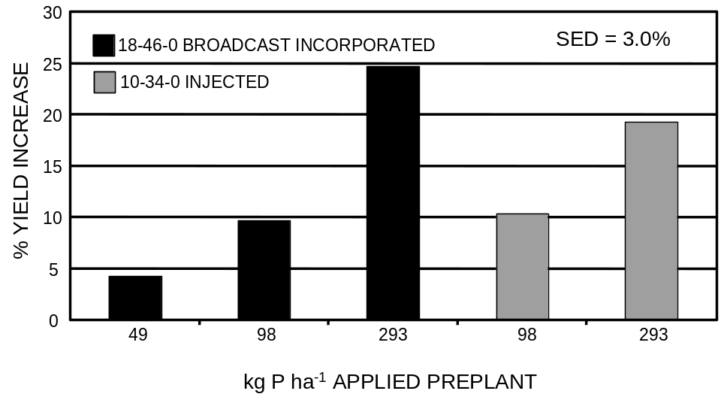
Figure 1. Percent alfalfa forage yield increase over the check (no P applied) in the first year of the study (1993) as a result of preplant applied rates of P. SED = standard error of the difference between two equally replicated means.

Figure 2. Percent alfalfa forage yield increase over the check (no P applied) in the fourth year of the study (1996). Treatments had received a total of 196 or 293 kg P ha⁻¹ applied using different timing and application methods. SED = standard error of the difference between two equally replicated means.

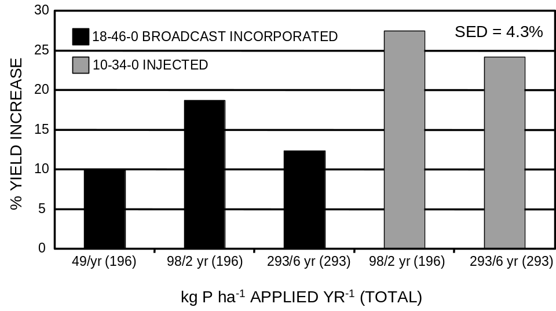

Figure 3. Percent alfalfa forage yield increase over the check (no P applied) in the final year of the study (1998). All treatments had received a total of 293 kg P ha⁻¹ applied using different timing and application methods over a six-year period. SED = standard error of the difference between two equally replicated means.
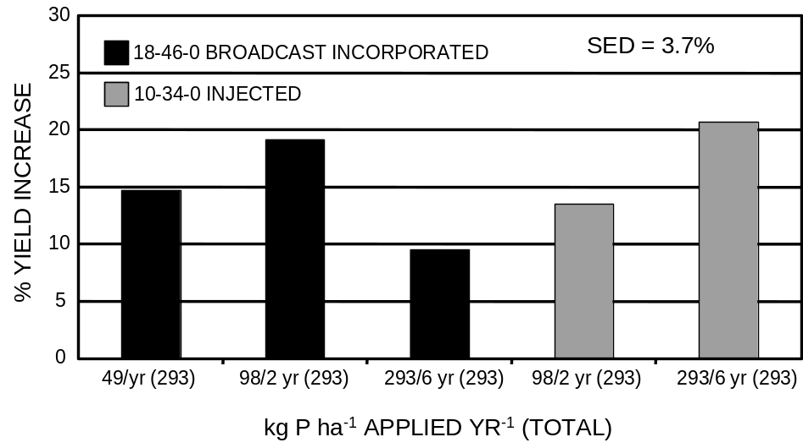

Figure 4. Total alfalfa forage yield increases over the check (no P applied) observed over a six-year period (1993 to 1998) as a result of different timing and methods of application of P fertilizer. SED = standard error of the difference between two equally replicated means.
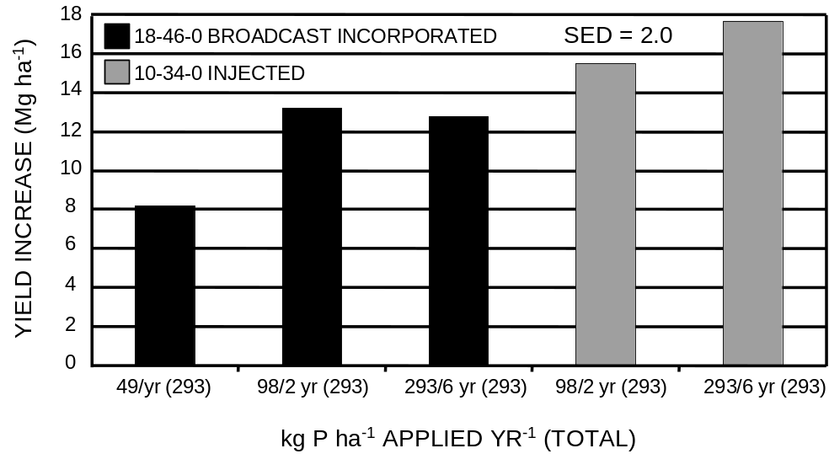
Figure 5. Response trends of alfalfa forage yield increases over the check (no P applied) over a six-year period (1993 to 1998) as a result of P fertilizer application methods.

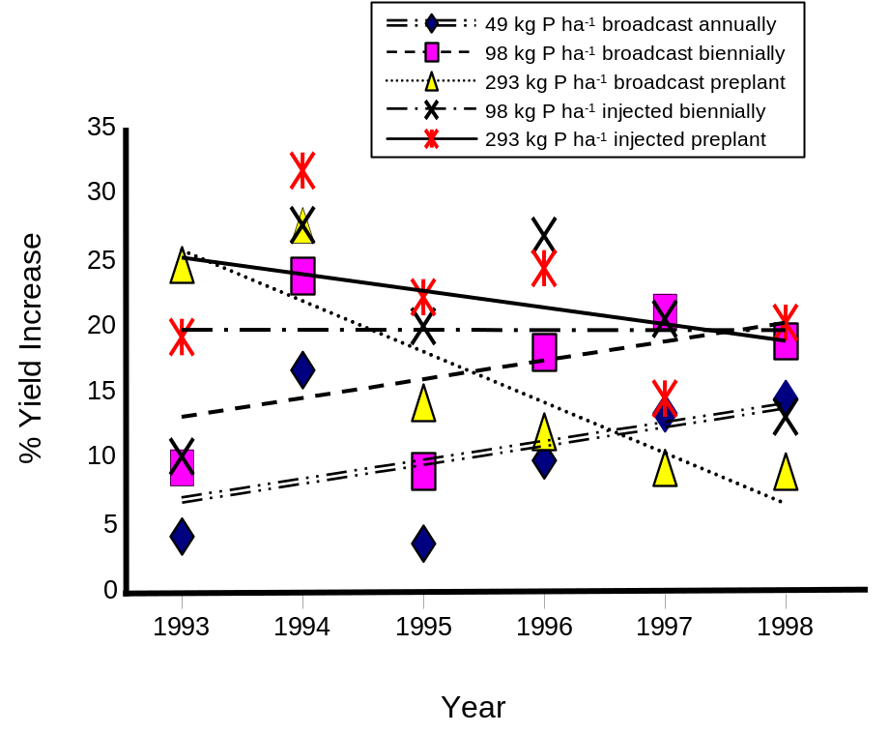

Switchgrass Response to Harvest Frequency, and Time and Rate of Applied Nitrogen

W.E. Thomason, C.M. Taliaferro, G.V. Johnson, K.W. Freeman,
K.J. Wynn, R. Teal, and W.R. Raun
Abstract
Switchgrass (Panicum virgatum L.) is currently being evaluated as a potential source of ethanol for addition to fuels. Ethanol production from switchgrass is bound by the growing environment that includes fertility. Experimental sites were initiated at Chickasha (Dale silt loam, fine-silty, mixed, superactive, thermic Pachic Haplustoll) and Perkins (Teller sandy loam, fine-loamy, mixed, thermic Udic Argiustoll), OK in 1996 and 1998, respectively. Both experiments were initiated to evaluate switchgrass response to applied nitrogen (N) at rates of 0, 112, 224, 448, and 896 kg ha-1. In addition, harvest frequency (once at the end of September, twice-in mid-July and September, and three times-in May, mid-July, and September), and time of N application (all in April, 1/2 in April and 1/2 following first harvest, and 1/3 in April, 1/3 following first harvest, and 1/3 following second harvest) were evaluated. A randomized complete block design with three replications was used at both locations with an incomplete factorial arrangement of treatments. The northern lowland switchgrass variety ‘Kanlow’ was broadcast seeded at both sites at a rate of 9-11 kg ha-1. At both sites, pre-plant rates of 112 kg N ha-1, 224 kg P205 ha-1, and 560 kg K2O ha-1 were applied to the entire area. Switchgrass was harvested at a height of 10-15 cm using a conventional “Carter” harvester. Yield maximums were achieved with N rates of 224 kg N ha-1 and two harvest dates and with application of 448 kg N ha-1 using 3 harvest dates.

Introduction
Nutrient uptake and loss from production sites are important issues for high-biomass producing crops such as switchgrass. This is especially true if removal, as in haying, and not grazing is practiced. Mineral content of switchgrass has been found to be higher on a percentage scale with lower yields for the macronutrients nitrogen, phosphorus, potassium and calcium. No change in concentration for many micronutrients has been noted but concentrations of boron and manganese have been found to increase with increasing yields (Balasko and Smith, 1971). Increases in plant N concentration with increased applied N throughout the season have been noted (Madakadze, et al.,1999a). Staley et al., (1991) found increasing N concentration in harvested plant parts with increases in applied N. They also found increased N uptake with increased N rates, but only in a one-harvest system. Using 15N as a tracer, they attributed only 15-39% of total N uptake to fertilizer sources but these uptake levels were still above those of tall fescue grown on the same marginal sites. Researchers in Pennsylvania have found N recoveries of 40% of that applied and noted that this number was thought to decrease as native soil N levels increased. Measured on a daily basis, switchgrass has been found to take up 1.49-2.63 kg N ha⁻¹ d⁻¹ (Stout and Jung, 1995). Other research states that if water is not limiting, then N levels account for 80% of the variation in yields. When water is limiting, however, the absence of moisture is the most important factor in yield determination (Stout et al., 1988). Depth of soil has been found to have little effect on N uptake (Stout et al., 1991).
Harvesting methods involving 1 to 2 cuttings per season have been shown to produce optimum yields in most systems (Balasko et al., 1984). The earlier harvest is usually much higher in feed value and a 2-cut system may allow early cuttings to be used as livestock feed and later cuttings for biofuel production (Sanderson et al., 1999). Sanderson (1992) found that as switchgrass matures through the growing season, stem components increase and leaf components decrease as a percent of total dry biomass. This increase in stem portion is attributed to internode elongation necessary for plant growth and competitiveness.
Switchgrass yields of 10-12 Mg ha⁻¹ have been reported in Canada (Madakadze et al., 1999b). This led the authors to surmise that switchgrass could be a valuable source of biomass for biofuel production. Hall et al., (1982) found switchgrass yields in Iowa to be around 6 Mg ha⁻¹ and noted consistent response to added N up to 75 kg ha⁻¹ rates.
Hintz et al., (1998) noted the need for pre-plant herbicides for establishing switchgrass stands. The loss of atrazine as one of these herbicides was thought to be detrimental. The authors planted corn concomitantly with switchgrass allowing atrazine application for the corn/grass crop. They concluded that this cropping system was useful and productive both for switchgrass establishment and for corn silage or grain production. They also state that this system could provide income to the producer (from the corn crop) during the year needed for switchgrass stand establishment.
Morphological development of switchgrass has been evaluated and it has been found that most important events can be correlated to accumulated degree days with 10° C as the baseline (Sanderson and Wolf, 1995).
Evaluation of switchgrass has shown that it is suitable for use as a biofuel producer, either as ethanol or fired directly with coal. It is also being researched as a replacement for wood pulp in the paper making process. The energy content of switchgrass has been found to be comparable to that of wood (McLaughlin et al., 1996). Analysis of ash and alkali content of switchgrass has shown relatively low alkali levels and therefore should have little slagging potential when used in coal firing systems (McLaughlin et al., 1996). This same researcher noted that due to the high cellulose content, low ash levels, and good fiber length to width ratios, switchgrass could substitute for hardwood pulp in production of high quality paper. Later work notes the cost of production of switchgrass at around $30 per T indicating that it would be viable, at least on a cost basis, as a replacement for wood pulp (Fox et al., 1999).
Bransby et al., (1998) noted switchgrass environmental benefits as an N buffer strip crop and as a net fixer of carbon (C). They state that the most important benefit of using switchgrass as a fuel is the net cycling of C in the environment and give only slight importance to soil C sequestration. Long-term research in Alabama has recently shown no change in soil organic C levels after 3 yrs in continuous switchgrass, but after 10 yrs soil organic C was 45% higher than adjacent fallow ground (Ma et al., 2000). The objectives of this study were to evaluate the response of switchgrass grown in Oklahoma to harvest frequency, time, and rate of applied nitrogen.

Materials and Methods
Two field experiments were initiated to evaluate switchgrass response to applied nitrogen (N) at rates of 0, 112, 224, 448, and 896 kg ha⁻¹. In addition, harvest frequency (once at the end of September, twice-in mid-July and September, and three times-in May, mid-July, and September), and time of N application (all in April, 1/2 in April and 1/2 following first harvest, and 1/3 in April, 1/3 following first harvest, and 1/3 following second harvest) were evaluated (Table 2). Experimental sites were initiated at Chickasha (Dale silt loam, fine-silty, mixed, superactive, thermic Pachic Haplustoll) and Perkins (Teller sandy loam, fine-loamy, mixed, thermic Udic Argiustoll), OK in 1996 and 1998, respectively. Pre-establishment soil test values and soil classifications for the two sites are reported in Table 1. A randomized complete block design with three replications was used at both locations with an incomplete factorial arrangement of treatments (Table 2). The northern lowland switchgrass variety ‘Kanlow’ was broadcast seeded at both sites at a rate of 9-11 kg ha⁻¹. At both sites, pre-plant rates of 112 kg N ha⁻¹, 224 kg P₂0₅ ha⁻¹, and 560 kg K₂O ha⁻¹ were applied to the entire area. Switchgrass was harvested at a height of 10-15 cm using a conventional “Carter” harvester.
Forage samples were dried and ground to pass a 140 mesh sieve (100 um) and analyzed for total N content using a Carlo-Erba NA 1500 automated dry combustion analyzer (Schepers et al., 1989). Forage samples are also analyzed for tissue concentrations of P,K, (Mehlich, 1984) Ca, Mg, and S (Benton et al.,1990). Nutrient removal was determined by multiplying total dry biomass times the measured tissue concentration of each respective element. Statistical evaluation and analysis of variance was performed using SAS (SAS Inst., 1989).

Results
Averaged over years, applying no N resulted in increased switchgrass dry matter yields when compared to N applied at a rate of 112 kg ha⁻¹ (April), with either 2 or 3 harvests/season (0 kg N = 17.1Mg, 112 kg N = 16.2 Mg of total biomass). Application of 112 kg N ha⁻¹ and harvesting once at the end of the season yielded 0.5 Mg more dry matter than the 0 N check. (17.6 Mg vs. 17.1 Mg).
Multiple harvests increased nutrient uptake especially in high producing years. Increased nutrient uptake was not necessarily associated with increased dry matter yields.
Even in years with high yield potential (high rainfall in late summer), one end-of-season harvest produced greater dry matter yields than two harvests. (24.8 vs 24.6 Mg ha⁻¹ at Chickasha in 1997). Applying 112 kg N ha⁻¹ and employing one end-of-season harvest resulted in maximum switchgrass dry matter production.

References
Balasko, J.A. and D. Smith. 1971. Influence of temperature and nitrogen fertilization on the growth and composition of switchgrass and timothy at anthesis. Agron. J. 63:853-857.

Balasko, J.A., D.M. Burner, and W.V. Thayne. 1984. Yield and quality of switchgrass grown without soil amendments. Agron. J. 76:204-208.

Benton Jr., J.B. and V.W. Case. 1990. Sampling, Handling, and Analyzing Plant Tissue Samples. p. 389-427. In R.L. Westerman (ed.) Soil Testing and Plant Analysis. 3rd ed. SSSA Book Ser. 3. SSSA, Madison, WI.

Bransby, D.I., S.B. McLaughlin, and D.J. Parrish. 1998. A review of carbon and nitrogen balances in switchgrass grown for energy. Biomass and Bioenergy 14:379-384.

Fox, G., P. Girouard, and Y. Syukat. 1999. An economic analysis of the financial viability of switchgrass as a raw material for pulp production in eastern Ontario. Biomass and Bioenergy 16:1-12.

Hall, K.E., J.R. George, and R.R, Riedl. 1982. Herbage dry matter yields of switchgrass, big bluestem, and indiangrass with N fertilization. Agron. J. 74:47-51.

Hintz, R.L., K.R. Harmoney, K.J. Moore, R. George, and E.C. Brummer. 1998. Establishment of switchgrass and big bluestem in corn with atrazine. Agron. J 90:591-596.

Ma, Z., C.W. Wood, and D.I. Bransby. 1999. Soil management impacts on soil carbon sequestration by switchgrass. Biomass and Bioenergy 14:469-477.

Madakadze, J.C., K. Stewart, P.R. Peterson, B.E. Coulman, and D.L. Smith. a. 1999. Cutting frequency and nitrogen fertilization effects on yield and nitrogen concentration of switchgrass in a short season area. Crop Sci. 39:552-560.

Madakadze, J.C., K. Stewart, P.R. Peterson, B.E. Coulman, and D.L. Smith. b. 1999. Switchgrass biomass and chemical composition for biofuel in eastern Canada. Agron. J. 91:696-701.

McLaughlin, S.B., R. Samson, D. Bransby, and A. Wiseloge. 1996. Evaluating physical, chemical and energetic properties of perennial grasses as biofuels. Proc., Bioenergy ’96 – The seventh national bioenergy conference: partnerships to develop and apply biomass technologies, Sept 15-20, 1996, Nashville, TN.

Mehlich, A. 1984. Mehlich number 3 extractant; a modification of Mehlich number 2 extractant. Commun. Soil Sci. Plant Anal. 15:1409-1416.

Raneses, A., K. Hanson, and H. Shapouri. 1998. Economic impacts from shifting cropland from food to fuel. Biomass and Bioenergy 15:417-422.

Sanderson, M.A. 1992. Morphological development of switchgrass and kleingrass. Agron. J. 84:415-419.

Sanderson, M.A., and D.D. Wolf. 1995. Morphological development of switchgrass in diverse environments. Agron. J. 87:908-915.

Sanderson, M.A., J.C. Read, and R.L. Reed. 1999. Harvest management of switchgrass for biomass feedstock and forage production. Agron. J. 91:5-10.

Staley, T.E., W.L. Stout, and G.A. Jung. 1990. Nitrogen use by tall fescue and switchgrass on acidic soils of varying water holding capacity. Agron. J. 83:732-738.

Stout, W.L., T.E. Staley, J.A. Shaffer, and G.A. Jung. 1991. Quantitative effects of soil depth and soil and fertilizer nitrogen on nitrogen uptake by tall fescue and switchgrass. Commun. Soil Sci. Plant Anal. 22(15&16),1647-1660.

Stout, W.L.,and G.A. Jung. 1995. Biomass and nitrogen accumulation in switchgrass: effects of soil and environment. Agron. J. 87:663-669.

Stout, W.L., G.A. Jung, and J.A. Shaffer. 1988. Effects of soil and nitrogen on water use efficiency of tall fescue and switchgrass under humid conditions. Soil Sci. Soc. Am. J. 52:429-434.

Table 1. Initial soil chemical characteristics (0-15 cm) and classification at Chickasha and Perkins, OK.

Location pHª NH₄-N NO₃-N P^{b} K^{b} Total N^{c} Organic C^{c}

------------------------mg kg⁻¹----------------------- -------mg g⁻¹--------
Chickasha 6.9 7.58 11.2 28 215 0.06 8.2

Classification: Dale silt loam (fine-silty, mixed, superactive, thermic Pachic Haplustoll)

Perkins 6.7 7.53 2.1 77 325 0.9 6.8

Classification: Teller sandy loam (fine-loamy, mixed, active, thermic Udic Argiustoll)

ªpH: 1:1 soil:water
^{b}P and K: Mehlich III
^{c}Organic C and total N: dry combustion

Table 2. Treatment structure for switchgrass experiment, Chickasha (initiated 1996) and Perkins (initiated 1998).
Trt N rate N Application Method # of Harvests

1 0 - one
2 0 - two
3 0 - three
4 100 all in April one
5 200 all in April one
6 400 all in April one
7 800 all in April one
8 100 all in April two
9 200 all in April two
10 400 all in April two
11 800 all in April two
12 100 all in April three
13 200 all in April three
14 400 all in April three
15 800 all in April three
16 100 ½ in April, ½ aft. 1st Harvest two
17 200 ½ in April, ½ aft. 1st Harvest two
18 400 ½ in April, ½ aft. 1st Harvest two
19 800 ½ in April, ½ aft. 1st Harvest two
20 100 1/3 in April, 1/3 aft. 1st Harv. 1/3 aft 2nd Harv three
21 200 1/3 in April, 1/3 aft. 1st Harv. 1/3 aft 2nd Harv three
22 400 1/3 in April, 1/3 aft. 1st Harv. 1/3 aft 2nd Harv three
23 800 1/3 in April, 1/3 aft. 1st Harv. 1/3 aft 2nd Harv three
______________________________________________________________________

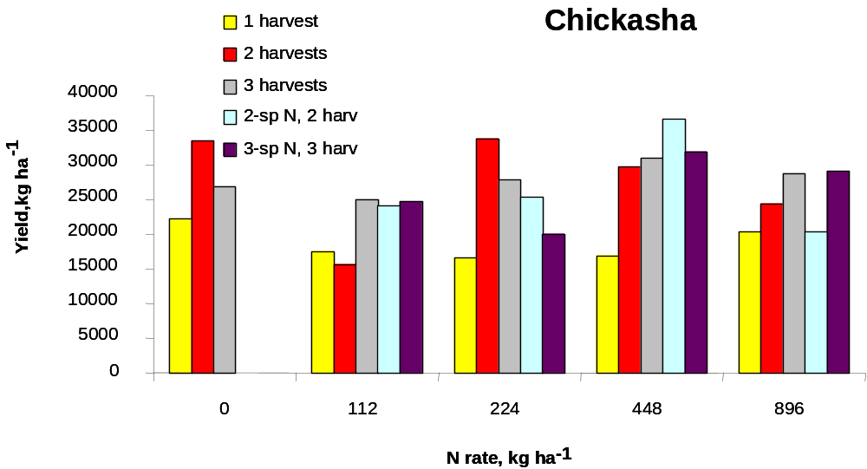

Figure 1. Dry matter yields as a function of harvest frequency and N applied, Chickasha, 1997.

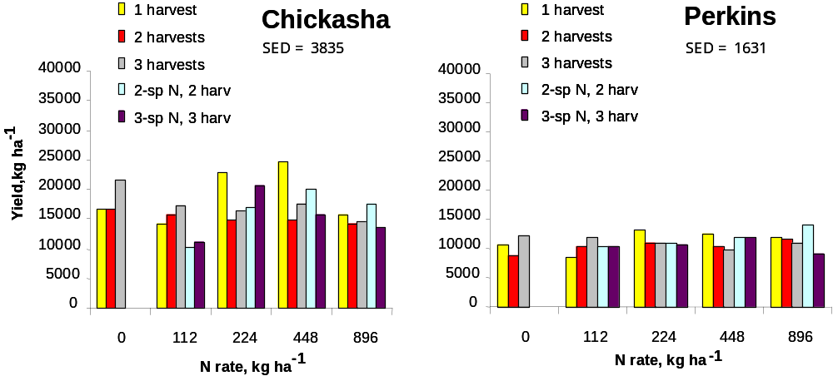

Figure 2. Dry matter yields as a function of harvest frequency and N applied, Chickasha and Perkins, 1998.

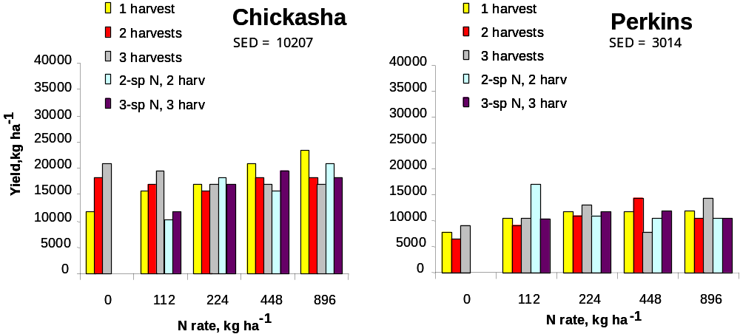

Figure 3. Dry matter yields as a function of harvest frequency and N applied, Chickasha and Perkins, 1999.

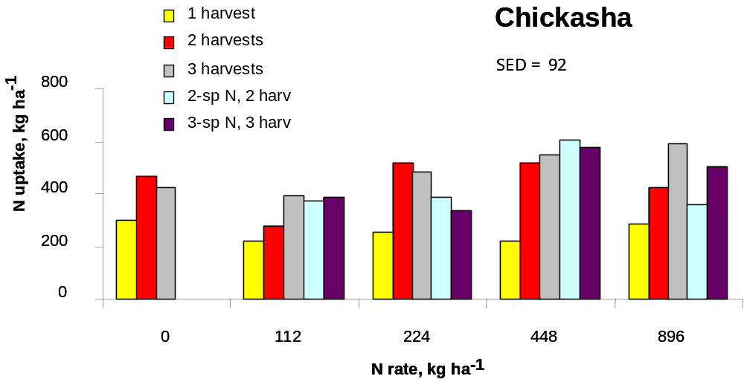
Figure 4. Total forage nitrogen uptake at Chickasha, 1997

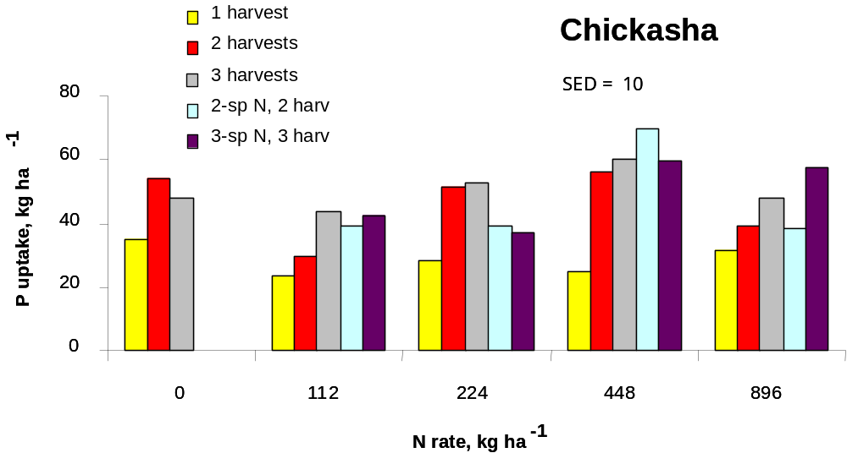
Figure 5. Total forage phosphorus uptake at Chickasha, 1997

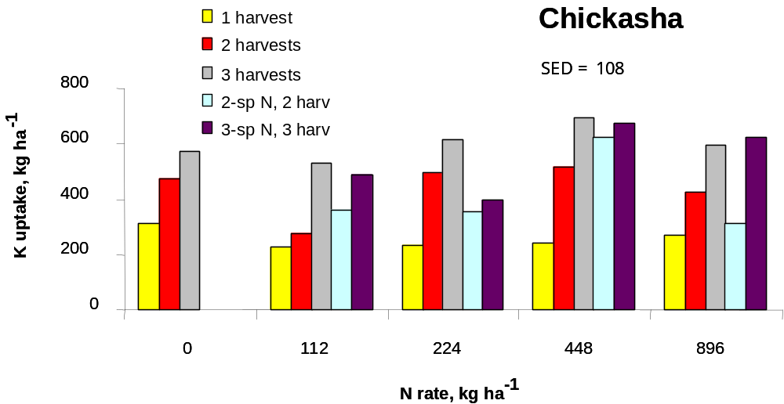
Figure 6. Total forage potassium uptake at Chickasha, 1997

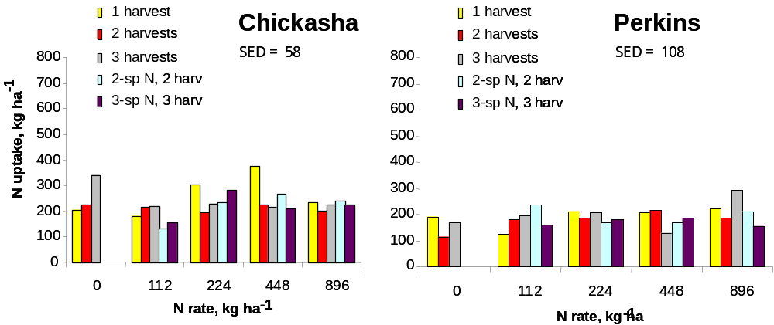

Figure 7. Total forage nitrogen uptake at Chickasha and Perkins, 1998
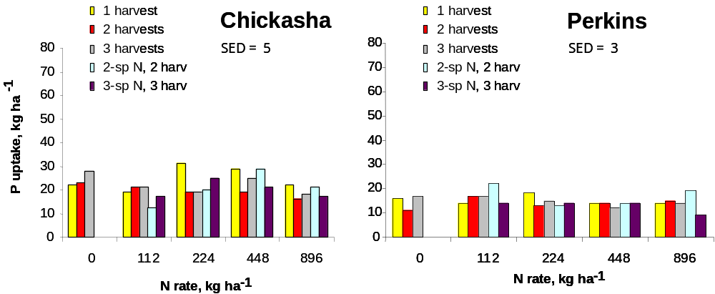

Figure 8. Total forage phosphorus uptake at Chickasha and Perkins, 1998
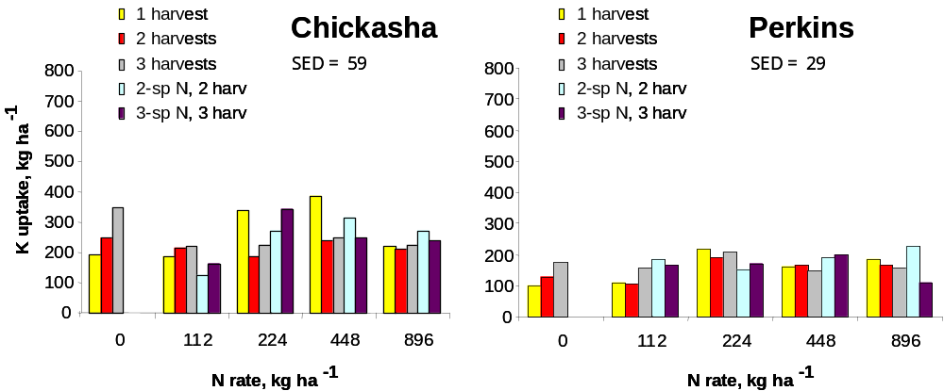

Figure 9. Total forage potassium uptake at Chickasha and Perkins, 1998

Forage Yield and Crude Protein of Interseeded Legume-Bermudagrass Mixtures as Affected by Phosphorus Fertilizer

R. W. Mullen, S. B. Phillips, W. R. Raun,
G. V. Johnson, and W. E. Thomason

ABSTRACT
Bermudagrass (Cynodon dactylon L.) is a warm season perennial that is well adapted in the southern Great Plains. It is one of the region’s most important forage crops used for livestock production, and is commonly grown without legume interseeding. Recent research has investigated ways of improving the quality and quantity of this forage. The objectives of this study were to determine the effect of interseeded legumes and P fertilizer on bermudagrass pasture forage yield and crude protein content. One experiment was initiated in 1993 in eastern Oklahoma in an established bermudagrass pasture. Red clover (Trifolium pratense L.), ladino clover (Trifolium repens L.), and two varieties of alfalfa (Medicago sativa L.), ‘alfagraze’ and ‘common’, were interseeded by hand into an established stand of bermudagrass. The effect of P on forage yield and crude protein was evaluated using a 30-kg P ha⁻¹ rate applied at establishment versus no applied P. Forage yield was collected three times throughout the growing season each year from 1994 through 1997. When both alfalfa varieties were interseeded into a bermudagrass pasture without applying additional P fertilizer, forage yields for the legume-grass mixtures decreased below those obtained from the monoculture bermudagrass in the first year of the stand. The alfalfa variety ‘alfagraze’ interseeded into established bermudagrass decreased total forage yield over the entire 4-yr study. Interseeded red clover and ladino clover increased crude protein of the forage compared with monoculture bermudagrass the first two years of the study, with red clover continuing to increase crude protein in the fourth year. However, when 30 kg P ha⁻¹ was applied to the bermudagrass prior to establishment of the legumes, no change in yield or protein was observed for both alfalfa varieties’ interseeding treatments versus the unfertilized mixtures. Although forage yield may not be increased, interseeding legumes into established bermudagrass could provide an efficient way to improve pasture crude protein without the use of inorganic fertilizers. However, if alfalfa (‘common’ or ‘alfagraze’) is interseeded, additional P may need to be applied at legume establishment to prevent possible yield decreases.

INTRODUCTION
Bermudagrass (Cynodon dactylon L.) is a warm season perennial that is well adapted in the southern Great Plains. It is one of the region’s most important forage crops used for livestock production. Recent research has been conducted to investigate ways of improving the quality and quantity of this forage for animal consumption (Brown and Byrd, 1990; Stringer et al., 1994). Various species of legumes have been reported to perform well in association with bermudagrass, provided the soil moisture and plant nutrient requirements of the legume are met and the mixture is managed properly (Barnes et al., 1995). Early work by Knight (1970) resulted in total forage production being 47% higher in a legume-bermudagrass mixture than monoculture bermudagrass fertilized with 224 kg N ha⁻¹. Other pasture grasses such as intermediate wheatgrass (Agropyron intermedium L.), crested wheatgrass (Agropyron desertorum L.), smooth bromegrass (Bromus inermus L.), and russian wildrye (Elymus junceus L.) have also been reported to result in higher production when competing with legumes than when competing with other grasses (Dubbs, 1971).
Interseeding legumes into bermudagrass and bahiagrass (Paspalum notatum L.) has also been reported to improve seasonal forage distribution by providing usable forage one to two months earlier than monoculture grass (Evers, 1985). Similarly, Baker (1980) reported that interseeding red clover (Trifolium pratense L.) and white clover (Trifolium repens L.) into established pastures increased yield and skewed the seasonal distribution pattern toward a higher percentage of total yields being produced earlier in the season.
Haque and Jutzi (1984) estimated that between 50 and 400 kg N ha⁻¹ can be fixed by different legumes annually, thus making significant contributions to soil fertility, pasture yield and its associated animal production, and any following food crop. Legume species common in the southern Great Plains such as alfalfa (Medicago sativa L.), red clover, and ladino clover (Trifolium repens L.) can symbiotically fix an average of 212 kg N ha⁻¹, 165 kg N ha⁻¹, and 154 kg N ha⁻¹ yr⁻¹, respectively (LaRue and Patterson, 1981). Increased N content of legumes compared to unfertilized bermudagrass is beneficial, as one of the main components of forage quality is crude protein content of the plant. Brown and Byrd (1990) reported that alfalfa had almost twice the crude protein concentration of bermudagrass fertilized with 100 kg N ha⁻¹. Likewise, when fertilized with 500 kg N ha⁻¹, crude protein content of bermudagrass was only 80% of the average of the alfalfa-bermudagrass mixtures.
Although forage legumes benefit pastures and hay crops by fixing N, improving seasonal distribution of growth, and enhancing animal performance, their lack of persistence is viewed as a major limitation. Duration of many legume species in interseeded pasture systems is typically three to five years, however, white clover can usually persist longer due to its capability to propagate vegetatively (Beuselinck et al., 1994). Stringer et al. (1994) reported that alfalfa interseeded into bermudagrass rapidly reduced bermudagrass vigor. This work also noted that grass-legume pastures should contain balanced mixtures of species for quality maintenance and bloat prevention.
It has been suggested that initial soil fertility levels greatly affect the establishment, performance, and persistence of interseeded legumes. After successful establishment of legumes in a grass pasture, persistence of the legumes can improve both quality and quantity of the forage produced. Therefore, the objectives of this study were to determine the effect of interseeded legumes and P fertilizer on bermudagrass pasture forage yield and crude protein.

MATERIALS AND METHODS
One experiment was initiated in the fall of 1993 at the Oklahoma State University Eastern Research Station near Haskell, OK, in an established bermudagrass pasture on a Taloka silt loam (fine, mixed, thermic Mollic Albaqualf). The experimental design employed at this site was a randomized complete block with three replications. Plot size was 4.9 by 12.0 m. Shallow disking (5 to 7 cm) of the bermudagrass was performed prior to legume seeding. Red clover, ladino clover, and two alfalfa varieties ‘common’ and ‘alfagraze’, were interseeded by hand into the established stand of bermudagrass. The ladino clover, due to its small size, was seeded at a rate of 3.4 kg ha⁻¹, while all other species were seeded at 9.0 kg ha⁻¹. The effect of P fertilizer on forage yield and crude protein was evaluated using a 30-kg P ha⁻¹ rate applied at establishment versus no applied P. Phosphorus was applied as single superphosphate (0-20-0) using a conventional dry-fertilizer spreader. After interseeding and fertilization, the entire experimental area was press-wheel packed.
Forage yield was collected three times throughout the growing season, each year from 1994 through 1997. Forage was harvested when legume species reached 50% bloom. Forage yield was determined by harvesting a 1.0 by 12.0-m area from the center of each plot using a self-propelled modified rotary mower (Norton et al., 1995) at a height of 7.6 cm. Harvested biomass was subsampled for moisture determination and chemical analysis. All forage samples were dried in a forced air oven at 70°C and ground to pass through a 150-micron screen. Percent N in the forage was determined on all samples using dry combustion (Schepers et al., 1989). Crude protein content was calculated by multiplying percent N in the forage by 6.25 (Tkachuk, 1969).
Visual ratings of each plot were made prior to the first harvest in 1997 to estimate legume coverage in each plot. Assessment of legume persistence was based on the visual estimates. Following the final harvest of 1997, composite surface soil samples (15 to 20 cores per plot; 0 to 15-cm deep) were collected from each plot and colorimetrically analyzed for Mehlich III extractable P (Mehlich, 1984). Initial and final soil test results at this site are reported in Table 1. Analyses of variance and single degree of freedom contrasts were performed using SAS (SAS, 1990).

RESULTS and discussion
No forage yield or crude protein differences for any of the legume-grass mixtures or the monoculture bermudagrass were observed when comparing plots that received 30 kg P ha⁻¹ in 1993 with plots not receiving the initial application of fertilizer. However, forage yield and crude protein differences between legume-grass mixtures not receiving P at establishment and monoculture bermudagrass not receiving P were observed (Tables 2 and 3). In the first year of the study, both unfertilized varieties of the alfalfa-grass mixtures decreased annual forage production compared with the monoculture bermudagrass (p<0.05; Table 2). Additionally, the red clover-grass mixture at the second harvest in 1994 also produced less forage than the monoculture bermudagrass, although annual forage yields for these treatments were not different (p<0.05; Table 2).
These results agree with Stringer et al. (1994) who noted reduced forage yields when a legume was interseeded into bermudagrass due to a possible shading effect created by the legume. However, when 30 kg P ha⁻¹ was applied at the time of interseeding this yield reduction was not observed. This suggests that although forage yields for specific treatments were not affected by the initial P application, the presence of the additional P in the early years following interseeding may have reduced competition between the legumes and the bermudagrass, thus eliminating any subsequent yield reduction.
Crude protein content was increased in 1994 when red clover or ladino clover was interseeded into unfertilized bermudagrass compared with the unfertilized monoculture treatment (Table 3). This increase was not observed when 30 kg P ha⁻¹ was applied at interseeding. In the case of forage yield, increased competition between the legumes and the bermudagrass in the unfertilized environment appeared to be the cause of decreased yields. Similarly, under P fertilization, more competitive bermudagrass would probably result in a forage mixture lower in crude protein due to a decreased percentage of legumes. These results support Ladd et al. (1986) who reported N₂ fixation by legumes to decrease with increasing competition, which would probably lead to lower crude protein contents.
No change in annual forage yield due to interseeding into unfertilized bermudagrass was observed in 1995 (Table 2). However, the plots which had been interseeded with red clover following the 30-kg P ha⁻¹ application produced greater forage yields than the P-fertilized monoculture bermudagrass (Table 2). Although percent legume coverage was not estimated in 1995, red clover was visually the most prominent legume species compared with the other legume species that had been interseeded. Red clover and ladino clover continued to result in higher annual crude protein averages compared with the monoculture bermudagrass in 1995 in the unfertilized plots (Table 3). Ladino clover also resulted in higher crude protein compared with monoculture bermudagrass at the second harvest of 1995 when P fertilizer was applied (Table 3).
No forage yield differences between interseeded legume-grass mixtures and monoculture bermudagrass were observed for either the P-fertilized or unfertilized plots in 1996. This may have been due to decreased rainfall (66 cm from March to September) compared with the previous two years (78.4 cm from March to September), which limited yields for all treatments (Tables 2 and 3). The only legume-grass mixture resulting in increased crude protein in 1996 was the ‘common’ alfalfa variety interseeded into unfertilized bermudagrass (p<0.10; Table 3). The ‘common’ alfalfa variety which had achieved a poor initial stand in 1994, improved in 1995 and was visually noted to be performing as well as any other species in 1996, although percentage estimates were not documented.
In 1997, the fourth year of the study, annual forage yields were again lowered due to the presence of interseeded legumes in unfertilized plots compared with monoculture bermudagrass (Table 2). The only legume species not decreasing forage yield in the fourth year was the ‘common’ alfalfa variety (Table 2). Similar to the first year of the study, this yield reduction was not observed when 30 kg P ha⁻¹ was applied at establishment of the legumes. Over the entire 4-yr experiment, only the alfalfa variety ‘alfagraze’-bermudagrass mixture resulted in significantly lower forage yields compared with monoculture bermudagrass (p<0.10; Table 2). Only the red clover-bermudagrass mixture increased crude protein content in 1997 (Table 3). Percent legume coverage in each plot was estimated in 1997, and red clover was the most prominent legume species, covering approximately 30% of the plot area. Ladino clover covered about 15% of the plot, while both alfalfa varieties averaged less than 10% coverage of the plot area. The legume species that appeared to be influenced by the P fertility treatment were the alfalfa varieties. The ‘common’ alfalfa variety plots that received 30 kg P ha⁻¹ at establishment were estimated to contain 10 to 12% ‘common’ alfalfa, while plots interseeded without the P fertilizer contained less than 6% ‘common’ alfalfa. Composite surface soil samples revealed that the monoculture bermudagrass plots contained higher residual soil test P than the legume-grass mixtures (19 vs. 11 mg kg⁻¹). This difference resulted in the legume-grass mixtures averaging approximately 80% sufficiency according to calibrated soil tests compared with 94% in the monoculture bermudagrass plots. No difference in percent sufficiency was observed when comparing plots that received the initial P application with those not receiving fertilizer (87 vs. 82%).

CONCLUSIONS
When either of the alfalfa varieties were interseeded into a bermudagrass pasture without applying additional P fertilizer, forage yields for the legume-grass mixtures decreased below those obtained from the monoculture bermudagrass in the first year of the stand. In the fourth year of the stand, both red clover and alfalfa variety ‘alfagraze’ mixtures resulted in decreased yields. The alfalfa variety ‘alfagraze’ interseeded into established bermudagrass decreased total forage yield over the entire 4-yr study.
Interseeded red clover and ladino clover increased crude protein of the forage compared with monoculture bermudagrass the first two years of the study, with red clover continuing to increase crude protein in the fourth year.
When 30 kg P ha⁻¹ was applied to the bermudagrass prior to establishment of the legumes, the initial yield decreases associated with either alfalfa variety were not observed. Additionally, the protein increases associated with red clover and ladino clover were also not observed. However, both forage yield and crude protein when comparing fertilized monoculture bermudagrass or any of the legume-grass mixtures to unfertilized treatments were not affected.
This research suggests that although forage yield may not increase, interseeding legumes into established bermudagrass could provide an efficient way to improve pasture crude protein without the use of inorganic fertilizers. However, if alfalfa (‘common’ or ‘alfagraze’) is interseeded, additional P may need to be applied at legume establishment to prevent possible yield decreases.

REFERENCES
Baker, B.S. 1980. Yield, legume introduction, and persistence in permanent pastures. Agron. J. 72:776-780.

Barnes, R.F., D.A. Miller, and C.J. Nelson. 1995. Forages: An introduction to grassland agriculture. Fifth ed. Iowa
State University Press, Ames, IA.

Bueselinck, P.R., J.H. Bouton, W.O. Lamp, A.G. Matches, M.H. McCaslin, C.J. Nelson, L.H. Rhodes, C.C. Sheaffer, and J.J. Volenec. 1994. Improving legume persistence in forage crop systems. J. Prod. Agric. 7:311-322.

Brown, R.H. and G.T. Byrd. 1990. Yield and botanical composition of alfalfa-bermudagrass mixtures. Agron. J. 82:1074-1079.

Dubbs, A.L. 1971. Competition between grass and legume species on dryland. Agron. J. 63:359-362.

Evers, G.W. 1985. Forage and nitrogen contributions of arrowleaf and subterranean clovers overseeded on bermudagrass and bahiagrass. Agron. J. 77:960-963.

Haque, I. and S. Jutzi. 1984. Nitrogen fixation by forage legumes in sub-Saharan Africa: Potential and limitations. ILCA bulletin 20. Addis Ababa, Ethiopia.

Knight, W.E. 1970. Productivity of crimson and arrowleaf clovers grown in a coastal bermudagrass sod. Agron. J. 62:773-775.

Ladd, J.N., J.H.A. Butler, and M. Amato. 1986. Nitrogen fixation by legumes and their role as sources of nitrogen for soil and crop. p. 183-200. In: J.M. Lopez-Real and R.D. Hodges (eds.) The Role of Microorganisms in a Sustainable Agriculture: Selected Papers from the Second International Conference on Biological Agriculture. Univ. of London, Wye College, Wye, Kent, UK.

LaRue, T. A. and T.G. Patterson. 1981. How much nitrogen do legumes fix? In Advances in Agronomy. Vol. 34. Academic Press Inc. Ithaca, NY.

Mehlich, A. 1984. Mehlich no.3 extractant: A modification of Mehlich no. 2 extractant. Commun. Soil Sci. Plant Anal. 15:1409-1416.

Norton, S.L., W.E. Thomason, S.B. Phillips, S.E. Taylor, and W.R. Raun. 1995. Modification of a self propelled rotary mower for bermudagrass, alfalfa, and wheat forage harvest. p.266. In Agronomy abstracts. ASA, Madison, WI.

SAS Institute. 1990. SAS/STAT user’s guide. Release 6.03 ed. SAS Inst., Cary, NC.

Schepers, J.S., D.D. Francis, and M.T. Thompson. 1989. Simultaneous determination of total C, total N, and 15N on soil and plant material. Commun. In Soil Sci. Plant Anal. 20:949-959.

Stringer, W.C., A. Khalilian, D.J. Undersander, G.S. Stapleton, and W.C. Bridges, Jr. 1994. Row spacing and nitrogen: Effect on alfalfa-bermudagrass yield and botanical composition. Agron. J. 86:72-76.

Tkachuk, R. 1969. Nitrogen-to-protein conversion factors for cereals and oilseed meals. Cereal Chem. 46:419-423.

TABLE 1. Initial soil test (0-15 cm) characteristics prior to treatment application in 1993 and final soil test characteristics of fertilized and unfertilized plots.

Soil Sample | Sample Date | pH | NO₃-N | P |  | K
 |  |  | -------------------------mg kg⁻¹--------------------
Initial Sample | 05/1993 | 5.4 | 0.8 | 15.3 | 55
Final Sample | 10/1997 | 5.8 | 4.2 | 12.9 | 152
NO₃-N – 2 M KCl extract; P, K – Mehlich III; pH – 1:1 soil-water

TABLE 2. Forage yields of unfertilized and fertilized (30 kg P ha⁻¹ applied once in 1993) legume-bermudagrass mixtures at each harvest, annual totals, and overall totals, 1994 through 1997.

 | 1994 |  |  |  | 1995 |  |  |  | 1996 |  |  |  |  |  | 1997 |  |  |  | 94-97
 | -------------------------------------------------------Harvest------------------------------------------------------------------------
 | 1 | 2 | 3 | Total | 1 | 2 | 3 | Total | 1 | 2 |  | 3 |  | Total | 1 | 2 | 3 | Total | Total
---Legume†--- | --------------------------------------------------------Mg ha⁻¹-----------------------------------------------------------------------
--------------------------------------------------------------------------Unfertilized----------------------------------------------------------------------
None | 2.1 | 2.8 | 0.8 | 5.7 | 3.1 | 2.3 | 1.5 | 6.9 | 1.9 |  | 1.9 |  | 0.8 | 4.6 | 2.8 | 3.5 | 2.6 | 9.1 | 26.0
Red Clover | 2.0 | 2.4** | 0.8 | 5.2 | 2.9 | 2.2 | 1.4 | 6.5 | 2.0 |  | 1.6 |  | 0.7 | 4.3 | 3.4 | 3.0 | 2.4 | 8.8** | 24.8
Ladino Clover | 2.6 | 2.5 | 0.9 | 6.0 | 2.9 | 2.3 | 0.9** | 6.2 | 2.1 |  | 1.7 |  | 0.7 | 4.6 | 3.2 | 3.4 | 2.3 | 8.9* | 24.8
Alfalfa ‘Common’ | 2.0 | 1.8*** | 0.7 | 4.5*** | 2.7 | 2.3 | 1.3 | 6.3 | 2.2 |  | 1.9 |  | 0.6 | 4.7 | 3.5 | 3.1 | 2.4 | 9.0 | 24.4
Alfalfa ‘Alfagraze’ | 2.1 | 2.0*** | 0.7 | 4.8** | 2.9 | 2.2 | 1.4 | 6.5 | 2.4 |  | 1.7 |  | 0.8 | 4.8 | 2.7 | 3.1 | 2.4 | 8.2*** | 22.8
---------------------------------------------------------------------------30 kg P ha⁻¹---------------------------------------------------------------------
None | 2.3 | 2.3 | 0.7 | 5.3 | 2.8 | 2.5 | 1.1 | 6.4 | 2.1 |  | 1.7 |  | 0.7 | 4.5 | 2.4 | 3.4 | 2.3 | 8.1 | 24.3
Red Clover | 2.0 | 2.1 | 0.6 | 4.7 | 2.9 | 3.1* | 1.2 | 7.2 | 2.2 |  | 1.7 |  | 0.6 | 4.5 | 2.7 | 3.1 | 2.3 | 8.1 | 24.5
Ladino Clover | 2.2 | 2.2 | 0.8 | 5.2 | 2.8 | 2.3 | 1.2 | 6.3 | 1.9 |  | 1.8 |  | 0.7 | 4.4 | 2.7 | 3.5 | --- | 6.2 | 22.1
Alfalfa ‘Common’ | 2.5 | 2.1 | 0.6 | 5.2 | 3.0 | 2.5 | 1.2 | 6.7 | 1.5 |  | 1.8 |  | 0.7 | 4.0 | 3.0 | 3.4 | 2.6 | 9.0 | 24.9
Alfalfa ‘Alfagraze’ | 2.1 | 2.1 | 0.7 | 4.9 | 3.2 | 2.6 | 1.3 | 7.1 | 1.7 |  | 1.7 |  | 0.6 | 4.0 | 3.4** | 3.3 | 2.5 | 9.2 | 25.2
† - Interseeded into an established bermudagrass pasture in 1993; ‡ - monoculture bermudagrass
***, **, * - significantly different from monoculture at p < 0.01, 0.05, and 0.1, respectively as determined using single degree of freedom contrasts
TABLE 3. Crude protein contents of unfertilized and fertilized (30 kg P ha⁻¹ applied once in 1993) legume-bermudagrass mixtures at each harvest and yearly averages, 1994 through 1997.

 | 1994 |  |  |  | 1995 |  |  |  | 1996 |  |  |  |  | 1997
 | -------------------------------------------------------Harvest------------------------------------------------------------
 | 1 | 2 | 3 | Avg. | 1 | 2 | 3 | Avg. |  | 1 | 2 | 3 | Avg. |  | 1 | 2 | 3 |  | Avg.
---Legume†--- | --------------------------------------------------------Mg ha⁻¹------------------------------------------------------------
--------------------------------------------------------------------------Unfertilized-----------------------------------------------------------
None | 196 | 134 | 147 | 159 | 154 | 192 | 142 | 162 |  | 97 | 112 | 118 | 109 |  | 79 | 137 | 100 | 105
Red Clover | 216 | 159* | 164 | 180* | 180 | 211 | 147 | 179*** |  | 100 | 110 | 139 | 116 |  | 89 | 142 | 110 | 114*
Ladino Clover | 185 | 158 | 203*** | 182* | 175 | 217 | 160 | 184*** |  | 99 | 109 | 137 | 115 |  | 68 | 127 | 103 | 99
Alfalfa ‘Common’ | 188 | 142 | 155 | 162 | 165 | 209 | 132 | 168 |  | 116* | 115 | 159** | 130* |  | 81 | 124 | 109 | 105
Alfalfa ‘Alfagraze’ | 174 | 142 | 156 | 157 | 161 | 208 | 137 | 169 |  | 110 | 113 | 103 | 109 |  | 79 | 125 | 108 | 104
---------------------------------------------------------------------------30 kg P ha⁻¹----------------------------------------------------------
None | 167 | 134 | 162 | 154 | 167 | 191 | 143 | 167 |  | 95 | 114 | 136 | 115 |  | 81 | 123 | 99 | 101
Red Clover | 190 | 144 | 173 | 169 | 179 | 174 | 140 | 164 |  | 101 | 114 | 125 | 113 |  | 73 | 134 | 126* | 111
Ladino Clover | 191 | 149 | 197* | 179* | 182 | 216** | 143 | 180 |  | 92 | 110 | 134 | 112 |  | 95 | 147 | 85 | 109
Alfalfa ‘Common’ | 169 | 143 | 135 | 149 | 162 | 181 | 132 | 158 |  | 104* | 113 | 143 | 120 |  | 109 | 120 | 114 | 114
Alfalfa ‘Alfagraze’ | 181 | 129 | 136 | 149 | 154 | 172 | 129 | 152 |  | 107** | 111 | 130 | 116 |  | 95 | 159 | 104 | 119
† - Interseeded into an established bermudagrass pasture in 1993; ‡ - monoculture bermudagrass
***, **, * - significantly different from monoculture at p < 0.01, 0.05, and 0.1, respectively as determined using single degree of freedom contrasts

Soybean Grain Yield and Protein Responses to Rate, Source, and Timing of Application of Fertilizer N

R.W. Mullen, S.B. Phillips, W.E. Thomason, W.R. Raun, and G.V. Johnson

ABSTRACT
Soybean (Glycine max L. Merr.) is an important legume crop worldwide. Although legumes meet their N requirement through rhizobial symbiosis, small amounts of N as starter fertilizer are commonly used when establishing soybeans. Despite the many advantages of starter fertilizers, there is evidence to suggest that inorganic N applied at planting can effectively inhibit N₂ fixation. Application of N at early flowering, when N is most needed, may provide the same benefits as starter N without adversely affecting rhizobium populations. Therefore, the objective of this study was to evaluate the effects of N rate, source, and timing of application on soybean grain yield and protein. One study was initiated in the summer of 1996 in eastern Oklahoma. Three N rates (22, 44, and 67 kg ha⁻¹) were evaluated using ammonium nitrate (34-0-0) and anhydrous ammonia (82-0-0). The fertilizer was applied either preplant (early June) or at flowering (early August). No increases in grain yield for either N source were found to exist in the first year of the study. However, a yield decrease was observed when 67 kg N ha⁻¹ as anhydrous ammonia was applied at flowering. In the second and third year, an increase in grain yield was observed when 45 kg N ha⁻¹ as anhydrous ammonia was applied at planting. A similar increase in grain yield was found when 45 kg N ha⁻¹ as anhydrous ammonia was applied at flowering in the third year of the study. No treatments resulted in significant increases in grain protein when compared to the checks in any of the trial years.

INTRODUCTION
Soybean (Glycine max L. Merr.) is one of the most important legume crops in the world today. Soybean is used for human consumption, processed foods, and livestock products. Soybean meal is an exceptional source of protein (≈40%; www.soyfoods.com) and also provides a high quality edible oil. Oklahoma soybean production has primarily been limited to the eastern one-third of the state. Currently, more soybean is being produced in the central and western regions of the state as part of crop rotations or in double-cropping systems with winter wheat (Triticum aestivum L.). Soybean is popular for these types of systems because it is a legume crop, which can provide a residual N source for subsequent crops.
Although legumes meet their N requirement through rhizobial symbiosis, some producers prefer to use small amounts of N as starter fertilizer when establishing soybean. Such starter fertilizer provides a plant-available source of N within the rooting zone of young seedlings (Touchton and Rickerl, 1986). Advantages of early seedling stimulation using N fertilizer include increased resistance to insects and diseases, increased competitiveness with weeds, and early maturity. Starter fertilizer can be particularly effective if soil N levels are low, resulting in decreased initial nodulation and N production, thus not providing sufficient N for early season growth (Hatfield et al., 1974). In addition, various researchers, including Soon and Miller (1977), have reported the presence of NH₄⁺ ions in the soil to be associated with increased P uptake, resulting in higher yields.
Despite the many advantages of this practice, there is evidence to suggest that inorganic N applied at planting can effectively inhibit N₂ fixation. In fact, the amount of symbiotically fixed N decreased with increases in available soil N or fertilizer N (Bhangoo and Albritton, 1976). Researchers have found that fertilizer N decreases nodulation (Weber, 1966) and therefore, limits the space available for bacteria to enzymatically convert atmospheric N into ammonia.
Scientists have recently identified a gene that regulates hypernodulation in soybean root systems (www.ars.usda.gov). If scientists learn how to regulate nodule number and therefore, increase N₂ fixation, starter fertilizer may no longer be an issue. Until then, alternative methods of N application, in terms of timing, need to be evaluated. Research has indicated that foliar application of a NPKS solution during the seed-filling period significantly increased soybean yields (Garcia and Hanway, 1976). This suggests that application of N at early flowering, when N is needed most, may provide the same yield benefits as starter N without adversely affecting rhizobium populations. Research conducted on grassland, winter wheat, and rice indicate the benefits of late-season N applications. A study conducted on upland swards in Wales found that crude protein levels in the herbage were increased by increasing the rate of N and delaying application until late in the season (Skinner and Allen, 1991). Linquist et al. (1992) found that late-season N applications followed by irrigation can lead to efficient N uptake and increased grain protein in winter wheat. Perez et al. (1996) reported N fertilizer applied at flowering increased protein content and quality of market rice. Therefore, the objective of this study was to evaluate the effects of N rate, source, and timing of application on soybean grain yield and protein.

MATERIALS AND METHODS
One study was initiated in the summer of 1996 at the Oklahoma State University Eastern Research Station, Haskell, Oklahoma, on a Taloka silt loam (fine-mixed, thermic Mollic Albaqualf). Initial soil test characteristics (0-15 cm) are reported in Table 1. The experimental design employed was a randomized complete block with three replications. Plot size was four 76-cm rows by 7.6 m.
Three N rates (22, 44, and 67 kg ha⁻¹) were evaluated using ammonium nitrate (34-0-0) and anhydrous ammonia (82-0-0). The fertilizer was applied either preplant (early June) or at flowering (early August). The ammonium nitrate was broadcast applied using a conventional dry fertilizer spreader. The ammonia was injected to a 15-cm depth using a custom-built applicator equipped with three knives spaced 76 cm apart. Phosphorus and potassium were applied at rates of 30 kg P ha⁻¹ and 84 kg K ha⁻¹, respectively, to the entire experimental area at establishment each year.
A maturity group VI variety ‘Choska’ was planted in 76-cm rows at a rate of 43 kg ha⁻¹. The experiment was cultivated as needed for weed control. The center two rows from individual plots were harvested using a Massey-Ferguson 8XP self-propelled grain combine. Subsamples were collected from each plot for total N analysis using a Carlo Erba NA 1500 dry combustion analyzer (Schepers et al., 1989). Analyses of variance and single degree of freedom contrasts were performed using SAS (SAS, 1990).

RESULTS
Riley and Barber (1971) demonstrated that NH₄⁺ is often superior to NO₃⁻ in stimulating P uptake, thus increasing yields. However, no increases in grain yield due to N source when applied at planting were found in the first year of the study (Table 2). A decrease in yield was observed when 67 kg N ha⁻¹ as anhydrous ammonia was applied at flowering. This yield reduction was not observed at other rates of anhydrous ammonia applied at flowering or when ammonium nitrate was the N source. Protein content was not determined the first year of the study. In 1997, only 45 kg N ha⁻¹ as anhydrous ammonia applied at planting resulted in increased yield (Table 2). No treatments resulted in significant protein increases as compared to the checks (Table 3). In the last year of this study, two treatments resulted in significant yield increases. An increase in grain yield was found when 45 kg N ha⁻¹ as anhydrous ammonia was applied both at planting and flowering (Table 2). As was the case in 1997, no differences in protein content were observed as a result of fertilizer N applied either at planting or flowering (Table 3).

REFERENCES
Bhangoo, M.S. and D.J. Albritton. 1976. Nodulating and non-nodulating lee soybean isolines response to applied nitrogen. Agron J. 68:642-645.

Garcia, R.L., and J.J. Hanway. 1976. Foliar fertilization of soybeans during the seed-filling period. Agron J. 68:653-657.

Hatfield, J.L., D.B. Egli, J.E. Leggett, and D.E. Peaslee. 1974. Effect of applied nitrogen on the nodulation and early growth of soybean. Agron J. 66:112-114.

Linquist, B.A., K.G. Cassman, A.E. Fulton, and L.F. Jackson. 1992. Late-season nitrogen may be efficient way to increase winter wheat protein. Calif. Ag. 46(2):13-16.

Perez, C.M., B.O. Juliano, S.P. Liboon, J.M. Alcantara, and K.G. Cassman. 1996. Effects of late nitrogen fertilizer application on head rice yield, protein content, and grain quality of rice. Cereal Chem. 73(5):556-560.

Riley, D. and S.A. Barber. 1971. Effect of ammonium and nitrate fertilization on phosphorus uptake as related to root-induced pH changes at the root-soil interface. Soil Sci. Soc. Amer. Proc. 35:301-306.

SAS Institute. 1990. SAS/STAT user’s guide. Release 6.03 ed. SAS Inst., Cary, NC.

Schepers, J.S., D.D. Francis, and M.T. Thompson. 1989. Simultaneous determination of total C, total N, and ¹⁵N on soil and plant material. Commun. in Soil Sci. Plant Anal. 20(9&10):949-959.

Skinner, R.J. and J.W. Allen. 1991. Response to late season nitrogen of upland swards in Wales. Grass and Forage Sci. 46:269-276.

Soon, Y.K. and M.H. Miller. 1977. Changes in the rhizosphere due to NH₄⁺ and NO₃⁻ fertilization and phosphorus uptake by corn seedlings (Zea mays L.). Soil Sci. Soc. Am. J. 41:77-80.

Touchton, J.T. and D.H. Rickerl. 1986. Soybean growth and yield responses to starter fertilizer. Soil Sci. Soc. Am. J. 50:234-237.

Weber, C.R. 1966. Nodulating and non-nodulating soybean isolines. II. Response to applied nitrogen and modified soil conditions. Agron J. 58:46-49.

TABLE 1. Initial soil test characteristics (0-15 cm) for Haskell, OK, 1996.

Organic C | Total N | NH₄-N | NO₃-N | P | K | pH
--------g kg⁻¹--------- |  | ---------------------mg kg⁻¹--------------------
8.1 | 0.6 | 21.9 | 7.91 | 29.6 | 124 | 6.3
%C (organic C), %N (total N) - dry combustion; NH₄-N, NO₃-N - 2M KCl extract; P, K - Mehlich III; pH - 1:1 soil-water.

TABLE 2. Soybean grain yield response to N fertilizer applied at planting and flowering, Haskell, OK, 1996 to 1998.
Time of  Application | N Sourceª | N Rate | 1996  Yield | 1997  Yield | 1998  Yield
 |  | ----kg ha⁻¹---- | ------------------Mg ha⁻¹--------------------
- | - | 0 | 1.12 | 1.82 | 0.86
Planting | AA | 22 | 1.10 | 1.84 | 0.97
Planting | AA | 45 | 1.21 | 2.08 | 1.10
Planting | AA | 67 | 1.05 | 1.65 | 1.05
Flowering | AA | 22 | 1.19 | 1.92 | 0.92
Flowering | AA | 45 | 0.96 | 1.78 | 1.13
Flowering | AA | 67 | 0.61 | 1.90 | 0.96
Planting | AN | 22 | 1.04 | 1.70 | 0.91
Planting | AN | 45 | 1.01 | 1.79 | 0.95
Planting | AN | 67 | 1.03 | 1.82 | 0.98
Flowering | AN | 22 | 1.14 | 1.71 | 1.01
Flowering | AN | 45 | 0.97 | 1.79 | 1.00
Flowering | AN | 67 | 1.14 | 1.82 | 0.98
 |  | SED^{b} | 0.12 | 0.14 | 0.11
ª – AN-ammonium nitrate (34-0-0), AA-anhydrous ammonia (82-0-0); ^{b} – SED-standard error of the difference between two equally replicated treatment means

TABLE 3. Soybean protein content in response to N fertilizer applied at planting and flowering, Haskell, OK, 1997 to 1998.
Time of  Application | N Sourceª | N Rate | 1997  Protein | 1998  Protein
 |  | ----kg ha⁻¹---- | --------------g kg⁻¹--------------
- | - | 0 | 424 | 467
Planting | AA | 22 | 411 | 490
Planting | AA | 45 | 430 | 480
Planting | AA | 67 | 450 | 462
Flowering | AA | 22 | 414 | 448
Flowering | AA | 45 | 445 | 472
Flowering | AA | 67 | 448 | 468
Planting | AN | 22 | 430 | 461
Planting | AN | 45 | 414 | 463
Planting | AN | 67 | 383 | 468
Flowering | AN | 22 | 426 | 464
Flowering | AN | 45 | 408 | 456
Flowering | AN | 67 | 419 | 469
 |  | SED^{b} | 26 | 14
ª – AN-ammonium nitrate (34-0-0), AA-anhydrous ammonia (82-0-0); ^{b} – SED-standard error of the difference between two equally replicated treatment means

Alfalfa Yield Response to Nitrogen Applied After Each Cutting

W.R. Raun*, G.V. Johnson, S.B. Phillips,
W.E. Thomason, J.L. Dennis, and D.A. Cossey

Abstract
Although alfalfa (Medicago sativa L.) usually obtains a high percentage of its required nitrogen (N) via symbiotic N fixation, additional fertilizer N applied once in the spring can increase forage yields. However, little is known about alfalfa yield response to low N rates (< 50 kg N ha⁻¹) immediately following each cutting. Low N rates (immediately following each cutting) were evaluated for total alfalfa dry matter production on a Grant silt loam (fine-silty, mixed, thermic, Udic Argiustoll). This non-irrigated experiment was initiated on a 2-yr old alfalfa stand where sufficient phosphorus (P) and potassium (K) had been applied. Nitrogen rates of 11, 22, and 44 kg N ha⁻¹ were applied immediately following each cutting for five years (4-5 cuttings yr⁻¹). After five years of continuous N application, no differences in soil NH₄-N or NO₃-N were found at depths > 15 cm (sampled 0 to 240 cm). In 1994, total alfalfa dry matter yield (sum of five harvests) increased 1.29 Mg ha⁻¹ from a total annual N application of 110 kg N ha⁻¹ (22 kg N ha⁻¹ following each cutting). Total forage N decreased from the second to the fifth harvest in most years. By-harvest dry matter yield increases due to applied N were only found in late-season harvests, consistent with late-season decreased N₂-fixing capacity in alfalfa documented by others.

Introduction
Nutrient use efficiency has been investigated in alfalfa production systems for many of the essential macro and micro elements. However, except for investigating N needs for stand establishment, these studies have not examined in-season applied N following each harvest on established stands.
Woodhouse and Griffith (1975) found that fertilizer N applied to legumes was not beneficial. They noted that applied N tends to cause N-fixing bacteria to cease fixation and may then replace, rather than supplement, the N that normally would be fixed. Similar results were reported by Markus and Battle (1965). Alternative work by Fishbeck and Phillips (1981) concluded that Rhizobium symbiosis cannot produce sufficient reduced N for optimum alfalfa growth during stand establishment, because N fertilization increased yields and percent N in the first two regrowth cycles while having no benefit at later stages.
Increased alfalfa yield from applied fertilizer N has been observed under irrigation and/or simulated irrigated conditions (Fishbeck and Phillips, 1981; Feigenbaum and Hadas, 1980) and non-irrigated environments (Schertz and Miller, 1972; Nutall, 1985; Eardly et al., 1985). A comprehensive review by Hannaway and Shuler (1993) reported that fertilizer N applied at planting can increase yields when soils are low in N (< 15 mg kg⁻¹ nitrate) or organic matter (< 15 g kg⁻¹).
Recently, Lamb et al. (1995) showed that in spite of fertilizer N application of up to 840 kg ha⁻¹, biological nitrogen fixation (BNF) in alfalfa continued to take place, and that alfalfa obtained 20-25% of its N from BNF. In a cool northern climate, Nuttall (1985) found that a one-time N application (45 kg N ha⁻¹) in early spring significantly increased alfalfa dry matter production when compared to the check (0-N), but that this practice was not economical. Feigenbaum and Hadas (1980) showed that 100 kg N ha⁻¹ as ammonium sulfate applied after the first cutting in the spring increased alfalfa yields. This same work also found that fertilizer N recovery was greatest in the first two cuttings, in an arid environment using supplemental irrigation. Kunelius (1974) found that N applied at seeding increased first but not second cutting yields, and increased weed growth in trials conducted near Charlottetown, Prince Edward Island, Canada.
Daliparthy et al. (1995) found that dairy manure can be applied to alfalfa immediately after the first cutting in June (Massachusetts, USA) at rates ranging between 112 and 336 kg N ha⁻¹ without any adverse effects on herbage yield or weed incidence and with no economic risk to productivity. Goss and Stewart (1979) found that feedlot manure had a higher P utilization efficiency than superphosphate, however, they did not consider the N contributions from manure on alfalfa yield and did not report total protein content in the alfalfa forage. Application of N fertilizer to alfalfa as ammonium nitrate or dairy manure at a rate of 112 kg N ha⁻¹ yr⁻¹ had no effect on dry matter yields, N accumulation in herbage, nor soil NO₃-N at depths 0-15, 25-50 and 50-100 cm in Massachusetts (Daliparthy et al., 1994). However, increased soil water NO₃-N concentrations were observed when a rate of 336 kg N ha⁻¹ yr⁻¹ was applied compared to the 0-N check, thus having the potential to adversely impact water quality.
One-time N applications up to 224 kg N ha⁻¹ did not increase soil profile NO₃-N in alfalfa, therefore, alfalfa was considered to have a value in a rotation for reducing soil profile NO₃-N, which can accumulate in continuous corn (Schertz and Miller, 1972). Campbell et al. (1994) noted that deep-rooted forage crops such as alfalfa can remove NO₃-N and water to a depth of 2.4 m. They also reported that considerable NO₃-N leaching can occur, especially if legume plowdown is followed by a fallow period, when N mineralization increases with increased soil moisture storage in fallow systems. Blumenthal and Russelle (1996) showed that non-N₂-fixing alfalfa cultivars would be more useful for bioremediation of nitrate-contaminated sites.
The rationale for this work is that favorable growing conditions immediately following harvest may create a growth potential and plant-N requirement that may exceed Rhizobium meliloti N supplying capacity. The objectives of this experiment were to evaluate the effect of applying low N rates (11-44 kg N ha⁻¹) following each cutting on alfalfa dry matter production and forage N removed, and to characterize soil profile inorganic N accumulation following long-term N applications in a perennial legume production system.

Materials and Methods
A field experiment was initiated on a Grant silt loam to evaluate applications of low N rates applied immediately following each cutting on total alfalfa dry matter production. The experimental area (North Central Research Station near Lahoma, OK) was selected from a weed-free 2-yr old alfalfa stand where sufficient P and K had been applied. Initial soil test analyses from a composite surface (0-15 cm) sample collected from the entire experimental area (May 16, 1992) prior to treatment establishment is reported in Table 1. Rates of 11, 22, and 44 kg N ha⁻¹ were applied following each cutting from 1992 to 1996 (total of 24 cuttings), excluding the final harvest of 1992 on September 28 when no fertilizer was applied following harvest. Nitrogen was applied as ammonium nitrate (34-0-0, N-P-K). Check (no N applied) and 22 kg N ha⁻¹ + 4480 kg dolomitic limestone ha⁻¹ treatments (lime only applied once at the start of the experiment) were included within a randomized complete block design with four replications. Plots were 4.9 m wide by 15 m in length. For each harvest date, alfalfa was cut 5 cm above the ground using a John Deere GT262 garden tractor with a 96 cm deck that was modified for forage collection. Harvest area from each plot was 5.8 m², from which total biomass was weighed and subsampled for moisture and total N analysis. Harvest and fertilization dates for the years the study was conducted are reported in Table 2. Alfalfa yields were determined on a dry weight basis. For each harvest, alfalfa forage samples were ground to pass a 0.125 mm sieve (120 mesh) and analyzed for total N using a Carlo-Erba (Milan, Italy) NA-1500 dry combustion analyzer (Schepers et al., 1989). Total N removal was calculated by multiplying dry matter yield by forage N content.
Because interests were in annual production, analysis of variance was performed on the sum of dry matter production and total N removed for each yr. By-harvest analysis of variance within years (harvest, split-in-time) was used for specific by-harvest data reported in Fig. 1 and 2. Significance of specific treatment comparisons was determined using non-orthogonal contrasts. The standard error of the difference (SED) between two equally replicated treatment means is reported in Tables 1, 3 and 4, and Fig. 1, 2 and 3. Significant treatment differences can be approximated by multiplying SED by 2.0 (value of t from t-table, significance level α, and degrees of freedom in residual error).
Following the final harvest in 1996, two soil cores 4.5 cm in diameter were taken to a depth of 240 cm from each plot and divided into increments of 0-15, 15-30, 30-45, 45-60, 60-90, 90-120, 120-150, 150-180, 180-210, and 210-240 cm. Samples were air-dried at ambient temperature and ground to pass a 0.075 mm sieve (200-mesh). Samples were extracted using 2M KCl (Bremner, 1965) and analyzed for NH₄-N and NO₃-N using an automated flow injection analysis system (Lachat, 1989, 1990). Accumulation of NH₄-N and NO₃-N was determined on the mean of the two cores after concentration was converted to kg ha⁻¹ based on measured bulk density to a depth of 240 cm. Total soil N and organic C were determined using a Carlo-Erba NA 1500 dry combustion analyzer (Schepers et al., 1989). Apparent nitrogen use efficiency (NUE) was determined by subtracting the total sum of forage N removed over 5 years in the check plot (no N applied) from N removal in plots receiving additional N and dividing by the total amount of N applied over 5 years.

Results
Rainfall from 1992 to 1996 was generally higher than normal for this site located in a region where dryland continuous winter wheat (Triticum aestivum L.) is the common crop. Average annual rainfall at this site is 794 mm, and the majority of the total (527 mm) is received during the growing season months of May to October. During the course of this experiment, rainfall departure from normal for May through October was +2, +66, -63, +191, and +147 mm for 1992, 1993, 1994, 1995 and 1996, respectively.
Analysis of variance for total alfalfa dry matter yield and N removed by yr (4 to 5 harvests yr⁻¹) is reported in Table 3. The main effect of treatment was not significant from 1992 to 1995. This is evident in the small differences in total by-yr yield and N removed means (Table 3). However, a significant quadratic response to applied N was detected in the single-degree-of-freedom non-orthogonal contrast in 1994. Over the five harvests in 1994, a yield increase of 1.29 Mg ha⁻¹ was observed when comparing the 22 kg N ha⁻¹ treatment to the check where no N was applied (Table 3). In general the 44 kg N ha⁻¹ cutting⁻¹ rate tended to result in somewhat lower yields and N removed when compared to the 11 and 22 kg N ha⁻¹ cutting⁻¹ rates (Table 3).
Total yield and N removed were greatest in 1994 than in the other four years. Demand for N was therefore expected to be greater during this yr. Timely but not excessive rainfall and the lack of excessively high temperatures from July to August presumably contributed to increased yields and a significant N response. In 1996, a significant depression in alfalfa yield was found from applied N. Although soil pH declined significantly from 1992 to 1996, and pH decreased with increasing rates of applied N, soil pH levels remained above 6.0 that is considered suitable for alfalfa production (Table 1). Soil test P and K declined over the five-yr period, were not affected by treatment, and remained above 85 and 100% sufficiency at the end of the experiment, respectively (Johnson et al., 1997).
Alfalfa dry matter yield and N removed over the entire five-yr period are reported in Table 4 along with analysis of variance. Differences in total N removed by yr were generally small. Treatment differences for alfalfa protein were very similar to results reported for total N removed (data not reported). When evaluated over the five-yr period as would be of interest for alfalfa producers, no significant treatment differences in either yield or N removed were apparent. Estimated N use efficiencies were all less than 18.6% (Table 4).
The application of dolomitic limestone (4480 kg ha⁻¹) did not produce a significant response in yield or N removal (Tables 3 and 4). This treatment was evaluated based on work by Fenn et al. (1991) that reported increased ammonium absorption with increased calcium supply even on calcareous soils. Similarly, the initial soil pH was relatively high (7.2) at this site although no significant response was found either by harvest or over years.
By-harvest yield differences
Significant yield increases as a result of applying N immediately following harvest were detected only on 3 of the 24 harvest dates (Fig. 1 and Table 2). These took place on October 5, 1993 (22 kg N ha⁻¹), August 12, 1994 (11 and 22 kg N ha⁻¹), and October 6, 1995 (11 and 22 kg N ha⁻¹). For these three dates, yield increases (percent of check yield) ranged from 17 to 26%. These increases all took place in either the last or second to last harvest. This was consistent with work by Jenkins and Bottomley (1984) who demonstrated that the number of effective nodules in alfalfa plants declined from the first to the third harvest suggesting the possible need for added N later in the season. Response to added fertilizer N observed by Jenkins and Bottomley (1984) took place in the third and final harvest. For the growing periods encompassing the three dates where we observed significant increases in yield, rainfall received since the previous cutting ranged between 58 and 82 mm and was generally evenly distributed over the 30 to 40-day growing periods. For some of the growing periods, much higher than normal rainfall (> 200 mm) was received over relatively short periods of time (Table 2). Although single harvest yield increases in excess of 0.4 Mg ha⁻¹ were observed on several dates, treatment variability was high, thus reducing the number of significant responses (Fig. 1).
Using $0.11 kg⁻¹ of alfalfa ($100/ton), $0.62 kg⁻¹ of N as 34-0-0 ($190/ton), and $2.00 application cost per cutting (23 total applications), applying 11 kg N ha⁻¹ following each cutting resulted in a net loss of $42 ha⁻¹. Similarly, applying 22 kg N ha⁻¹ following each cutting would have resulted in a net loss of $125 ha⁻¹ over the five-yr period.
Total forage N
Total forage N in the check plot (no N applied) and the 22 kg N ha⁻¹ treatment is reported by harvest and yr in Fig. 2a and 2b, respectively. Excluding the first yr of the study, forage N tended to decline from the second to the fifth harvest. This paralleled work by Jenkins and Bottomley (1984) who found decreased tissue N and effective nodules with advancing harvest. They attributed this to a seasonal decline in the N₂-fixing capacity of the alfalfa plants. Also, similar to the work of Jenkins and Bottomley (1984), the three significant yield increases as a result of applying N reported here took place in either the last or second to last harvest.
Soil profile inorganic N accumulation
Soil profile accumulation of NH₄-N and NO₃-N following five years of alfalfa production where N was applied following each cutting is illustrated in Fig. 3. Surface (0-15 cm) NO₃-N levels in plots receiving additional N generally were higher compared to no N. Surface NH₄-N levels were significantly higher where 44 kg N ha⁻¹ had been applied following each harvest, but no differences were detected when compared to the check for the lower N rates. No significant differences among treatments were found for NH₄-N or NO₃-N at depths > 15 cm. Although there were significant treatment differences in surface NH₄-N and NO₃-N, neither exceeded 50 kg ha⁻¹ which indicates that these amounts were apparently residual from the last one to two years.

Discussion and Conclusions
For this five-yr study, total fertilizer N applied to alfalfa exceeded 1.0 Mg N ha⁻¹, for the 44 kg N ha⁻¹ cutting⁻¹ treatment (Table 4). Because total alfalfa forage N removed was similar in plots with or without added fertilizer N, and no increase in soil profile inorganic N accumulation was observed, the soil-plant system was apparently able to compensate for the surplus N. If increased subsoil inorganic N accumulation were an indicator of increased risk for NO₃-N leaching (Westerman et al., 1994), applied fertilizer N in this non-irrigated alfalfa experiment cannot be considered to increase leaching risk. Soil-plant buffering was proposed by Johnson and Raun (1995) to explain why limited amounts of inorganic N were found in soil profiles of long-term wheat experiments, even when N rates exceeded that required for maximum yield. Their work documented the fates of inorganic N that can take place before leaching (storage in soil organic matter, removal by increased plant uptake and gaseous N loss from soil and plants) and that buffer against accumulation of soil profile inorganic N. Lamb et al. (1995) found that BNF in alfalfa declined with increasing N fertilization, but that BNF was not reduced to zero, even with high N fertilization. Because no increase in soil profile inorganic N accumulation was observed in this study (Fig. 3), BNF likely was lower in plots receiving additional fertilizer N, especially since total N removed was similar for fertilized and non N fertilized plots. Increased total N in the surface (0-15 cm) horizon was evident at the 44 kg N ha⁻¹ rate (Table 1), however, no differences in total N were noted at depths > 15 cm (data not reported). Decreased BNF as a result of adding fertilizer N is yet another buffering mechanism in a legume production system, and this helps explain why no observed increase in soil profile inorganic N accumulation was found.
This work suggests that low N rates can be applied to alfalfa following each cutting without increasing the risk of subsurface NO₃-N accumulation. In our work, increased yields due to applied N were found in either the last or second to last harvest. This agrees with work by Jenkins and Bottomley (1984) that suggested a seasonal decline in N₂-fixing capacity and forage tissue N in alfalfa. We speculate that the potential benefits of applying low N rates in alfalfa will take place in later harvests and in arid, irrigated systems with high yield potential and good water management.

References
Blumenthal, Jurg M., and Michael P. Russelle. 1996. Subsoil nitrate uptake and symbiotic dinitrogen fixation by alfalfa. Agron. J. 88:909-915.

Bremner, J.M. 1965. Inorganic forms of nitrogen. p. 1179-1237. In C.A. Black et al. (ed.) Methods of soil analysis. Part 2. Agron. Monogr. 9. ASA and SSSA, Madison, WI.

Campbell, C.A., G.P. Lafond, R.P. Zentner, and Y.W. Jame. 1994. Nitrate leaching in a Udic Haploboroll as influenced by fertilization and legumes. J. Environ. Qual. 23:195-201.

Daliparthy, J., S.J. Herbert, and P.L.M. Veneman. 1994. Dairy manure applications to alfalfa: crop response, soil nitrate, and nitrate in soil water. Agron. J. 86:927-933.

Daliparthy, J., S.J. Herbert, L.J. Moffitt, and P.L.M. Veneman. 1995. Herbage production, weed occurrence, and economic risk from dairy manure applications to alfalfa. J. Prod. Agric. 8:495-501.

Eardly, B.D., David B. Hannaway, and P.J. Bottomley. 1985. Nitrogen nutrition and yield of seedling alfalfa as affected by ammonium nitrate fertilization. Agron. J. 77:57-62.

Feigenbaum, Sala, and Aviva Hadas. 1980. Utilization of fertilizer nitrogen-nitrogen-15 by field-grown alfalfa. Soil Sci. Soc. Am. J. 44:1006-1010.

Fenn, L.B., R.M. Taylor, M.L. Binzel, and C.M. Burks. 1991. Calcium stimulation of ammonium absorption in onion. Agron. J. 83:840-843.

Fishbeck, K.A., and D.A. Phillips. 1981. Combined nitrogen and vegetative regrowth of symbiotically-grown alfalfa. Agron. J. 73:975-978.

Goss, D.W., and B.A. Stewart. 1979. Efficiency of phosphorus utilization by alfalfa from manure and superphosphate. Soil Sci. Soc. Am. J. 43:523-528.

Hannaway, D.B., and P.E. Shuler. 1993. Nitrogen fertilization in alfalfa production. J. Prod. Agric. 6:80-85.

Jenkins, M.B., and P.J. Bottomley. 1984. Seasonal response of uninnoculated alfalfa to N fertilizer: Soil N, nodule turnover, and symbiotic effectiveness of Rhizobium meliloti. Agron. J. 84:959-963.

Johnson, G.V., and W.R. Raun. 1995. Nitrate leaching in continuous winter wheat: use of a soil-plant buffering concept to account for fertilizer nitrogen. J. Prod. Agric. 8:486-491.

Johnson, G.V., W.R. Raun, H. Zhang, and J.A. Hattey. 1997. Soil fertility handbook. Dep. of Plant and Soil Sci., Okla. State Univ. Stillwater, OK 74078.

Kunelius, H.T. 1974. Effects of weed control and N fertilization at establishment on the growth and nodulation of alfalfa. Agron. J. 66:806-809.

Lachat Instruments. 1989. Quickchem method 12-107-04-1-B. Lachat Instr., Milwaukee, WI.

Lachat Instruments. 1990. Quickchem method 12-107-06-1-B. Lachat Instr., Milwaukee, WI.

Lamb, J.F.S., Barnes, D.K., M.P. Russelle, C.P. Vance, and G.H. Heichel. 1995. Ineffectively and effectively nodulated alfalfas demonstrate biological nitrogen fixation continues with high nitrogen fertilization. Crop Sci. 35:153-157.

Markus, D.K., and W.R. Battle. 1965. Soil and plant responses to long-term fertilization of alfalfa (Medicago sativa L.). Agron. J. 57:613-616.

Nutall, W.F. 1985. Effect of N, P, and S fertilizers on alfalfa grown in three soil types in northeastern Saskatchewan. I. Yield and soil tests. Agron. J. 77:41-46.

Schepers, J.S., D.D. Francis, and M.T. Thompson, 1989. Simultaneous determination of total C, total N, and ¹⁵N on soil and plant material. Commun. Soil Sci. Plant Anal. 20:949-959.

Schertz, D.L., and D.A. Miller. 1972. Nitrate-N accumulation in the soil profile under alfalfa. Agron. J. 64:660-664.

Westerman, R.L., R.K. Boman, W.R. Raun, and G.V. Johnson. 1994. Ammonium and nitrate nitrogen in soil profiles of long-term winter wheat fertilization experiments. Agron. J. 86:94-99.

Woodhouse, W.W., and W.K. Griffith. 1975. Soil fertility and fertilization of forages. In M. E. Heath et al. (ed.) Forages, the science of grassland agriculture. 3rd ed. The Iowa State University Press. Ames, IA.

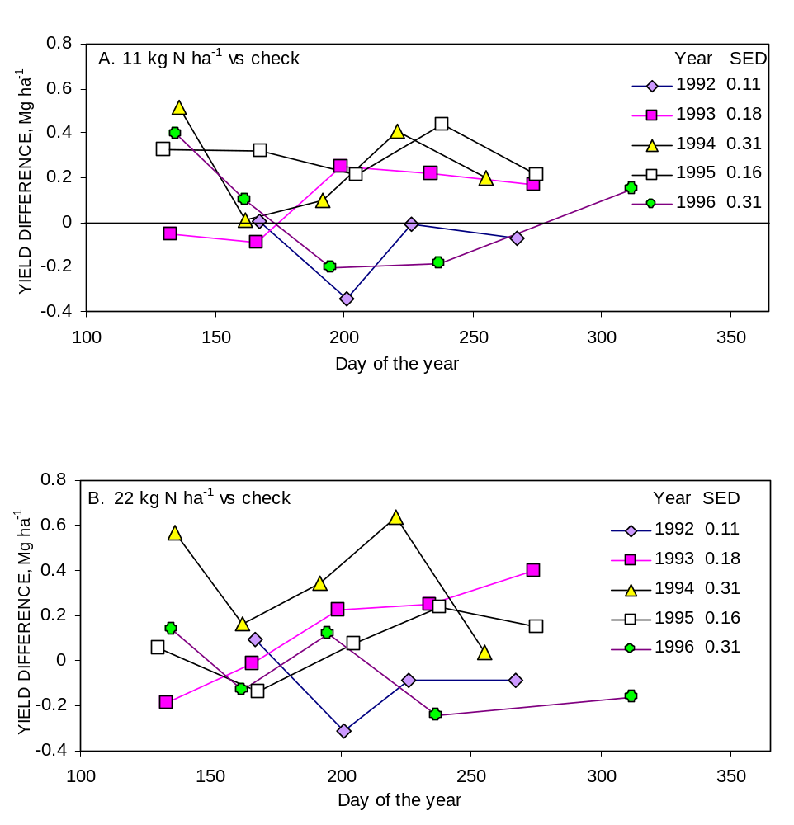

FIGURE 1. By-harvest alfalfa dry matter yield differences for treatments receiving A. 11 or B. 22 kg N ha⁻¹ following each harvest compared to the check (no N applied), 24 harvests, 1992-1996, Lahoma, OK. SED - standard error of the difference between two equally replicated means.

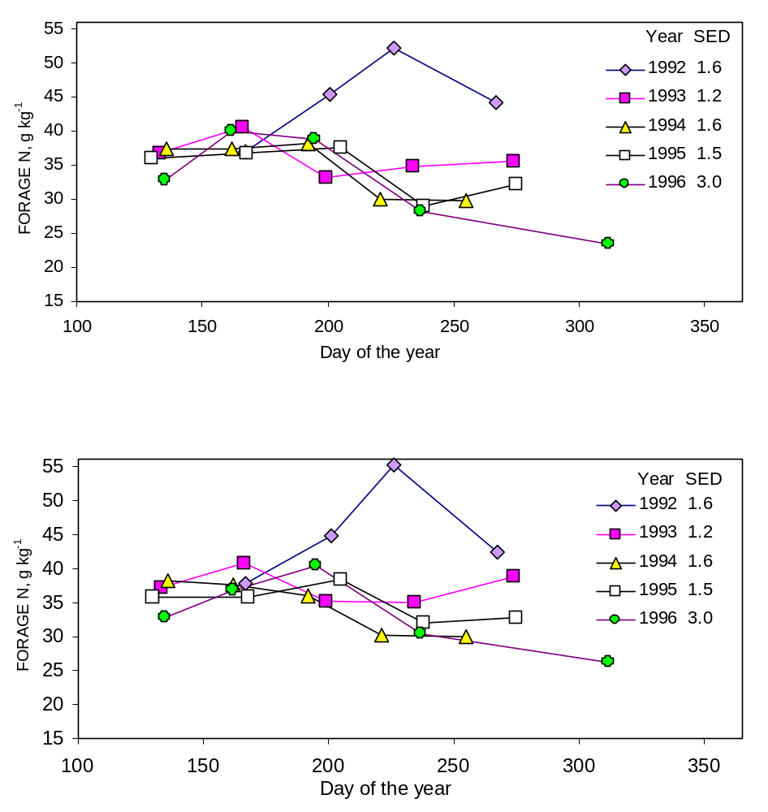

FIGURE 2. By-harvest alfalfa forage N in the check plot (no N applied, (A)) and the 22 kg N ha⁻¹ treatment (B), 24 harvests, 1992-1996, Lahoma, OK. SED - standard error of the difference between two equally replicated means.

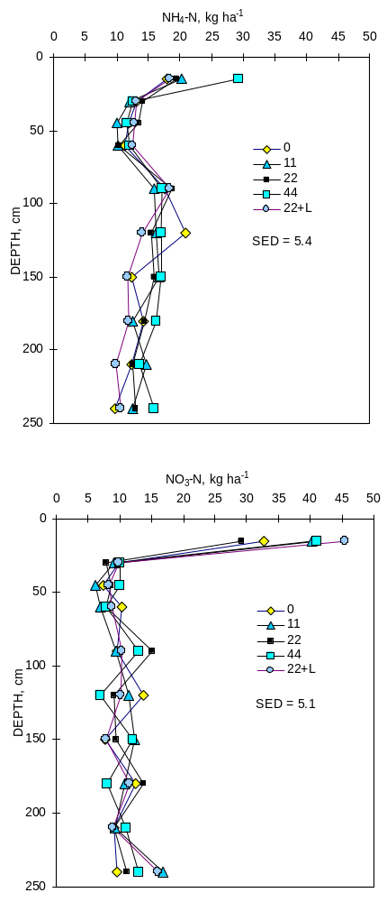

FIGURE 3. Soil NH₄-N and NO₃-N per profile increment as a function of N applied, following five years of applied N after each cutting in a continuous alfalfa production experiment, Lahoma, OK. SED - standard error of the difference between two equally replicated means.

Table 1. Surface (0-15 cm) soil test characteristics of a fine-silty, mixed, thermic, Udic Argiustoll, prior to treatment establishment (1992), and after 5 years of applied N to alfalfa, Lahoma, OK.
______________________________________________________________________________
1992 1996
--------------- N applied, kg cutting⁻¹ ha⁻¹ ----------------
composite 0 11 22 44 22+L SED
----------------------------------------------------------------------------------------
pH † 7.2 6.73 6.75 6.52 6.38 6.60 0.14
Total N‡, g kg⁻¹ 0.96 0.67 0.69 0.63 0.79 0.78 0.09
Organic C‡, g kg⁻¹ 9.51 8.53 8.25 7.70 9.29 8.94 0.72
NH₄-N §, mg kg⁻¹ 15 8 10 8 22 6 4.9
NO₃-N §, mg kg⁻¹ 16 16 19 8 19 18 5.3
P ¶, mg kg⁻¹ 49 18 21 15 27 16 4.2
K ¶, mg kg⁻¹ 236 165 151 141 192 156 20
_____________________________________________________________________________
† 1:1 soil:water.
‡ dry combustion.
§ 2M KCl extraction.
¶ Mehlich III.
SED standard error of the difference between two equally replicated treatment means
Table 2. Harvest, soil sampling dates, and rainfall received from 1992 to 1996, Lahoma, OK.
__________________________________________________________________________________
Year Harvest date Rainfall, mm† Average yield
Mg ha⁻¹
__________________________________________________________________________
1992 June 18 - 1.27
1992 July 22 203 2.54
1992 August 17 96 1.95
1992 September 28 60 1.62

1993 May 14 3.38
1993 June 17 70 1.31
1993 July 20 260 0.99
1993 August 25 25 1.56
1993* October 5 58 1.69

1994 May 17 - 5.04
1994 June 13 122 2.02
1994 July 13 5 1.38
1994* August 12 70 2.87
1994 September 16 121-hail 1.63

1995 May 11 - 2.33
1995 June 19 262 3.62
1995 July 26 138 2.34
1995 August 29 221 2.42
1995* October 6 82 1.04

1996 May 16 - 1.71
1996 June 13 62 1.95
1996 July 16 115 1.75
1996 August 28 234 2.48
1996 November 13 245 1.11
_____________________________________________________________________________
† rainfall since last consecutive summer harvest.
hail, hail damage observed on all plots.
* significant by-harvest increase in alfalfa dry matter yield as a result of applying N at the 0.05 probability level
Table 3. Analysis of variance by year and treatment means on total alfalfa dry matter yield and total N removed, 1992-1996, Lahoma, OK.
______________________________________________________________________________________________________________________
Source of df Yield N Removed Yield N Removed Yield N Removed Yield N Removed Yield N Removed
-----------1992--------- -----------1993--------- -----------1994--------- -----------1995--------- -----------1996---------
_______________________________________________________________________________________________________

------------------------------------------------------------ Mean Squares †-------------------------------------------------------------------

Rep 3 0.447 0.00112 0.165 0.00018 3.718 0.00709 3.017 0.00517 16.641** 0.01988*
Trt 4 0.190 0.00039 0.385 0.00082 1.766 0.00226 1.739 0.00252 2.081* 0.00111
Error 12 0.144 0.00025 0.360 0.00067 1.442 0.00267 1.913 0.00381 0.511 0.00069

N rate linear 1 NS NS NS NS NS NS NS NS * NS
N rate quadratic 1 NS NS NS § § NS NS NS NS NS
11 and 22 vs. 44 1 NS NS NS NS NS NS NS NS * NS
22 vs. 22+Lime‡ 1 NS NS § NS NS NS NS NS * NS

______________________________________________________________________________________________________________________
Treatment -------------------------------------------------------------- Mg ha⁻¹ -----------------------------------------------------------------------

Check, 0-N 7.45 0.352 8.62 0.316 12.54 0.423 11.04 0.388 9.50 0.319
11 kg N ha⁻¹ 7.32 0.328 9.16 0.342 12.88 0.455 12.56 0.443 9.76 0.321
22 kg N ha⁻¹ 7.35 0.335 9.35 0.351 13.83 0.488 11.42 0.405 9.22 0.313
44 kg N ha⁻¹ 7.42 0.332 8.93 0.329 12.53 0.455 11.39 0.404 8.44 0.296
22 kg N ha⁻¹ + Lime‡ 7.15 0.330 8.63 0.322 13.06 0.468 12.34 0.443 8.05 0.281

SED 0.26 0.011 0.42 0.018 0.84 0.036 0.97 0.044 0.51 0.019
______________________________________________________________________________________________________________________

† mean squares followed without a symbol are not significant.
‡ 4480 kg ha⁻¹ dolomitic limestone applied following the first cutting
§, * significant at the 0.10 and 0.05 probability levels, respectively.
NS not significant.
SED standard error of the difference between two equally replicated means.
Table 4. Analysis of variance and treatment means on total alfalfa dry matter yield, total N removed, and estimated nitrogen use efficiency (NUE), 1992-1996, Lahoma, OK.
________________________________________________________________________
Source of df Yield N Removed NUE¶
________________________________________________________________________
--------- Mean Squares †---------
Rep 3 41.70* 0.0613§ 1620
Trt 4 5.39 0.0055 2900
Error 12 10.92 0.0214 320
N rate linear 1 NS NS NS
N rate quadratic 1 NS NS NS
11 and 22 vs. 44 1 NS NS NS
22 vs. 22+Lime‡ 1 NS NS NS
________________________________________________________________________
Treatment Total N -------- Mg ha⁻¹------- Percent
Applied, Mg ha⁻¹
Check, 0-N 0 49.02 1.798 -
11 kg N ha⁻¹ 0.253 50.48 1.845 18.6
22 kg N ha⁻¹ 0.506 51.16 1.891 18.4
44 kg N ha⁻¹ 1.012 48.72 1.817 1.9
22 kg N ha⁻¹ + Lime‡ 0.506 49.23 1.845 9.3
SED 2.34 0.103 12.6
________________________________________________________________________
† mean squares followed without a symbol are not significant.
‡ 4480 kg ha⁻¹ dolomitic limestone applied following the first cutting.
§, * significant at the 0.10 and 0.05 probability levels, respectively. NS not significant.
¶ 3 degrees of freedom for treatment and 8 degrees of freedom in error.
SED standard error of the difference between two equally replicated means.

Effects of Ethephon and KH₂PO₄ on
Winter Wheat Nitrogen Use Efficiency

W.E. Thomason, G.V. Johnson, R.W. Mullen, K.J. Wynn, R. Teal,
K.W. Freeman and W.R. Raun

Abstract
Nitrogen use efficiency (NUE) is an important topic when discussing fertilizer applications and plant growth. Nitrogen use efficiency is defined as production per unit of N available in the soil. This is represented by the amount of grain or forage produced divided by the amount of N supplied to the plant by the soil. The two components of NUE are efficiency of uptake and efficiency of N utilization to produce grain or forage (Moll et al., 1982). Nitrogen use efficiency depends on the nitrification rate of the soil, the form of N applied and the growth stage of the plant. Application of chemicals to winter wheat (Triticum aestivum L.) late in the season has shown increases in NUE and N mobilization within the plant. Ethephon ([2-chloroethyl] phosphonic acid) applied at either Feekes growth stage 6 or 9 has shown increased N remobilization from vegetative plant parts and increased dry matter levels at harvest (Van Sanford et al., 1989). Foliar applications of KH₂PO₄ at rates of 10 kg ha⁻¹ have been shown to increase grain yields in regions where late season drought and temperature stress occurs (Benbella and Paulson, 1998). Initial results from the first years indicate no benefit of using these chemicals. The 2000 crop year was not ideal for evaluating NUE as environmental factors limited response to applied N at many sites throughout the state. A decrease in NUE was noted at the Stillwater site in 2000, again emphasizing environmental effects on NUE.

Introduction
Application of chemicals to winter wheat (Triticum aestivum L.) late in the season has shown increases in NUE and N mobilization within the plant. Ethephon ([2-chloroethyl] phosphonic acid) applied at either Feekes growth stage 6 or 9 has shown increased N remobilization from vegetative plant parts and increased dry matter levels at harvest (Van Sanford et al., 1989). Foliar applications of KH₂PO₄ at rates of 10 kg ha⁻¹ have been shown to increase grain yields in regions where late season drought and temperature stress occurs (Benbella and Paulson, 1998). Initial results from the first years indicate no benefit of using these chemicals. The 2000 crop year was not ideal for evaluating NUE as environmental factors limited response to applied N at many sites throughout the state. A decrease in NUE was noted at the Stillwater site in 2000, again emphasizing environmental effects on NUE. Previous research has shown potential increases in NUE with late-season application of these growth-inhibiting chemicals. The objectives for this study were to evaluate the effects of different rates of Ethephon ([2-chloroethyl] phosphonic acid) and of KH₂PO₄ on wheat grain yield and NUE.

Materials and methods
Two experimental sites were initiated in Stillwater, OK on a Norge loam (fine-silty, mixed, active, thermic Udic Paleustolls) and in Tipton, OK on a Tillman-Hollister sandy loam (fine, mixed, superactive, thermic Typic Paleustolls). An RCBD design with treatments of 10 kg ha⁻¹ of KH₂PO₄ , 42 kg ha⁻¹ a.i. Ethephon and one treatment with a combination of the two was employed at both sites. The entire experimental area received 78 kg ha⁻¹ N at topdress (February) and another 33 kg ha⁻¹ N at flowering. KH2PO4 treatments were applied at Feekes growth stage 9 (Large, 1954) and Ethephon treatments were made at flowering. All plots were harvested from an area of 3.05 x 2 m using a self-propelled combine harvester Initial soil test data are presented in Table 1. Planting and harvest dates for both sites and all years are shown in Table 2. Grain samples were dried and ground to pass a 140 mesh sieve (100 um) and analyzed for total N content using a Carlo-Erba NA 1500 automated dry combustion analyzer (Schepers et al., 1989). Statistical evaluation and analysis of variance was performed using SAS (SAS Inst., 1989)

Results
No significant effect of treatment except at the Stillwater site in the 2000 crop year where plots treated with Ethephon at flowering yield less than any of the other treatments (Table 6). Yields at the Tipton site in 1999 were greatly reduced by a late-season hail storm (Table 3). Average yields at the Stillwater experiment were higher than at Tipton in 2000, probably due to a dry growing season in the Tipton area (Tables 4 and 6). The Stillwater site in the 1999-2000 crop year was the only site year to show a significant response of nitrogen uptake to chemical application (Table 6). The ethephon treatment at this site had significantly lower N uptake when compared to the other treatments. It would seem logical that since both yield and N uptake were both inhibited by this treatment, then some damage occurred. However, there was no visible damage observed for this treatment and the combination treatment that also received the ethephon at the same time showed no such negative effect. Nitrogen use efficiency was also measured for all treatments. For the purposes of this experiment, NUE was determined by the difference method. That is, N uptake in the treated plot - N uptake in the untreated check divided by the applied N rate. No positive effect of treatment on NUE was found at any location. The Stillwater site has responded negatively to all treatments thus far (Tables 5 and 6). Values for NUE have decreased in plots where chemical treatments were applied when compared to the check (Table 5). At Tipton, no constant trend is evident (Tables 3 and 4). Further research should allow us to evaluate the effectiveness of these treatments over years to compensate for environmental changes.

Table 1. Initial soil chemical characteristics and classification (0-15 cm) at Stillwater and Tipton OK.

Location pHª NH₄-N NO₃-N P^{b} K^{b} Total N^{c} Organic C^{c}
---------------------mg kg⁻¹----------------------- -------mg g⁻¹--------
Stillwater 6.2 2.2 5.6 28 472 .09 1.06
Classification: Norge loam (fine-silty, mixed, thermic Udic Argiustoll)

Tipton 7.4 23.6 5.6 85 1006
Classification: Tillman-Hollister sandy loam (fine, mixed, superactive, thermic Typic Paleustoll)
ªpH: 1:1 soil:water
^{b}P and K: Mehlich III
^{c}Organic C and total N: dry combustion
Table 2. Planting, and harvest dates, 1998-2000.
___________________________________________

Location Planting Date Harvest Date

Tipton 10/8/98 6/8/99
Stillwater 10/13/98 6/29/99
Tipton 10/13/99 5/25/00
Stillwater 10/21/00 6/15/00
_______________________________________________

Table 3. Analysis of variance for grain yield and efficiency of use in wheat at Tipton, OK 1998-99.
Source of variation | df | Grain  yield  kg ha⁻¹ | N Uptake  kg ha⁻¹ | Efficiency  of use, %
 |  | -----Mean squares----
Rep | 2 | 0.0004 | 50.02 | ns
Chemical | 3 | ns | ns | ns
Error | 6 | 2944.96 | 2.32 | 2.18
Chemical |  | --------Means--------
None |  | 516 | 13 | --
KH₂PO₄ |  | 548 | 14 | 1
Ethephon |  | 516 | 13 | 0.4
Both |  | 549 | 14 | 1
SED |  | 44.31 | 1.24 | 1.20
CV, % |  | 10.2 | 11.4 | 155.3
- Significant at the 0.05 probability level; df = degrees of freedom; ns = not significant; SED = standard error of the difference between two equally replicated treatment means; CV = coefficient of variation

Table 4. Analysis of variance for grain yield and efficiency of use in wheat at Tipton, OK 1999-00.
Source of variation | df | Grain  yield  kg ha⁻¹ | N uptake  kg ha⁻¹ | Efficiency  of use, %
 |  | -----Mean squares----
Rep | 2 | ns | 481.2 | ns
Chemical | 3 | ns | ns | ns
Error | 6 | 215813.04 | 57.92 | 83.2
Chemical |  | --------Means--------
None |  | 3011 | 56 | --
KH₂PO₄ |  | 2674 | 52 | 1
Ethephon |  | 2956 | 59 | -8
Both |  | 2980 | 67 | -27
SED |  | 379.3 | 6.2 | 7.4
CV, % |  | 16 | 13.0 | 266.8
- Significant at the 0.05 probability level; df = degrees of freedom; ns = not significant; SED = standard error of the difference between two equally replicated treatment means; CV = coefficient of variation

Table 5. Analysis of variance for grain yield and efficiency of use in wheat at Stillwater, OK 1998-99.
Source of variation | df | Grain  yield  kg ha⁻¹ | N uptake  kg ha⁻¹ | Efficiency  of use  %
 |  | -----Mean squares----
Rep | 2 | ns | ns | 12.53*
Chemical | 3 | ns | ns | ns
Error | 6 | 158040.77 | 242.28 | 141.58
Chemical |  | --------Means--------
None |  | 2713 | 86 | --
KH₂PO₄ |  | 2772 | 88 | 0.7
Ethephon |  | 2563 | 79 | -7.8
Both |  | 2020 | 60 | -27.4
SED |  | 324.6 | 12.7 | 9.72
CV, % |  | 15.8 | 19.8 | -103.1
* Significant at the 0.05 probability level; df = degrees of freedom; ns = not significant; SED = standard error of the difference between two equally replicated treatment means; CV = coefficient of variation

Table 6. Analysis of variance for grain yield and efficiency of use in wheat at Stillwater, OK 1999-00.
Source of variation | df | Grain  yield  kg ha⁻¹ | N uptake  kg ha⁻¹ | Efficiency  of use  %
 |  | -----Mean squares----
Replication | 2 | 0.0007 | 1179.45 | 154.03*
Chemical | 3 | 0.044 | 120.01 | 143.78*
Error | 6 | 22957.40 | 23.44 | 15.91
Chemical |  | --------Means--------
None |  | 3217 | 75 | --
KH₂PO₄ |  | 3229 | 73 | -1.7
Ethephon |  | 2810 | 61 | -13.7
Both |  | 3148 | 73 | -1.7
SED |  | 123.7 | 4.0 | 3.26
CV, % |  | 4.9 | 6.8 | -70.3
* Significant at the 0.05 probability level; df = degrees of freedom; ns = not significant; SED = standard error of the difference between two equally replicated treatment means; CV = coefficient of variation

Effect of Nitrogen Source and Method of Application on NUE in Winter Wheat

R.K. Teal, W.E. Thomason, R.W. Mullen, G.V. Johnson, and W.R. Raun

ABSTRACT
Averaged over all cereals produced in the world today, nitrogen use efficiency (NUE) is estimated to be 33%. Alternative practices and management schemes are necessary to increase NUE which will provide both economical and environmental benefits. Increasing ammoniacal forms of N in the soil may result in more efficient N use because ammonium is relatively immobile. Two field experiments were initiated to determine the effect of method of application on winter wheat yield response and NUE. Experimental sites were established near Stillwater and Hennessey in the fall of 1998. The DMI applicator increased NUE above all other treatments at the 56 kg N ha⁻¹ rate at the Hennessey site in the crop year 1998-99. The addition of gypsum to AN application increased yields at the 90 kg N ha⁻¹ rate at the Hennessey site in 1999-00.

INTRODUCTION
Current nitrogen use efficiency (NUE) of cereal production systems are estimated to be 33% using worldwide averages (Raun and Johnson, 1999). Alternative practices and management schemes are necessary to increase NUE which will provide both economical and environmental benefits. Single, preplant applications of N are commonly used in hard red winter wheat production in the southern Great Plains. Kidwaro and Kephart (1998) pointed to three advantages of fall-only applications: (i) use of anhydrous ammonia (AA) as a cheaper source of N, (ii) avoiding inclement weather that can limit opportunities to topdress N during late winter and early spring, and (iii) improved management of equipment and labor that often competes with spring crop activities. Preplant incorporation of the total N required for winter wheat production also has the potential to reduce soil compaction and crop injury that can be incurred during spring N application (Liu et al., 1983).
Greater fixation of NH₄⁺ has been reported with AA than with other forms of NH₄⁺-releasing fertilizers (Young and Cattani, 1962). Raun and Johnson (1999) reported that ammoniacal forms of N are more efficient because they are less susceptible to leaching and denitrification. Therefore, utilizing AA as the sole source of N may increase soil ammonium and ultimately NUE. However, Bouman et al. (1995) found that long-term use of AA resulted in significant decreases in pH and depletion of exchangeable Ca and Mg which can lead to decreased yield due high levels of aluminum in the soil solution.
Ammonium nitrate as a fertilizer may lead to less change in pH since bicarbonate (HCO₃⁻) released from the plant root after NO₃⁻ absorption, neutralizes the H⁺ released in NH₄⁺ absorption (Fenn and Feagley, 1999). Bartlett (1965) noted that plants grown without added Ca⁺⁺, but with a NO₃⁻ source, developed Ca⁺⁺ deficiency whereas plants grown with an NH₄⁺ source had normal Ca⁺⁺ concentrations. Calcium enhances the rate of nitrate (NO₃⁻) uptake by plants, either by increasing the activity of NO₃⁻ transport systems (Goyal and Huffaker, 1986), or by shielding the negative charge at membrane surfaces (Heplar and Wayne, 1985). By raising the concentration of Ca in the rhizosphere, applied lime and gypsum both appear to have the potential to increase N uptake by plants at the expense of these other processes (Bailey, 1995). This study was established to determine wheat yield and NUE response to method of AA application and method of AN application.

MATERIALS AND METHODS
Two experimental sites were established in the fall of 1998 one near Stillwater, Oklahoma at the Efaw Research Station and one in Hennessey, Oklahoma at the Hajek Farm. Results of initial soil test and soil classification are reported in Table 1. The experimental design was a randomized complete block with three replications. Plot size was 3.0 x 4.6 m.
Anhydrous ammonia (82-0-0) and ammonium nitrate (34-0-0) were applied at rates of 56, 90, and 123 kg N ha⁻¹ using four different methods. Two methods of AA injection were evaluated. One method of AA injection utilized a rolling coulter applicator (DMI) with five knives spaced 46 cm apart at a depth of 15 cm. This is a common method of nitrogen application in wheat production. The other method of application of AA was an experimental applicator commonly called an undercutting or noble blade (V-Blade). The noble blade applicator has a single coulter, centered in front of the point of the undercutting blade, where AA was applied in 15-cm bands at a depth of only 10 cm. Ammonium nitrate was applied broadcast with a conventional dry-fertilizer spreader and incorporated preplant with and without gypsum. Gypsum was applied as the Ca⁺⁺ source at a rate of 2240 kg ha⁻¹ to assure ample amounts available for plant uptake.
The winter wheat variety ‘Tonkawa’ was planted in 21-cm rows at a rate of 68 kg ha⁻¹. Wheat was harvested using a Massey Ferguson 8XP experimental combine which harvested an area of 2.0 x 4.6 m from the center of each plot. Yield data was determined from a Harvest Master yield monitoring computer installed on the combine. Straw yield was determined for each plot and a sample of grain and straw were collected for N analysis. Samples were dried in an air-forced oven at 66ºC, ground to pass a 140 mesh sieve (100 um), and analyzed for total N content using a Carlo-Erba NA 1500 automated dry combustion analyzer (Schepers et al., 1989). Fertilization, planting, and harvest dates are reported in Table 2. Analyses of variance and single-degree-of-freedom-contrasts were performed using SAS (SAS, 1990).

RESULTS
Hennessey, 1998-99
All N treatments increased yield above the 0-N check except for the V-blade applicator at the 90 kg N ha⁻¹ rate. A positive linear and quadratic response with increasing N rate was found for grain yield, grain N %, and N uptake for the DMI applicator. Nitrogen use efficiency had a negative linear and quadratic response to N rate for the DMI applicator. A linear response was noted for yield and N uptake for all methods of application. There were no significant differences between any of the methods of application on yield. The DMI applicator was the only method to result in grain N concentrations above the check. However, significant differences did occur in nitrogen content in grain, nitrogen uptake, and NUE. The DMI applicator increased grain N at all three nitrogen rates above the other application methods. At the 56 kg N ha⁻¹ rate the DMI applicator resulted in higher N uptake than the V-Blade applicator and AN only treatment. The DMI applicator at the 90 kg N ha⁻¹ rate resulted in higher N uptake than the other methods of application. Nitrogen use efficiency of the DMI applicator at the 56 kg N ha⁻¹ rate was the highest of all the application methods, but at the 90 kg N ha⁻¹ rate the DMI applicator was only better than the V-Blade.

Efaw, 1998-99
All N treatments increased yield above the 0-N check except for the V-blade applicator at the 90 kg N ha⁻¹ rate. A linear and quadratic response in yield to nitrogen rate was obtained for the DMI applicator, AN only, and AN+gypsum, and a linear response was also noted for the V-Blade applicator. The DMI applicator showed increased yields above the V-Blade applicator at the 56 and 90 kg N ha⁻¹ rates and higher yields than the AN at the 123 kg N ha⁻¹ rate. The AN+gypsum method increased yield over the V-Blade applicator at the 90 kg N ha⁻¹ rate and AN only at the 123 kg N ha⁻¹ rate.

Hennessey, 1999-00
The AN+gypsum method had higher yields than all other methods evaluated at the 123 kg N ha⁻¹ rate, and AN+gypsum resulted in increased yield above the DMI applicator at the 90 kg N ha⁻¹ rate.

Efaw, 1999-00
There were no significant responses in yield between any of the methods of application evaluated.

CONCLUSIONS
The DMI applicator appeared to be the best method of N application the first year of the study, showing increases in grain N, N uptake, and NUE at the low application rate. The linear responses to nitrogen rates that were present at both sites the first year did not exist in the second year. Since the comparison of NUE of these four methods of application was the objective of this experiment, it would not be relevant to make any further conclusions at this point with just one observation to conclude from.

REFERENCES
Bailey, J.S. 1995. Liming and Nitrogen Efficiency: some effects of increased calcium supply and increased soil pH on nitrogen recovery by perennial ryegrass. Commun. Soil Sci. Plant Anal. 26(7&8):1233-1246.

Barlett, R.J. 1965. Importance of carbon dioxide in uptake of calcium by plants receiving only a nitrate source of nitrogen. Soil Sci. Soc. Am. Proc. 29:555-558.

Bouman, O.T., D. Curtin, C.A. Campbell, V.O. Biederbeck, and H. Ukrainetz. 1995. Soil acidification from long-term use of anhydrous ammonia and urea. Soil Sci. Soc. Am. J. 59:1488-1494.

Fenn, L.B. and S. Feagley. 1999. Review of beneficial uses of calcium and ammonium salts for stimulating plant growth and metabolite translocation. Commun. Soil Sci. Plant Anal. 30(19&20):2627-2641.

Goyal, S.S. and R.C. Huffaker. 1986. The uptake of NO₃⁻, NO₂⁻, and NH₄⁺ by intact wheat (Triticum aestivum) seedlings. I. Induction and kinetics of transport. Plant Physiol. 82:1051-1056.

Heplar, P.K. and R.O. Wayne. 1985. Calcium and plant development. Ann. Rev. Plant Physiol. 36:397-439.

Kidwaro, F.M. and K.D. Kephart. 1998. Retention of nitrogen from stabilized anhydrous ammonia in the soil profile during winter wheat production in Missouri. Commun. Soil Sci. Plant Anal., 29(3&4):481-499.

Liu, S.L., E.C. Varsa, G. Kapusta, and D.N. Mburu. 1983. Effect of etridiazol and nitrapyrin treated N fertilizers on soil mineral N status and wheat yields. Agron. J. 76:265-270.

Raun, W.R. and G.V. Johnson. 1999. Improving nitrogen use efficiency for cereal production. Agron. J. 91:357-363.

SAS Institute. 1990. SAS/STAT user’s guide. Release 6.03 ed. SAS Inst., Cary, NC.

Schepers, J.S., D.D. Francis, and M.T. Thompson. 1989. Simultaneous determination of total C, total N, and ¹⁵N on soil and plant material. Commun. Soil Sci. Plant Anal. 20(9&10):949-959.

Young, J.L., and R.A. Cattani. 1962. Mineral fixation of anhydrous ammonia by air-dry soils. Soil Sci. Soc. Am. Proc. 26:147-152.

Table 1. Initial soil test results prior to treatment application and soil classification at Hennessey and Stillwater, Oklahoma.

Location | Depth (cm) | pH | NH₄-N | NO₃-N | P | K | Total N | Organic C
 |  |  | ---------------------mg/kg----------------------- |  |  |  | ---------g/kg---------
Hennessey | 0-15 | 5.85 | 6.8 | 18.6 | 62.3 | 470 | 1.05 | 11.9
 | 16-60 | 6.23 | 5.5 | 10.7 | 40.5 | 448
Classification: Shellabarger sandy loam (fine-loamy, mixed, thermic Udic Argiustoll)
Stillwater | 0-15 | 6.23 | 2.2 | 5.6 | 13.7 | 236 | 0.94 | 10.4
 | 16-60 | 6.76 | 3.3 | 4.6 | 5.7 | 215
Classification: Easpur loam (fine-loamy, mixed, superactive, thermic Fluventic Haplustoll)
pH – 1:1 soil: deionized water; P and K – Mehlich-3 extraction; NH₄-N and NO₃-N – 2 M KCL extract, organic C and total N – dry combustion

TABLE 2. Planting, treatment application, and harvest dates, 1998 &1999.
Location | Crop year | Planting Date | Treatment Application Date | Harvest Date
Hennessey | 1998-99 | 11/25/98 | 10/28/98 | 06/29/99
 | 1999-00 | 10/12/99 | 09/30/99 | 06/07/00
Stillwater | 1998-99 | 11/09/98 | 10/26/98 | 06/15/99
 | 1999-00 | 10/07/99 | 10/04/99 | 07/07/00

TABLE 3. Wheat grain yield, grain N, N uptake, and NUE at the Hennessey location, 1999.
N Source | N rate  (kg ha⁻¹) | Yield  kg ha⁻¹ | Grain N  (%) | N uptake  kg ha⁻¹ | NUE
Check | 0 | 1350.3 | 2.54 | 40.5 | ---
DMI (AA) | 56 | 1971.1 | 2.92 | 69.8 | 52.4
 | 90 | 1980.8 | 2.98 | 70.5 | 33.4
 | 123 | 1818.8 | 3.04 | 67.8 | 22.1
Linear, Quadratic Significance |  | **, ** | ***, * | ***, ** | *, ***
V-Blade (AA) | 56 | 1739.3 | 2.50 | 51.4 | 19.6
 | 90 | 1654.6 | 2.48 | 50.3 | 10.9
 | 123 | 1863.9 | 2.58 | 55.3 | 12.1
Linear, Quadratic Significance |  | **, NS | NS, NS | *, NS | NS, NS
AN | 56 | 1922.2 | 2.50 | 56.9 | 29.3
 | 90 | 1777.8 | 2.58 | 56.2 | 17.5
 | 123 | 1889.9 | 2.67 | 59.9 | 15.7
Linear, Quadratic Significance |  | **, NS | NS, NS | **, NS | NS, NS
AN+gypsum | 56 | 1959.9 | 2.48 | 58.5 | 32.2
 | 90 | 1723.8 | 2.55 | 56.8 | 18.1
 | 123 | 2131.8 | 2.56 | 67.8 | 22.1
Linear, Quadratic Significance |  | ***, NS | NS, NS | ***, NS | *, *
SED between N source at the same N rate |  | 172.3 | 0.072 | 6.1 | 8.9
***, **, *, NS – significance at the 0.001, 0.01, and 0.05 level or non-significant (NS). SED – standard error of the difference between two equally replicated means.

TABLE 4. Wheat grain yield at the Efaw and Hennessey locations in 1999 and 2000.

N Source | N rate  (kg ha⁻¹) | Efaw |  |  | Hennessey
N Source | N rate  (kg ha⁻¹) | 1999 | 2000 |  | 2000
 |  | --------------------------Yield kg ha-1------------------------------------
Check | 0 | 1984.9 | 2155.8 |  | 3554.6
DMI (AA) | 56 | 3546.0 | 2745.2 |  | 3198.1
 | 90 | 3445.8 | 2650.4 |  | 2938.8
 | 123 | 3360.9 | 2526.4 |  | 3372.2
Linear, Quadratic Significance |  | ***, ** | NS, NS |  | NS, NS
V-Blade (AA) | 56 | 2638.2 | 2322.1 |  | 3749.8
 | 90 | 2524.1 | 2111.7 |  | 3345.3
 | 123 | 2976.9 | 2590.7 |  | 391.7
Linear, Quadratic Significance |  | **, NS | NS, NS |  | NS, NS
AN | 56 | 2703.7 | 2495.8 |  | 3503.3
 | 90 | 3126.3 | 2874.1 |  | 3371.8
 | 123 | 2657.6 | 2129.7 |  | 3434.4
Linear, Quadratic Significance |  | **, * | NS, NS |  | NS, NS
AN+gypsum | 56 | 3067.8 | 2369.3 |  | 4118.7
 | 90 | 3607.5 | 2096.8 |  | 4200.0
 | 123 | 3473.7 | 2250.1 |  | 3582.0
Linear, Quadratic Significance |  | ***, * | NS, NS |  | NS, NS
SED between N source at the same N rate |  | 304.8 | 536.8 |  | 320.0
***, **, *, NS – significance at the 0.001, 0.01, and 0.05 level or non-significant (NS). SED – standard
error of the difference between two equally replicated means.

Relationship Between Mean Yield, Coefficient of Variation, Mean Square Error and Plot Size in Wheat Field Experiments

S.L. Taylor, M.E. Payton and W.R. Raun

ABSTRACT
Large coefficients of variation (>30%) are often associated with increased experimental variability. The objective of this study was to examine the relationships between mean square errors, yield means, coefficients of variation (CV) and plot size using statistical information compiled from past wheat field research projects. Three hundred and sixty two wheat field research projects were selected from over 2000 published wheat experiments that included soil fertility, weed, tillage, and variety evaluation. Little or no relationship between mean square error (MSE) and mean yield or plot size was found. However, mean yields and CVs demonstrated a significant negative correlation. This work proposes decreased variability among experimental units as defined by the CV can be accomplished simply by increasing the mean yield, suggesting that the use of the CV may be improper when comparing variability of trials from similar experiments. Attempts to compare variation from similar experiments should be done using the MSE since unit differences would not be a problem. The CV should only be used when comparing variation from experiments using different metrics. Plot size in plant breeding variety trials (average of 3.59m²) was much smaller than that in fertilizer/weed/tillage trials (average of 37.2m²). The smaller plot size employed in the variety trials reduced the variability encountered in the estimation of the mean and is consistent with the resolution where detectable differences in soil test parameters exist and that should be treated independently.

INTRODUCTION
Experimental error is defined as a measure of the variation which exists among observations on experimental units treated alike (Steel et al. 1997, p. 129). Steel et al., (1997) further noted that variation comes from two main sources; 1) inherent variability that exists in the experimental material to which treatments are applied and 2) variation which results from any lack in uniformity in the physical conduct of the experiment.
Coefficients of variation were first employed as relative measures of variation. The CV is defined as the standard deviation expressed as a percentage of the mean (Tippett, 1952; Senders, 1958; Steel et al. 1997; Lewis, 1963). Mills (1924) indicated that the CV is affected by the value of the mean, as well as by the size of the standard deviation. Since the CV is a ratio, Zar (1984, p. 32) claimed that the CV should only be used for ratio-type data. The CV should not be used for strictly interval or nominal data since ratios have no explicit meaning with these data types.
Conceptually, the CV is not defined for means equal to zero, and the CV is unreliable for means that are close to zero relative to the standard deviation. This often poses problems for researchers who wish to use the CV. However, if the data is truly ratio-type data, this scenario will not occur since small valued means (relative to the standard deviation) cannot occur.
Moore (1958) found that if it is desired to discover whether one distribution is relatively more variable than another, it follows that it is necessary to find some method to eliminate the basic units. This is achieved by using the CV. Moore (1958) also showed that the CV does not depend on the units of measurement since both the mean and standard deviation are linear functions of the units involved.
Ostle (1954) found that the CV is an ideal device for comparing the variation in two series of data, which are measured in two different units (e.g., a comparison of variation in height with variation in weight). Lewis (1963) noted that the CV may be used to compare the dispersion of series measured in different units and that of series with the same units but running at different levels of magnitude. Similarly, CVs have been used to evaluate results from different experiments involving the same units of measure, possibly conducted by different persons (Steel et al., 1997).
Little and Hills (1978, p.18), stated that the variability among experimental units of experiments involving different units of measurements and/or plot sizes can be compared by CVs. Their extrapolation suggested that a lima bean experiment (s = 5.8 seedlings/plot, yield mean of 82.7 seedlings/plot, CV = 7.0%) had 1.8 times more variability among the plots within a treatment than a sugar beet root yield experiment (s = 1.18 t/ac, yield mean of 30.5 t/ac, CV = 3.9%). Snedecor and Cochran (1980, p.37) indicated that the CV is often used to describe the amount of variation in a population.
Gomez and Gomez (1976) stated that the CV is an indication of the degree of precision to which the treatments are compared and is a good index of the reliability of the experiment. Gomez and Gomez (1976, p. 17) further indicated that the higher the CV value, the lower is the reliability of the experiment.
Work by McClave and Benson (1988) indicated that it is common for the standard deviation of a random variable to increase proportionally as the mean increases. Snedecor and Cochran (1980, p. 37) indicated that the CV is often used to describe the amount of variation in a population. For data from different populations or sources, the mean and standard deviation often tend to change together so that the CV is relatively stable or constant (Snedecor and Cochran, 1980, p. 37). Steel et al. (1997) stated that the CV is a relative measure of variation, in contrast to the standard deviation, which is in the same units as the observation.
Ostle (1954) indicated that experimental error essentially reflects in each particular instance all the extraneous sources of variation which, by their occurrence, help to disguise the true effect of the "treatments" under examination.
The objective of this study was to examine the relationships between mean square errors, yield means, coefficients of variation and plot size using statistical information compiled from past wheat field research projects.

MATERIALS AND METHODS
Data from 362 wheat field experiments were targeted for additional statistical analysis. From this population of experiments, 220 were fertilizer, weed management and tillage trials and 142 were variety trials. All experiments were conducted by field researchers, included more than two replications from past M.S. and Ph.D. thesis and published wheat field research projects (Agronomy Journal, Crop Science, and Soil Science Society of America Journal). From each experiment the following information was obtained: number of replications, number of treatments, plot size, CV, degrees of freedom in the error term, mean square error (variance), mean yield, and the standard error of the difference between two treatment means. If all of the above information was not reported, back calculation of the missing term was accomplished when possible (e.g., yield mean determined from the reported CV and MSE). Data for the variables mentioned was only collected for wheat grain yield. The type of experiment was recorded into four separate groups: soil fertility, weed management, tillage and variety trials. From these groups, soil fertility, weed management and tillage trials were combined into a separate group apart from the variety trials due to distinct differences in plot size. Average plot sizes for the fertility/weed/tillage and variety trials were 37.2±24.3 and 3.59±3.13 m², respectively.
Where necessary, all experimental results were converted into metric units. Correlation matrices were established between all variables collected and simple linear regression equations were determined for specific relationships.

RESULTS AND DISCUSSION
This work assumes that residual mean square error (MSE) from analysis of variance is the best estimate of experimental error or the variability present in a given field experiment. Since all of these data are from similar experiments, MSEs can be compared in order to ascertain the relative variability from experiment to experiment.
In general, when the sums of squares for all independent effects included in an experiment are accounted for in the model, residual error and experimental error are considered to be synonymous. Very few of the experiments reported CVs that exceeded 30%; therefore, grouping experiments with CVs less than 30% was not attempted.

Linear Relationships
No distinct relationship was found between MSE and plot size for either group (Figures 1 and 2). However, there was a tendency for MSE to decrease when plot sizes were between 30 and 100 m² and 6 and 20m² for the fertility/weed/tillage and variety data, respectively. Previous work by Barreto and Raun, (1990), which evaluated corn field experiments conducted in Mexico, demonstrated that increasing plot size decreased mean square errors.
Mean yield and CV were negatively correlated for both groups (Figures 1 and 2). Because site mean yields are used as the divisor in calculating CVs, increasing mean yields were expected to produce smaller coefficients of variation.
No highly significant linear relationship could be established between MSE and CV for the fertilizer/weed/tillage trials (Figure 1). Alternatively, MSE and CV were positively correlated for the variety trials. Assuming that the mean square error from analysis of variance is the best measure of variability for field experimentation, and because CVs are considered to be a relative measure of variation (Steel et al., 1997), MSE and CV were expected to be highly correlated. Because this was not the case for the fertilizer/weed/tillage trials, this work demonstrates that CVs are not measuring what some researchers are expecting in field trials. However, there was one critical difference between the fertilizer/weed/tillage trials and the variety trials, and that was plot size which averaged 37.2 and 3.59 m², respectively.
How could plot size affect the relationship between MSE and CV? Work by Solie et al. (1996) and Raun et al. (1998) attempted to establish the fundamental field element size (area to which an independent rate of a nutrient should be applied). The fundamental field element size is essentially the resolution or scale where detectable differences in soil test parameters exist and that should ultimately be treated differently. Solie et al. (1996) reported that in order to optimize nutrient inputs, areas of 1.96m² should be treated independently, largely because of significant microvariability in soil test parameters found in soils (Raun et al., 1998). CVs and MSEs were positively correlated in variety trials because the plot size was smaller than those in the fertilizer/weed/tillage trials and nearer the size recommended by Solie et al. (1996). We believe this positive relationship occurs for two reasons. First, the small plot size allows for a better estimate of MSE and minimizes the intra-plot variability. Secondly, smaller plot sizes will reduce the variability encountered in the estimation of the mean, thus reducing the problems experienced by changes in the mean affecting the CV. Alternatively, the fertilizer/weed/tillage trials had average plot sizes 10 times greater than the variety trials, which may have led to the apparent independence of MSE and CV.
Although MSE and CV were positively correlated in the variety trials, the presence of an equally significant negative correlation between CV and mean yield (for both groups, Figures 1 and 2) suggests that CVs were influenced by the environment (mean yield being an indicator of the environment or environment mean). This trait (increasing mean yield and decreasing CV), is not desirable when using the CV as a measure of variability. It is important to remember that the CV is a measure of relative variability. Even though an increase in mean yield will usually result in a corresponding increase in MSE, no linear relationship was found between mean yield and MSE for either of the groups evaluated (Figures 1 and 2). The lack of a significant linear relationship between mean yield and MSE clearly shows why weak relationships between CV and MSE were found since the mean yield entered into the calculation of CV. These results would incorrectly suggest that experimental variability could be reduced simply by increasing the mean yield. For similar types of trials, comparing MSE's (residual error or variance) would be more appropriate in terms of assessing experimental variability since CVs were greatly influenced by the value of the mean yield. The CV would be an appropriate measure for comparing the variation differences in experiments that have variables measured in different units.

CONCLUSIONS
The CV is useful when comparing the experimental variation differences in experiments that have variables measured in different units. A researcher must remember that the CV is measuring relative variability and that it has an inverse relationship with the sample mean. If one wishes to compare the experimental variation of trials containing variables with common units, the MSE would be the appropriate measure to use. The lack of a strong relationship between MSE and CV should cause concern for researchers using the CV as a measure of the 'reliability of the experiment' or to compare results from different experiments involving the same units of measure. The smaller plot size employed in plant breeding variety trials (average of 3.59m²) when compared to the fertilizer/weed/tillage trials (average of 37.2m²) reduced the variability encountered in the estimation of the mean. The smaller plot size employed in the variety trials is considered to be advantageous in field plot work since it is consistent with the resolution where detectable differences in soil test parameters exist and that should be treated independently.

REFERENCES
Barreto, H.J., and W.R. Raun. 1990. La precision experimental de los ensayos regionales con maiz (Zea mays L.) a traves de centroamerica. In Programa regional de maiz para Centro America, Panama y El Caribe. CIMMYT, Mexico D.F., 06600.

Chaddock, R.E. 1925. Principles and methods of statistics. 1st ed. Houghton Mifflin Co., Cambridge MA.

Gomez K.A., and A.A. Gomez. 1984. Statistical procedures for agricultural research. 2nd ed. John Wiley and Sons, New York, NY.

Lewis E.E. 1963. Methods of statistical analysis in economics and business. 2nd ed. Houghton Mifflin Co., Boston, MA.

Little, Thomas M., and F. Jackson Hills. 1978. Agricultural experimentation. John Wiley and Sons, New York, NY.

McClave, James T., and P. George Benson. 1988. Statistics for business and economics. Dellen Publishing Co., San Francisco, CA.

Mills, F.C. 1924. Statistical methods. 3rd ed. Henry Holt and Co., New York, NY.

Moore, P.G. 1958. Principles of statistical techniques. 1st ed. Cambridge at the Univ. Press, New York, NY.

Ostle, B. 1954. Statistics in research basic concepts and techniques for research workers. 1st ed. Iowa State College Press, Ames, IA.

Raun, W.R., J.B. Solie, G.V. Johnson, M.L. Stone, R.W. Whitney, H.L. Lees, H. Sembiring, and S.B. Phillips. 1998. Microvariability in soil test, plant nutrient, and yield parameters in bermudagrass. Soil Sci. Soc. Am. J. 62:683-690.

Senders, V.L. 1958. Measurement and statistics. 1st ed. Oxford University Press, New York, NY.

Snedecor, George W., and William G. Cochran. 1980. Statistical methods. 7th ed. The Iowa State Univ. Press, Ames, IA.

Solie, J.B., W.R. Raun, R.W. Whitney, M.L. Stone and J.D. Ringer. 1996. Optical sensor based field element size and sensing strategy for nitrogen application. Trans. ASAE 39(6):1983-1992.

Steel, Robert G.D., James H. Torrie, and David A. Dickey. 1997. Principles and procedures of statistics, a biometrical approach. 3rd ed. McGraw-Hill Book Co., New York, NY.

Tippett, L.H. 1952. The methods of statistics. 4th ed. John Wiley & Sons, Inc., New York, NY.

Zar, J.H. (1984) Biostatistical Analysis. 2nd ed. Prentice Hall, Inc., Englewood Cliffs, N.J.

TABLE 1. Mean, minimum, maximum and standard deviation for selected components from wheat field experiments that included fertilizer, weed and/or tillage variables.

____________________________________________________________________

Mean Min Max Std. Dev.

No. of replications 3.83 2.00 6.00 0.77

No. of treatments 11.1 4.00 49.0 8.10

Mean yield (kg/ha) 2802 379 5915 1222

MSE (kg² /ha²) 113782 8256 480822 97743

CV, % 13.3 3.09 61.8 7.51
Plot size (m²) 37.2 8.4 96.0 24.3

Standard error (kg/ha) 231 64.2 558 98.7

_____________________________________________________________________

TABLE 2. Mean, minimum, maximum and standard deviation for selected components from wheat variety field experiments.

____________________________________________________________________

Mean Min Max Std. Dev.

No. of replications 3.34 2.00 6.00 0.92

No. of treatments 14.8 4.00 60.0 11.7

Mean yield (kg/ha) 2841 967 5196 924
MSE (kg²/ha²) 140179 40576 342290 78607

CV, % 13.7 5.17 30.9 5.29
Plot size (m²) 3.49 0.31 19.1 3.13

Standard error (kg/ha) 290 138 532 107

________________________________________________________________
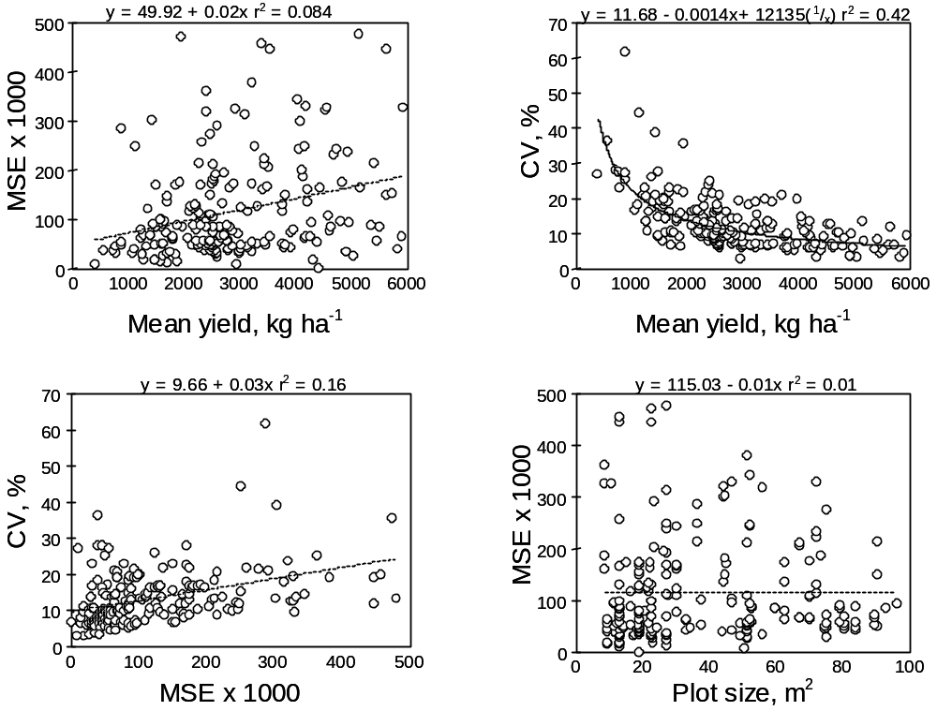

FIGURE 1. Relationship between mean yield, mean square error (MSE), coefficient of variation (CV) and plot size from 220 fertilizer, weed management and tillage trials.
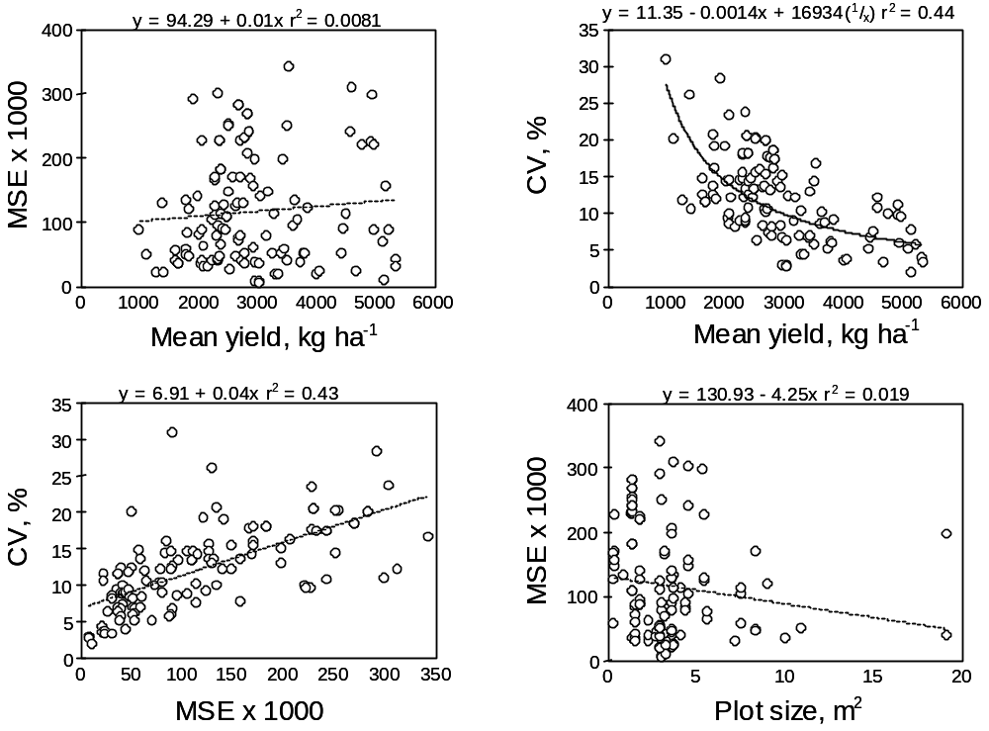

FIGURE 2. Relationship between mean yield, mean square error (MSE), coefficient of variation (CV) and
plot size from 142 variety trial

CARBON SEQUESTRATION

Estimated Land Area Increase of Agricultural Ecosystems to Sequester Excess Atmospheric Carbon Dioxide

D. G. Wright, R. W. Mullen, W.E. Thomason, and W. R. Raun

ABSTRACT
An estimated 3.3 Pg carbon (C) is accumulating in the atmosphere annually, with carbon dioxide (CO₂) concentrations increasing approximately 1.5-2.0 ppm per year. The conversion of land to agroforestry, rangeland, and cropping systems has been identified as a possible option to offset rising CO₂ levels. The objective of this work was to estimate the increase in land area for the leading global cereal crops (maize, rice, wheat), temperate rangeland, and temperate forest ecosystems to sequester the surplus atmospheric C. Based on calculations and previously published data, maize cropping systems are the most efficient at sequestering C. An additional 6.7-7.6 x 10⁸ ha of maize would be required to assimilate the 3.3 Pg C yr⁻¹, a 477-543% increase in global corn production. Agroforestry appears to be the only agricultural system that could realistically be implemented to reduce global CO₂ levels with a calculated increase of 4.6-4.6 x 10⁸ ha (a 52-66% growth in worldwide area). Also, the estimated net productivity of 6.7-7.1 Mg C ha⁻¹ for temperate forests is significantly greater than the productivity of maize, rice, or wheat cropping systems, which ranged from 2.7 to 4.3 Mg C ha⁻¹. Increasing land area for agricultural production may not be the answer to the global C dilemma, but intensive management systems that result in increased soil organic matter are a significant part of the solution.

INTRODUCTION
Carbon dioxide (CO₂) is a greenhouse gas that is believed to contribute to global warming (U.S. EPA, 1995; United Nations, 1992). The concentration of CO₂ in the atmosphere is increasing by 1.5-2.0 ppm per year, giving rise to an approximate 0.5ºC increase in global temperature (Wittwer, 1985; Perry, 1983). Keeling and Whorf (1998), report an increase in atmospheric CO₂ concentration from 280 ppm to a present level of 365 ppm over the past 60 years. Approximately 3.3 Pg C is added to the atmosphere each year from numerous natural and anthropogenic processes (Follett and McConkey, 2000). The increase in atmospheric levels is primarily due to fossil fuel burning and deforestation (Skog and Nicholson, 1998). Additionally, the oxidizing of soil organic matter from cultivation has accounted for an estimated 6 to 25% of the 80 mg kg⁻¹ increase in atmospheric CO₂ over the past 150 years (Mullen et al., 1999).
To offset atmospheric accumulation of CO₂ and global warming, the conversion of land to agroforestry, rangeland, and no-till/minimum till cropping systems has been identified. Plant photosynthesis can increase the net carbon flux from the atmosphere to terrestrial ecosystems (Rosenweig and Hillel, 1998). Carbon sequestration of crops, grassland, and forest systems differs greatly and is difficult to predict due to poor understanding of the biogeochemical dynamics of C among plants, soil, and the atmosphere (Lohry, 1998). Many scientists believe that agriculture can have the greatest impact in reducing atmospheric C due to our ability to intensively manage agriculture over long periods of time. The U.S. Department of Energy published a report that categorized the C sequestration potential of intensively managed biomes (DOE, 2000). Forestry displayed the highest level of potential C sequestration quantitatively with an estimate of 1-3 Pg C yr⁻¹, but qualitatively the sustained management of forests was ranked moderate. Likewise, the sequestration by cropping systems was assessed to be 0.85-0.90 Pg C yr⁻¹ and ranked high in intensive sustained management. Rangeland sequestered 1.2 Pg C yr⁻¹ and had a moderate ranking in sustained management.
Increasing land area in agricultural production that sequesters greater concentrations of CO₂ appears to be an environmentally friendly means for decreasing atmospheric C. Increased soil organic matter, higher biomass production, decreased nutrient loss, and improved soil and water quality are other benefits from increased sequestration in soil/plant systems (DOE, 2000). However, some ill effects of major land use change are degradation of sensitive ecosystems (from erosion of highly erodable land or desertification in arid regions), increased energy costs for production, and large economic investments. Schlesinger (1999) noted that as agricultural production increases, the net C sequestered by the crop is nullified by the CO₂ released from fertilization, irrigation, and manuring. For example, the Haber-Bosch process produces 1180 kg CO₂ per 1000 kg N synthesized.
At this stage in earth’s history, it is believed that mankind can make strides to decrease the current excess C accumulation in the atmosphere. Creating agricultural ecosystems that scrub CO₂ is a widely held solution to this global dilemma. The objective of this work was to estimate the amount of area required to annually sequester the 3.3 Pg C excess by three different cropping systems (maize, rice, or wheat), temperate forest, or temperate rangeland ecosystems.

RESULTS
Many scientists believe that agriculture is the answer to reducing the rising CO₂ levels in the atmosphere. The increase in global agricultural land area required to sequester the excess 3.3 Pg C per year is evaluated in this work. Terrestrial C storage and fluxes within plants are very difficult to quantify on a global scale, ranging from 420 to 830 Pg C in living plant tissue (Post et al., 1990). Currently, a great deal of uncertainty exists concerning methods and models used to determine the total plant C pool. For this work, prior data from numerous sources is compiled to determine the total C sequestered per year for maize, rice, wheat, rangeland, and temperate forest ecosystems. The assumption that C sequestering ability is constant across varieties of corn, wheat, and rice is made for the calculations.

Maize Cropping System
Worldwide, maize ranks first in cereal grain production with an approximate 5.97 x 10⁸ Mg produced in 1999 (FAO, 2000). This approach uses the mean harvest index and percent C in plant biomass along with average global maize yield (Table 1). To determine the total mass of C sequestered by the global corn crop, a worldwide mean yield of 4.32 Mg maize ha⁻¹ (FAO, 2000) is divided by the 0.5 harvest index (Sinclair, 1998; Dale and Drennan, 1997) for a total of 8.64 Mg biomass ha⁻¹. The total biomass per hectare is multiplied by the 50% C in maize tissue (Fischer and Turner, 1978) resulting in a total of 4.32 Mg C ha⁻¹ sequestered annually. Finally, the 3.3 Pg C (Follett and McConkey, 2000) in the atmosphere is divided by the 4.32 Mg C ha⁻¹ (FAO, 2000) to obtain a value of 7.4 x 10⁸ ha of maize per year required to assimilate the surplus C. To find the increase in global maize production, the 7.4 x 10⁸ ha is divided by the area under corn production in 1999, 1.4 x 10⁸ ha (FAO, 2000), and a 529% increase in total corn production is found. Using data published by Lohry (1998), the estimated increase in maize production needed would be 476% beyond current production area.

Rice Cropping System
Rice production ranks second among cereals in hectares cultivated globally (FAO, 2000). For the increased area estimation of rice systems, the mean harvest index and percent C data is used for the first calculation. For this calculation, a mean global rice yield of 3.84 Mg ha⁻¹ (FAO, 2000) is divided by a harvest index of 0.5 (Sinclair, 1998) to acquire a total biomass of 7.68 Mg rice ha⁻¹ (Table 1). Then, the rice biomass per hectare is multiplied by the percent C, 50% (Fischer and Turner, 1978), for a mean total C of 3.84 Mg C sequestered for every hectare of rice grown. Thus an area of 8.3 x 10⁸ ha is needed (3.3 Pg C/ 3.84 Mg C ha⁻¹ rice) to remove the 3.3 x 10⁹ Mg C. The area is a 544% increase from the 1.5 x 10⁸ ha under production in 1999 (FAO, 2000).

Wheat Cropping System
Wheat is the third ranking cereal crop with an approximate 5.9 x 10⁸ Mg of grain produced in 1999 (FAO, 2000). The mean global wheat yield from the FAO (2000) database records an average of 2.73 Mg wheat per hectare. The average yield is divided by the mean harvest index of 0.5 (Slafer et al., 1999) and the quotient is multiplied by the 50%C (Fischer and Turner, 1978) in the tissue to find a total of 2.73 Mg C ha⁻¹ in the wheat biomass (Table 1). The final step is to divide the biomass C per hectare by the 3.3 Pg C in the atmosphere. This results in 1.2 x 10⁹ ha of wheat necessary to sequester the annual atmospheric C excess, which would be a 548% increase in global wheat production (2.14 x 10⁸ ha cultivated in 1999). The increase in wheat production necessary to sequester excess atmospheric C would be 467% beyond current production land area using Lohry (1998) data.

Temperate Forest Ecosystem
The temperate forest ecosystem is chosen to represent the global region where agroforestry currently or potentially can be practiced. Dixon et al. (1994) estimated that between 5.9-12.2 x 10⁸ ha of land are technically suitable for the establishment of agroforestry in Africa, Asia, North and South America. For this work, the estimate by Amthor et al. (1998) of 7.5 x 10⁸ ha of temperate and plantation forest is used for the first calculation. A second method is used to crosscheck these results and the estimate of 9.0 x 10⁸ ha of temperate forest by Bolin (1979) will be utilized. Net primary productivity of temperate forests established through prior data is utilized for both calculations to determine the C sequestering ability of these ecosystems.
Using the data provided by Amthor et al. (1998), a mean net primary productivity of 6.7 Mg C ha⁻¹ yr⁻¹ is assimilated in forest vegetation (Table 2). To find the area needed to sequester the excess atmospheric C, the 3.3 Pg C surplus is divided by 6.7 Mg C ha⁻¹ yr⁻¹ resulting in a total area of 4.9 x 10⁸ ha needed to sequester the excess 3.3 Pg C. Bolin (1979) estimated a primary productivity of 7.1 Mg C ha⁻¹ yr⁻¹ for a temperate forest ecosystem. Dividing the 3.3 Pg C excess by the primary productivity generates a land area of 4.6 x 10⁸ ha needed to sequester excess atmospheric C. The areas calculated by Amthor (1998) and Bolin (1979) represent a global increase in temperate forestry of 66% and 52%, respectively.

Temperate Rangeland Ecosystem
Rangeland ecosystems cover a large geographic region, which includes shrubland, grassland, and open forest areas. Approximately 47% of the earth’s land surface is occupied by rangeland (Heady, 1975). Due to the broad interpretation of a rangeland ecosystem, the estimation of the global land area and net primary productivity of range has differed greatly in prior research. Data from Amthor et al. (1998) and Bolin (1979) is used for the rangeland ecosystem calculations.
Amthor et al. (1998) reported a mean net primary productivity for a temperate rangeland ecosystem of 3.5 Mg C ha⁻¹ yr⁻¹. The 3.3 x 10⁹ Mg excess of atmospheric C is divided by the 3.5 Mg C ha⁻¹ yr⁻¹ and a solution of 9.4 x 10⁸ ha is found (Table 2). This area constitutes an increase of 75% from the 1.25 x 10⁹ ha currently in rangeland. Bolin (1979) documented a biomass production of 4.6 Mg C ha⁻¹ yr⁻¹ for a range system. Dividing the excess C by the productivity yields an area of 7.1 x 10⁸ ha. From the 9.0 x 10⁸ ha currently under range reported by Bolin, the 7.1 x 10⁸ ha increase is approximately a 79% rise in global land area.

Discussion
The objective of this work was to compute the sequestering potential of agricultural ecosystems and the feasibility of converting land into temperate forest, rangeland, maize, rice, or wheat to reduce the atmospheric CO₂ concentrations. Tropical and temperate forests, temperate woodland, tropical savanna, and temperate grasslands are environments with suitable climates that most likely could support crop production. Of the total C sequestered by these ecosystems maize, rice, and corn cropping systems (the top three cereal crops grown worldwide) only account for approximately 4% of the C sequestered. Additionally, the net productivity of corn, rice, and wheat are considerably lower than native ecosystems. Other ecosystems exist that could be accounted for in the table, but the chosen ecosystems represent the largest biomes that man can conceivably replace with agriculture.
Although the calculations are simple and the estimates ignore numerous other factors, the areas computed provide a relative idea of the impracticality of agricultural land conversion to reduce atmospheric C. In particular, the millions of additional hectares needed for maize, rice, and wheat production would require vast amounts of resources, labor, finances, and suitable land. Agroforestry appears to be the most sensible agricultural system evaluated that mankind could realistically implement to reduce global CO₂ levels. With a net primary productivity of 6.7-7.1 Mg C ha⁻¹, temperate forestry ecosystems require less management and inputs than cropping systems and exhibit significantly higher productivity values over the cereal crops. A 52-66% increase of temperate forests is still improbable, but much more rational than the other ecosystems analyzed. Rangeland can also play a significant role by storing large volumes of soil organic C. Approximately 75% of terrestrial C is stored in the soil (DOE, 2000), therefore agricultural systems that do not employ cultivation could substantially aid in C sequestration.
Transforming land into agricultural ecosystems cannot be viewed as a plausible solution to combat global warming. The environmental impacts associated with expanding global agriculture would be increased fossil fuel consumption, a rise in methane emission from rice paddies and NO_{x} from grassland ecosystems, and a decrease in soil organic matter. The conversion of native ecosystems into millions of agricultural hectares would significantly alter plant and wildlife habitats across the globe. Shifting land use could also change global nutrient cycling. For example, increased crop production will in turn cause greater plant ammonia loss that could impact atmospheric, oceanic, and freshwater nitrogen pools.

CONCLUSIONS
The conversion of land into agricultural ecosystems could improve the sequestration of atmospheric C; however, the effectiveness of this practice would be marginal due to the enormous land area conversion required to assimilate the 3.3 Pg of atmospheric C accumulating annually. Of the ecosystems evaluated in this work, temperate forests sequester more C per year (6.7-7.1 Mg C ha⁻¹ yr⁻¹) and require the smallest net global increase in land area (an addition of 4.6-4.9 x 10⁸ ha) when compared to other systems. The maize cropping system is the most effective in C sequestration of the cereal crops calculated with an estimated potential of 4.3 Mg C ha⁻¹ yr⁻¹, or 6.0 x 10⁸ Mg C per year. Using this C sequestering potential for maize, an additional 6.7-7.6 x 10⁸ ha of corn production would be needed to absorb the surplus atmospheric C. The worldwide land area under maize production in 1999 was 1.4 x 10⁸ ha; therefore, a 476-546% increase in global maize production would be required. To realize the area calculated, land unsuitable for agriculture would likely have to be utilized. Furthermore, large volumes of natural and economic resources would be consumed in order to implement agricultural production in the areas needed to reduce the atmospheric CO₂ level. It is important to note that these calculations are for current emissions. If emissions increased or decreased, the static calculations reported here would obviously change.

REFERENCES
Amthor, J.S., M.A. Huston, et al. 1998. Terrestrial Ecosystem Responses to Global Change: A Research Strategy, ORNL/TM-1998/27, Oak Ridge National Laboratory.

Bolin, B., E.T. Degens, P. Duvigneaud, and S. Kempe. 1979. The global biogeochemical carbon cycle, pp.1-56. In: Bolin, B., E.T. Degens, and S. Kempe (eds.), The Global Carbon Cycle. John Wiley and Sons. New York, NY.

Dale, A.E. and D.S.H. Drennan. 1997. Transplanted maize (Zea mays) for grain production in southern England. II. Effects of planting date, transplant age and cultivar on growth, development and harvest index. J. Agricultural Sci. 128:37-44.

Dixon, R.K., J.K. Winjum, K.J. Andrasko, J.J. Lee, and P.E. Schroeder. 1994. Integrated land-use systems: assessment of promising agroforestry and alternative land-use practices to enhance carbon conservation and sequestration, pp. 71-92. In: White, D.H. and S.M. Howden (eds.), Climate change: significance for agriculture and forestry. Kluwer Academic Publishers. Norwell, MA.

Food and Agriculture Organization of the United Nations. 2000. Available at http://apps.fao.org/lim500/nph-wrap.pl?Production.Crops.Primary&Domain=SUA&servlet=1. (verified 1 March 2000).

Fischer, R.A. and N.C. Turner. 1978. Annual review of plant physiology 29:277.

Follett, R.F. and B. McConkey. 2000. The role of cropland agriculture for C sequestration in the Great Plains. p. 1-15. In A. Schlegel (ed.) Proc. Of Great Plains Soil Fertility Conf., Denver, CO. 7-8 March, 2000.

Heady, H.F. 1975. Rangeland Management. McGraw-Hill, Inc. New York, NY.

Keeling, C.D. and T.P. Whorf. 1998. Atmospheric CO2 records from sites in the SIO air sampling network. Trends: A Compendium of Data on Global Change. Carbon Dioxide Information Analysis Center, Oak Ridge National Laboratory.

Lohry, B. 1998. One answer to global warming: high-yield agriculture. Fluid J. Spring 1998:22-25.

Mullen , R.W., W.E. Thomason, and W.R. Raun. 1999. Estimated increase in atmospheric carbon dioxide due to worldwide decrease in soil organic matter. Commun. Soil Sci. Plant Anal., 30(11&12), 1713-1719.

Perry, A.M. 1983. Estimating the greenhouse effect. Science 222:1072.

Post, W.M., T. Peng, W.R. Emanuel, A.W. King, V.H. Dale, and D.L. DeAngelis. 1990. The Global Carbon Cycle. American Scientist 78:310-326.

Rosenzweig, C. and D. Hillel. 1998. Carbon dioxide, climate change, and crop yields. p. 71. In: Rosenzweig, C. and D. Hillel (eds.), Climate change and the global harvest. Oxford Press, New York, NY.

Slafer G.A., J.L. Araus, and R.A. Richards. 1999. Physiological traits that increase the yield potential of wheat, pp. 379-415. In: Satorre, E.H. and G.A. Slafer (eds.), Wheat: ecology and physiology of yield determination. Food Products Press, Binghamton, NY.

Schlesinger, W.H. 1999. Carbon sequestration in soils. Science 284:209.

Sinclair, T.R. 1998. Historical changes in harvest index and crop nitrogen accumulation. Crop Sci. 38:638-643.

Skog, K.E. and G.A. Nicholson. 1998. Carbon cycling through wood products: the role of wood and paper products in carbon sequestration. Forest Products J. 48(7/8):75-83.

United Nations Conference on Trade and Development. 1992. Combating global warming: study on a global system of tradeable carbon emission entitlements. UNCTAD/RDP/DFP/1. United Nations, New York.

U.S. Department of Energy. 2000. Carbon Sequestration State of the Science [Online]. Available at http://www.fe.doe.gov/coal_power/sequestration/index_rpt.html. (verified 1 March 2000).

U.S. Environmental Protection Agency. 1995. Inventory of U.S. greenhouse gas emissions and sinks: 1990-1994. EPA-230-R-96-006. U.S. Gov. Print. Office, Washington, DC.

Wittwer, S.H. 1985. Carbon dioxide levels in the biosphere: Effects on plant productivity. CRC
Critical Rev. Plant Sci. 2:171-198.
Table 1. Components used for calculating global land area increase in maize, rice, and wheat production needed to sequester excess atmospheric CO₂ using harvest index and %C in biomass.

 | Maize |  | Rice |  | Wheat
 | ------------------------------------------------------------- |  | --------------------------------------------------------------- |  | ------------------------------------------------------------------
Component | Value | Reference and/or calculation | Value | Reference and/or calculation | Value | Reference and/or calculation
Average global yield in 1999 | 4.32 Mg ha⁻¹ | FAO, 2000 | 3.84 Mg ha⁻¹ | FAO, 2000 | 2.73 Mg ha⁻¹ | FAO, 2000
Harvest index | 50% | Sinclair, 1998; Dale and Drennan, 1997 | 50% | Sinclair, 1998 | 50% | Slafer et al., 1999
Total biomass per hectare | 8.64 Mg ha⁻¹ | 4.32 Mg maize ha⁻¹ * 0.5 (harvest index) | 7.68 Mg ha⁻¹ | 3.84 Mg maize ha⁻¹ * 0.5 (harvest index) | 5.46 Mg ha⁻¹ | 2.73 Mg maize ha⁻¹ * 0.5 (harvest index)
Percent C in biomass | 50% | Fischer and Turner, 1978 | 50% | Fischer and Turner, 1978 | 50% | Fischer and Turner, 1978
Total C in biomass per hectare | 4.32 Mg ha⁻¹ | 8.64 Mg maize ha⁻¹ * 0.5 (%C) | 3.84 Mg ha⁻¹ | 7.68 Mg maize ha⁻¹ * 0.5 (%C) | 2.73 Mg ha⁻¹ | 5.46 Mg maize ha⁻¹ * 0.5 (%C)
Total atmospheric C excess | ------------------------------------------------- |  | 3.3 x 10⁹ Mg | Follett and McConkey, 2000 | -----------------------------------------------------
Area required to sequester excess C | 7.6 x 10⁸ ha | 3.3 x 10⁹ Mg C/4.32 Mg C ha⁻¹ | 8.59 x 10⁸ ha | 3.3 x 10⁹ Mg C/3.84 Mg C ha⁻¹ | 1.2 x 10⁹ ha | 3.3 x 10⁹ Mg C/2.73 Mg C ha⁻¹
1999 global land area in production | 1.4 x 10⁸ ha | FAO, 2000 | 1.53 x 10⁸ ha | FAO, 2000 | 2.14 x 10⁸ ha | FAO, 2000
Estimated percent increase in global production to sequester excess CO₂ | 543% | (7.6 x 10⁸ ha/1.4 x 10⁸ ha) * 100 | 561% | (8.59 x 10⁸ ha/1.53 x 10⁸ ha) * 100 | 561% | (1.2 x 10⁹ ha/2.14 x 10⁸ ha) * 100

Table 2. Components used for calculating the global land area increase of temperate forest and rangeland ecosystems to sequester excess atmospheric CO₂ using net primary productivity of ecosystems from Amthor et al. (1998) data.

Component | Value | Reference and/or calculation

Temperate forest ecosystem
Mean net primary productivity of temperate forests per hectare | 6.7 Mg C ha⁻¹ yr⁻¹ | Amthor et al., 1998
Total annual excess atmospheric C | 3.3 x 10⁹ Mg | Follett and McConkey, 2000
Area required to sequester excess CO₂ | 4.93 x 10⁸ ha | 3.3 x 10⁹ Mg C yr⁻¹/6.7 Mg C ha⁻¹ yr⁻¹
Global land area currently under temperate forest | 7.5 x 10⁸ ha | Amthor et al., 1998
Estimated increase in global temperate forest area to sequester excess CO₂ | 66% | (4.93 x 10⁸ ha /7.5 x 10⁸ ha) * 100

Temperate rangeland ecosystem
Mean net primary productivity of temperate rangeland per hectare | 3.5 Mg C ha⁻¹ yr⁻¹ | Amthor et al., 1998
Total annual excess atmospheric C | 3.3 x 10⁹ Mg | Follett and McConkey, 2000
Area required to sequester excess CO₂ | 9.43 x 10⁸ ha | 3.3 x 10⁹ Mg C yr⁻¹/3.5 Mg C ha⁻¹ yr⁻¹
Global land area currently under temperate rangeland | 1.25 x 10⁹ ha | Amthor et al., 1998
Estimated increase in global temperate rangeland to sequester excess CO₂ | 75% | (9.43 x 10⁸ ha/1.25 x 10⁹ ha) * 100

Estimated Increase in Atmospheric CO₂ due to Worldwide Decreases in Soil Organic Matter

R.W. Mullen, W.E. Thomason, and W.R. Raun

ABSTRACT
Atmospheric CO₂ levels have risen from 260 to 340 mg kg⁻¹ (ppm) over the last 150 years, largely attributed to worldwide industrialization and continual change in land use. Conventional tillage practices have also added to the atmospheric CO₂ pool via the accelerated decay of soil organic matter. The objective of this work was to derive a simple estimate of CO₂ in the atmosphere that could be attributed to tillage and decomposition of soil organic matter from arable land. The percent increase in atmospheric CO₂ due to a worldwide decrease of 3, 2, and 1% in soil organic matter of arable land was estimated to be 20 mg kg⁻¹, 12.5 mg kg⁻¹, and 5 mg kg⁻¹, respectively. This decrease in soil organic matter would have accounted for 6 to 25% of the 80 mg kg⁻¹ increase in atmospheric CO₂ over the last 150 years.

INTRODUCTION
Atmospheric CO₂ has increased over the last 150 years from 260 to 340 mg kg⁻¹ (Wittwer, 1985 and Wallace, 1990), and is reported to be the cause of a 0.5º C increase in global temperature (Perry, 1983). The increasing atmospheric CO₂ level is due to the industrial burning of fossil fuels (Wallace, 1990) and changing land use (deforestation and cultivation) (Lal et al., 1997). The amount of carbon released by industrial processes and changing land use was estimated to be 5.0 x 10¹² and 2.0 x 10¹² kg C yr⁻¹, respectively (Lal et al., 1997).
Scientists believe that by selecting proper soil management practices, soil organic matter can be used as a carbon sink, decreasing the atmospheric CO₂ pool. Carbon can be sequestered by the crop-root system and redistributed deeper into the soil profile, making it less likely to be converted back to CO₂ (Reicosky and Lindstrom, 1993). Consumption and decay of food and plants naturally recycles carbon from crops and trees through the ecosystem with carbon being temporarily stored in soil organic matter (Reicosky, 1995).
Conventional tillage practices (moldboard plow, disk harrow, chisel plow, etc.) can release carbon as CO₂ via the accelerated decomposition of soil organic matter (Reicosky and Lindstrom, 1993). Reicosky and Lindstrom (1993) also reported that 19 days after tilling wheat stubble in the fall, more organic carbon was decomposed than was produced all year in wheat straw and roots, while untilled plots lost five times less CO₂. Reicosky (1997) reported that when the soil is tilled, a burst of CO₂ is released to the atmosphere; oxygen enters the soil and enhances the organic matter decomposition, releasing more carbon as CO₂. The objective of this work was to derive a simple estimate of CO₂ in the atmosphere that could be attributed to tillage and decomposition of soil organic matter.

DISCUSSION
Soil organic matter has declined in agricultural soils largely due to cultivation (Boman et al., 1996 and Reicosky, 1994). Untilled upland soils contain between 1 and 6% organic matter (Troeh and Thompson, 1993), and virgin prairie soils can have as much as 8% (Reicosky and Lindstrom, 1994). Estimates on the amount of soil organic matter lost since initial cultivation range from as low as 20% (Schlesinger, 1986) to as high as 54% (Smith et al., 1997). The amount of soil organic matter lost is dependent on the quantity present prior to cultivation, the tillage system, and the number of years the soil was tilled. Native prairie soils in the Central Great Plains contained 4% soil organic matter in the 1800s, and after more than 150 years of cultivation that number is now less than 1% (Boman et al., 1996). For this work, a 3% loss in organic matter from arable soils worldwide will be assumed. Assuming that organic carbon = ((% organic matter – 0.35)/1.80) (Ranney, 1969) and 1 ha of soil (15-cm deep) with a bulk density of 1.49 Mg m⁻³ weighs approximately 2.235 x 10⁶ kg, the net loss in organic carbon would be 3.285 x 10⁴ kg C ha⁻¹, if organic matter decreased by 3%. If all arable land worldwide (1.382 x 10⁹ ha (www.fao.org)) lost 3% organic matter over the past 150 years, a total of 4.55 x 10¹³ kg organic carbon would be released to the atmosphere. One mole of CO₂ weighs 44 g while one mole of carbon weighs 12 g. Therefore, the amount of CO₂ lost would be 3.67 times the amount of organic carbon lost. Only 60% of carbon is actually converted to CO₂ (Brady and Weil, 1996), so the total amount of CO₂ released worldwide due to a 3% organic matter loss would be 1.00 x 10¹⁴ kg. Atmospheric CO₂ has increased from 260 to 340 ppm over the last 150 years, which translates into an increase in CO₂ concentration of 31%. Multiplying the mass of the Earth’s atmosphere (5.00 x 10¹⁸ kg (Wild, 1993)) by the change in CO₂ results in an increase of CO₂ in the atmosphere of 4.00 x 10¹⁴ kg over the last 150 years. The amount contributed via soil organic matter decay over the same time period was 1.00 x 10¹⁴ kg, thus the increase due to carbon released from organic matter is 25.03% or 20.03 ppm (Table 1). This value is based on the assumption of a 3% loss of organic matter worldwide. Schlesinger (1984) reported that between 1860 and 1960 3.60 x 10¹³ kg C was lost from agricultural soils, and later (Schlesinger 1995) determined the current rate of loss to be 8.00 x 10¹¹ kg C yr⁻¹. Based on these values, arable lands worldwide would have lost 4.22% soil organic matter over the last 148 years. The increase due to carbon lost from organic matter would be 36.55% or 29.24 mg kg⁻¹ (Table 2). One possible explanation for the difference between the two values could be the carbon released from deforestation, which was not considered in this work.

Methods to Decrease Atmospheric CO₂
One option for increasing organic matter is conservation tillage. Changing to conservation tillage practices could convert many soils from sources of atmospheric carbon to carbon sinks (Reicosky and Lindstrom, 1993). Increasing the use of conservation tillage from 25 to 75% of total croplands would substantially enlarge the soil carbon pool (Kern and Johnson, 1991). A report by Smith (1995) noted that widespread adoption of conservation tillage could offset as much as 16% of worldwide fossil fuel emissions. Some estimates show that as much as 4.00 x 10¹¹ to 8.00 x 10¹¹ kg C yr⁻¹ could be sequestered globally using conservation tillage systems (IPCC, 1995). Reicosky et al. (1995) reported a 260%, 160%, and 100% increase in soil organic matter in the surface depths 0-1.27 cm, 1.27-2.54 cm, and 2.54-5.08 cm, respectively, under conservation tillage in a long-term (>10 years) study. Increases in soil organic matter of 0.25% over 10 years in the top 30-cm of soil have also been reported for no-till corn production (Blevins et al., 1983). Conservation tillage not only increases organic matter it also benefits farmers by providing higher quality soil, better yields, and improved sustainability (Fawcett, 1996). It is important to note that increases in soil organic carbon can also be achieved via the application of high nitrogen rates in grain crop production systems where straw yields are annually high (Raun et al., 1998).

CONCLUSION
Atmospheric CO₂ levels have increased 80 mg kg⁻¹ over the last 150 years. The continuous tillage of arable land worldwide is likely responsible for 6 to 36% of the increase in atmospheric CO₂ due to decreased soil organic matter. However, it should be noted that the continued use of conservation tillage can increase soil organic matter by as much as 260%. Increasing soil organic matter increases water-holding capacity, decreases erosion, improves sustainability, and increases overall fertility of the soil. The incorporation of a low-till or no-till management system could simultaneously increase soil productivity by increasing organic matter, while acting as a sink for atmospheric CO₂.

REFERENCES
Blevins, R.L., M.S. Smith, G.W. Thomas, and W.W. Frye. 1983. Soil properties unchanged after ten years of no-till corn. Agrichemical Age, October-November 276:420-43.

Boman, R.K., S.L. Taylor, W.R. Raun, G.V. Johnson, D.J. Bernardo, and L.L. Singleton. 1996. The Magruder Plots; A Century of Wheat Research in Oklahoma. 45.

Brady N.C. and R.R. Weil. 1996. Soil Organic Matter. p. 377. In N.C. Brady and R.R. Weil (ed.) The Nature and Properties of Soils. 11th edition. Prentice Hall, Inc., Upper Saddle River, NJ.

Fawcett, R. 1996. Giving back to the soil. Farm J. March, A-4.

Food and Agriculture Organization of United Nations. http://apps.fao.org/lim500/nphwrap.pl?LandUse&Domain=LUI. 14 August 1998.

IPCC. 1995. Technical Summary. Inter-Governmental Panel on Climate Change, WMO, Geneva Switzerland, 44 pp.

Kern, J.S. and M.G. Johnson. 1991. The impact of conservation tillage use on soil and atmospheric carbon in the contiguous United States. USEPA Rep. EPA/600/3-91/056. USEPA, Corvallis, OR.

Lal, R., J. Kimble, and R.F. Follett. 1997. Pedospheric Processes and the Carbon Cycle. p. 1-8. In R.Lal, J.M. Kimble, R.F. Follett, and B

Perry, A.M. 1983. Estimating the greenhouse effect. Science 222:1072.

Ranney, R.W. 1969. An organic carbon-organic matter conversion equation for Pennsylvania surface soils. Soil Science Soc. Amer. Proc. 33:809-811.

Raun, W.R., G.V. Johnson, S.B. Phillips, and R.L. Westerman. 1998. Effect of long-term N fertilization on soil organic C and total N in continuous wheat under conventional tillage in Oklahoma. Soil and Tillage Research (47): 323-330. B.A. Stewart (ed.) Soil Processes and the Carbon Cycle. CRC Press, Boca Raton, FL.

Reicosky D.C. and M.J. Lindstrom. 1994. Conservation Tillage Tool Demonstration Barnes-Aastad Swan Lake Research Farm. August 24, 1994.

Reicosky, D.C. 1995. Impact of tillage on soil as a carbon sink. p. 50-53. In: Farming for a Better Environment. A White paper published by the Soil and Water Conservation Society.

Reicosky, D.C., W.D. Kemper, G.W. Langdale, C.L. Douglas Jr., and P.E. Rasmussen. 1995. Soil organic matter changes resulting from tillage and biomass production. J. of Soil and Water Conservation 50: 253-261.

Reicosky, D.C. 1997. Tillage, residue management, and soil organic matter. National Conservation Tillage Digest. January 1997. 22-23.

Reicosky, D.C. and M.J. Lindstrom. 1993. Farm tillage method: Effect on short-term carbon dioxide flux from soil. Agronomy J. 85(6): 1237-1243.

Schlesinger, W.H. 1984. Soil organic matter: A source of atmospheric CO₂. p. 111-127. In G.M. Woodwell (ed.) The Role of Terrestrial Vegetation in the Global Carbon Cycle: Measurement by Remote Sensing. John Wiley and Sons, New York, NY.

Schlesinger, W.H. 1986. Changes in soil carbon storage and associated properties with disturbance and recovery. p. 194-220. In J.R. Trabalka and D.E. Reichle (eds.) The Changing Carbon Cycle: A Global Analysis. Springer-Verlag, New York, NY.

Schlesinger, W.H. 1995. An overview of the carbon cycle. In R. Lal, J. Kimble, E. Levine, and B.A. Stewart (eds.) Soils and Global Change. Adv. Soil Sci. CRC/Lewis Publishers, Boca Raton, FL.

Smith, Darrell. 1995. You can build organic matter. Farm J. December, Z-1 - Z-4.

Smith, W.N., P. Rochette, C. Monreal, R.L. Desjardins, E. Pattey, and A. Jacques. 1997. The rate or carbon change in agricultural soils in Canada at the landscape level. Can. J. Soil Sci. 77: 219-229.

Troeh, F.R. and L.M. Thompson. 1993. Soil. In F.R. Troeh and L.M. Thompson (eds.) Soils and Soil Fertility. Oxford University Press, New York, NY.

Wallace, A., G.A. Wallace, and J.W. Cha. 1990. Soil organic matter and the global carbon cycle. J. of Plant Nutrition 13(3 & 4): 459-466.

Wild, Alan. 1993. Soil and the Atmosphere. p. 212. In A. Wild (ed.) Soils and the Environment: An introduction. Cambridge University Press, New York, NY.

Wittwer, S.H. 1985. Carbon dioxide levels in the biosphere: Effects on plant productivity. CRC Critical Reviews in Plant Sciences 2:171-198.
TABLE 1. Components used for calculating increased atmospheric CO₂ due to worldwide decreases in soil organic matter, assuming a decrease from 4% to 1% over the past 150 years on worldwide arable land.

Component | Value | Reference and/or calculation
Weight of 1 hectare of soil to a depth of 15 cm (soil bulk density of 1.49 Mg/m³) | 2 235 000 kg ha⁻¹ | 10 000 m² * 1.49 Mg m⁻³ * 0.15 m
Organic carbon lost | 1.47% | Organic carbon = (organic matter  – 0.35)/1.8 (Ranney, 1969)
Carbon lost from organic matter per hectare | 32 845.5 kg ha⁻¹ | 2 235 000 kg ha⁻¹ * 0.0147
Arable land in the world | 1 381 917 000 ha | www.fao.org, 1996
Total carbon lost from all arable land in the world | 4.55 x 10¹³ kg | 32 845.5 kg ha⁻¹ * 1 381 917 000 ha
60% of carbon lost from organic matter converted to CO₂ | 2.73 x 10¹³ kg | 4.55 x 10¹³ kg * 0.60  (Brady and Weil, 1996)
Total CO₂ lost to the atmosphere | 1.00 x 10¹⁴ kg | 2.73 x 10¹³ kg * 3.67  ((44 g/mol CO₂)/(12 g/mol C))
Mass of Earth's Atmosphere | 5.00 x 10¹⁸ kg | Wild, 1993
Change in atmospheric CO₂ | 0.008% | 80 mg kg⁻¹ (Lal et al., 1997) change  in CO₂/10 000
Increase in atmospheric CO₂ | 4.00 x 10¹⁴ kg | 5.00 x 10¹⁸ kg * 0.00008
Change in atmospheric CO₂ due to organic matter decay | 25.03% | 1.00 x 10¹⁴ kg/400 x 10¹⁴ kg
Increase in atmospheric CO₂ due to 3% loss of organic matter worldwide | 20.03 mg kg⁻¹ | 80 mg kg⁻¹ * 0.2503

TABLE 2. Components used for the calculating increased atmospheric CO₂ due to worldwide decreases in soil organic matter, using Schlesinger (1984 and 1995) data.

Component | Value | Reference and/or Calculation
Carbon lost from organic matter | 48 052.5 kg | 6.64 x 10¹³ kg (Schlesinger, 1984 and 1995)  / 1 318 917 000 ha
Organic carbon lost | 2.15% | 48 052.5 kg / 2 235 000 000
Organic carbon matter lost | 4.22% | (0.0215 * 180) + 0.35  (Ranney, 1969)
Total carbon lost from world | 6.64 x 10¹³ kg | Schlesinger, 1984 and 1995:  3.6 x 10¹³ kg + (38 yrs * 8.00 x 10¹¹ kg)
60% of carbon lost from organic matter converted to CO₂ | 3.984 x 10¹³ kg | 6.64 x 10¹³ kg * 0.60  (Brady and Weil, 1996)
Total CO₂ lost to atmosphere | 1.462 x 10¹⁴ kg | 3.984 x 10¹³ kg * 3.67
Change in atmospheric CO₂ due to organic matter decay | 36.55% | 1.462 x 10¹⁴ kg/4.00 x 10¹⁴ kg
Increase in atmospheric CO₂ due to 3% loss of organic matter worldwide | 29.24 mg kg⁻¹ | 80 mg kg⁻¹ * 0.3655

LONG TERM EXPERIMENTS

The Magruder Plots:
Environmental Production History 1892-2000

In 1892, A.C. Magruder initiated a soil fertility experiment which would be continued for more than 100 years. The Magruder plots were initially established to evaluate wheat production on native prairie soils without fertilization. Although several changes have been made to the initial trial, the Magruder plots remain the oldest continuous soil fertility wheat experiment west of the Mississippi River. One of the key findings of the Magruder Plots has been the sustained wheat production of more than 16 bu/ac, following more than 100 years without any fertilization. Not until the last 5-10 years have we seen any benefit of K fertilization. Early on, the response to P fertilization was notable (P-only versus the check). As issues of sustainability and environmental safety become increasingly more important, trials such as the Magruder Plots will be further explored.

Procedures
Initially only one plot was established to evaluate native wheat production without the application of organic or inorganic fertilizers from 1893 to 1898. From 1899 to 1929, half of the experimental area was fertilized with barnyard manure while the other half received no fertilization. In 1930, Dr. H.J. Harper established ten separate fertilization treatments on these plots which would continue to 1947. Due to a university construction decision for a new dormitory, plots from six of the ten treatments were moved (surface 0- 16") following wheat harvest in 1947 to its present location on the Agronomy Research Station (Figure 1). The subsoil at the new location was noted to be very similar to that of the original site located just west of present day Stout Hall.

Table 1. Changes in location and treatment modifications for Magruder plots,1892-present.

Year | Trts. | Nitrogen source | N rate, lb. N/ac | N rate, manure lb. N/ac | P source | Row spacing inches | Seed Rate lb/ac | Loc. | Seed Type
1892-1898 | 1 | - | - | - | - | 7 | 75 | Old | SRWW
1899-1912 | 2 | Manure only | - | - | - | 7 | 75 | Old | SRWW
1913-1929 | 2 | Manure only | - | 120** | - | 7 | 75 | Old | HRWW
1930-1933 | 10 | NaNO₃ (16-0-0) | 33 | 120** | OSP (0-20-0-12S) | 7 | 75 | Old | HRWW
1934-1945 | 10 | NaNO ₃(16-0-0) | 33 | 120** | OSP (0-20-0-12S) | 14 | 50 | Old | HRWW
1946-1947 | 10 | NH₄NO₃(33.5-0-0) | 33 | 120** | OSP (0-20-0-12S) | 14 | 50 | Old | HRWW
1948 | 6 | NH₄NO₃(33.5-0-0) | 33 | 120** | OSP (0-20-0-12S) | 7 | 75 | New | HRWW
1949-1957 | 6 | NH₄NO₃(33.5-0-0) | 33 | 120** | OSP (0-20-0-12S) | 14 | 50 | New | HRWW
1958-1967 | 6 | NH₄NO₃(33.5-0-0) | 33 | 120** | OSP (0-20-0-12S) | 10 | 60 | New | HRWW
1968-1993 | 6 | NH₄NO₃(33.5-0-0) | 60 | 240** | TSP (0-46-0) | 10 | 60 | New | HRWW
1994-pres | 6 | NH₄NO₃(33.5-0-0) | 60 | 240** | TSP (0-46-0) | 7.5 | 60 | New | HRWW

Table 2. Soil fertility treatment effects on Magruder Plot wheat grain yields, Stillwater, OK, 1930-2000
 | Treatment  N P₂O₅ K₂O  lb/ac/yr |  |  | 1930-37 | 1938-47 | 1948-57 | 1958-67 | 1968-77 | 1978-87 | 1988-97 | 1998-00
1. Manure only + |  |  |  | 24.1 | 17.5 | 18.0 | 29.9 | 30.2 | 34.1 | 28.0 | 36.2
2. | 0 | 0 | 0 | 16.6 | 9.5 | 13.3 | 18.9 | 18.0 | 19.6 | 15.1 | 21.1
3. | 0 | 30 | 0 | 21.2 | 15.9 | 19.1 | 21.5 | 18.8 | 22.4 | 14.7 | 20.7
4. | 33* | 30 | 0 | 22.6 | 17.2 | 19.8 | 31.7 | 36.0 | 30.5 | 27.4 | 39.7
5. | 33* | 30 | 30 | 23.4 | 17.4 | 19.9 | 29.4 | 33.9 | 30.9 | 32.4 | 42.8
6. | 33* | 30 | 30+ lime | 22.3 | 17.3 | 22.5 | 33.0 | 37.6 | 33.0 | 32.9 | 37.2
Mean |  |  |  | 21.7 | 15.8 | 18.8 | 27.4 | 28.9 | 28.4 | 25.1 | 32.9
SED |  |  |  | 2.6 | 1.8 | 1.8 | 2.0 | 2.6 | 1.9 | 2.6 | 3.9
* N rate increased to 60 lbs N/ac in 1968. + Beef manure applied at a rate of 120 and 240 lb N/ac every fourth year for periods 1930-1967 and 1967-present, respectively. Lime (L) applied when soil analysis indicated a pH of 5.5 or less.

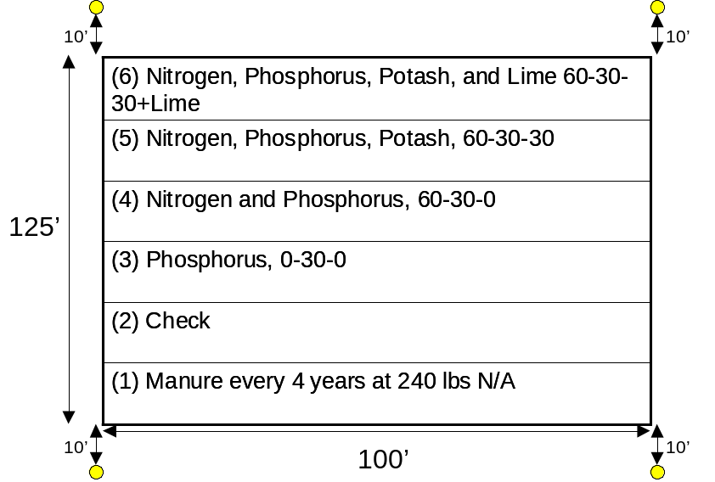

Figure 1. Physical location and treatment structure of the Magruder Plots, 1947-present, Agronomy Experiment Station, Stillwater, OK.

Experiment 222: Long-Term Winter Wheat Fertility With Continuous Application of N, P and K

Abstract
In 1969, experiment #222 was initiated at the Agronomy Research Station in Stillwater, Oklahoma. This trial was established to evaluate long-term winter wheat grain yield response to applied nitrogen (N), phosphorus (P) and potassium (K). Applications of sulfur (S) and magnesium (Mg) (Sul-Po-Mag) were also compared. In the first decade of the experiment, few responses to applied N, P and/or K were found. Following twenty years without fertilization, average check plot yields were 20 bu/ac. It was not until the third decade of this experiment that a dramatic response to applied N was observed. A tendency for increased yields with applied P and K (5 vs 6 and 8 vs 9) was present for the 1989-98 time period, but, this was not significant. Over the 31 years that these treatments have been evaluated, only applied N has produced a significant increase in grain yields. In many regards this continuous wheat data demonstrates the difficulty of evaluating P and K fertilizers since no response could be induced without fertilization following 31 years. Nitrogen applied at an annual rate of 80 pounds per acre was adequate to produce near maximum yields in all three decades evaluated. Considering these results it can also be concluded that if there was no response to applied K (as KCl), there would also be no response to applied Cl. Also, no response was seen to applied S and/or Mg as K,MgSO₄. Grain %N increased with increasing rates of applied N in all three decades evaluated.

Materials and Methods
Experiment #222 was established in 1969 under conventional tillage on a Kirkland silt loam (fine, mixed, thermic Udertic Paleustoll). Wheat was planted for 22 continuous years in 10-inch rows at seeding rates of 60 pounds per acre. Since 1992, winter wheat has been planted in 7.5-inch rows. The variety 'Scout 66' was planted from 1968-73, 'Triumph 64' from 1974-1977, 'Osage' from 1978-80 and 'TAM W-101' from 1981-91, 'Karl' from 1992-1994, 'Tonkawa' from 1995 to 1998 and ‘Custer’ since 1999. Changes in management, fertilization and application dates are reported in Table 1. The experimental design employed was a randomized complete block with four replications. Fertilizer treatments used in this experiment and average grain yield means over selected periods are reported in Table 2. Surface soil (0-6 inches) test analyses from samples collected in 1995 are also reported in Table 2. Individual plots at this site are 20 feet wide and 60 ft long. The center 10 feet (1969-1995) and 6 ft (1996-present) of each plot was harvested with a conventional combine the entire 60 ft in length for yield. In addition to wheat grain yield measured every year from this experiment, periodic soil and grain samples were taken for further chemical analyses.
A significant response to applied N was not seen until the second decade of the experiment (Table 2, 1979-1988). Since that time, applied N has resulted in significant yield increases. Other than applied N, limited response to applied P or K has been found in this experiment. However, a recent trend for increased yields as a result of applying K has been observed, especially at the high rates of applied N. Considering these results it can also be concluded that if there was no consistent response to applied K (as KCl), there would also be no response to applied Cl. Also, no response was seen to applied S and/or Mg as K,MgSO₄ (treatment 13 versus 3).
The fertilizer treatments evaluated have resulted in relatively small surface soil pH (0-6 inches) changes following 27 years (1969-1995) of continuous winter wheat. Soil test P declined with increasing applied N, a result of increased depletion. Surface soil organic matter levels have not changed dramatically, however, organic matter levels have increased at the high N rates when compared to the 0 N checks.

References
Ranney, R.W. 1969. An organic carbon-organic matter conversion equation for Pennsylvania surface soils. Soil Sci. Soc. Amer. Proc. 33:809-811.

Table 1. Treatment applications, and experimental management for continuous winter wheat Experiment 222, Stillwater, OK, 1969-2000.
____________________________________________________________________
Year Variety Fertilizer Planting Date Harvest Date Seeding Rate Topdress
Application lb/ac Date
Date
____________________________________________________________________________________
1969 Scout 66 60
1970 Scout 66 60
1971 Scout 66 60
1972 Scout 66 60
1973 Scout 66 10-3-72 10-9-72 60 3-16-73
1974 Triumph 64 60
1975 Triumph 63 8-29-75 60
1976 Triumph 64 60
1977 Triumph 64 6-15-77 60
1978 Osage 9-9-77 6-14-78 60 3-29-78
1979 Osage 6-29-79 60
1980 Osage 6-25-80 60
1981 TAM W-101 6-31-81 72
1982 TAM W-101 9-18-81 9-22-81 6-14-82 60
1983 TAM W-101 9-29-82 6-21-83 90 3-1-83
1984 TAM W-101 8-31-83 10-5-83 6-25-84 72
1985 TAM W-101 8-23-84 10-2-84 6-12-85 72 3-8-85
1986 TAM W-101 10-7-85 6-12-86 72 2-18-86
1987 TAM W-101 8-20-86 10-17-86 6-15-87 72 3-6-87
1988 TAM W-101 9-17-87 6-14-88 72
1989 TAM W-101 8-18-88 6-20-89 60
1990 TAM W-101 8-29-89 10-11-89 6-13-90 60
1991 TAM W-101 60
1992 TAM W-101 9-10-91 9-30-91 6-17-92 75 2-3-92
1993 Karl 9-16-92 10-12-92 6-17-93 95 2-3-93
1994 Karl 9-22-93 9-27-93 6-8-94 95
1995 Tonkawa 8-30-94 9-29-94 6-20-95 90 2-24-95
1996 Tonkawa 10-9-95 10-10-95 6-11-96 70 3-13-96
1997 Tonkawa 9-5-96 10-3-96 6-19-97 70 2-17-97
1998 Tonkawa 9-29-97 10-3-97 6-10-98 68 1-30-98
1999 Tonkawa 9-3-98 10-13-98 6-15-99 68 2-15-99
2000 Custer 9-5-99 10-7-99 7-6-00 68 2-17-00
____________________________________________________________________________________

Table 2. Soil fertility treatment effects on wheat grain yields, Experiment #222, Stillwater, OK 1969-2000, and surface (0-6 inches) soil test results from 1995.
_____________________________________________________________________________________
Year Period Soil Test (1995)
Treatment 69-78 79-88 89-98 99-00 69-2000 -------------------
N P2O5 K2O pH P OM
lb/ac ---------------bu/ac-------------- ppm %
______________________________________________________________________________________
1. 0 60 40 25.3 19.2 12.8 14.9 18.3 5.85 50 2.27
2. 40 60 40 27.9 27.2 18.0 22.1 23.9 5.83 37 2.35
3. 80 60 40 28.5 28.6 21.8 30.4 26.4 5.50 34 2.27
4. 120 60 40 26.7 31.2 25.2 30.3 27.9 5.72 26 2.37
5. 80 0 40 25.0 27.2 23.3 32.9 25.7 5.59 14 2.20
6. 80 30 40 25.0 31.6 25.1 32.9 27.8 5.48 23 2.25
7. 80 90 40 29.1 28.4 20.5 27.1 25.8 5.54 50 2.30
8. 80 60 0 25.5 27.7 20.8 28.8 24.9 5.67 32 2.27
9. 80 60 80 27.3 29.9 22.4 30.1 26.7 5.55 38 2.24
10. 0 0 0 23.7 20.1 12.7 12.3 18.0 5.93 16 2.13
11. 120 90 80 27.6 30.7 26.3 34.7 28.7 5.73 40 2.27
12. 120 90 0 24.5 27.9 23.7 30.2 25.8 5.91 38 2.20
13. 80 60 40* 32.3 27.4 21.4 28.6 25.9 5.89 26 2.23

Mean 26.6 27.5 21.1 27.3 25.0 5.73 33 2.26
SED 3.1 2.8 2.0 4.8 2.7 0.15 8 0.11
CV, % 17 15 13 25 15 3.7 32 7
_____________________________________________________________________________
N, P2O5, and K2O applied as ammonium nitrate (34-0-0), triple superphosphate ( 0-46-0) and potassium chloride (0-0-60), respectively. *- K2O applied as sul-po-mag (0-0-22). SED standard error of the difference between two equally replicated means. CV coefficient of variation. pH 1:1 soil:water, P, Mehlich III extraction, OM = organic matter = OC*1.8+0.35 (Ranney, 1969)

Table 3. Soil fertility treatment effects on wheat grain %N, Experiment #222, Stillwater, OK 1969-2000.
_____________________________________________________________________________________
Year Period
Treatment 69-78 79-88 89-98 99-00 1969-2000
N P2O5 K2O
lb/ac --------------------------------- % N ------------------------------------ ______________________________________________________________________________________
1. 0 60 40 1.99 2.01 2.30 2.22 2.12
2. 40 60 40 2.06 2.08 2.37 2.28 2.19
3. 80 60 40 2.14 2.26 2.69 2.46 2.40
4. 120 60 40 2.58 2.46 2.76 2.60 2.59
5. 80 0 40 2.33 2.39 2.51 2.47 2.40
6. 80 30 40 2.31 2.26 2.62 2.45 2.32
7. 80 90 40 2.24 2.34 2.62 2.41 2.36
8. 80 60 0 2.24 2.35 2.56 2.46 2.36
9. 80 60 80 2.23 2.27 2.56 2.48 2.31
10. 0 0 0 2.14 2.08 2.00 2.19 2.09
11. 120 90 80 2.55 2.43 2.75 2.71 2.51
12. 120 90 0 2.58 2.50 2.70 2.63 2.54
13. 80 60 40* 2.15 2.25 2.54 2.37 2.27

Mean 2.27 2.28 2.53 2.44 2.34
SED 0.17 0.12 0.15 0.11 0.14
CV, % 10 8 8 6 8
_____________________________________________________________________________
N, P2O5, and K2O applied as ammonium nitrate (34-0-0), triple superphosphate ( 0-46-0) and potassium chloride (0-0-60), respectively. *- K2O applied as sul-po-mag (0-0-22). SED standard error of the difference between two equally replicated means. CV coefficient of variation. pH 1:1 soil:water, P, Mehlich III extraction, OM = organic matter = OC*1.8+0.35 (Ranney, 1969)

Experiment 301: Long-Term Application of Sewage Sludge and
Ammonium Nitrate on Wheat Grain Yield and Forage Quality

K.J. Wynn, N.T. Basta, J. Schroder, W.E. Thomason,
K.W. Freeman, R.W. Mullen, R. Teal, G.V. Johnson, and W.R. Raun

ABSTRACT
Environmentally sound management practices for sewage sludge in grain crop production systems are becoming increasingly important. The objectives of this study were to compare N rates of sewage sludge and ammonium nitrate on yield and heavy metal uptake in winter wheat (Triticum aestivum L.). One field experiment was established in 1993 that evaluated six N rates (0 to 538 kg ha⁻¹ yr⁻¹) as dry anaerobically digested sewage sludge and ammonium nitrate. Lime application in 1993 (8.96 Mg ha⁻¹), 1999 (8.96 Mg ha⁻¹) and 2000 (12.99 Mg ha⁻¹) was also evaluated. In general, wheat yields peaked at the 180 kg N ha⁻¹ rate when N was applied as either sewage sludge or ammonium nitrate. However, wheat grain yields were significantly higher using ammonium nitrate when compared to sewage sludge at comparable rates. Averaged over this seven year period, ammonium nitrate treatments resulted in 28.1 bu/ac (1.9 Mg/ha) while sewage sludge resulted in 20.2 bu/ac (1.4 Mg/ha)(both averaged over N rates). Fertilizer N immobilization was expected to be high in the first few years since this site was previously in native bermudagrass (Cynodon dactylon L.). Following 2-3 years of applying sewage sludge, we expected to achieve the same yields at comparable rates as that using ammonium nitrate. Because ammonium nitrate treatments continue to produce significantly higher yields (following 7 years) when compared to sewage sludge, either N mineralization rates are markedly lower than that previously thought (21% for sewage sludge), or the soil-plant system has yet to achieve equilibrium. Molybdenum concentrations in wheat forage at Feekes growth stage 4 were significantly higher in sewage sludge treated plots when compared to ammonium nitrate. Alternatively, Cu and Fe levels did not differ in wheat forage as a function of N source (sewage sludge versus ammonium nitrate). The Cu to Mo ratio in the wheat forage was above 2 for all treatments. When Cu:Mo ratios are less than 2 in wheat forage, cattle can develop Cu deficiencies. When lime was applied, forage Mo levels were dramatically higher for sewage sludge plots as compared to ammonium nitrate.

Table 1. Treatment structure and grain yield means, 1994-2000, Stillwater, OK.
__________________________________________________________________________________________________

Treatment N rate N Source 1994 1995 1996 1997 1998 1999 2000 Average
lb/ac --------------------------------------bu/ac -------------------------------------
1 0 - 6.9 7.4 9.1 16.8 28.8 13.5 13.7 13.7
2 0 - 5.6 7.7 8.6 19.1 23.9 13.4 14.5 13.3
3 40 SS 7.8 8.5 10.8 23.2 35.4 14.1 19.5 17.0
4 80 SS 9.2 8.5 9.8 22.5 33.4 15.9 22.3 17.4
5 160 SS 13.2 8.5 18.4 20.8 45.4 20.3 23.4 21.4
6 240 SS 15.4 9.1 13.7 20.7 42.1 14.3 18.3 19.1
7 480 SS 22.4 15.3 12.2 21.7 53.6 27.3 28.6 25.9
8 40 AN 26.5 9.2 5.0 20.4 30.6 13.4 25.6 18.7
9 80 AN 25.9 13.5 7.6 26.2 42.6 23.9 42.9 26.1
10 160 AN 28.6 17.8 9.9 32.4 51.2 35.2 49.1 32.0
11 240 AN 38.5 21.1 8.0 35.0 45.2 43.0 41.4 33.2
12 480 AN 34.8 19.1 8.3 38.0 46.2 36.8 30.5 30.5
13 480 SS+L 24.8 15.6 13.1 24.2 55.5 38.7 23.3 27.9
14 480 AN+L 32.5 19.7 11.6 42.3 55.2 42.5 32.9 33.8

SED 2.62 2.55 2.93 4.74 4.4 4.9 5.4
CV, % 15 24 34 22 13 24 28
_________________________________________________________________________________________________
L - lime applied at a rate of 8960 kg/ha (4 tons/acre) in the fall of 1993
L – lime applied at a rate of 8960 kg/ha (4 tons/acre) in the fall of 1999 (87% ECCE)
L - lime applied at a rate of 12,992 kg/ha (5.8 tons/acre) in the fall of 2000 (85% ECCE)
SS - sewage sludge obtained from the City of Stillwater, AN - ammonium nitrate (34-0-0)
SED - standard error of the difference between two equally replicated means, CV - coefficient of variation, %

Table 2. Total nitrogen and moisture content of Stillwater sewage sludge, 1993 to 2000.
_______________________________________________________________
1993 1994 1995 1996 1997 1998 1999 2000 Avg.
-------------------------------------Total N, % ------------------------------------------
2.02 1.74 1.97 2.73 2.42 2.43 2.02 2.44 2.22
------------------------------------- Moisture, % ---------------------------------------
60 35 59 na 55 46 45 17 45
________________________________________________________

Table 3. Forage yield (Feekes 4, collected in December) and metal concentrations
from unwashed and washed forage, Stillwater, OK, 1999.

Treatment | yld lb/ac | unwashed, Cu | washed, Cu | unwashed, Fe | washed, Fe | unwashed, Mo | washed, Mo | Cu/Mo, washed
 |  | mg kg⁻¹
1 | 442.32 | 9.72 | 7.06 | 5033 | 248 | 0.47 | 0.47 | 18.7
2 | 220.489 | 9.29 | 6.99 | 3990 | 383 | 0.42 | 0.3 | 32.6
3 | 677.6 | 9.61 | 6.49 | 4944 | 226 | 0.31 | 0.27 | 27.1
4 | 375.1 | 10.94 | 7 | 5826 | 268 | 0.49 | 0.45 | 15.8
5 | 368.378 | 13.16 | 7.33 | 5207 | 302 | 0.83 | 0.49 | 15.3
6 | 778.433 | 13.69 | 6.69 | 5377 | 303 | 0.82 | 0.65 | 10.7
7 | 240.656 | 13.15 | 7.87 | 3052 | 260 | 1.41 | 0.96 | 8.3
8 | 415.433 | 9.78 | 7.28 | 6143 | 207 | 0.29 | 0.19 | 67.7
9 | 401.489 | 10.38 | 7.5 | 5003 | 286 | 0.25 | 0.16 | 53.4
10 | 731.378 | 8.74 | 7.45 | 5359 | 232 | 0.25 | 0.08 | 133.4
11 | 254.1 | 10.83 | 8.36 | 3231 | 422 | 0.17 | 0.07 | 109.6
12 | 361.656 | 9.78 | 7.9 | 4394 | 182 | 0.16 | 0.05 | 147.1
13 | 395.267 | 30.32 | 7.66 | 4109 | 226 | 1.9 | 1.28 | 7.3
14 | 280.98 | 10.06 | 7.7 | 4139 | 252 | 0.24 | 0.14 | 87.3

Table 4. Treatment applications and experimental management for continuous winter wheat Experiment 301, Stillwater, OK, 1994-2000.
____________________________________________________________
Year Variety Fertilizer Planting Date Harvest Seeding Rate Application Date lb/ac
Date
1994 Karl 10-6-93 10-7-93 6-8-94 60
1995 Tonkawa 10-13-94 10-14-94 6-15-95 75
1996 Tonkawa 11-16-95 11-17-95 6-10-96 70
1997 Tonkawa 10-9-96 10-10-96 6-19-97 68
1998 Tonkawa 10-20-97 10-20-97 6-10-98 68
1999 Tonkawa 10-12-98 10-15-98 6-15-99 68
2000 Custer 10-4-99 10-7-99 6-15-00 68

Experiment 406: Wheat Grain Yield Response to Nitrogen, Phosphorus and Potassium Fertilization

ABSTRACT
Grain yield response of irrigated winter wheat to fertilization with nitrogen (N), phosphorus (P) and potassium (K) in a long-term experiment has not been extensively evaluated. Experiment 406 was established in 1966 to evaluate fertilizer applications on irrigated winter wheat grown in southwestern Oklahoma. Following 34 years of continuous wheat, response to applied N, P, and K remains somewhat dynamic. Over a 34 year period, only applied N has provided consistent wheat yield increases. Grain yield maximums have been achieved at an average annual N rate of 40 lb N/ac. However, grain percent N (grain protein) has increased when N was applied at rates greater than 40 lb N/ac. In the last ten years, soil test P has approached deficient levels and yield response to applied P has been significant over this time period. Yield response due to applied K has not been observed in this 34 year experiment where soil test K levels were initially high.

Materials and Methods
In the fall of 1965, Experiment 406 was established under conventional tillage on a Tillman-Hollister clay loam (fine-mixed, thermic Typic Paleustoll) at the Irrigation Research Station near Altus, Oklahoma. Winter Wheat has been planted in 10 inch rows at seeding rates of 90 pounds per acre. In 1969 and 1971, grain yield data was not obtained. In most years, plots were not irrigated in the spring because the economics of the irrigation district have dictated that water is only released for summer crops. When water was applied, it was usually a pre-irrigation prior to planting. The experimental design employed is a randomized complete block with six replications. Management, varieties, and application dates are reported in Table 1. Fertilizer treatments used in this experiment and average grain yields over selected periods are reported in Table 2. Soil test levels from surface samples collected in 1995 are included in Table 3. Individual plots at this site are 15 feet wide and 60 feet long. The center 10 (1966-1995) and 6 (1996-present) feet were harvested with a conventional combine the entire 60 feet in length. In addition to wheat grain yield measured every year, periodic soil and grain samples were taken for further chemical analyses.

Table 1. Treatment applications and experimental management for continuous winter wheat Experiment 406, Altus, OK, 1966-2000.
_____________________________________________________________________________
Year Variety Fertilizer Planting Date Harvest Date Seeding Rate Irrigation Topdress
Application lb/ac Date Date
Date
________________________________________________________________________________________________
1966 10-1-66 2-9-67
1967
1968
1969 4-28-69 1-28-69
1970 Tascosa 10-10-69 10-11-69 6-6-70 90 2-17-70 2-2-70
1971* Tascosa 10-14-70 10-21-71 6-1-71 90 8-27-70 1-25-71
1972 Sturdy 8-17-71 10-9-71 6-8-72 90 None 2-21-72
1973 TAM W-101 9-11-72 10-12-72 6-11-73 90 9-13-72
1974 TAM W-101 8-31-73 10-26-73 6-13-74 90 None 2-11-74
1975 TAM W-101 9-5-74 9-6-74 6-13-75 90 8-2-74
1976 TAM W-101 8-20-75 10-9-75 6-8-76 90 9-3-75 1-13-76
1977 TAM W-101 8-9-76 10-14-76 6-9-77 80 8-11-76 2-16-77
1978 TAM W-101 9-14-77 10-31-77 6-23-78 90 None 3-13-78
1979 TAM W-101 8-20-78 10-10-78 6-20-79 90 None 3-13-79
1980 TAM W-101 9-13-79 10-18-79 6-13-80 96 None 3-7-80
1981 TAM W-101 8-22-80 11-7-80 6-10-81 90 None 1-26-81
1982 TAM W-101 9-9-81 10-27-81 6-30-82 90 None 2-23-82
1983 TAM W-101 8-16-82 8-16-82 6-15-83 90 None 3-2-83
1984 TAM W-101 8-25-83 11-3-83 6-13-84 90 None 3-1-84
1985 TAM W-101 8-29-84 10-10-84 6-20-85 90 9-7-84 3-14-85
1986 TAM W-101 8-23-85 11-4-85 6-10-86 90 None 2-18-86
1987 TAM W-101 9-18-86 11-15-86 6-8-87 90 None 3-6-87
1988 TAM W-101 9-1-87 10-6-87 6-9-88 90 9-2-87 2-17-88
1989 TAM W-101 10-24-88 11-17-88 6-22-89 90 9-1-88 All N preplant
1990 TAM W-101 8-10-89 9-22-89 6-9-90 90 8-24-89 All N preplant
1991 TAM W-101 8-30-90 10-10-90 6-18-91 90 None All N preplant
1992 TAM-W-101 9-22-91 9-27-91 6-15-92 90 7-25,8-8-91 2-9-92
1993 Karl 10-20-92 6-15-93 90 8-12-92 3-25-93
1994 Karl 8-17-93 9-28-93 6-3-94 90 8-20-93 3-24-94
1995 Tonkawa 8-19-94 10-27-94 6-17-95 90 8-9-94 3-8-95
1996 Tonkawa 8-17-95 10-12-95 6-5-96 90 None 2-3-96
1997 Tonkawa 8-15-96 10-1-96 6-14-97 90 8-1-96 2-3-97
1998 Tonkawa 9-19-97 10-3-97 6-4-98 90 8-12-97 3-12-98
1999 Tonkawa 9-9-98 10-12-98 6-7-99 90 7-21,8-14-98 1-27-99
2000 Custer 8-24-99 10-8-99 5-24-00 90 8-5-99 3-9-00
___________________________________________________________________________________________________________
*crop loss due to drought.

Table 2. Treatment structure of a long-term supplemental irrigation winter wheat Experiment 406 and overall means,
Altus, OK, 1966-2000.
__________________________________________________________________________________________________________________

Trt . N P2O5 K2O 1966-1970 1972-1980 1981-1990 1991-2000 1966-2000
lb/ac bu/ac %N bu/ac %N bu/ac %N bu/ac %N bu/ac %N
__________________________________________________________________________________________________________________
1 0 0 0 14.1 2.47 23.1 2.37 21.3 2.04 13.5 2.53 18.6 2.35
2 40 0 0 19.8 2.57 31.5 2.65 27.4 2.40 20.5 2.68 25.5 2.57
3 80 0 0 18.8 2.82 32.1 2.83 27.6 2.53 21.9 2.95 26.0 2.77
4 120 0 0 18.6 2.95 33.7 2.91 26.7 2.64 22.2 3.02 26.3 2.88
5 160 0 0 17.5 2.97 32.9 3.07 27.3 2.58 23.0 3.08 26.3 2.92
6 40 40 0 22.3 2.54 33.4 2.63 29.6 2.10 21.6 2.58 27.3 2.46
7 80 40 0 18.6 2.91 34.6 2.83 28.9 2.63 25.2 2.93 28.1 2.82
8 120 40 0 17.6 2.96 34.8 2.90 29.1 2.68 27.7 3.06 28.9 2.90
9 160 40 0 16.6 3.19 31.9 2.97 28.7 2.92 26.0 3.11 27.3 3.05
10 40 40 40 20.9 2.64 32.7 2.48 29.3 2.16 21.5 2.61 26.9 2.47
11 80 40 40 19.5 2.82 35.4 2.78 29.8 2.59 24.7 2.91 28.5 2.77
12 120 40 40 15.9 2.88 32.1 2.96 28.3 2.76 26.0 3.10 27.1 2.91
13 160 40 40 15.0 3.00 31.6 3.04 27.3 2.74 24.8 3.08 26.2 2.96

SED 2.37 0.23 3.24 0.19 3.24 0.21 2.47 0.11 2.9 0.20
CV, % 18 12 14 10 17 12 15 5 16 10
__________________________________________________________________________________________________________________
N, P and K applied as 34-0-0, 0-46-0 and 0-0-60 respectively. N applied 1/2 fall, 1/2 spring
1971-crop loss due to drought.

Table 3. Treatment structure and surface (0-6 inches) soil test analyses from samples collected in the summer of 1995, Experiment 406, Altus, OK.
_____________________________________________________________________________

Trt . N P2O5 K2O pH Organic C Total N P K
lb/ac % % ppm ppm
_____________________________________________________________________________
1 0 0 0 7.29 0.84 0.073 9 409
2 40 0 0 7.22 0.88 0.078 9 414
3 80 0 0 7.39 0.90 0.079 7 403
4 120 0 0 7.97 0.90 0.082 8 421
5 160 0 0 7.39 0.90 0.086 9 415
6 40 40 0 7.42 0.87 0.080 31 418
7 80 40 0 7.35 0.93 0.083 26 410
8 120 40 0 7.30 1.00 0.089 27 408
9 160 40 0 7.20 0.96 0.088 27 407
10 40 40 40 7.12 0.87 0.076 32 444
11 80 40 40 7.38 0.93 0.082 25 432
12 120 40 40 7.12 0.95 0.085 24 445
13 160 40 40 6.79 0.93 0.083 24 441

SED 0.18 0.03 0.004 2.3 14
CV, % 4 6 9 20 5
_____________________________________________________________________________
N, P and K applied as 34-0-0, 0-46-0 and 0-0-60 respectively. N applied 1/2 fall, 1/2 spring.
SED - standard error of the difference between two equally replicated means, CV - coefficient of variation.

Experiment 407: Response of Dryland Winter Wheat to Nitrogen, Phosphorus and Potassium Fertilization

ABSTRACT
Winter wheat grain yield response to fertilization with nitrogen (N), phosphorus (P) and potassium (K) in long-term experiments continues to be relevant in terms of sustainability and environmental risk. Experiment 407 was established in 1966 and has now been conducted for 34 years. Response to applied N, P, and K has been limited at this site, largely due to high soil test nutrient levels and low yields over the extensive number of years evaluated. From 1966 to 1980, only limited increases in grain yield due to applied N were observed. Since 1980, grain yields have increased significantly due to applied N, generally being maximized at the 40 lb N/ac/yr rate. Yield increases due to applied N in this dryland winter wheat experiment have ranged from 5 to 10 bu/ac. Grain %N levels have been found to increase linearly up to 80 lb N/ac/yr (beyond the N rate required for maximum yields). As grain protein premiums become increasingly more important, optimum N rates for grain %N will need to be refined.

Materials and Methods
In the fall of 1965, Experiment 407 was established under conventional tillage on a Tillman-Hollister clay loam (fine-mixed, thermic Typic Paleustoll) at the Irrigation Research Station near Altus, Oklahoma. Winter Wheat has been planted for 31 continuous years in 10 inch rows at seeding rates of 60 pounds per acre. Grain yield data for the 1971 crop year was lost due to drought. The experimental design employed is a randomized complete block with six replications. Variety changes and associated fertilizer application, planting and harvest dates are included in Table 1. Fertilizer treatments used in this experiment and grain yield averages from selected periods are reported in Table 2. Individual plots at this site are 15 feet wide and 60 feet long. The center 10 feet were harvested with a conventional combine the entire 60 feet in length. In addition to wheat grain yield measured every year, periodic soil and grain samples were taken for further chemical analyses. Soil test results from surface samples collected in the summer of 1995 are included in Table 3.

Table 1. Treatment applications, and experimental management for continuous winter wheat Experiment 407, Altus, OK, 1966-2000.
_____________________________________________________________________________
Year Variety Fertilizer Planting Date Harvest Date Seeding Rate Topdress Date
Application Date lb/ac
_________________________________________________________________________________________________
1966
1967
1968
1969 6-3-69
1970 KAW 61 10-9-69 10-11-69 6-5-70 40
1971 KAW 61 10-14-70 10-20-70 6-1-71 60 1-26-71
1972 Danne 8-17-71 10-5-71 6-8-72 40 2-23-72
1973 Nicoma 9-5-72 10-4-72 6-6-73 40
1974 Nicoma 9-21-73 10-24-73 6-13-74 50 2-11-74
1975 Nicoma 10-9-74 10-11-74 6-12-75 40
1976 Triumph 64 8-14-75 10-7-75 6-10-76 60 1-13-76
1977 Triumph 64 8-10-76 10-14-76 6-8-77 60 2-17-77
1978 Triumph 64 9-14-77 11-7-77 6-22-78 60 3-14-78
1979 Triumph 64 8-20-78 10-9-78 6-20-79 60 3-12-79
1980 Triumph 64 9-12-79 10-18-79 6-19-80 60 3-10-80
1981 TAM W-101 8-20-80 11-7-80 6-10-81 60 1-26-81
1982 TAM W-101 9-8-81 10-27-81 6-30-82 60 2-23-82
1983 TAM W-101 8-18-82 10-28-82 6-16-83 60 3-4-83
1984 TAM W-101 8-25-83 12-5-83* 6-12-84 60 3-2-84
1985 TAM W-101 8-29-84 10-10-84 6-20-85 90 3-5-85
1986 TAM W-101 8-23-85 11-5-85 6-2-86 60 2-19-86
1987 TAM W-101 9-16-86 11-15-86 6-23-87 60 3-5-87
1988 TAM W-101 9-4-87 10-6-87 6-10-88 60 2-18-88
1989 TAM W-101 10-26-88 11-17-88 6-22-89 60 3-9-89
1990 TAM W-101 8-10-89 9-22-89 6-8-90 60 3-9-90
1991 TAM W-101 8-30-90 9-27-90 6-19-91 60 2-7-91
1992 TAM W-101 9-22-91 9-27-91 6-16-92 60 2-9-92
1993 Karl 10-20-92 6-16-93 60 3-25-93
1994 Karl 8-17-93 9-28-93 6-3-94 60 3-24-94
1995 Tonkawa 8-19-94 10-27-94 6-17-95 60 3-8-95
1996 Tonkawa 8-18-95 10-11-95 6-6-96 60 2-3-96
1997 Tonkawa 8-15-96 10-1-96 6-14-97 60 2-3-97
1998 Tonkawa 9-19-97 10-3-97 6-4-98 60 3-12-98
1999 Tonkawa 9-9-98 10-12-98 6-7-99 60 1-27-99
2000 Custer 8-24-99 10-8-99 5-24-00 60 3-9-00
_________________________________________________________________________________________________
N, P and K applied as 34-0-0, 0-46-0 and 0-0-60 respectively. All N applied in the spring. P and K applied preplant and incorporated. SED - standard error of the difference between two equally replicated means, CV - coefficient of variation.

Table 2. Treatment structure of a long-term supplemental irrigation winter wheat Experiment 407 and overall means, Altus, OK, 1966-2000.
__________________________________________________________________________________________________________________

Trt . N P2O5 K2O 1966-1970 1973-1980 1981-1990 1991-2000 1966-2000
lb/ac bu/ac %N bu/ac %N bu/ac %N bu/ac %N bu/ac %N
__________________________________________________________________________________________________________________
1 0 0 0 19.2 2.88 24.2 2.32 21.3 2.08 15.0 2.37 19.8 2.42
2 20 0 0 18.4 2.90 25.9 2.63 23.9 2.41 19.3 2.60 22.2 2.64
3 40 0 0 17.4 2.96 26.2 2.58 24.3 2.54 20.4 2.83 22.5 2.72
4 80 0 0 18.3 2.97 27.7 2.76 25.3 2.60 22.3 3.00 23.9 2.83
5 0 40 0 22.1 2.74 25.1 2.11 22.7 1.86 15.2 2.41 20.9 2.28
6 20 40 0 19.9 2.94 27.1 2.46 28.2 2.10 20.5 2.46 24.3 2.49
7 40 40 0 16.8 3.00 30.2 2.72 29.4 2.40 22.7 2.71 25.6 2.71
8 80 40 0 15.9 2.98 26.5 2.74 27.6 2.77 25.1 3.02 24.8 2.88
9 0 40 40 21.9 2.71 24.3 2.10 22.5 2.15 15.5 2.36 20.7 2.33
10 20 40 40 21.4 3.01 28.6 2.52 29.6 2.06 19.9 2.49 25.2 2.52
11 40 40 40 17.9 2.93 30.4 2.76 29.5 2.44 23.4 2.66 26.1 2.70
12 80 40 40 15.9 2.93 28.1 2.85 28.1 2.69 24.4 2.91 25.2 2.84

SED 1.5 0.13 2.4 0.18 2.22 0.34 2.44 0.11 2.29 0.21
CV, % 11 6 13 10 12 20 17 6 14 11
__________________________________________________________________________________________________________________
N, P and K applied as 34-0-0, 0-46-0 and 0-0-60 respectively.
1971-1972-crop loss due to drought.
Table 3. Treatment structure and surface (0-6 inches) soil test analyses from samples collected
in the summer of 1995, Experiment 407, Altus, OK, 1966-1997.
_____________________________________________________________________________
Trt . N P2O5 K2O pH Organic C Total N P K
lb/ac % % ppm ppm
_____________________________________________________________________________
1 0 0 0 6.8 0.929 0.079 7.4 502
2 20 0 0 6.8 0.989 0.094 8.4 480
3 40 0 0 6.8 0.982 0.084 9.2 546
4 80 0 0 6.5 1.038 0.091 9.2 528
5 0 40 0 6.8 0.948 0.084 42.2 496
6 20 40 0 6.7 0.950 0.082 36.6 525
7 40 40 0 6.7 1.045 0.092 34.1 530
8 80 40 0 6.4 1.087 0.104 33.5 516
9 0 40 40 6.9 0.931 0.081 45.8 590
10 20 40 40 6.8 1.006 0.085 37.3 570
11 40 40 40 6.6 1.024 0.087 33.0 583
12 80 40 40 6.4 1.076 0.095 32.5 564

SED 0.12 0.12 0.004 3.5 84
CV 3 10 8 22 7
_____________________________________________________________________________
N, P and K applied as 34-0-0, 0-46-0 and 0-0-60 respectively. All N applied in the spring. P and K
applied preplant and incorporated. SED - standard error of the difference between two equally
replicated means, CV - coefficient of variation.

Experiment 439: Effect of Long-Term Applications of N, P, and K on Cotton Lint Yields

ABSTRACT
Fertilizer use in cotton production remains an important issue, especially in continuous cotton where farmers commonly apply the same rates year after year. This experiment was initiated in 1972 to evaluate the long-term effects of N, P and K fertilization on lint yield and lint quality. Each year, N, P and K fertilizers (depending on the treatment) were surface applied and incorporated prior to planting. Cotton yields were determined using a machine stripper. Lint yields peaked at the 40 lb N/ac rate with or without P and/or K fertilization. Although some increases in lint yields were observed in selected years at the 80 lb N/ac rate, increased N above 40 lb N/ac in the irrigated cotton study was not significant. Limited differences in P and K fertilization were noted from 1972 to 1999. One of the largest differences noted over the years was in yield potential as a result of changing varieties. Most recently, the use of Paymaster (145 and HS26) varieties have shown significant increases in lint yields, exceeding 1000 lbs/acre. This long-term experiment clearly shows that N applied at the 40 lb N/ac rate (when soil test P or K are adequate) resulted in near maximum lint yields.

Experiment 439 was initiated in the spring of 1972 to evaluate the long-term effects of N, P and K on cotton yields at the Irrigation Research Station near Altus. This study along with 222, 406, 407, 501, 502, 503, 504, 505 was started by Dr. Billy Tucker, and continued by Dr. Robert L. Westerman. The Irrigation Research Station is located in the Lugert Altus Irrigation District (LAID), which consists of surface impoundment by the Lugert Dam of some tributaries of the North Fork of the Red River. Irrigation at the research station is accomplished by utilizing concrete ditches, with water furrow applied via siphon tubes. The irrigation district allocates irrigation water to the research station as it does to local producers, with the amount varying each year as to the supply available in the reservoir. Large unlined earth canals are used to distribute the water to the various areas within the district. Some farms near these canals experience drainage problems associated with canal seepage which adversely affect crop yields. Underground tile drainage (installed in the late 1970’s) has been employed to facilitate lowering of the water table. The objective of this experiment is to determine the effect of long-term applications of N, P, and K on lint yield and cotton quality.

Procedures
Experiment 439 was established in 1972 on the western side of the Irrigation Research Station on soil that had previously been in continuous cotton under conventional tillage since approximately 1964. This soil was classified as a Tillman-Hollister clay loam (fine, mixed, thermic Typic Paleustolls). Soil test characteristics in from the 1988 for selected treatments are listed in Table 1. Each plot within the experiment has received annual applications of fertilizers at the rates indicated in Table 2. The N, P, and K fertilizer sources used are ammonium nitrate (33.5-0-0), triple super phosphate (0-46-0) and potassium chloride (0-0-62), respectively. The plot dimensions are six rows wide (40 inch row spacing) by 60 feet in length. The experimental design is a randomized complete block with four replications. Irrigation is applied as available, with allocations from the Lugert Altus Irrigation District varying from year to year. Since the irrigation water is furrow applied, the amount applied per application would be approximately 3 to 4 acre-inches. Cultural practices and other information pertaining to the experiment are found in Table 3. In the early years of the experiment harvest was accomplished by hand pulling the center two rows of the plot by 50 feet in length. In 1976 harvest was performed by machine stripper harvesting the rows. Beginning in 1983, grab samples were collected from the harvested material in each plot and ginned on small ginning equipment in order to approximate lint turn out or ginning percent. Also beginning in 1983, boll samples were taken, ginned and fiber properties on these lint samples determined by appropriate procedures.
Table 1. Treatment applications and experimental management for Experiment #439, Altus, OK, 1972-1999.
_____________________________________________________________________________________
Year Fertilizer Planting Variety Seeding #of Harvest
Application Date Rate Irrigations Date
Date lb/ac
_____________________________________________________________________________________
1972 5-15-72 5-31-72 Stoneville 213 22 3 12-22-72
1973 5-16-73 5-25-73 Stoneville 213 22 3 No Data
1974 5-10-74 5-30-74 Stoneville 213 22 2 12-18-74
1975 5-19-75 5-16-75 Lankart LX-571 21 1 12-3-75
1976 5-12-76 5-18-76 Lankart LX-571 20 5 11-19-76
1977 4-8-77 5-17-77 Lankart LX-571 21 2 11-18-77
1978 8-7-78 5-10-78 Westburn M 21 4 12-7-78
1979 5-17-79 5-31-79 Westburn M 21 1 12-7-79
1980 7-24-80 5-22-80 Westburn M 21 6 12-2-80
1981 7-16-81 5-23-81 Westburn M 20 1 12-2-81
1982 5-19-82 5-20-82 Westburn M 21 4 1-11-83
1983 5-11-83 6-1-83 Westburn M 21 7 12-9-83
1984 4-26-84 5-24-84 Westburn M 21 5 1-1-85
1985 5-17-85 5-17-85 Westburn M 21 4 12-21-85
1986 5-10-86 5-23-86 Westburn M 18 3 1-6-87
1987 5-11-87 5-13-87 Westburn M 18 4 12-2-87
1988 5-4-88 6-21-88 Westburn M 18 6 11-30-88
1989 4-27-89 5-23-89 Paymaster 145 16 3 11-8-89
1990 5-14-90 5-15-90 Paymaster 145 21 2 11-2-90
1991 3-11-91 5-28-91 Paymaster 145 21 4 12-5-91
1992 5-5-92 7-1-92* Paymaster 145 17.8 1 2-1-93
1993 3-25-93 5-27-93 Paymaster 145 17.6 5 11-30-93
1994 4-21-94 5-10-94 Paymaster 145 18.4 5 10-4-94
1995** 5-3-95 5-16-95 Paymaster HS26 16.2
1996 4-25-96 5-9-96 Paymaster HS26 17.2 3 11-7-96
1997 4-22-97 5-14-97 Paymaster HS26 17.2 2 10-31-97
1998 4-23-98 5-19-98 Paymaster HS26 17.2 7 10-9-98
1999 5-14-99 5-19-99 Paymaster HS26 17.2 5 10-21-99
_______________________________________________________________________________
* initial planting date 6-11-92 ** crop lost due to hail storm
Table 2. Treatment structure and mean lint yields for the periods 1972-1981, 1982-1991, 1992-1999 and 1972-1999, Experiment #439, Altus, OK.

Trt. | N  lb/ac | P₂O₅  lb/ac | K₂O  lb/ac | 1972-1981 | 1982-1991 | 1992-1999 | 1972-1999
 |  |  |  | Lint yield, lb/ac
1 | 0 | 0 | 0 | 415 | 523 | 641 | 517
2 | 0 | 40 | 80 | 424 | 522 | 638 | 519
3 | 40 | 40 | 80 | 426 | 629 | 919 | 637
4 | 80 | 40 | 80 | 387 | 631 | 928 | 627
5 | 120 | 40 | 80 | 388 | 655 | 932 | 637
6 | 160 | 40 | 80 | 407 | 577 | 926 | 612
7 | 200 | 40 | 80 | 361 | 578 | 908 | 592
8 | 0 | 0 | 0 | 414 | 521 | 625 | 512
9 | 120 | 0 | 80 | 396 | 626 | 893 | 618
10 | 120 | 80 | 80 | 398 | 631 | 957 | 638
11 | 120 | 120 | 80 | 381 | 569 | 922 | 599
12 | 0 | 0 | 0 | 433 | 541 | 646 | 532
13 | 120 | 40 | 0 | 399 | 605 | 912 | 616
14 | 0 | 0 | 0 | 420 | 544 | 624 | 523

Table 3. Soil test characteristics for selected treatments, Experiment #439, Altus, OK

Trt | Year | pH | BI | NO3-N | P | K | Ca | Mg | Na
0-0-0
0-40-80
80-40-80

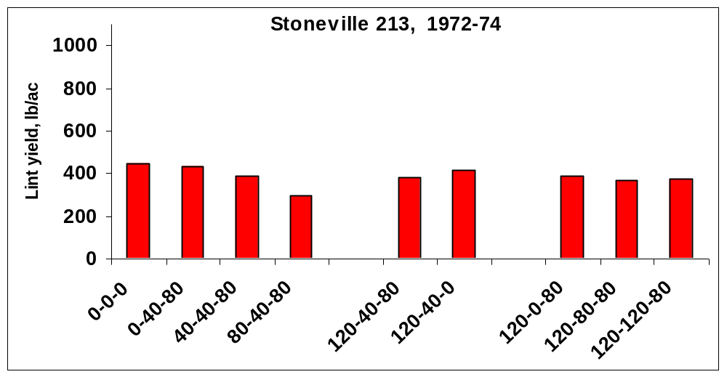

Figure 1. Mean lint yields for selected treatments using the variety, Stoneville 212, 1972-1974, Altus, OK.
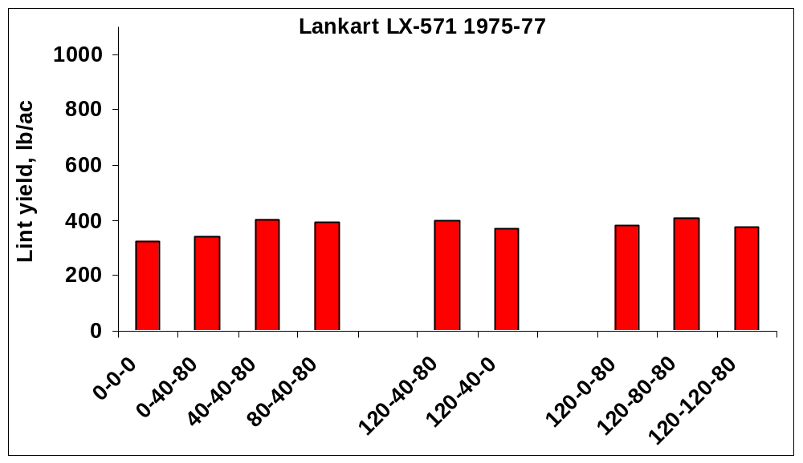
Figure 2. Mean lint yields for selected treatments using the variety, Lankart LX-571, 1975-1977, Altus, OK.

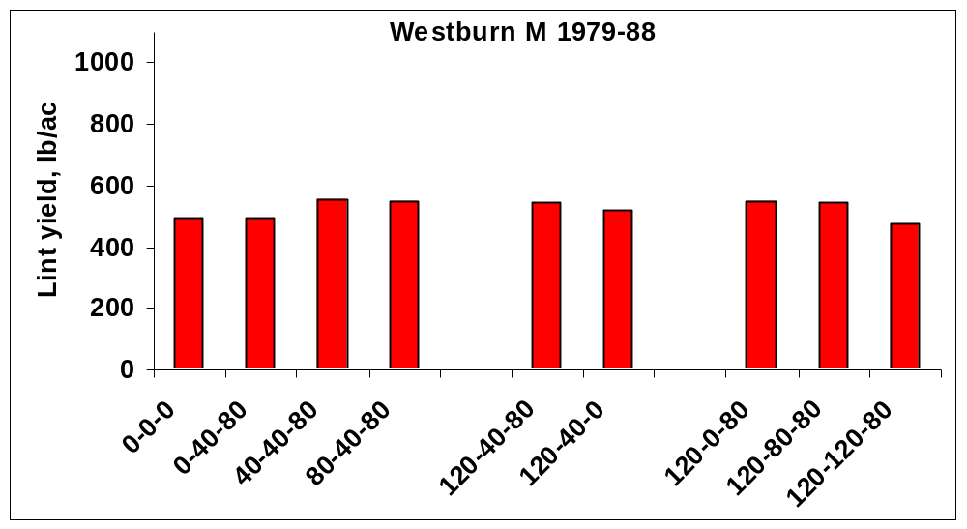
Figure 3. Mean lint yields for selected treatments using the variety, Westburn M 1979-88, Altus, OK.

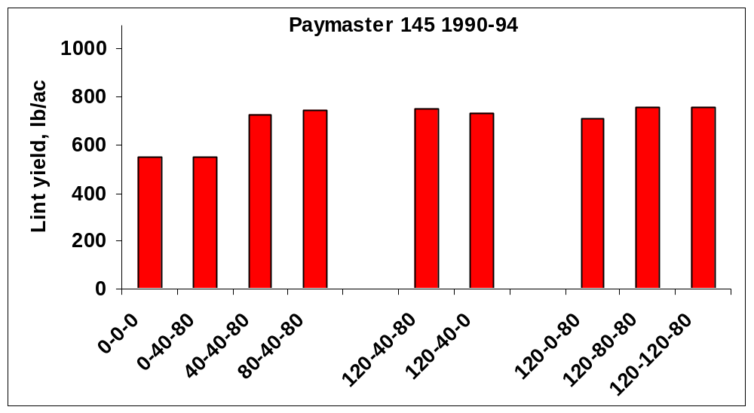
Figure 4. Mean lint yields for selected treatments using the variety, Paymaster 145, 1990-1994, Altus, OK.

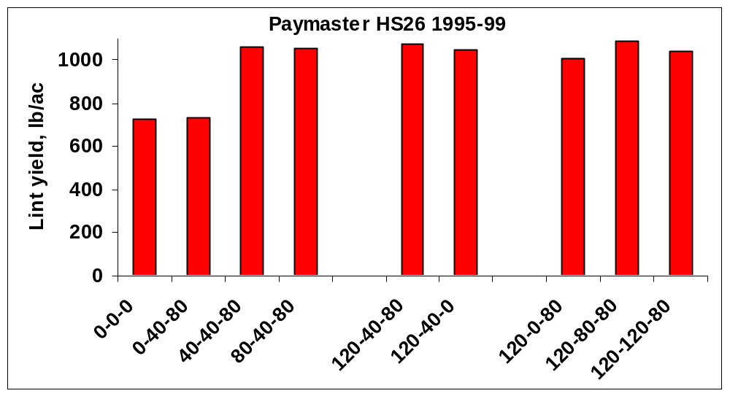
Figure 5. Mean lint yields for selected treatments using the variety, Paymaster HS26, 1995-1999, Altus, OK.

Experiment 501: Response of Grain Sorghum to Nitrogen, Phosphorus and Potassium Fertilization

abstracT
Sorghum grain yield response to long-term applications of nitrogen (N), phosphorus (P) and potassium (K) remains extremely important relative to maximum yields and the potential for environmental risk. Experiment 501 was established in 1971 to evaluate fertilizer applications on grain sorghum grown in western Oklahoma. This experiment has now been conducted for 30 years. Response to applied N was not seen until the second decade of the experiment. In the last 20 years of the experiment, sorghum grain yields have been maximized at an average annual N rate of 60 lb N/ac. Grain % N levels were generally maximized at the same N rate as that noted for maximum yields. To date, no response to applied P and/or K has been found in this long-term grain sorghum experiment.

Materials and Methods
In the spring of 1971, Experiment 501 was established under conventional tillage on a Grant silt loam (fine-silty, mix, thermic Udic Argiustoll) at the North Central Research Station near Lahoma, Oklahoma. Grain Sorghum has been planted for 20 continuous years in 36 inch rows at seeding rates of 4.3 pounds per acre. The variety 'ACCOR1019' was planted from 1971-79, 'DKC42Y+' from 1980-1994, SG-822 from 1995-1998 and SG-753 from 1999 to present. Experimental methods, application dates and changes over time are reported in Table 1. The experimental design employed is a randomized complete block with four replications. Fertilizer treatments and average grain yield means over selected periods are reported in Table 2. Individual plots at this site are 20 feet wide and 60 feet long. The center 2 rows of each plot were harvested for yield using a conventional combine the entire 60 feet in length. In addition to grain sorghum yield measured every year (exception was 1973 where crop failure resulted due to lack of rainfall for most experiments at the North Central Research Station), periodic soil and grain samples were taken for further chemical analyses. Results from surface (0-6 inches) soil test analyses from samples collected in 1988 are reported in Table 3.

Table 1. Treatment applications, and experimental management for continuous sorghum Experiment 501, Lahoma, OK, 1971-2000.
_________________________________________________________________________________________________
Year Variety Fertilizer Planting Harvest Seeding Rate Harvest Area
Application Date Date
Date
_________________________________________________________________________________________________
1972 2rows*60ft
1973 11-15-73 180sqft
1974 ACCO R1019 5-22-74 6-24-74 12-4-74 10lb/A 10'*60'
1975 11-14-75 3row*60ft
1976 11-9-76 10'*60'
1977 11-18-77 10'*60'
1978 12-5-78 10'*60'
1979 12-3-79 2row*60ft
1980 DKC42Y+ 6-12-80 11-10-80 3row*60ft
1981 DKC42Y+ 7-12-81 12-4-81 4.3#/A
1982 DKC42Y+ 6-14-82 11-9-82 5#/A 85%germ
1983 DKC42Y+ 5-26-83 6-17-83 11-16-83 4.5#/A 3row*60ft
1984 DKC42Y+ 6-22-84 11-14-84
1985 DKC42Y+ 12-6-85 3row*60ft
1986 DKC42Y+ 6-18-86 11-14-86
1987 DKC42Y+ 6-23-87 6-24-87
1988 DKC42Y+ 6-7-88 3#/A
1989 DKC42Y+ 10-26-89 10'*60'
1990 DKC42Y+ 6-5-90 10-26-90 10'*60'
1991 DKC42Y+ 6-21-91 11-8-91 6#/A 10'*60'
1992 DKC427 5-1-92 5-7-92 6#/A 10’*60’
1993 DKC427 5-28-93 5-28-93 8#/A 10’*60’
1994 DKC427 5-10-94 6-1-94 Hailed out 8#/A 10’*60’
1995 SG-822 6-13-95 6-19-95 6#/A 10’*60’
1996 SG-822 5-21-96 5-29-96 6#/A 10’*60’
1997 SG-822 5-23-97 6-19-97 6#/A 10’*60’
1998 SG-822 5-22-98 7-15-98 12-15-98 6#/A 10’*60’
1999 SG-753 5-26-99 5-27-99 11-11-99 10’*60’
2000 SG-753 5-12-00 6-5-00 6#/A
_______________________________________________________________________________________________

Table 2. Treatment structure of long-term sorghum Experiment 501, sorghum grain yield and percent N in the grain for selected periods, Lahoma, OK, 1971-1999.
_____________________________________________________________________________
Trt. N P2O5 K2O 1971-1980 1981-1990 1991-1999 1971-1999
lb/ac applied lb/ac %N lb/ac %N lb/ac %N lb/ac %N

1 0 0 0 2071 2.16 1363 1.41 940 1.21 1473 1.60
2 0 40 40 2284 2.18 1339 1.30 1039 1.24 1567 1.54
3 20 40 40 2239 2.26 2053 1.61 1356 1.27 1908 1.75
4 40 40 40 2273 2.26 1942 1.69 1347 1.61 1875 1.84
5 60 40 40 2066 2.39 2287 1.82 1790 1.64 2066 1.95
6 80 40 40 2264 2.21 2217 1.75 1748 2.07 2093 1.93
7 60 0 40 2416 2.08 2097 1.81 1710 1.91 2088 1.90
8 60 20 40 2242 2.21 2073 1.76 1497 1.75 1957 1.89
9 60 40 0 2213 2.35 2211 1.77 1608 1.81 2032 1.95
10 60 60 40 2238 2.19 2433 1.83 1627 2.01 2129 1.96
11 60 80 40 2169 2.28 2245 1.88 1592 1.66 2026 1.96
12 60 40 40 2180 2.33 2314 1.76 1735 1.81 2097 1.93
13 60 40 40* 2070 2.30 2396 1.75 1770 1.65 2102 1.89
SED 422 0.22 290 0.28 366 0.15 372 0.15
CV 27 14 20 7 34 13 27 11
____________________________________________________________________________ __
N, P2O5, and K2O applied as ammonium nitrate (34-0-0), triple superphosphate (0-46-0) and potassium chloride (0-0-60), respectively. * -K2O as Sul-po-mag, **- 60-40-40 + Cyamid Micro charger in 0-38-10 applied to give 40# P2O5. SED - standard error of the difference between two equally replicated means, CV - coefficient of variation.

Table 3. Treatment structure of long-term grain sorghum Experiment 501 and results from surface (0-6 inches) soil test analyses conducted in 1988, Lahoma, OK.
_____________________________________________________________________________
Trt . N P2O5 K2O pH P K
lb/ac ppm ppm
_____________________________________________________________________________
1 0 0 0 5.33 25 537
2 0 40 40 5.30 64 705
3 20 40 40 5.17 41 634
4 40 40 40 5.07 40 668
5 60 40 40 4.95 43 663
6 80 40 40 4.87 44 713
7 60 0 40 4.87 24 646
8 60 20 40 4.97 35 653
9 60 40 0 4.95 44 562
10 60 60 40 4.92 46 613
11 60 80 40 5.00 59 625
12 60 40 40* 4.92 34 593
13 60 40 40** 4.95 42 622

SED 0.05 12 47
CV, % 1.4 39 11
_____________________________________________________________________________
N, P2O5, and K2O applied as ammonium nitrate (34-0-0), triple superphosphate (0-46-0) and potassium chloride (0-0-60), respectively. * -K2O as Sul-po-mag, **- 60-40-40 + Cyamid Micro charger in 0-38-10 applied to give 40# P2O5. SED - standard error of the difference between two equally replicated means, CV - coefficient of variation.

Experiment 502: Effect of Annually Applied N, P and K on Long-Term Wheat Grain Yields

abstract
Response of wheat grain yields to fertilization with nitrogen (N), phosphorus (P) and potassium (K) has been determined in numerous soil fertility experiments around the world. Experiment 502 was established in 1971 to evaluate the effect of long-term N, P and K fertilization in continuous winter wheat. Yield increases due to applied N (80 pounds N/acre) have averaged between 15 and 20 bushels/acre/year. No response to applied P or K has been seen in any year, since soil test P and K levels were high when this experiment was initiated in 1970. Soil test P levels have declined somewhat where no P has been applied, however, sufficiency levels still exceed 100%. Soil organic C levels have increased with increasing N applied when compared to the check. Grain yields were maximized at the 80 lb N/ac/yr rate. In the first ten years of the experiment, N applied preplant and incorporated had no effect on grain %N. However, in the last 20 years, grain %N increased linearly up to 100 lb N/ac.

Materials and Methods
Experiment 502 was established in the fall of 1970 under conventional tillage on a Grant silt loam (fine-silty, mixed, thermic Udic Argiustoll). Wheat has been planted for 28 continuous years in 10 inch rows at seeding rates of 60 pounds per acre. The variety 'Nicoma' was planted from 1971-74, 'Triumph 64' from 1975-1976, 'Osage' in 1977 and 1979, 'Triumph 64' in 1978, 'TAM W-101' from 1980-91, Karl 92 from 1993 to 1994 and Tonkawa from 1995 to present. Changes in management, application dates and fertilization are reported in Table 1. The experimental design employed is a randomized complete block with four replications. Fertilizer treatments used in this experiment and average grain yield means for selected periods are reported in Table 2. Results from surface (0-6 inches) soil samples collected in 1995 are reported in Table 3. Individual plots at this site are 16 feet wide and 60 feet long. The center 10 feet of each plot was harvested for yield using a conventional combine. In addition to wheat grain yield measured every year (exception was 1973 where crop failure resulted due to lack of rainfall), periodic soil and grain samples were taken for further chemical analyses.

Results
In the first ten years of the experiment, grain yields increased by an average of 14 bushels/acre/year when 80 pounds of N as ammonium nitrate was applied preplant. Similarly, applied N over the last twenty years of the experiment resulted in yield increases up to 20 bu/ac. No increase in grain yield could be attributed to P or K in any year of the experiment. Soil test P levels have declined somewhat where no P has been applied, but sufficiency levels still exceed 100%. Soil organic C levels increased with increasing applied N when compared to the check (Table 3). Soil pH and K have changed very little over the 28 years that these treatments have been evaluated. In the first ten years of the experiment N applied preplant and incorporated had no effect on grain %N. However, in the last 20 years, grain %N increased linearly up to 100 lb N/ac.

Table 1. Treatment applications and experimental management for continuous winter wheat Experiment 502, Lahoma, OK, 1971-2000.
____________________________________________________________
Year Variety Fertilizer Planting Date Harvest Seeding Rate Application Date lb/ac
Date
1971
1972
1973
1974
1975
1976
1977
1978 6-13-78
1979 TAM W-101 6-28-79
1980 TAM W-101 6-24-80
1981 TAM W-101 10-31-80 6-18-81 65
1982 TAM W-101 6-28-82
1983 TAM W-101 10-18-82 7-1-83
1984 TAM W-101 6-21-84
1985 TAM W-101 10-30-84 6-13-85 75
1986 TAM W-101 10-21-85 6-11-86 74
1987 TAM W-101 10-28-86 6-18-87 68
1988 TAM W-101 8-31-87 10-2-87 6-20-88 67
1989 TAM W-101 10-10-88 10-14-88 6-19-89 70
1990 TAM W-101 10-13-89 6-20-90 65
1991 TAM W-101 8-2-90 10-15-90 6-6-91 65
1992 TAM W-101 9-9-91 9-26-91 63
1993 Karl 8-24-92 10-1-92 76
1994 Karl 9-14-93 9-28-93 75
1995 Tonkawa 8-5-94 10-28-94 6-19-95 62
1996 Tonkawa 8-31-95 10-10-95 6-21-96 69
1997 Tonkawa 9-4-96 10-3-96 6-13-97 66
1998 Tonkawa 9-11-97 10-17-97 6-12-98 70
1999 Tonkawa 9-3-98 10-9-98 6-30-99 73
2000 Custer 9-8-99 10-12-99 6-13-00 75

Table 2. Treatment structure of long-term wheat Experiment 502, wheat grain yield and percent N in the grain for selected periods, Lahoma, OK, 1971-2000.
_____________________________________________________________________________
Trt. N P2O5 K2O 1971-1980 1981-1990 1991-2000 1971-2000
lb/ac applied bu/ac %N bu/ac %N bu/ac %N bu/ac %N

1 0 0 0 25.6 2.07 25.8 2.06 23.5 2.26 24.9 2.10
2 0 40 60 25.3 1.88 25.9 1.97 23.1 2.29 25.3 2.10
3 20 40 60 31.0 1.94 34.4 1.94 31.6 2.23 32.8 2.08
4 40 40 60 33.4 1.88 36.0 2.17 35.8 2.37 35.9 2.21
5 60 40 60 37.4 1.99 39.7 2.33 39.7 2.45 39.6 2.33
6 80 40 60 40.1 1.88 41.2 2.47 43.0 2.53 41.9 2.41
7 100 40 60 38.5 2.04 38.4 2.62 43.6 2.73 41.3 2.58
8 60 0 60 35.0 2.11 34.5 2.55 40.5 2.60 37.6 2.46
9 60 20 60 37.0 1.98 38.6 2.38 40.7 2.50 39.3 2.31
10 60 60 60 36.9 2.05 38.8 2.31 40.5 2.43 39.9 2.28
11 60 80 60 38.6 2.03 41.2 2.29 40.4 2.47 41.0 2.27
12 60 60 0 37.2 1.84 38.6 2.35 41.7 2.48 40.3 2.27
13 100 80 60 39.2 2.18 38.4 2.43 40.3 2.76 40.0 2.45
14 60 40 60* 39.3 1.98 41.3 2.40 42.3 2.43 41.1 2.31
SED 3.1 0.17 3.1 0.12 2.7 0.09 2.9 0.13
CV 12 12 12 7 10 6 11 8
____________________________________________________________________________
N, P2O5, and K2O applied as ammonium nitrate (34-0-0), triple superphosphate (0-46-0) and potassium chloride (0-0-60), respectively. * K2O applied as sul-po-mag (0-0-22). SED - standard error of the difference between two equally replicated means, CV - coefficient of variation.

Table 3. Treatment structure of long-term wheat Experiment 502, and surface (0-6 inches) soil test analyses from samples collected in the summer of 1995, Lahoma, OK.
_____________________________________________________________________________

Trt. N P2O5 K2O pH Total N Organic C P K
lb/ac applied % % ppm ppm
_____________________________________________________________________________

1 0 0 0 5.69 0.085 0.89 45 423
2 0 40 60 5.81 0.083 0.88 69 481
3 20 40 60 5.69 0.083 0.91 71 456
4 40 40 60 5.60 0.088 0.91 69 458
5 60 40 60 5.47 0.086 0.96 79 478
6 80 40 60 5.38 0.088 0.92 76 453
7 100 40 60 5.23 0.089 0.98 83 443
8 60 0 60 5.59 0.089 1.04 38 487
9 60 20 60 5.65 0.090 1.09 63 472
10 60 60 60 5.63 0.091 1.12 96 525
11 60 80 60 5.65 0.093 1.16 103 472
12 60 60 0 5.52 0.090 1.12 92 387
13 100 80 60 5.44 0.095 1.17 129 535
14 60 40 60* 5.59 0.089 1.10 64 460

SED 0.16 0.005 0.10 14 47
CV, % 4 8 14 27 15
_____________________________________________________________________________
N, P2O5, and K2O applied as ammonium nitrate (34-0-0), triple superphosphate (0-46-0) and potassium chloride (0-0-60), respectively. * K2O applied as sul-po-mag (0-0-22). SED - standard error of the difference between two equally replicated means, CV - coefficient of variation.

Experiment 505: Nitrogen Source and Rate Effects on Long-Term Continuous Winter Wheat Grain Yield

ABSTRACT
Environmental concerns relative to nitrogen applications in grain crop production systems have become increasingly important. Recommendations are based on projected yield potentials (yield goals) and estimated economic returns. Various sources of nitrogen are available to farmers in wheat production systems, however, few have ever been evaluated over a long period of time. In 1971, Experiment 505 was initiated to compare sources and rates of N application on wheat grain yield. Few differences between N sources were found in this experiment. Wheat grain yields increased significantly when N was applied at low annual N rates (30-60 pounds/acre), becoming greater with time. In recent years, split applied N has resulted in increased yields (14 vs 8 and 24 vs 18) when compared using the same N source and total N rate (30-30 split versus 60 lb N/ac applied preplant). Grain % N continued to increase beyond the N rate required for maximum yield for most N sources. The highest rates of N (120-240 lb N/ac) are associated with decreased yield and critically low (<5.0) soil pH. Similar to results reported for other long-term winter wheat experiments, applied N tended to increase soil organic C when compared to the check, especially at rates in excess of that required for maximum yield.

Materials and Methods
In the fall of 1970, Experiment 505 was established under conventional tillage on a Grant silt loam (fine-silty, mixed, thermic Udic Argiustoll). For 28 years, wheat has been planted in 10 inch rows in this North Central Research Station experiment. The experimental design employed is a randomized complete block with four replications. Variety changes and associated fertilizer application, planting and harvest dates are included in Table 1. Fertilizer treatments used in this experiment are defined in Table 2. The sources of nitrogen included anhydrous ammonia (AA), ammonium nitrate (AN), urea, (UR), and sulfur coated urea (SCU) applied at rates of 0, 30, 60, 120 and 240 pounds of N/ac. Additional topdress treatments were also evaluated using AN, UR and SCU as defined in Table 2. Sources of AN, UR, and SCU were broadcast and incorporated prior to planting in the fall while AA was injected preplant with knife spacings of 18 inches. Topdress applications were broadcast without incorporation on the dates listed in Table 1. Phosphorus and potassium were applied as triple superphosphate and potassium chloride at rates of 60 pounds P₂O₅ /acre and 60 pounds K₂O/ac respectively. Individual plots at this site are 16 feet wide and 60 feet long. The center 6-10 feet (depending on year) of each plot was harvested with a conventional combine for yield. In addition to wheat grain yield measured every year, periodic soil and grain samples were taken for further chemical analyses. Results from surface (0-6 inches) soil test analyses from samples collected in 1995 are reported in Table 3.

Table 1. Treatment applications, and experimental management for continuous winter wheat Experiment 505, Lahoma, OK, 1971-2000.
_________________________________________________________________________________________________
Year Variety Fertilizer Planting Date Harvest Seeding Rate Topdress Dates
Application Date lb/ac
Date
_________________________________________________________________________________________________
1971 Nicoma 10-13-70
1972 Nicoma 5-8-72
1973 Nicoma 9-15-72 6-18-73
1974 Nicoma 9-20-73 10-19-73 6-12-74 55 11-19-73, 1-7-74, 2-12-74
1975 Triumph 9-10-74 10-11-74 6-18-75 58 9-9-74, 10-2-74, 1-14-75
1976 Triumph 8-22-75 10-20-75 6-12-76 60 11-19-75, 1-12-76, 2-17-76
1977 Osage 8-18-76 10-12-76 6-9-77 67 9-21-76, 11-17-76, 12-30-76
1978 Triumph 9-1-77 10-12-77 6-14-78 70 11-17-77, 1-3-78, 3-13-78
1979 Osage 9-11-78 10-4-78 6-28-79 70 12-4-78, 1-22-79, 3-9-79
1980 TAM W-101 9-30-79 10-24-79 6-25-80 60 11-15-79,1-15-80,2-15-80
1981 TAM W-101 10-2-80 10-31-80 6-12-81 65 12-3-80,1-7-81,2-17-81
1982 TAM W-101 9-30-81 10-23-81 6-23-82 65 12-8-81,1-4-82,3-2-82
1983 TAM W-101 8-24-82 10-18-82 7-1-83 70 11-17-82,1-7-83,3-1-83
1984 TAM W-101 8-31-83 10-28-83 6-19-84 67 11-16-83,1-6-84,2-15-84
1985 TAM W-101 9-10-84 10-30-84 6-13-85 75 13-3-84, 1-25-85, 3-6-85
1986 TAM W-101 8-12-85 10-4-85 6-9-86 74 11-11-85, 1-15-86, 2-24-86
1987 TAM W-101 8-4-86 10-20-86 6-17-87 68 12-4-86, 1-6-87, 3-5-87
1988 TAM W-101 8-31-87 9-25-87 6-20-88 67 11-13-87,2-2-88,2-15-88
1989 TAM W-101 9-29-88 10-13-88 6-19-89 70 11-18-88,1-5-89,2-21-89
1990 TAM W-101 8-25-89 9-25-89 6-18-90 75 11-16-89,1-4-90,2-15-90
1991 TAM W-101 8-3-90 10-12-90 6-5-91 50 11-19-90,1-11-91,2-14-91
1992 TAM W-101 9-9-91 9-27-91 73 11-25-91,1-3-92,2-13-92
1993 Karl 8-24-92 10-1-92 76 11-17-92,1-5-93,3-9-93
1994 Karl 9-14-93 9-28-93 75 11-15-93,1-4-94,2-15-94
1995 Tonkawa 8-5-94 10-28-94 6-19-95 62 11-16-94,1-3-95,2-15-95
1996 Tonkawa 8-31-95 10-13-95 6-21-96 63 11-16-95,1-3-96,2-15-96
1997 Tonkawa 9-4-96 10-3-96 6-13-97 66 1-24-97,2-16-97
1998 Tonkawa 9-11-97 10-17-97 6-19-98 70 11-18-97,1-13-98,2-12-98
1999 Tonkawa 9-3-98 10-8-98 7-3-99 73 11-25-98,1-4-99,2-15-99
2000 Custer 9-7-99 10-12-99 6-15-00 75 11-19-99,1-3-00,2-14-00
_________________________________________________________________________________________________
Table 2. Treatment structure of long-term Experiment 505, grain yield and %N in the grain, Lahoma, OK, 1971-2000.
_______________________________________________________________________________________
Time of Application
Trt. Preplant Nov 16 Jan 1 Feb 15 Source 1971-1980 1981-1990 1991-2000 1971-2000
lb N/ac bu/ac %N bu/ac %N bu/ac %N bu/ac %N
_____________________________________________________________________________________________________________
1 0 - 24.2 1.81 24.6 2.33 20.4 2.51 23.1 2.18
2 30 AA 35.6 1.95 38.5 2.67 40.2 3.13 38.1 2.50
3 60 AA 38.0 2.12 35.8 2.73 37.5 3.24 37.1 2.60
4 120 AA 36.9 2.70 36.4 2.84 26.8 3.27 33.4 2.87
5 240 AA 37.5 2.68 33.2 2.78 11.6 3.23 27.4 2.83
6 0 - 25.9 1.84 32.5 2.26 27.2 2.50 28.5 2.15
7 30 UR 34.3 1.94 38.1 2.31 32.1 2.55 34.8 2.22
8 60 UR 40.6 1.95 42.9 2.62 40.8 2.89 41.4 2.42
9 120 UR 38.5 2.60 40.7 2.89 40.8 3.03 39.9 2.81
10 240 UR 38.1 2.69 37.9 2.88 30.2 3.04 35.4 2.84
11 30 30 30 30 UR 37.6 2.48 35.3 2.97 38.9 3.26 37.3 2.85
12 60 60 60 60 UR 38.7 2.63 36.3 2.94 34.3 3.29 26.5 2.89
13 15 15 15 15 UR 39.0 2.01 41.0 2.66 38.8 2.89 39.6 2.47
14 30 30 UR 39.9 2.08 44.1 2.79 43.3 3.00 42.5 2.57
15 60 60 UR 39.2 2.52 39.5 2.95 40.8 3.15 39.8 2.83
16 120 120 UR 37.7 2.63 37.2 2.82 25.8 3.15 33.6 2.81
17 30 AN 31.5 1.85 39.7 2.42 34.6 2.56 35.3 2.24
18 60 AN 36.1 1.87 42.1 2.68 39.5 2.67 39.2 2.38
19 120 AN 40.4 2.34 41.1 2.91 42.5 3.00 41.3 2.71
20 240 AN 37.6 2.67 39.4 2.99 25.2 2.97 34.1 2.86
21 30 30 30 30 AN 38.2 2.51 38.6 2.98 40.3 3.16 39.0 2.84
22 60 60 60 60 AN 38.3 2.71 37.5 2.96 19.2 3.09 31.6 2.88
23 15 15 15 15 AN 38.3 2.10 39.9 2.88 39.4 3.07 39.2 2.63
24 30 30 AN 38.9 1.98 43.3 2.81 44.1 2.92 42.1 2.52
25 60 60 AN 39.9 2.28 36.9 2.91 39.2 3.16 38.6 2.73
26 120 120 AN 38.1 2.71 39.7 2.80 22.9 3.10 33.5 2.82
27 30 SCU 31.5 1.79 35.3 2.32 29.3 2.36 32.0 2.13
28 60 SCU 39.8 2.01 41.9 2.58 41.0 2.86 40.9 2.43
29 120 SCU 41.7 2.43 41.0 2.84 41.6 2.97 41.4 2.72
30 240 SCU 38.4 2.72 39.1 2.89 12.5 3.01 30.0 2.85

SED 2.86 0.13 2.88 0.16 4.54 0.09 3.85 0.14
CV, % 11 8 11 8 19 4 15 8
_______________________________________________________________________________________________________________
*All plots received 60 lbs P2O5 (0-46-0) and 60 lbs K2O (0-0-60) applied broadcast preplant. AA-anhydrous ammonia, UR-urea,
AN-ammonium nitrate, SCU-sulfur coated urea.

Table 3. Treatment structure of long-term nitrogen source-method-rate wheat Experiment 505 and surface (0-6 inches) soil test analyses from samples collected in 1995, Lahoma, OK.
_____________________________________________________________________________
Preplant --- Sidedress N --
Trt N Nov 16 Jan 1 Feb 15 Source pH NO₃-N P K Total N Org. C
ppm ppm ppm % %
_____________________________________________________________________________________
1 0 - 5.74 1.6 120 420 0.079 0.736
2 30 AA 4.97 6.9 107 407 0.095 0.854
3 60 AA 4.98 9.7 112 417 0.094 0.864
4 120 AA 4.76 18.9 131 417 0.101 0.885
5 240 AA 4.53 41.3 147 380 0.113 0.895
6 0 - 5.55 1.5 102 373 0.089 0.764
7 30 UR 5.60 3.9 96 340 0.085 0.760
8 60 UR 5.28 5.4 104 383 0.096 0.866
9 120 UR 5.17 7.5 100 400 0.096 0.864
10 240 UR 5.07 5.6 107 357 0.101 0.920
11 30 30 30 30 UR 5.01 12.6 96 390 0.093 0.905
12 60 60 60 60 UR 4.72 24.4 118 373 0.097 0.974
13 15 15 15 15 UR 5.33 4.6 105 390 0.087 0.891
14 30 30 UR 5.15 6.0 85 360 0.091 0.948
15 60 60 UR 5.15 7.9 98 393 0.095 0.962
16 120 120 UR 4.48 34.6 114 383 0.093 0.923
17 30 AN 5.43 2.0 94 343 0.086 0.850
18 60 AN 5.24 5.5 104 340 0.086 0.901
19 120 AN 5.05 6.0 121 413 0.097 0.965
20 240 AN 4.85 11.2 93 367 0.105 1.071
21 30 30 30 30 AN 5.09 11.2 100 443 0.093 0.973
22 60 60 60 60 AN 4.36 68.2 118 403 0.109 1.000
23 15 15 15 15 AN 5.44 5.9 84 420 0.099 0.958
24 30 30 AN 5.18 6.6 86 357 0.088 0.934
25 60 60 AN 5.28 8.5 83 360 0.092 0.987
26 120 120 AN 4.48 45.0 128 403 0.105 1.033
27 30 SCU 5.51 2.0 103 360 0.082 0.908
28 60 SCU 5.18 6.0 99 373 0.091 0.966
29 120 SCU 5.01 6.0 88 407 0.089 0.922
30 240 SCU 4.34 29.9 101 363 0.102 1.016

SED 0.16 8.4 17 40 0.005 0.07
CV, % 4 76 19 13 7 10
______________________________________________________________________________________
*All plots received 60 lbs P2O5 (0-46-0) and 60 lbs K2O (0-0-60) applied broadcast preplant. AA-anhydrous ammonia, UR-urea, AN-ammonium nitrate, SCU-sulfur coated urea. SED - standard error of the difference between two equally replicated means, CV - coefficient of variation.

Experiment 801: Effects of Nitrogen, Phosphorus, and Potassium on Yield of Winter Wheat

abstract
Many of the soils where winter wheat is grown in northeastern Oklahoma are extremely acid and deficient in phosphorus. Experiment 801 was established in the fall of 1977 to evaluate the long-term effects of nitrogen, phosphorus and potassium fertilizer applications in continuous winter wheat grown on an acid soil. Applied P was expected to precipitate some of the Al in soil solution, especially at the low soil pH levels where increased Al was expected at this site. Applied P without N produced the highest grain yields from 1978 to 1987, and 1988 to 1997. Following two consecutive years of applied lime (2240 kg/ha, 71% ECCE) to the entire area, the highest yielding plots were those receiving both N and P. The lowest yielding plots were those receiving only N. In general, those plots with the highest yields had the lowest grain %N at this site. This suggests that yield maximums were not achieved since increased grain %N has been found at N rates in excess of that required for maximum yields.

Materials and Methods
Experiment 801 was established in the fall of 1977 under conventional tillage on a Taloka silt loam (fine-mixed, thermic Mollic Albaqualf). This trial along with 802, 803, and 804 was initiated by Dr. Robert L. Westerman, Professor and Head of the Department of Plant and Soil Sciences. Wheat has been planted for 19 continuous years in 10 inch rows at seeding rates of 90 pounds per acre (rates increased when planting was delayed). Fertilization, planting and management dates are listed in Table 1. The experimental design in this continuing experiment employs a randomized complete block with four replications. Fertilizer treatments and average grain yields for selected periods are reported in Table 2. Individual plots at this site are 17 feet wide and 50 feet long. The center 10 feet are harvested with a conventional combine the entire 50 feet in length. In addition to wheat grain yield measured every year, periodic soil and grain samples were taken for chemical analyses. Results from surface (0-6 inches) soil samples collected in 1995 are reported in Table 3.

Results
Soil pH declined significantly in all plots receiving N (with or without P and K). As a result, low soil pH (increased Al and Mn in soil solution) is the controlling factor for wheat grain production at this site. The lowest soil pH values were also those associated with the highest NO₃-N levels in the surface. Applied P was expected to precipitate some of the Al in soil solution, especially at low soil pH levels where increased Al was expected. Applied P without N produced the highest grain yields from 1978 to 1987, and 1988 to 1997. Applied N did not result in any increased yield with or without P in the first twenty years of the experiment. However, following two consecutive years of applied lime (2240 kg lime/ha, 71% ECCE), the combined application of N and P has resulted in the highest yields. It was interesting to find NO₃-N levels in excess of 300 ppm in the surface six inches. This translates into over 600 lb N /ac that would be available. Over the 18 years from the time the experiment was initiated to being soil sampled in 1995, accumulation of N was expected. However, if leaching of excess N were a viable pathway over time, surface accumulation at levels greater than the annual rate applied would likely not be found. Increased applied K (treatments 6, 7 and 8) tended to increase surface NO₃-N.

Table 1. Treatment applications and experimental management for continuous winter wheat Experiment 801, Haskell, OK, 1978-2000.
_____________________________________________________________________________
Year Variety Fertilizer Planting Date Harvest Seeding Rate
Application Date lb/ac
Date
_____________________________________________________________________________________
1978 6-26-78 75
1979 Osage 10-15-78 10-24-78 7-2-79 100
1980 TAM W-101 10-15-79 10-17-79 6-30-80 120
1981 TAM W-101 10-8-80 10-14-80 6-24-81 90
1982 TAM W-101 10-28-81 10-30-81 7-16-82 90
1983 TAM W-101 9-9-82 9-29-82 7-5-83 90
1984 Vona 11-4-83 11-4-83 6-20-84 90
1985 Vona 10-3-84 10-8-84 6-18-85 90
1986 Vona 1-10-86 1-11-86 6-19-86 150
1987 Chisholm 9-22-86 9-23-86 6-17-87 90
1988 Chisholm 10-2-87 10-6-87 6-9-88 90
1989 Chisholm 10-13-88 10-14-88 6-20-89 90
1990 Chisholm 10-12-89 10-18-89 6-13-90 90
1991 Chisholm 8-21-90 10-15-90 6-20-91 90
1992 Chisholm 10-1-91 10-2-91 6-20-92 90
1993 Karl 10-5-92 10-6-92 6-18-93 120
1994 2163 10-5-93 10-6-93 6-15-94 90
1995 Tonkawa 10-10-94 10-12-94 6-17-95 90
1996 Tonkawa 10-6-95 10-12-95 6-18-96 90
1997 Tonkawa 10-9-96 10-11-96 6-18-97 100
1998-L 2163 10-2-97 10-3-97 6-18-98 90
1999-L 2137 9-30-98 10-14-98 7-6-99 110
2000 2137 9-29-99 10-8-99 6-2-00 95
______________________________________________________________________________________
L – lime applied at a rate of 2240 kg/ha (1 ton/acre) in July 1998 (71% ECCE)
L – lime applied at a rate of 2240 kg/ha (1 ton/acre) in July 1999 (71% ECCE)

Table 2. Treatment structure and wheat grain yields of long-term wheat Experiment 801, Haskell, OK, 1978-1997.
____________________________________________________________________________

Trt. N P2O5 K2O 1978-87 1988-97 1998-00 1978-2000
lb/ac bu/ac %N bu/ac %N bu/ac bu/ac %N
____________________________________________________________________________________
1. 0 0 0 18.2 2.52 17.6 2.65 22.7 18.6 2.55
2. 0 120 120 34.9 2.07 29.8 2.67 27.9 31.8 2.20
3. 100 0 0 14.8 2.61 1.4 2.93 6.8 7.9 2.68
4 150 0 0 15.3 2.63 0.0 2.83 3.7 7.2 2.66
5. 100 120 0 27.7 2.50 14.2 3.06 24.8 21.5 2.60
6. 100 120 40 31.5 2.47 20.4 2.72 29.8 26.5 2.52
7. 100 120 80 30.2 2.57 20.7 2.76 27.2 25.7 2.60
8. 100 120 120 30.5 2.52 16.5 2.91 29.7 24.3 2.59
9. 100 0 120 16.0 2.57 1.1 3.15 5.7 8.3 2.68
10. 100 40 120 30.4 2.45 5.8 2.81 24.7 19.0 2.52
11. 100 80 120 34.2 2.49 15.6 2.75 30.7 25.7 2.55
12. 150 120 120 29.3 2.63 8.6 2.97 16.1 18.6 2.70
13. 150* 120 120 28.3 2.60 7.8 2.40 14.6 17.6 2.56

SED 2.9 0.11 3.2 0.22 3.6 3.4 0.15
CV, % 16 6 37 11 25 24 8
_____________________________________________________________________________
*-N split applied, 100 lb N/ac in the fall and 50 lb N/ac in the spring. N applied as 34-0-0, P as 0-46-0, and K as 0-0-60. SED - standard error of the difference between two equally replicated means. CV - coefficient of variation.

Table 3. Treatment structure of long-term wheat Experiment 801 and surface (0-6 inches) soil test analyses from samples collected in 1995, Haskell, OK.
____________________________________________________________________________

Trt. N P2O5 K2O pH NO₃-N P K Total N Organic C
lb/ac ppm ppm ppm % %
____________________________________________________________________________
1. 0 0 0 5.32 1.6 8 163 0.069 0.741
2. 0 120 120 5.15 3.4 71 302 0.075 0.817
3. 100 0 0 4.17 300.6 13 118 0.110 0.748
4 150 0 0 4.18 312.2 32 199 0.141 0.724
5. 100 120 0 4.65 66.5 62 147 0.086 0.794
6. 100 120 40 4.80 11.7 88 157 0.087 0.839
7. 100 120 80 4.67 31.7 82 193 0.083 0.800
8. 100 120 120 4.43 64.6 92 334 0.091 0.801
9. 100 0 120 4.21 311.7 15 385 0.111 0.707
10. 100 40 120 4.15 203.4 31 359 0.104 0.771
11. 100 80 120 4.46 59.4 59 265 0.087 0.815
12. 150 120 120 4.19 205.4 95 326 0.108 0.812
13. 150* 120 120 4.07 321.8 86 308 0.131 0.806

SED 0.22 59 11 46 0.010 0.030
CV, % 7 58 27 26 15 5 _____________________________________________________________________________
*-N split applied, 100 lb N/ac in the Fall and 50 lb N/ac in the Spring. N applied as 34-0-0, P as 0-46-0, and K as 0-0-60. SED - standard of the difference between two equally replicated means. CV - coefficient of variation.

Experiment 802: Wheat Grain Yield Response in Acid Soils to Phosphorus Applications

abstract
Soils in northeastern Oklahoma are generally acid where winter wheat is grown. Experiment 802 was established in the fall of 1977 to evaluate one-time fixed rates of phosphorus fertilizer in continuous winter wheat. All one-time preplant P rates, excluding the 1200 P₂O₅ rate, became inadequate within 7 years (60-600 lb P₂O₅/ac) on this highly acid soil. Soil test P levels were 100% sufficient for the 600 and 1200 lb P₂O₅ rates in 1995, however, the 600 lb P₂O₅ rate no longer resulted in grain yields near that achieved by the 1200 lb P₂O₅ treatment. The one-time application of 1200 lb P₂O₅/ac in 1977 has resulted in near maximum grain yields for 20 years. From 1988 to 1997, yields were depressed due to the effects of decreased soil pH. Following 20 years of continuous wheat, all plots were limed in 1998 and 1999 (1 ton 71% ECCE). In the last two years (1999-2000) following the lime application, the one-time 1200 lb P₂O₅ (applied in the fall of 1977) has resulted in average grain yields in excess of 45 bu/ac. Although frequency of application was not evaluated in this study, higher rates over less frequent intervals may prove to be advantageous for highly acid soils. Based on high soil test P levels for the 600 lb P₂O₅/ac rate in 1995 (32.6 ppm or a P soil test index of 65.2 which is 100 % sufficient), and observed decreased yields in recent years, these results also suggest the need for re-calibration of soil test P levels at low pH.

Materials and Methods
Experiment 802 was established in the fall of 1977 under conventional tillage on a Taloka silt loam (fine-mixed, thermic Mollic Albaqualf). Wheat has been planted for 19 continuous years in 10 inch rows at seeding rates of 90 pounds per acre (rates increased when planting was delayed). Fertilization, planting and management dates are listed in Table 1. The experimental design in this continuing experiment employs a randomized complete block with four replications. Fertilizer treatments used in this experiment along with average grain yields for selected periods are reported in Table 2. Individual plots at this site are 17 feet wide and 50 feet long. The center 10 feet are harvested with a conventional combine the entire 50 feet in length. In addition to wheat grain yield measured every year, periodic soil and grain samples were taken for further chemical analyses. Results from surface (0-6 inches) soil samples collected in 1995 are reported in Table 3.

Results
From 1978 to 1986, wheat grain yields were maximized from the one-time application of 60 lb P₂O₅/ac applied in the fall of 1977. From 1987 to 1997, the maximum yield was achieved from applied P at a rate of 1200 lb P₂O₅/ac in the fall of 1977. When observing relative wheat grain yields plotted by treatment over time, it is evident that all P treatments, excluding the 1200 P₂O₅ rate, became inadequate soon after 1985, with little difference between the 240 and 600 lb P₂O₅ rates (Figure 1). Soil test P levels were 100 % sufficient for the 600 and 1200 lb P₂O₅ rates in 1995, however, the 600 lb P2O5 rate no longer resulted in grain yields near that achieved by the 1200 lb P₂O₅ treatment. The one-time application of 1200 lb P₂O₅/ac in 1977 has resulted in near maximum grain yields for 20 years. Although frequency of application was not evaluated in this study, higher rates over less frequent intervals may prove to be advantageous for highly acid soils. Based on high soil test P levels for the 600 lb P₂O₅/ac rate in 1995 (32.6 ppm or a P soil test index of 65.2 which is 100 % sufficient), and observed decreased yields in recent years, these results also suggest the need for re-calibration of soil test P levels at low pH.

Table 1. Treatment applications, and experimental management for continuous winter wheat Experiment 802, Haskell, OK, 1978-2000.
_____________________________________________________________________________
Year Variety Fertilizer Planting Date Harvest Seeding Rate
Application Date lb/ac
Date
1978 6-26-78 75
1979 Osage 10-15-78 10-24-78 7-2-79 100
1980 TAM W-101 10-15-79 10-17-79 6-30-80 120
1981 TAM W-101 10-14-80 10-14-80 6-25-81 90
1982 TAM W-101 10-28-81 10-30-81 7-19-82 90
1983 TAM W-101 9-9-82 9-29-82 7-5-83 90
1984 Vona 11-4-83 11-4-83 6-20-84 90
1985 Vona 10-3-84 10-8-84 6-18-85 90
1986 Vona 10-10-85 1-11-86 6-19-86 150
1987 Chisholm 9-22-86 9-23-86 6-17-87 90
1988 Chisholm 10-2-87 10-6-87 6-9-88 90
1989 Chisholm 10-13-88 10-14-88 6-20-89 90
1990 Chisholm 10-12-89 10-18-89 6-13-90 90
1991 Chisholm 10-15-90 10-15-90 6-20-91 90
1992 Chisholm 10-1-91 10-2-91 6-20-92 90
1993 Karl 10-5-92 10-6-92 6-18-93 120
1994 2163 10-5-93 10-6-93 6-15-94 90
1995 Tonkawa 10-10-94 10-12-94 6-17-95 90
1996 Tonkawa 10-6-95 10-12-95 6-18-96 90
1997 Tonkawa 10-9-96 10-11-96 6-18-97 100
1998-L 2163 10-3-97 10-3-97 6-18-98 90
1999-L 2137 9-30-98 10-14-98 7-7-99 110
2000 2137 9-29-99 10-8-99 6-2-00 95
____________________________________________________________________________
L – lime applied at a rate of 2240 kg/ha (1 ton/acre) in July 1998 (71% ECCE)
L – lime applied at a rate of 2240 kg/ha (1 ton/acre) in July 1999 (71% ECCE)

Table 2. Treatment structure and wheat grain yields of long-term wheat Experiment 802, Haskell, OK, 1978-2000.
____________________________________________________________________________
Trt. N P2O5 K2O 1978-87 1988-97 1998-00 1978-2000
lb/ac bu/ac %N bu/ac %N bu/ac %N bu/ac %N
____________________________________________________________________________________
1. 100 0 100 15.9 2.62 1.9 - 6.5 3.30 8.7 2.70
2. 100 60 100 28.4 2.54 3.1 - 9.5 3.26 15.0 2.62
3. 100 120 100 26.7 2.51 2.4 - 17.3 2.81 14.9 2.55
4 100 240 100 25.3 2.64 3.2 - 12.7 3.08 14.1 2.70
5. 100 600 100 22.3 2.71 6.9 2.5 27.4 2.81 16.3 2.70
6. 100 1200 100 20.6 2.78 15.5 2.6 30.5 2.63 20.1 2.74

SED 2.7 0.10 2.8 0.05 6.2 0.17 3.8 0.13
CV, % 17 5 70 3 49 8 36 7
_____________________________________________________________________________
N applied as 34-0-0, P as 0-46-0, and K as 0-0-60. SED - standard error of the difference between two equally replicated means. CV - coefficient of variation.

Table 3. Treatment structure of long-term winter wheat Experiment 802, and surface (0-6 inches) soil test analyses from samples collected in 1995, Haskell, OK.
_____________________________________________________________________________
Trt. N P2O5 K2O pH NO₃-N P K Total N Organic C
lb/ac ppm ppm ppm % %
_____________________________________________________________________________
1. 100 0 100 4.04 126 6.9 247 0.086 0.933
2. 100 60 100 3.93 162 11.6 248 0.094 0.983
3. 100 120 100 3.93 108 8.6 251 0.089 0.973
4 100 240 100 4.03 96 14.4 204 0.091 1.013
5. 100 600 100 4.35 33 32.6 183 0.083 0.993
6. 100 1200 100 4.48 18 84.4 187 0.081 1.004

SED 0.10 20 1.7 24 0.003 0.036
CV, % 3 31 9 15 5 5
_____________________________________________________________________________
N applied as 34-0-0, P as 0-46-0, and K as 0-0-60. SED - standard error of the difference between two equally replicated means. CV - coefficient of variation.

Figure 1. Relative wheat grain yields, by treatment and year, Experiment 802, Haskell, OK, 1978-2000.
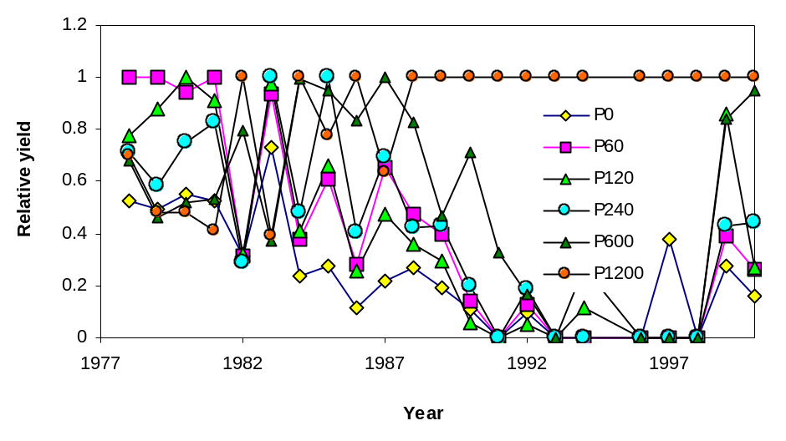

Experiment 803: Wheat Grain Yield Response in Acid Soils to Potassium Applications

Abstract
Soils in northeastern Oklahoma are generally acid where winter wheat is grown. Experiment 803 was established to evaluate potassium fertilizer applications at fixed rates of nitrogen and phosphorus on long-term wheat grain yields. No response to applied K has been observed in this experiment from the one-time K applications in 1977. In general, applied K has had little impact on grain %N. However, in the last two years there has been a trend for applied K to increase grain %N. Soil pH has decreased in this experiment since 1977 and may well be controlling response since all plots are now below 4.7. Soil total N and organic C have largely been unaffected by K fertilization.

Materials and Methods
Experiment 803 was established in the fall of 1977 under conventional tillage on a Taloka silt loam (fine-mixed, thermic Mollic Albaqualf). Wheat has been planted for 19 continuous years in 10 inch rows at seeding rates of 90 pounds per acre (rates increased when planting was delayed). Fertilization, planting and management dates are listed in Table 1. The experimental design in this continuing experiment employs a randomized complete block with four replications. Fertilizer treatments used in this experiment along with average grain yields for selected periods are reported in Table 2. Individual plots at this site are 17 feet wide and 50 feet long. The center 10 feet are harvested with a conventional combine the entire 50 feet in length. In addition to wheat grain yield measured every year, periodic soil and grain samples were taken for further chemical analyses. Results from surface (0-6 inches) soil samples collected in 1995 are reported in Table 3.

Results
Since 1978 no response to the one-time application of applied K has been observed in any year, or over the time periods reported in Table 2. Yield levels were higher in the first ten years of the experiment. Decreased yields with time can be attributed to increased soil acidity that has been measured with time. Soil test K levels were below 80% sufficiency in the check plot (treatment 1, Table 3) by 1994, yet no yield differences have been observed when compared to the high K rate treatments. Soil pH has decreased in this experiment since 1977 and may well be controlling response since all plots are now below 4.7. Soil total N and organic C have largely been unaffected by K fertilization.
Table 1. Treatment applications and experimental management for continuous winter wheat Experiment 803, Haskell, OK, 1978-2000.
_____________________________________________________________________________
Year Variety Fertilizer Planting Date Harvest Seeding Rate
Application Date lb/ac
Date
_____________________________________________________________________________
1978 6-26-78 75
1979 Osage 10-15-78 10-24-78 7-2-79 100
1980 TAM W-101 10-15-79 10-17-79 6-30-80 120
1981 TAM W-101 10-8-80 10-14-80 6-25-81 90
1982 TAM W-101 10-27-81 10-30-81 7-19-82 90
1983 TAM W-101 9-9-82 9-29-82 7-6-83 90
1984 Vona 11-4-83 11-4-83 6-21-84 90
1985 Vona 10-3-84 10-8-84 6-18-85 90
1986 Vona 10-10-85 1-11-86 6-19-86 150
1987 Chisholm 9-22-86 9-23-86 6-17-87 90
1988 Chisholm 10-2-87 10-6-87 6-9-88 90
1989 Chisholm 10-13-88 10-14-88 6-20-89 90
1990 Chisholm 10-12-89 10-18-89 6-13-90 90
1991 Chisholm 10-15-90 10-15-90 6-20-91 90
1992 Chisholm 10-1-91 10-2-91 6-20-92 90
1993 Karl 10-5-92 10-6-92 6-18-93 120
1994 2163 10-5-93 10-6-93 6-15-94 90
1995 Tonkawa 10-10-94 10-12-94 6-17-95 90
1996 Tonkawa 10-6-95 10-12-95 6-18-96 90
1997 Tonkawa 10-9-96 10-11-96 6-18-97 100
1998 2163 10-2-97 10-3-97 6-18-98 90
1999 2137 9-30-98 10-14-98 7-7-99 110
2000* 2137 9-29-99 10-8-99 95
_____________________________________________________________________________
* No harvest due to rye grass problem
Table 2. Treatment structure and wheat grain yields of long-term wheat Experiment 803, Haskell, OK, 1978-1999.
____________________________________________________________________________
Trt. N P2O5 K2O 1978-87 1988-97 1998-99 1978-1999
lb/ac bu/ac %N bu/ac %N bu/ac %N bu/ac %N
____________________________________________________________________________________
1. 100 100 0 28.8 2.59 21.7 2.68 8.9 2.67 23.9 2.61
2. 100 100 60 29.9 2.59 21.7 2.53 10.9 2.69 24.6 2.59
3. 100 100 120 30.6 2.62 25.1 2.57 12.9 2.69 26.7 2.62
4 100 100 240 29.5 2.67 23.2 2.61 9.8 2.71 25.0 2.66
5. 100 100 600 30.1 2.64 21.3 2.55 10.8 2.75 24.5 2.65
6. 100 100 1200 28.9 2.64 18.7 2.61 10.1 2.84 22.8 2.66

SED 2.7 0.13 3.1 0.06 1.8 0.07 3.0 0.11
CV, % 13 7 20 3 24 4 17 6
_____________________________________________________________________________
N applied as 34-0-0, P as 0-46-0, and K as 0-0-60. SED - standard error of the difference between two equally replicated means. CV - coefficient of variation.

Table 3. Treatment structure of long-term winter wheat Experiment 803 and surface (0-6 inches) soil test analyses from 1994, Haskell, OK, 1978-1999.
_____________________________________________________________________________

Trt. N P2O5 K2O pH NO₃-N P K Total N Organic C
lb/ac ppm ppm ppm % %
_____________________________________________________________________________
1. 100 100 0 4.58 14.0 76 66 0.079 0.969
2. 100 100 60 4.65 13.6 74 83 0.081 0.967
3. 100 100 120 4.73 14.2 85 89 0.084 0.991
4 100 100 240 4.68 16.8 74 78 0.083 0.969
5. 100 100 600 4.70 15.8 69 116 0.083 0.992
6. 100 100 1200 4.65 14.6 81 161 0.080 0.983

SED 0.07 2.0 7.4 17 0.002 0.030
CV, % 2 19 14 25 4 4
_____________________________________________________________________________
N applied as 34-0-0, P as 0-46-0, and K as 0-0-60. SED - standard error of the difference between two equally replicated means. CV - coefficient of variation.

Experiment 804: Wheat Grain Yield Response in Acid Soils to Lime Applications

abstract
Soil acidity has become a serious concern in soils in northeastern Oklahoma, which are generally acid where winter wheat is grown. Experiment 804 was established in the fall of 1977 to evaluate lime applications on continuous winter wheat. In the latter years of this experiment, yield increases ranged from 8 to 14 bushels/acre/year as a result of a one-time application of lime in the fall of 1977. Grain %N has been largely unaffected by applied lime, even though yield levels have differed greatly. Relative yields demonstrate that the 1.2 ton ECCE lime was as effective as 2.4 ton ECCE lime up until 1991. Since that time, the 2.4 ton treatment has produced the highest yields. Because soil pH is a limiting production factor at this site, it was important to find that the 1.2 ton ECCE treatment was effective for almost 15 years.

Materials and Methods
Experiment 804 was established in the fall of 1977 under conventional tillage on a Taloka silt loam (fine-mixed, thermic Mollic Albaqualf). Wheat has been planted for 19 continuous years in 10 inch rows at seeding rates of 90 pounds per acre (rates increased when planting was delayed). Fertilization, planting and management dates are listed in Table 1. The experimental design in this continuing experiment employs a randomized complete block with four replications. Fertilizer treatments used in this experiment along with average grain yields for selected periods are reported in Table 2. Individual plots at this site are 24 feet wide and 50 feet long. The center 10 feet are harvested with a conventional combine the entire 50 feet in length. In addition to wheat grain yield measured every year, periodic soil and grain samples were taken for further chemical analyses. Results from surface (0-6 inches) soil samples collected in 1995 are reported in Table 3.

Results
Wheat grain yields did not respond to applied lime in the first ten years of the experiment (Table 2) where soil pH was initially at 5.5 and BI was 6.8. However, from 1986 to 2000, yield increases ranged from 8 to 14 bushels/acre/year. Relative yield comparisons show that the 1.2 ton ECCE lime application in 1977 was as effective as the 2.4 ton ECCE lime treatment up until 1991. Since that time, the 2.4 ton treatment applied in 1977 has produced the highest yields. Because soil pH is a limiting production factor at this site, it was important to find that the 1.2 ton ECCE treatment was effective for almost 15 years. Soil test P, K, total N and organic C levels have been unaffected over time (Table 3). Grain %N has been largely unaffected by applied lime, even though yield levels have differed greatly.
Table 1. Treatment applications and experimental management for continuous winter wheat Experiment 804, Haskell, OK, 1978-2000.
_____________________________________________________________________________
Year Variety Fertilizer Planting Date Harvest Seeding Rate
Application Date lb/ac
Date
1978 6-26-78 75
1979 Osage 10-15-78 10-24-78 7-2-79 100
1980 TAM W-101 10-15-79 10-17-79 6-30-80 120
1981 TAM W-101 10-8-80 10-14-80 6-25-81 90
1982 TAM W-101 10-27-81 10-30-81 7-19-82 90
1983 TAM W-101 9-9-82 9-29-82 7-6-83 90
1984 Vona 11-4-83 11-4-83 6-21-84 90
1985 Vona 10-8-84 10-8-84 6-18-85 90
1986 Vona 10-10-85 1-11-86 6-19-86 150
1987 Chisholm 9-22-86 9-23-86 6-17-87 90
1988 Chisholm 10-2-87 10-6-87 6-9-88 90
1989 Chisholm 10-13-88 10-14-88 6-20-89 90
1990 Chisholm 10-12-89 10-18-89 6-13-90 90
1991 Chisholm 10-15-90 10-15-90 6-20-91 90
1992 Chisholm 10-1-91 10-2-91 6-20-92 90
1993 Karl 10-5-92 10-6-92 6-18-93 120
1994 2163 10-5-93 10-6-93 6-15-94 90
1995 Tonkawa 10-10-94 10-12-94 6-17-95 90
1996 Tonkawa 10-6-95 10-12-95 6-17-96 90
1997 Tonkawa 10-9-96 10-11-96 6-17-97 100
1998 2163 10-2-97 10-3-97 6-18-98 90
1999 2137 9-30-98 10-14-98 7-7-99 110
2000 2137 9-29-99 10-8-99 6-4-00 95
____________________________________________________________________________

Table 2. Treatment structure of long-term wheat Experiment 804, Haskell, Oklahoma, 1978-2000.
_____________________________________________________________________________Trt. N P2O5 K2O Lime 1978-87 1988-97 1998-00 1978-2000
lb/ac t/ac bu/ac %N bu/ac %N bu/ac %N bu/ac %N
1. 100 60 60 0 33.9 2.51 22.0 2.81 12.0 2.68 25.8 2.58
2. 100 60 60 0.6 35.9 2.51 30.4 2.74 12.5 2.70 30.4 2.57
3. 100 60 60 1.2 35.8 2.39 34.5 2.69 13.7 2.68 32.3 2.46
4 100 60 60 2.4 35.8 2.47 37.3 2.75 26.9 2.60 35.3 2.54
SED 2.9 0.16 3.0 0.13 5 0.05 3.5 0.15
CV, % 11 9 13 7 44 2 16 8
______________________________________________________________________________________
N applied as 34-0-0, P as 0-46-0, and K as 0-0-60. SED - standard error of the difference between two equally replicated means. CV - coefficient of variation.

Table 3. Treatment structure of long-term wheat Experiment 804, Haskell, Oklahoma, 1978-1997 and surface (0-6 inches) soil test analyses from samples collected in 1994.
_____________________________________________________________________________

Trt. N P2O5 K2O Lime pH NO₃-N P K Total N Organic C
lb/ac t/ac ppm ppm ppm % %
1. 100 60 60 0 4.84 15.5 35.3 204 0.086 1.044
2. 100 60 60 0.6 4.89 14.7 33.1 181 0.086 1.054
3. 100 60 60 1.2 5.00 15.1 29.9 184 0.089 1.051
4 100 60 60 2.4 5.12 14.5 26.5 193 0.088 1.080
SED 0.07 1.4 2.1 10.4 0.002 0.033
CV, % 2 13 10 8 4 4
_____________________________________________________________________________
N applied as 34-0-0, P as 0-46-0, and K as 0-0-60. SED - standard error of the difference between two equally replicated means. CV - coefficient of variation.

Figure 1. Relative wheat grain yields, by treatment and year, Experiment 804, Haskell, OK, 1978-2000.
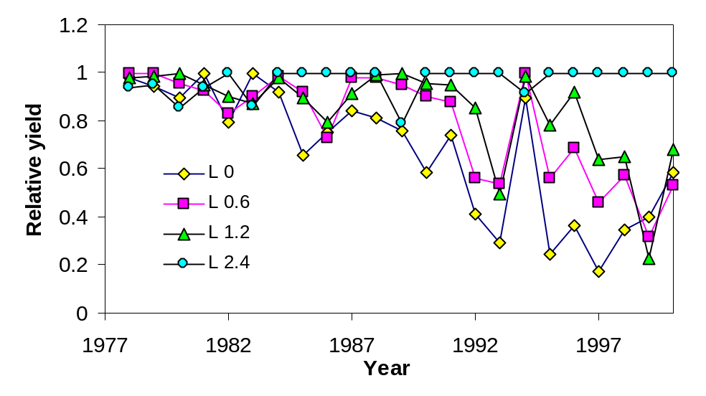

CHLORIDE and LIME

Soil Chloride, Nitrate and Sulfate in Oklahoma Soils

Hailin Zhang

- Chloride fertilization may increase wheat yields if soil Cl is less than 60 lbs. per acre in the top 24 inches of soil
- About 32% of fields tested in 1999 had Cl less than 60 lbs. per acre
- Oklahoma soils had adequate amount of sulfur, but most fields were low in nitrate nitrogen
- Subsoil samples from 6 to 24 inches are needed to accurately assess soil chloride, nitrate and sulfur levels

Why Chloride Is Important

Extensive research has documented that small grains (including wheat, barley, corn and sorghum) respond to chloride (Cl) fertilization. Grain yield in nearly half the trials in the Great Plains showed positive response to Cl fertilization, with an average 5 bushels per acre higher than the controls. Though Oklahoma is one of the largest small grain production states in the United States, Cl in the soil has never been routinely tested.
The benefits of Cl fertilization has been attributed to the suppression of certain diseases, increasing in kernel weight, kernel volume and test weight in small grains. Plants utilize Cl as the chloride ion (Cl⁻), which is mobile in soils, especially in soils with sandy texture and low organic matter. Therefore, frequent Cl soil testing is needed to assess its availability as we often do for assessing available nitrogen.
Previous studies suggested that soil tests of 30 lb/A or less Cl, in the upper 2 feet soil profile, have a high probability of crop response to added Cl; between 30 and 60 lb/A, a fair chance of crop responses; and those testing over 60 lb/A are not likely to respond to added Cl. However, some cultivars responded to Cl better than the others. Since most soils are high in potassium in Oklahoma, Cl could be deficient in many fields if potassium chloride (KCl) has not been applied as a K source for extended period of time. Field research conducted by OSU scientists showed that wheat grain yields were significantly increased by applying 60 lbs. of Cl per acre at Perkins field trials, but no response was observed at Hennessey and Carrier test sites.
This report presents soil Cl, S and nitrate-N status in Oklahoma soils through a statewide soil testing program. It was supported by the Oklahoma Wheat Commission and Potash and Phosphate Institute, and completed with the assistance of OCES area agronomists and numerous county extension agriculture educators who assisted with soil sampling.

Procedures
A soil Cl test protocol was first established at the Soil, Water, and Forage Analytical Laboratory using a Flow Injection Autoanalyzer. Over 200 pairs of surface (0-6”) and subsurface (6-24”) soil samples were collected from 17 counties in Oklahoma in 1999. A minimum of 20 subsample cores were required to make a composite sample from a sampling area to ensure consistent test results. Surface samples were analyzed for Cl, SO₄-S, pH, NO₃-N, P and K; subsurface samples for Cl, SO₄-S and NO₃-N.

Results
Table 1 shows the general properties of all the samples. This data may not accurately represent all of Oklahoma since only about 200 sets of samples were received for this survey, but it is the best available information we have on soil Cl and S. The average amount of Cl⁻, NO₃-N and SO₄-S in the top 6 inches, from 6 to 24 inches, and the top two feet is presented in Figure 1. All three compounds are fairly low if only the top 6 inches are considered, but substantial amounts of those nutrients lie in the subsoil (6-24”). This is the region where wheat roots can reach and utilize the nutrients. In general, Oklahoma soils are low in nitrate nitrogen, but high in sulfur. No sulfur fertilizer is probably needed for most crops and in most areas. The S requirement is low for most crops and normally is 5% of the nitrogen requirement. About 32% of the fields may respond to Cl fertilization since the top 24 inches of soil contains less than 60 lbs. of Cl per acre. The percentage of fields that would potentially respond to Cl increased to 98% if only surface soil Cl was considered (Figure 2). It is very important to include subsoil samples when assessing the availability of Cl⁻, NO₃-N and SO₄-S.

Table 1. Average Soil Properties
 | Minimum | Average | Maximum
pH*  STP*  STK*  Cl⁻**  NO₃-N**  SO₄-S** | 4.3  12  75  31  7  40 | 6.0  61  485  90  32  129 | 8.2  203  1225  429  130  735
*pH, STP (soil test P index) and STK (soil test K index) are
for surface samples (0-6”). **Cl, N and S are in lbs./acre in the top 2-foot soils.

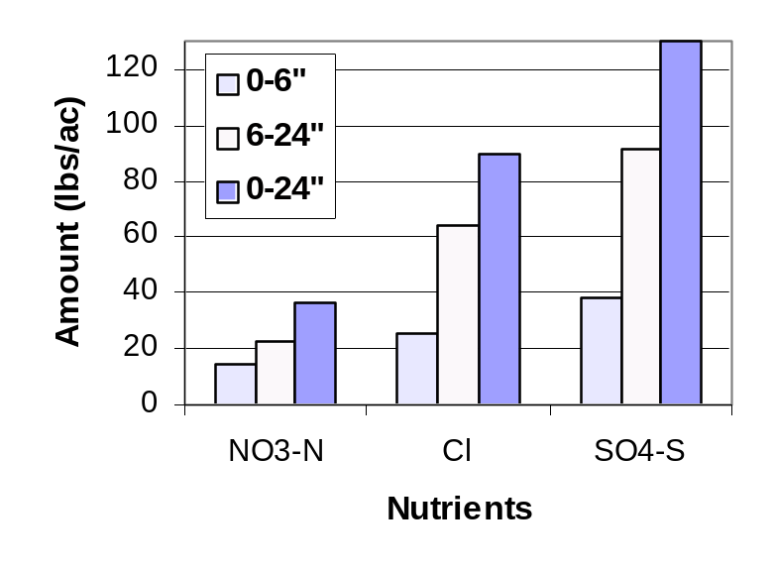
Figure 1. Amount of Cl⁻, NO₃-N and SO₄-S in the top 6 and 24 inches of soil. Note substantial amount of nutrients lie in the subsoil.

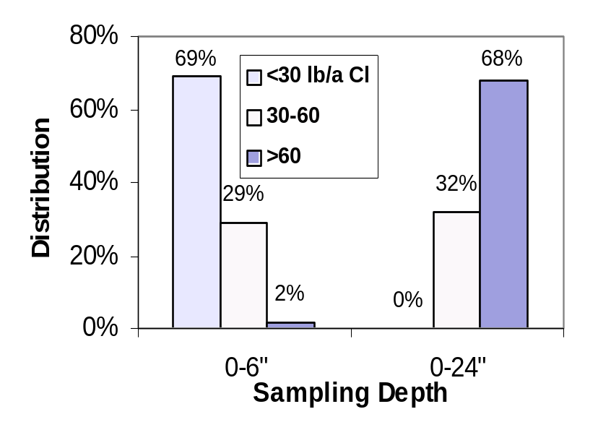

Figure 2. Percent of soil samples with Cl in the range <30, 30-60, and >60 lbs. per acre. Note, majority of samples are low in Cl if only top 6 inches of soil is considered, but most soils have adequate Cl when top 24 inches of soil is considered.

Effect of Chloride Fertilizers and Lime on
Wheat Grain Yield and Take-All Disease
W.E. Thomason, K.J. Wynn, K.W. Freeman, E.V. Lukina,
R.W. Mullen, G.V. Johnson, R.L. Westerman and W.R. Raun

Abstract
One experiment was initiated in the fall of 1991 to evaluate the effect of chloride (Cl) fertilizers on the suppression of take-all disease (Gaeumannomyces graminis var. tritici Walker) in winter wheat (Triticum aestivum L.). Preplant and topdress rates of potassium chloride (KCl) and calcium chloride (CaCl₂) (0, 34, 67 and 101 kg Cl ha⁻¹) were applied each year. In 1995, plots were split in half whereby one half received 2.24 Mg of 76% ECCE lime ha-1 to elevate the pH and potentially increase disease incidence. Wheat grain yield was not affected by lime applications in any year (1995-1999). Plots exhibited visual symptoms of take-all in almost all years, however, grain yields increased in only two of eight years by the application of CaCl₂ and KCl. Applied fertilizer Cl for take-all disease suppression was inconsistent, even following the application of lime where increased soil pH can increase disease severity.

Introduction
Take-all, (Gaeumannomyces graminis var. tritici Walker) is a soil-borne fungal pathogen of wheat, often found in conjunction with other root diseases. Few control measures other than crop rotation are available. Take-all is generally more severe where wheat is grown continuously, with little evidence of take-all in years immediately following rotation from a non-host crop (Powelson et al., 1985).
Over the past 50 years, much has been published reporting effects of various fertilizers and soil amendments on crop response to diseases. Garrett (1941) reported on some of the first work to demonstrate disease suppression with NH₄-N. Complementary work showed that the nitrification inhibitor nitropyrin improved suppression of take-all when applied with NH₄-N fertilizers (Huber et al., 1980; Huber and Dorich, 1988). Inhibition of nitrification makes fall application of anhydrous ammonia and other NH4-N fertilizers more feasible for winter wheat production, thus allowing greater flexibility in seeding dates needed for disease control (Huber et al., 1980). These same authors noted that delayed seeding and adequate N fertilization are recommended to reduce the severity of take-all, thus the use of nitropyrin (applied with NH₄-N fertilizers) may allow for earlier plantings without increasing the severity of take-all. Furthermore, periods of N stress are known to predispose wheat to take-all, which can in part be alleviated by an adequate supply of N, and/or split N applications (Huber et al., 1980).
Recent work at Indiana has shown that supplying NH₄-N increases the availability of soil Mn, which decreases take-all severity (Huber and Dorich, 1988). Huber and McCay-Buis (1993) noted that take-all is severe on soils characteristically low in Mn, and that direct Mn amendment of these soils has been demonstrated to reduce take-all. In this regard, it is important to note that liming an acid soil can reduce Mn availability and increase the severity of take-all (Huber and McCay-Buis, 1993). Under moderately-severe disease conditions, plants with higher Mn in the seed were more vigorous, and had an average of 11% less take-all (McCay-Buis et al., 1995).
Research results indicate that take-all depresses wheat grain yields when wet and mild fall-winter periods are encountered in winter wheat production systems (R.H. Hunger, 2000, Oklahoma State University, personal communication). This is consistent with work by Engel (1988) noting that take-all was commonly observed when wheat was grown under irrigation in Montana and Canada. While the growing conditions are well known concerning where take-all is likely to be encountered, so too are some of the controls, which include crop rotations. Unfortunately, crop rotations are not implemented nor are they popular due to market and equipment constraints. From a farmer survey, Follwell et al. (1991) reported that take-all occurs regardless of the tillage system, however, some farmers indicated that it was more severe with no-till. Coventry et al. (1989) demonstrated the importance of crop rotation for disease control (take-all), particularly where soils are limed to amend severe soil acidity.
Application of lime to increase soil pH can favor increased incidence of take-all infection, and as soil pH increases above 4, take-all infection increases substantially (Christensen and Brett, 1985). Analogous results by Taylor et al. (1983) showed reduced grain yield when soil pH increased from 5.6 to 6.2, a result of increased incidence of take-all.
Addition of ammonium chloride fertilizer increased yields 10 to 40 percent over plots with no Cl applied (Christensen et al., 1981). Chloride has been found to slow the disappearance of NH₄-N and appearance of NO₃-N in un-limed soil but not in limed soil (Christensen and Brett, 1985). This same work noted that NH₄-N:NO₃-N ratio’s needed to be greater than 3:1 in order to observe suppression of take-all. Also, it is thought that applied Cl may suppress take-all by inhibiting nitrification in moderately acid (pH 5.3 to 5.8) soils (Christensen and Brett, 1985). Powelson et al., (1985) suggest that this inhibition takes place by Cl- competing with nitrate (NO₃) for plant uptake and by reducing nitrification rates thus leaving more nitrogen (N) in the ammonia form. Powelson et al., (1985) further note that Cl can enhance plant uptake of NH₄-N which favors the activity of epiphytic bacteria suppressive to G. Graminis var. tritici. It is suggested that this effect is similar to natural take-all decline and may enhance or encourage this activity. Engel (1988) evaluated applied Cl (45 kg Cl ha⁻¹) on an alkaline soil (pH 7.9) and found that Cl had little effect on take-all severity, but did increase wheat grain yields. Work by LaRuffa et al. (1999) noted a significant response to Cl at one location where grain yields were low as a result of N stress (soil pH = 5.9). As was noted earlier, N stress can lead to increased take-all in wheat (Huber et al., 1980). Brennan (1993) reported that Cl containing fertilizers did not control take-all disease of wheat in five experiments in southwestern Australia (soil pH range: 4.7-5.5), however, it should be noted that this was observed where no N stress was present.
Christensen et al. (1981) noted that applied Cl reduced the osmotic potential in winter wheat leaves. They further suggested that take-all susceptibility in winter wheat could be reduced by lowering the chemical potential of water in the plant, achieved in part via Cl application. At present, in the Pacific Northwest and in North and South Dakota, researchers generally recommend application of Cl fertilizers to reduce take-all severity (Oregon State Agricultural Experiment Station, 1983).
The objective of this experiment was to evaluate Cl fertilizer sources and rates, and applied lime on wheat grain yield and take-all disease in winter wheat.

MATERIALS AND METHODS
One field experiment was initiated in the fall of 1991 to evaluate the effects of Cl fertilizer sources and rates on wheat grain yield and take-all disease in winter wheat at the Ray Nelson farm near Carrier, OK. A randomized complete block experimental design was used with 4 replications. The treatment structure evaluated at this site is reported in Table 1. The wheat variety planted, planting date, topdress date and harvest date for all years are reported in Table 2. Initial soil test results at the time of trial initiation in 1991 are reported in Table 3. Chloride fertilizer rates of 34, 67 and 101 kg Cl ha⁻¹ using KCl (0-0-62) and CaCl2 were broadcast preplant and a topdress rate of 101 kg Cl ha⁻¹ was also included for both sources. Two completely untreated check plots were included in the experimental design.
Annual applications of anhydrous ammonia (AA) have traditionally been used as a management practice, and 90 kg N ha⁻¹ as AA was applied in the fall of each year to all plots. Plots were planted with a conventional grain drill at an 84 kg ha⁻¹ seeding rate using a 21 cm row spacing. Twenty-two kg ha⁻¹ of P₂O₅ using diammonium phosphate (DAP, 18-46-0) was banded with the seed at planting. Plot size was 4.88 m x 15.24 m. In 1995, plots were split in half and 2.24 Mg lime ha⁻¹ (76% ECCE) was applied to the east half of each plot. Wheat grain was harvested from a strip 2m wide in the center of each plot using a self-propelled conventional combine in June of each year. Following the completion of the experiment, sixteen soil cores 0-15 cm were taken from each plot, air dried, mixed, ground to pass a 100-mesh sieve (<0.15mm), and analyzed for pH, NH4-N, NO3-N, P, K, total N, organic C and Cl. Total N and organic C analyses were determined using a Carlo-Erba (Milan, Italy) NA 1500 dry combustion analyzer (Schepers et al., 1989). NH₄-N and NO₃-N were determined following a 2M KCl (Bremner, 1965) extraction and analyzed using an automated flow injection analysis system. Soil pH was determined using a glass electrode and a soil/water ratio of 1:1. Extractable P and K were determined using the Mehlich III procedure (Mehlich, 1984). Soil test Cl was determined as per the methods described by Fixen et al. (1988) on the 0-15 and 15-60 cm depths.

RESULTS AND DISCUSSION
Since 1992, a significant wheat grain yield increase as a result of applying Cl has only been observed three times (Table 4). A significant increase in wheat grain yield was found when KCl was applied in 1992 and 1994. Since 1994, no yield increases due to annual applications of KCl have been observed. Grain yields also increased in 1993 and 1994 as a result of applying CaCl2. A linear increase was observed over all rates evaluated in the 1994 crop year. In 1998 the 34 kg ha⁻¹ rate of Cl had the highest yield. Yields decreased with increasing rates of applied Cl at rates above 34 kg Cl ha⁻¹. Differences between preplant incorporated and topdress (KCl and CaCl2) were generally small. A significant increase in wheat grain yield was observed in 1997 when CaCl2 was applied topdress at a rate of 101 kg Cl/ha compared to preplant (Table 4). In 1993, the overall effect of CaCl2 treatment did produce significantly higher yields when compared to the check with no Cl applied.
Over the four years since lime was applied to the east half of each plot, no significant differences in yield have been observed in either the treated or untreated plots. No significant effect of lime application was noted in grain yield in any year (means not reported). It was anticipated that the elevated pH would induce take-all, therefore, allowing better evaluation of Cl treatments for possible disease suppression. However, the severity of take-all in these plots was minimal since lime was applied in 1995. Average surface (0-15 cm) soil pH was only slightly higher in limed plots (pH=6.1) compared to plots not receiving lime (pH=5.8) (samples collected following 1999 harvest).
Treatment means for soil test parameters from samples collected following the 1999 harvest are reported in Table 5. No treatment differences were detected for soil pH, NO3-N, P, Cl, organic C, and total N. As was expected, soil pH remained somewhat higher in the limed plots in 1995 when compared to the un-limed plots (Table 5). Soil test NH4-N was generally higher where CaCl2 was applied annually compared to KCl (Table 5). However, NH4-N levels were never high enough (or NO3-N levels low enough) to result in a critical NH4-N:NO3-N ratio of 3:1, (ratio averaged 1.5 for all plots in this experiment) where suppression of take-all would likely be realized as a result of applying Cl fertilizers (Christensen and Brett, 1985). As was expected, soil test K levels were greater where KCl was applied as the Cl source.
Data from soil samples (0-15 and 15-60 cm) taken at the conclusion of the experiment for soil test Cl resulted in small differences. Soil test Cl ranged from 26-31 mg kg-1, or approximately 232-277 kg Cl ha⁻¹ in the 0-60 cm depth, and was high at this site (Table 5). As a result, a nutritional yield response due to applied Cl was not expected. If applied Cl in this experiment were to have increased yields, it would have been the result of disease suppression, or an alternative nutrient interaction as a result of applying KCl and/or CaCl2. Soil test Cl levels reported here were notably higher than that reported by Fixen et al. (1986) who showed a yield response to applied Cl (range of 20-95 kg Cl ha⁻¹, 0-60cm), and markedly higher than soil test Cl levels noted by Engle et al. (1998).
In summary, wheat grain yields were not affected by lime applications from 1995 to 1999. Several plots exhibited visual symptoms of take-all in almost all years, however, grain yields increased in only two of eight years by the application of CaCl2 and KCl. At this site where soil test Cl levels were relatively high, applied fertilizer Cl for take-all disease suppression was inconsistent, even following the application of lime where increased soil pH was expected to increase disease severity.

Acknowledgements
The authors acknowledge the continued support of Mr. David Nelson who patiently provided the land needed for this eight-year on-farm experiment near Carrier, OK.

References

Bremner, J.M. 1965. Inorganic forms of nitrogen. In C.A. Black et al. (ed.) Methods of soil analysis, Part 2. Agronomy 9:1179-1237. Am. Soc. of Agron., Inc., Madison, WI.

Brennan, R.F. 1993. Effect of ammonium chloride, ammonium sulphate, and sodium nitrate on take-all and grain yield of wheat grown on soils in south-western Australia. J. Plant Nutr. 16:349-358.

Christensen, N.W., R.G. Taylor, T.L. Jackson, and B.L. Mitchell. 1981. Chloride effects on water potentials and yield of winter wheat infected with take-all root rot. Agron J. 73:1053-1058.

Christensen, N.W., and M. Brett. 1985. Chloride and liming effects on soil nitrogen forms and take-all of wheat. Agron. J. 77:157-163.

Coventry, D.R., H.D. Brooke, J.F. Kollmorgen, and D.J. Ballinger. 1989. Increases in wheat yield on limed soil after reduction of take-all by fungicide application and crop rotation. Aust. J. Exp. Agric. 29:85-89.

Engel, R.E., and D.E. Mathre. 1988. Effect of fertilizer nitrogen source and chloride on take-all of irrigated hard red spring wheat. Plant Disease 72(5):393-396.

Engel, R.E., P.L. Bruckner and J. Eckhoff. 1998. Critical tissue concentration and chloride requirements for wheat. Soil Sci. Soc. Am. J. 62:401-405.

Fixen, P.E., R.H. Gelderman, and J.L. Denning. 1988. Chloride tests. p. 26-29. In W. Dahnke (ed.) Recommended chemical soil test procedures for the North Central Region. North Dakota Agric. Exp. Stn., North Central Reg. Publ. 221.

Fixen, P.E., R.H. Gelderman, J. Gerwing, and F.A. Cholick. 1986. Response of spring wheat, barley, and oats to chloride in potassium chloride fertilizers. Agron. J. 78:664-668.

Folwell, R.J., R.J. Cook, M.N. Heim and D.L. Moore. 1991. Economic significance of take-all on winter wheat in the Pacific Northwest USA. Crop Protection 10:391-395.

Garrett, S.D. 1941. Soil conditions and the take-all disease of wheat. VI. The effect of plant nutrition upon disease resistance. Ann. Appl. Biol. 28:14-18.

Huber, D.M., and R.A. Dorich. 1988. Effect of nitrogen fertility on take-all disease in wheat. Down to Earth. 44:3:12-17.

Huber, D.M., H.L. Warren, D.W. Nelson, C.Y. Tsai, and G.E. Shaner. 1980. Response of winter wheat to inhibiting nitrification of fall-applied nitrogen. Agron. J. 72:632-637.

Huber, D.M., and T.S. McCay-Buis. 1993. A multiple component analysis of the take-all disease of cereals. Plant Disease 77(5):437-447.

LaRuffa, J.M., G.V. Johnson, S.B. Phillips, and W.R. Raun. 1999. Sulfur and chloride response in Oklahoma winter wheat. Better Crops 32(4):28-30.

McCay-Buis, T.S., D.M. Huber, R.D. Graham, J.D. Phillips, and K.E. Miskin. 1995. Manganese seed content and take-all of cereals. J. Plant Nutr. 18(8):1711-1721.

Mehlich, A. 1984. Mehlich No. 3 extractant: A modification of Mehlich No. 2 extractant. Commun. Soil Sci. and Plant Anal. 15:1409-1416.

Oregon State Agricultural Experiment Station. 1983. Combating take-all root rot of winter wheat in western Oregon. Oregon St. Agric. Exp. Sta. Bull. FS 250.

Powelson, R.L., T.L. Jackson, and N.W. Christensen. 1985. Enhanced suppression of take-all root rot of wheat with chloride fertilizers. Oregon Agric. Exp. Sta., Tech. Paper 7153.

Schepers, J.S., D.D. Francis, and M.T. Thompson, 1989. Simultaneous determination of Total C, Total N, and 15N on Soil and Plant Material. Commun. In Soil Sci. Plant Anal. 20:949-959.

Taylor, R.G., T.L. Jackson, R.L. Powelson and N.W. Christensen. 1983. Chloride, nitrogen form, lime, and planting date effects on take-all root rot of winter wheat. Plant Disease 67(10):1116-1120.

TABLE 1. Rate of applied chloride, source and method of application for take-all suppression, 1991-1999, Carrier, OK (plots split in the fall of 1995, half receiving 2.24 Mg 76%ECCE lime/ha).
_____________________________________________
Cl rate Source Method
kg/ha
0 - -
34 CaCl₂ preplant
67 CaCl₂ preplant
101 CaCl₂ preplant
101 CaCl₂ topdress
34 KCl preplant
67 KCl preplant
101 KCl preplant
101 KCl topdress
_____________________________________________

TABLE 2. Planting and harvest dates, and varieties used, Carrier, OK, 1991-1999.
_______________________________________________________________________
Year Variety Fertilizer Planting Topdress Harvest
application date date date date
_______________________________________________________________________
1992 2163 October 10, 1991 11-13-91 2-22-92 6-24-92
1993 2163 September 29, 1992 10-12-92 3-9-93 6-24-93
1994 2163 October 16, 1993 late-October 3-17-94 6-13-94
1995 2163 October 16, 1994* late-October 3-6-95 6-21-95
1996 Jagger September 4, 1995 mid-October 4-1-96 6-21-96
1997 Custer September 4, 1996 mid-October 4-1-97 6-21-97
1998 Custer September 18, 1997 mid-October 2-19-98 6-11-98
1999 2174 September 20, 1998 mid-October 2-2-99 6-16-99
_______________________________________________________________________
*plots split in the fall of 1995, half receiving 2.24 Mg ECCE lime ha⁻¹

TABLE 3. Initial surface soil (0-15cm) chemical characteristics and classification at Carrier, OK (1991)

Location pHª NH₄-N NO₃-N P^{b} K^{b} Total N Organic C Cl^{d}
--------------mg kg⁻¹--------------- ------- g kg⁻¹ ------

Carrier 6.0 7.4 33 64 470 0.90 8.8 27

Classification: Pond Creek silt loam (fine-silty, mixed, superactive, thermic Pachic Argiustoll)
_____________________________________________________________________________
ªpH: 1:1 soil:water
^{b}P and K: Mehlich III
^{c}Organic C and Total N: dry combustion
^{d} Cl determined using Fixen et al. (1988)

TABLE 4. Mean yields, corresponding treatments and significant effects, 1991-1999, Carrier, OK.
__________________________________________________________________________________________________
Cl rate Source Method 1992 1993 1994 1995 1996 1997 1998 1999
kg ha⁻¹ ------------------------------- Mg ha⁻¹ -----------------------------------
__________________________________________________________________________________________________
0 - - 1.73 2.68 3.06 1.11 2.64 3.22 3.54 4.17
34 CaCl₂ preplant 1.82 2.96 3.02 1.07 2.66 3.18 3.65 4.31
67 CaCl₂ preplant 1.74 2.94 3.22 1.13 2.73 3.13 3.51 4.13
101 CaCl₂ preplant 1.78 2.76 3.29 1.07 2.69 3.11 3.45 4.07
101 CaCl₂ topdress 1.72 2.68 3.18 1.08 2.67 3.29 3.46 4.08
34 KCl preplant 1.97 2.76 3.11 1.04 2.55 3.22 3.45 4.07
67 KCl preplant 2.07 2.87 3.19 1.09 2.60 3.21 3.65 4.31
101 KCl preplant 1.96 2.67 3.27 1.16 2.56 3.12 3.56 4.20
101 KCl topdress 1.97 2.79 3.22 1.10 2.62 3.12 3.59 4.23

SED 0.06 0.12 0.15 0.07 0.13 0.12 0.42 0.51

Contrasts
CaCl₂ - linear ns ns * ns ns ns ns ns
CaCl₂ - quadratic ns * ns ns ns ns ns ns
KCl - linear ** ns @ ns ns ns ns ns
KCl - quadratic ** ns ns ns ns ns ns ns
CaCl₂-101 preplant vs CaCl₂-101 topdress ns ns ns ns ns * ns ns
KCl-101 preplant vs KCl-101 topdress ns ns ns ns ns ns ns ns
CaCl₂ vs check ns * ns ns ns ns ns ns
KCl vs check ** ns ns ns ns ns ns ns
__________________________________________________________________________________________________
**, *, @-significant at the 0.01, 0.05, and 0.10 probability levels, respectively.
SED- standard error of the difference between two equally replicated means

TABLE 5. Mean soil test levels from surface samples (0-15 cm) collected following the completion of the experiment, and mean treatment levels for limed versus non-limed plots, 1999, Carrier, OK
___________________________________________________________________________
Cl rate Source Method pH NH₄-N NO₃-N P K Cl† OC TN
kg ha⁻¹ ------------------ mg kg⁻¹ ----------------- ---- g kg⁻¹ ---
____________________________________________________________________________________________
0 - - 5.8 9.3 5.8 34 418 26 8.9 0.91
34 CaCl₂ preplant 5.9 10.3 6.1 34 418 24 9.1 0.90
67 CaCl₂ preplant 5.9 7.9 5.5 33 414 26 9.1 0.93
101 CaCl₂ preplant 5.9 10.6 6.6 33 420 26 9.1 0.92
101 CaCl₂ topdress 5.9 10.2 6.2 34 426 26 8.9 0.88
34 KCl preplant 5.9 7.2 5.7 34 421 27 9.0 0.94
67 KCl preplant 5.9 8.5 6.2 33 436 31 8.9 0.90
101 KCl preplant 5.9 9.1 6.0 35 471 29 9.1 0.93
101 KCl topdress 6.0 9.1 6.1 34 498 29 9.1 0.93
Limed 6.1 9.5 5.9 34 433 29 9.2 0.93
Not Limed 5.8 8.8 6.1 33 435 26 8.9 0.90
SED 0.1 1.3 0.7 1.7 19 5 0.2 0.03

Contrasts
CaCl₂ - linear ns ns ns ns ns ns ns ns
CaCl₂ - quadratic ns @ ns ns ns ns ns ns
KCl - linear ns ns ns ns ns ns ns ns
KCl - quadratic ns ns ns ns ** ns ns ns
CaCl₂-101 preplant vs CaCl₂-101 topdress ns ns ns ns * ns ns ns
KCl-101 preplant vs KCl-101 topdress ns ns ns ns ns ns ns ns
CaCl₂ vs check ns ns ns ns ns ns ns ns
KCl vs check ns ns ns ns ** ns ns ns
KCL-101topdress vs check ns ns ns ns ** ns ns ns
† average for 0-60 cm, **, *, @ -significant at the 0.01, 0.05 and 0.10 probability levels, respectively.
SED- standard error of the difference between two equally replicated means, OC-organic carbon, TN-total nitrogen

Working for SB-314

Since, 1989, the Plant and Soil Sciences Department at OSU has benefited greatly from the establishment of Senate Bill 314. To date, 29 M.S. and Ph.D. students have received advanced degrees via assistance from this funding source. Various journal articles, books, web sites, and other publications have been completed thanks in part to SB-314. Laboratory and field equipment, computers, and supplies of all kinds have been purchased via support from the fertilizer checkoff funds. As we embark on a new millennium, we hope that history will look upon this investment as favorably as the many students, faculty, and producers have thus far.

Soil Fertility Research and Education Project, 1992-2000

Product Number Average/Yr
Student Degrees (M.S. and Ph.D) 29 3.6
Journal Publications 62 7.8
Books/Book Chapters 7 0.9
Web Sites 7 0.9
Proceedings 16 2.0
Other Publications 21 2.6
Abstracts 120 15
Research Bulletins 15 1.9
Fact Sheets 3 0.4

Earlier this year, Dr. Gordon Johnson was asked to comment on what took place in the late 1980’s that motivated Dr. Robert Westerman and Dr. Billy Tucker to work on obtaining a fertilizer checkoff fund for soil fertility research in Oklahoma. His comments follow.

Here is what I remember about the development of the fertilizer check-off program. We first became aware of this approach for funding soil fertility research when reading about it in Agronomy News after Montana was successful in implementing such a program in the 70's. We tried to get it at the University of Arizona, but the Dean stonewalled it (we sent the Associate Dean a proposal and never heard back from him). When we (Westerman and I) got to Oklahoma we tossed the idea around with Billy Tucker, he liked it, and we began talking privately with the fertilizer industry (members of the Oklahoma Plant Food Educational Society, OPFES). The industry was generally in favor of it, but there were some skeptics that apparently thought any rise in the cost of fertilizer would impact the market negatively. Westerman showed them that the cost per field for most farmers would be equal to that of a “cup of coffee and a piece of pie.” We pointed out that other states, notably Iowa and Illinois had passed fertilizer check-off legislation to fund environmental work, and that unfortunately for the fertilizer industry the funds were being used by "environmentalists" to fund research to limit fertilizer use. We suggested that this source and use of funds might be generated in all states, including Oklahoma, and that we could prevent misuse if we passed legislation directing the check-off funds to the research program that would be pro-active, that is the OSU soil fertility program. Writing the legislation to bypass administration prevented having to fund direct and indirect costs, and this would be appropriate because the funds would not be used to hire faculty, but rather supplement an existing program.
The first attempt to have this brought up in the legislature failed because industry contacts with the legislator’s sensed the bill would not pass, that the political climate was not right, and the amendment was not submitted for action. A couple of years later (after gaining the support of groups like the Farmers Union and the Farm Bureau, who could not vote but would lobby for passage of the amendment) it was introduced in the legislature and passed.

Appendix Table 1. Conversion factors and relationships between English and metric units.
_____________________________________________________________________________
Yield and Rate

lb/ac * 1.12 = kg/ha
bu/ac * 67.2 = kg/ha (60 lb test weight)
bu/ac * 0.0672 = Mg/ha (60 lb test weight)
1 Mg/ha = 14.88 bu/ac (60 lb test weight)

Area

1 hectare = 1000 m2
1 acre = 43560 ft2
1 acre (ac) = 0.405 hectares (ha) 1 ha = 2.47 ac

Length

1 inch (in) = 2.54 centimeters (cm) 1 cm = 0.393 in
1 foot (ft) = 30.48 centimeters (cm)
1 mile (mi) = 1.609 kilometers (km); 1 mile=5280ft 1 km = 0.621 mi
1 yard (yd) = 0.914 meters (m) 1 m = 1.094 yd
1 mile2 (mi) = 259 hectares (ha)

Volume

1 gallon (gal) = 3.785 liters (l) 1 l = 0.264 gal
1 quart (qt) = 1.057 liters (l) 1 l = 0.964 qt

Mass

1 kilogram (kg) = 1000 grams (g)
1 Megagram (Mg) = 1000 kilograms (kg)
1 ounce (oz) = 28.35 grams (g) 1 g = 0.03527 oz
1 pound (lb) = 0.454 kilograms (kg) 1 kg = 2.205 lb
1 ton (2000 lb) = 907 kilograms (kg)

Temperature

Centigrade (°C) = 5/9 (°F - 32)
Fahrenheit (°F) = (9/5 °C) + 32
_____________________________________________________________________________

