Tile Irrigation Reclamation
Increasing Efficiency and Protecting the Environment

Irrigation and tile are important assets that have helped increase world crop yields. During the 2008 cropping season 54.9 million acres were irrigated in the U.S, and increasing (USDA). Limited resources such as nutrients are leached during irrigation, as well as diminishing water sources.
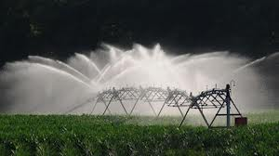
Reclaiming previous irrigation water for future applications would reduce the amount of water transported elsewhere. Using reclaimed water would also reintroduce leached nutrients back into the plant and soil system for available uptake.

Combining the technologies of irrigation and tile would minimize water and nutrient losses throughout a cropping season. A biological filter used to remove salts and unwanted chemicals will connect the tile outlet to the irrigation well. This would allow excess water not taken up by the crop to flow back into the well for future use, as well as the reintroduction of leached nutrients back into the cropping system.

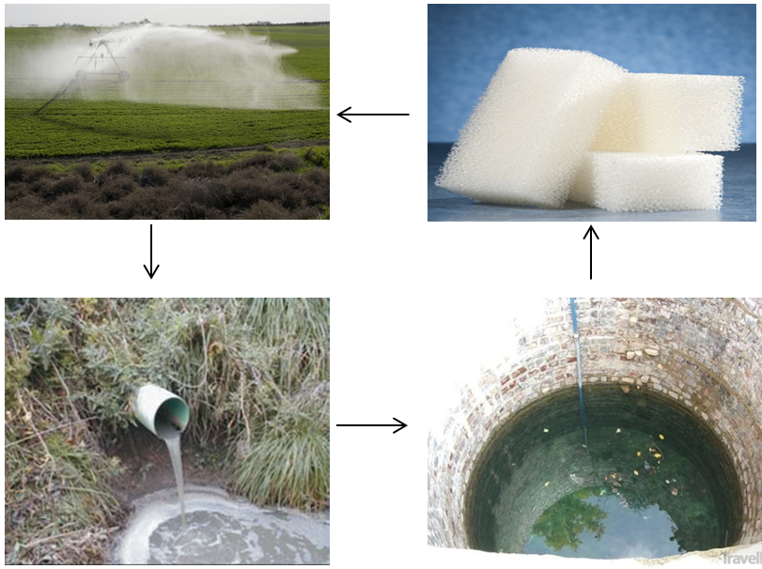
Benefits:
- Recycle nutrients
- Decrease runoff
- Decreases water waste
- Increase nutrient efficiencies
- Widely adaptable practice
USDA Values
- Farms with irrigation, 206,834
- Acres irrigated, 54,900,000
- Acre feet applied, 91,200,000

