
Executive Summary for 2007

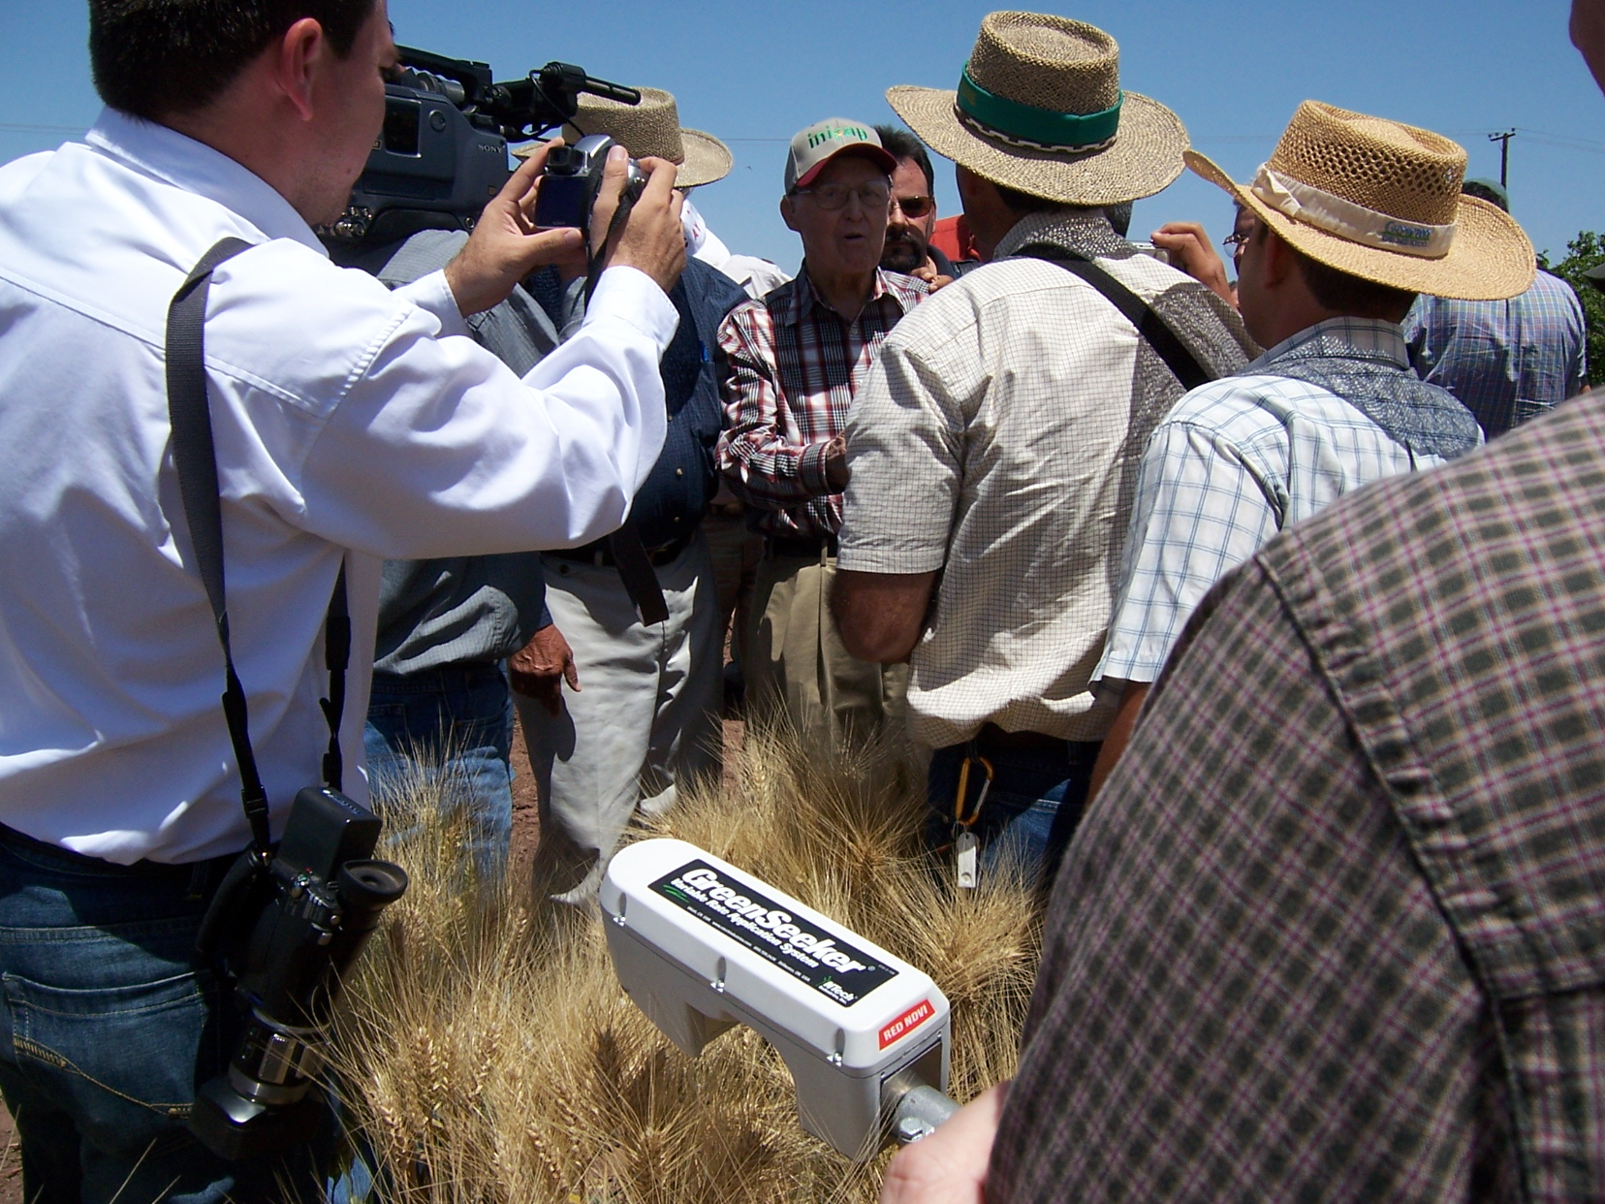
On April 7, 2007, Dr. Norman Borlaug, 1970 Nobel Peace Prize Recipient formally endorsed the GreenSeeker Nitrogen Fertilization Strategy developed at Oklahoma State University. This endorsement was formally made at a ceremony at the CIANO Experiment Station, followed by a dinner hosted by PATRONATO (farmer cooperative) outside Ciudad Obregon, Mexico, in the state of Sonora. The announcement was attended by over 300 people and more than 35 representatives from US and Mexican Press, including the Wall Street Journal.

Our work in 2007 exceeded the 2006 record with more than 33 significant products including journal publications, degrees, books, book chapters, patents, workshops, web sites, grants, classes, and proceedings (Figure 1). Further extension of the Ramped Calibration Strip Applicator with BIOEN Faculty has had a significant impact in 2007, with more than 2000 placed in farmer fields by both industry and OSU extension. This year, our recommendations for wheat farmers should result in N savings approaching $2,000,000.

Other milestones for 2007 included the following:

- 5 students completed Graduate Degrees (3 M.S., 2 Ph.D)
- 20 refereed Journal Publications
- Demonstrated increase in yield to low rates of foliar P
- 5 students traveled to Ciudad Obregon, Mexico to conduct a sensor-based N rate recommendation workshop with CIMMYT.
- Taught 3 classes (SOIL 4234, SOIL 5111, SOIL 4213).
- Web-based dissemination of field scale N fertilization rates based on our optical sensor-based technology (http://www.nue.okstate.edu) in Argentina, Uzbekistan, Mexico, Australia, China, Canada, India, Turkey, and 17 states in the US.
- 2007 Extramural Grants totaled $91,622.

Figure 1. Products generated including journal publications, degrees, books, book chapters, patents, workshops, web sites, grants, classes, and proceedings, from 1991 to 2007.

We currently have 8 graduate students in our program thanks to continued support from the Soil Fertility Research and Education Advisory Board. These students are paid on average $15,660 per year, working full time in the summer and ½ time in the fall and spring semesters. They are the life-blood of our program and we are most grateful to them. In January, 2008 we will have 1 new student from Iraq, and another from India.

Current Students

Name Country Degree Completion Date
1. Arnall, Brian USA Ph.D. 2008
2. Walsh, Olga Russia Ph.D. 2009
3. Turner, Pam USA M.S. 2008
4. England, Brandon USA M.S. 2008
5. Edmonds, Daniel USA M.S. 2008
6. Daft, Cody USA M.S. 2008
7. Kanke, Yumiko Japan M.S. 2008
8. Desta, Birehane Ethiopia M.S. 2009

Figure 2. Total income coming from SB314 and that generated from extramural grant activities, 1989-2007.

