
Executive Summary for 2008

- By-plant N fertilization strategy implemented in corn production systems that resulted in increased NUE.
- N Rich Strips adopted by Oklahoma Fertilizer Dealers throughout central and western portions of the state. Areas using the GreenSeeker sensor based N recommendations in many other regions in the US, and around the world have become extensive.
- OSU N fertilization methodology was fully endorsed by Dr. Norman Borlaug (1970 Nobel Peace Prize Recipient). Use of the OSU N fertilization approach in the US, and other parts of the world documented in various popular press sources (http://www.nue.okstate.edu/International/GreenSeeker.htm).

Our work in 2008 resulted in 27 significant products including journal publications, degrees, books, book chapters, patents, workshops, web sites, grants, classes, and proceedings (Figure 1). Further extension of the Ramped Calibration Strip Applicator with BIOEN Faculty has had a significant impact in 2008, with more than 2000 placed in farmer fields by both industry and OSU extension. This year, our recommendations for wheat farmers should result in N savings approaching $2,000,000.

Other milestones for 2008 included the following:

- 5 students completed Graduate Degrees (4 M.S., 1 Ph.D)
- 9 refereed Journal Publications
- Demonstrated increase in yield to low rates of foliar P
- 2 students traveled to Ciudad Obregon, Mexico, 2 travelled to Harare, Zimbabwe, 1 to Samara, Russia, and 1 to Tashkent, Uzbekistan to conduct a sensor-based N rate recommendation workshops with CIMMYT personnel.
- Taught 3 classes (SOIL 4234, SOIL 5813, SOIL 4213).
- Web-based dissemination of field scale N fertilization rates based on our optical sensor-based technology (http://www.nue.okstate.edu) in Argentina, Uzbekistan, Mexico, Australia, China, Canada, India, Turkey, Russia, Zimbabwe, Ethiopia, Kenya, and 17 states in the US.
- 2008 Extramural Grants totaled $226,692.

Figure 1. Products generated including journal publications, degrees, books, book chapters, patents, workshops, web sites, grants, classes, and proceedings, from 1991 to 2008.

We currently have 8 graduate students in our program thanks to continued support from the Soil Fertility Research and Education Advisory Board. These students are paid on average $15,660 per year, working full time in the summer and ½ time in the fall and spring semesters. They are the life-blood of our program and we are most grateful to them. In January, 2009 we will have 1 additional new student from the US.

Current Students

Name Country Degree Completion Date
- Walsh, Olga Russia Ph.D. 2009 ‡
- Desta, Birehane Ethiopia M.S. 2009 ‡
- Kanke, Yumiko Japan M.S. 2009 ‡
- Edmonds, Daniel USA Ph.D. 2011 ‡
- Vossenkemper, Jacob USA M.S. 2010 ‡
- Ruto, Emily Kenya Ph.D. 2011 ‡
- May, Jerry USA M.S. 2010 ‡
- Torres, Guilherme Brazil M.S. 2010 ‡

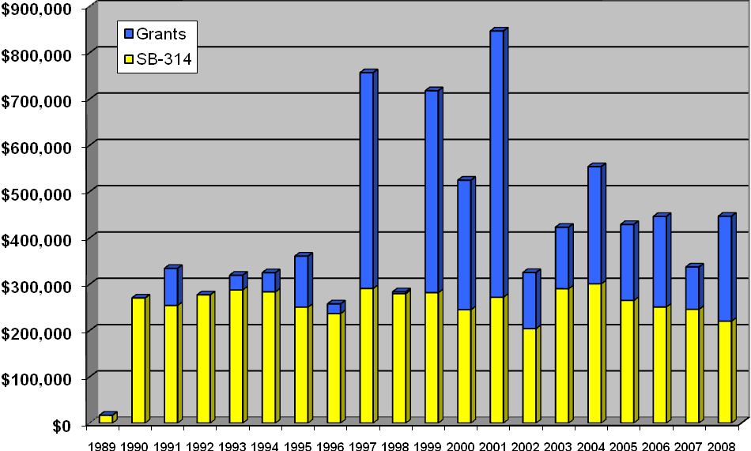
Figure 2. Total income coming from SB314 and that generated from extramural grant activities, 1989-2008.

