
Executive Summary for 2011

- Generalized algorithm developed that can be accessed over the phone
- 3 BAE supported assistantships working with Randy Taylor, Ning Wang, and Carol Jones.
- 60 pocket sensors delivered and currently being used all over the world.
- Hand planter prototype planning nears completion
- Graduate students placed in full time positions at Kansas State University and Virginia Tech.

Faculty level graduates
Oklahoma State University
Washington State University
Montana State University
Virginia Tech
Kansas State University
Louisiana State University
IPNI Alabama
McNeese State (LA)
Northwest College (WY)
USDA-ARS (SD)

Industry/Private graduates
Mosaic VP
Potash Corp. Director Agronomy
Noble Foundation
John Deere
Bayer Crop Science
SST
CIMMYT-Kenya
CARE-El Salvador
Chapingo, Mexico
National Program, Indonesia
Monsanto 5
Pioneer 2

Our work in 2011 resulted in 19 significant products including journal publications, degrees, books, book chapters, patents, workshops, web sites, grants, classes, and proceedings (Figure 1). Further extension of the N Rich Strip program continues. We are now focused in producing and distributing the “Pocket Sensor” both here and abroad.

Other milestones for 2011 included the following:

- 3 students completed Graduate Degrees (2 M.S., 1 Ph.D)
- 13 refereed Journal Publications
- 5 students traveled to Ciudad Obregon, Mexico, to test and deliver new GS2 sensors with CIMMYT personnel.
- Web-based dissemination of field scale N fertilization rates based on our optical sensor-based technology (http://www.nue.okstate.edu)
- 2011 Extramural Grants totaled $30,000.

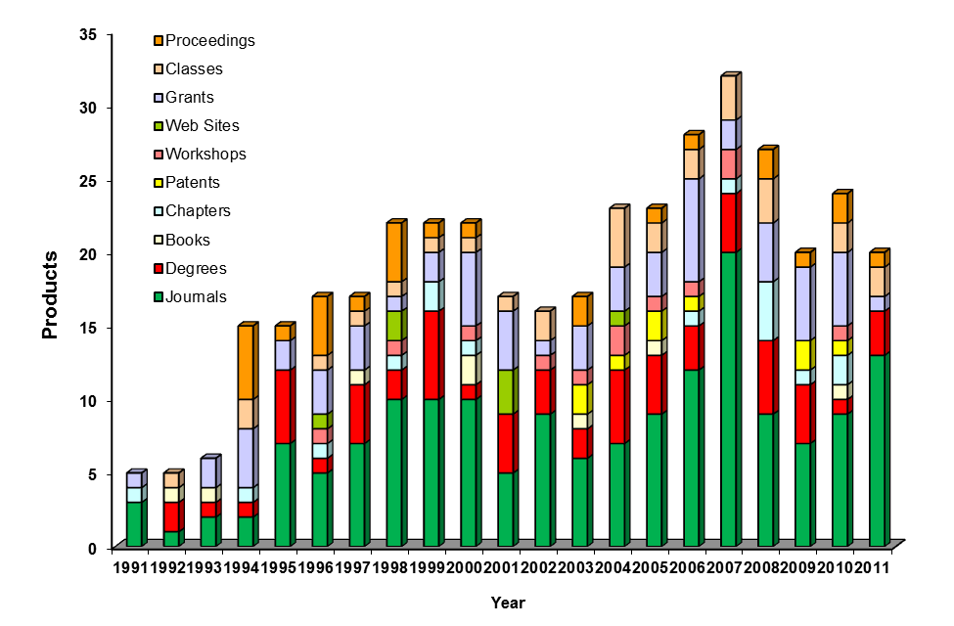

Figure 1. Products generated including journal publications, degrees, books, book chapters, patents, workshops, web sites, grants, classes, and proceedings, from 1991 to 2011.

We currently have 14 graduate students (11 PASS, 3 BAE) supported by our program thanks to continued support from the Soil Fertility Research and Education Advisory Board. These students are paid on average $15,660 per year, working full time in the summer and ½ time in the fall and spring semesters. They are the life-blood of our program and we are most grateful to them.

Current Students

Name Country Degree Date
- Rutto, Emily Kenya Ph.D. 2012*
- Torres, Guilherme Brazil Ph.D. 2012
- Bushong, Jacob USA Ph.D. 2014
- Mullock, Jeremiah USA Ph.D. 2014
- Chim, Bee Malaysia M.S. 2012
- Jared Crain USA M.S. 2012
- Natasha Macnack Suriname Ph.D. 2014
- Lance Shepherd USA M.S. 2012
- Mohammed, Yesuf Ethiopia Ph.D. 2012
- Dhital, Sulochana Nepal M.S. 2013
- Shi, Yeyin China Ph.D. 2013**
- Rascon, Jorge Mexico M.S. 2012***
- Okiror, Grace Uganda Ph.D. 2012****
- Barrett, Malarie USA M.S. 2012@

*co-advised by Dr. Brian Arnall
** Advised by Dr. Ning Wang
*** Advised by Dr. Randy Taylor
****Advised by Dr. Carol Jones
@advised by Dr. Hailin Zhang

Project Funds Needed

NPKS –farmer field demo’s $40,000
John Deere Vacuum Planter/refurbishing $10,000
Lake Carl Blackwell-Fence $70,000
Kincaid Research Combine $213,000
Research Funding BAE $20,000
Graduate Student Assistantship, BAE, Taylor $25,000
Graduate Student Assistantship, BAE, Wang $25,000
$403,000

Current Students on Assistantship, paid by checkoff program
Yeyin Shi assistantship, BAE
Jorge Rascon assistantship, BAE
Grace Okiror, BAE
Jared Crain, M.S. assistantship
Yesuf Mohammed assistantship (Dr. Desta)
Lance Shepherd, M.S. assistantship
Guilherme Torres, PhD assistantship
Emily Rutto PhD assistantship
Bee Chim MS assistantship
Natasha Macnack, PhD assistantship
Jeremiah Mullock, MS assistantship
Sijo Kootara, computer support
Aayush Gupta, MS assistantship (computer science + dept. support)
Candi Byani, laboratory technician

